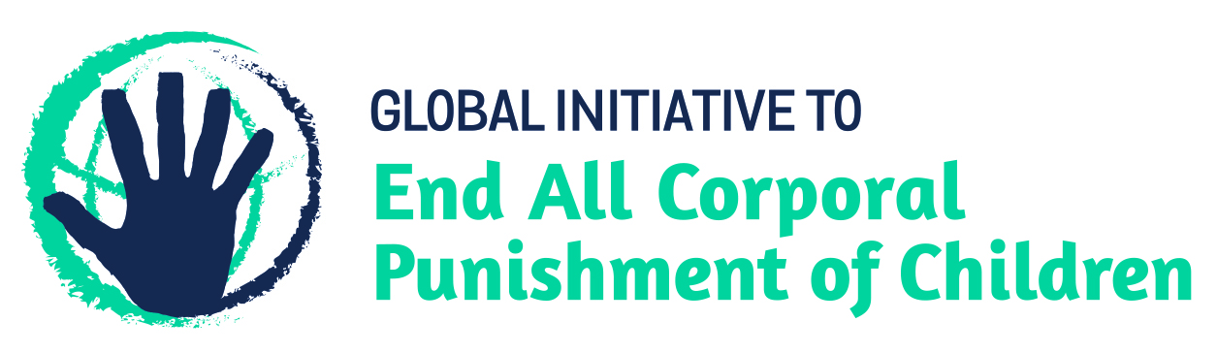
BRIEFING ON FRANCE FOR THE COMMITTEE ON THE RIGHTS OF THE CHILD, SESSION 87 PRE-SESSIONAL WORKING GROUP – September 2020
From the Global Initiative to End All Corporal Punishment of Children, June 2020
This briefing provides an update on the legality of corporal punishment of children in France since its previous examination by the Committee in 2016. We are delighted to inform the Committee that France has now prohibited corporal punishment in all settings, including the home.
We hope the Committee will, in its concluding observations on France’s sixth/seventh periodic report, welcome the prohibition of all corporal punishment of children in France and recommend that the ban is extended to apply in the territories of St Pierre et Miquelon and French Polynesia. We further hope the Committee will recommend all measures be taken to ensure implementation of the prohibition of corporal punishment in all settings, including the home, such as appropriate public education and professional training on the ban and positive, participatory and non-violent forms of education and childrearing.

1 Prohibition of all corporal punishment of children in France
  - Corporal punishment is prohibited in all settings, including the home. The Law on the prohibition of ordinary educational violence (violences éducatives ordinaires, which is the French term for corporal punishment), adopted unanimously by the Senate in July 2019, amends article 371-1 of the Civil Code to include (unofficial translation): “Parental authority is exercised without any physical or psychological violence”. This is interpreted as prohibiting all corporal punishment of children.
  - Concerns have been raised about the 'right of correction' which exists in jurisprudence (judicial decisions) and has not been explicitly repealed in the Law. However, it was made clear during the debates that the intention of the Law is to remove this option for judicial courts. In the French civil legal system, the law is higher in the hierarchy of norms than judicial decisions; meaning that this prohibition in the Civil Code should prevent judges from upholding the 'right of correction'.
  - The ban took effect immediately and applies in at least eight out of France’s eleven overseas territories: French Guiana, Guadeloupe, Martinique, Mayotte, Réunion, St-Barthelemy, St-Martin and the Wallis and Futuna Islands. We are still waiting for confirmation that it also applies in St Pierre et Miquelon. Further work is needed to extend the ban to French Polynesia. The Law does not apply in New Caledonia due to the territory’s special status.

Briefing prepared by the Global Initiative to End All Corporal Punishment of Children
www.endcorporalpunishment.org; info@endcorporalpunishment.org

