Intersex Genital Mutilation
Human Rights Violations Of Children
With Variations Of Reproductive Anatomy

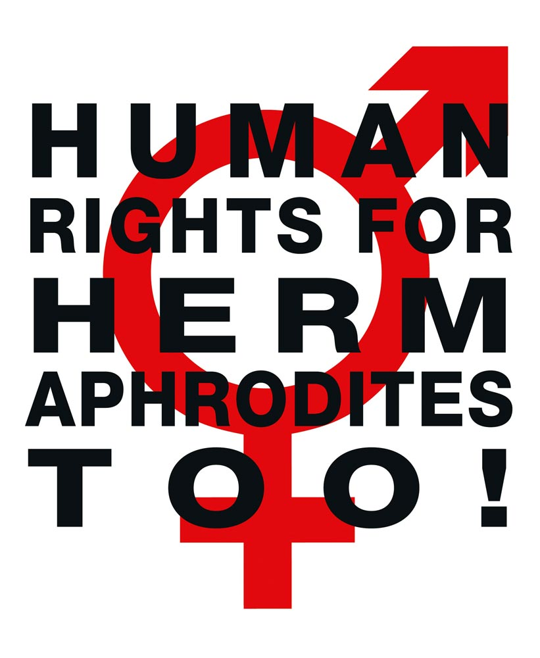

NGO Report (for Session)
to the 5th and 6th Report of Croatia on the Convention on the Rights of the Child (CRC)
Compiled by:

StopIGM.org / Zwischengeschlecht.org (International Intersex Human Rights NGO)
Markus Bauer, Daniela Truffer
Zwischengeschlecht.org
P.O.Box 1318
CH-8031 Zurich
info_at_zwischengeschlecht.org
https://Zwischengeschlecht.org/
https://StopIGM.org

May 2021

This NGO Report online:
http://intersex.shadowreport.org/public/2021-CRC-Croatia-NGO-Zwischengeschlecht-Intersex-StopIGM.pdf

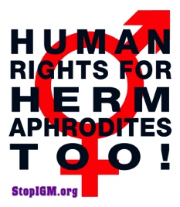
Executive Summary
All typical forms of Intersex Genital Mutilation are still practised in Croatia in University, General and Specialist Hospitals operated by the Ministry of Health, and paid for by the State party via the mandatory public health system, administered by the Croatian Health Insurance Fund (Hrvatski zavod za zdravstveno osiguranje, HZZO) under the control of the Ministry of Health.
Croatia is thus in breach of its obligations under CRC to (a) take effective legislative, administrative, judicial or other measures to prevent harmful practices on intersex children causing severe mental and physical pain and suffering of the persons concerned, and (b) ensure access to redress and justice, including fair and adequate compensation and as full as possible rehabilitation for victims, as stipulated in CRC art. 24 para. 3 in conjunction with the
CRC-CEDAW Joint general comment No. 18/31 “on harmful practices”.
This Committee has consistently recognised IGM practices to constitute a harmful practice under the Convention in Concluding Observations.
In total, UN treaty bodies CRC, CAT, CCPR, CEDAW and CRPD have so far issued 52 Concluding Observations recognising IGM as a serious violation of non-derogable human rights, typically obliging State parties to enact legislation to (a) end the practice and (b) ensure redress and compensation, plus (c) access to free counselling. Also, the UN Special Rapporteurs on Torture (SRT) and on Health (SRH), the UN High Commissioner for Human Rights (UNHCHR), the World Health Organisation (WHO), the Inter-American Commission on Human Rights (IACHR), the African Commission on Human and Peoples’ Rights (ACHPR) and the Council of Europe (COE) recognise IGM as a serious violation of non-derogable human rights.
Intersex people are born with Variations of Reproductive Anatomy, including atypical genitals, atypical sex hormone producing organs, atypical response to sex hormones, atypical genetic make-up, atypical secondary sex markers. While intersex people may face several problems, in the “developed world” the most pressing are the ongoing Intersex Genital Mutilations, which present a distinct and unique issue constituting significant human rights violations.
IGM practices include non-consensual, medically unnecessary, irreversible, cosmetic genital surgeries, and/or other harmful medical procedures that would not be considered for “normal” children, without evidence of benefit for the children concerned. Typical forms of IGM include “masculinising” and “feminising”, “corrective” genital surgery, sterilising procedures, imposition of hormones, forced genital exams, vaginal dilations, medical display, involuntary human experimentation and denial of needed health care.
IGM practices cause known lifelong severe physical and mental pain and suffering, including loss or impairment of sexual sensation, painful scarring, painful intercourse, incontinence, urethral strictures, impairment or loss of reproductive capabilities, lifelong dependency of artificial hormones, significantly elevated rates of self-harming behaviour and suicidal tendencies, lifelong mental suffering and trauma, increased sexual anxieties, and less sexual activity.
For more than 25 years, intersex people have denounced IGM as harmful and traumatising, as western genital mutilation, as child sexual abuse and torture, and called for remedies.
This NGO Report has been compiled by StopIGM.org / Zwischengeschlecht.org, an international intersex NGO. It contains Suggested Recommendations (see p. 15).
NGO Report (for Session)
to the 5th and 6th Report of Croatia
on the Convention on the Rights of the Child (CRC)

Table of Contents

IGM Practices in Croatia (p. 6-15, 23)

Executive Summary 3
A. Introduction 5
1. Croatia: Intersex, IGM, Human Rights and State Report 5
2. About the Rapporteurs 5
3. Methodology 5
B. IGM in Croatia: State-sponsored and pervasive, Gov fails to act 6
1. Overview: IGM practices in Croatia: Pervasive and unchallenged 6
2. Most Common IGM Forms advocated and perpetrated by Croatia 6
a) IGM 3 – Sterilising Procedures: Castration / “Gonadectomy” / Hysterectomy 7
b) IGM 2 – “Feminising Procedures”: Clitoris Amputation/“Reduction”, “Vaginoplasty” 9
c) IGM 1 – “Masculinising Surgery”: Hypospadias “Repair” 11
3. The Croatian Government fails to act despite criticism 13
4. Lack of Independent Data Collection and Monitoring 14
5. Obstacles to redress, fair and adequate compensation 14
C. Suggested Recommendations 15
Annexe 1 – IGM Practices in Croatia as a Violation of CRC 16
1. The Treatment of Intersex Children in Croatia as Harmful Practice and Violence 16
a) Harmful Practice (art. 24(3) and JGC No. 18) 16
b) Violence against Children (art. 19 and GC No. 13) 17
2. Required Legislative Provisions to Ensure Protection from IGM Practices, Impunity 17
3. Obstacles to Redress, Fair and Adequate Compensation, and Rehabilitation 18
Annexe 2 – Intersex, IGM and Non-Derogable Human Rights 19
1. Intersex = variations of reproductive anatomy 19
2. IGM = Involuntary, unnecessary and harmful interventions 19
3. Intersex is NOT THE SAME as LGBT or Transgender 21
4. IGM is NOT a “Discrimination” Issue 22
5. IGM is NOT a “Health” Issue 22
Annexe 3 – “IGM in Medical Textbooks: Current Practice” 23
Croatia: IGM 2 – “Feminising Surgery”: “Clitoral Reduction”, “Vaginoplasty” 23
IGM 1 – “Masculinising Surgery”: “Hypospadias Repair” 24
IGM 2 – “Feminising Surgery”: “Clitoral Reduction”, “Vaginoplasty” 26
IGM 3 – Sterilising Surgery: Castration / “Gonadectomy” / Hysterectomy 28
“Bad results” / “Gonadectomy, Feminising Genitoplasty” 30

A. Introduction
1. Croatia: Intersex, IGM, Human Rights and State Report
IGM practices are known to cause severe, lifelong physical and psychological pain and suffering, and have been repeatedly recognised by multiple UN treaty bodies including CRC as constituting a harmful practice, violence, and cruel, inhuman or degrading treatment.
The current practice in Croatia has been criticised by intersex advocates, NGOs and academics. However, intersex and IGM were not mentioned in the 5th to 6th Croatian State Report 2020.
This Thematic NGO Report demonstrates that the current and ongoing harmful medical practices on intersex children in Croatia – advocated and facilitated in University, General and Specialist Hospitals operated by the Ministry of Health and paid for by the State party via the mandatory public health system, administered by the Croatian Health Insurance Fund (Hrvatski zavod za zdravstveno osiguranje, HZZO) under the control of the Ministry of Health – constitute a serious breach of Croatia’s obligations under the Convention.
2. About the Rapporteurs
This NGO report has been prepared by the international intersex NGO StopIGM.org:
- StopIGM.org / Zwischengeschlecht.org is an international intersex human rights NGO based in Switzerland, working to end IGM practices and other human rights violations perpetrated on intersex people, according to its motto, “Human Rights for Hermaphrodites, too!” According to its charter, StopIGM.org works to support persons concerned seeking redress and justice and regularly reports to relevant UN treaty bodies, often in collaboration with local intersex persons and organisations, substantially contributing to the so far 52 Treaty body Concluding Observations recognising IGM as a serious human rights violation.
In addition, the Rapporteurs would like to acknowledge the work of Croatian intersex advocate E. And we would like to acknowledge the thesis of Aleksandra Relić. And we would like to acknowledge some of the work of Trans Aid.
3. Methodology
This thematic NGO report is a localised update to the 2020 CRC Czechia NGO Report (for Session) by the same Rapporteurs. Translations from Croatian texts are automatic translations revised by the Rapporteurs.
B. IGM in Croatia: State-sponsored and pervasive, Gov fails to act
1. Overview: IGM practices in Croatia: Pervasive and unchallenged
In Croatia, same as in the fellow European Union member states of Italy (CRC/C/ITA/CO/5-6, para 23; CRPD/C/ITA/CO/1, paras 45-46), Austria (CRC/C/AUT/CO/5-6, para 27(a)-(b); CAT/C/AUT/CO/6, paras 44-45), France (CRC/C/FRA/CO/5, paras 47-48; CAT/C/FRA/CO/7, paras 34-35; CEDAW/C/FRA/CO/7-8, paras 18e-f+19e-f), as well as in many more State parties, there are
- no legal or other protections in place to prevent all IGM practices as stipulated in art. 24(3) and the CRC-CEDAW Joint General Comment No. 18/31,
- no legal measures in place to ensure access to redress and justice for adult IGM survivors,
- no legal measures in place to ensure the accountability of all IGM perpetrators and accessories,
- no measures in place to ensure data collection and monitoring of IGM practices.
Despite that the persistence of IGM practices in Croatia is a matter of public record, same as the criticism and appeals by intersex persons, NGOs and academics (see below, p. 13), to this day the Croatian Government fails to recognise the serious human rights violations and the severe pain and suffering caused by IGM practices, let alone to “take effective legislative, administrative, judicial or other measures” to protect intersex children from harmful practices, but instead allows IGM to continue with impunity.
2. Most Common IGM Forms advocated and perpetrated by Croatia
To this day, in Croatia all forms of IGM practices remain widespread and ongoing, persistently advocated, prescribed and perpetrated by state-funded University, General and Specialist Hospitals operated by the Ministry of Health and paid for by the State party via the mandatory public health system, administered by the Croatian Health Insurance Fund (Hrvatski zavod za zdravstveno osiguranje, HZZO) under the control of the Ministry of Health.
There are at least 7 Croatian University, General and Specialist Hospitals with paediatric departments that practice IGM, all of them operated by the Croatian Ministry of Health:
- The Children’s Hospital Zagreb (Klinika za dječje bolesti)
- The University Hospital Zagreb (KBC Zagreb)
- The University Hospital Split (KBC Split)
- The University Hospital Rijeka (KBC Rijeka)
- The University Hospital Osijek (KBC Osijek)
- The General Hospital Zabok (OB Zabok)
- The General Hospital Varaždin (OB Varaždin)
Currently practiced forms of IGM in Croatia include:
a) IGM 3 – Sterilising Procedures:
Castration / “Gonadectomy” / Hysterectomy /
Removal of “Discordant Reproductive Structures” / (Secondary) Sterilisation
Plus arbitrary imposition of hormones
Note: Early “prophylactic” gonadectomies on intersex children diagnosed with Complete Androgen Insufficiency Syndrome (CAIS) are often performed under the pretext of an alleged “high cancer risk”, however, the actual cancer risk is only 0,8%.
The Croatian Society of Urology (“Hrvatsko Urološko Društvo”) endorses the 2021 Guidelines of the European Association of Urology (EAU), which include the current ESPU/EAU “Paediatric Urology” Guidelines 2021 of the European Society for Paediatric Urology (ESPU) and the European Association of Urology (EAU) which stress:
“Individuals with DSD have an increased risk of developing cancers of the germ cell lineage, malignant germ cell tumours or germ cell cancer in comparison with to the general population.”
Further, regarding “whether and when to pursue gonadal or genital surgery”, the Guidelines refer to the “ESPU/SPU standpoint on the surgical management of Disorders of Sex Development (DSD)”, which advocates “gonadectomies”:
“Testes are either brought down in boys or removed if dysgenetic with tumour risk or in complete androgen insensitivity syndrome or 5 alpha reductase deficiency. Testicular prostheses can be inserted at puberty at the patient’s request.”
Also, the “2016 Global Disorders of Sex Development Consensus Statement” refers to the “ESPU/SPU standpoint”, advocates “gonadectomy” – even when admitting “low” cancer risk for CAIS (and despite explicitly acknowledging CRC/C/CHE/CO/2-4):
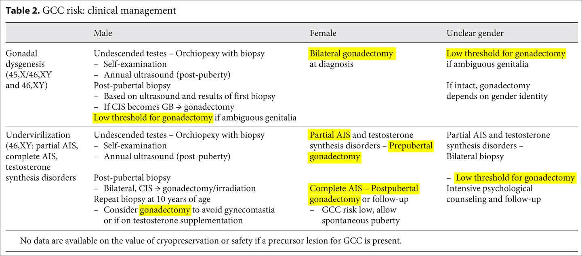
Source: Lee et al., in: Horm Res Paediatr 2016;85:158-180, at 174
Accordingly, a 2011 medical publication by a professor from the Medical Faculty of the University of Zagreb notes:
“Surgical treatment […]
- developmental anomalies
- gonadectomy (for XY intersexualism)
[…]
- corrective procedures”
And a 2016 medical thesis from the Medical Faculty of the University of Split discussing the experience at the University Hospital Split (KBC Split) states:
“Androgen insensitivity syndrome (Morris syndrome) is also caused by a genetic disorder on the X-chromosome receptor androgen. It is an example of male pseudohermaphroditism; male karyotype (XY), but are phenotypically female. […] gonadectomies are performed due to the increased risk of developing cancer from the remaining testicles. Children of such parents are often phenotypically normal, but male children are infertile.”
Also, a 2007 medical publication from the Medical Faculty of the University of Osijek and the Clinic for Paediatrics at the University Hospital Osijek (KBC Osijek) recommends (despite noting some caveats):

“The prevalence of these tumors in CAIS was estimated at almost 30% in the first studies, but recent data on a larger sample show that it is still overestimated, especially before puberty, when the prevalence is about 0.8% (12, 30). […] it is recommended to leave the gonads until the end of puberty and then perform a gonadectomy (39)”
To this day, IGM 3 procedures are paid for by the public Health System via the Hospital Invoicing System (CUS, Centralni upravljački sustav) according to the relevant “DTS Procedure Codes”, including codes “30641-00 – Orchidectomy, unilateral” (“Orhidektomija, jednostrana”) and “30641-01 – Orchidectomy, bilateral” (“Orhidektomija, obostrana”). According to the Central health information system of the Republic of Croatia (CEZIH, Centralni zdravstveni informacijski sustav Republike Hrvatske), between 2015-2019 in total 5,235 such procedures were performed at Croatian University, General and Specialist Hospitals, many of them with paediatric surgery departments, including 46 procedures at the Children’s Hospital Zagreb (Klinika za dječje bolesti).
b) IGM 2 – “Feminising Procedures”: Clitoris Amputation/“Reduction”,
“Vaginoplasty”, “Labiaplasty”, Dilation
The Croatian Society of Urology (“Hrvatsko Urološko Društvo”) endorses the 2021 Guidelines of the European Association of Urology (EAU), which include the current ESPU/EAU “Paediatric Urology” Guidelines 2021 of the European Society for Paediatric Urology (ESPU) and the European Association of Urology (EAU). In chapter 3.17 “Disorders of sex development”, despite admitting that “Surgery that alters appearance is not urgent” and that “adverse outcomes have led to recommendations to delay unnecessary [clitoral] surgery to an age when the patient can give inform consent”, the ESPU/EAU Guidelines nonetheless explicitly refuse to postpone non-emergency surgery, but in contrary insist to continue with non-emergency genital surgery (including partial clitoris amputation) on young children based on “social and emotional conditions” and substituted decision-making by “parents and caregivers implicitly act[ing] in the best interest of their children” and making “well-informed decisions […] on their behalf”, and further explicitly refusing “prohibition regulations” of unnecessary early surgery, referring to the 2018 ESPU Open Letter to the Council of Europe (COE), which further invokes parents’ “social, and cultural considerations” as justifications for early surgery (p. 2).

Accordingly, a 2019 medical publication by doctors of the Clinic for Paediatrics at the University Hospital Zagreb (KBC Zagreb) prescribes:
“Surgical corrections of the ambiguous genitalia of female children with the classic form of CAH due to 21-hydroxylase deficiency
The views on at what age and which surgical procedures should be performed on the genitals of girls with CAH due to 21-hydroxylase deficiency are still far from agreed. However, the prevailing opinion is that this should preferably be done in one act before the first year of life, when the tissue is still elastic and adaptable, and the psychological consequences for the child are reduced to a minimum. In any case, such procedures should be performed exclusively by specialised surgeons.”
And a 2010 medical publication by doctors of the Department of Paediatric Surgery at the University Hospital Zagreb (KBC Zagreb) prescribes:
“Surgical correction of infants with ambiguous external genitalia is one of the greatest challenges in paediatric surgery. [...] The goal of the surgical correction of a child with intersex features of the external genitalia is to achieve an almost normal appearance of the genitals with good function in sexual intercourse.
[...]
Successful genitoplasty should meet five main goals (2):
● ensure adequate opening of the vagina on the perineum;
● create a normal-looking vestibule;
● completely separate the vagina from the urinary system;
● remove the corpus spongiosum of the hypertrophic clitoris and preserve the circulation, innervation and sensation of the glans as erogenous zones;
● avoid possible complications of the urinary system such as infections or incontinence.
[…]
The contentious issue in the reconstruction of the ambiguous genitalia is the right time for the procedure. [...]
The current opinion is that it is better to do it at an earlier age than to postpone it until adolescence. […] First, early in life, between 3 and 6 months, the hypertrophic clitoris (which is sometimes larger than the penis for the appropriate age) is reduced and the urogenital sinus is opened. This gives the external genitalia a more natural appearance, which prevents anxiety of parents and the environment and helps the child to develop normally, psychologically and sexually. Vaginoplasty is postponed to a slightly older age in order to prevent postoperative stenosis of the vaginal opening, which are otherwise common complications if the procedure is performed in infancy.
In most patients with amphibious genitalia (mixed gonadal dysgenesis, female pseudohermaphroditism, true hermaphroditism), […] opening the urogenital sinus […] is followed by a partial clitorectomy. […] If necessary, depending on the opening of the vagina, dilation begins after a month or two, first on an outpatient basis under medical supervision, and later on by parents at home.”
See also pictorial example from a 2013 medical presentation by a doctor from the Medical Faculty of the University of Zagreb, p. 23.
To this day, IGM 2 procedures are paid for by the public Health System via the Hospital Invoicing System (CUS, Centralni upravljački sustav) according to the relevant “DTS Procedure Codes”, including codes “37848-00 – Reduction clitoroplasty and vaginoplasty for ambiguous genitals with urogenital sinus” (“Redukcijska klitoroplastika i vaginoplastika radi dvosmislenih spolnih organa s urogenitalnim sinusom”) and “37851-00 – Vaginoplasty due to congenital adrenal hyperplasia, mixed gonadal dysgenesis or similar conditions” (“Vaginoplastika zbog kongenitalne adrenalne hiperplazije, miješane gonadalne dizgeneze ili sličnih stanja”). According to the Central health information system of the Republic of Croatia (CEZIH, Centralni zdravstveni informacijski sustav Republike Hrvatske), between 2015-2019 in total 5,235 such procedures were performed in Croatian University, General and Specialist Hospitals, many of them with paediatric surgery departments, including 46 procedures at the Children’s Hospital Zagreb (Klinika za dječje bolesti).
c) IGM 1 – “Masculinising Surgery”: Hypospadias “Repair”
The Croatian Society of Urology (“Hrvatsko Urološko Društvo”) endorses the 2021 Guidelines of the European Association of Urology (EAU), which include the current ESPU/EAU “Paediatric Urology” Guidelines 2021 of the European Society for Paediatric Urology (ESPU) and the European Association of Urology (EAU). In chapter 3.6 “Hypospadias”, the ESPU/EAU Guidelines’ section 3.6.5.3 “Age at surgery” nonetheless explicitly promotes, “The age at surgery for primary hypospadias repair is usually 6-18 (24) months.” – despite admitting to the “risk of complications” and “aesthetic[…]” and “cosmetic” justifications.

Accordingly, the Children’s Hospital Zagreb (Klinika za dječje bolesti) advertises on the homepage of its Department of Paediatric Urology:
“In the tradition of our department, surgical-reconstructive treatment of hypospadias has a special place, from the simplest to the most complex forms and common anomalies, treating patients with modern surgical methods, if possible in a single procedure.”
And doctors from the University Hospital Osijek (KBC Osijek) went on record in a 2020 article in a local newspaper:
“The procedure we are especially proud of is surgery for hypospadias, ie boys in whom the opening of the urethra does is not situated in the right place, so children have problems urinating [while standing]. Unfortunately, this phenomenon is not so rare in male children and it is really not easy to find a centre where this procedure can be performed - says doc. Dulic.”
And a 2006 medical article by doctors of the Medical Faculty of the University of Zagreb and the Clinic for Paediatrics at the University Hospital Zagreb (KBC Zagreb) states:
“Despite of advancements in technique, instruments and postoperative treatment, correction of hypospadias continues to be one of technically most challenging aspects of pediatric urology. There are different approaches to the timing of treatment of hypospadia[s]. Some surgeons believe that the operation should be done in the first year of life, while the more liberal ones suggest that the surgical treatment should be done before the child begins school.”
Also, doctors from the General Hospital Zabok (OB Zabok) contributed to an 2012 Illustrated Surgical Atlas on “hypospadias repair”.
And a 2015 medical article from the Medical Faculty of the by doctors from the Department of Paediatric Surgery of the University Hospital Split (KBC Split) reveals:
“The aim of this study is to describe surgical treatment of children with urinary tract anomalies in the Department of Pediatric Surgery, University Hospital Split. Data were collected for hospitalized children from January 2000 to December 2014. […] 706 hypospadias was 78% glandular and coronary, penile 13% and scrotal 9%. 550 children underwent urethral reconstruction with local or rotating flap, in 156 was made tube plasty. 11% of children were operated in two, 5% in three, 4% in four or more acts. 80% of children were operated in one act. Most common complication was urethral fistula (11%). […] Surgery is the only method of treatment of hypospadias.”
To this day, IGM 1 procedures are paid for by the public Health System via the Hospital Invoicing System (CUS, Centralni upravljački sustav) according to the relevant “DTS Procedure Codes”, including codes “37818-00 – Glanduloplasty of the penis due to hypospadias” (“Plastika glansa penisa zbog hipospadije”), “37821-00 – Distal hypospadias, treatment in one procedure” (“Distalna hipospadija, liječenje u jednom zahvatu”), “37824-00 – Proximal hypospadias treatment in one stage” (“Proksimalna hipospadija liječenje u jednoj fazi”), “37827-00 – Hypospadias, treatment in stages, first stage” (“Hipospadija, liječenje u fazama, prva faza”), “37830-00 – Hypospadias, treatment in stages, second stage” (“Hipospadija, liječenje u fazama, druga faza”) and “37833-00 – Hypospadias, treatment of postoperative urethral fistula” (“Hipospadija, liječenje postoperativne uretralne fistule”). According to the Central health information system of the Republic of Croatia (CEZIH, Centralni zdravstveni informacijski sustav Republike Hrvatske), between 2015-2019 in total 736 such procedures were performed in Croatian University, General and Specialist Hospitals, many of them with paediatric surgery departments, including 192 procedures at the Children’s Hospital Zagreb (Klinika za dječje bolesti).
3. The Croatian Government fails to act despite criticism
The persistence of IGM practices in Croatia is a matter of public record, same as the criticism and appeals by intersex persons, NGOs and academics.
However, to this day the Croatian Government fails to recognise the serious human rights violations and the severe pain and suffering caused by IGM practices, let alone to “take effective legislative, administrative, judicial or other measures” to protect intersex children from harmful practices, but instead allows IGM doctors to continue practicing with impunity.
4. Lack of Independent Data Collection and Monitoring
The Croatian Government fails to collect and disclose disaggregated data on intersex persons and IGM practices. With no statistics available on intersex births, let alone surgeries and costs, and perpetrators, governments and health departments colluding to keep it that way as long as anyhow possible, persons concerned as well as civil society lack possibilities to effectively highlight and monitor the ongoing mutilations.
As IGM practices in Croatia are paid for by the public Health System via the Hospital Invoicing System (CUS, Centralni upravljački sustav) according to relevant “DTS Procedure Codes”, and stored in the Central health information system of the Republic of Croatia (CEZIH, Centralni zdravstveni informacijski sustav Republike Hrvatske), partial data on IGM practices is available via the published Annual Reports of “DTS Procedures” disaggregated by procedure codes and hospitals (for relevant examples, see above p. 9, 11, 13). However, what’s missing in these annual statistics is disaggregation by age group and diagnosis. Nonetheless, the Ministry of Health in cooperation with the Croatian Health Insurance Institute and the Croatian Public Health Institute could surely collect and retrieve this missing data in the Central health information system of the Republic of Croatia (CEZIH).
Conclusion, the Croatian Government should facilitate independent, ongoing and comprehensive data collection on intersex births and IGM procedures disaggregated by diagnosis, procedure, age at intervention and clinic where the intervention took place, and make it publicly available.
5. Obstacles to redress, fair and adequate compensation
Also in Croatia the statutes of limitation prohibit survivors of early childhood IGM practices to call a court, because persons concerned often do not find out about their medical history until much later in life, and severe trauma caused by IGM practices often prohibits them to act in time once they do. So far, in Croatia there was no case of a victim of IGM practices succeeding in going to court, despite survivors criticising the practice in public.
This situation is clearly not in line with Croatia’s obligations under the Convention.

C. Suggested Recommendations

The Rapporteurs respectfully suggest that, with respect to the treatment of intersex persons in Croatia, the Committee includes the following measures in their recommendations to the Croatian Government (in line with this Committee’s previous recommendations on IGM practices):

Harmful practices: Intersex genital mutilation
The Committee remains seriously concerned about cases of medically unnecessary and irreversible surgery and other treatment on intersex children without their informed consent, which can cause severe suffering, and the lack of redress and compensation in such cases.
In the light of its joint general comment No. 18 (2014) and No. 31 of the Committee on the Elimination of Discrimination against Women on harmful practices and taking note of target 5.3 of the Sustainable Development Goals, the Committee urges the State party to:
(a) Ensure that the State party’s legislation explicitly prohibits all forms of intersex genital mutilation, by criminalising or adequately sanctioning unnecessary medical or surgical treatment during infancy or childhood, provide families with intersex children with adequate counselling and support;
(b) Adopt legal provisions and repeal time-limits in order to provide redress to the victims of such treatment, including adequate compensation and as full rehabilitation as possible, and undertake investigation of incidents of surgical and other medical treatment of intersex children without their informed consent;
(c) Systematically collect disaggregated data on harmful practices in the State party and make information on the ways to combat these practices widely available;
(d) Educate and train medical, psychological and education professionals on intersex as a natural bodily variation and on the consequences of unnecessary surgical and other medical interventions for intersex children.

Annexe 1 – IGM Practices in Croatia as a Violation of CRC
1. The Treatment of Intersex Children in Croatia as Harmful Practice and Violence
a) Harmful Practice (art. 24(3) and JGC No. 18)
Article 24 para 3 CRC calls on states to abolish harmful “traditional practices prejudicial to the health of children”. While the initial point of reference for the term was the example of Female Genital Mutilation/Cutting (FGM/C), the term consciously wasn’t limited to FGM/C, but meant to include all forms of harmful, violent, and/or invasive traditional or customary practices.
This Committee has repeatedly considered IGM as a harmful practice, and the
CRC-CEDAW Joint General Comment No. 18/31 on harmful practices as applicable.
Also CEDAW has repeatedly considered IGM as a harmful practice, and the CRC-CEDAW Joint General Comment/Recommendation No. 18/31 on harmful practices as applicable.
Harmful practices (and inhuman treatment) have been identified by intersex advocates as the most effective, well established and applicable human rights frameworks to eliminate IGM practices and to end the impunity of the perpetrators.
The CRC-CEDAW Joint General Comment/Recommendation No. 18/31 “on harmful practices” “call[s] upon States parties to explicitly prohibit by law and adequately sanction or criminalize harmful practices, in accordance with the gravity of the offence and harm caused, provide for means of prevention, protection, recovery, reintegration and redress for victims and combat impunity for harmful practices” (para 13).
Particularly, the Joint General Comment/Recommendation further underlines the need for a “Holistic framework for addressing harmful practices” (paras 31–36), including “legislative, policy and other appropriate measures that must be taken to ensure full compliance with [state parties’] obligations under the Conventions to eliminate harmful practices” (para 2), as well as
“Data collection and monitoring” (paras 37–39)
“Legislation and its enforcement” (paras 40–55), particularly:
“adequate civil and/or administrative legislative provisions” (para 55 (d))
“provisions on regular evaluation and monitoring, including in relation to implementation, enforcement and follow-up” (para 55 (n))
“equal access to justice, including by addressing legal and practical barriers to initiating legal proceedings, such as the limitation period, and that the perpetrators and those who aid or condone such practices are held accountable” (para 55 (o))
“equal access to legal remedies and appropriate reparations in practice” (para 55 (q)).
Last but not least, the Joint General Comment explicitly stipulates: “Where medical professionals or government employees or civil servants are involved or complicit in carrying out harmful practices, their status and responsibility, including to report, should be seen as an aggravating circumstance in the determination of criminal sanctions or administrative sanctions such as loss of a professional licence or termination of contract, which should be preceded by the issuance of warnings. Systematic training for relevant professionals is considered to be an effective preventive measure in this regard.” (para 50)
Conclusion, IGM practices in Croatia – as well as the failure of the state party to enact effective legislative, administrative, social and educational measures to eliminate them and to ensure effective access to remedies and redress for IGM survivors – clearly violate Article 24 CRC, as well as the CRC-CEDAW Joint General Comment No. 18/31 on harmful practices.
b) Violence against Children (art. 19 and GC No. 13)
Similarly, the Committee has also considered IGM practices as violence against children, and Art. 19 and the General Comment No. 13 also offer strong provisions to combat IGM practices.
2. Required Legislative Provisions to Ensure Protection from IGM Practices,
Impunity of the Perpetrators (CRC art. 24(3) and JGC No. 18)
Article 24 para. 3 of the Convention in conjunction with the CRC-CEDAW Joint General Comment/Recommendation No. 18/31 “on harmful practices” (2014) underline state parties’ obligations to “explicitly prohibit by law and adequately sanction or criminalize harmful practices” (JGC 18/31, para 13), as well as to “adopt or amend legislation with a view to effectively addressing and eliminating harmful practices” (JGC 18/31, para 55), and specifically to ensure “that the perpetrators and those who aid or condone such practices are held accountable” (JGC 18/31, para 55 (o)).
Accordingly, with regards to IGM practices, and referring to Article 24 para 3 and the CRC-CEDAW Joint General Comment/Recommendation No. 18/31, CRC repeatedly recognised the obligation for State parties to “[e]nsure that the State party’s legislation prohibits all forms of harmful practices [including intersex genital mutilation]”, as well as to “ensure that no-one is subjected to unnecessary medical or surgical treatment during infancy or childhood, guarantee bodily integrity, autonomy and self-determination to children concerned”, and to “[u]ndertake investigation of incidents of surgical and other medical treatment of intersex children without informed consent and adopt legal provisions in order to provide redress to the victims of such treatment, including adequate compensation”.
3. Obstacles to Redress, Fair and Adequate Compensation, and Rehabilitation
(CRC art. 24(3) and JGC No. 18)
Article 24 para. 3 of the Convention in conjunction with the CRC-CEDAW Joint General Comment/Recommendation No. 18/31 “on harmful practices” clearly stipulate the right of victims of IGM practices to “equal access to legal remedies and appropriate reparations” (JGC 18/31, para 55 (q)), and specifically to ensure that “children subjected to harmful practices have equal access to justice, including by addressing legal and practical barriers to initiating legal proceedings, such as the limitation period” (JGC 18/31, para 55 (o)).
However, also in Croatia the statutes of limitation prohibit survivors of early childhood IGM practices to call a court, because persons concerned often do not find out about their medical history until much later in life, and severe trauma caused by IGM practices often prohibits them to act in time even once they do. So far there was no case of a victim of IGM practices succeeding in going to an Croatian court.
Annexe 2 – Intersex, IGM and Non-Derogable Human Rights
1. Intersex = variations of reproductive anatomy
Intersex persons, in the vernacular also known as hermaphrodites, or medically as persons with “Disorders” or “Differences of Sex Development (DSD)”, are people born with variations of reproductive anatomy, or “atypical” reproductive organs, including atypical genitals, atypical sex hormone producing organs, atypical response to sex hormones, atypical genetic make-up, atypical secondary sex markers. Many intersex forms are usually detected at birth or earlier during prenatal testing, others may only become apparent at puberty or later in life.
While intersex people may face several problems, in the “developed world” the most pressing are the ongoing Intersex Genital Mutilations, which present a distinct and unique issue constituting significant human rights violations, with 1 to 2 in 1000 newborns at risk of being submitted to non-consensual “genital correction surgery”.
For more information and references, see 2014 CRC Switzerland NGO Report, p. 7-12.
2. IGM = Involuntary, unnecessary and harmful interventions
In “developed countries” with universal access to paediatric health care 1 to 2 in 1000 newborns are at risk of being submitted to medical IGM practices, i.e. non-consensual, unnecessary, irreversible, cosmetic genital surgeries, and/or other harmful medical treatments that would not be considered for “normal” children, practiced without evidence of benefit for the children concerned, but justified by societal and cultural norms and beliefs, and often directly financed by the state via the public health system.
In regions without universal access to paediatric health care, there are reports of infanticide of intersex children, of abandonment, of expulsion, of massive bullying preventing the persons concerned from attending school (recognised by CRC as amounting to a harmful practice), and of murder.
Governing State bodies, public and private healthcare providers, national and international medical bodies and individual doctors have traditionally been framing and “treating” healthy intersex children as suffering from a form of disability in the medical definition, and in need to be “cured” surgically, often with openly racist, eugenic and suprematist implications..
Both in “developed” and “developing” countries, harmful stereotypes and prejudice framing intersex as “inferior”, “deformed”, “disordered”, “degenerated” or a “bad omen” remain widespread, and to this day inform the current harmful western medical practice, as well as other practices including infanticide and child abandonment.
Typical forms of medical IGM include “feminising” or “masculinising”, “corrective” genital surgery, sterilising procedures, imposition of hormones (including prenatal “therapy”), forced genital exams, vaginal dilations, medical display, human experimentation, selective (late term) abortions and denial of needed health care.
Medical IGM practices are known to cause lifelong severe physical and mental pain and suffering, including loss or impairment of sexual sensation, poorer sexual function, painful scarring, painful intercourse, incontinence, problems with passing urine (e.g. due to urethral stenosis after surgery), increased sexual anxieties, problems with desire, less sexual activity, dissatisfaction with functional and aesthetic results, lifelong trauma and mental suffering, elevated rates of self-harming behaviour and suicidal tendencies comparable to those among women who have experienced physical or (child) sexual abuse, impairment or loss of reproductive capabilities, lifelong dependency on daily doses of artificial hormones.
UN Treaty bodies and other human rights experts have consistently recognised IGM practices as a serious violation of non-derogable human rights. UN Treaty bodies have so far issued 52 Concluding Observations condemning IGM practices accordingly.
3. Intersex is NOT THE SAME as LGBT or Transgender
Unfortunately, there are also other, often interrelated harmful misconceptions and stereotypes about intersex still prevailing in public, notably if intersex is counterfactually described as being the same as or a subset of LGBT or SOGI, e.g. if intersex is misrepresented as a sexual orientation (like gay or lesbian), and/or as a gender identity, as a subset of transgender, as the same as transsexuality, or as a form of sexual orientation.
The underlying reasons for such harmful misrepresentations include lack of awareness, third party groups instrumentalising intersex as a means to an end for their own agenda, and State parties trying to deflect from criticism of involuntary intersex treatments.
Intersex persons and their organisations have spoken out clearly against instrumentalising or misrepresenting intersex issues, maintaining that IGM practices present a distinct and unique issue constituting significant human rights violations, which are different from those faced by the LGBT community, and thus need to be adequately addressed in a separate section as specific intersex issues.
Also, human rights experts are increasingly warning of the harmful conflation of intersex and LGBT.
Regrettably, these harmful misrepresentations seem to be on the rise also at the UN, for example in recent UN press releases and Summary records misrepresenting IGM as “sex alignment surgeries” (i.e. voluntary procedures on transsexual or transgender persons), IGM survivors as “transsexual children”, and intersex NGOs as “a group of lesbians, gays, bisexuals, transgender and intersex victims of discrimination”, and again IGM survivors as “transgender children”, “transsexual children who underwent difficult treatments and surgeries”, and IGM as a form of “discrimination against transgender and intersex children” and as “sex assignment surgery” while referring to “access to gender reassignment-related treatments”.
Particularly State parties are constantly misrepresenting intersex and IGM as sexual orientation or gender identity issues in an attempt to deflect from criticism of the serious human rights violations resulting from IGM practices, instead referring to e.g. “gender reassignment surgery” (i.e. voluntary procedures on transsexual or transgender persons) and “gender assignment surgery for children”, “a special provision on sexual orientation and gender identity”, “civil registry” and “sexual reassignment surgery” , transgender guidelines or “Gender Identity” when asked about IGM by e.g. Treaty bodies.
What’s more, LGBT organisations (including “LGBTI” organisations without actual intersex representation or advocacy) are frequently using the ubiquitous misrepresentation of intersex = LGBT to misappropriate intersex funding, thus depriving actual intersex organisations (which mostly have no significant funding, if any) of much needed resources and public representation.
4. IGM is NOT a “Discrimination” Issue
An interrelated diversionary tactic is the increasing misrepresentation by State parties of IGM as “discrimination issue” instead of a serious violation of non-derogable human rights, namely inhuman treatment and a harmful practice, often in combination with the misrepresentation of intersex human rights defenders as “fringe elements”, and their legitimate demands and criticism of such downgrading and trivialising of IGM as “extreme views”.
5. IGM is NOT a “Health” Issue
An interrelated, alarming new trend is the increasing misrepresentation of IGM as “health-care issue” instead of a serious violation of non-derogable human rights, and the promotion of “self-regulation” of IGM by the current perpetrators – instead of effective measures to finally end the practice (as repeatedly stipulated also by this Committee).
Even worse, Health Ministries construe UN Concluding observations falling short of explicitly recommending legislation to criminalise or adequately sanction IGM as an excuse for “self-regulation” promoting state-sponsored IGM practices to continue with impunity.
Annexe 3 – “IGM in Medical Textbooks: Current Practice”
Croatia: IGM 2 – “Feminising Surgery”: “Clitoral Reduction”, “Vaginoplasty”

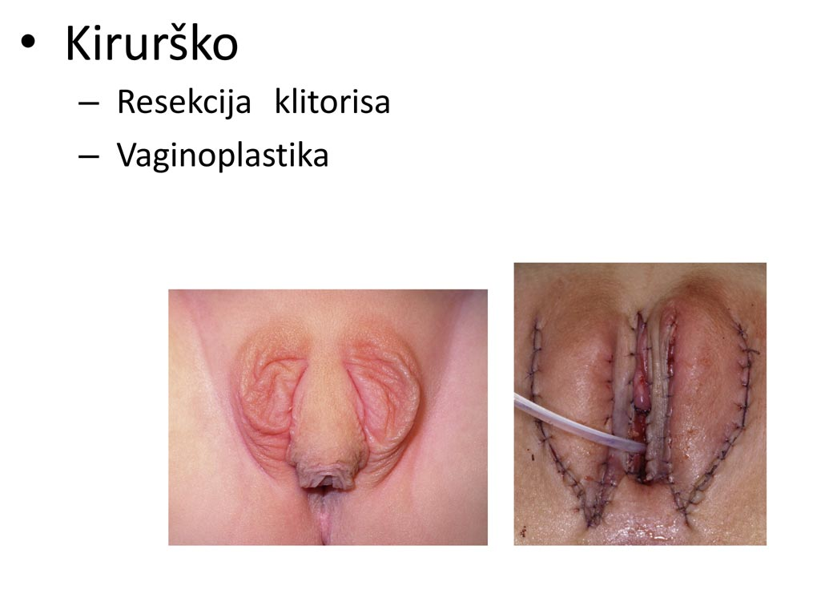

Caption: “Surgery: Clitoral Resection, Vaginoplasty”

Source: Miroslav Dumić: “Kongenitalna adrenalna hiperplazija” (“Congenital Adrenal Hyperplasia”), presentation at the 9th Croatian Congress on Gynecological Endocrinology, Human Reproduction and Menopause, 2013, slide 12, http://www.hdhr.org/endo2013/predavanja/cetvrtak/KAH Brijuni.ppt

IGM 1 – “Masculinising Surgery”: “Hypospadias Repair”
“Hypospadias,” i.e. when the urethral opening is not on the tip of the penis, but somewhere on the underside between the tip and the scrotum, is arguably the most prevalent diagnosis for cosmetic genital surgeries. Procedures include dissection of the penis to “relocate” the urinary meatus. Very high complication rates, as well as repeated “redo procedures” — “5.8 operations (mean) along their lives … and still most of them are not satisfied with results!”
Nonetheless, clinicians recommend these surgeries without medical need explicitly “for psychological and aesthetic reasons.” Most hospitals advise early surgeries, usually “between 12 and 24 months of age.” While survivors criticise a.o. impairment or total loss of sexual sensation and painful scars, doctors still fail to provide evidence of benefit for the recipients of the surgeries.
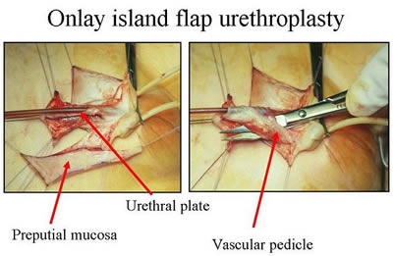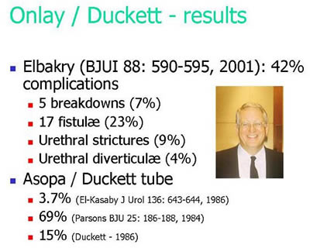
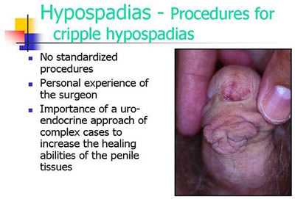
Official Diagnosis “Hypospadias Cripple”
= made a “cripple” by repeat cosmetic surgeries

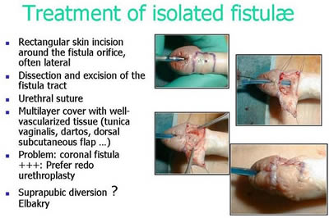
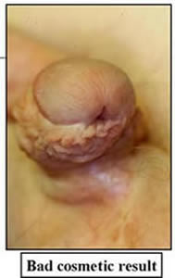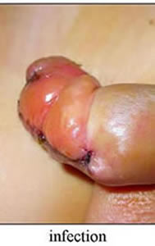
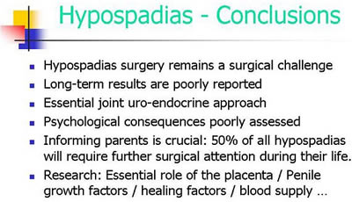
Source: Pierre Mouriquand: “Surgery of Hypospadias in 2006 - Techniques & outcomes”

IGM 2 – “Feminising Surgery”: “Clitoral Reduction”, “Vaginoplasty”
Partial amputation of clitoris, often in combination with surgically widening the vagina followed by painful dilation. “46,XX Congenital Adrenal Hyperplasia (CAH)” is arguably the second most prevalent diagnosis for cosmetic genital surgeries, and the most common for this type (further diagnoses include “46,XY Partial Androgen Insufficiency Syndrome (PAIS)” and “46,XY Leydig Cell Hypoplasia”).
Despite numerous findings of impairment and loss of sexual sensation caused by these cosmetic surgeries, and lacking evidence for benefit for survivors, current guidelines nonetheless advise surgeries “in the first 2 years of life”, most commonly “between 6 and 12 months,” and only 10.5% of surgeons recommend letting the persons concerned decide themselves later.
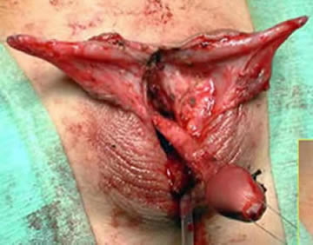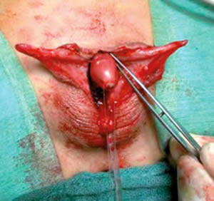
Source: Christian Radmayr: Molekulare Grundlagen und Diagnostik des Intersex, 2004
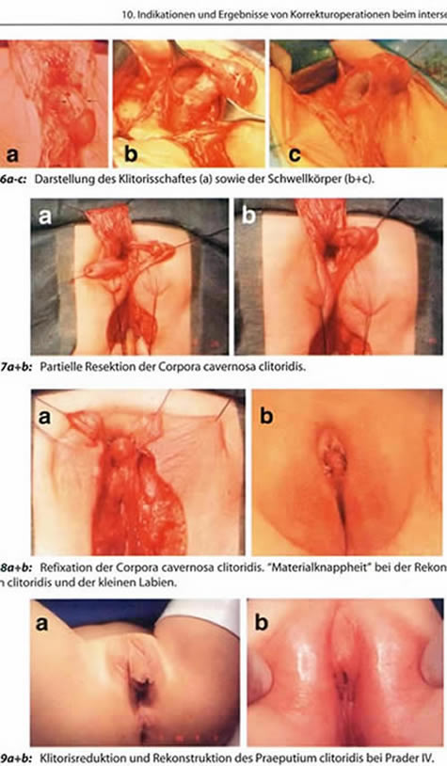
Source: Finke/Höhne: Intersexualität bei Kindern, 2008
Caption 8b: “Material shortage” [of skin] while reconstructing the praeputium clitoridis and the inner labia.
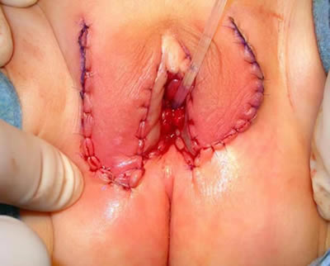
Source: Pierre Mouriquand: “Chirurgie des anomalies du développement sexuel - 2007”, at 81: “Labioplastie”
IGM 3 – Sterilising Surgery: Castration / “Gonadectomy” / Hysterectomy
Removal of healthy testicles, ovaries, or ovotestes, and other potentially fertile reproductive organs. “46,XY Complete Androgen Insufficiency Syndrome (CAIS)” is arguably the 3rd most common diagnosis for cosmetic genital surgeries, other diagnoses include “46,XY Partial Androgen Insufficiency Syndrome (PAIS)”, male-assigned persons with “46,XX Congenital Adrenal Hyperplasia (CAH)”, and other male assigned persons, who have their healthy ovaries and/or uteruses removed.
Castrations usually take place under the pretext of an allegedly blanket high risk of cancer, despite that an actual high risk which would justify immediate removal is only present in specific cases (see table below), and the admitted true reason is “better manageability.” Contrary to doctors claims, it is known that the gonads by themselves are usually healthy and “effective” hormone-producing organs, often with “complete spermatogenesis [...] suitable for cryopreservation.”
Nonetheless, clinicians still continue to recommend and perform early gonadectomies – despite all the known negative effects of castration, including depression, obesity, serious metabolic and circulatory troubles, osteoporosis, reduction of cognitive abilities, loss of libido. Plus a resulting lifelong dependency on artificial hormones (with adequate hormones often not covered by health insurance, but to be paid by the survivors out of their own purse).
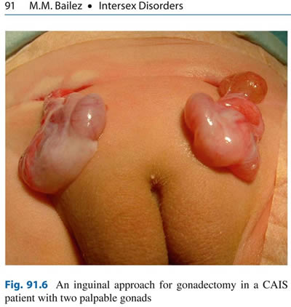
Source: Maria Marcela Bailez: “Intersex Disorders,” in: P. Puri and M. Höllwarth (eds.),
Pediatric Surgery: Diagnosis and Management, Berlin Heidelberg 2009.
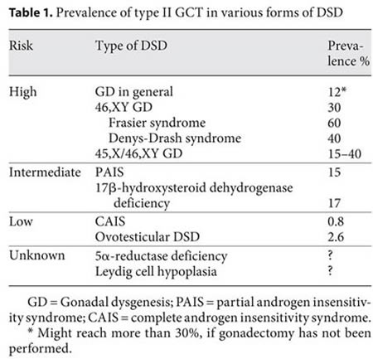
Source: J. Pleskacova, R. Hersmus, J. Wolter Oosterhuis, B.A. Setyawati, S.M. Faradz, Martine Cools, Katja P. Wolffenbuttel, J. Lebl, Stenvert L.S. Drop, Leendert H.J. Looijenga: “Tumor risk in disorders of sex development,” in: Sexual Development 2010 Sep;4(4-5):259-69.
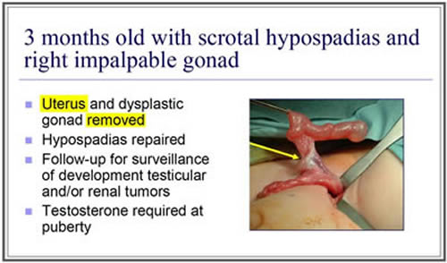
Source: J. L. Pippi Salle: “Decisions and Dilemmas in the Management
of Disorders of Sexual [sic!] Development (DSD),” 2007, at 20.
“Bad results” / “Gonadectomy, Feminising Genitoplasty”
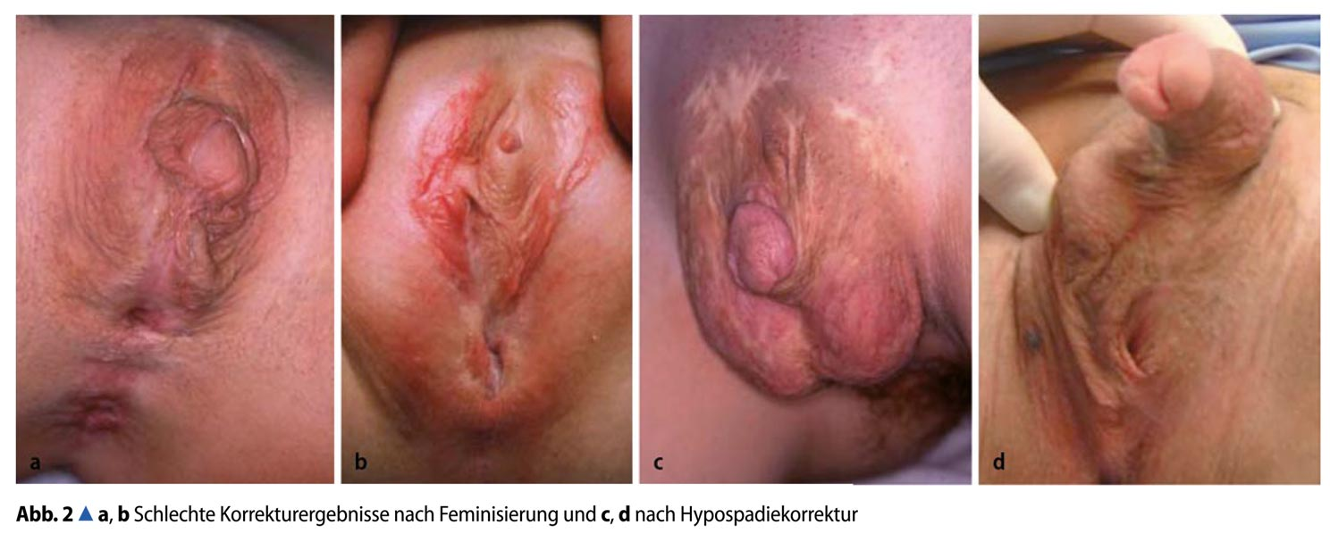
Caption: 2a,b: “Bad Results of Correction after Feminisation, and”, c,d: “after Hypospadias Repair” – Source: M. Westenfelder: “Medizinische und juristische Aspekte zur Behandlung intersexueller Differenzierungsstörungen,” Der Urologe 5 / 2011 p. 593–599.
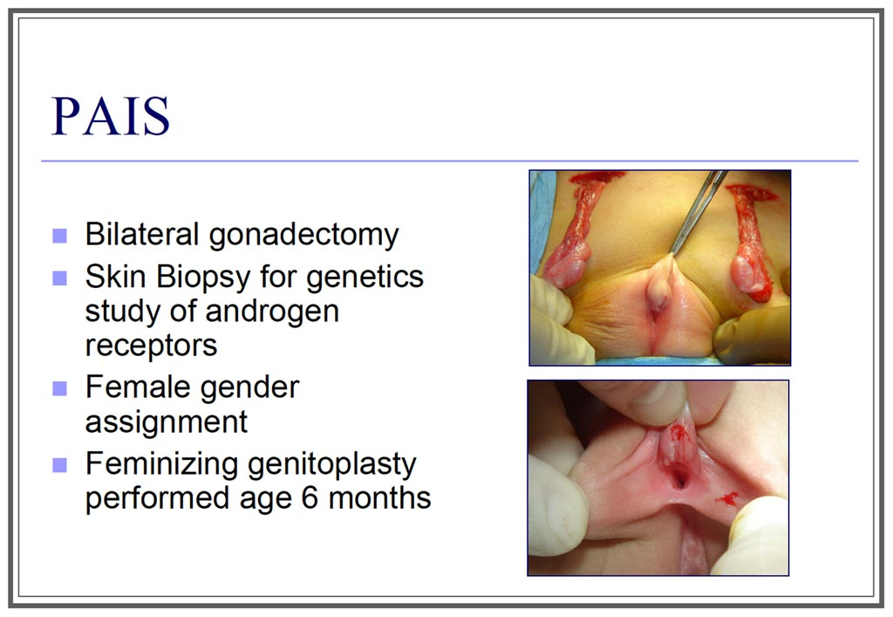
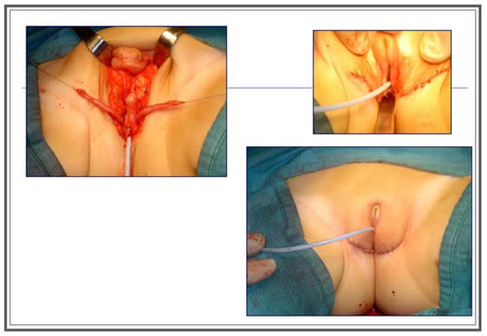
Source: J. L. Pippi Salle: “Decisions and Dilemmas in the Management
of Disorders of Sexual [sic!] Development (DSD)”, 2007, at 20.

CAT, CRC, CRPD, SPT, SRT, SRSG VAC, COE, ACHPR, IACHR (2016), “End violence and harmful medical practices on intersex children and adults, UN and regional experts urge”, http://www.ohchr.org/EN/NewsEvents/Pages/DisplayNews.aspx?NewsID=20739&LangID=E
https://Zwischengeschlecht.org/ English homepage: https://StopIGM.org
https://zwischengeschlecht.org/post/Statuten
https://intersex.shadowreport.org
https://stopigm.org/post/IAD-2016-Soon-20-UN-Reprimands-for-Intersex-Genital-Mutilations
See: Aleksandra Relić (2021), “Biti interspolan u Hrvatskoj – studija slučaja E.(25)” (“Being Intersexual in Croatia - Case Study E. (25)”, Master’s thesis, University of Zagreb, Faculty of Humanities and Social Sciences / Sveučilište u Zagrebu, Filozofski fakultet, https://repozitorij.ffzg.unizg.hr/islandora/object/ffzg:3667/datastream/PDF/download
Ibid.
See “Bodily Integrity”, https://www.ilga-europe.org/sites/default/files/2020/croatia.pdf
https://intersex.shadowreport.org/public/202-CRC-Czechia-NGO-Zwischengeschlecht-Intersex-IGM.pdf
Currently we count 52 UN Treaty body Concluding Observations explicitly condemning IGM practices as a serious violation of non-derogable human rights, see: https://stopigm.org/post/IAD-2016-Soon-20-UN-Reprimands-for-Intersex-Genital-Mutilations
For general information, see 2016 CEDAW NGO Report France, p. 47. https://intersex.shadowreport.org/public/2016-CEDAW-France-NGO-Zwischengeschlecht-Intersex-IGM.pdf
J. Pleskacova, R. Hersmus, J. Wolter Oosterhuis, B.A. Setyawati, S.M. Faradz, Martine Cools, Katja P. Wolffenbuttel, J. Lebl, Stenvert L.S. Drop, Leendert H.J. Looijenga: “Tumor risk in disorders of sex development,” in: Sexual Development 2010 Sep;4(4-5):259-69
https://uroweb.org/guidelines/endorsement/
https://uroweb.org/wp-content/uploads/EAU-Guidelines-on-Paediatric-Urology-2021-1.pdf
Ibid., p. 90
Ibid., p. 89
P. Mouriquand, A. Caldamone, P. Malone, J.D. Frank, P. Hoebeke, “The ESPU/SPU standpoint on the surgical management of Disorders of Sex Development (DSD)”, Journal of Pediatric Urology vol. 10, no. 1 (2014), p. 8-10, http://www.jpurol.com/article/S1477-5131(13)00313-6/pdf
Lee et al., “Global Disorders of Sex Development Update since 2006: Perceptions, Approach and Care”, Horm Res Paediatr 2016;85:158–180, https://www.karger.com/Article/Pdf/442975
Ibid., at 180 (fn 111)
Velimir Šimunić (2011), “Poremećaji menstruacijskog ciklusa Amenoreje i oligomenoreje” (“Menstrual Disorders Amenorrhea and Oligomenorrhea”), p. 16, https://paperzz.com/doc/5148712/
Karmela Majić (2016), “Utjecaj rizičnih čimbenika na parametre spermiograma, analiza spermiograma u centru za medicinski pomognutu oplodnju, KBC Split” (“Influence of risk factors on spermiogram parameters, spermiogram analysis in the center for medically assisted fertilization, KBC Split”), Graduation thesis, Medical Faculty, University of Split, p. 9, https://repozitorij.mefst.unist.hr/islandora/object/mefst%3A399/datastream/PDF/view
Jasenka Wagner, Ivana Škrlec, Sanela Štibi, Barbara Viljetiæ, Silvija Pušeljiæ, Feodora Stipoljev, Marija Heffer-Lauc (2007), “Sindrom potpune neosjetljivosti na androgene” (“Complete Androgen Insensitivity Syndrome”, Med Vjesn 2007; 39(1-4): 35-44, p. 40-41, p. 41, https://hrcak.srce.hr/file/282288
See Annual Report 2015: http://www.cezih.hr/rezultati/2015/12/DTS_postupci_1512.xls Annual Report 2016: http://www.cezih.hr/rezultati/2016/12/DTS_postupci_2016.xls Annual Report 2017: http://www.cezih.hr/rezultati/2017/1_12/Postupci_1712.xls Annual Report 2018: http://www.cezih.hr/rezultati/2018/1_12/DTS_postupci_1812.xls Annual Report 2019: http://www.cezih.hr/rezultati/2018/1_12/DTS_postupci_1812.xls
For general information, see 2016 CEDAW NGO Report France, p. 48. https://intersex.shadowreport.org/public/2016-CEDAW-France-NGO-Zwischengeschlecht-Intersex-IGM.pdf
https://uroweb.org/guidelines/endorsement/
https://uroweb.org/wp-content/uploads/EAU-Guidelines-on-Paediatric-Urology-2021-1.pdf
Ibid., p. 86
Ibid., p. 89
Ibid., p. 89
Ibid., p. 90
https://www.espu.org/images/documents/ESPU_Open_Letter_to_COE_2018-01-26.pdf
Katja Dumić Kubat, Duje Braovac, Maja Vinković (2019), “Kongenitalna adrenalna hiperplazija” (“Congenital Adrenal Hyperplasia”), Paediatr Croat. 2019; 63 (Supl 1): 81-86, http://www.hpps.com.hr/sites/default/files/Dokumenti/2019/lijecnici/Dok%2019.pdf
Katja Dumić Kubat, Duje Braovac, Maja Vinković (2019), “Kongenitalna adrenalna hiperplazija” (“Congenital Adrenal Hyperplasia”), Paediatr Croat. 2019; 63 (Supl 1): 81-86, http://www.hpps.com.hr/sites/default/files/Dokumenti/2019/lijecnici/Dok%2019.pdf
See Annual Report 2015: http://www.cezih.hr/rezultati/2015/12/DTS_postupci_1512.xls Annual Report 2016: http://www.cezih.hr/rezultati/2016/12/DTS_postupci_2016.xls Annual Report 2017: http://www.cezih.hr/rezultati/2017/1_12/Postupci_1712.xls Annual Report 2018: http://www.cezih.hr/rezultati/2018/1_12/DTS_postupci_1812.xls Annual Report 2019: http://www.cezih.hr/rezultati/2018/1_12/DTS_postupci_1812.xls
For general information, see 2016 CEDAW NGO Report France, p. 48-49, https://intersex.shadowreport.org/public/2016-CEDAW-France-NGO-Zwischengeschlecht-Intersex-IGM.pdf
https://uroweb.org/guidelines/endorsement/
https://uroweb.org/wp-content/uploads/EAU-Guidelines-on-Paediatric-Urology-2021-1.pdf
Ibid., p. 26
Ibid., p. 28
Ibid., p. 27
Ibid., p. 27-28
https://www.kdb.hr/klinika-za-djecje-kirurgiju/odjel-za-urologiju
Nefreteta Z. Eberhard (2020), “Klinika za kirurgiju KBC-A Osijek: U samo dvije godine ušli u krug najboljih kirurgija u Hrvatskoj” (“Clinic for surgery, KBC Osijek: In just two years, they entered the circle of the best surgeries in Croatia”, “Glas Savonije” (“Voice of Slavonia”), 12.02.2020, https://glas-slavonije.hr/424125/3/U-samo-dvije-godine-usli-u-krug-najboljih-kirurgija-u-Hrvatskoj
BOŽIDAR ŽUPANČIĆ, VERA ŽUPANČIĆ, ZVONIMIR VRTAR (2006), “SUVREMENO LIJEČENJE HIPOSPADIJE” (“Contemporary treatment of hypospadias”), Paediatr Croat 2006; 50 (Supl 1): 299-307, http://www.hpps.com.hr/sites/default/files/Dokumenti/2006/pdf/dok42.pdf
Silvio Altarac, Dino Papeš, Aivar Bracka (2012), “Two-stage hypospadias repair with inner preputial layer Wolfe graft (Aivar Bracka repair)” (2012), BJU Int. 2012 Aug;110(3):460-73, https://bjui-journals.onlinelibrary.wiley.com/doi/abs/10.1111/j.1464-410X.2012.11304.x
D. Budimir, J. Todorić, K. Pjer Milunović, Marijan Saraga, I. Jurić, Tomislav Šušnjar, Davor Todorić, Dubravko Furlan, Jakov Mestrovic, Zenon Pogorelić, (2015), “Surgical treatment of congenital urinary tract anomalies in children at University Hospital Split”, Paediatr Croat. 2015; 59 (Supl 1): 18-23, p. 23, https://www.researchgate.net/publication/305240168_Surgical_treatment_of_congenital_urinary_tract_anomalies_in_children_at_University_Hospital_Split
See Annual Report 2015: http://www.cezih.hr/rezultati/2015/12/DTS_postupci_1512.xls Annual Report 2016: http://www.cezih.hr/rezultati/2016/12/DTS_postupci_2016.xls Annual Report 2017: http://www.cezih.hr/rezultati/2017/1_12/Postupci_1712.xls Annual Report 2018: http://www.cezih.hr/rezultati/2018/1_12/DTS_postupci_1812.xls Annual Report 2019: http://www.cezih.hr/rezultati/2018/1_12/DTS_postupci_1812.xls
Bojana Mrvoš Pavić (2011), “Interseksualnost pod kirurškim nožem” (“Intersexuality under a surgical knife”), NL NOVI LIST, 29.07.2011, https://www.novilist.hr/novosti/hrvatska/interseksualnost-pod-kirurskim-nozem-noads/
Ženska soba – Centar za seksualna prava (Women's Room - Center for Sexual Rights (2013), “Interseksualnost – na kontinuumu spolova” (“Intersexuality - on the gender continuum”), http://zenskasoba.hr/hr/podrucja-rada/lgbtiq-seksualne-i-rodne-manjine/interseksualnost/
Rainbow Europe (2020), “Annual Review of the Human Rights Situations of Lesbian, Gay, Bisexual, Trans, and Intersex People in Croatia”, https://www.ilga-europe.org/sites/default/files/2020/croatia.pdf
“To my narrator [Croatian intersex advocate E.], the abolition of unnecessary aesthetic surgeries on intersex children is one of the main goals. In an interview with me, he expressed his opinion on these actions in several places: ‘[…] To me, it is generally no different from genital mutilations; all people are horrified by the genital mutations of girls, most often in some tribes in Africa, where they remove their clitoris because of some of their beliefs, whatever I do not know why this is so acceptable ... Cut off the penis, a girl who has a big clitoris to make something other than that, I really don't see why and how different it is. […] I have some, I hope, realistic goals and something that I would like to be, it seems to me, some long term system: to put intersex in the law, to legally ban surgeries on intersex babies, to be called as they should be called – genital mutilations.’” In: Aleksandra Relić (2021), “Biti interspolan u Hrvatskoj – studija slučaja E.(25)” (“Being Intersexual in Croatia - Case Study E. (25)”, Master’s thesis, University of Zagreb, Faculty of Humanities and Social Sciences / Sveučilište u Zagrebu, Filozofski fakultet, p. 46. See also p. 19-20, https://repozitorij.ffzg.unizg.hr/islandora/object/ffzg:3667/datastream/PDF/download
Globally, no survivor of early surgeries ever managed to have their case successfully heard in court. All relevant court cases resulting in damages or settlement (3 in Germany, 1 in the USA) were either about surgery of adults, or initiated by foster parents.
For a more extensive version, see 2017 CRC Spain NGO Report, p. 12-13, https://intersex.shadowreport.org/public/2017-CRC-Spain-NGO-Brujula-Zwischengeschlecht-Intersex-IGM.pdf
UNICEF (2007), Implementation Handbook for the Convention on the Rights of the Child, at 371
CRC/C/CHE/CO/2-4, paras 42-43; CRC/C/CHL/CO/4-5, paras 48-49; CRC/C/FRA/CO/5, paras 47-48; CRC/C/IRL/CO/3-4, paras 39-40; CRC/C/NPL/CO/3-5, paras 41-42; CRC/C/GBR/CO/5, paras 46-47; CRC/C/NZL/CO/5, paras 25+15; CRC/C/ZAF/CO/2, paras 39-40+23-24; CRC/C/DNK/CO/5, paras 24+12; CRC/C/ESP/CO/5-6, para 24; CRC/C/ARG/CO/5-6, para 26; CRC/C/ITA/CO/5-6, para 23; CRC/C/BEL/CO/5-6, paras 25(b)+26(e); CRC/C/MLT/CO/3-6, paras 28-29; CRC/C/AUS/CO/5-6, paras 25(b)+26(e); CRC/C/PRT/CO/5-6, paras 28(b); CRC/C/AUT/CO/5-6, para 27(a)-(b)
CEDAW/C/FRA/CO/7-8, paras 18e-f+19e-f; CEDAW/C/CHE/CO/4-5, paras 24-25, 38-39; CEDAW/C/NLD/CO/6, paras 21-22, 23-24; CEDAW/C/DEU/CO/7-8, paras 23-24; CEDAW/C/IRL/CO/6-7, paras 24-25; CEDAW/C/CHL/CO/7, paras 22-23, 12(d)-13(d), 14(d)-15(d); CEDAW/C/LUX/CO/6-7, paras 27b-c+28b-c; CEDAW/C/MEX/CO/9, para 21-22; CEDAW/C/NZL/CO/8, paras 23(c)-24(c); CEDAW/C/AUS/CO/8, paras 25(c)-26(c); CEDAW/C/LIE/CO/5, paras 35+36(c); CEDAW/C/NPL/CO/6, paras 18(c)-19(c)
Daniela Truffer, Markus Bauer / Zwischengeschlecht.org: “Ending the Impunity of the Perpetrators!” Input at “Ending Human Rights Violations Against Intersex Persons.” OHCHR Expert Meeting, Geneva 16–17.09.2015, online: http://StopIGM.org/public/S3_Zwischengeschlecht_UN-Expert-Meeting-2015_web.pdf
For a more extensive version with sources, see 2016 CRC UK Thematic NGO Report, p. 57, https://intersex.shadowreport.org/public/2016-CRC-UK-NGO-Zwischengeschlecht-Intersex-IGM_v2.pdf
CRC/C/ZAF/CO/2, 27 October 2016 paras 39–40
CRC/C/CHE/CO/2-4, 26 February 2015, para 43
CRC/C/DNK/CO5, 26 October 2017, para 24
Globally, no survivor of early surgeries ever managed to have their case successfully heard in court. All relevant court cases resulting in damages or settlement (3 in Germany, 1 in the USA) were either about surgery of adults, or initiated by foster parents.
The currently still official medical terminology “Disorders of Sex Development” is strongly refused by persons concerned. See 2014 CRC NGO Report, p. 12 “Terminology”.
https://intersex.shadowreport.org/public/2014-CRC-Swiss-NGO-Zwischengeschlecht-Intersex-IGM_v2.pdf
For references and general information, see 2015 CAT NGO Report Austria, p. 30-35, https://intersex.shadowreport.org/public/2015-CAT-Austria-VIMOE-Zwischengeschlecht-Intersex-IGM.pdf
For Nepal, see CEDAW/C/NPL/Q/6, para 8(d). See also 2018 CEDAW Joint Intersex NGO Report, p. 13-14, https://intersex.shadowreport.org/public/2018-CEDAW-Nepal-NGO-Intersex-IGM.pdf For example in South Africa, see 2016 CRC South Africa NGO Report, p. 12, https://intersex.shadowreport.org/public/2016-CRC-ZA-NGO-Zwischengeschlecht-Intersex-IGM.pdf For South Africa, see also https://mg.co.za/article/2018-01-24-00-intersex-babies-killed-at-birth-because-theyre-bad-omens For example in Uganda, Kenya, Rwanda, see “Baseline Survey on intersex realities in East Africa – Specific focus on Uganda, Kenya, and Rwanda” by SIPD Uganda, relevant excerpts and source: https://stopigm.org/post/Africa-Intersex-Survey-Documents-Intersex-Genital-Mutilation-Infanticide-Abandonment-Expulsion-Uganda-Kenya-Rwanda ; for Uganda, see also 2015 CRC Briefing, slide 46, https://intersex.shadowreport.org/public/Zwischengeschlecht_2015-CRC-Briefing_Intersex-IGM_web.pdf For Kenya, see also http://www.bbc.com/news/world-africa-39780214 For Mexico, see 2018 CEDAW NGO Joint Statement, https://stopigm.org/post/CEDAW70-Mexico-Joint-Intersex-NGO-Statement-05-07-2018
For example in Uganda, Kenya, Rwanda, see “Baseline Survey on intersex realities in East Africa – Specific focus on Uganda, Kenya, and Rwanda” by SIPD Uganda, relevant excerpts and source: https://stopigm.org/post/Africa-Intersex-Survey-Documents-Intersex-Genital-Mutilation-Infanticide-Abandonment-Expulsion-Uganda-Kenya-Rwanda For example in China, see 2015 Hong Kong, China NGO Report, p. 15, https://intersex.shadowreport.org/public/2015-CAT-Hong-Kong-China-NGO-BBKCI-Intersex.pdf
For example in Uganda, Kenya, Rwanda, see “Baseline Survey on intersex realities in East Africa – Specific focus on Uganda, Kenya, and Rwanda” by SIPD Uganda, relevant excerpts and source: https://stopigm.org/post/Africa-Intersex-Survey-Documents-Intersex-Genital-Mutilation-Infanticide-Abandonment-Expulsion-Uganda-Kenya-Rwanda
For example in Nepal (CRC/C/NPL/CO/3-5, paras 41–42), based on local testimonies, see https://stopigm.org/post/Denial-of-Needed-Health-Care-Intersex-in-Nepal-Pt-3
For example in Kenya, see https://76crimes.com/2015/12/23/intersex-in-kenya-held-captive-beaten-hacked-dead/
2014 CRC NGO Report, p. 52, 69, 84, https://intersex.shadowreport.org/public/2014-CRC-Swiss-NGO-Zwischengeschlecht-Intersex-IGM_v2.pdf
In the WHO “World Atlas of Birth Defects (2nd Edition)”, many intersex diagnoses are listed, including “indeterminate sex” and “hypospadias”: http://web.archive.org/web/20160305152127/http://prenatal.tv/lecturas/world%20atlas%20of%20birth%20defects.pdf
“The Racist Roots of Intersex Genital Mutilations” https://stopigm.org/post/Racist-Roots-of-Intersex-Genital-Mutilations-IGM
For 500 years of “scientific” prejudice in a nutshell, see 2016 CEDAW France NGO Report, p. 7, https://intersex.shadowreport.org/public/2016-CEDAW-France-NGO-Zwischengeschlecht-Intersex-IGM.pdf
See “IGM Practices – Non-Consensual, Unnecessary Medical Interventions”, ibid., p. 38–47
CAT, CRC, CRPD, SPT, SRT, SRSG VAC, COE, ACHPR, IACHR (2016), “End violence and harmful medical practices on intersex children and adults, UN and regional experts urge”, http://www.ohchr.org/EN/NewsEvents/Pages/DisplayNews.aspx?NewsID=20739&LangID=E
https://stopigm.org/post/IAD-2016-Soon-20-UN-Reprimands-for-Intersex-Genital-Mutilations
CRC67 Denmark, https://stopigm.org/post/CRC67-Intersex-children-used-as-cannon-fodder-LGBT-Denmark
CEDAW66 Ukraine, https://stopigm.org/post/Ukraine-Instrumentalising-Intersex-and-IGM-for-LGBT-and-Gender-Politics
For references, see 2016 CEDAW France NGO Report, p. 45 https://intersex.shadowreport.org/public/2016-CEDAW-France-NGO-Zwischengeschlecht-Intersex-IGM.pdf
For example ACHPR Commissioner Lawrence Murugu Mute, see https://stopigm.org/post/ACHPR-African-Commissioner-warns-Stop-conflating-intersex-and-LGBT
2018 Report of the Kenya National Commission on Human Rights (KNCHR), p. 15, https://www.knchr.org/Portals/0/GroupRightsReports/Equal%20In%20Dignity%20and%20Rights_Promoting%20The%20Rights%20Of%20Intersex%20Persons%20In%20Kenya.pdf?ver=2018-06-06-161118-323
CAT60 Argentina, https://stopigm.org/post/UN-Press-Release-calls-IGM-survivors-transsexual-children-CATArgentina-UNCAT60
CRC77 Spain, https://stopigm.org/post/UN-Press-Release-mentions-genital-mutilation-of-intersex-children
CRC76 Denmark, https://stopigm.org/post/UN-Press-Release-calls-IGM-survivors-transsexual-children-CRC-Denmark-UNCRC67
CAT/C/DNK/QPR/8, para 32
CRC73 New Zealand, https://stopigm.org/post/NZ-to-be-Questioned-over-Intersex-Genital-Mutilations-by-UN-Committee-on-the-Rights-of-the-Child
CCPR120 Switzerland, https://stopigm.org/post/Pinkwashing-of-Intersex-Genital-Mutilations-at-the-UN-CCPR120
CAT56 Austria, https://stopigm.org/post/Geneva-UN-Committee-against-Torture-questions-Austria-over-Intersex-Genital-Mutilations
CAT60 Argentina, https://stopigm.org/post/CAT60-Argentina-to-be-Questioned-on-Intersex-Genital-Mutilation-by-UN-Committee-against-Torture
CRPD18 UK, https://stopigm.org/post/UK-Questioned-over-Intersex-Genital-Mutilations-by-UN-Committee-on-the-Rights-of-Persons-with-Disabilities-CRPD
For example in Scotland (UK), LGBT organisations have so far collected at least £ 135,000.– public intersex funding, while actual intersex organisations received ZERO public funding, see 2017 CRPD UK NGO Report, p. 14, https://intersex.shadowreport.org/public/2017-CRPD-UK-NGO-Coalition-Intersex-IGM.pdf Typically, during the interactive dialogue with CRPD, the UK delegation nonetheless tried to sell this glaring misappropriation as “supporting intersex people”, but fortunately got called out on this by the Committee, see transcript (Session 2, 10:53h + 11:47h), https://stopigm.org/post/UK-Questioned-over-Intersex-Genital-Mutilations-by-UN-Committee-on-the-Rights-of-Persons-with-Disabilities-CRPD
See e.g. “Instrumentalizing intersex: ‘The fact that LGBTs in particular embrace intersex is due to an excess of projection’ - Georg Klauda (2002)”, https://stopigm.org/post/Instrumentalizing-Intersex-Georg-Klauda-2002
For example Amnesty (2017), see https://stopigm.org/post/Amnesty-Report-fails-Intersex-Children-and-IGM-Survivors
For example FRA (2015), see Presentation OHCHR Expert Meeting (2015), slide 8, https://stopigm.org/public/S3_Zwischengeschlecht_UN-Expert-Meeting-2015_web.pdf
For example CEDAW Italy (2017), see https://stopigm.org/post/Major-Setback-for-Intersex-Human-Rights-at-the-UN
For example CEDAW Austria (2019): CEDAW/C/AUT/CO/9, paras 34(h), 35(h)
For example Ministry of Health Chile (2016), see https://stopigm.org/post/Circular-7-step-back-for-intersex-human-rights-in-Chile
For example Ministry of Health France (2018), see 2020 CRC Intersex NGO Report (for LOIPR), p. 19, https://intersex.shadowreport.org/public/2020-CRC-France-LOIPR-NGO-Intersex-IGM.pdf
For example Ministry of Health Austria (2019), see 2019 CRC Intersex NGO Report (for Session), p. 4-5, https://intersex.shadowreport.org/public/2019-CRC-Austria-NGO-Zwischengeschlecht-Intersex-IGM.pdf

