CIVIL SOCIETY -NGO SUBMISSION REPORTS FOR THE 85THC “PRE-SESSION OF THE CHILD COMMITTEE ON THE RIGHTS ON THE CHILD UNITED NATIONS GENEVA

STATE CONCERINNG: CHILE

NGO INFORMATION

THEMATIC UNITY ADOLESCENT CRIMINAL JUSTICE SYSTEM

The Law of Adolescent Criminal Responsibility (LRPA or 20.084) exists in our country since 2007. This law was created in order to give a response to the deals assumed by the State of Chile when returning to a democratic system, agreeing to generate the required actions to give fair treatment to those teenagers presenting conflicts with justice. This measure represents an attempt of changing the guardianship of children and teenagers (NNA) who presented unlawful conducts to a recognition framework that regarded them as legal subjects while looking, at the same time, for a legal treatment embedded in the guaranties belonging to the rule of law.

Regardless of its proclamation, and since then, serious lacks mainly associated with the treatment of childhood and adolescence of our country have been highlighted in the execution of this law. Specifically, it lacked both the implementation system integrated into the acting guarantees, and a cultural and symbolic framework allowing people, and the institutions they were working with, to agree - both in theory and practice - with the guidelines required by such legal framework. Consequently, the law is missing a minimum level that fosters that those adolescents reached an adequate process of responsibilisation and reparation.

The proclamation of the Law 20.084 was framed in a series of international treaties including the International Convention of the Rights of NNA, the UN Directives for Crime Prevention (RIAD), and the Kyoto Treaty related with the minimum Rules of the UN on non-custodial measures. Nevertheless, this law was an object of biased interests, together with a sort of “criminal populism”, both in its redaction and in its implementation. In this way, it was privileged to show that the Government was acting vigorously in response to the “youth crime” reported by the press from that time until the present days.

As it will be explored in continuation, both practical experience and the different sources quoted in this report allow arguing that despite the objectives of the LRPA of intervening over adolescents criminal responsibility, the definition of investigative methods, the establishment of criminal responsibilities, the determination of sanctions and the execution of those, occasionally its implementation falls into the vice of form and content that attempts to the dignity of the adolescents of our country. This is reflected mainly in the way in which the State and its policies intervene when a situation of conflict with the law with adolescents is presumed. This worsen when people belong to indigenous communities and LGBTQ+ groups, who present major violations from the State.

During the last years, different political and civil sectors expressed critiques to this law. Still, it results unquestionable that its implementation signified an improvement for those teenagers experiencing conflict with the law. It is possible to identify as an improvement the fact that users where recognised as subjects of Law, the privilege of social inclusion over the implementation of a punishment, and the knowledge and use of the Convention on Children and Adolescent Rights from the professional body compelling the cases associated with transgressive behaviours, etc.

At the same time, the implementation of the law leaned to a decrease in infringements from teenagers, as reported by different institutions addressing the issue. Nevertheless, the chant showed by the different media regarding “the loose of teenage crime” socialised the belief instead of the evidence. This decrease in the teenage criminal rate since the application of the LRPA obtained little coverage due to both its biased use by media, and the lack of interest in going beyond the immediate punishment to the infractions carried out by teenagers. Yet, the tendency clearly shows that the crimes committed by people aged between 14 and 18 systematically decreased during the last years. It follows a first instance of mediatic violation due to the stigmatisation process experienced by the teenagers of our country, in a context where the State does not react to stop it, strengthening a public opinion that goes against the scope of prevention and integration policies for this group.

By taking this context into account, a series of violations taking place in our country with teenagers presenting problem with justice will be listed, together with the way in which social control organisms approach them through three instruments (detention, sanction and sanction executions). When analysing these violations, specific events will be presented, together with their sources, in order to map the violations and associated figures to the case exposed.

- Detention

By the end of 2018, the killing of the Mapuche Camilo Catrillanca by the State was recorded, becoming an act of strong public connotation constitutive of police violence. At the moment of his death, Catrillanca was accompanied by a teenager, who not only witnessed the murder, he also suffered strong tortures when he was detained.
In relation to this fact, the teenager remembers: “when I was handcuffed, a policeman comes behind me and hits me with the UCI (sic), another one comes behind me - the one they called coronel - and he hit me again”. He goes on saying “He hit me with their hand on my head and they punched me against the door of the tank and they get me into it”.

The story highlights that the Chilean police did not have the minimum respect for the Convention of Children and Adolescent Rights at the moment of detaining a teenager. Neither their attitude followed the protocols established by the Chilean State nor the legal framework regulating police behaviour.

Moreover, another fact highlighting the abuses present at the moment of carrying out detentions happened in December 2017. In this occasion, policemen decided to shoot against the teenager (now adult) Brandon Hernández Huentecol while they were overcoming him. Specifically, they shot more than 100 pellets against his back that provoked Brandon strong physical and psychological injuries that still affect him.

These cases reiterate in different parts of our country with any type of teenager, particularly in the groups with a lower socioeconomic level and in groups that are infringed by society (Mapuche people, LGBTQ+ communities, etc.). Additionally, throughout 2019 the Police Force of Chile, following the order of the Government and facilitated by different mayoralties has intervened regularly in the schools of the country, exercising violence that attempted against students’ psychological and physical health. An example of this is what happens in the National Institute (Santiago), where the loyer Alfredo Morgado presented an appeal in representation of several students against the “illegal, arbitrary, disproportionate and abusive” use of teargas by the Special Division of the Police Force. Another instance of this is what happened in the girl highschool number 1 when the police - armed with shields, teargas and water tanks - violently detained students.

On Thursday, October 17 after the institutional break that is happening in the country, the dynamics of violation explored have worsen with the declaration of State of Exception. This provoked that State repression impacted transversally the life of children and teenagers in Chile. As a result, the State stopped is democratic function framed in the rule of law. Even if not all teenagers have been affected in the same way, the actions (and negligence) of the State come to them under different forms, generating a series of violations under this “state of exception”.

This is how on October 23, 2019, two students from Viña del Mar that were going back home before the curfew - declared by the Government of Sebastían Piñera - were approached by more than 15 policemen who brutally beaten them up during several minutes. Following this line of violence from state bodies, it has been denounced the use of pellets by the police and military forces in order to attempt against children and teenagers. Also, the use of teargas to repress this part of the population has been criticised, particularly because of its level of toxicity.

On October 18, when students protests for the rise of the cost of transportation started, a policeman pushed a student inside the metro, making him fall down the stairs, causing him different contusions.

The violation of childhood during the period of institutional crisis in Chile has been so serious that the Defensory of Infancy - an organisation in charge of safeguarding the rights of NNAs - reported 283 instances between October 18 and October 26 where their rights were violated with evidence of responsibility of both the military and police force.

In this way, it is possible to validate that teenage detention goes through a process of violence, that turns into a daily practice attempting not only against teenagers freedom of movement, it also constrains their possibility of studying, giving their opinion and socialising. This, in turn, attempts directly against their health and, in the worst case, against their lives.

Another aspect at the edge of the detention process is related to the violations taking place when teenagers are detained and taken to the social order police station. As reported by a report of the INDH, there are cases where detainees are not separated according to their age, and between accused people and those subjected to an identity control. So that there is an infringement of both the law 16.618 (the Law of Minors) and the Beijing protocols to which Chile agreed on.

Also, the report also mentions that within the police station exist “situations of physical and psychological mistreatment at the moment of the privation of freedom, causing arbitrary freedom privation, without communicating the rights of the detainee, delaying in explaining the reason for detainment in order to question the police action.

In turn, the cases collected by the INDH related to the instances of police violence that got judicial proceedings reflect the presence of dents - resulting from different kinds of injuries -, stripping and sexual aggressions by the Chilean police force when they have detainees into custody. By doing so, they are going against their function of State guarantors given them by law.

Related to these points, the Popular Defensory complained against the police force for torturing a teenager inside a police station; the legal action was presented by the teenager’s family. The teenager stated that he was “obliged of stripping” and “squatting” after his detention during a social manifestation.

In the same way as the previous point, with reference to the systematic abuses of the police force during the social crisis of October 2019, a series of cases showing the actions of the police at the time of detaining teenagers in police stations or spaces set aside for reclusion had been presented.

On Sunday, October 20, Daniel Nain Colin was detained for the supposed crime of theft in the context of supermarket robberies in the centre of San Bernardo (Metropolitan Region of Chile). He was moved to the 14th commissary of the same commune. According to the version told by Daniel, he was obliged to strip and squat by a police officer. Moreover, Daniel’s nephew, who is underage, was standing in the same place and was obliged to strip and to squat in the same way.

On the other hand, on October 21st at 1 am, members of the police force belonging to the 43rd police station of Peñalolén detained a teenager together with three adults. The police force in the police station crucified him in a metallic structure and tortured him for hours.

Moreover, repeated cases of sexual abuses by the police force are mentioned. For instance, a teenager declared she was obliged to strip and to squat inside a cell in the presence of members of the police in the 12th commissary.

- Sanctions

It is important to highlight that the majority of crimes committed by teenagers are robbery and offence (see graphic 1) and not what the media shows. Violent robberies are less than 15% of the crimes committed by this sector of the population. When analysing violent crimes, it is highlighted that their rate systematically decreased during the last 0 years.
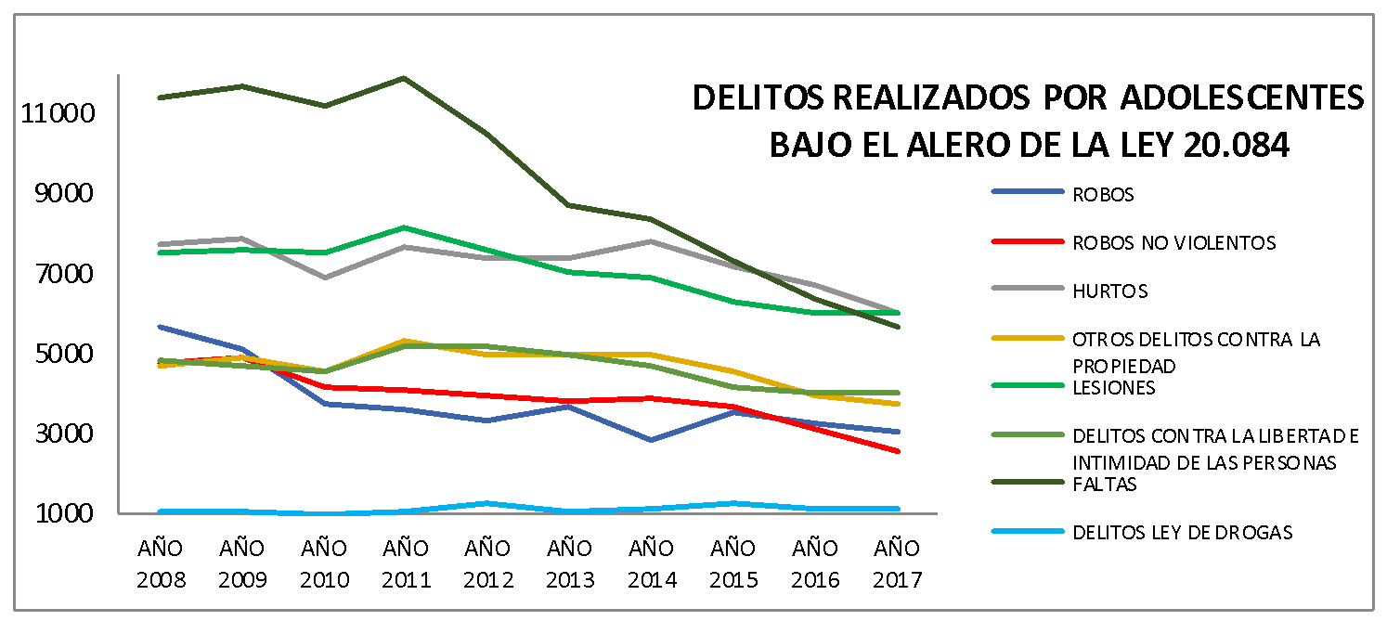

Graph No. 1. Types of crimes entered by the public prosecutor under the eaves of law 20,084 between 2008-2017 divided by region. Source: Statistical Yearbooks Public Ministry (2017), own elaboration

By taking into account that there is a steady decrease in the amount of crimes committed, it is possible to ask why people want to reduce the age of criminal responsibility and the application of stronger sanctions to teenagers? According to the data shown, there is no explication based on the evidence in relation to what has been set out. This is due to the fact that experts at a global level recommend that the institutionalisation of teenagers should be avoided, as it negatively impacts their development and aggravates their criminal career. At the same time, there is not a significant increase in the break of the law justifying a penal reinforcement.

On top of this, it results menacing that juridical actors working with teenagers in conflict with justice not always count with the necessary specialisation to intervene in the framework of the Convention of the Rights of NNA. Indeed, in a study published by the journal “La Defensa” points out that both public prosecutors and judges miss the required specialisation to execute the law 20.084. In the study they interviewed judges, public prosecutors and advocates and, based on their accounts, experts highlight sentences including: “I insist, I would like to see a certain degree of specialisation. Without it, we cannot ask for much from the public prosecutor’s office. We can see that they do not give much importance to this topic, and the Government neither does…”

In the article the difficulties coming from the lack of specialisation are emphasised; the implementation of the law has been sped up without counting with the suitable professionals and infrastructure. This perspective is validated by what has been indicated by different authors who point out the fallacies of the implementation of the law.

With teenagers, the juridical process needs to be composed by an educative aspect and a rehabilitative one as established by international treaties and our legislation in force. Because of this, the contributions of the juridical process might get lost, turning into a violation of the rights of teenagers, if they do not count with the conditions to be taken into account and understand what is going on.

From this perspective, it calls the attention that twelve years after the implementation of the law 20.084 the system continues manifesting lacks in professional specialisation in the juridical system. As pointed out by both experts and interviewee, this is particularly important as the adequate specialisation allows the application of a suitable sanction and the execution of an individualised and appropriate sanction to the teenager. This, in turn, requires the knowledge not only of the law 20.084 but also the familiar, social and psychological factors of the teenager.

One of the main discoveries is associated with the over utilisation of provisional internment of teenagers in the context of the law 20.084. In 2008 this cautionary measure was applied in 4455 cases and, in 2016 in 1589 instances. It is possible to notice a steady reduction between the year 2008 and 2011 (1483 internments) with an average decrease of 900 internments per year. In the following years, this trend has not changed (see graphic number 2).

If we analyse and compare figure 1 (evolution of crimes) with figure 2 (utilisation of cautionary measure with provisional internment) it is possible to notice that although there is a constant decrease in the number of crimes since 2010, this has not been translated into a decrease in the amount of provisional internments. This highlights a percentage increase if we take into account the number of court cases.
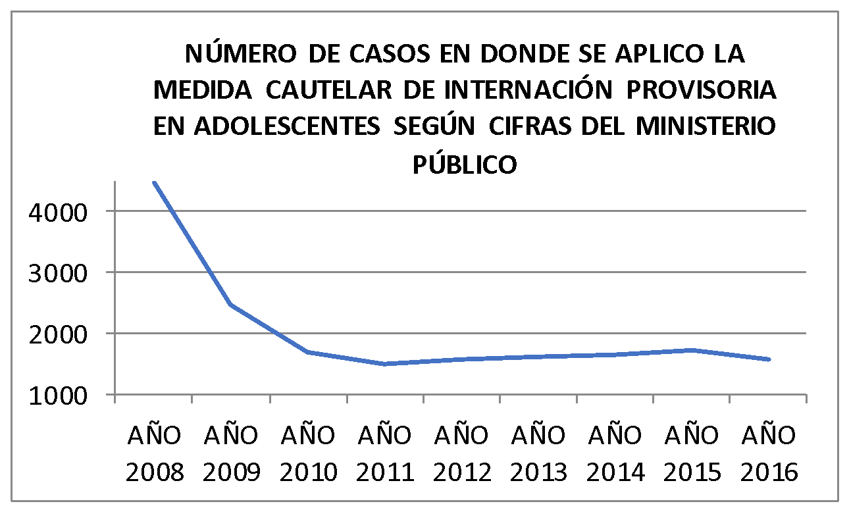

Graph No. 2. Number of cases where the provisional interim injunction was applied according to public ministry between the years 2008-2016. Source: Statistical Yearbooks Public Ministry (2017), own elaboration.

- EXECUTION

In the context generated under the LRPA the benefits of privatising closed detention centres (CRC) for teenagers called media attention. This contributed to the creation of specific discourse and public imaginaries, from the mandate of Michelle Bachelet and following the administration of the Government of Sebastián Piñera, with the scope of hardening the approach to Private Detention Centres. This way, for instance, the CRC of TilTil was the response to the difficulties that were visualised among the different CRCs of Chile in relation to overcrowding issues, the lack of professional training, the abuses taking place within the facilities, etc. and the imprisonment. Privatisation was presented as an effective measure to face “youth criminality” (they made an inversion without precedents where the initial cost of the project was 12 thousand million CLP).

Unfortunately, specific variables present at the time of implementing programs with teenagers presenting infractions identified by experts were left aside. For example, the professional training of people that are going to work in direct contact with teenagers, the importance of coordinating with the academic sphere, dignifying and protected working conditions, etc.

Few months after the implementation serious instances of violence were recorded among teenagers, from employees to teenagers and vice versa until getting to the death of a teenager that was detained in the centre. This situation relatively improved during the years, when the State took responsibility to oblige privates to give up on their job as they were not respecting the technical bases.

It is important to mention that within 4 months of 2017, 135 instances of injury from quarries were recorded, producing different results: 12 workers injured and 7 teenagers about to lose their lives.

Moreover, within this centre another issue is the lack of establishment of reparation and responsabilisation dynamics, teenagers are replicating criminal actions present in adult detention centres where violence and abuses are serious. It exists an elevated rotation of staff, salary conditions and protection are worrying and there are many instances of sexual violation where professional workers took part. Moreover, a considerable delay in implementing the facility’s infrastructure, impeding the realisation of workshops or activities that can alleviate the level of stress.

The quality of intervention is low and mechanism controlling the work of these kind of institutions from the State are currently missing, specifically in relation to the violations from educators or other agents of direct contact whose discourse is not unified with the expectations of LRPA. During the first three months of 2018, 11 teenagers that were part of the SENAME network and were presenting conflicts with the law died (SENAME, 2018), demonstrating the importance of the situation.
Concluding remarks.

Having explored the precedents and the associated sources, together with a short analysis of the local context in relation to the approach to NNA in conflict with the law it is inevitable to make an appeal to the State of Chile:

- To frame its conduct in respect of the agreements previously approved (the Convention on the Rights of NNAs, RIAD, etc.) with an emphasis on the major interest, which is taking into account the opinion of NNAs at any stage as the implementation of a right cannot come with the negation of another.
- A stronger emphasis on the treatment realised by the police forces of social control (article 19), impeding that the forces of public order (or any other actor under the State responsibility) impose NNAs neither tortures and/or other cruel, inhuman or degrading treatments nor arbitrary or illegal detention.
- The State needs to create and monitor the guarantees so that the detention, imprisonment or detainment of a teenager is carried out under the law and that such measures are implemented as the last resort and for the shortest time possible ( article 37). Under any circumstance a NNA can disappear after being detained. Moreover, after being detained, NNA need to have quick access to legal assistance (article 37).
- To not prevent the content of articles 14 and 15 of the Convention, that refer to the free expression of opinion of NNA and the free association without receiving a violent treatment. The freedom of moving around the streets needs to be guaranteed at any time and the association with equals is part of a nutritive framework for an healthy development.
- In line with article 17, the State needs to safeguard to not give information to media outlets that can undermine the healthy development of NNA. The generation of fear and stigmatisation are practices that should be avoided at a national level.
- Lastly, when an NNA is accused of a crime, their value and dignity need to be respected, guaranteeing a framework based on the respect of Human Rights at any stage of the legal process, emphasising the presumption of innocence and the accomplishment of their rights, making sure they receive information about their accuse and that they will be taken in front of a judge.

Roberto Francisco Conejeros González
Representant of Civil Society in Infancy
Msc. in Clinic Psychology

https://www.leychile.cl/Navegar?idNorma=244803
Duce, Mauricio (2004). El Proceso Establecido en el Proyecto de Ley que Crea un Sistema de Responsabilidad de los Adolescentes por Infracciones a la Ley Penal: Avances y Problemas, Revista de Derechos del Niño Nº 2, UNICEF-UDP, Santiago, enero de 2004, pp. 99-113.
Tsukame, A. (2017). Jóvenes desacreditados. Santiago: Ediciones Universidad Academia de Humanismo Cristiano.
Ibid.
Couso, Jaime (2006). Principio educativo y (re) socialización en el Derecho penal juvenil, Justicia y Derechos del Niño, N° 8, UNICEF, Santiago, 2006, pp. 51-64.
Couso, Jaime (2006). Principio educativo y (re) socialización en el Derecho penal juvenil, Justicia y Derechos del Niño, N° 8, UNICEF, Santiago, 2006, pp. 51-64.
Cámara de Diputados. (2015). Evaluación de la Ley N°20.084
Ibid.
Scherman, Andrés & Etchegaray, Nicolle. (2013). Consumo de noticias y temor al delito en Chile. Estudios sobre el Mensaje Periodístico. 19. 10.5209/rev_ESMP.2013.v19.n1.42539.
DEFENSORÍA PENAL PÚBLICA. (2016). Informe estadístico año 2015. Santiago: Defensoría Penal Pública.
Conejeros, C., González, C. y Salinas, S. (2017). Reincidencia en adolescentes en conflicto con la justicia que presentan consumo problemático. Ministerio Público, Santiago.
La Tercera (noviembre, 2018). El informe del INDH que cambió el escenario en el caso del comunero mapuche. Recuperado el 12-10-2019 de https://www.latercera.com/nacional/noticia/el-informe-del-indh-que-cambio-el-escenario-en-el-caso-del-comunero/407341/
TheClinic (enero, 2017). Los sueños truncados de Brandon Hernández Huentecol. Recuperado el 12-10-2019 de https://www.theclinic.cl/2017/01/30/los-suenos-truncados-brandon-hernandez-huentecol/
El desconcierto (agosto, 2019) Violencia de Carabineros en Instituto Nacional: Declaran admisible recurso de protección contra FFEE. Recuperado el 12-10-2019 de https://www.eldesconcierto.cl/2019/08/25/violencia-de-carabineros-en-instituto-nacional-declaran-admisible-recurso-de-proteccion-contra-ffee/
La Izquierda Diario (junio, 2019). Brutal represión contra alumnas del Liceo 1. Recuperado el 30-10-2019 de http://www.laizquierdadiario.cl/VIDEO-Brutal-represion-contra-alumnas-del-Liceo-1
Bio Bio Chile (octubre, 2019). Defensoría de la Niñez denuncia vulneración de derechos a 283 menores en contexto de crisis social. Recuperado el 28-10-2019 https://www.biobiochile.cl/noticias/nacional/chile/2019/10/28/defensoria-de-la-ninez-denuncia-vulneracion-de-derechos-a-283-menores-en-contexto-de-crisis-social.shtml
Soy Chile (octubre, 2019). Escolares fueron golpeados por carabineros en Viña del Mar: colegio condenó los hechos. Recuperado el 28-10-2019 de https://www.soychile.cl/Valparaiso/Sociedad/2019/10/23/621591/VIDEO-Escolares-fueron-golpeados-por-carabineros-en-Vina-del-Mar-colegio-condeno-los-hechos.aspx
24 horas noticias (octubre, 2019). 20 niños heridos con perdigones: Denuncia la Defensoría de la Niñez y preocupa a Unicef El Colegio médico, la defensoría de la niñez y la Unicef. Recuperado el 28-10-2019 https://www.24horas.cl/nacional/-20-ninos-heridos-con-perdigones-denuncia-la-defensoria-de-la-ninez-y-preocupa-a-unicef-3684978
Chilevisión noticias (octubre, 2019). Video muestra a carabinero tirando a joven por la escalera de un Metro en medio de protestas. Recuperado el 30-10-2019 de https://www.chvnoticias.cl/sucesos/video-carabinero-joven-escalera-metro_20191018/
Bio Bio Chile (octubre, 2019). Defensoría de la Niñez denuncia vulneración de derechos a 283 menores en contexto de crisis social. Recuperado el 28-10-2019 de https://www.biobiochile.cl/noticias/nacional/chile/2019/10/28/defensoria-de-la-ninez-denuncia-vulneracion-de-derechos-a-283-menores-en-contexto-de-crisis-social.shtml
Chilevisión Noticias (octubre, 2019). Abuso policial y militar: Las graves denuncias contra uniformados que indignaron a Chile. Recuperado de https://www.chvnoticias.cl/reportajes/abuso-policial-y-militar-graves-denuncias_20191027/
Instituto Nacional de Derechos Humanos (INDH) (2018). Informe Programa de Derechos Humanos, Función Policial y Orden Público 2017. Instituto Nacional de Derechos Humanos: Santiago.
Ibid.
Ibid.
Diario Universidad de Chile (enero, 2016). Defensoría Popular se querella contra Carabineros por “torturas” a adolescente. Recuperado el 12-10-2019 de https://radio.uchile.cl/2016/02/26/defensoria-popular-se-querella-contra-carabineros-por-torturas-a-adolescente/
El Ciudadano (octubre, 2019). La amenazaron con “penetrarla” con un arma: La violencia sexual contra detenidas denunciada durante las protestas. Recuperado el 28-10-2019 de https://www.elciudadano.com/portada/la-amenazaron-con-penetrarla-con-un-arma-la-violencia-sexual-contra-detenidas-denunciada-durante-las-protestas/10/23/
Cooperativa (octubre, 2019). INDH: Detenidos fueron "crucificados" en la antena de una comisaría de Peñalolén. Recuperado el 28-10-2019 de https://www.cooperativa.cl/noticias/pais/manifestaciones/indh-detenidos-fueron-crucificados-en-la-antena-de-una-comisaria-de/2019-10-23/215258.html
Interferencia (octubre, 2019). Dos nuevas denuncias contra la 51°Comisaría de Pedro Aguirre Cerda apuntan a que ahí violan detenidos. Recuperado el 28-10.2019 de https://interferencia.cl/articulos/dos-nuevas-denuncias-contra-la-51degcomisaria-de-pedro-aguirre-cerda-apuntan-que-ahi
El mostrador (octubre, 2019). "Fue desnudada y obligada a hacer sentadillas": 39 recursos por violencia uniformada contra niños. Recuperado el 28-10-2019 de https://www.biobiochile.cl/noticias/nacional/chile/2019/10/23/fue-desnudada-y-obligada-a-hacer-sentadillas-39-acciones-por-violencia-uniformada-contra-ninos.shtml
Scherman, Andrés & Etchegaray, Nicolle. (2013). Consumo de noticias y temor al delito en Chile. Estudios sobre el Mensaje Periodístico. 19. 10.5209/rev_ESMP.2013.v19.n1.42539.
Ministerio Público. (2017). Boletín estadístico anual. Santiago: Ministerio Público.
Ibid.
tsukame, A. (2017). Jóvenes desacreditados. Santiago: Ediciones Universidad Academia de Humanismo Cristiano.
Ministerio Público. (2017). Boletín estadístico anual. Santiago: Ministerio Público.
DEFENSORÍA PENAL PÚBLICA. (2016). Informe estadístico año 2015. Santiago: Defensoría Penal Pública.
Servicio Nacional del Menor (SENAME). (2015). Anuario estadístico. Santiago: SENAME.
Conejeros & González. (2019). Relatos sobre la ley 20.084: un acercamiento al sistema penal adolescente desde los actores jurídicos de los juzgados de garantía de la zona metropolitana oriente. En Defensa 2, p 4-7.
Ibid.
DEFENSORÍA PENAL PÚBLICA. (2011). 3 años de vigencia ley de responsabilidad penal del adolescente: de 8 de junio de 2007 a 7 de junio de 2010. Santiago: Defensoría Penal Pública.
Zambrano, A., Muñoz, J. & Andrade, C. (2015). El desafío de incorporar las redes institucionales y comunitarias en la intervención con adolescentes infractores: una investigación-acción en tres regiones del sur de Chile. Universitas Psychologica, 14 (4), 15-28.
Tsukame, A. (2017). Jóvenes desacreditados. Santiago: Ediciones Universidad Academia de Humanismo Cristiano.
Ibid.
Conejeros & González. (2019). Relatos sobre la ley 20.084: un acercamiento al sistema penal adolescente desde los actores jurídicos de los juzgados de garantía de la zona metropolitana oriente. En Defensa 2, p 4-7.
Ministerio Público. (2017). Boletín estadístico anual. Santiago: Ministerio Público.
La Segunda (octubre, 2012). Antes de fin de año funcionará Centro de reclusión para jóvenes en TilTil: Radicales cambios en rehabilitación.
Subsecretaría del Trabajo (2014). Subsecretario del Trabajo destaca labor de reinserción social de jóvenes del Sename. Extraído el 13-10-2019 de http://www.subtrab.trabajo.gob.cl/subsecretario-del-trabajo-destaca-labor-de-reinsercion-social-de-jovenes-del-sename/
CIPER (mayo, 2013). Las fotos inéditas que grafican la descarnada violencia del centro “modelo” del SENAME. Extraído el 13-10-2013 de https://ciperchile.cl/2013/12/05/las-fotos-ineditas-que-grafican-la-descarnada-violencia-del-centro-%E2%80%9Cmodelo%E2%80%9D-del-sename/
TheClinic (abril, 2017). La crisis del ex centro modelo del Sename en Tiltil. Recuperado el 13-10-2019 de https://www.theclinic.cl/2017/04/05/la-crisis-del-ex-centro-modelo-del-sename-en-tiltil/

