Common Core Document by the Government of Finland
ANNEXES

ANNEX I: MAP OF ÅLAND 2
ANNEX II: GENERAL INFORMATION ABOUT FINLAND 3
Table 20. Number of births and fertility rate, 2007–2018 3
Table 21. Deaths by year and sex and deaths of infants under age 1, 2002–2018 3
Table 22. Families by family type, 1990–2018 4
Table 23. Number of households and proportion of all households according to lifecycle, 2017 5
Table 24. Household income and change in income by lifecycle, 2017 6
Table 25. Infant mortality, 2005–2018 7
Table 26. Life expectancy, 2004–2018 7
Table 27. Causes of death, 2017 8
Table 28. Average teaching group size in years 1–6, 2010–2016 8
Table 29. Basic education students by region, 2018 9
Table 30. Number and size of comprehensive schools, 2014–2018 10
Table 31. Unionisation rate of wage-earners and persons whose interests are represented, 2002–2017 11
Table 32. Monthly employment rate trend, 2009–2019 12
Table 33. Monthly unemployment rate trend, 2009–2019 12
Table 34. Employed persons by industry, 2011–2018, 100 persons 13
Table 35. Legal aid applications considered by year and category, 2010–2018 14
Table 36. Prosecution Authority personnel development, 2016–2018 15
Table 37. Development of certain types of offences, 2012–2018 16
Table 38. Sexual offences, 2007–2018 18
ANNEX III: GENERAL FRAMEWORK FOR THE PROTECTION AND PROMOTION OF HUMAN RIGHTS 19
Table 39. United Nations human rights instruments and optional Protocols 19
Table 40. Other United Nations instruments relating to human rights 23
Table 41. International Labour Organization ILO instruments 23
Table 42. UNESCO instruments 24
Table 43. UNIDROIT instruments 24
Table 44. Hague Conference on Private International Law instruments 24
Table 45. Geneva Convention and other humanitarian law instruments 25
Table 46. Regional human rights instruments of the Council of Europe 26

ANNEX I: MAP OF ÅLAND

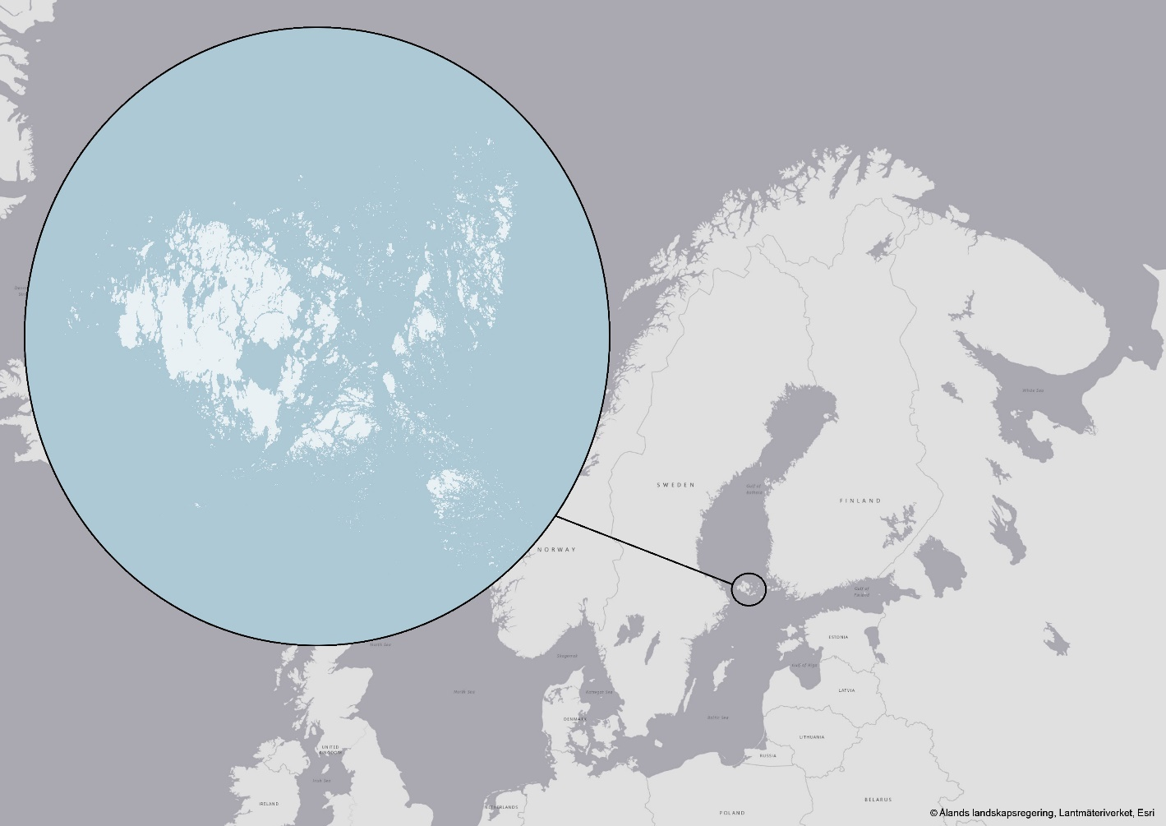

ANNEX II: GENERAL INFORMATION ABOUT FINLAND

Table 20. Number of births and fertility rate, 2007–2018
Year | Number of live births | Total fertility rate | Mother’s mean age by all live births | Mother’s mean age by first live birth
2007 | 58 729 | 1.83 | 30.0 | 28.1
2008 | 59 530 | 1.85 | 30.1 | 28.2
2009 | 60 430 | 1.86 | 30.1 | 28.2
2010 | 60 980 | 1.87 | 30.1 | 28.3
2011 | 59 961 | 1.83 | 30.3 | 28.4
2012 | 59 493 | 1.80 | 30.3 | 28.5
2013 | 58 134 | 1.75 | 30.4 | 28.6
2014 | 57 232 | 1.71 | 30.5 | 28.6
2015 | 55 472 | 1.65 | 30.6 | 28.8
2016 | 52 814 | 1.57 | 30.8 | 29.1
2017 | 50 321 | 1.49 | 30.9 | 29.2
2018 | 47 577 | 1.41 | 31.1 | 29.4
Source: Statistics Finland

Table 21. Deaths by year and sex and deaths of infants under age 1, 2002–2018
Year | Total | Men | Women | Infants under 1
2002 | 49 418 | 23 992 | 25 426 | 168
2003 | 48 996 | 23 922 | 25 074 | 176
2004 | 47 600 | 23 802 | 23 798 | 191
2005 | 47 928 | 24 057 | 23 871 | 174
2006 | 48 065 | 24 315 | 23 750 | 167
2007 | 49 077 | 24 809 | 24 268 | 161
2008 | 49 094 | 24 457 | 24 637 | 157
2009 | 49 883 | 25 150 | 24 733 | 158
2010 | 50 887 | 25 539 | 25 348 | 140
2011 | 50 585 | 25 335 | 25 250 | 143
2012 | 51 707 | 25 623 | 26 084 | 141
2013 | 51 472 | 25 631 | 25 841 | 102
2014 | 52 186 | 25 748 | 26 438 | 124
2015 | 52 492 | 25 992 | 26 500 | 97
2016 | 53 923 | 26 922 | 27 001 | 100
2017 | 53 722 | 26 895 | 26 827 | 102
2018 | 54 527 | 27 184 | 27 343 | 101
Source: Statistics Finland, Deaths

Table 22. Families by family type, 1990–2018
Family type | 1990 | 1995 | 2000 | 2005 | 2010 | 2015 | 2017 | 2018 | Change 2017–2018
Families, total | 1 365 341 | 1 382 970 | 1 401 963 | 1 426 002 | 1 455 073 | 1 475 335 | 1 471 500 | 1 468 681 | -2 819
Married couple, no children, total | 364 452 | 395 953 | 436 019 | 481 209 | 513 889 | 528 539 | 531 575 | 533 763 | 2 188
-opposite sex | 364 452 | 395 953 | 436 019 | 481 209 | 513 889 | 528 539 | 530 404 | 532 304 | 1900
- same sex | .. | .. | .. | .. | .. | .. | 1 171 | 1 459 | 288
Married couple and children, total | 640 062 | 579 578 | 514 868 | 468 266 | 446 433 | 424 185 | 412 497 | 404 663 | -7 834
-opposite sex | 640 062 | 579 578 | 514 868 | 468 266 | 446 433 | 424 185 | 412102 | 404 142 | -7 960
-same sex | .. | .. | .. | .. | .. | .. | 395 | 521 | 126
Cohabiting couple, no children | 123 471 | 135 996 | 160 132 | 180 590 | 195 967 | 215 620 | 217 644 | 220 179 | 2 535
Cohabiting couple and children | 65 896 | 85 309 | 102 581 | 112 847 | 117 254 | 122 657 | 123 234 | 122 614 | -620
Mother and children | 147 297 | 159 063 | 159 432 | 153 024 | 149 651 | 150 274 | 152 460 | 152 888 | 428
Father and children | 24 161 | 27 071 | 28 931 | 29 238 | 30 278 | 31 452 | 32 616 | 33 292 | 676
Registered male couple | .. | .. | .. | 398 | 706 | 1 023 | 640 | 586 | -54
Registered female couple | .. | .. | .. | 430 | 895 | 1 585 | 834 | 696 | -138
Family population | 4 101 922 | 4 093 238 | 4 053 850 | 4 037 753 | 4 065 168 | 4 080 544 | 4 055 224 | 4 033 721 | -21 503
Population at 31 Dec | 4 998 478 | 5 116 826 | 5 181 115 | 5 255 580 | 5 375 276 | 5 487 308 | 5 513 130 | 5 517 919 | 4 789
Proportion of family population, % | 82.1 | 80.0 | 78.2 | 76.8 | 75.6 | 74.4 | 73.6 | 73.1 | -0.5
Average family size | 3.00 | 2.96 | 2.89 | 2.83 | 2.79 | 2.77 | 2.76 | 2.75 | 0.0
Source: Statistics Finland, families

Table 23. Number of households and proportion of all households according to lifecycle, 2017
Economic unit | Number of households | Proportion of all households (%) | Average size (number of persons) | Economically active (number of persons)
One-person households, total | 1 167 000 | 43.0 | 1.0
One-person household aged under 35 | 285 000 | 10.5 | 1.0 | 0.35
One-person household aged 35–64 | 431 000 | 15.9
One-person household aged over 64 | 451 000 | 16.6
Single parent households | 96 000 | 3.6 | 2.75 | 0.67
Childless couples, total | 815 000 | 30.0 | 2.0 | 0.89
Childless couples aged under 35 | 173 000 | 6.4
Childless couples aged 35–64 | 328 000 | 12.1
Childless couples aged over 64 | 341 000 | 11.6
Couples with children, total | 477 000 | 17.6 | 4.04 | 1.64
Couples with children, all aged under 7 | 156 000 | 5.7
Couples with children, youngest aged under 7 | 92 000 | 3.4
Couples with children, youngest aged 7–12 | 113 000 | 4.2
Couples with children, youngest aged 13–17 | 64 000 | 2.3
Couples with children aged both under and over 18 | 53 000 | 1.9
Other households | 157 000 | 5.8
All households | 2 713 000 | 100.0 | 2.00 | 0.82
Source: Statistics Finland, Income distribution statistics, StatFin database

Table 24. Household income and change in income by lifecycle, 2017
Economic unit | Income, EUR | Change in income, %
 |  | 2000–2010 | 1989–2017
One-person households, total | 18 000 | 26 | 39
One-person household aged under 35 | 16 700 | 15 | 9
One-person household aged 35–64 | 22 100 | 30 | 37
One-person household aged over 64 | 17 000 | 28 | 55
Single parent households | 18 100 | 21 | 17
Childless couples, total | 28 100 | 28 | 42
Childless couples aged under 35 | 26 000 | 27 | 20
Childless couples aged 35–64 | 34 000 | 33 | 55
Childless couples aged over 64 | 23 900 | 38 | 65
Couples with children, total | 26 400 | 28 | 38
Couples with children, all aged under 7 | 26 300 | 28 | 38
Couples with children, youngest aged under 7 | 23 700 | 27 | 33
Couples with children, youngest aged 7–12 | 28 900 | 29 | 45
Couples with children, youngest aged 13–17 | 27 800 | 27 | 39
Couples with children aged both under and over 18 | 25 700 | 28 | 31
Other households | 27 300 | 29 | 44
All households | 23 041 | 28 | 33
Source: Statistics Finland, Income distribution statistics, StatFin database

Table 25. Infant mortality, 2005–2018
Year | Births | Number of deaths of infants under 1 | Number of infant deaths per one thousand live-born children
2018 | 47 577 | 101 | 2.1
2017 | 50 321 | 102 | 2.0
2016 | 52 814 | 100 | 1.9
2015 | 55 472 | 97 | 1.7
2014 | 57 232 | 124 | 2.2
2013 | 58 134 | 102 | 1.8
2012 | 59 493 | 141 | 2.4
2011 | 59 961 | 143 | 2.4
2010 | 60 980 | 140 | 2.3
2009 | 60 430 | 158 | 2.6
2008 | 59 530 | 157 | 2.6
2007 | 58 729 | 161 | 2.7
2006 | 58 840 | 167 | 2.8
2005 | 57 745 | 174 | 3.0
Source: Statistics Finland, Population and cause of death statistics

Table 26. Life expectancy, 2004–2018
Year | Total | Men | Women
2018* | 81.6 | 78.9 | 84.3
2017 | 81.5 | 78.7 | 84.2
2016 | 81.3 | 78.4 | 84.1
2015 | 81.4 | 78.5 | 84.1
2014 | 81.1 | 78.2 | 83.8
2013 | 80.9 | 77.8 | 83.8
2012 | 80.5 | 77.5 | 83.4
2011 | 80.4 | 77.2 | 83.5
2010 | 80.0 | 76.7 | 83.2
2009 | 79.8 | 76.5 | 83.1
2008 | 79.7 | 76.3 | 83.0
2007 | 79.4 | 75.8 | 82.9
2006 | 79.4 | 75.8 | 82.8
2005 | 79.0 | 75.5 | 82.3
2004 | 78.8 | 75.3 | 82.3
*Preliminary data for 2018

Source: Statistics Finland, Deaths

Table 27. Causes of death, 2017
Cause of death | Total deaths | % | Men | % | Women | %
Diseases of the circulatory system | 19 077 | 36 | 9 553 | 36 | 9 524 | 36
Neoplasms | 12 949 | 24 | 6 905 | 26 | 6 044 | 23
Dementia, Alzheimer’s disease | 9 390 | 17 | 3 059 | 11 | 6 331 | 24
Accidents (excl. accidental poisoning by alcohol) | 2 325 | 4 | 1 519 | 6 | 806 | 3
Diseases of the respiratory system | 2 084 | 4 | 1 263 | 5 | 821 | 3
Alcohol-related diseases and accidental poisoning by alcohol | 1 558 | 3 | 1 160 | 4 | 398 | 1
Diseases of the digestive system | 1 231 | 2 | 606 | 2 | 625 | 2
Suicides | 824 | 2 | 611 | 2 | 213 | 1
Other causes of death | 4 232 | 8 | 2 183 | 8 | 2 049 | 8
Total | 53 670 | 100 | 26 859 | 100 | 26 811 | 100
Source: Statistics Finland, Causes of death

Table 28. Average teaching group size in years 1–6, 2010–2016
 | Average group size 2010 | Average group size 2013 | Average group size 2016 | Change in group size 2010–2013 | Change in group size 2013–2016
All years, total | 19.2 | 18.8 | 19.4 | -0.4 | 0.6
Pre-primary education | 14.1 | 14.7 | 15.4 | 0.6 | 0.7
Year 1 | 18.5 | 18.6 | 19.0 | 0.1 | 0.4
Year 2 | 19.1 | 18.8 | 19.4 | -0.2 | 0.6
Year 3 | 20.3 | 20.0 | 20.2 | -0.4 | 0.2
Year 4 | 20.9 | 19.8 | 20.7 | -1.1 | 0.9
Year 5 | 21.3 | 20.4 | 20.7 | -0.9 | 0.4
Year 6 | 21.7 | 20.7 | 20.9 | -1.1 | 0.2
Multi-grade class/ other | 16.3 | 15.8 | 16.0 | -0.5 | 0.2
Years 1–6, total | 20.2 | 19.7 | 20.1 | -0.6 | 0.4
Source: National Finnish Agency for Education, Teachers and Principals in Finland 2016

Table 29. Basic education students by region, 2018
Region of school location | Number of schools | Pupils in pre-primary education | Pupils in years 1–6 | Pupils in years 7–9 | Pupils in additional education (year 10) | Pupils, total
Finland, total | 2 341 | 9 995 | 370 020 | 180 058 | 430 | 560 503
Mainland Finland, total | 2 319 | 9 995 | 368 042 | 179 097 | 426 | 557 560
Uusimaa | 533 | 1 647 | 113 040 | 53 385 | 188 | 168 260
Southwest Finland | 204 | 257 | 30 050 | 14 780 | 15 | 45 102
Satakunta | 114 | 407 | 13 853 | 6 978 | 5 | 21 243
Kanta-Häme | 86 | 160 | 11 741 | 5 795 | 4 | 17 700
Pirkanmaa | 172 | 1 641 | 34 542 | 16 482 | 62 | 52 727
Päijät-Häme | 67 | 152 | 12 608 | 6 548 | 12 | 19 320
Kymenlaakso | 82 | 229 | 10 115 | 5 455 | 13 | 15 812
South Karelia | 37 | 60 | 7 694 | 3 825 | 0 | 11 579
South Savo | 74 | 248 | 8 012 | 4 336 | 5 | 12 601
North Savo | 115 | 439 | 15 290 | 7 783 | 31 | 23 543
North Karelia | 72 | 340 | 9 271 | 4 637 | 0 | 14 248
Central Finland | 109 | 461 | 19 009 | 8 952 | 4 | 28 426
Southern Ostrobothnia | 134 | 799 | 13 522 | 6 841 | 4 | 21 166
Ostrobothnia | 121 | 677 | 13 158 | 6 189 | 8 | 20 032
Central Ostrobothnia | 55 | 148 | 5 414 | 2 569 | 1 | 8 132
Northern Ostrobothnia | 212 | 1 880 | 34 740 | 16 867 | 57 | 53 544
Kainuu | 33 | 112 | 4 464 | 2 217 | 0 | 6 793
Lapland | 99 | 338 | 11 519 | 5 458 | 17 | 17 332
Åland, total | 22 | 0 | 1 978 | 961 | 4 | 2 943
Åland | 22 | 0 | 1 978 | 961 | 4 | 2 943
Source: Statistics Finland, Education

Table 30. Number and size of comprehensive schools, 2014–2018
 |  | Under 50 pupils | 50–99 pupils | 100–299 pupils | 300–499 pupils | 500 pupils or more | Total
2014 | Comprehensive schools | 483 | 449 | 906 | 468 | 192 | 2 498
2015 | Comprehensive schools | 418 | 424 | 870 | 468 | 216 | 2 396
2016 | Comprehensive schools | 383 | 406 | 847 | 469 | 233 | 2 338
2017 | Comprehensive schools | 376 | 381 | 816 | 444 | 258 | 2 275
2018 | Comprehensive schools | 358 | 374 | 796 | 431 | 274 | 2 233
Source: Statistics Finland, Education

Table 31. Unionisation rate of wage-earners and persons whose interests are represented, 2002–2017

neither (Working Life Barometers)
unemployment fund only (Working Life Barometers)
trade union (Working Life Barometers)
unionisation rate among those whose interests are represented based on reports by L. Ahtiainen

Source: Working Life Barometers and reports by Lasse Ahtiainen (published by the Ministry of Economic Affairs and Employment

Table 32. Monthly employment rate trend, 2009–2019

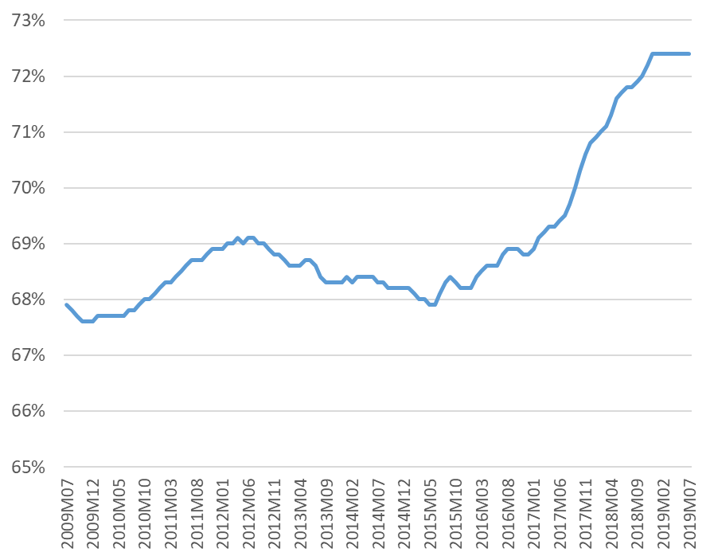

Source: Statistics Finland, Labour Force Survey

Table 33. Monthly unemployment rate trend, 2009–2019

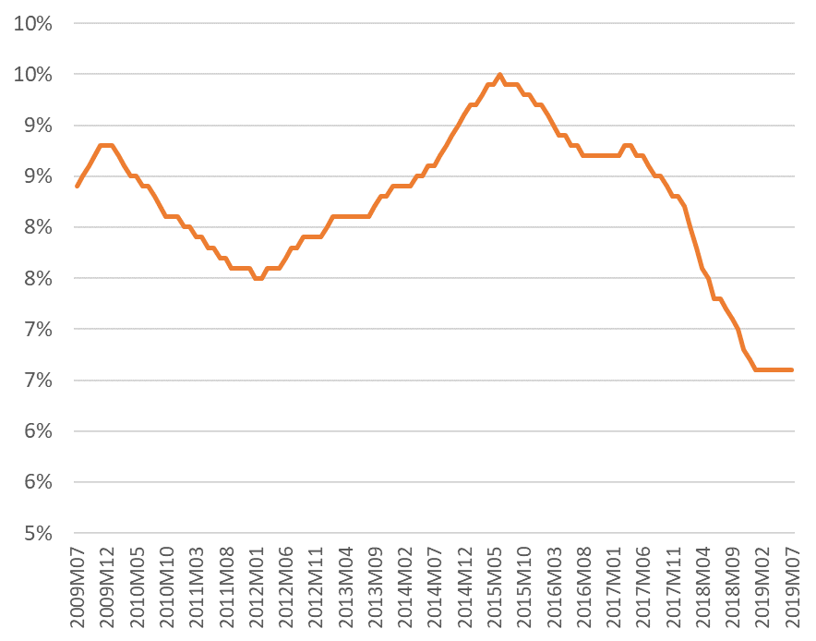

Source: Statistics Finland, Labour Force Survey

Table 34. Employed persons by industry, 2011–2018, 100 persons
Industry | 2011 | 2012 | 2013 | 2014 | 2015 | 2016 | 2017 | 2018
Agriculture, forestry and fishing; mining and quarrying | 110 | 109 | 107 | 109 | 109 | 101 | 99 | 101
Manufacturing; electricity, gas, steam and air conditioning and water supply; sewerage and waste management | 384 | 382 | 377 | 359 | 352 | 356 | 355 | 361
Construction | 176 | 175 | 176 | 169 | 168 | 178 | 187 | 198
Wholesale and retail trade; repair of motor vehicles and motorcycles | 303 | 300 | 296 | 290 | 284 | 290 | 282 | 292
Transportation and storage | 147 | 144 | 142 | 140 | 137 | 141 | 139 | 143
Accommodation and food service activities | 83 | 86 | 86 | 86 | 87 | 85 | 85 | 86
Information and communication | 99 | 101 | 100 | 100 | 106 | 101 | 106 | 114
Financial, insurance and real estate activities | 75 | 74 | 71 | 74 | 73 | 75 | 81 | 77
Professional, scientific and technical activities; administrative and support service activities | 253 | 262 | 260 | 269 | 277 | 271 | 283 | 291
Public administration and defence; compulsory social security | 116 | 113 | 111 | 106 | 106 | 111 | 115 | 116
Education | 179 | 175 | 175 | 180 | 179 | 173 | 181 | 184
Human health and social work activities | 396 | 409 | 399 | 402 | 404 | 409 | 404 | 417
Arts, entertainment and recreation; other service activities | 141 | 142 | 144 | 151 | 145 | 148 | 152 | 153
Source: Statistics Finland, Labour Force Survey

Table 35. Legal aid applications considered by year and category, 2010–2018
Year / Category | 2010 | 2011 | 2012 | 2013 | 2014 | 2015 | 2016 | 2017 | 2018
Total | 70 284 | 69 314 | 65 492 | 69 780 | 70 088 | 76 408 | 80 051 | 71 340 | 71 663
Marital and family law | 11 788 | 11 697 | 11 027 | 11 299 | 120 54 | 12 691 | 11 987 | 11 716 | 11 898
Pensions and other social benefits | 2 075 | 1 866 | 1 735 | 1 639 | 1 556 | 1 478 | 1 334 | 1 349 | 1 358
Tenancy | 2 034 | 1 873 | 1 726 | 1 755 | 2 087 | 2 197 | 2 143 | 2 088 | 2 069
Movable property | 770 | 760 | 650 | 641 | 725 | 724 | 680 | 693 | 639
Disasters | 1 |  | 2 |  | 1 |  | 1
Real estate | 1 681 | 1 669 | 1 632 | 1 520 | 1 556 | 1 672 | 1 516 | 1 387 | 1 412
Employment and equality | 1 312 | 1 240 | 1 130 | 1 205 | 1 175 | 1 273 | 1 170 | 1 005 | 1 099
Inheritance | 11 222 | 11 083 | 10 550 | 10 499 | 10 862 | 10 771 | 10 641 | 10 645 | 10 344
Crimes | 8 657 | 8 710 | 7 371 | 7 853 | 7 456 | 7 466 | 6 914 | 6 752 | 6 496
Compensation for damage | 1 281 | 1 345 | 1 205 | 1 285 | 1 301 | 1 311 | 1 223 | 1 240 | 1 217
Payment of debts | 2 658 | 2 611 | 2 577 | 2 791 | 2 633 | 2 810 | 2 674 | 2 631 | 2 628
Debt reorganisation, private individual | 295 | 322 | 337 | 310 | 335 | 334 | 297 | 293 | 309
Other | 4 607 | 4 812 | 4 665 | 4 772 | 4 993 | 5 672 | 6 578 | 6 166 | 6 094
Aliens |  |  |  |  |  |  | 985 | 2 907 | 3 148
Legal aid decisions for private attorneys | 21 903 | 21 326 | 20 885 | 24 211 | 23 354 | 28 009 | 31 908 | 22 468 | 22 952

Source: Statistics Finland Official Statistics of Finland (OSF): Public legal aid [e-publication]

Table 36. Prosecution Authority personnel development, 2016–2018
Office / Year | 2016 |  |  | 2017 |  |  | 2018
 | Men | Women | Total | Men | Women | Total | Men | Women | Total
Office of the Prosecutor General | 9 | 30 | 39 | 10 | 30 | 40 | 10 | 33 | 43
Helsinki | 30 | 52 | 82 | 33 | 53 | 86 | 33 | 66 | 99
Western Uusimaa | 12 | 31 | 43 | 17 | 26 | 43 | 17 | 30 | 47
Eastern Uusimaa | 14 | 47 | 61 | 16 | 48 | 64 | 13 | 45 | 58
Salpausselkä | 19 | 36 | 55 | 16 | 39 | 55 | 14 | 37 | 51
Western Finland | 24 | 34 | 58 | 26 | 34 | 60 | 26 | 33 | 59
Pirkanmaa/ Inland Finland | 18 | 44 | 62 | 17 | 45 | 62 | 17 | 48 | 65
Ostrobothnia | 13 | 20 | 33 | 14 | 20 | 34 | 12 | 19 | 31
Eastern Finland | 20 | 23 | 43 | 20 | 21 | 41 | 18 | 20 | 38
Oulu | 14 | 26 | 40 | 13 | 29 | 42 | 12 | 26 | 38
Lapland | 3 | 17 | 20 | 6 | 14 | 20 | 4 | 17 | 21
Åland | 3 | 2 | 5 | 2 | 2 | 4 | 2 | 3 | 5
Prosecution Authority, total | 179 | 362 | 541 | 190 | 361 | 551 | 178 | 377 | 555
Source: Statistics Finland

Table 37. Development of certain types of offences, 2012–2018
 | 2012 | 2013 | 2014 | 2015 | 2016 | 2017 | 2018
1) OFFENCES AND INFRACTIONS, TOTAL | 860 692 | 869 402 | 828 296 | 817 307 | 823 449 | 861 921 | 873 415
2) OFFENCES AGAINST THE CRIMINAL CODE | 491 846 | 489 765 | 482 050 | 472 646 | 466 857 | 438 373 | 443 525
A Offences against property | 237 609 | 240 547 | 241 326 | 235 945 | 230 174 | 210 773 | 206 961
Burglaries, total | 35 046 | 32 514 | 33 972 | 34 178 | 33 251 | 29 754 | 28 254
Breaking into a residence | 6 281 | 5 749 | 6 363 | 5 969 | 5 300 | 4 770 | 4 922
- into a free-time residence | 1 478 | 1 791 | 1 840 | 1 684 | 1 227 | 1 512 | 1 200
- into another residence | 4 803 | 3 958 | 4 523 | 4 285 | 4 073 | 3 258 | 3 722
Breaking into business premises | 4 001 | 3 843 | 4 044 | 4 081 | 3 329 | 3 034 | 2 927
Breaking into a motor vehicle | 10 738 | 9 597 | 9 253 | 9 484 | 8 654 | 7 650 | 6 972
Other burglaries | 14 026 | 13 325 | 14 312 | 14 644 | 15 968 | 14 300 | 13 433
Unauthorised uses and thefts of a motor vehicle, thefts of use of a motor vehicle, total | 8 815 | 7 963 | 7 773 | 7 435 | 6 700 | 6 103 | 5 795
Robberies 31:1–2, total | 1 616 | 1 524 | 1 689 | 1 546 | 1 673 | 1 640 | 1 701
-Aggravated robbery, Preparation of an aggravated robbery 31:2, 2a | 218 | 196 | 216 | 266 | 277 | 264 | 303
Criminal damage 35:1–3, total | 44 417 | 43 375 | 42 516 | 37 705 | 35 170 | 33 466 | 30 448
-Aggravated criminal damage 35:2 | 239 | 266 | 253 | 252 | 300 | 262 | 239
Embezzlement, petty embezzlement 28:4,6 | 2 898 | 3 216 | 2 703 | 2 476 | 2 529 | 2 791 | 2 975
Embezzlement, total | 3 272 | 3 574 | 3 075 | 2 832 | 2 924 | 3 149 | 3 385
Aggravated embezzlement 28:5 | 374 | 358 | 372 | 356 | 395 | 358 | 410
Fraud, total | 20 946 | 22 835 | 23 515 | 25 526 | 25 065 | 23 380 | 24 483
Aggravated fraud 36:2 | 1 052 | 1 100 | 1 351 | 1 441 | 1 422 | 1 429 | 1 692
Means of payment fraud, total | 6 231 | 7 607 | 7 771 | 10 891 | 15 124 | 6 678 | 6 111
Aggravated means of payment fraud 37:9 | 127 | 123 | 123 | 192 | 161 | 245 | 212
B Crimes against life and health | 40 853 | 38 026 | 35 236 | 36 005 | 36 094 | 35 744 | 36 074
Manslaughter, murder or killing | 89 | 95 | 101 | 96 | 78 | 73 | 85
Attempted manslaughter, murder or killing 21:1–3,34a:1 | 350 | 264 | 327 | 299 | 311 | 348 | 355
Assaults 21:5–7,34a:1§1/6, total | 38 231 | 35 515 | 32 928 | 33 661 | 33 769 | 33 535 | 33 639
Aggravated assault 21:6,34a:1(1/6) | 1 874 | 1 791 | 1 645 | 1 563 | 1 592 | 1 581 | 1 609
C Sexual crimes | 3 511 | 3 310 | 3 001 | 2 955 | 3 327 | 3 269 | 3 779
Sexual abuse of a child, aggravated sexual abuse of a child 20:6–7 | 1 567 | 1 657 | 1 416 | 1 225 | 1 242 | 1 168 | 1 373
Rape, aggravated rape, rape (subsection 3) 20:1–2 | 1 009 | 975 | 1 009 | 1 043 | 1 160 | 1 245 | 1 393
D Crimes against public authority and public peace | 14 361 | 13 700 | 12 592 | 12 743 | 13 399 | 12 355 | 12 482
(Violent) Resistance to a public official 16:1–2 | 1 852 | 1 682 | 1 704 | 1 717 | 1 883 | 1 723 | 1 895
Obstruction of a public official 16:3 | 2 183 | 1 916 | 1 863 | 1 809 | 1 852 | 1 525 | 1 542
L Traffic offences | 142 372 | 137 231 | 134 349 | 129 684 | 121 235 | 110 292 | 116 411
Causing a traffic hazard, Flight from the scene of a traffic accident 23:1,11 | 94 367 | 91 980 | 88 792 | 84 761 | 76 476 | 65 204 | 67 651
…speeding as reason for causing a traffic hazard | 57 492 | 58 970 | 58 400 | 56 620 | 51 555 | 43 363 | 45 150
Causing a serious traffic hazard 23:2 | 3 635 | 3 809 | 3 854 | 3 912 | 3 879 | 3 808 | 4 047
…speeding as reason for causing a serious traffic hazard | 2 374 | 2 561 | 2 518 | 2 535 | 2 480 | 2 394 | 2 579
Driving while intoxicated, total 23:3–4 | 19 134 | 17 994 | 17 608 | 17 620 | 17 308 | 17 685 | 19 006
Driving while seriously intoxicated 23:4 | 10 333 | 9 001 | 8 304 | 7 815 | 7 285 | 7 019 | 7 238
M Other offences against the Criminal Code | 53 139 | 56 951 | 55 546 | 55 314 | 62 628 | 65 940 | 67 818
Narcotics offences 50:1–4, total | 20 102 | 22 656 | 21 781 | 23 410 | 25 082 | 27 777 | 29 140
Aggravated narcotics offence 50:2 | 1 025 | 1 237 | 1 161 | 1 071 | 1 179 | 1 282 | 1 251
Alcohol offence 50a:1 | 126 | 186 | 140 | 139 | 121 | 89 | 118
Aggravated alcohol offence 50a:2 | 7 | 29 | 15 | 13 | 6 | 12 | 2
Petty alcohol offence 50a:3 | 1 246 | 1 288 | 1 320 | 1 080 | 786 | 533 | 558
N Offences against other Acts and Decrees | 368 846 | 379 637 | 346 246 | 344 661 | 356 592 | 423 548 | 429 890
Alcohol infraction (Act 1102/2017) | 3 222 | 2 971 | 2 211 | 1 982 | 1 963 | 1 177 | 992
Traffic infraction, violation of social welfare legislation on road traffic, vehicle infraction, Act 729/2018, 103, 105a | 340 904 | 352 636 | 321 606 | 321 021 | 335 248 | 405 998 | 413 887
...speeding as reason for traffic infraction | 229 038 | 254 318 | 232 834 | 232 196 | 245 277 | 329 385 | 338 622
Source: Statistics Finland, Statistics on offences and coercive measures (e-publication)

Table 38. Sexual offences, 2007–2018
 | Sexual offences | Sexual abuse of a child, aggravated sexual abuse of a child 20:6–7 | Rape, aggravated rape, rape (subsection 3) 20:1–2 | Other sexual offences 20:4–5,5a, 8–9
2007 | 2 326 | 1 025 | 739 | 562
2008 | 2 906 | 1 321 | 915 | 670
2009 | 2 205 | 1 068 | 660 | 477
2010 | 2 417 | 1 102 | 818 | 497
2011 | 3 252 | 1 682 | 1 039 | 531
2012 | 3 511 | 1 567 | 1 009 | 935
2013 | 3 310 | 1 657 | 975 | 678
2014 | 3 001 | 1 416 | 1 009 | 576
2015 | 2 955 | 1 225 | 1 043 | 687
2016 | 3 327 | 1 242 | 1 160 | 925
2017 | 3 269 | 1 168 | 1 245 | 856
2018 | 3 779 | 1 373 | 1 393 | 1 013
Source: Statistics Finland. Statistics on offences and coercive measures

ANNEX III: GENERAL FRAMEWORK FOR THE PROTECTION AND PROMOTION OF HUMAN RIGHTS

Table 39. United Nations human rights instruments and optional Protocols
Convention / Optional Protocol | Signed (S)  Ratified (R) | Reservations | Recognition of additional jurisdiction
International Convention on the Elimination of All Forms of Racial Discrimination (CERD), 1965 | R 14/07/1970 |  | Finland recognises the competence of the Committee on the Elimination of Racial Discrimination to receive and consider communications from individuals or groups of individuals within the jurisdiction of Finland claiming to be victims of a violation by Finland of any of the rights set forth in the said Convention, with the reservation that the Committee shall not consider any communication from an individual or a group of individuals unless the Committee has ascertained that the same matter is not being examined or has not been examined under another procedure of international investigation or settlement.
International Covenant on Economic, Social and Cultural Rights (ICESCR), 1966 | R 23/06/1975
Optional Protocol to the International Covenant on Economic, Social and Cultural Rights, 2008 | R 1/1/2014 |  | Finland declares that it recognises the competence of the committee to receive and consider inter-state communications made against it provided for in article 10 of the Protocol and the competence of the committee concerning an inquiry procedure provided for in article 11 of the Protocol.
International Covenant on Civil and Political Rights (ICCPR), 1966 | R 19/08/1975 | With respect to article 10, paragraph 2 (b) and 3, of the Covenant, Finland declares that although juvenile offenders are, as a rule, segregated from adults, it does not deem appropriate to adopt an absolute prohibition not allowing for more flexible arrangements;  With respect to article 14, paragraph 7, of the Covenant, Finland declares that it is going to pursue its present practice, according to which a sentence can be changed to the detriment of the convicted person, if it is established that a member or an official of the court, the prosecutor or the legal counsel have through criminal or fraudulent activities obtained the acquittal of the defendant or a substantially more lenient penalty, or if false evidence has been presented with the same effect, and according to which an aggravated criminal case may be taken up for reconsideration if within a year until then unknown evidence is presented, which would have led to conviction or a substantially more severe penalty.  With respect to article 20, paragraph 1, of the Covenant, Finland declares that it will not apply the provisions of this paragraph, this being compatible with the standpoint Finland already expressed at the 16th United Nations General Assembly by voting against the prohibition of propaganda for war, on the grounds that this might endanger the freedom of expression referred in article 19 of the Covenant. | Finland declares, under article 41 of the International Covenant on Civil and Political Rights, that it recognises the competence of the Human Rights Committee referred to in article 28 of the said Covenant, to receive and consider communications to the effect that a State Party claims that another State Party is not fulfilling its obligations under this Covenant.
Optional Protocol to the International Covenant on Civil and Political Rights on communications from individuals, 1966 | R 19/08/1975
Second Optional Protocol to the International Covenant on Civil and Political Rights aiming at the abolition of the death penalty , 1989 | R 04/04/1991
Convention on the Elimination of all Forms of Discrimination Against Women (CEDAW), 1979 | R 04/09/1986
Optional Protocol to the Convention on the Elimination of All Forms of Discrimination against Women on communications from individuals and groups of individuals, 1999 | R 29/12/2000
Convention against Torture and Other Cruel, Inhuman or Degrading Treatment or Punishment (CAT), 1984 | R 30/08/1989 |  | Finland declares that it recognises fully the competence of the Committee against Torture as specified in article 21, paragraph 1 and article 22, paragraph 1 of the Convention.
Optional Protocol to the Convention against Torture on visits by national and international bodies, 2003 | R 08/10/2014
Convention on the Rights of the Child (CRC), 1989 | R 20/06/1991
Optional Protocol to the Convention on the Rights of the Child on the involvement of children in armed conflict, 2000 | R 10/04/2002 | Finland declares that the minimum age for any recruitment of persons into its national armed forces is 18 years. The minimum age applies equally to the military service of men and to the voluntary service of women.
Optional Protocol on the Sale of Children, Child Prostitution and Child Pornography, 2000 | R 01/06/2012
Optional Protocol to the Convention on the Rights of the Child on a communications procedure, 2011 | R 12/11/2015 |  | Finland declares that it recognises the competence of the Committee to receive and consider inter-state communications made against it provided for in Article 12 of the Protocol.
Convention on the Rights of Persons with Disabilities, 2006 | R 11/05/2016
Optional Protocol to the Convention on the Rights of Persons with Disabilities on a communications procedure, 2006 | R 11/05/2016
International Convention for the Protection of All Persons from Enforced Disappearance, 2006 | S 6/2/2007 | The Government is currently preparing ratification of the Convention.

Table 40. Other United Nations instruments relating to human rights
Convention / Optional Protocol | Signed (S)  Ratified (R)  Acceded (A)
Convention on the Prevention and Punishment of the Crime of Genocide, 1948 | A 18/12/1959
Convention to Suppress the Slave Trade and Slavery, 1926, amended 1955 | R29/09/1927, 19/03/1954
Convention for the Suppression of the Traffic in Persons and of the Exploitation of the Prostitution of Others, 1949 | R 08/06/1972
Convention Relating to the Status of Refugees 1951 and its 1967 Optional Protocol | A 10/10/1968
Convention relating to the Status of Stateless Person, 1954 | A 10/10/1968
Convention on the Reduction of Statelessness , 1961 | A 07/08/2008
Rome Statute of the International Criminal Court, 1998 | R 29/12/2000
United Nations Convention against Transnational Organized Crime 2000 and its supplemental Protocol against the Smuggling of Migrants by Land, Sea and Air and Protocol to Prevent, Suppress and Punish Trafficking in Persons, especially Women and Children | R 10/02/2004

Table 41. International Labour Organization ILO instruments
Convention / Protocol | Ratified (R)
Weekly Rest (Industry) Convention, 1921 (No. 14) | R 19/06/1923
Forced Labour Convention, 1930 (No. 29) | R 13/01/1936
Labour Inspection Convention, 1947 (No. 81) | R 20/01/1950
Freedom of Association and Protection of the Right to Organise Convention, 1948 (No. 87) | R 20/01/1950
The Right to Organise and Collective Bargaining Convention, 1949 (No. 98) | R 22/12/1951
Equal Remuneration Convention, 1951 (No. 100) | R 14/01/1963
Abolition of Forced Labour Convention, 1957 (No. 105) | R 27/05/1960
Discrimination (Employment and Occupation) Convention, 1958 (No. 111) | R 23/04/1970
Equality of Treatment (Social Security) Convention, 1962 (No. 118) | R 15/08/1969
Employment Policy Convention, 1964 (No. 122) | R 23/09/1968
Labour Inspection (Agriculture) Convention, 1969 (No. 129) | R 03/09/1974
Holidays with Pay Convention (Revised), 1970 (No. 132) | R 15/01/1990
Minimum Age Convention, 1973 (No. 138) | R 13/01/1976
Labour Relations (Public Service) Convention, 1978 (No. 151) | R 25/02/1980
Occupational Safety and Health Convention, 1981 (No. 155) | R 24/04/1985
Workers with Family Responsibilities Convention, 1981 (No. 156) | R 09/02/1983
Worst Forms of Child Labour Convention, 1999 (No. 182) | R 17/01/2000
Protocol of 2014 to the Forced Labour Convention, 1930 | R 27/01/2017
Violence and Harassment Convention, 2019 (No. 190)

Table 42. UNESCO instruments
Convention / Protocol | Ratification (R)
Convention against Discrimination in Education, 1960 | R 18/10/1971
Convention Concerning the Protection of the World Cultural and Natural Heritage, 1972 | R 04/03/1987
Hague Convention for the Protection of Cultural Property in the Event of Armed Conflict and related Protocol, 1954 | R 16/09/1994
Convention on the Means of Prohibiting and Preventing the Illicit Import, Export and Transport of Ownership of Cultural Property, 1970 | R 14/06/1999
Convention on the Protection and Promotion of the Diversity of Cultural Expressions, 2005 | R 600/2006
Convention for the Safeguarding of the Intangible Cultural Heritage, 2003 | R 21/02/2013
International Convention against Doping in Sport, 2005 | R 22/12/2006

Table 43. UNIDROIT instruments
Convention / Protocol | Ratification (R)
Convention on Stolen or Illegally Exported Cultural Objects, 1995 | R 28/05/1999

Table 44. Hague Conference on Private International Law instruments
Convention / Protocol | Signed (S)  Ratified (R)
Convention concerning the recognition and enforcement of decisions relating to maintenance obligations towards children, 1958 | R 26/06/1967
Convention on the Recognition of Divorces and Legal Separations, 1970 | R 16/06/1977
Convention of on the Recognition and Enforcement of Decisions Relating to Maintenance Obligations, 1973 | R 29/04/1983
Convention on the Civil Aspects of International Child Abduction, 1973 | R 25/05/1994
Convention on Celebration and Recognition of the Validity of Marriages,1978 | S 24/09/1980
Convention on International Access to Justice, 1980 | R 13/06/1980
Convention on Protection of Children and Co-operation in Respect of Intercountry Adoption, 1993 | R 27/03/1997
Convention on Jurisdiction, Applicable Law, Recognition, Enforcement and Co-operation in Respect of Parental Responsibility and Measures for the Protection of Children, 1996 | R 19/11/2010
Convention of 13 January 2000 on the International Protection of Adults, 2002 | R 19/11/2010

Table 45. Geneva Convention and other humanitarian law instruments
Convention / Protocol | Signed (S)  Ratified (R)
Geneva Convention (I) for the Amelioration of the Condition of the Wounded and Sick in Armed Forces in the Field 1949 | R 22/02/1955
Geneva Convention (II) for the Amelioration of the Condition of Wounded, Sick and Shipwrecked Members of Armed Forces at Sea, 1949 | R 22/02/1955
Geneva Convention (III) relative to the Treatment of Prisoners of War, 1949 | R 22/02/1955
Geneva Convention (IV) relative to the Protection of Civilian Persons in Time of War, 1949 | R 22/02/1955
Protocol Additional to the Geneva Conventions of 12 August 1949, and relating to the Protection of Victims of International Armed Conflicts (Protocol I), 1977 | R 07/08/1980
Protocol Additional to the Geneva Conventions of 12 August 1949, and relating to the Protection of Victims of Non-International Armed Conflicts (Protocol II), 1977 | R 07/08/1980
Convention on the Prohibition of the Use, Stockpiling, Production and Transfer of Anti-Personnel Mines and on their Destruction, 1997 | R 09/01/2012

Table 46. Regional human rights instruments of the Council of Europe
Convention / Protocol | Ratified (R)
Convention for the Protection of Human Rights and Fundamental Freedoms, 1950 | R 10/05/1990
European Agreement relating to Persons participating in Proceedings of the European Commission and Court of Human Rights | R 27/02/1991
European Convention for the Prevention of Torture and Inhuman or Degrading Treatment or Punishment , 1987 | R 20/12/1990
European Charter for Regional or Minority Languages, 1992 | R 09/11/1994
Framework Convention for the Protection of National Minorities ,1995 | R 03/10/1997
European Convention on the Exercise of Children’s Rights, 1996 | R 29/11/2010
European Agreement relating to persons participating in proceedings of the European Court of Human Rights, 1996 | R 23/12/1998
Revised European Social Charter, 1996 | R 21/06/2002
Convention for the Protection of Human Rights and Dignity of the Human Being with regard to the Application of Biology and Medicine, 1999 | R 30/11/2009
Additional Protocol to the Convention on Cybercrime, concerning the criminalisation of acts of a racist and xenophobic nature committed through computer, 2003 | R 20/05/2011
Council of Europe Convention on Action against Trafficking in Human Beings, 2005 | R 30/05/2012
Council of Europe Convention on preventing and combating violence against women and domestic violence, 2011 | R 17/04/2015
Council of Europe Framework Convention on the Value of Cultural Heritage for Society, 2005 | R 31/05/2018

