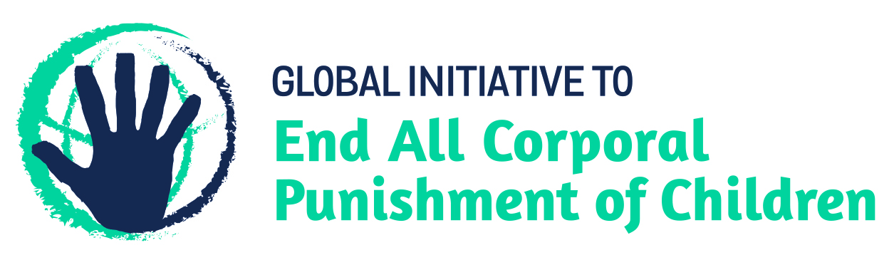
BRIEFING ON TRINIDAD AND TOBAGO FOR THE HUMAN RIGHTS COMMITTEE, COUNTRY REPORT TASK FORCE, 124th session (October/November 2018)
From the Global Initiative to End All Corporal Punishment of Children, July 2018
This briefing describes the legality of corporal punishment of children in Trinidad and Tobago. In light of the obligation under international human rights treaties to prohibit all corporal punishment of children, the global commitment to ending violence against children – including corporal punishment – in the context of the 2030 Agenda for Sustainable Development, the recommendations of the UN Secretary General’s Study on Violence against Children, and those made to Trinidad and Tobago by the Committee on the Rights of the Child, the Committee on Economic, Cultural and Social Rights, and during the Universal Periodic Review of Trinidad and Tobago in 2011 and 2016, we hope the Human Rights Committee will:
- raise the issue of corporal punishment of children in its List of Issues Prior to Reporting for Trinidad and Tobago, in particular asking what progress is being made on enacting legislation prohibiting all corporal punishment of children in the home, and
- in its concluding observations on Trinidad and Tobago’s fifth state party report, recommend that prohibition of all corporal punishment of children in the home is enacted and implemented as a matter of priority.

1 The legality of corporal punishment of children in Trinidad and Tobago
1.1 Summary: Corporal punishment of children in Trinidad and Tobago is unlawful in all settings outside the home.
1.2 Home (lawful): Corporal punishment is lawful in the home. Article 4 of the Children Act 2012, which came into force in May 2015, punishes cruelty to children but states in subsection 6: “Nothing in this section shall be construed as affecting the right of any parent, teacher or other person having the lawful control or charge of a child to administer reasonable punishment to such child.” Subsection 7 states that for persons other than parents this does not authorise the use of corporal punishment, implicitly confirming that parents may use corporal punishment: “Reasonable punishment referred to in subsection (6), in relation to any person other than a parent or guardian, shall not include corporal punishment.”
1.3 In 2011, the Government rejected recommendations to prohibit corporal punishment in all settings including the home made during the Universal Periodic Review of Trinidad and Tobago, stating that corporal punishment is traditionally accepted in disciplining children. However, in June 2015 Minister of Gender, Youth and Child Development Minister of Gender, Youth and Child Development Clifton De Coteau spoke publicly against corporal punishment by parents, noting that it has a negative impact on children and he is no longer in favour of it. In 2016, during the second Universal Periodic Review of Trinidad and Tobago, the Government “noted” recommendations to prohibit corporal punishment in the home, stating “it has traditionally been accepted as a legitimate form of discipline for youngsters in the Caribbean and mainly inherited as a result of traditional lifestyles from the vast diaspora which constitutes the social and historical composition of most Caribbean countries.”
1.4 Alternative care settings (unlawful): Corporal punishment is unlawful in alternative care settings with effect from May 2015 under article 4(7) of the Children Act 2012. In addition, the Children’s Community Residences Regulations 2014, under the Children’s Community Residences, Foster Care and Nurseries Act 2000, explicitly prohibits corporal punishment in community residential care (art. 15): “A child placed in the care of a community residence shall not be subjected to (a) corporal punishment, (b) solitary confinement, (c) unreasonable immobilisation; or (d) unreasonable physical restraint.” The Foster Care Regulation 2014 and the Children’s Authority Regulations 2014 are silent on the issue.
1.5 Day care (unlawful): Corporal punishment is unlawful in early childhood care and in day care for older children, with effect from May 2015, under article 4(7) of the Children Act 2012.
1.6 Schools (unlawful): Corporal punishment is unlawful in schools under article 4(7) of the Children Act 2012. Prohibition had previously been included in the Children (Amendment) Act 2000 but this had never been brought into force. The Education Act 1996 makes no reference to corporal punishment. The National School Code of Conduct (2009) of the Ministry of Education states that corporal punishment should not be used.
1.7 Penal institutions (unlawful): Corporal punishment is unlawful as a disciplinary measure in penal institutions under article 4(7) of the Children Act 2012. It would appear that the provisions for corporal punishment in the Young Offenders (Male) Detention Regulations, pursuant to the Young Offenders Detention Act 1926, are still to be formally repealed.
1.8 Sentence for crime (unlawful): Corporal punishment is unlawful as a sentence for crime. The Miscellaneous Provisions (Children) Act 2000 prohibited corporal punishment as a sentence for persons under 18 by repealing the Corporal Punishment (Offenders Not Over Sixteen) Act and amending the Corporal Punishment (Offenders Over Sixteen) Act to apply to offenders over the age of 18. But the Act did not repeal other laws which allowed under 18s to be sentenced to corporal punishment, including article 83(g) of the Children Act 1925 which provided for a child or young person found guilty of an offence to be ordered to be whipped: this provision would have been repealed in the Children (Amendment) Act 2000 (art. 24), but this Act was never brought into force. However, with the proclamation of article 4 of the Children Act 2012 in May 2015, all judicial corporal punishment of children is now prohibited.

2 Recommendations by human rights treaty bodies and during the UPR
2.1 CRC: The Committee on the Rights of the Child has twice recommended to Trinidad and Tobago that corporal punishment of children be prohibited in all settings including the home – in its concluding observations on the initial report in 1997 and on the second report in 2006.
2.2 CESCR: In 2002, the Committee on Economic, Social and Cultural Rights recommended that corporal punishment of children be prohibited “in all areas of life” in Trinidad and Tobago.
2.3 UPR: In 2011, the Government rejected recommendations to prohibit corporal punishment extended during the Universal Periodic Review, stating that corporal punishment was a traditional form of child discipline. In 2016, the Government noted recommendations to prohibit in the home, reiterating its traditional character in the Caribbean.

Briefing prepared by the Global Initiative to End All Corporal Punishment of Children
www.endcorporalpunishment.org; info@endcorporalpunishment.org

1 March 2012, A/HRC/19/7/Add.1, Report of the working group: Addendum, para. 22
Reported in Daily Express, 24 June 2015, http://www.trinidadexpress.com/20150624/news/de-coteau-find-other-ways-to-punish-children, accessed 25 June 2015
21 September 2016, A/HRC/33/15/Add.1, Report of the working group: Addendum, paras. 16, 17
10 October 1997, CRC/C/15/Add.82, Concluding observations on initial report, paras.17, 23, 32 and 39; 17 March 2006, CRC/C/TTO/CO/2, Concluding observations on second report, paras 8, 9, 39, 40 and 47
5 June 2002, E/C.12/1/Add.80, Concluding observations to the second report, paras. 29 and 52
1 March 2012, A/HRC/19/7/Add.1, Report of the working group: Addendum, para. 22
21 September 2016, A/HRC/33/15/Add.1, Report of the working group: Addendum, paras. 16, 17

