Supplemental submission regarding the Islamic Republic of Iran’s compliance
with the International Covenant on Civil and Political Rights
as concerns the situation of the Bahá'ís
(August 2022)

- This submission is supplemental to the main submission made by the Bahá’í International Community for consideration at the 136th session of the United Nations Human Rights Committee regarding the list of issues prior to reporting of the Islamic Republic of Iran.

- In our main submission, we detail concerns regarding Iran’s compliance with ICCPR Articles 2, 9, 14, 16, 18, 19, 20, 26, and 27 and include examples of specific cases. Since our main submission was made in August 2020, we are now providing an update regarding Iran’s treatment of Bahá’ís by detailing further specific cases of concern since our main submission.

Intensified targeting of Bahá’ís as official government policy (Articles 16 and 26)

- A recently uncovered official directive instructing authorities in the city of Sari, Mazandaran, dated 21 September 2020 provides instructions to authorities to target and persecute Bahá’ís merely for their beliefs. The directive outlines a “detailed plan” to ensure that the Bahá’í community is “rigorously controlled”, including their “public and private meetings” as well as “their other activities”. The document was issued by the Commission on Ethnicities, Sects and Religions in Sari, which operates under the aegis of Iran’s Supreme National Security Council, a body chaired by Iran’s president and which is responsible for security matters. The directive was sent to local and provincial police, the head of Sari’s Intelligence Department, the commander of the local Basij paramilitary force, the head of Education, the Industry, Mining and Trade and the Cultural Heritage, Handicrafts and Tourism departments, and school and university officials, with the Department of Education ordered to “increase the level of alertness and awareness” among school teachers and principals regarding “their handling of Bahá’í students in order to bring them to Islam.” This document shows the targeting of Bahá’ís and their beliefs as an official policy of authorities in their quest to restrict this community’s freedom of religion or belief and their freedom of association and peaceful assembly.

- The official directive from Mazandaran clearly results in Bahá’ís not receiving equal recognition and treatment before the law in contravention of Articles 16 and 26 of the ICCPR.

Mass raids, arrests, and arbitrary detention on the basis of religion (Articles 9 and 14)

- Since our main submission in August 2020, there has been a steady stream of arrest and detention of Bahá’ís. These arrests, detentions, and interrogations are continually carried out against adherents of the Bahá’í Faith throughout the country, and the charges they are accused of show that they are targeted merely because of their faith. Bahá’ís are regularly convicted of charges such as assembly and collusion “for the purpose of causing intellectual and ideological insecurity in Muslim society”, “involvement in propaganda activities against the regime by way of spreading sectarian Baha’i ideology, production and distribution of improper photos online and on social media and action against national security by way of spreading and teaching sectarian Baha’i ideology”, “propaganda against the regime”, “activities against the national security”, and “membership in the perverse Bahá’í sect”. Currently, more than a thousand Bahá’ís are awaiting their legal hearings on spurious charges or waiting to be summoned and placed into overcrowded prisons.

- In addition to the above, there have been a number of mass raids, arrests, and detentions where Bahá'ís across Iran have been targeted en-masse in a coordinated manner by the authorities. One of these coordinated mass raids and arrests occurred as recently as July/August 2022 where at least 125 instances of persecution and targeting of Bahá'ís occurred. Details of these instances of concern under articles 9 and 14 of the ICCPR can be found in Appendix 1 along with other mass raids, arrests, and detentions since our main submission.

Denial of economic rights of Bahá’ís, including forcible evictions and confiscation of property because of their religion (Articles 1 and 18)

- The Islamic Republic of Iran has taken measures to make it nearly impossible for Bahá’ís to earn a living. Incidents include arbitrary shop closures, unjust dismissals, the actual or threatened revocation of business licenses, and other actions to suppress the economic activity of Bahá’ís. More recently, the government has found a new way to limit the livelihoods of Bahá’ís by confiscating their properties, farmlands and personal homes. A recent ruling by the Constitutional Court has now formalized these confiscations and “legitimized” the actions of the authorities by invoking Article 49 of Iran’s Constitution, which allows the government to confiscate “illegitimate wealth”. If this pattern of confiscation continues, it can potentially displace a large number of Bahá’í families across Iran.

- More recently, a mass confiscation of Bahá’í owned properties in the village of Roshankouh has taken place with more than 20 hectares of land confiscated and a number of homes destroyed. Details of this case and other similar cases can be found at Appendix 2 and demonstrate that Bahá’ís are being specifically and systematically targeted because of their religion.

- Further evidence of Iran’s contravention of Article 18 of the ICCPR can be found in recent formal statements made by the country’s Ministry of Intelligence. The Ministry of Intelligence issued a formal statement and claimed the arrests were against members of the “Bahá’í espionage [political] party” and that those arrested were “propagating the teachings of the fabricated Bahá’í colonialism and infiltrating educational environments” including kindergartens. The mention of kindergartens is an apparent pretext for the targeting of a number of Bahá’ís who are preschool teachers. Appendix 6 provides the text of the article quoting the Ministry of Intelligence, along with an English translation. Such statements deny Bahá’ís their freedom of religion by falsely targeting and labeling them as spies in contravention of Article 18 of the ICCPR

Appendix 1

Cases of raids, arbitrary arrests, and detention of Bahá’ís

The following cases and names have been provided with the consent of the individuals mentioned.

Below are some of the recent mass raids and arrests. These cases occurred on 31 July 2022.

Qazvin
- The homes of two Bahá’ís, Mr. Omid Keshavarz and Ms. Pariya Aghdasi in Qazvin, were searched by the security forces. The security forces confiscated some of their personal belongings, including mobile phones, laptops and hard drives.

- The security forces searched the homes of four other Bahá’ís, Mr. Navid Moulai, Ms. Sowgand Rangraz, Mr. Masoud Bahrami, and Mr. Rozhin Bayk Aghaie in Qazvin and confiscated some of their personal belongings.

Tehran

- The security forces searched the homes of two Bahá’ís in Tehran, Ms. Shaghayegh Keshavarz Rahbar and Mr. Esmail Jamali and confiscated some of their personal belongings. The workplace of Mr. Esmail Jamali was also searched by the security forces.

- The homes and workplaces of two other Bahá’ís in Tehran, Mr. Nima Haghar and Ms. Nazila Karambakhshian (Haghar) were searched by the security forces. The home of Ms. Soheila Ajir was also searched and some of her personal belongings were confiscated.

Alborz

- Security forces searched the homes of two Bahá’ís in Karaj, Ms. Sara Shabanpour (Heravi) and Ms. Nakisa Sadeghi and confiscated some of their personal belongings.

- Security agents searched the homes of two other Bahá’ís, Ms. Bita Momtazi (Sarraf) and Pouya Momtazi (Sarraf), in Karaj.

- In addition, the home and workplace of Mr. Sabin Yazdani, a Bahá’í in Karaj, were searched by the security forces. During the search of Mr. Yazdani’s home, the agents confiscated all of his digital devices and those of his family members.

Khorasan Razavi

- The security agents searched the homes of a Bahá’í, Ms. Farideh Hedayati in Mashhad.

- On the same day, agents from the Ministry of Information, with a search warrant, searched the homes of Mrs. Shadi Kasezad (Tabrizi) and Ms. Hadieh Ghiabi, Bahá’ís in Mashhad and confiscated their personal and electronic equipment belonging to their family members. At the time of the home search, Mrs. Kasezad (Tabrizi) was on a trip, and her husband was told that she should report to the Ministry of Intelligence after returning from her trip.

Fars

- Security agents searched the homes of two Bahá’ís in Shiraz, Mr. Ehsan Jaberi and Ms. Bahar Bangaleh.

- Security agents searched the home of Ms. Raheleh Keshani, another Bahá’í in Shiraz, and confiscated some of her personal items and religious books. Ms. Keshani had recently had surgery and was not arrested because of her poor physical condition.

Mazandaran

- The security agents searched the home of Mr. Navid Misaghi in Sari.

- On the same day, the homes of other Bahá’ís, including Ms. Sanaz Alizadeh and Ms. Soraya Manouchehrzadeh (Misaghi) in Sari, were searched by the security forces.

Golestan

- The security agents searched the homes of Bahá’ís, Shafagh Fahandezh, Mr. Shakib Movadi Masoumi, Ms. Afsoon Movadi (Masoumi), Ms. Shaghayegh Pourenayati, and Ms. Neda Taefi in Gorgan.

- The homes of other Bahá’ís in Gonbad-e Kavus, Ms. Azadeh Yaghini (Hedayati) and Ms. Afsaneh Tashakkor were also searched by security forces.

***
The following are further mass raids, arrests, and detention which have occurred since our main submission. It is important to note that the below only represent the major mass raids, arrests, and detentions and that many other individuals have been, and continue to be arrested in separate individual cases details of which can be provided upon request.

- It was learnt on 19 July 2022 that Ms. Niloufar Hoseini, Ms. Bahiyyeh Manavipour (Moeinipour), Mr. Misagh Manavipour, Ms. Alhan Hashemi and Ms. Hanan Hashemi, all Bahá’ís living in Shiraz, were arrested by the security forces and taken to an unknown location. During the arrests, the officers searched their homes. At the time of their arrest, the sister of Misagh Manavipour was also summoned to the judicial authorities. As of the time of writing, there is no information about the reasons for their arrest and their whereabouts.

- It was learned on 13 June 2022 that 26 Bahá’ís from Shiraz were sentenced by Branch 1 of the Revolutionary Court to a total of 85 years in prison, 24 years in exile, and are banned from leaving the country. In addition, these citizens must report to the provincial intelligence office daily for 2 years. The third court hearing of these Bahá’í citizens was held on Wednesday, 18 May 2022.

According to the verdict, Yekta Fahandezh Saadi, Lala Salehi, Bahareh Norouzi, Rezvan Yazdani, and Mojgan Gholampour, were each sentenced to 5 years in prison under tazir law, banned from leaving the country for 2 years by revoking their passport, and required to report daily to the provincial intelligence office for 2 years. Nabil Tahzib, Sahba Moslehi, Behnam Azizpour, Esmail Rousta, Ramin Shirvani and Saied Hasani, were each sentenced to 5 years in prison under tazir law, banned from leaving the country for 2 years by revoking their passports, and forced residency (exiled from Shiraz) for Nabil Tahzib in Izeh, Sahba Moslehi in Ferdows, Behnam Azizpour in Dehdasht, Esmail Rousta in Bafq, Yazd, Ramin Shirvani in Baghmalek, Saied Hasani in Lordegan, along with daily reporting to the provincial intelligence service.

Maryam Eslami, Parisa Rouhizadegan, Marjan Gholampour, Shadi Sadegh Aqdam, Ahdieh Enayati, Samareh Ashnaie, Nasim Kashaninejad, Sahba Farahbakhsh, and Noushin Zenhari were each sentenced to 2 years in prison under tazir law, banned from leaving the country for 2 years by revoking their passports, along with daily reporting to the provincial intelligence office for 2 years. Mahyar Sefidi, Varqa Kaviani, Shamim Akhlaghi, Farzad Shadman, Farbud Shadman and Soroush Ighani were each sentenced to 2 years in prison under tazir law, banned from leaving the country for 2 years by revoking their passports, and exiled for 2 years forced residency for Mahyar Sefidi in Lamerd, Varqa Kaviani in Kashmar, Shamim Akhlaghi in Semirom, Farzad Shadman in Minab, Farbud Shadman in Firuzabad and Soroush Ighani in Mehriz, along with reporting to the provincial intelligence service on a daily basis for 2 years.

Each of the 26 Bahá’ís were charged with assembly and collusion “for the purpose of causing intellectual and ideological insecurity in Muslim society.” The Bahá’ís had, in fact, been gathering across Shiraz as part of their efforts to address local community needs and to assess the severity of the region’s water crisis.

The accused have 20 days to lodge an appeal against the convictions.

In addition to the sentences received by these 26 Bahá’ís, another 7 Bahá’ís were awaiting their court hearings in late June (further information will be provided once received).

- On 27 December 2021, Mr. Jamal Afshar, Mr. Behzad Afshar, Ms. Farideh Farzaneh, Mr. Mehran Afshar, Ms. Azam Afshar, Mr. Kioumars Afshar, and Ms. Golnoush Afshar, seven Bahá’ís from Mahshahr, were arrested by Iranian security agents. Mr. Jamal Afshar and Mr. Behzad Afshar were transferred to the detention centre of a security institution in Ahvaz and the five others were released a few hours after their arrest. At the time of arrest, the security agents searched their homes and confiscated a number of their personal belongings. On 28 December 2021, Mr. Mehran Afshar, Ms. Azam Afshar and Ms. Golnoush Afshar were again summoned to a security facility and were released hours later. On 14 January 2022, Mr. Behzad Afshar, and on 22 January 2022, Mr. Jamal Afshar, were released from Ahvaz Prison on bail pending trial.

- It was learnt on 4 November 2021 that Mrs. Sedigheh Aghdasi, Ms. Aliyyeh Foroutan, Mr. Siamak Honarvar, Mr. Ghasem Masoumi, Mr. Saeid Etehad and Mr. Behrouz Farzandi Ardakani, six Bahá’ís in Shiraz, were sentenced to a total of more than 19 years and 6 months in prison.

According to the sentence, which was issued by the Branch 1 of the Revolutionary Court of Shiraz on 1 November 2021, these Bahá’ís were each sentenced to 7 months and 16 days in prison under tazir law on charges of “Propaganda activity against the regime” and 31 months and 16 days in prison under tazir law on charges of “Membership in hostile groups”.

If these sentences are upheld, according to Article 134 of the Islamic Penal Code, a sentence of 31 months and 16 days of imprisonment is classified as a severe punishment for each of these Bahá’ís.

By way of background: Starting around 9:30 p.m. on 6 April 2021 to about 3:00 a.m. on 7 April 2021, security agents raided and searched the homes of at least 13 Bahá’í families and one workplace in Shiraz. During the raid they confiscated personal belongings such as identification documents, pictures, books, mobile phones, and laptops. Some of these houses were searched without a warrant and when they were prevented from entering the house due to the lack of a warrant, the residents faced violence, intimidation, beatings and security agents even attempted to break down doors.

Following the raids, Mr. Behrouz Farzandi Ardakani, Mr. Saeid Etehad, Mr. Ghasem Masoumi, Mr. Siamak Honarvar, Mr. Soroush Abadi, Ms. Sedigheh Aghdasi, and
Ms. Aliyyeh Foroutan were arrested and transferred to a detention centre in Shiraz.

Mr. Ardakani, Ms. Aghdasi, and Mr. Etehad were released on bail pending trial after having spent around 27 days in detention. Later, it was learnt on 16 May 2021 that
Mr. Abadi, Mr. Honarvar, Ms. Foroutan, and Mr. Masoumi, were also released on bail pending trial.

Mr. Abadi was held in Detention Centre No. 100 of the Fars Intelligence Office and
Mr. Masoumi was held in one of the Sepah Intelligence Detention Centres. Also,
Mr. Honarvar and Ms. Foroutan spent a considerable amount of time in solitary confinement in the Police Detention Centre No. 201 in Shiraz after their arrests.

Some of these individuals have faced persecution in the past. Mr. Ardakani (who is one of the wounded and former prisoners of war from the Iran-Iraq war and who has been under medical care for the past 25 years due to heart disease, and neurological and hearing problems caused by a blast wave in the war), and Mr. Etehad faced issues related to their denial of higher education by university officials on 26 October 2009 and 10 August 2014 respectively. Further, Mr. Abadi was previously arrested on 21 October 2019 and released on bail on 7 November 2019.

- On the morning of 25 April 2021, the homes of at least 14 Bahá’í families in the Baharestan City of Isfahan were raided and searched by security agents in two stages. The raids began at about 6 a.m. on Sunday and lasted until about 1 p.m., often with the use of violence. At least nine Bahá’ís—Ms. Maryam Khorsandi, Ms. Firouzeh Rastinejad (Behnam), Ms. Sanaz Rasteh, Ms. Azita Rezvani (who was in poor health suffering from COVID-19 and was being treated at home), Ms. Mojgan Pourshafi, Ms. Nasrin Khademi, Mr. Afshin Vojdani, and his wife Mrs. Noushin Hemmat—were arrested and transferred to an unknown location. In addition, the security agents searched the homes of Ms. Sanam Behin-Aien, an 83-year-old, and Ms. Boushra Motahhar.

Ms. Khorsandi was detained despite undergoing chemotherapy, and was not able to take any medication with her. Ms. Khorsandi’s family had recently moved from Baharestan to Isfahan. At the time of her arrest, the security agents entered the house of Ms. Khorsandi by climbing the wall, searched her house and confiscated many personal belongings, including cell phones, laptops, books, pictures related to the Bahá’í Faith and cash.

Further, the security agents showed an arrest warrant and severely beat Mr. Vojdani during his detention. Mr. Vojdani and his wife, Mrs. Noushin Hemmat, had just moved to a new house. The security agents removed the items from the moving boxes, confiscated books and pamphlets related to the Bahá’í Faith, and filmed the process. After that, they went to Mrs. Hemmat’s mother’s house in Isfahan, where they confiscated her laptop, tablet and hard drive.

The second stage of the mass raids included the arrest of Ms. Roya Azadkhosh and searches of the homes of at least five other Bahá’ís, including Ms. Mojdeh Behamin, Ms. Elnaz Khavas, Ms. Akram Ettehadi, Ms. Nahid Rezvani, and Ms. Zareie. The home searches were carried out by a large number of security agents.

During all the raids, officers confiscated a number of personal belongings, including family photographs, laptops, some CDs, cell phones, books and pamphlets related to the Bahá’í Faith.

Mr. Vojdani was released hours after his arrest. Regarding the other arrested individuals, they were released from Dolatabad Prison in Isfahan after posting bail. Ms. Khorsandi was released on 17 May 2021; Ms. Azadkhosh and Ms. Khademi were released on
18 May; Ms. Rasteh and Ms. Rastinejad (Behnam) were released on bail on 20 May;
Mrs. Hemmat and Ms. Azita Rezvani were released on 22 May; and Ms. Mojgan Poursahfi was released on 23 May 2021.

Separately, at 6:45 a.m., when Mr. Sina Shakib and Ms. Sara Shakib (brother and sister) left their house by car, they were stopped by two cars of security agents, who got them out of their car and took their mobile phones. The two Bahá’ís were treated harshly and very violently. Following Mr. Sina Shakib’s protest, he was beaten, transferred to another car, blindfolded and handcuffed. Ms. Sara Shakib was also taken to another car and was shown a search warrant for their house. Finally, 16 security agents arrived in 4 cars, raided and inspected all 3 floors of the house and after a complete inspection, showed the arrest warrant for Ms. Sara Shakib and took her away; she was released on bail from Dolatabad Prison on 22 May 2021.

- It was learnt on 8 February 2021 that Branch 2 of the Court of Appeals in the Province of Hormozgan upheld the conviction of eight Bahá’ís in that province. They were previously sentenced under tazir law by Branch 2 of the Revolutionary Court in Bandar Abbas to a cumulative 14 years in prison between them on charges of assembly and collusion with the purpose of disrupting national security.

Mr. Farhad Amri and Mr. Adib Haghpajouh were sentenced to one year of imprisonment, while Mrs. Mahnaz Jan-Nesar, Mrs. Nasim Ghanavatian, Mr Arash Rasekhi, Mrs. Maral Rasti, Mr. Mehrollah Afshar, and Mr. Omid Afaghi were sentenced to two years’ imprisonment under tazir law. As a supplementary punishment, all persons accused are banned from membership in social and political parties and groups, including attending Feasts and Bahá’í gatherings for a period of two years. In addition, they are mandated to attend five sessions of counselling on sectarian issues under the supervision of professors at Andisheh Sajjadieh Institute in Bandar Abbas. Should the named individuals fail to comply with the terms of the supplementary punishment, the court will, in the first instance, increase the terms of the supplementary punishment by one-third, and, if repeated, will change the punishment to imprisonment or a monetary fine. Further information and documentation regarding this case can be provided upon request.

By way of background: On 24 December 2020, these 8 Bahá’ís in Bandar Abbas, Hormozgan, received their court verdict, which was signed by Ali Balador, the Prosecutor of Branch 2 of the Revolutionary Court in Hormozgan. Pursuant to Article 610 of the Islamic Penal Code, Mr. Farhad Amri and Mr. Adib Haghpajouh were sentenced to one year of imprisonment under tazir law and Mrs. Mahnaz Jan-Nesar, Mrs. Nasim Ghanavatian, Mr Arash Rasekhi, Mrs. Maral Rasti, Mr. Mehrollah Afshar, and Mr. Omid Afaghi were sentenced to two years’ imprisonment under tazir law. As a supplementary punishment, these individuals are banned from membership in social and political parties and groups, including formation of Feasts and attending Bahá’í gatherings for a period of two years. In addition, they are mandated to attend five sessions of counselling on sectarian issues under the supervision of professors at Andisheh Sajjadieh Institute in Bandar Abbas. Should these individuals fail to comply with the terms of the supplementary punishment, the court will, in the first instance, increase the terms of the supplementary punishment by one-third, and, if repeated, will change the punishment to imprisonment or monetary fine.

Previously on 12 December 2020, these 8 Bahá’ís were tried in a court as a result of the assignment of a new prosecutor in Bandar Abbas and submitted their final defence in the interrogation process under Article 500, however, their charge according to the new indictment was changed from Article 500 to Article 610. This means they are charged with assembly and collusion with intent to commit crime against national security by membership in “the perverse Bahá’í sect”. This is a clear case of discrimination based solely on these individuals’ religious belief.

- It was learnt in December 2020 that the Court of Appeals in Khorasan Razavi upheld the convictions of 5 Bahá’ís in Mashhad: Ms. Faraneh Daneshgari, Ms. Sanaz Eshaghi, Ms. Nakisa Hajipour, Ms. Nika Pakzadan, and Ms. Naghmeh Zabihian. These Bahá’ís had each been sentenced to 1 year in prison under the charge of propaganda against the regime through teaching the Bahá’í Faith. The verdict was issued by Branch 3 of the Revolutionary Court of Mashhad and was conveyed to the five women on 19 October 2020. These Bahá’ís were first arrested on 15 November 2015 and were later released on bail pending trial. That trial was held on 28 September 2019 in the Revolutionary Court of Mashhad.

- In the morning of Sunday 22 November 2020 several homes of Bahá’ís in various cities were raided and books and Bahá’í materials along with mobile telephones of family members, tablets and laptops were taken. The Bahá’ís affected are as follows:

  - In Alborz Province: Mr. Jamshid Shahmohammadi, Mr. Shahrokh Taef, Mr. Taher Safajou, Mr. Shahram Safajou, Mr. Afif Naimi, Mrs. Khodadadeh, Mr. Alasti, Mrs. Fahimeh Adeli (Abbasi), Mr. Sirous Misaghieh and the workplace of Mr. Anis Safajou and concurrently the workplace of Messrs. Safajous.
  - In Isfahan Province: Mr. Khosrow Shafiezadeh, Mr. Bahador Motearefi, Mr. Ehsan Mokari, Mr. Abbas Eshraghi, and Mrs. Elham Amiri.
  - In Tehran Province: Mr. Riaz Sobhani, Mr. Niki Khanjani, Mr. Ataollah Ashrafi, Mrs. Homa Etemadi, Mrs. Shahla Hekmatshoar and Mr. Daryoush Dayyani.
  - In Razavi Khorasan Province: Mrs. Parvin Namdar
  - In Kerman Province: Mr. Naser Nabili.
After thorough searches of the homes, these Bahá’ís were asked to provide property deeds. They were also asked to report to the Bureau of Investigation. From Alborz province, 3 Bahá’ís reported to the Bureau on Tuesday 24 November. Also a number of Bahá’ís reported to the Bureau on Monday 23 November and were released after hours of interrogations. Some were told that they would be contacted as to when they should report to the Bureau of Investigation.

Appendix 2

Cases targeting the economic activity of Bahá’ís because of their religion

- At 6:00a.m. on 2 August 2022, up to 200 Iranian government and local agents sealed off the village of Roshankouh, in Mazandaran Province, where a large number of Bahá’ís live, and used heavy earthmoving equipment to demolish homes. Six homes were destroyed and over 20 hectares of land were confiscated. The homes of Mr. Keyhan Ghanbari, Mr. Sasan Alavi, Mr. Omid Ghanbari, Mr. Ghavamoddin Sabetian, Mr. Hadi Chalangari, and Mr. Arman Gholinejad were destroyed. The home of Mr. Gholinejad was fully demolished. These agents did not succeed in destroying Behzad Zabihi’s house due to the inability of heavy vehicles to enter that section.

From the moment the security forces arrived, they blocked the entry and exit roads of this village and prevented the residents from entering and exiting. Pepper spray was used to disperse people and gunshots were heard during the operation. Anyone who tried to challenge the agents was arrested and handcuffed. Agents confiscated the mobile devices of those present and prohibited filming, and neighbors were warned to stay in their homes and barred from filming or photographing the events taking place. In addition to destroying the homes of the Bahá’ís of Roshankouh Village, the authorities installed robust metal fences to restrict access of the Bahá’ís to their own homes and properties. This action has been taken without a court ruling or prior warning.

Mr. Farid Alavi, a Bahá’í, was arrested by the security forces during this operation in Roshankouh Village. Mr. Hoseini, an elderly Bahá’í, was also beaten by the security forces during the demolition of his home. One of the elderly women of the village fainted due to the sudden arrival and harsh treatment by the government agents, and after several hours, she was taken to hospital.

- Starting in on 4 November 2019, the Special Court for Article 49 of the Constitution decided to confiscate all properties belonging to Bahá’ís in the Village of Ivel. In its ruling, the court referred to age-old and discredited conspiracy theories regarding the Bahá’ís and their supposed collusion with the Shah (the previous regime) and other international actors and “enemies” of the Islamic Republic. It is worth noting that these properties were in the possession of the Bahá’ís since the mid-1800s. English translation and scans of the original order at Appendix 3.
On 1 August 2020, Branch 54 of the Special Court for Article 49 of the Constitution in Tehran rejected the appeal and issued a final and binding order upholding the previous decision of the Special Court for Article 49 of the Constitution, Mazandaran Branch handed down on 4 November 2019, which determined that the ownership of the lands belonging to the Bahá’ís of Ivel to be illegal. English translation and scans of the original order at Appendix 4.
Despite repeated visits to the appropriate authorities, and without a chance for the lawyers to see the files in order to prepare a statement of defense and produce documents and disclosures, in a final decision on 13 October 2020, Branch 8 of the Court of Appeal of Mazandaran citing the 1 August 2020 decision also ruled that the ownership of lands of the 27 Bahá’ís of Ivel were illegal and there was no error made in law, and as such, endorsed the decision in favour of the Sitád-i-Ijrá’íy-i-Farmán-i-Imám (the Execution of Imam Khomeini’s Order, known as EIKO), to forcibly confiscate and sell the lands owned by the Bahá’ís. Following this order, the case was then closed. English translation and scans of the original order at Appendix 5.
- On 31 January 2022 the Islamic Revolutionary Court of Semnan handed down a judgment confiscating the properties of six Bahá’ís. The case for confiscation was filed by Mr. Hamid Ahmadi, the Provincial manager of Sitád-i-Ijrá’íy-i-Farmán-i-Imám (the parastatal organization “Execution of Imam Khomeini’s Order” (EIKO) at Branch 1 of the Special Court for Constitutional Article 49. At the request of EIKO the court has ordered the confiscation of the registered premises belonging to Mr. Bahador Motearefi, Mr. Mansur Manuchehri, Ms. Atousa MehrchiManshadi, Seyyed Aṭaollah Naṣrollah, Ms. Farzaneh Malekzadeh Manavi (Baydaqi), Mr. Shahrokh Taef, six Bahá’ís in the province of Semnan in favor of EIKO. The Semnan properties are ordered under Article 49 of the Iranian Constitution to be transferred to EIKO, which is controlled by Iran’s Supreme Leader. This article of the constitution has been misused to justify the confiscations and requires the government to prove the legitimacy of such seizures under Islamic law.

By way of background, Mr. Bahador Matearefi and Mr. Shahrokh Taef were among the individuals whose homes were raided as part of the mass raids carried out on Bahá’í-owned properties across Iran by security forces in November 2020. A large number of property deeds belonging to individual Bahá’ís were taken during these raids—including deeds for the Semnan properties now ordered to be confiscated.

- On 10 November 2021 further steps were taken to dispossess the lands and properties of Bahá’ís in the village of Kata. Soon after the revolution in 1979, 300 Bahá’í families were forced out of Kata Village and their farmlands confiscated under the false pretext that they were abandoned. Following extensive legal and administrative efforts on the part of the community at that time, the authorities appeared to suspend their activities aimed at taking the land and properties.

The Government has now advertised these lands for sale on the internet, on which the Bahá’ís continue to live and farm.

The Bahá’ís have been told that the auction was closed to them, and also to any Muslims that have had dealings with Bahá’ís. These are valuable irrigated lands and this confiscation comes in the midst of serious water shortages in Iran, and it appears that this is a motivating factor in the seizure and sale of these valuable lands at this time, further proof that in an insecure environment, the government continues to target Bahá’ís, who have no legal protections.

- On 8 November 2021, the business operations of eight Bahá’ís in Qaemshahr and one Bahá’í in Babol were sealed by the officials of the Public Places Supervision Office.

The eight Bahá’ís in Qaemshahr are Mr. Nima Nowkhah, owner of a Puppet and Children’s Play business, Mr. Nabet Asadi, owner of an Optical Repair business, Mr. Soheil Babaie, owner of a Sanitary Ware business, Mr. Kourosh Rezaie, owner of a Refrigerator and Air Conditioner Repair business, Mr. Maziar Abbasi, owner of a Paint and Construction Materials business, Mr. Zekrollah Akbari, owner of Welding and Ironworks business, Mr. Soheil Ahmadzadegan, distributor of various types of adhesives, Mr. Sepehr Hashemi, owner of a carpentry business. The Bahá’í in Babol is Mr. Payvand Bagheri, owner of an alarms, cameras and electric shutter installation business.

The closure of these businesses owned by Bahá’ís has taken place on the pretext that they closed their businesses on Saturday 6 November and Sunday 7 November 2021 to observe a two-day Bahá’í religious holiday. Two of these businesses contended that they did not close their businesses on those days. Mr. Hashemi’s and Mr. Nowkhah’s claim that their businesses were not closed on those days and that they only closed the shop for lunch. After the protest, these Bahá’ís were told to provide evidence to prove their claim. However, after presenting videos recorded at the time, and proving that their businesses were open, they were told that the case had gone to Sari for a final decision and that they would have to wait for an order to be handed down.

It is worth noting that in 2016, the businesses of a number of Bahá’ís in Mazandaran province, including the Bahá’ís of Qaemshahr, Babol, and Babolsar were sealed by the order of the Public Places Supervision Office, and despite the passage of 6 years, the reopening of some of these businesses has been prevented.

- On 2 August 2021, the homes of three Bahá’í families, Mr. Sabetian, Mr. Navid Derakhshan, and Mr. Enayati, in the village of Roshankouh, Sari, were destroyed by government forces. The demolition of the houses of these three Bahá’í s took place while Mr. Navid Derakhshan and Mr. Enayati were not at home. These lands have belonged to these Bahá’ís for more than seventy years. In recent years, systematic and extensive efforts have been made to force the Bahá'ís to leave the village. The Bahá’í villagers in Roshankouh are not allowed to build, or finish work simply because they are Bahá’ís, while construction is easy in neighbouring villages where Bahá’í citizens do not live.

- In July 2021, a request was filed by Sitád-i-Ijrá’íy-i-Farmán-i-Imám of the province of Semnan (EIKO) at Branch 1 of the Court (for Constitutional Article 49) in which they requested the court to confiscate the registered premises belonging to Mr. Bahador Motearefi, Mr. Mansur Manuchihri, Ms. Atousa MehrchiManshadi, Seyyed Aṭaollah Naṣrollah, Ms. Farzaneh Malekzadeh Manavi (Baydaqi), Mr. Shahrokh Taef, six Bahá’ís in the province of Semnan, in favour of, and to be managed by, the EIKO. A court notice on the Iranian judiciary website informing the property owners the imminent seizures appeared earlier this month. The notice came after a series of raids were carried out on Bahá’í-owned properties across Iran by security forces in November 2020. A large number of property deeds belonging to individual Bahá’ís were taken during these raids – including deeds for the Semnan properties now listed for confiscation.

The charge claimed by the court as the reason for the confiscations is that the properties belong to Bahá’í institutions. However, these institutions were banned in 1979 by the Islamic Republic, and formally dissolved in 1983. Moreover, all their properties were confiscated after the Islamic Revolution; consequently, no properties currently belong to Bahá’í institutions in Iran.

The Semnan properties—if these seizures proceed—will be transferred to the parastatal organisation “Execution of Imam Khomeini’s Order” which is controlled by the Supreme Leader. Article 49 of the Iranian Constitution, which is mis-used to justify the confiscations, requires the government to prove the legitimacy of such seizures under Islamic law.

Appendix 3

English translation of court order of 4 November 2019 against property owners in Ivel, along with scan of the original

Court Order Number:  9809971512800084  Date of Issuance:  13/08/1398 [4 November 2019]  File Number:  9809981512800075  Branch Archival Reference:  980084 | “Do not follow (your) base desires, lest you deviate”  Special Court for Article 49 of the Constitution  Mazandaran Branch  Court Order | Judiciary  of Mazandaran Province

Case reference: 9809981512800075, Special Court for Article 49 of the Constitution
Mazandaran Branch, final order number 9809971512800084

Report: 1- Residents of the Village of Ivel; 2- Sitád-i-Ijrá’íy-i-Farmán-i-Imám, Mazandaran Division [address]

Subject: Review of the remaining possessions of [the members of] the perverse sect of Baha’ism in the Village of Ivel, Sari

[stamp – Certified Copy]

Court Decision

As to the decision concerning the remaining possessions of the members of the perverse sect of Baha’ism in the Village of Ivel, in Sari, and the appeal of the local residents in the village, as well as the Setad-e-Ijraiy-e-Farman-i-Imam, pertaining to the issuance of a decision against the legality of the ownership of the Bahá’ís in the Village of Ivel—including many parcels of farmland, totalling approximately 10 acres, and many smaller pieces of land with erected buildings, totalling approximately 5,000 m²—the investigation carried out by the court indicates that prior to the victory of the Islamic Republic of Iran, the perverse sect of Baha’ism moved to the area through the influence and support of the government of the time, and took up residence in the region with intent to spread its perverse belief and ideology, and while occupying fertile lands in the area, registered the lands in their names, and for the purpose of establishing their power and spreading their perverse ideology, invited the person of Hoveyda to visit the region. For this reason, the person of Hoveyda, the prime minister at the time, who himself was a Bahá’í and one of the leaders of the sect, visited the area along with the other leaders of this sect, and while endorsing the governance and influence of the Bahá’ís in the area, engaged in creating fear and terror in Muslims through threats, intimidation and harassment. After the glorious victory of the Islamic Republic of Iran, the Bahá’ís of the Village of Ivel dispersed around the province and now live under the supervision of the government and control of the security forces.

After the passage of three decades from the victory of the Islamic Republic, in light of the pressures on the Islamic Republic from the arrogant governments of the United States and other hostile states, and by taking advantage of the existing atmosphere, some of the remaining families of this perverse sect returned to the village and the area and built structures for their own pleasures and economic advantages, and to establish assemblies to promote their perverse ideology—at which point the local residents appealed to the government authorities and expressed their objection and disgust at the presence of this perverse sect. For this reason, the director of the Presidential Office at the time visited the area and appeared among the martyr-raising residents of Ivel—who had suffered for years under trying circumstances and the atmosphere of suffocation under the authority of this sect—and issued an instruction to resolve the problems of the local residents. However, owing to the pressures from various hostile states in the international field, nothing in particular has been done with respect to final resolutions about these lands.

According to the investigations and reports from the locals and the governor’s office, and the record of this perverse sect, they came to the area, with financial support from the head of Baha’ism in the centre, with intent to spread their perverse ideology in the village and in the area, through their influence in the court of the Shah and with the support of the occupying Zionist regime, to occupy lands which had historically belonged to Muslims, and to use the financial income from the lands to spread the perverse ideology. Following the reaction of the local residents and the commencement of the judicial procedure, the members of this group, through communication with opposition groups and networks outside the country, made efforts to reflect the news of the case in an attempt to weaken the regime and the people. The connection and collaboration of the Bahá’í group at the time of taghut with the outlawed SAVAK and the prime minister at the time (the annihilated Hoveyda) and other such leaders is made clear in a piece of correspondence dated 20/3/1342 [10 June 1963] with General Parviz Khosravani, then chief commander of the Central Gendarmerie, who labelled the God-loving Muslim residents in the area rabble rousers and louts, and publically pledged his allegiance to guard and protect the Bahá’í figures and history, and throughout his presence in the region persecuted and harassed the local residents.

To prevent the formation of clusters of propaganda for the perverse ideology, the sacred regime of the Islamic Republic, based on the principle of Islamic mercy, obtained an undertaking from the Bahá’í leaders, and permitted their stay and livelihood in cities in the Mazandaran Province, where they are now dispersed, and by disallowing their presence in the area and through supervision over their behaviour and actions they are controlled against the possibility of any action against the regime.

After three decades from the victory of the Islamic Revolution, the said individuals, under the pretext of tolerant living for the purpose of making a livelihood and checking the land and following up, have again attempted to return to the area, and their presence in the area has caused the uprising and strengthening of this perverse group, as all of the residents in the region are Muslims of the Twelver Jafari school. By the establishment of this group in the area and by fortifying the roots of this perverse group, with the support of agnostic groups, they try to claim ownership over lands in the area by procuring documents in which, for the most part, the parameters of the land are unclear. This is how they attempt to establish and spread their perverse ideology in the area. Furthermore, according to the esteemed points of imitation, the perverse sect of Baha’ism is confirmed as heretical and nejasat; there is no legitimacy in their ownership, and it is incumbent upon the fervent believers to confront the deception and corruption of this perverse sect and prevent the deviation and attraction of others towards them, and any contact with them has been declared haram.

As such, pursuant to the fatwa from the esteemed points of imitation and the order of the Imam, dated 19/12/1359 [10 March 1981], as well as the procedural act concerning matters in regard to Article 49 of the Constitution, and given that certain individuals associated with this perverse faith among their leaders are now outside the country collaborating with the opposition groups against the regime, the court rules that there is no legal merit in leaving the remaining properties in the possession of the perverse sect of Baha’ism in the Village of Ivel, Chahar Dangeh Division, and issues a court order in that effect. Considering the decades of the presence of this perverse sect in the area for the purpose of spreading Baha’ism, the lands that are subject to this court order will be endowed upon the Setad-e-Ijraiy-e-Farman-i-Imam, Mazandaran Division, so that by the sale of the land to people with meagre properties in the Village of Ivel, a cultural centre may be established for the propagation of Mahdaviyyat and the remaining funds from the sale of these lands could be used for cultural matters and the expansion, development and flourishing of the village.

This court order, with respect to those who are abroad and were not present in court, is issued in absentia and can be appealed for review within 20 days in this court. With respect to others who were present, this court order can be appealed within 20 days in the Special Court of Appeal in the Province of Tehran for Article 49 of the Constitution.

Seyed Morteza Mousavi

Chief Judicial Advisor and Head of Special Court for Article 49 of the Constitution in Mazandaran Province

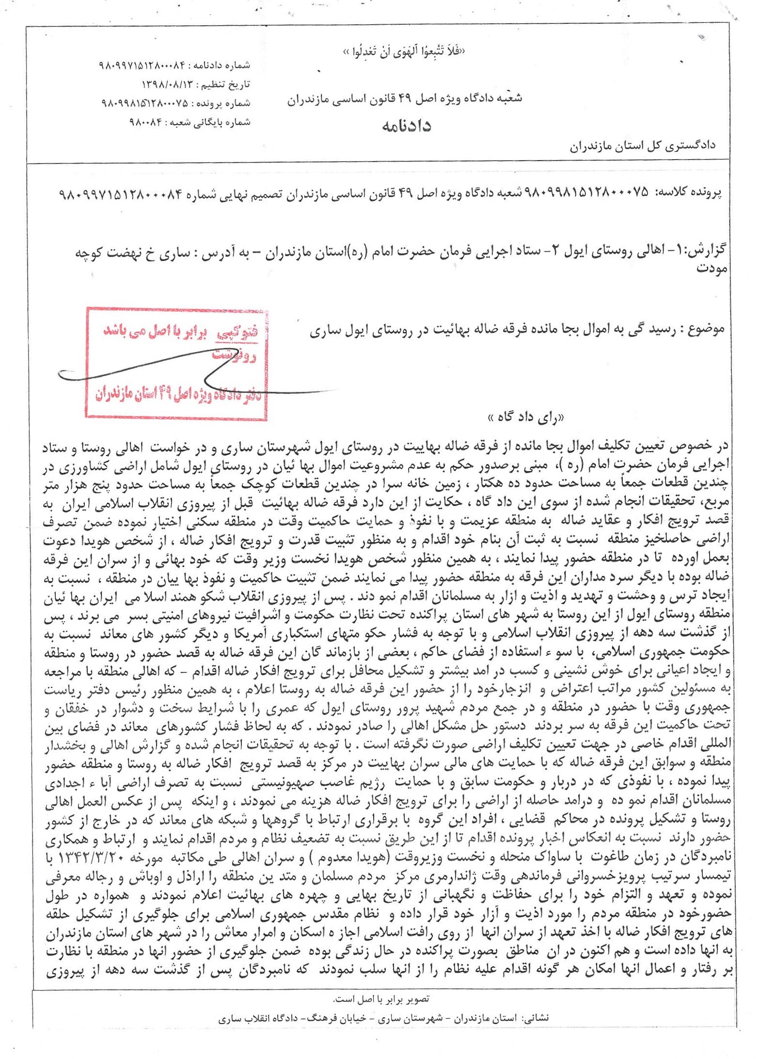

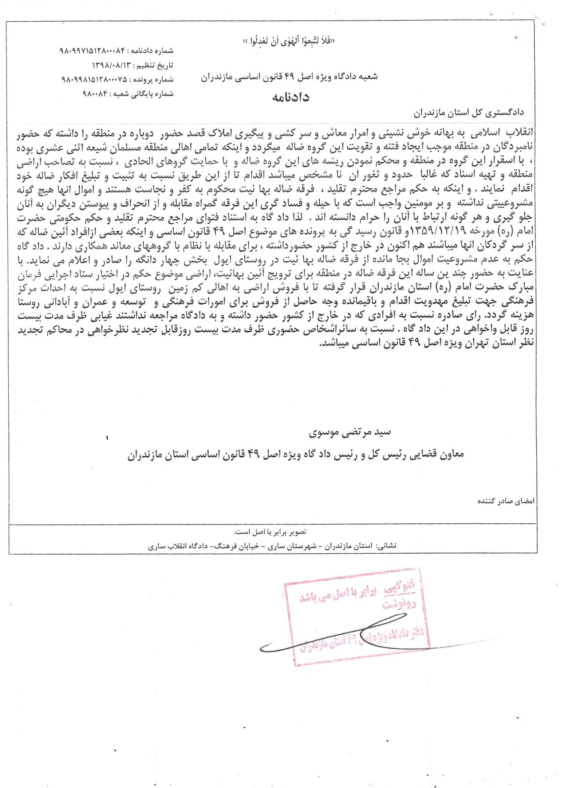

Appendix 4

English translation of court order of 1 August 2020 upholding previous decision to confiscate Bahá’í-owned property, along with scan of the original
Personal information has been redacted.

Date: 11 Mordad 1399 (1 August 2020)
Case Reference: 842/54/98
Court Order Number: 453

Administrative Court: Branch 54 of the Court of Appeal in the Province of Tehran, Special Court for Article 49 of the Constitution

Appellants: Execution of Imam Khomeini’s Orders (EIKO), Mazanderan Province [address]; Faramarz Moghaddasi Rowhani, Hossein Sabetian Iveli, Ali Ahmadi, Rouhol-Amin Aali Iveli, Asadollah Naimi Iveli, Morteza Movaffaghi Iveli, Shahab Sabetian, Seyyed Ilyas Sadeghi, Nayerieh Sabetian, Ali Akbar Movaffaghi Iveli, Fakhrieh Aalishah, Roshan Movaffaghi, Mansour Rowhani, Ali Piri, Nejatollah Laghaie, Khayran Bonyani Iveli, Aghabarar Jazbani Iveli, Saadat Rowhani, Golverdi Movaffaghi Iveli, Seyyed Mohammad Derakhshan, Galin Movaffaghi, Abdolrahman Rowhani, Seyyedeh Miran Hoseini Iveli, Darioush Movaffaghi Iveli, Atrollah Movaffagh Iveli, Kamaloddin Akbari Iveli, Ataollah Movaffagh Iveli, Ghavamoddin Sabetian, Nasroddin Nowbakht Iveli, Parviz Jazbani, Parvin Khodavand [redacted], represented by Messrs. Mostafa Nili and Mohammad Hadi Erfanian [address]
Respondents: [1-] Residents of the Village of Ivel [address: Kiasar, Chahardangeh, Village of Ivel]; 2- Execution of Imam [Khomeini’s] Orders [address]
Subject of Appeal: Court Order Number 98-84, dated 13 Aban 1398 (4 November 2019), of the Islamic Revolutionary Court, Special Court for Article 49 of the Constitution, Mazandaran

Procedural Synopsis
Subsequent to receipt of the file and its registration under the above case reference, and the observance of legal procedures, an extraordinary hearing is in session, presided over by the undersigned. After a review of the file records, the panel at this Branch concludes this hearing and, in reliance on the almighty God, and its judicial conscience, issues a decision.

Court Decision
Concerning the appeal of the Execution of Imam Khomeini’s Orders and Faramarz Rowhani against court order number 98-84, dated 13 Aban 1398 (4 November 2019), issued by the Special Court for Article 49 of the Constitution in the Province of Mazanderan, by virtue of which the residents of Ivel and the Execution of Imam Khomeini’s Orders ask for a final settlement of the assets left behind without supervision by the locals belonging to the perverse sect of Baha’ism, which comes to about 10 acres and the land of khaneh sara, approximately 500 m², and so on, in light of the usual investigation and inquiry, those assets were associated with the previous regime and the perished Hoveyda, who moved and settled here with intent to spread the ideologies of this sect, and usurped these lands, and, as indicated in the court order, due to the illegality of the assets left behind by the perverse sect in the Village of Ivel, a decision was issued in favour of the Execution of Imam Khomeini’s Order to assign the lands to the locals who have small holdings.

In light of the file records and the appellant’s statement of appeal, and given that no relevant or substantive errors were identified to discredit the issued court order, as per the provisions of Article 348 of the Civil Code of Procedure for Public and Revolutionary Courts that would result in rescinding the ruling and requiring further review, and that the main issues in the statement of appeal are mainly a repeat of the preliminary matters, the litigious court order is determined to be without legal error, based on procedural and judicial standards.

Therefore, pursuant to Article 358 of the said Code and the amendments of the Code of Procedure relating to the cases pertaining to Article 49 of the Constitution of the Islamic Republic of Iran, the court dismisses the appeal, amends a section of the decision of the Court of Appeal pertaining to “the sales of the lands to the locals at the regional market rate to locals who have small holdings,” and otherwise endorses the ruling. This order, pursuant to Article 365 of the said Code, is final and binding.

Head of Branch 54 of the Court of Appeal in the Province of Tehran
Hasan Babaie
Court Advisor of Branch 54 of the Court of Appeal in the Province of Tehran
Ebrahimi

[Stamp: Certified Copy]

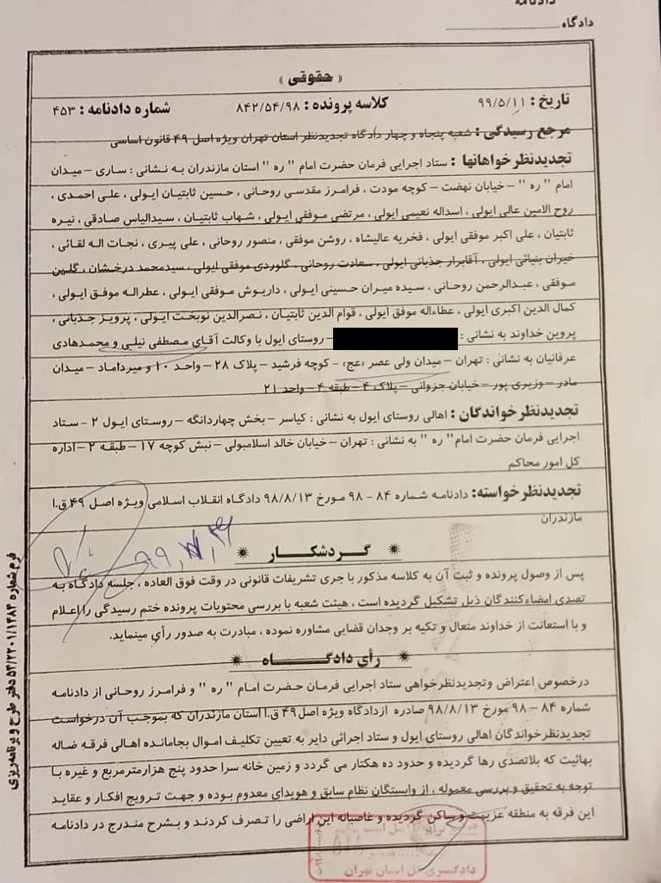

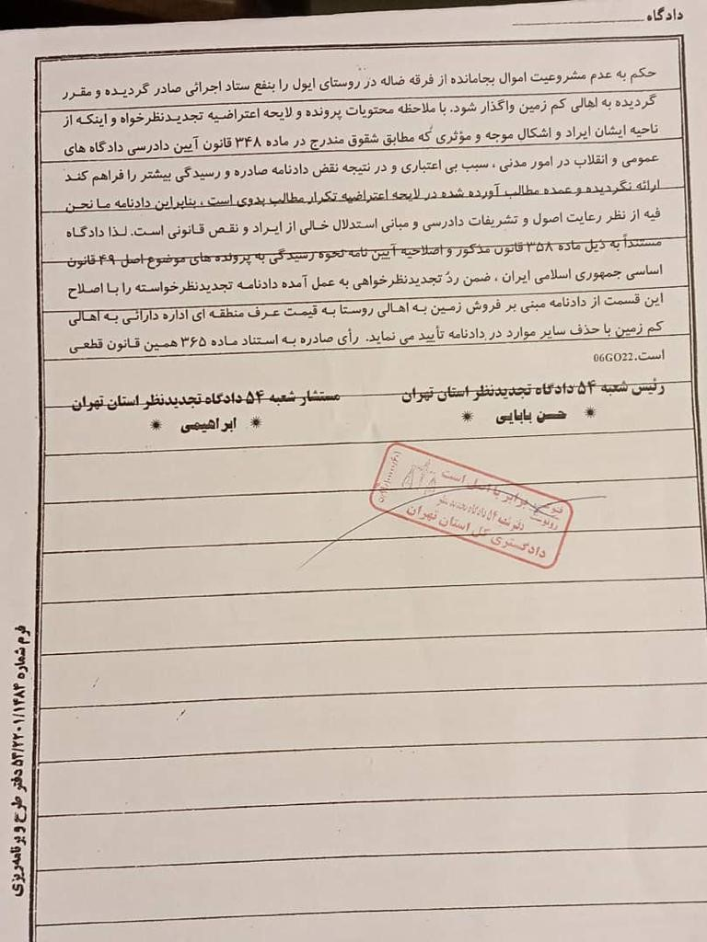

Appendix 5

English translation of court order of 13 October 2020 containing final verdict confiscating Bahá’í-owned property in Ivel, along with scan of the original

Personal information has been redacted.
[Emblem]
Judiciary of the Province of Mazandaran
“Do not follow (your) base desires, lest you deviate”
Branch 8 of the Provincial Court of Appeal of Mazandaran Province
Judgment Number: 9909971516101025
Date of Appeal: 22 Mehr 1399 [13 October 2020]
Case Number: 9009981992100155
Archives Number of the Branch: 900732
Case Number 9009981992100155 - Branch 8 of the Court of Appeal of Mazandaran Province – Final Verdict Number 9909971516101025
Appellants:
1- Mr. Rouhol-Amin Aali Iveli, son of Mohammad-Nabi; 2- Mr. Avaz-Ali Akbari; 3- Mr. Parviz Jazbani, son of Mohammad Ghaem; 4- Mr. Farajollah Naeimi Iveli, son of Fazlollah; 5- Seyyed Serrollah Hoseini, son of Seyyed Zaker; 6- Mr. Jahanbakhsh Movaffaghi Iveli, son of Einollah; 7- Mr. Saadat Rowhani, son of Zekrollah; 8- Mr. Toli [Natoli] Derakhshan; 9- Mr. Horrollah Naeimi; 10- Mr. Nejatollah Laghaie, son of Hosein; 11- Mr. Ali Jazbani; 12- Mr. Seyyed Ali Sadeghi Iveli; 13- Mr. Ghavamoddin Sabetian, son of Fazlollah; 14- Mr. Ataollah Movaffaghi Iveli, son of Karimollah; 15- Mr. Faramarz Moghaddasi Rowhani, son of Rahmatollah; 16- Mrs. Afsaneh Movaffaghi, daughter of Mohammad-Hosein; 17- Mr. Rouhollah Rowhani, son of Vajihollah; 18- Mr. Shahab Sabetian, son of Masihollah; 19- Mr. Riazollah Sabetian, son of Ziaollah; 20- Mr. Jamal Movaffaghi (with power of attorney for Mr. Tavakkol Farajpour Kordasiabi, son of Mousa, with address: the Province of Mazandaran, Qaemshahr County, City of Qaemshahr, Babol Street, Parvaresh Alley, in front of the second cul-de-sac, and for Mr. Hosein Seddigh Tonekaboni, son of Yousef, address: Mazandaran Province, County of Sari, City of Sari, Gharan Street, Kasra Business Complex, T[floor] 1, Seddigh Legal Office); 21- Mr. Ali Ahmadi, address [redacted] 22- Mr. Azizollah Movaffaghi Iveli; 23- Mr. Nasiroddin Nowbakht; 24-Mr. Hasan Sabetian; all of whom have the same address in [redacted] 25- Rowshan Movaffaghi, son of Mohammad-Hosein; 26- Mr. Kamaloddin Akbari Iveli, son of Abdol-Ali; with power of attorney for Mr. Seddigh Tonekaboni, and Tavakkol Farajpour Kordasiabi, son of Mousa, address: Mazandaran Province, Qaemshahr County, City of Qaemshahr, Babol Street, Parvaresh Alley, in front of second cul-de-sac; 27- Ali Piri, address: [redacted]

Appellees:
1- Mr. Feizollah Esmaiili Iveli, son of Yadollah; 2- Mr. Mansour Layali Iveli, son of Ghani; 3- Mr. Nad-Ali Fallahpour Iveli, son of Mohammad, with representation by the legal expert Mr. Hamed Ebadi Fard, address: Mazandaran Province, Amol County, City of Amol, Imam Reza (PBUH) Street, Rezvan 14/1- Seventh Ghadir, Rejal Building, First floor; 4- Mr. Ghaffar Ahangari, address: Kolijan Rostaq District, Sari County, City of Sari; 5- Mr. Esmail Emadi; 6- Mr. Mojtaba Derakhshan―the address of [both] of them is [in the village of] Ivel; 7- Mr. Seyyed Jalal Mousavi, address: Mazandaran Province, Sari County, Sari, Lesani, Shahid Taghavi Alley, first apartment on the left, second floor; 8- Mr. Safar Ali Esmaili, son of Yadollah; 9- Mr. Seyyed Javad Derakhshan, son of Seyyed Mahmoud, with representation by the legal expert from the Office of Legal and Judicial Support of Veterans, Mr. Hamed Ebadi Fard, address: Sari, Mazandaran Office of Legal and Judicial Support of the Veterans of Mazandaran; 10- Mr. Asghar Ahangari, address: Kolijan Rostaq District, Sari County, Sari, Village of Ivel; 11- Mr. Hadi Sheikhani, address: Kolijan Rostaq District, Sari County, Sari.
Subject of the Appeal: Court Order issued by Branch 1 of the Public Court of Kiasar District
Court Decision:
The appeal of: Mr. Ataollah Movaffaghi Iveli, son of Karimollah; Mr. Rowshan Movaffaghi, son of Mohammad-Hosein; Mr. Azizollah Movaffaghi Iveli, son of Zabihollah; and Seyyed Serrollah Hoseini, son of Seyyed Zaker; Mr. Nasiroddin Nowbakht, son of Sab; Mr. Ali Ahmadi, son of Yousef-Ali; Ali Piri, son of Tahourollah [Zohourollah]; Hosein Sabetian Iveli, son of Nosratollah; Mr. Avaz-Ali Akbari, son of Ali-Asghar; Mr. Rouhol-Amin Aali Iveli, son of Mohammad; Mr. Saadat Rowhani, son of Zekrollah; Mr. Seyyed Ali Sadeghi Iveli, son of Seyyed Mehdi; Mr. Toli [Natoli] Derakhshan; Mr. Faramarz Moghaddasi Rowhani, son of Rahmatollah; Mr. Ataollah Movaffaghi Iveli, son of Ghodratollah; Mr. Farajollah Naeimi; Mr. Horrollah Naeimi; Mrs. Afsaneh Movaffaghi, daughter of Mohammad-Hosein; Mr. Shahab Sabetian, son of Masihollah; Mr. Rouhollah Rowhani, son of Vajihollah; Mr. Parviz Jazbani, son of Mohammad; Mr. Jahanbakhsh Movaffaghi, son of Eynollah; Mr. Ghavamoddin Sabetian, son of Fazlollah; Mr. Riazollah Sabetian, son of Ziaollah; Mr. Nejatollah Laghaie, son of Hasan; Mr. Ali Jazbani, son of Mohammad-Mehdi; Mr. Jamal Movaffaghi, son of Mohammad; Mr. Kamaloddin Akbari, son of Abdol-Ali; with power of attorney for Mr. Seddigh Tonekaboni; and Mr. Tavakkol Farajpour of Court Ruling Number 900997-337, dated 20 Tir 1390 [11 July 2011], which was issued by Branch 1 of the Public Court of Kiasar District, which had acquitted:
1- Mr. Safar-Ali Esmaili, son of Yadollah; 2- Feizollah Esmaili, son of Yadollah; 3- Nad-Ali Fallahpour, son of Mohammd; 4- Seyyed Javad Derakhshan, son of Seyyed Mahmoud; 5- Mr. Mansour Layali, son of Ghani; 6- Seyyed Mojtaba Derakhshan Iveli, son of Seyyed Ali Naghi; 7- Mr. Ali-Asghar Ahangari, son of Ghaffar; 8- Mr. Seyyed Hadi Hoseini; 9- Mr. Seyyed Jalal Mousavi; 10- Mr. Seyyed Esmail Ebadi, and 11- Mr. Rahim Layali of the destruction of more than 50 residential homes and the forcible confiscation, sale and relinquishing of its properties has been rejected and not accepted by the Court of Appeal―since, from the point of view of the appellant or from the point of view of the appellants and their lawyers, there has been no reasonable objection to the basis and principles of the judgment, and the said judgment, according to the contents of the case and the reasons reflected in it, and the basis of reasoning and the judgment issued, which is based on Article 49 of the Constitution, in Mazandaran Province and the Court of Appeal of Tehran Province, based on the confiscation and forcible occupation of the assets and properties claimed by the appellants in favour of the residents of the Village of Ivel in the Chahardangeh District of Sari, and the judgment issued on the illegality of the [ownership of] the remaining property, according to the Court Order 453, dated 11 Mordad 1399 [1 August 2020] by Branch 54 of the Court of Appeals of Tehran Province, is correct.
In terms of observing the principles and procedures of the trial, it is free of substantive legal errors.
Therefore, this Court, based on paragraph A of Article 455 of the Criminal Code of Procedure, while rejecting the appeal of the mentioned persons, approves and upholds the requested appeal. The ruling issued as prescribed by Article 443 of the Law [Criminal Code of Procedure] is final.
Branch 8 of the Court of Appeal of Mazandaran Province
Court Adviser: Hemmatollah Nadi Babaei
Judge: Mohammad Sadegh Savadkouhi
[Notes at the bottom of the pages:] Certified Copy
Address: Sari, Maziar Street, Building of the Judiciary of Mazandaran Province, Courts of Appeal and Branch 1 of the Criminal Court of Mazandaran Province.

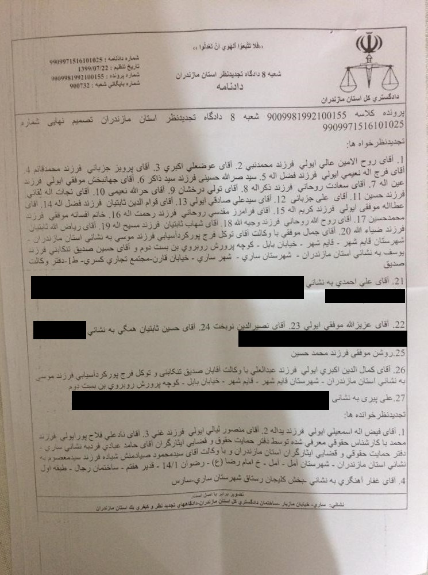
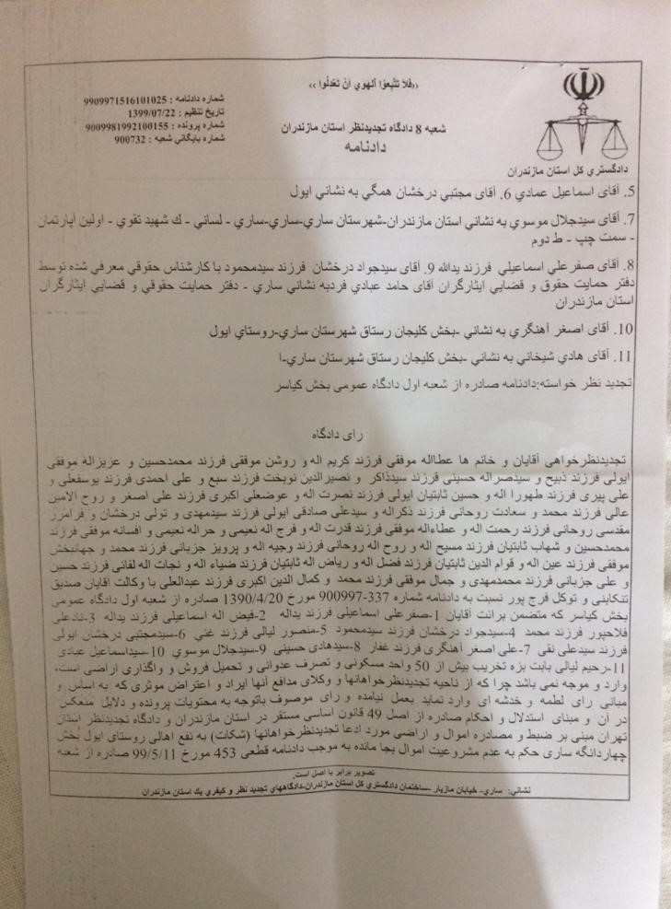

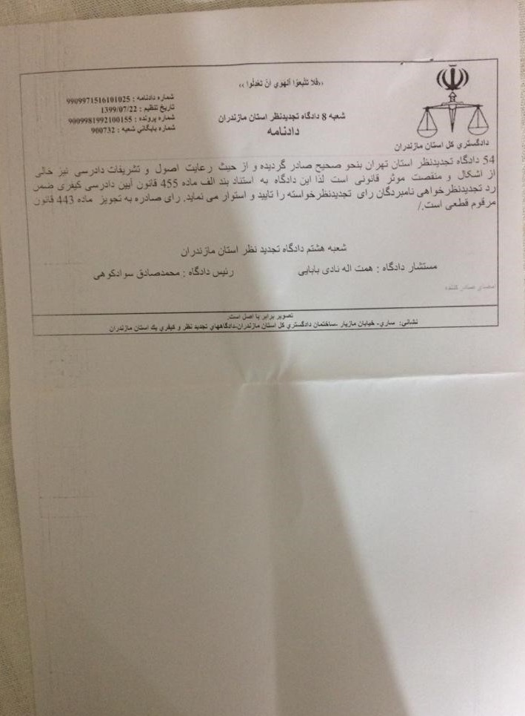

Appendix 6

Article against Bahá’ís: https://akharinkhabar.ir/politics/9219461
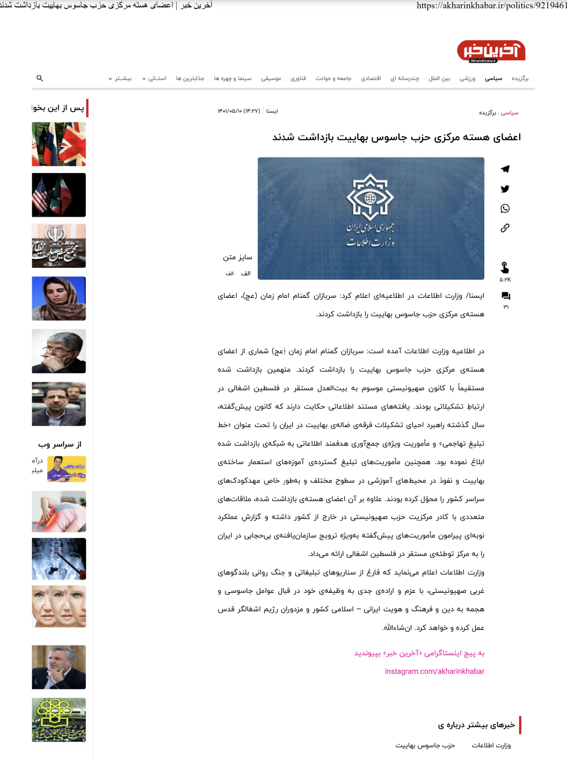

English translation of article
Website: https://akharinkhabar.ir/politics/9219461

1 August 2022

The Core Members of the Baha'i Spy Party [in Iran] Were Arrested

ISNA [Iranian Student’s News Agency] / The Ministry of Intelligence announced in a notice, “The anonymous soldiers of Imam-i-Zaman(may God hasten His return), have arrested the core members of the Baha'i spy party [in Iran].

In the announcement of the Ministry of Intelligence, it has stated, “The anonymous soldiers of Imam-i-Zaman arrested a number of core members of the Baha’i spy party. The arrested were directly related to the Zionist centre known as [Universal] House of Justice based in occupied Palestine. The findings of the intelligence documents indicate that the aforementioned centre had communicated the strategy of reviving the organization of the perverse Baha’i sect in Iran under the title of “aggressive propaganda line” and a special mission to gather targeted information for the arrested network. Also, they had assigned the missions of widely propagating the teachings of fabricated Baha’i colonialism and infiltrating educational environments at different levels, especially kindergartens across the country. In addition, the arrested core members had several meetings with the central staff of the Zionist Party abroad. The report of the performance regarding the aforementioned missions, especially the organized promotion of unveiling cover in Iran, was presented to the conspiracy centre based in occupied Palestine.

The Ministry of Intelligence declares that regardless of the propaganda scenarios and psychological warfare of Western Zionist mouthpiece, it has acted and will continue to do its duty with serious determination towards agents of espionage and attacks on the Iranian religion, culture and identity of the Islamic country and the mercenaries of the occupying Quds regime.

God willing

https://www.fidh.org/en/region/asia/iran/iran-leaked-document-reveals-plans-to-intensify-suppression-of-baha https://www.bic.org/news/exposed-sinister-plan-iranian-authorities-monitor-and-suppress-bahais
The original and English translation of the document can be found here: https://iranbahaipersecution.bic.org/archive/minutes-commission-ethnicities-sects-and-religions-sari
Feasts: Once in every nineteen days, meetings are held in every locality by the Bahá’í community. Known as the “Nineteen Day Feast”, these gatherings serve as the bedrock of Bahá’í community life.
Tazir law (discretionary punishment): Punishment with maximum and minimum limits determined by law and judge, respectively.
Sepah-i-Pasdaran: Islamic Revolutionary Guard.
Tazir law (discretionary punishment): Punishment with maximum and minimum limits determined by law and judge, respectively.
Setad-e-Ijraiy-e-Farman-i-Imam: The Execution of Iman Khomeini's Order, known as EIKO
Taghut: Elitist, arrogant.
SAVAK: The intelligence service of the Shah’s regime.
Najis: Religiously unclean or dirty.
Haram: Forbidden by Sharia law.
Mahdaviyyat: Coming of the Mahdi.
The ​​Execution of Imam Khomeini’s Order (EIKO) is a parastatal agency controlled by the Supreme Leader, Ayatollah Ali Khamenei.
Link to article: https://akharinkhabar.ir/politics/9219461
[Imam-i-Zaman: The Lord of the Age]

