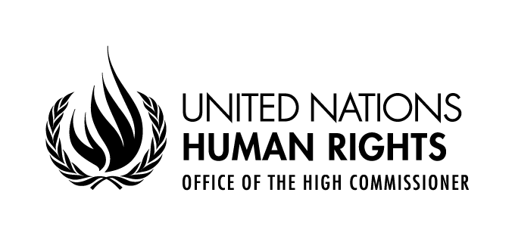

Statement by Ibrahim Salama
Chief, Human Rights Treaties Branch
Office of the High Commissioner for Human Rights

18 April 2017, 10:00
1st floor conference room, Palais Wilson, Geneva

Mr. Chairperson,
Distinguished Members of the Committee against Torture,
Ladies and Gentlemen,
It is my pleasure to welcome you to your 60th session, your first for 2017. This session comes at a time when we are living in significant turmoil. Amongst the many challenges facing the world, protecting the rights of migrants and refugees must be prioritised and I believe this Committee has a role to play in this regard. Allow me therefore to make some observations on this important issue.
For the first time since the Second World War, hundreds of millions of women, men and children have been leaving their country as a result of war or dire economic circumstances.
A significant number among them – be they refugees, asylum seekers, stateless persons and international migrants – have suffered torture and ill-treatment in their country of origin or along migratory routes, or both. And they may also be vulnerable to torture or harm in the destination country.
Instead of providing them with protection, many countries have resorted to repressive policies, sealing borders and harshly enforcing refusals to permit entry, not to speak of treating them as criminals.
Your Committee, on several occasions when reviewing States reports, has rightly denounced the fact that migrants have been detained solely for reasons related to their immigration status. In that regard, you have stressed the vulnerability of children being deprived of their liberty on the basis of their or their parents’ migration status in clear violation of the best interest of the child and his or her fundamental rights. You have also expressed serious concerns at the appalling conditions of detention of migrants, including sexual abuse and ill-treatment, in many parts of the world.
Under your complaint procedure, you have constantly reaffirmed the fact that no one may be expelled, returned or extradited to another State where there are substantial grounds for believing that he or she would run a personal, foreseeable risk of being subjected to torture. This is all the more crucial when every day we see migrants being expulsed, returned or deported, in violation of the non-refoulement principle contained in article 3 of the Convention against torture.
Non-governmental organizations specialized in rehabilitation have praised your General Comment N°3 on redress and rehabilitation. It has provided crucial guidance to states, human rights defenders and others, including in the context of migration.
Chairperson, members of the Committee,
Throughout your crucial activities I just briefly described, you are reminding the international community that the only effective approach to migrants must be grounded in the respect for their fundamental rights as human beings. Through your concluding observations, your views on individual complaints and your legal interpretation, you can have a direct impact on the international community – on States but also on OHCHR and civil society organizations working for the protection of migrants as well as on victims of torture themselves.
With powerful voices currently promoting messages that are contrary to a human rights approach to migration, your voice is relevant now as much as ever.
For this reason, the current drafting of a revised General Comment on the implementation of article 3 of the Convention and the public discussion you will have during this session with States, specialized agencies and other international bodies, civil society organizations and many other actors are raising high expectations and hopes for the most vulnerable, all those migrants whose rights are under attack.
In the same vein, we are looking forward to the outcome of your participation to the Expert Workshop on Torture in the Context of Migration organized by the United Nations Voluntary Fund for Victims of Torture.
I have been informed that your informal meetings with States and NGOs at the present session will include a discussion on the implementation of the Convention against Torture in the context of mass migration. Addressing both duty-bearers and rights-holders on this major challenge is definitely the right way to focus on rights and duties but also on root-causes and long-term solutions. It is also a direct contribution to the Human Rights up Front initiative.
Chairperson, members of the Committee,
As you know, on 19 September 2016 by resolution 71/1, the General adopted the Declaration for Refugees and Migrants which expresses the political will of world leaders to protect the rights of refugees and migrants, to save lives and share responsibility for large movements on a global scale.
By adopting the New York Declaration, Member States made bold commitments including: to start negotiations leading to an international conference and the adoption of a global compact for safe, orderly and regular migration in 2018; to develop guidelines on the treatment of migrants in vulnerable situations; to achieve a more equitable sharing of the burden and responsibility for hosting and supporting the world’s refugees by adopting a global compact on refugees in 2018.
In March this year, the Secretary-General nominated former High Commissioner for Human Rights, Louise Arbour, as his Special Representative for International Migration. Ms Arbour will have a strong hand in moving this agenda forward.
It is our hope that your work will contribute to this global compact and that you will be engaged in that process. I am sure that the ongoing drafting of the General Comment on article 3 and the other discussions planned for this session will provide food for thought on how to do so. Let me conclude by wishing you, on behalf of the High Commissioner, a fruitful and successful session for a full realization of the Convention against Torture and therefore for the benefit of all human beings, including the most vulnerable ones throughout the world.

