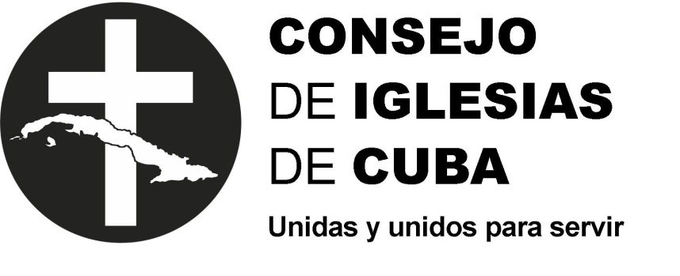

Name of NGO: Cuban Council of Churches (CIC, in Spanish)
Contact person: Rev. Antonio Santana Hernández, President
Address: Calle 14 No. 314 E/ 3era y 5ta, Miramar, Playa, La Habana, Cuba
Telephone: 7203-7791 and 7203-9336
E-mail: iglesias@cic.co.cu
Web page: www.consejodeiglesiasdecuba.org

Contribution of the Cuban Council of Churches (CIC) to the 21st session of the Committee on the Rights of Persons with Disability. Cuban Report. (March 2019)

Introduction of the sending organization
The Cuban Council of Churches is a Christian-based, non-governmental, non-profit organization, founded on May 28, 1941, legally established and recognized with legal status in the Register of Associations of the Ministry of Justice of the Republic of Cuba.

Vision, Mission and Objectives of the Institution

Vision
To be an ecumenical fellowship of churches and other Christian institutions that confess the Lord Jesus Christ as God and Saviour, according to the Scriptures, and seek to carry out their common vocation for the glory of God the Father, Son and Holy Spirit.

Mission
We promote spaces for encounter, celebration, reflection, formation and joint actions of churches and other Christian institutions in order to serve our people as a clear expression of the ecumenism to which we are called by God in Jesus Christ.

Strategic Objectives
1. To be a space of encounter and dialogue to foster a spirit of fraternity and unity of the Christian Church in Cuba through the implementation of participatory and articulated programmes for the ecclesial and social context.
2. To promote an ecumenical expression of service to the community.
3. To foster biblical-theological formation and training that contribute to testimony in the midst of our reality.
4. To develop awareness and commitment to the Kingdom of God and his righteousness.

Organizational Structure
- Associative Structure
This is the institutional structure in which a group of Cuban Christian institutions are linked as full or associate members, with a view to implement the vision, mission and objectives formulated in the CIC Constitution.
Components of the Associative Structure
- Full Members
- Associate Members
- General Assembly
- Governing Board
- Executive Council
- Provincial Coordinators
- Extended Executive Council

- Operational Structure
This is the institutional structure responsible for executing the vision, mission and objectives stated in the CIC Constitution through various lines of action. Its components are:

- Institutional Strengthening Unit
This is the general support of the development and sustainability of the work of CIC. It coordinates the implementation of Institutional Policies and Strategies. It is comprised of:
- Projects and Initiatives for Institutional Strengthening
- Training Centre
- Human Resources
- Partnerships
- Communications.

- Programme Unit
This is the support of CIC work on training and Diaconia (service). It links, coordinates and monitors institutional programmes and the accomplishment of results in keeping with the CIC constitutional purposes and strategic objectives.

Programmes
- Theological, Pastoral and Ecumenical Training
- Evangelism and Church Dialogue
- Evangelical Chaplaincy
- Women and Gender
- Adolescence and Youth
- Pastoral of Children
- Pastoral of Persons with Disability
- Life and Community Health
- Sustainable Development
- Disaster Reduction and Humanitarian Action
Each Programme is organized around Results geared towards the Strategic Objectives of the Period and is responsible for specific projects that help to achieve the expected results.

- Administrative Area
This is the logistical arm to ensure proper CIC functioning, through its support of the components of the Associative Structure and the execution of the plans of the Units of the Operational Structure. Its components are:
- Internal and Productive Services
- Donations and Purchases
- Immigration Liaison Office
- Accounting and Finances
Note: It should be highlighted that since the inclusion of persons with disability in all its dealings is an institutional policy, this good practice is a cross-cutting element of the work of the associative and operational structures, as is evidenced by the participation of persons with disability in the various activities, meetings and events of the Cuban Council of Churches.

Presentation of the work of the Pastoral of Persons with Disability of the Cuban Council of Churches and its objectives and proposals, prepared by persons with disability who are active members of this Pastoral.

The Pastoral of Persons with Disability of the Cuban Council of Churches has accumulated 25 years of work, serving church communities and the society in general, facilitating the participation, equal rights, opportunities and inclusion of persons with disability in the social and church context. In terms of inclusion in the church context, the Pastoral promotes the presence and participation of persons with disability in various spheres of institutional life within the Cuban Council of Churches.

The leadership of persons with hearing, visual, physical and intellectual disabilities is promoted through training actions with an emphasis on rights.

The Programme pays particular attention to sensitization and gender approach through two Promoters, in order to foster disability culture in the society. There are also sub-programmes of youth, family, pastors and missionaries with disability and collaborators. The national structure includes three Regional Coordinators, Facilitators in all provinces and Referents in some municipalities, with the peculiarity that all these posts are occupied by persons with disability.

The Convention on the Rights of Persons with Disability (CRPD), the 2030 Agenda and the Inclusive Development approach are permanent tools in the work of the Pastoral.

There have been meetings of persons with specific disabilities, such as deaf and deaf-blind persons, persons who use wheelchairs, blind persons and those with low visual acuity; meetings of families, children, youth and couples; and workshops on sexuality, communication, participation and socio-ecclesiastical leadership.

It is of note that from 2015 to 2018, the Vida Plena Project for the Social Inclusion of Persons with Disability in Equal Rights and Opportunities was carried out under the auspices of CBM and the European Union. Through this project, 40 persons with disability in 6 municipalities of 4 provinces were direct beneficiaries and were able to find employment by starting their own business, but there was also the indirect benefit of a very positive influence on the sensitization of families, communities and churches in the promotion of a rights-based approach and the visibility of persons with disability as social agents. One of the most positive impacts of this Project was the opportunity to work in conjunction with the Ministry of Labour and Social Security and the Associations of Persons with Disability (ANCI, ACLIFIM and ANSOC) at all levels.

Towards the end of 2018, the Pastoral sponsored a meeting of persons with intellectual disability and their families in Havana. Such meetings have been held for 5 consecutive years and seek to contribute to the approval for the formation of a Cuban Association for these persons who are a statistical majority and do not have an organization that defends their rights.

Challenges
As a programme of the Cuban Council of Churches, we consider that in the field of disability in Cuba, there is need for continued work to:

- Achieve greater participation of persons with disability as citizens.
- Diversify decent employment options for persons with disability.
- Foster spaces for sharing experiences and empowerment of persons with disability in the different spheres of society.
- Approve a National Disability Law in keeping with the stipulations of the CRPD.
- Increase sensitization of families, communities and society to promote a disability culture.
- Create a National Association of Persons with Intellectual Disability and Their Families.

The collaboration of political and government officials in the work of the Pastoral at the national and local level must also be highlighted.

