CLIMATE CHANGE AND WOMEN’S RIGHTS IN JAPAN
NGO PARALLEL REPORT

JAPAN’S REPORT TO THE 77TH PSWG FOR THE COMMITTEE ON THE ELIMINATION OF ALL FORMS OF DISCRIMINATION AGAINIST WOMEN

2 - 6 March 2020

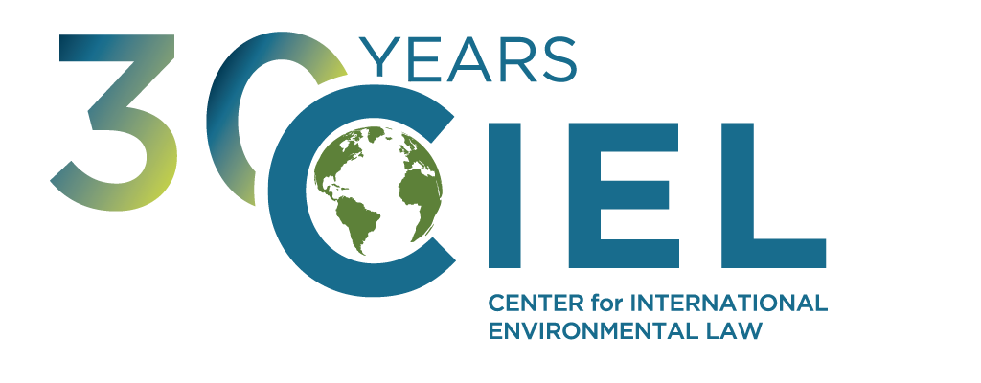

CENTER FOR INTERNATIONAL ENVIRONMENTAL LAW

--- Executive Summary ---
Japan’s current domestic climate policy violates the obligations of the State under the Convention on the Elimination of all Forms of Discrimination against Women as it permits the excessive emission of greenhouse gases resulting in the increase of adverse climate-induced impacts on the rights of women both in Japan abroad.
We thus urge the Committee on the Elimination of Discrimination against Women to ask Japan to:
- provide information regarding how the current climate mitigation and energy policy of Japan is compatible with its obligation to protect the rights of women, both in Japan and abroad, taking into consideration the disproportionate impact of climate change on women.1
Additionally, Japan continues to fund extensively the development of coal-fired energy in third countries, disregarding the adverse implications of this policy for the rights of women in communities located in proximity to these power plants as demonstrated by many scientific and medical studies and contributing to even greater emissions of greenhouse gases.
We thus also encourage the Committee on the Elimination of Discrimination against Women to ask Japan to:
- provide information indicating how women’s rights, and in particular their right to health, are protected in the context of Japan’s policy to provide financial support for coal-fired power plants in third countries, given the known scientific and medical evidence about the adverse health impacts on women living in proximity to coal-fired power plants and the adverse climate-induced impacts of women rights resulting from this policy.

Submitting Organization

The CENTER FOR INTERNATIONAL ENVIRONMENTAL LAW (CIEL) uses the power of law to protect the environment, promote human rights, and ensure a just and sustainable society. CIEL seeks a world where the law reflects the interconnection between humans and the environment, respects the limits of the planet, protects the dignity and equality of each person, and encourages all of earth’s inhabitants to live in balance with each other.

Climate change impacts on the rights of women and Japan’s climate mitigation policy

The current and anticipated impacts of climate change constitute one of the most significant global threats for the enjoyment of human rights – especially those protected under the Convention on the Elimination of Discrimination against women.2 As noted by the Committee on the Elimination of Discrimination against women (CEDAW), climate change and natural disasters that result from climate change disproportionately impact women, particularly in rural areas.3 The CEDAW has highlighted previously that climate change results in adverse impacts on many of the rights protected by the Convention on the Elimination of all Forms of Discrimination against Women, particularly the rights to live free from gender-based violence, to education and information, to work and social protection, to health, to and adequate standard of living and to freedom of movement.4 The magnitude of these impacts will keep increasing as temperatures continue to rise.

In Japan, the mean air temperature rose by about 1˚C in the 20th century, and the Japan Meteorological Agency
(JMA) is now virtually certain that a long-term trend in the frequency of extremely high monthly temperatures has

1 See CEDAW Concluding Observation on Norway (2017), Australia (2018) and South Korea (2018) for precedents of recommendations by the CEDAW in relation to the mitigation policy of individual states
2 See e.g. General Recommendation No. 37 on Gender-related dimensions of disaster risk reduction in the context of climate change CEDAW/C/GC/37 (CEDAW 2018) noting that “Women, girls, men and boys are affected differently by climate change and disasters, with many women and girls experiencing greater risks, burdens and impacts.” (para. 2)
3 CEDAW/C/ARG/CO/7 (CEDAW 2016) para. 38.
4 CEDAW/C/GC/37 (CEDAW 2018) para. 55 et seq.

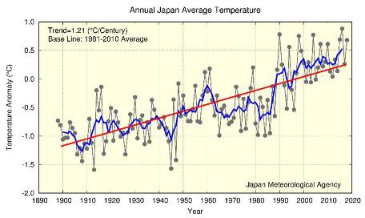
increased as shown in the graphic below.5 The JMA also reports that “it is virtually certain that the annual mean surface temperature over Japan has risen at a rate of 1.21ºC per century”. Without mitigation efforts to decrease a long-term trend of extremely high temperatures due to climate change, vulnerable groups like women will continue to experience adverse impacts.
Figure 1: Annual surface temperature anomalies from 1898 to 2018 in Japan (source: Japanese Meteorological Agency, “Climate Change Monitoring Report” 2018).

Under the Paris Climate Agreement, States committed to limit the increase of global average temperature to well below 2ºC above pre-industrial levels and to pursue efforts to limit the temperature increase to 1.5ºC.6 States recognised that keeping global temperature increase to below this threshold would ‘significantly reduce the risks and impacts of climate change’.7

Consistent with these obligations, States must ensure that they reduce emissions of greenhouse gases so as to avoid a level of climate change that threatens the enjoyment of human rights, including the rights of women. The Intergovernmental Panel on Climate Change (IPCC) has highlighted that keeping to a 2°C temperature target requires industrialised countries to reduce their emissions by 2020 by 25% to 40% below 1990 levels.8 All parties to the UN Framework Convention on Climate Change (UNFCCC) have committed to acting in accordance with this finding both through the adoption of the report of the IPCC as well as through several decisions under the UNFCCC.9 As an industrialised country, Japan is therefore required — at a minimum — to reduce its emissions by 25% to 40% below 1990 levels by 2020.

5 Japan Meteorological Agency, “Climate Change Monitoring Report 2018,” September 2019. https://www.jma.go.jp/jma/en/NMHS/ccmr/ccmr2018.pdf. Long-term trends of extremely high temperature events are derived from analysis of temperature records from 15 observation stations. These results have at a 99% confidence level.
6 Paris Agreement, Article 2.1.a.
7 Ibid.

8 Fourth Assessment Report of the Intergovernmental Panel on Climate Change (AR4), Box 13.7.
9 E.g.: Bali Action Plan (Decision 1/CP.13, 2007); Decision 1/CP.16 (2010); Decision 1/CMP.6 (2010); Decision 1/CMP.7 (2011); Decision 1/CMP.8 (2012); Decision 1/CP.19 (2013); Decision 1/CP.20 (2014);
Decision 1/CP.21 (2015).

However, Japan’s total emissions have increased from 1,274 million tonnes CO2-eq10 in 1990 to 1,325 million tonnes CO2-eq in 2015, which is the equivalent of an increase in emissions by 4.0% between 1990 and 2015.11 Between 2010 and 2020, total GHG emissions (excluding land use, land use change and forestry) are projected to increase by 7.3% according to data provided by the Japanese government.12

Moreover, as stated in Japan’s Nationally Determined Contribution,13 the Japanese Government only intends to reduce greenhouse gas emissions by 26% below 2013 levels by 2030, equivalent to 18% below 1990 levels by 2030.14 This illustrates an enormous gap between Japan’s current commitments and the reductions necessary to avoid a dangerous level of climate change.
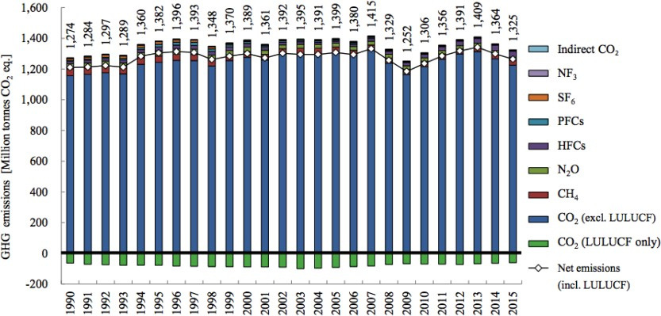
Figure 2: Trends in greenhouse gases emissions and removals (source: Japanese Government, “7th National Communication under the UN Framework Convention on Climate Change”, 2017)

International studies assessing the adequacy of national climate policies consistently describe the emissions reductions by Japan and its climate change targets as “highly insufficient”15 or “very low”16. Further, if all countries adopted Japan’s low level of ambition in reducing emissions, average global temperature increase would likely exceed 3°C to 4°C in the 21st century.17 This would have catastrophic implications for the enjoyment of human rights around the world and be particularly dangerous for women.

In its General Recommendation on the Gender-related dimensions of disaster risk reduction in the context of climate change, the CEDAW reiterated that “limiting fossil fuel use and greenhouse gas emissions and the harmful environmental effects of extractive industries (…) are regarded as crucial steps in mitigating the negative human rights impact of climate change and disasters.”18 As noted by the CEDAW in 2017, the obligations to ensure women’s

10 When indicating the volume of all greenhouse gases taken together, including CO2 (carbon dioxide), the notation CO2-eq which stands for ‘CO2 equivalent’ is often used. To express the total effect of all greenhouse- gas emissions, an accounting unit is used in which the effects of all greenhouse gases are converted into the heating potential of CO2.
11 Ministry of the Environment, Greenhouse Gas Inventory Office of Japan, “National Greenhouse Gas Inventory Report of Japan”, 2017, E.S.2.1 (http://www-gio.nies.go.jp/aboutghg/nir/2017/NIR-JPN-2017- v3.1_web.pdf)
12 https://cop23.unfccc.int/sites/default/files/resource/docs/2016/trr/jpn.pdf, p. 15.
13 Japan national emission reduction commitment under the Paris Climate Agreement (“Nationally Determined Contribution”) http://www4.unfccc.int/submissions/INDC/Published%20Documents/Japan/1/20150717_Japan%27s%20INDC. pdf. Japan ratified the Paris Agreement on 8 November 2016.
14 Climate Action Tracker, Japan (last updated 6 November 2017).
15 Ibid.

16 See the Climate Change Performance Index : https://www.climate-change-performance-index.org/
17 Climate Action Tracker, Japan (last updated 6 November 2017) http://climateactiontracker.org/countries/japan.html
18 ibid. para 14

substantive equality with men provided in the CEDAW requires State parties to reduce their emissions, as climate change “disproportionately impacts women, especially in situations of poverty, since they are more reliant on natural resources for their livelihoods than men and have lesser capacity to deal with natural hazards”.19 In its Concluding Observations on Australia and South Korea in 2018, the CEDAW has explicitly expressed its concern over these States’ high reliance on coal due to the greenhouse gas emissions resulting from coal-fired power plants.20 Finally, the CEDAW along with four other UN Human Rights Treaty Bodies has clarified in a Joint Statement that policies to reduce emissions must “reflect the highest possible ambition”.21

The upcoming review of Japan’s obligations under the Convention on the Elimination of all Forms of Discrimination against Women offers an opportunity for the CEDAW to ask Japan to provide further information regarding whether its climate mitigation policy complies with the legal obligations of the country to protect the rights of women as provided under the Convention on Elimination of all Forms of Discrimination against Women and in accordance with internationally agreed environmental standards.

Financing of coal power plants overseas and adverse impacts for women in local communities

In a 2016 report on energy and air pollution, the International Energy Agency estimated that coal is responsible for the largest share of air pollution in the power sector worldwide - leading to respiratory illnesses and premature deaths.22 The impacts of atmospheric pollution generated by coal fired power plants such as fine particulate matter (PM 2.5) are also not gender neutral as these particles affect women’s reproductive systems, particularly pregnant women. Exposure can result in lower birth weight, impaired fetal growth, premature birth, and impaired physical and mental development.23

Since at least 2007, Japan has provided the largest share among OECD countries of overseas financing for the construction of coal-fired power plants in third countries.24 From 2012 to 2019, the three major Japanese public finance agencies - the Japan Bank for International Cooperation (JBIC), Nippon Export and Investment Insurance (NEXI) and the Japan International Cooperation Agency (JICA) – invested in 18 coal-fired thermal power plant projects, including, seven in Vietnam, six in Indonesia, two in India and one each in Morocco, Bangladesh and Chile.25

This financial support results in Japanese companies benefiting economically from these investments while communities in the developing countries hosting these projects suffer from their environmental and social externalities.26 Additionally, coal-fired power plants financed by Japan overseas are more polluting and less efficient than the worldwide average as the best technologies available are not systematically used in these projects.27

19 CEDAW/C/NOR/CO/9 (CEDAW 2017) para. 14.
20 See CEDAW Concluding Observation on Australia (2018) and South Korea (2018)
21 Committee on the Elimination of Discrimination Against Women, Committee on Economic, Social and Cultural Rights, Committee on the Protection of the Rights, of All Migrant Workers and Members of their Families, Committee on the Rights of the Child, Committee on the Rights of Persons with Disabilities, Joint Statement on "Human Rights and Climate Change", 16 September 2019, available here
22 International Energy Agency, World Energy Outlook Special Report 2016, available at https://www.iea.org/newsroom/news/2016/november/world-energy-outlook-2016.html, page 57.
23 See for instance : Fleischer NL, Merialdi M, van Donkelaar A, et al. Outdoor Air Pollution, Preterm Birth, and Low Birth Weight: Analysis of the World Health Organization Global Survey on Maternal and Perinatal Health. Environmental Health Perspectives. 2014;122(4):425-430. doi:10.1289/ehp.1306837.
24 Swept under the rug: how G7 nations conceal public financing for coal around the world”, NRDC (2016), available at https://www.nrdc.org/sites/default/files/swept-under-rug-coal-financing-report.pdf
25 See http://sekitan.jp/jbic/wp-content/uploads/2014/01/factsheet-en.pdf
26 Dejusticia, Business and Human Rights Resource Centre, Digging Deeper: The Human Rights Impacts of Coal in the Global South (2015) available at http://docs.wixstatic.com/ugd/c04a21_55722707895847839433655205a851ff.pdf
27 Dirty Coal Breaking the Myth About Japanese-Funded Coal Plants, Kiko Network (2015), available at http://sekitan.jp/jbic/wp-content/uploads/2015/04/Dirty-Coal-JBIC.pdf.

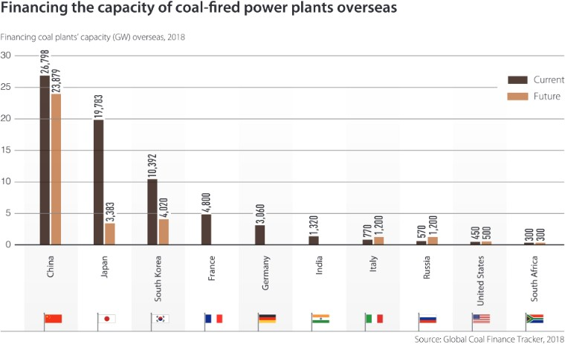
Figure 3: Coal finance overseas by G20 Country (by capacity), showing financing up to 2018 (“current”) and planned in 2018 and beyond (“future”) (source: Climate Transparency, “Managing the Phase-Out of Coal”, 201928)

In recent years, the majority of other industrialized countries have shown signs of phasing out their public financing of overseas coal projects. On the other hand, Japan continues to finance coal in several countries.29 The country is also considering providing funding for new projects. Given that the lifespan of new coal-fired power plants is several decades, these new projects will result in long term adverse impacts for local communities in the regions where they are built and will generate emissions of greenhouse gases for several decades.Women, and in particular pregnant women, will remain particularly impacted by this pollution.30 Additionally, these power plants will generate large amounts of emissions of greenhouse gases for several decades, thus contributing to increase the gender-skewed impacts of climate change globally.

Research conducted in relation to 17 of the power plants funded by Japanese public finance agencies has highlighted the high impacts of coal fired-power plants on the health of local residents, projecting that they will cause between 158,000 to 439,000 premature deaths based on an average 30-year lifespan- the majority of which could be avoided if the emission limits applied to plants abroad were the same as in Japan.31 Local communities have protested the constructions of these projects in many countries and have challenged these projects in courts, denouncing the impacts of these projects on their health and livelihoods.32

28 Available here
29 See for instance the beginning of the construction work for the Bangladeshi Matarbari power plant in January 2018.
30 See for instance Minh Ha-Duong, An Ha Truong, Hong Nam Nguyen, Hoang Anh Nguyen Trinh. Synthesis Report on Socio-environmental Impacts of Coal and Coal-fired Power Plants in Vietnam. [Technical Report] Vietnam Sustainable Energy Alliance. 2016.
31 Greenpeace Philippines (2019), A Deadly Double Standard, available at https://issuu.com/gpsea/docs/double_standard_report
32 See for instance information related to recent local opposition to Japanese-funded coal power plants based on health and environmental concerns in Vietnam (http://www.mekongwatch.org/PDF/V_Coal- NGOstatementENG_20170414.pdf), in India (http://www.thehindu.com/todays-paper/tp-national/tp- karnataka/kudgi-plant-krrs-hasiru-sene-to-lead-protest/article6692153.ece), or in Indonesia

The CEDAW has previously noted in its Concluding Observations on South Korea (2018) that the State’s energy policies (which, as in the case of Japan, include the financing of coal-fired power plants in third countries) “negatively affect women, especially pregnant women, as they increase rates of female and child mortality” and has recommended that the state “review its energy and climate change policies to ensure that they do not have an adverse impact on the life and health of women and girls.” In the joint statement by five UN Human Rights Treaty Bodies on Human Rights and Climate Change, the Treaty Bodies (including CEDAW) state that States “should effectively contribute to phasing out fossils fuels” and “should also discontinue financial incentives or investments in activities and infrastructure which are not consistent with low greenhouse gas emissions pathways”.33 Under the Paris Climate Agreement, States have also committed to “making finance flows consistent with a pathway towards low greenhouse gas emissions and climate resilient development”.34

In this context, we urge the CEDAW to also ask Japan to provide information indicating how women’s rights are protected in the context of Japan’s policy to provide financial support for coal-fired power plants in third countries.

This short briefing note was prepared by the Center for International Environmental Law (CIEL). Please do not hesitate to contact us for any additional information: Sébastien Duyck sduyck@ciel.org (+41786966362)

(https://medium.com/economic-policy/despite-protests-japan-gives-lifeline-to-dangerous-fossil-fuel-projects- d3ce94714fe7).
33 Committee on the Elimination of Discrimination Against Women, Committee on Economic, Social and Cultural Rights, Committee on the Protection of the Rights, of All Migrant Workers and Members of their Families, Committee on the Rights of the Child, Committee on the Rights of Persons with Disabilities, Joint Statement on "Human Rights and Climate Change", 16 September 2019, available here
34 Paris Agreement, Article 2.1(c)

