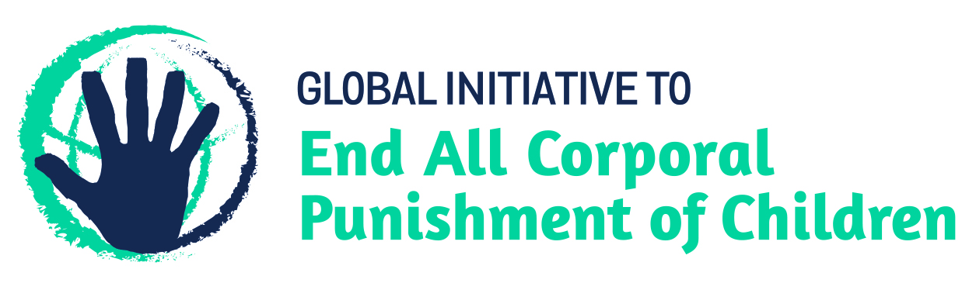
BRIEFING ON BOLIVIA FOR THE COMMITTEE AGAINST TORTURE PRESESSIONAL WORKING GROUP, 69th session, Apr/May 2020
From the Global Initiative to End All Corporal Punishment of Children, January 2020
This briefing provides an update on the legality of corporal punishment of children in Bolivia since its previous examination by the Committee in 2013. We are delighted to inform the Committee that Bolivia has now prohibited corporal punishment in all settings, including the home.
We hope the Committee will, in its concluding observations on Bolivia’s third periodic report, welcome the prohibition of all corporal punishment of children in Bolivia and recommend that all measures be taken to ensure implementation of the prohibition of corporal punishment in all settings, including the home, such as appropriate public education and professional training on the ban and positive, participatory and non-violent forms of education and childrearing.

1 Prohibition of all corporal punishment of children in Bolivia
  - Corporal punishment is prohibited in all settings, including the home. In 2014, a new Children and Adolescents Code was enacted which came into force on 6 August 2014. Chapter 8 of the Code provides for the right to personal integrity and protection from violence, including in article 146 explicit prohibition of all corporal punishment (unofficial translation): “Right to good treatment. (1) The child and adolescent has the right to good treatment, comprising a non-violent upbringing and education, based on mutual respect and solidarity. (2) The exercise of the authority of the mother, father, guardian, family members and educators should use non-violent methods in parenting, education and correction. Any physical, violent and humiliating punishment is prohibited.” Article 147 states that where violence against a child constitutes a criminal offence it will be punished under criminal law; where violence breaches the Children and Adolescents Code but does not constitute a criminal offence, it will be sanctioned according to the Code. Article 153 confirms that this includes the “subjection to physical punishment or other forms that degrade or adversely affect the dignity of the child or adolescent, whether by way of disciplinary or educational measures, unless the lesions are classified in criminal legislation”.
  - Corporal punishment is prohibited as a disciplinary measure in specialised centres (orientation centres and social reintegration centres) in article 338 of the Children and Adolescents Code 2014 (unofficial translation): “Disciplinary regime. … (2) Specialised centres where custodial measures are met should have internal regulations that respect the rights and guarantees recognised by this Code, and include as a minimum the following: … (b) Exhaustive regulatory sanctions that may be imposed on the adolescent and for compliance with the measure. Under no circumstances may be applied cruel, inhuman or degrading disciplinary measures, including corporal punishment and confinement in dark and filthy cells….” Article 342 reiterates the right of children and adolescents deprived of their liberty not to be subjected to corporal punishment.
  - There is no provision for judicial corporal punishment in criminal law and in the Children and Adolescents Code 2014. Sentences of corporal punishment are traditionally ordered by community elders in indigenous justice systems, but the Children and Adolescents Code 2014 is clear that it applies to all children and adolescents within the national territory (art. 4).

Briefing prepared by the Global Initiative to End All Corporal Punishment of Children
www.endcorporalpunishment.org; info@endcorporalpunishment.org

