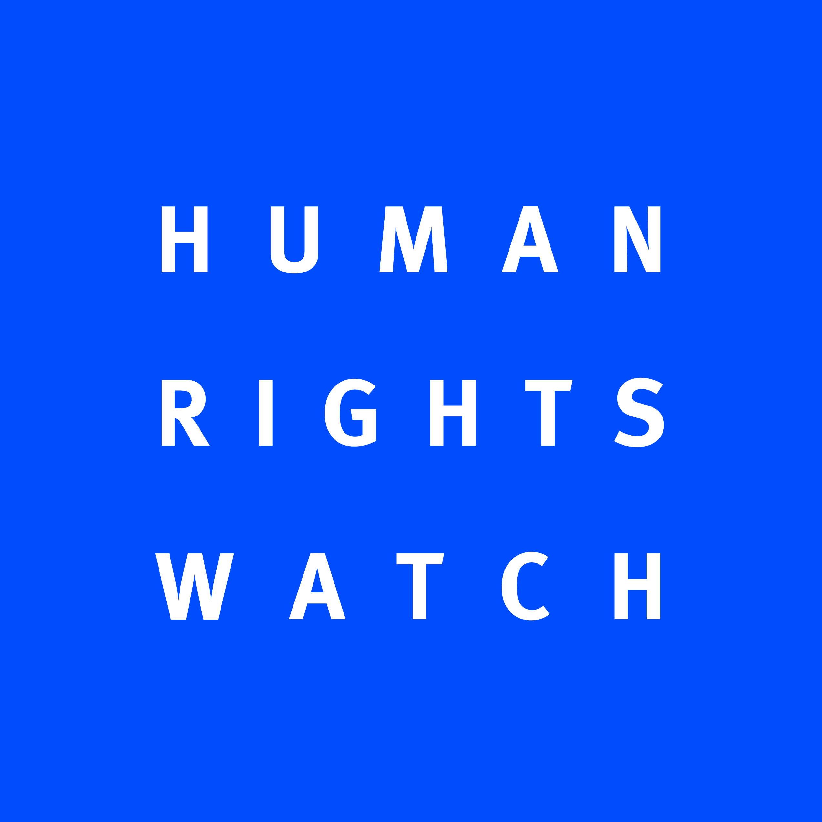

Human Rights Watch submission to the UN Committee on the Rights of the Child
in advance of the pre-sessional review of Ethiopia
July 2014

Human Rights Watch welcomes the upcoming pre-sessional review of Ethiopia by the Committee on the Rights of the Child. This briefing provides an overview of our concerns with regard to Ethiopia’s compliance with the Convention on the Rights of the Child in respect to the political indoctrination of students and teachers, political repression against teachers, and the right to education in the context of the Ethiopian government’s “villagization” program.

Right to Education (Article 28)

Access to Education

The Ethiopian government forcibly moved thousands of indigenous people in the western Gambella region from their homes to new villages under its “villagization” program. Populations affected by the relocations in Gambella include the Anuak, Nuer, and other groups that identify themselves as indigenous to the area. An investigation by Human Rights Watch from May to June 2011, following the first year of the three year villagization program, found that despite government promises to provide basic resources and infrastructure, the new villages have inadequate education facilities and due to this lack of service provision, children have not been able to attend school. While anecdotal reports since that time indicate that while the situation has improved, many schools are still not fully functional.

While one of the stated intents of the villagization program is to improve access to education, many students are no better off in the new locations. Several villagers with whom Human Rights Watch spoke said that they had been cautiously optimistic about moving to the new villages in part because they were led to believe that their children would be closer to schools. However, operational schools are absent from many of the new villages.
This has meant that some children are walking back to their old villages to attend school while some children who were attending school previously are no longer attending school.
The increased army presence in the area accompanying the villagization program has raised concerns among parents about allowing their children, particularly older boys, to walk long distances to go to school, out of fear of them being assaulted. In 2011 and 2012, during periods of more intense crackdowns from the army, students stayed at home rather than risk being arrested or assaulted from the army.
One resident said:
There is a psychological impact on children. No learning is happening. There was a school in the old village, here there is none. No one is going to school now, as they are afraid. Who will protect them going to the old village? Even the children themselves are refusing to go.

Those in school were also at risk. In several schools in which villagization was not occurring at that time government officials had compelled students to provide labor for tukul (traditional hut) construction by cutting grass or wood in nearby villages. Students said that woreda (district) officials told them that they would not be allowed to “write their Grade 10 examination” if they did not come.

Government officials would show up at the schools and tell students that “tomorrow they would go to cut.” Students typically were brought in in the morning and returned in the evening. A teacher said: “As teachers we were told to organize students to cut grasses, usually on weekends but sometimes on Fridays.… The students are not happy about cutting grass. But what can they do?”

One boy, who is now a refugee in Kenya, said:
I was a student in Pugnido attending the primary school. During vacation I came to visit my family. That was the day they showed up to tell everyone to go. “This is a national campaign, so you are involved,” I was told. I refused twice. So I was beaten by the police then taken to the police station with the militias for two days. Elders came to prison to talk to me: “It’s happening to us all. Just do it. It will be easier for you.” So I was released in order to go build tukuls in the new village, and I just then went to Pugnido and fled to South Sudan. I no longer go to school.

A government worker in Itang woreda told Human Rights Watch:
Before we had school underneath a mango tree, with teachers from our community, which was fine. Now we have a building, but with no teachers, no nothing, and the children do not go to school. But the government can now show the world that there is a “school” whereas before there was “nothing.”

Political Indoctrination of Students and Teachers

Many people interviewed by Human Rights Watch during a six-month investigation conducted across three regions of Ethiopia between June and December 2009, including teachers, students, and concerned parents, noted that the ruling party’s efforts to mobilize Ethiopian People’s Revolutionary Democratic Front (EPRDF) supporters and restrict opposition support are often targeted at students and teachers. Since that time, Human Rights Watch notes that students and teachers continue to be targeted throughout Oromia.
School children told Human Rights Watch that they were indoctrinated in ruling party ideology during school hours. This is not a new practice; Human Rights Watch reported similar partisan political activity by the ruling party on school premises in Oromia in 2005. Conducting partisan political activities on school premises and on school time and pressuring students to join the ruling party violates the rights to education protected under the ICESCR. These activities continue to happen throughout schools in Ethiopia.

All high school students above grade 10, around the age of 14 and older, have been required to participate in party political trainings, presented as workshops on “government policy.” Every school in every region visited by Human Rights Watch, including in Addis Ababa, had at some point during 2009 held a conference on the topic of “awareness of government policy and strategy.” Three students interviewed by Human Rights Watch researchers talked about the “propaganda.” One student told Human Rights Watch about one of these conferences, for which each student was paid 25 Birr (US$2) for attending:
They were not teaching us subjects, but their policy and their aims for the 2010 election and their educational policy.... They took our names and they called us and they said that anytime when they want us they have our phones, names, addresses, and they will call us. And they give us a party form—all of us in the seminar fill out the form. No one refused to fill. We were not forced, but we are not free. The party identification is very important for us. At university level they will ask for this and if you want other opportunities you will need it.

One student at a training in Awassa said:

We have learned in civics [class] that politics and school have no relationship, but in our school there is propaganda—we are learning about EPRDF. The amazing thing is the teachers are the head of our sub-city, the government officials, they come and teach us about EPRDF. They say, “EPRDF is good, huh?”

A teacher in Gonder complained to the authorities at the teachers’ conference about the indoctrination of students. He said:
EPRDF advocates their ideology in primary and secondary schools. I asked why they were pushing the political program of one party in schools—it should be a place of education not political indoctrination. They even have cells of teachers (10) and cells of students (10) in the school.
Not only is the EPRDF advocating its ideology in schools, but it is also denying access to education for students with suspected links to the opposition. In 2009, a high school student in Dessie, Amhara, who was inspired by the example of Birtukan Midekssa, the then-jailed United for Democracy and Justice Party (UDJ) leader, explained the consequences of joining the opposition:

It has brought dire results to my family, who has been denied all government services. Our access to safety net, emergency aid, and fertilizer is blocked, as is that of all those suspected of links with the opposition. My result was 2.0 for the national exam, which entitles me to maintain my academic pursuit, but I was unable to do so because of my UDJ membership. The kebele refused to issue me with mandatory paperwork from its office in order for me to continue my education, citing my UDJ membership, and, as they alleged, that of my father too.

Human Rights Watch has documented numerous examples where students who were not members of the EPRDF or who were suspected members of the opposition parties were denied opportunities to attend higher education and faced discrimination in schools. In some cases students were harassed by teachers and administrators, in several cases students were suspended for their suspected links to the opposition.

One student in western Oromia describes his experience in 2012:

I was politically active in our school. I would often ask questions that made the teachers uncomfortable about the ruling party. But we were taught in school that we can do that. Then one day I was called to the administrator’s office, and the police were there. I was arrested and taken away for two weeks and interrogated about my links to the OLF [banned opposition group]. When I was released I was told I could not go back to school for the rest of the school year because “I was causing trouble”. I haven’t gone back to school since.

The ruling party also controls teacher advancement. Teachers in all regions said that certain positions within schools—such as head teachers, school accountants, and civics teachers—are reserved for party members. Civics gets particular attention because the curriculum is adapted for ruling party purposes and introduces the students to the EPRDF and Revolutionary Democracy. One teacher said that Hailemariam Desalegn, then-adviser to the prime minister and now the Ethiopian prime minister, delivered a message via video conferencing at a propaganda meeting in which he declared, “Civics is political…. Teachers who teach this subject should promote the ideas of EPRDF.”

A teacher in a town in the Southern Nations, Nationalities and Peoples’ Region (SNNPR) echoed that the civics curriculum was partisan: “I am not a member of any political party. But I am already teaching their [EPRDF] policies because that is the curriculum.”

Teachers living in different woredas and in different regions repeatedly told Human Rights Watch that they were under immense pressure by local administrations to join the ruling party, pay annual party contributions, and attend training conferences that included EPRDF indoctrination.

In Ambo, a town in western Oromia, a teacher complained of what he called “an intimidation campaign by woreda administrators and woreda school supervisors to enlist teachers as EPRDF members.” And once you become a member, he said, the party “deducts [party dues] from our salary—most comply because it’s not prudent to be openly defiant. Some have done it, though, and they pay the price.”

A teachers’ training conference in Awassa, in SNNPR, included three days of discussions of EPRDF policies and programs. According to one teacher who attended, “the last day was about joining the EPRDF party.” Other teachers from Ambo, Dessie, and Gonder described similar conferences with an overtly political agenda.

Political Repression of Teachers

Not only are teachers forced to participate in these political training conferences, but they are also often subject to harassment and arbitrary detention, as the government has viewed teachers as a possible source of dissent. The government has waged an extensive campaign to limit and control activities of the more than 50-year-old independent teachers union, despite repeated condemnation from the International Labor Organization (ILO).

The government refused to register the independent National Teachers’ Association (NTA) and waged a lengthy struggle to stop teachers from organizing independently of the government. Teachers in Arba Minch, Addis Ababa, Awassa, Dessie, Gonder, and Ambo complained that they are forced to contribute a percentage of their salary to the government-controlled Ethiopian Teachers’ Association (distinct from the now-defunct independent Ethiopian Teachers’ Association and the independent NTA, mentioned above) and in some cases to the ruling party as well. They said that government paymasters in the school and woreda automatically deducted EPRDF dues from their salary once they signed up as party members, that they were repeatedly harassed to join the ruling party, and that the Ministry of Education denied them training opportunities if they did not. Teachers in Ambo in Oromia region said that they were forced to join the ruling Oromo People’s Democratic Organization (OPDO), a member of the ruling EPRDF coalition, or else be suspected of sympathizing with the banned Oromo Liberation Front (OLF).

Their accounts echo those of the US State Department, which in 2013 wrote that there were “credible reports” that teachers and other government workers were fired for belonging to opposition political parties. In 2009, the Oromo Federalist Democratic Movement and Oromo National Congress opposition groups also said that “the Oromia Regional Government continued to dismiss opposition party members—particularly teachers—from their jobs,” according to the State Department report. Simply refusing to join the ruling party is enough to be branded a dissident. One teacher in Gonder told Human Rights Watch that he had been accepted to the civil service college six months earlier to do a post-graduate masters program, but had not been allowed to continue because he was not a member of the ruling party:

The dean of the Teachers Training College in Gonder told me that I cannot get the chance until I join the EPRDF. I made a complaint to the head of office of the education bureau in the regional administration, they said the same thing: you cannot get the chance until you join the party.

A teacher in Arba Minch, in the south of the country, told a similar story in which the dean of the teacher training college told him that his “political contribution” had been “inadequate”—plainly referring to his not joining the party. All neutral or opposition-supporting teachers mentioned that superiors had repeatedly requested that they join the party, and two “dissident” teachers in Awassa said kebele (villages or neighborhoods) officials had pressured their landlords to raise their rents by up to 200 percent.

One teacher in eastern Oromia finally fled Ethiopia in 2013 after being arrested on four separate occasions for refusing to join the EPRDF:

I was a member of the opposition. How could I be a member of a party I do not agree with? And every time I would refuse I would get arrested and accused of belonging to a banned organization. When I came back each time my pay was less, and I would end up teaching subjects I did enjoy. If you wanted to be successful as a teacher, you had to join the party and not ask any questions.

A teacher in SNNPR said, “When you are an independent person you cannot imagine how discriminated against you are in every respect. Sometimes you feel like you are living in an alien country.”

Recommendations to the Government of Ethiopia:
- Ensure that populations affected by villagization programs have access to adequate educational facilities.
- Cease using educational facilities as sites of partisan political activity, and take appropriate actions against those who do so.
- Issue clear, public orders to all government officials stating that access to all educational facilities should be fair, equitable, and never based on political affiliation.

We encourage the Committee to take these findings into account during Ethiopia’s pre-sessional review. Thank you for your attention to our concerns, and with best wishes for a productive pre-session.

The complete findings of Human Rights Watch’s investigation can be found in “Waiting Here for Death”: Forced Displacement and “Villagization in Ethiopia’s Gambella Region, January 2012, http://www.hrw.org/sites/default/files/reports/ethiopia0112webwcover_0.pdf
Human Rights Watch interviews, Gambella and Dadaab, Kenya, May and June 2011.
Gambella Peoples’ National Regional State, “Villagization Program Action Plan (2003 EFY)”, pp. 10-12
Human Rights Watch interviews, Abobo woreda, May 24, 2011.
Ibid.
Human Rights Watch interviews with a teacher and students, Gog woreda, May 26, 2011
Human Rights Watch interviews, Gog woreda, May 25, 2011.
Human Rights Watch interviews with a former Dimma student, Dadaab, Kenya, June 19, 2011.
Human Rights Watch interviews, Itang woreda, May 26, 2011.
The complete findings of Human Rights Watch’s investigation can be found in “One Hundred Ways of Putting Pressure: Violations of Freedom of Expression and Association in Ethiopia, March 2010, http://www.hrw.org/sites/default/files/reports/ethiopia0310webwcover.pdf
Human Rights Watch, Suppressing Dissent, pp. 22-24.
ICESCR, art. 13.
Human Rights Watch interview with high school student, Awassa, October 1, 2009.
Human Rights Watch interview with high school student, Awassa, October 1, 2009.
Human Rights Watch interview with teacher, Gonder, September 18, 2009.
Human Rights Watch interview with high school student, Dessie, October 3, 2009.
Human Rights Watch interview with high school student, location withheld, June 16, 2014.
Human Rights Watch interview with teacher, Awassa, September 29, 2009.
Human Rights Watch interview with teacher, Dilla, October 3, 2009.
Human Rights Watch interview with teacher, Ambo, November 14, 2009.
Human Rights Watch interview with teacher, Awassa, September 29, 2009.
Human Rights Watch interviews, September and October 2009.
See Human Rights Watch, Ethiopia: The Curtailment of Rights
Human Rights Watch, “One Hundred Ways of Putting Pressure,” p. 43.
Human Rights Watch interviews, Ambo, November 14, 2009; Arba Minch, June 24, 2009; Awassa June 26,2009; Dessie, October 3, 2009; Dilla, October 3, 2009; Gonder, September 18, 2009; and Addis Ababa, October 7, 2009. Fifty teachers in Arba Minch signed a petition on February 7, 2009, demanding the return of enforced union dues. The Ethiopian Teachers’ Association is a government-controlled professional body that replaced the independent former union of the same name. The former association was forced to change its name to the National Teachers’ Association and has been the victim of a long-running campaign of intimidation and harassment since the early 1990s. For a summary of that history, see Human Rights Watch, “One-Hundred Ways of Putting Pressure,” pp. 40-44.
Human Rights Watch interviews with teachers, Ambo, November 14, 2009.
US State Department, “Country Reports on Human Rights Practices 2009: Ethiopia.”
Human Rights Watch interview with teacher, Gonder, September 18, 2009.
Human Rights Watch interview with teacher, Arba Minch, June 24, 2009.
Human Rights Watch interviews with teachers, Awassa, June 26, 2009, and September 30, 2009.
Human Rights Watch interview with teacher, location withheld, July 30, 2013.
Human Rights Watch interview with teacher, SNNPR, September 29, 2009.

