Alternative Information to the Committee on the Protection of the Rights of All Migrant Workers and Members of Their Families by the Human Rights Commission of Sri Lanka

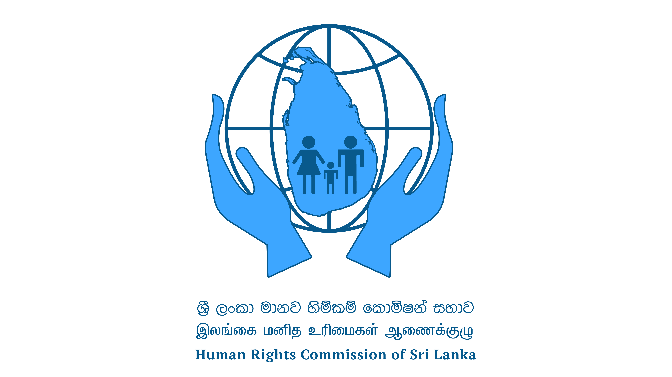
13th January 2022
Alternative Information to the Committee on the Protection of the Rights of All Migrant Workers and Members of Their Families by the Human Rights Commission of Sri Lanka

Introduction
The Human Rights Commission of Sri Lanka (HRCSL) received an email from the Secretary of the Committee on the Protection of the Rights of All Migrant Workers and Members of Their Families on 18 November 2021. The said email was regarding an invitation to the HRCSL to provide alternative Information in writing to the Committee on implementing the key recommendations contained in para. Sixty-two of the concluding observations on the second periodic report of Sri Lanka and the Information provided by Sri Lanka in its follow-up report.
It is a pleasure to write a report to provide Alternative Information to the Committee on the Protection of the Rights of All Migrant Workers and Members of Their Families.
Background
Sri Lanka acceded to the International Convention on the Protection of the Rights of All Migrant Workers and Members of Their Families on 11 March 1996, which entered into force on 1 July 2003. On 20 May 2021, there were 56 State parties to the Convention, and a majority of them were labour sending countries. Currently, significant labour receiving countries are not a party to the Convention.
The remittances of Sri Lankans sent to Sri Lanka are the most significant income of foreign export. According to the Table shown below, in the last five years between 2016 to 2020, it was over 50% of the total export of Sri Lanka.

Table 1. Private Remittances and Foreign Earnings (Rs. Million) during the year 2016-2020
Year | Private Remittance | Total Export | Percentage of Private remittances against total export
2016 | 1,054,489 | 1,500,766 | 70.26
2017 | 1,091,972 | 1,732,439 | 63.03
2018 | 1,138,124 | 1,747,423 | 65.13
2019 | 1,200,766 | 2,134,796 | 56.24
2020 | 1,317,007 | 1,858,927 | 71.00
Source: Annual Statistic of Foreign Employment -2020

Landmark point of HRCSL on the protection of Rights of Migrant Workers
- Launching the report of the Committee on the Rights of Women Migrant Workers in 2005,
- Conducting a Fact-finding mission on Mirihana Foreign Citizen Centre in 2010
- HRCSL established a Focal Point for the rights of migrant workers in 2012
- Intervening in re-opening of the Foreigners Detention Home, Mirihana under the name of Foreign National Holding Centre, Mirihana in 2012
- Establishment of a thematic subcommittee on rights of migrant workers 2016

Para 62 of the Concluding observation on the second periodic report of Sri Lanka
In para 62 of the concluding observation is as follows;
'Follow-up report
62. The Committee requests that the State party provide, within two years, that is, by 1 October 2018, written Information on the implementation of the recommendations contained in paragraphs 9, 11, 37, and 45 above.'

Provisions in the Concluding observation on the second periodic report of Sri Lanka
9. Reiterating its previous recommendation (CMW/C/LKA/CO/1, para. 14), the Committee recommends that the State party adopt comprehensive legislation on migration and take the steps necessary to ensure that its national laws and policies, including the draft Employment Migration Authority Act, are in line with the provisions of the Convention.
Provisions of the Sri Lanka response by Information received from Sri Lanka on the follow-up to the concluding observations on its second periodic report.
I. Information on the implementation of paragraph 9 of the concluding observations (CMW/C/LKA/CO/2)
1. The draft Employment Migration Authority Bill did not proceed due to various practical issues pointed out by the Ministry of Justice:
- Difficulty in establishing four corporate bodies through one Bill;
- Overlapping objects and powers of the bodies;
- The role of the proposed Authority vis-á-vis other entities;
- Some activities envisaged not being within the mandate of the subject Ministry.
2. Accordingly, Sri Lanka continues with the existing Sri Lanka Bureau of Foreign Employment (SLBFE) Act No 21 of 1985, which is now being reviewed for amendments required for promotion and protection of the rights of migrant workers and their family members. Adequate provisions have been made under the SLBFE Act to institute legal action against the illegal operators and to streamline irregular migration for employment. The revised SLBFE Act, once the proposed amendments are enacted, would further strengthen the protection and well-being of the migrant workers and their family members, especially by recognizing the role of intermediaries, introducing social protection schemes, implementing return and reintegration sub-policy and a code of ethical conduct for licensed recruitment agencies.
3. Apart from the compulsory pre-departure training programmes, the SLBFE has been conducting awareness programmes island-wide on safe migration, benefits of registration with the SLBFE, risks associated with irregular migration, the importance of planned migration for family well-being, roles, and responsibilities of migrant workers, etc., to ensure safe, orderly and regular migration for employment.

HRCSL observations
The Sri Lanka Bureau of Foreign Employment currently provides its services to Sri Lankan migrant workers. It is necessary to cover all migrant workers of Sri Lankan origin and persons in Sri Lanka by Sri Lankan legislation and policies. All the legislation needs to consider Article 1 of the Convention.
It is necessary to establish a separate institution to regulate and protect the rights of non-Sri Lankan migrant workers in Sri Lanka.

Provisions in the Concluding observation on the second periodic report of Sri Lanka
11. The Committee recommends that the State party take the steps necessary to withdraw the declarations and reservations made with respect to articles 49 and 54 of the Convention.

Provisions of the Sri Lanka response by Information received from Sri Lanka on follow-up to the concluding observations on its second periodic report.
II. Information on the implementation of paragraph 11 of the concluding observations
4. Being predominantly a labor-sending country, Sri Lanka would give further consideration with regard to this recommendation of the Committee. In this respect, the developments pertaining to labour-receiving countries increasingly becoming party to the Convention will have to be taken into account, in order to avoid uneven situations that may not be favourable to the sending countries in the long term.

HRCSL observations
It is necessary to withdraw declarations and reservations concerning articles 49 and 54 of the Convention.
Sri Lanka is also a part of the United Nations "Guiding Principles on Business and Human Rights". It is necessary to take immediate steps to implement the provisions of the said guidelines. According to the general principles;
(a) States' existing obligations to respect, protect and fulfil human rights and fundamental freedoms;
(b) The role of business enterprises as specialized organs of society performing technical functions are required to comply with all applicable laws and to respect human rights;
(c) The need for rights and obligations to be matched to appropriate and effective remedies when breached.
On the other hand, these Guiding Principles apply to all States and business enterprises, both transnational and others, regardless of their size, sector, location, ownership, and structure.

Provisions in the Concluding observation on the second periodic report of Sri Lanka
37. The Committee recommends that the State party take all measures necessary, including legislative amendments, to guarantee all migrant workers, including those in an irregular situation, the right to take part in trade union activities and to join trade unions freely, in accordance with article 26 of the Convention.

The provisions of the Sri Lanka response by Information received from Sri Lanka on the follow-up to the concluding observations on its second periodic report.
III. Information on the implementation of paragraph 37 of the concluding observations
5. While the right to form and join a trade union applies to citizens, it should be emphasized that the constitutional guarantees of equal protection extend to all persons in terms of Article 12 (1) of the Constitution. Articles 10, 11, and 13 of the Constitution also guarantee fundamental rights to all persons, including non-citizens. Any foreign migrant worker has the right and access to legal protection and coverage under the labour legislation of Sri Lanka without discrimination. Further, the collective bargaining agreements arrived at by trade unions and respective employers apply to all employees despite their citizenship. Therefore, it can be inferred that the labour rights of foreign workers are also protected by existing legislation.
6. The 'Select Committee of Parliament to look into and report on the possibility of enabling Sri Lankans employed overseas to exercise their franchise in future elections and matters incidental to it' was appointed on 17 November 2016.

HRCSL observations
According to Article 14. (1) of the Constitution of Sri Lanka, there is 'Freedom of speech, assembly, association, occupation, movement', and these rights are limited to the citizens of Sri Lanka. It should be enhanced and need to add non-citizens living in Sri Lanka. In 2016 HRCSL sent its proposals to the Hon. Prime Minister, Hon. Speaker & the Public Representations Committee on Constitutional Reform for Constitutional Reform in Sri Lanka. According to the said proposal, rights relating to occupations were proposed for all persons, not only citizens. It is necessary to implement future constitutional reforms or a draft new constitution.

Provisions in the Concluding observation on the second periodic report of Sri Lanka
45. The Committee urges the State party to take, without further delay, measures, including of a legislative nature, to ensure the implementation of the right to vote for Sri Lankan migrant workers residing abroad and to increase its efforts to facilitate the exercise of the right to vote by Sri Lankan nationals residing and working abroad in the presidential and parliamentary elections to be held in 2020.

Provisions of the Sri Lanka response by Information received from Sri Lanka on follow-up to the concluding observations on its second periodic report.
No response for this by the report of Sri Lanka state report

HRCSL observations
According to Article 3 of the Constitution of Sri Lanka, "in the Republic of Sri Lanka sovereignty is in the People and is inalienable. Sovereignty includes the powers of government, fundamental rights, and the franchise. ". Therefore, it is the government's responsibility to facilitate necessary access to the citizens to exercise their power through the franchise. Unfortunately, few millions of Sri Lanka regularly are not exercising their rights for selecting their representatives for democratic intuitions, including parliament.
In 2005 HRCSL launched a report of the Committee on the Rights of Women Migrant Workers 2005. In the said report, HRCSL identified voting rights as a post-departure issue and issued its recommendations as follows;
"Voting Rights
Specific provisions in the Constitution and international instruments to which Sri Lanka is a signatory guarantee voting rights to all citizens. In these circumstances, it is recommended that;
Arrangements are made to grant migrant workers an opportunity to exercise their franchise rights.
It is necessary to be concerned deeply about allowing all Sri Lankans without considering their place of living to use their rights to choose their representatives in a democratic society.

Conclusion
HRCSL is functioning as an independent monitoring body for the rights of migrant workers. In addition to the monitoring mandate, HRCSL, according to Article 10 of Act No 21 of 1996 of the Human Rights Commission of Sri Lanka, has the power to advise the government on introducing new laws compatible with Sri Lanka obligations to international human rights standards . HRCSL expects to send its concerns to the relevant government authority and to conduct continuous follow-ups.

Justice Rohini Marasinghe
Judge of Supreme Court (Retired)
Chairperson
Human Rights Commission of Sri Lanka

13. 01. 2022 Colombo.

Concluding observations on the second periodic report of Sri Lanka https://tbinternet.ohchr.org/_layouts/15/treatybodyexternal/Download.aspx?symbolno=CMW%2fC%2fLKA%2fCO%2f2&Lang=en
Information received from Sri Lanka on follow-up to the concluding observations on its second periodic report https://tbinternet.ohchr.org/_layouts/15/treatybodyexternal/Download.aspx?symbolno=CMW%2fC%2fLKA%2fFCO%2f2&Lang=en
Consideration of reports submitted by states parties under article 73 of the convention, initial reports of states parties due in 2004 Sri Lanka https://tbinternet.ohchr.org/_layouts/15/treatybodyexternal/download.aspx?symbolno=cmw%2fc%2flka%2f1&lang=en
Report of the Committee on the Protection of the Rights of All Migrant Workers and Members of Their Families Thirty-second session (6–16 and 29–30 April 2021) https://tbinternet.ohchr.org/_layouts/15/treatybodyexternal/Download.aspx?symbolno=A%2f76%2f48&Lang=en
Annual Statistic of Foreign Employment -2020 http://www.slbfe.lk/file.php?FID=569
2004-2005 Annual Report of Human Rights Commission of Sri Lanka https://www.hrcsl.lk/wp-content/uploads/2020/01/Annual-Report-HRC-2004-2005.pdf
Report of the Committee on the Rights of Women Migrant Workers in 2005https://www.hrcsl.lk/wp-content/uploads/2020/01/Report-of-the-commitee-on-the-rights-of-women-migrant-workers.pdf
Annual Report of Human Rights Commission of Sri Lanka on 2010 https://www.hrcsl.lk/wp-content/uploads/2020/01/Annual_Report-2010.pdf
Annual Report of Human Rights Commission of Sri Lanka on 2012 https://www.hrcsl.lk/wp-content/uploads/2020/01/Annual_Report-2012.pdf
Annual Report of Human Rights Commission of Sri Lanka on 2012 https://www.hrcsl.lk/wp-content/uploads/2020/01/Annual_Report-2012.pdf
Thematic Sub-Committees https://www.hrcsl.lk/about/thematic-sub-committees/
Concluding observations on the second periodic report of Sri Lanka https://tbinternet.ohchr.org/_layouts/15/treatybodyexternal/Download.aspx?symbolno=CMW%2fC%2fLKA%2fCO%2f2&Lang=en
Concluding observations on the second periodic report of Sri Lanka https://tbinternet.ohchr.org/_layouts/15/treatybodyexternal/Download.aspx?symbolno=CMW%2fC%2fLKA%2fCO%2f2&Lang=en
Information received from Sri Lanka on follow-up to the concluding observations on its second periodic report https://tbinternet.ohchr.org/_layouts/15/treatybodyexternal/Download.aspx?symbolno=CMW%2fC%2fLKA%2fFCO%2f2&Lang=en
Sri Lanka Bureau of Foreign Empolyment Act No 21of 1985 https://drive.google.com/file/d/1Iv2jGRldmwDcd95TRXOPk4ktEetShQtA/view
Concluding observations on the second periodic report of Sri Lanka https://tbinternet.ohchr.org/_layouts/15/treatybodyexternal/Download.aspx?symbolno=CMW%2fC%2fLKA%2fCO%2f2&Lang=en
Information received from Sri Lanka on follow-up to the concluding observations on its second periodic report https://tbinternet.ohchr.org/_layouts/15/treatybodyexternal/Download.aspx?symbolno=CMW%2fC%2fLKA%2fFCO%2f2&Lang=en
United Nations “Guiding Principles on Business and Human Rights https://www.ohchr.org/Documents/Publications/GuidingPrinciplesBusinessHR_EN.pdf
Concluding observations on the second periodic report of Sri Lanka https://tbinternet.ohchr.org/_layouts/15/treatybodyexternal/Download.aspx?symbolno=CMW%2fC%2fLKA%2fCO%2f2&Lang=en
Information received from Sri Lanka on follow-up to the concluding observations on its second periodic report https://tbinternet.ohchr.org/_layouts/15/treatybodyexternal/Download.aspx?symbolno=CMW%2fC%2fLKA%2fFCO%2f2&Lang=en
Constitution of Sri Lanka https://www.parliament.lk/files/pdf/constitution.pdf
HRCSL proposals to the Hon. Prime Minister, Hon. Speaker & the Public Representations Committee on Constitutional Reform for Constitutional Reform in Sri Lanka in 2016 https://www.hrcsl.lk/wp-content/uploads/2020/02/Proposals-for-Constitutional-Reform-by-HRC-in-English-1.pdf
Concluding observations on the second periodic report of Sri Lanka https://tbinternet.ohchr.org/_layouts/15/treatybodyexternal/Download.aspx?symbolno=CMW%2fC%2fLKA%2fCO%2f2&Lang=en
Constitution of Sri Lanka https://www.parliament.lk/files/pdf/constitution.pdf
Act No 21 of 1996 the Human Rights Commission of Sri Lanka https://www.hrcsl.lk/wp-content/uploads/2020/01/HRC-Act.pdf

