Report on the Situation of LGBTIQ* Children and Youth in Germany

Submitted for consideration at the 64th Session of the Committee on Economic, Social and Cultural Rights, September to October 2018

Submitted by:

Youth Network Lambda – Jugendnetzwerk Lambda e.V.

Schillerstraße 7, 99096 Erfurt, Germany

www.lambda-online.de



The German youth network Lambda advocates for the interests of young lesbians, gays, bisexuals, trans*, inter* and queers in society and politics. As a national umbrella to five federal youth organizations, Lambda also provides nation-wide counselling for LGBTIQ* youth, leisure opportunities and training for young activists. Our goal is to create a discrimination-free environment and opportunities for growth for LGBTIQ* youth in all areas of their lives.

Contact person: Hannah Klaubert, hannah.klaubert@lamda-online.de

----------

This report is also supported by the **European Youth Forum** and **IGLYO** – The International Lesbian, Gay, Bisexual, Transgender, Queer and Intersex Youth and Student Organization.

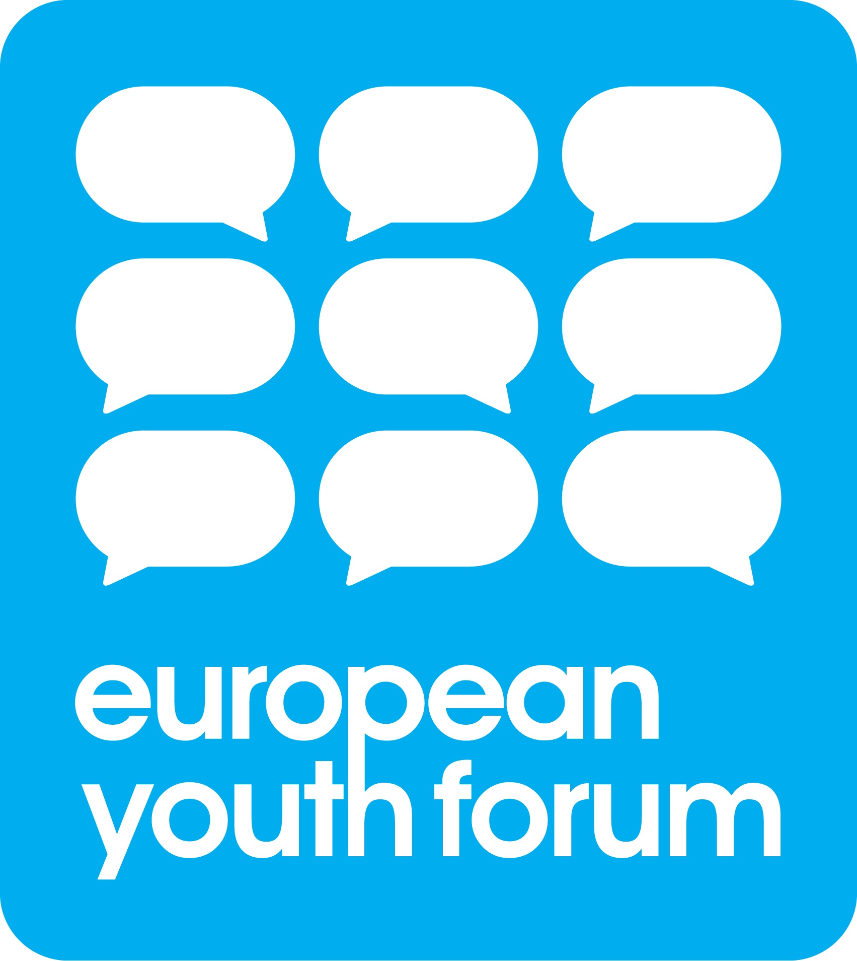The European Youth Forum (YFJ) is an independent platform of over 100 youth organisations in Europe, to which IGLYO is a full member. Founded in 1996 and bringing together National Youth Councils and International Non-Governmental Youth Organisations, the European Youth Forum represents the common interests of tens of millions of young people in Europe.

Rue de l'Industrie 10, 1000 Brussels, Belgium. Contact person: George-Konstantinos Charonis, [george-konstantinos.charonis@youthforum.org](mailto:george-konstantinos.charonis@youthforum.org), +3227937525, [www.youthforum.org](http://www.youthforum.org).



IGLYO - The International Lesbian, Gay, Bisexual, Transgender, Queer and Intersex (LGBTQI) Youth & Student Organisation is the largest LGBTQI youth and student network in the world, with over 95 members in 40+ countries.

Chaussée de Boondael 6, Brussels B-1050, Belgium. Contact person: Elin Liljenbladh, elin@iglyo.com, www.iglyo.com.

1. Introduction

In addition to firmly supporting the report submitted by Bundesvereinigung Trans* e.V., in anticipation of the Committee’s upcoming review of Germany, the LGBTIQ* Youth Network Lambda would like to draw the Committee’s attention to the challenges faced by LGBTIQ* children and youth in Germany. Specifically, this report addresses the failure to secure the Right to Non-Discrimination (Article 13), Right to Health (Article 12) and Right to Education (Article 13) of LGBTIQ* children and youth according to the International Covenant on Economic, Social and Cultural Rights.

The first step to improve the situation of LGBTIQ* in Germany is to acknowledge their ongoing discrimination in many spheres of life; therefore, we ask the Committee to reaffirm their recommendation to change the national hate crime legislation to explicitly address trans*, inter* and homophobia (instead of the vague term of “sexual identity” of the current “Allgemeines Gleichbehandlungsgesetz” from 2006) and would like to add the recommendation to explicitly address the discrimination against children in relation to inter* and trans* medical and legal treatment as some of the most blatant breaches of Human Rights and the International Covenant on Economic, Social and Cultural Rights in Germany (see below).

1. Discrimination against LGBTIQ* in schools

LGBTIQ* children and youth are amongst the most vulnerable members of our society, as they not only regularly face discrimination, but are often not able to distance themselves from the contexts (family, school, apprenticeships, …) in which the discrimination occurs. A report on the “Attitudes toward Lesbian, Gay, and Bi-Sexual Persons in Germany,” commissioned by the German Federal Anti-Discrimination Agency itself and published in 2017, stresses that the school could play a central role in improving the situation for LGBT people in general and children and youth more specifically (Küpper, Klocke, & Hoffmann, 2017). However, while no extensive study on discrimination of LGBTIQ* youth in German schools exists, smaller studies find that LGBT pupils in Germany regularly face homophobia and ignorance surrounding sexual orientation or gender identity (Küpper et al., 2017, p. 138; Pohl, 2017, n.p.). Similarly, a study on the situation of LGBT teachers in German schools, also commissioned by the German Anti-Discrimination Agency, revealed that less than half of LGBT teachers felt confident to open up about their sexuality or gender identity in their workplace, while 40% of all LGBT teachers have faced open discrimination due to their sexual orientation or gender identity (Kastner, 2017, p. 45). Not surprisingly, Germany scored low (31 points, among the lowest scores in the Western European countries) in the ‘LGBTQI Inclusive Education Index’ brought forward by IGYLO in early 2018 (IGLYO International LGBTQI Youth and Student Organization, 2018). Germany must act to make schools a safer space for LGBT youth to ensure their Right to Education and Right to Non-Discrimination according to the CESCR.

German education law is organized federally; therefore, direct intervention into the curricula or education laws of the Bundeslaender by the federal government is not possible. However, the Federal Anti-Discrimination Agency (ADS) should make a more targeted effort to help (1) change the education laws as well as the curricula in all federal states to directly address the issue of LGBTIQ* discrimination, (2) encourage the development of educational material   
  
across disciplines that addresses different forms of sexual orientation, gender identity, family, (3) demand that LGBTIQ*-related issues become a mandatory element of teacher training at universities as well as professional development for managerial staff in schools, and (4) provide and widely spread guidelines specifically addressing issues like name change or access to bathrooms relevant for non-binary, trans* or inter* youth in the school environment.

Specifically, we urge the Committee to demand from the German government to

|  |
| --- |
| * provide regular and wide-reaching studies monitoring   + the experience of and discrimination faced by LGBTIQ* youth in school contexts.   + the teaching of topics related to LGBTIQ* in schools across disciplines. * explicitly address inter*-, trans*- and homophobia as categories of discrimination in hate crime legislation to serve as blueprints for the education laws in federal states. |

1. Discrimination against trans* and inter* children and youth
2. Non-consensual ‘normalizing’ treatment of inter* infants and children

A most blatant breach of the Right to Health in Germany is the failure to address and criminalize non-consensual ‘genital-normalizing’ surgeries and treatments of infants and children (with and without an official intersex diagnosis). As mentioned in the Reply to the List of Issues submitted by Germany to the Committee on 6th July 2018, a recent study has found that there wasn’t a significant decline in the number of surgeries performed since 2005 (Klöppel, 2016, p. 8). The same study also calls for a critical reconsideration of the current medical practice in light of the Human Rights and right of self-determination of inter* children (p. 9). However, Germany continuously fails to address the calls of experts and inter* organizations to create, in addition to the medical guidelines, a legal framework that navigates the Right to Health and right to self-determination of inter* children and youth, i.e. protects them from non-consensual intervention (which often occurs with the consent of parents), while offering counseling and medical treatment if wished. Germany also has failed to provide current reliable data on the number of ‘normalizing’ surgeries and hormonal treatment of intersex* infants and children (as the Committee had requested in the list of issues of the 6th period of the CESRC review), thereby ignoring an infringement of Human Rights and the Right to Health and self-determination of intersex* children and youth.

Therefore, we urge the Committee to demand from Germany

|  |
| --- |
| * to collect and publish reliable and current statistical data on the number of ‘genital-normalizing’ surgeries performed on (inter*) infants and children. * a legal banning of medically not required ‘normalizing’ surgeries or hormonal or other treatment of infants and children (with and without an official intersex diagnosis) without the informed consent of the patient. |

1. Legal discrimination of non-binary, trans* and inter* children and youth

Research has shown that trans* children and youth are more vulnerable to depression and suicide than their peers (Schirmer, 2017, p. 179); however, this variation almost goes down to zero in children and adolescents who have been enabled to socially transition by a supporting environment (family, school, medical staff) (Olson, Durwood, DeMeules, & McLaughlin, 2016, p. 5). As mentioned above, creating a safe education environment is an important step to protecting the mental and physical health of LGBTIQ* youth. However, additionally addressing the discrimination and legal challenges faced by non-binary, trans* or inter* children and youth and their support networks is of utmost importance to guarantee their Right to Non-Discrimination and Right to Health.

The current legal framework in Germany fails to protect trans* and inter* children and youth against discrimination and physical harm. While a draft law by the Ministry of the Interior that was accepted by the parliament on 15th August 2018 promises a third option for gender entry (“diverse”), this option is still bound to medical attestation – thereby keeping trans* and especially inter* persons dependent on a medical system that continuously has failed to address their needs and has often committed discriminatory and violent acts against them (Klöppel, 2016). Furthermore, the law only accepts medical attestations of “variances of sexual development” (“Varianten der Geschlechterentwicklung”), which does not necessarily include trans* or non-binary identities and certain inter* manifestations. Children under 14 years old will only have access to a third gender entry or change of gender entry with the consent of a custodian or through Family Court, which means that in the case of refusing parents, children cannot self-determine their gender entry. This also goes for the change of first name, which is only possible with consent of the parents until the age of 14. Furthermore, the procedure of change of name or change of gender entry, which is regulated by the outdated “Law on Transsexuals” (TSG), is very time-consuming (9 months average) and costly (1800€), which further restricts access especially of young persons to those procedures.

To address the discrimination against inter* and trans* children and youth and infringement of their Rights to Health and self-determination, we urge the Committee to demand from the German government

|  |
| --- |
| * to make the third gender entry and name change accessible without medical attestation and costly court procedures. * to create legal frameworks and practicable guidelines for self-determined change of the gender entry or first name for trans*, inter* or non-binary children under the age of 14 in the case of non-supporting parents. |

Sources:

IGLYO (2018). *LGBTQI Inclusive Education Report*. Brussels: IGLYO International LGBTQI Youth and Student Organization.

Kastner, C. (2017). LSBTIQ*-Lehrkräfte in Deutschland. Berlin: Antidiskriminierungsstelle des Bundes.

Klöppel, U. (2016). *Zur Aktualität kosmetischer Operationen „uneindeutiger“ Genitalien im Kindesalter* (Vol. 27). Berlin: Geschäftsstelle des Zentrums für transdisziplinäre Geschlechterstudien der Humboldt-Universität zu Berlin.

Küpper, B., Klocke, U., & Hoffmann, L.-C. (2017). Einstellungen gegenüber lesbischen, schwulen und bisexuellen Menschen in Deutschland. Berlin: Antidiskriminierungsstelle des Bundes.

Olson, K. R., Durwood, L., DeMeules, M., & McLaughlin, K. A. (2016). Mental Health of Transgender Children Who Are Supported in Their Identities. *Pediatrics*, *137* (3).

Pohl, F. G. (2017). Lebenswirklichkeiten und Antidiskriminierung im Erfahrungsraum Schule. Akzeptanzarbeit am Beispiel von Schule der Vielfalt. *Diskurs Kindheits- und Jugendforschung*, *12* (2), 231–234.

Schirmer, U. (2017). Zwischen Ausblendung und Sozialpädagogisierung? Dilemmata bei der Konstruktion von LSBT*-Jugendlichen als Zielgruppe Sozialer Arbeit. *Diskurs Kindheits- und Jugendforschung*, *12* (2), 177–189.