BRIEFING ON ECUADOR FOR THE COMMITTEE ON THE RIGHTS F THE CHILD, SESSION 90 PRE-SESSIONAL WORKING GROUP- October 2021
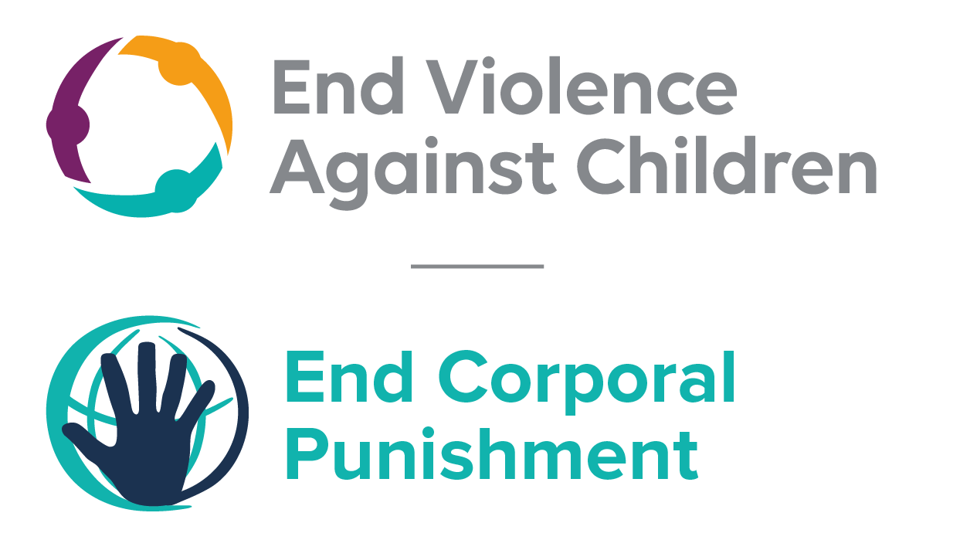
The Global Partnership to End Violence Against Children, June 2021

This briefing describes the legality of corporal punishment of children in Ecuador. In light of the Committee’s General Comment No. 8 on “The rights of the child to protection from corporal punishment of children and other cruel or degrading forms of punishment”, its repeated recommendations on the issue and the importance of eradicating this form of violence given by the UN Secretary General’s Study on Violence against Children. Considering the recommendations to prohibit all corporal punishment made to Ecuador by the Committee Against Torture, the Human Rights Committee, the Committee on the Rights of Persons with Disabilities, and during the Universal Periodic Review in 2012 and 2017 (which the Government supported), as well as the global commitment to ending all violence against children in the context of the 2030 Agenda for Sustainable Development, we hope the Committee will:
• in its List of Issues Prior to Reporting for Ecuador, raise the issue of corporal punishment of children, in particular asking what progress is being made on enacting the Bill to prohibit corporal punishment of children in all settings; and
• in its concluding observations on the seventh report of Ecuador, recommend that the Bill is enacted as a matter of priority to explicitly prohibit corporal punishment of children, in all settings including the home.

Ecuador’s commitment to prohibiting corporal punishment
Ecuador expressed its commitment to prohibiting all corporal punishment of children by accepting clearly the recommendations to do so made during the Universal Periodic Review of Ecuador in 2012 and again in 2017. A Bill prohibiting all corporal punishment of children has been examined by the National Assembly since 2018.

Summary of necessary legal reform to achieve full prohibition
Prohibition is still to be achieved in the home, alternative care settings, day care and as a sentence for crime.
We have been unable to establish whether legislation confirms a right of parents and others to “moderately correct” children, but corporal punishment is widely accepted in childrearing and legal provisions against violence and abuse are not interpreted as prohibiting all corporal punishment. The near universal social acceptance of corporal punishment in childrearing necessitates clarity in law that no level of corporal punishment is acceptable. Prohibition should be enacted of all corporal punishment and other cruel or degrading forms of punishment, in the home and all other settings where adults have parental authority, together with the repeal of all legal defences for its use.
Alternative care settings – Prohibition should be enacted in legislation applicable to all alternative care settings (foster care, institutions, places of safety, emergency care, etc).
Day care – Corporal punishment should be prohibited in all early childhood care (nurseries, crèches, kindergartens, preschools, family centres, etc) and all day care for older children (day centres, after-school childcare, childminding, etc).
Sentence for crime – Corporal punishment as a sentence should be unlawful in all justice systems, including among indigenous communities.

- Current legality of corporal punishment in Ecuador
  - Home: Corporal punishment is lawful in the home. Article 67 of the Children and Adolescents Code 2003 defines ill-treatment of children as “any conduct, any act of omission or commission, that causes or may cause harm to the integrity or physical, psychological or sexual health of a child or young person, by any persons, including their parents, other relatives, educators and persons responsible for their care, whatever means used, whatever the consequences and whatever time is necessary for the victim to recover” (art. 67), and article 76 states that abusive practices suffered by children cannot be justified on the grounds that they are educative methods or traditional cultural practices, but this is not interpreted as prohibiting all corporal punishment, however light, in childrearing. Provisions against violence and abuse in the Law against Violence against Women and the Family 1995, the Childhood and Adolescence Code 2003 and the Criminal Code 1991 do not include clear prohibition of all corporal punishment in childrearing.
  - The Constitution 2008 states that the State, society and the family shall guarantee the full exercise of the rights of children and adolescents and that their best interests shall be always upheld (art. 44). Article 45 states: “Children and adolescents shall enjoy the rights that are common to all human beings, in addition to those that are specific to their age…. Children and adolescents have the right to physical and psychological integrity; … to respect for their freedom and dignity.” Article 46 states: “The State shall adopt, among others, the following measures that safeguard children and adolescents: … (4) protection and care against all forms of violence, mistreatment, sexual exploitation or exploitation of any other kind or against neglect leading to these situations.…” However, the Constitution does not send a clear message that all forms of corporal punishment are prohibited.
  - The Government signalled its commitment to prohibition by clearly accepting the recommendations to prohibit corporal punishment in all settings made during the Universal Periodic Review of Ecuador in 2012. In reporting to the Human Rights Committee in 2016, the Government suggested that corporal punishment in the home is unlawful under articles 156 and 159 of the Comprehensive Criminal Code 2014. However, reforms to the Penal Code in 2014, addressing violence against women and children in the family, did not prohibit all corporal punishment in childrearing. Article 156 of the Code states (unofficial translation): “Physical violence against women or members of the family - The person who, as a manifestation of violence against women or members of the household, causes injury, shall be punished with the same penalties for the crime of injury increased by one third.”
  - In November 2016, a Bill prohibiting corporal punishment of children was put before the National Assembly. Article 10 of the Bill states (unofficial translation): “…No corporal punishment shall be qualified as reasonable or moderate and its use is completely forbidden…” and extends the prohibition to (unofficial translation) “…the father, mother, family, legal representatives and persons responsible for the education or care of children and adolescents, people who work in education, social services, health, administration of Justice, in the public or private sector and any other person who has custody or responsibility of a child or adolescent.” In July 2017, the draft Law was still being discussed in the second Committee stage – the last phase before the final vote. The Government reported in September 2017 that “observations on the bill had recently been submitted by various bodies, including the United Nations Children’s Fund (UNICEF)” and that it was hoped that the Bill “would soon be adopted”. As of July 2018, no further progress had been made. The Children and Adolescents Code 2003 is under review – the draft new Code was introduced to Parliament in January 2020.
  - Alternative care settings: There is no explicit prohibition of all corporal punishment in alternative care settings. Children are protected from some corporal punishment under articles 67 and 76 of the Children and Adolescents Code 2003 (see under “Home”).
  - Day care: Corporal punishment is prohibited in preschool provision in articles 40 and 41 of the Children and Adolescents Code 2003 (see under “Schools”), but it is not explicitly prohibited in other early childhood care and in day care for older children. Articles 67 and 76 of the Code protect children from some but not all corporal punishment (see under “Home”).
  - Schools: Corporal punishment is explicitly prohibited in schools in articles 40 and 41 of the Children and Adolescents Code 2003: “40: Disciplinary measures. Teaching methods and discipline in educational institutions shall respect the rights and guarantees of children and young persons and shall exclude all forms of abuse, ill-treatment and disrespect, and, accordingly, any form of cruel, inhuman or degrading punishment. 41: Prohibited punishments. Educational institutions are: (1) Prohibited from using corporal punishment; (2) Prohibited from using psychological punishments that offend the dignity of children and young persons….”
  - Penal institutions: Corporal punishment is unlawful as a disciplinary measure in penal institutions. Article 38 of the Penal Code 2014 states (unofficial translation): “Persons under the age of eighteen - Persons under eighteen years of age in conflict with the criminal law shall be subject to the Organic Code of Children and Adolescents”. This includes articles 40 and 41 (see under “Schools”).
  - Sentence for crime: Corporal punishment is unlawful as a sentence for crime under the Constitution 2008, the Criminal Code 1991 and the Criminal Procedure Code, which make no provision for it although do not explicitly prohibit it. The Children and Adolescents Code 2003 provides for socio-educational measures in the case of juvenile offenders, and, in exceptional circumstances, deprivation of liberty. However, the Constitution allows indigenous communities to follow their traditional customary forms of justice providing that they do not conflict with the Constitution or with national laws. Media reports suggest that these can include corporal punishments such as whipping and dousing with cold water and other public humiliation. In 2009, draft laws on indigenous justice were under discussion but we have no further information.

Recommendations by human rights treaty bodies and during the UPR
  - CAT: In its 2010 concluding observations on the state party’s fourth-sixth report, the Committee Against Torture recommended that legislation be enacted to explicitly prohibit corporal punishment in the home.

  - CRC: On three occasions, the Committee on the Rights of the Child has recommended to Ecuador that legislation be enacted to explicitly prohibit corporal punishment in all settings: in its concluding observations on the state party’s second-third report in 2005, on the fourth report in 2010, and on the fifth-sixth report in 2017.

  - HRC: The Human Rights Committee recommended that the Government put an end to corporal punishment in all settings in its concluding observations on the state party’s fifth-sixth report in 2009.

  - CRPD: The Committee on the Rights of Persons with Disabilities recommended that the Government introduce legislation to explicitly prohibit corporal punishment both in the home and in shelters in its concluding observations on the state party’s second-third report in 2019.

  - UPR: At the second cycle of the Universal Periodic Review of Ecuador in 2012, recommendations to adopt legislation explicitly prohibiting corporal punishment were issued and accepted by the Government. Recommendations to prohibit all corporal punishment made in the third cycle UPR in 2017 were also accepted.

5 July 2012, A/HRC/21/4, Report of the working group, paras. 135(21) and 135(22)
3 November 2015, CCPR/C/ECU/6, Sixth state party report, paras. 30
Information given by ChildFund Ecuador, January 2017; see also http://www.asambleanacional.gob.ec/es/blogs/comision-de-justicia-y-estructura-del-estado/50541-traves-de, accessed 8 August 2017
18 September 2017, CRC/C/SR.2223, Summary records of the 2223rd meeting, paras. 50 and 53
Information given by ChildFund Ecuador, September 2019; see also https://www.elcomercio.com/actualidad/reforma-codigo-ninez-pension-alimenticia.html, accessed 13 February 2020
See, for example, The Star, 11 May 2003; Hemisphere, 22 March 2004; IPSNews.net, 26 May 2010
7 December 2010, CAT/C/ECU/CO/4-6, Concluding observations on fourth-sixth report, para. 18
13 September 2005, CRC/C/15/Add.262, Concluding observations on second/third report, paras. 37, 38, 39, 73 and 74
2 March 2010, CRC/C/ECU/CO/4, Concluding observations on fourth report, paras. 7, 8, 9, 10, 45, 46, 47, 64 and 65
29 September 2017, CRC/C/ECU/CO/5-6, Concluding observations on fifth/sixth report, Advance unedited version, paras. 23 and 24
4 November 2009, CCPR/C/ECU/CO/5, Concluding observations on fifth/sixth report, para. 14
21 October 2019, CRPD/C/ECU/CO/2-3, Concluding observations on second-third report, paras. 31 and 32
5 July 2012, A/HRC/21/4, Report of the working group, para. 135
3 May 2017, A/HRC/WG.6/27/L.2, Draft report of the working group, unedited version, paras. 7(137), 7(138) and 7(139)

