ALTERNATIVE REPORT OF INDONESIAN WOMEN WITH DISABILITY ORGANIZATIONS FOR INDONESIA CEDAW LIST OF ISSUES ADOPTION

The report submitted by Indonesian Association of Women with Disabilities (HWDI)

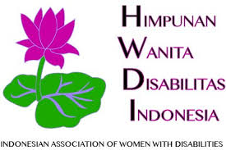

This report created by HWDI based on the HWDI Branch Offices in 11 Provinces in Indonesia
(Aceh, South Sumatera, Bangka Belitung Islands, Lampung, DKI Jakarta, Central Java, East Java, West Nusa Tenggara, North Maluku, Central Sulawesi, East Kalimantan, Central Kalimantan, Southeast Sulawesi, North Sulawesi, and Bali)

Content of Report

Introduction 3
Principal areas of concern and recommendations 3
Visibility of the Convention 3
Parliament, Constitutional and legislative framework 4
The Proposed List of Issues 5
National machinery for advancement of women 5
Violence against women 6
The Proposed List of Issues 9
Education 9
Proposed List of Issues: 11
Employment 11
Proposed List of Issues 13
Health 13
Proposed List of Issues 14
Women facing multiple forms of discriminations 14
The Proposed List of issues 15
Access to Justice for Women with Disabilities 15
The Proposed List of issues 17
Marriage and family relations 18
Proposed List of issues: 19
Profil of Indonesian Association of Women with Disabilities (HWDI) 19

Introduction
- This Alternative Report is drafted by the Indonesian Association Women with Disabilities (Himpunan Wanita Disabilitas Indonesia), hereafter will be refer to as HWDI), which having 32 provincial level representative offices out of 34 Provinces of Indonesia, located across Indonesia with its National Secretariat located in Jakarta. This report serves as a shadow report to supplement the official Indonesian Report as well as input to the CRPD Committee in drafting the List of Issues.
- HWDI’s alternative report was drafted since 2019 by holding a National Consultation that was attended by 28 provincial branches, workshops and technical data collection guidance; by establishing monitoring instrument; the data collection were carried out by 15 HWDI regional offices across Indonesia. The report was then drafted through a series of FGD that were conducted at national level, after which it was submitted to the CEDAW Committee.
- The report of the data was collected by HWDI regional offices network in Indonesia in the following provinces: Aceh, South Sumatera, Bangka Belitung Islands, Lampung, DKI Jakarta, Central Java, East Java, West Nusa Tenggara, North Maluku, Central Sulawesi, East Kalimantan, Central Kalimantan, Southeast Sulawesi, North Sulawesi, and Bali.

Principal areas of concern and recommendations

Visibility of the Convention
- To push the law enforcers to commit in handling the cases of violence against women with disabilities, Organisation of People with Disabilities) have created MoU to collaborate with State institutions. In October 2019, HWDI made an MoU with the Chief of Indonesian Police Force concerning the service and protection of the rights of women with disabilities. However, the biggest challenge is actually in implementing the MoU to local level due to the lack of understanding and awareness on the protection of women with disabilities among law enforcers.
- The Indonesian Police Force has a Women and Children Protection Unit as stipulated in the Regulation of the Chief of Police Number 10 Year 2007 on the Organisation and Management of Women and Children Protection Unit within the Scope of Indonesian Police Force. Special police personnel have been given training and are in charge for the unit that specially established to handle the cases of violence against women and children. This unit can be found in 34 provinces across Indonesia. The problem, however, the mechanism to handle such cases have not fulfilled the requirements for reasonable accommodation for children and women with disabilities who are dealing with legal matters, including the proper facilities and infrastructure, physical and non-physical, such as an officer who understand sign language, accessible communication device, information media using Simple Language format
- Capacity building related to CEDAW or protection of women has not been so massive carried out by the Government, including also related to access to justice of women with disability. A number of trainings were actually initiated by civil society.
Proposed List of Issues:
- Please explain the budget format in Ministries, Institutions and Local Governments related to the capacity building of the State apparatus (law enforcement) on the rights of women, including women with disabilities? What is the impact of the training that has been done? Has an independent evaluation been carried out to measure the success of the training?

Parliament, Constitutional and legislative framework
- The Law No. 8/2016 on Persons with Disabilities has ensured a special protection for women with disabilities. This is stipulated in Article 5.125, 126, and 127.

- One of the challenges in the efforts to protect the rights of women with disabilities in Indonesia is related to the existing policies that were enacted before the ratification of CRPD or the enactment of the Law No. 8/2016. Not only are these policies biased against disability, but they also contain gender-bias, rendering women with disabilities prone to multiple discriminations. Some of existing regulations that are still discriminative against women with disabilities are:
  - The Law No. 1 Year 1974 that allows the practice of poligamy for husbands whose wives become physically disabled or afflicted by an incurable disease; and a provision stipulating that one of the requirements to file for divorce is if one party becomes physically disabled or afflicted by a disease that render the said party unable to fulfill his/her obligations as a husband/wife. In South Sumatera case, a women who become blind at the age of 37 was divorced and sent to her parents house by the husband, she has no activities in her daily life and made her stress out.
  - The Law No. 17/2014 on Exclusive Breastfeeding, Article 6 clause (3) and (7) allow mothers with mental disabilities to not breastfeed their babies exclusively.
  - The Indonesia Law on Criminal Code and Administrative code are not acknowledge the testimony of women with disabilities before the law, impacted to the cases of them failed to be in trial and court.

- A number of report submitted by the state institutions and organisations of people with disabilities (DPOs) states that the cases of discrimination, violence, and refuse the rights of women with disabilities are still taking place. The National Commission on Anti-Violence Against Women reports that the number of women with disabilities that become victims of sexual violence are increasing, from 40 cases in 2015 to 89 cases as of January 2019. Unfortunately, there are no guidelines for law enforcers and the government that can be used to close such cases. It resulted in a high number of violence cases (including rape) that are not opened and processed (See, Graphic 1).

Graphic 1: Number of Case of Violence against Women With Disabilities
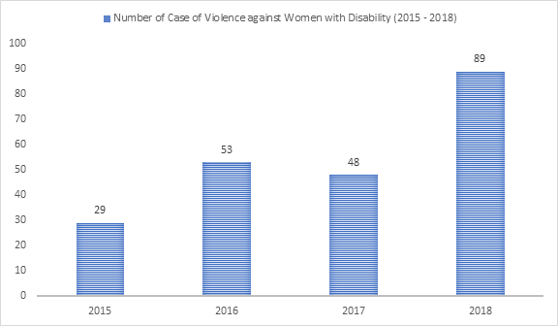

Source: Women National Commission, 2019

The Proposed List of Issues
- What legislative and administrative steps have been taken by the Indonesian Government to ensure the implementation of Article 5 (2), Article 125, 126 and 127 of the Law No. 8/2016 concerning the special protection for women with disabilities?
- The Government Report paragraph 177 mentions about the Government Regulation of Ministry of Women Empowerment No.23/2010 on PIK-PPD, an information and consultation institution for women with disabilities. Is this institution opening its branches in 34 provinces and what this institution has done in empowering and protecting women with disabilities? what contribution in handling the cases of violence against women with disabilities?

National machinery for advancement of women
- Law No. 8/2016 mandates the establishment of the National Commission on Disabilities (KND), yet the Commission is still non-existent. In handling women with disabilities, there is still a gap between KPPPA and the Ministry of Social Affairs in dealing with women with disabilities. This causes the handling of women with disabilities is not optimal.

Proposed List of Issues:
      - With regard to paragraph 23 of the Government Report, we want to emphasize on how does this budget accommodate vulnerable groups, especially women and children with disabilities?
      - Is PIK PPD (based on Ministry Regulation No. 23/2010) included in the 33 institutions mentioned, and how is the budget allocated?

Violence against women
- The condition of women with disabilities is also described in a number of reports written by Organisation of People with Disabilities such as the one published by SAPDA (the centre of advocacy for women and children with disability), in Yogyakarta, in 2015, 29 women with disabilities were reported suffered from many forms of assaults: sexual violence, physical violence, and economical violence. As many as 33 cases occurred in 2016 and it was increased to 35 cases in 2017. In 2016, only 3 out of 76 sexual violence cases that are reported to DPOs in Yogyakarta and legal aid institutions that went to trial.
- The new monitoring cases by HWDI in 2019 (covered 2017 – 2019) found 136 cases in 11 provinces with the following explanation in the graphics (Number of cases, type of abuses, type of victims’ disability, and perpetrators).

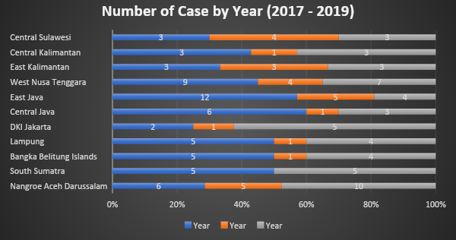
Source: HWDI, 2019

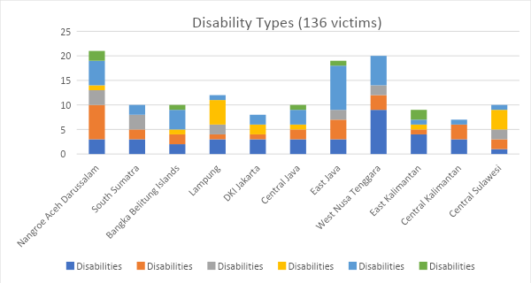
Source: HWDI, 2019
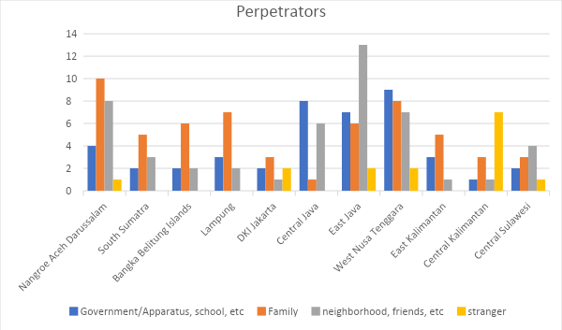
Source: HWDI, 2019

- The latest observation in 2019 conducted by HWDI in 11 provinces shows that a number of regional regulations have been published to protect women and children from exploitations, violence, and harassment, but in practice, there are still a number of obstacles between the regulations, the state apparatus and the government, and the availability of access to services and legal aid towards the protection of the rights of women with disabilities. Likewise, there are no comprehensive mechanisms to ensure such laws are effectively implemented. This condition has resulted in unsolved cases of violence, exploitation and the violation of the rights against persons with disabilities.

- The absence of well-planned, systematic, and measurable efforts taken by the Government to protect women with disabilities has resulted in the occurrence of violence cases and violations. The data collected in the monitoring of the rights of persons with disabilities conducted by HWDI on 2015.
- Current mapping of women with disabilities conditions carried out by HWDI in 2019, within 2017-2019 were collected 142 legal cases faced by women with disabilities were recorded. Majority of them are rape 33%, discrimination 20%, and other physical violence 17%, exploitation 9%, domestic violence 8%. Sexual harassment 7%, Psychological violence 5%, and inhuman degrading 1%.

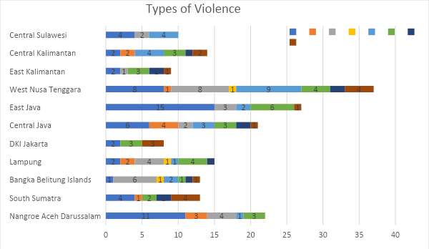
Source: HWDI, 2019

- The perpetrators of the violence and exploitation cases and other violations are varied, ranging from family members, society, to government apparatus. The lack of social security outside family life renders women with disabilities prone to be the victim of violence at home, which happened in Palembang, South Sumatera, in 2019. The victim, who has Down syndrome, was alone in her house and was raped by his brother. The perpetrator threatened her to not tell anyone about it. In Lhoksukon, Aceh, on September 2018, a man raped her step deaf daughter twice.
- Another case took place in East Java. A blind woman di Sidoarjo district was raped and gave birth to a child from the rape. It happened in 2009 and was only found in July 2017 because it was never reported by her family or the village administration to police. The child is now 10 years old (as of 2019). In Pasuruan East Java, on 10 September 2018, a woman with intellectual disability, 20 years old, in Beji District, Pasuruan Municipality, was raped by her neighbour and became pregnant. The family members of both sides took an amicable solution by marrying them off, but the perpetrator escaped. This case was finally reported to the police, and the police said that this case is difficult to process because the victim is mentally disability.

The Proposed List of Issues
- Until the Bill of the Elimination of Sexual Violence (RUU PKS) and the RPP on Access to the Court for Persons with Disabilities are passed, what the Indonesian Government can do to ensure that women with disabilities who were victimised by violent crimes (particularly sexual crime) can receive a range of justice, from preventing the crime to reoccur to the recovery and empowerment?

Education
- Many attempts have been made by the Indonesian Government to fulfill the right to education, as stipulated in the 1945 Indonesian Constitution, the Law No. 8/2016, the Minister of National Education Regulation No. 70/2009 on Inclusive Education, School Operation Support, scholarships, free schools, nine year mandatory learning, and so on. Despite those attempts, there are many women with disabilities who still cannot access education because of various reasons. The government has yet to have segregated data by various types of disabilities on the percentage of women with disabilities who do not receive education and are illiterate.
- Based on OPDs observation, the number one problem in accessing education despite the provision of scholarships and inclusive schools is the location of the school, which is usually far from students’ home. The number of special and inclusive schools are limited, the lack of access and reasonable accommodations even in inclusive schools, school buildings that are not accessible, the lack of information which renders parents confused, the lack of teacher assistants in inclusive schools, and additional costs for certain types of disability such as mental and intellectual disability.
- Some education policies have yet to fully accommodate the needs of persons with disabilities, particularly women and children, rendering them unable to fully access education as mandated by CRPD. The observation conducted by HWDI (2017 - 2019) in a number of provinces in Indonesia reveals several problems in accessing education, namely:
- The lack of understanding and awareness among state apparatus and the government. This is due to the lack of policies propagated in all levels of education to local level. As a consequence, it is not uncommon to find women and children with disabilities experiencing troubles in accessing education.
- Additional costs for special schools. Special schools that are administered by the government require extra cost (i.e. they are not free).
- School or university policies that are not sensitive to the needs and interests of women with disabilities. In Lampung, a woman who became disabled because of an accident in 2014 must quit her study because she went paralyzed for two years and unable to attend classes. She recovered and must use a wheelchair. She returned to her study spending her 2-year academic leave. Unfortunately, the university did not take her back on the grounds that she has exceeded two years.
- The absence of access and physical and psychological reasonable accommodations. In Lampung (in 2019), a 10-year old girl did not have arms and a right leg. She used a prosthetic on her left leg. She was denied entry to a public school on the ground that it did not have any accessible facilities and infrastructures. The case of denying a student to school on the ground of disability also happened in Banda Aceh.
- The strong stigma about, discrimination, and bullying against disability. An 11-year old girl with intellectual disability (in 2019) in Central Sulawesi had been constantly bullied by her classmates ever since she was in elementary school. Her teacher even sometimes made discriminating comments to her parents. Her mother eventually decided to take her out of the school.
- Zonation system restricts persons with disabilities from choosing their own schools. In 2014, a student with disabilities was denied entry to an inclusive elementary school in Banda Aceh on the ground that he was from a different zone. Once they found an inclusive school within the allowed zone, he was still denied entry because her teacher felt distracted by the presence of the teacher assistant during the class. Disappointed, the parents decided to send him to a special school in the City of Banda Aceh.
- Parents forced their child to not go to school. In West Nusa Tenggara, a 16-year old girl with autism enjoyed school in a public special school for only a week before her parents no longer let her go. Victim’s parents were not poor; in fact, they were quite well off and respected by their community.
- Another case happened in West Nusa Tenggara, where a teenage girl with physical disability could not continue her education in high school because her parents did not allow her because they feared that she would be bullied by her classmates.
- Moreover, government-owned public school are still hostile for children with disabilities. HWDI notes that there is a sexual violence case that was committed by government apparatus (teacher) against 12-year old student with intellectual disability who went to a Special School in Sungai Liat, Bangka Induk Regency, Bangka Belitung. This child was sodomised by a teacher. When the family found out about this assault from the child, they reported the case to the police. The medical examination revealed that the victim’s anus was wounded.

Proposed List of Issues:
- Please elaborate the condition of access for women with disabilities in general to education, starting from elementary school to higher education. Are there any segregated data on women with disabilities who are educated, illiterate, or uneducated?
- How the central government, in this case is the Ministry of Education, ensures that all education elements at local level fulfil their obligations in providing education for all, including the level of accessibility, for women and children with disabilities?
- What steps that have been taken to ensure that there are no discrimination committed by school administration and government personnel in providing education for women with disabilities? Are education policies sensitive to the situation and condition of women with disabilities?

Employment
- Indonesian government ensures the rights of employment for persons with disabilities through Article 11 and 53 of the Law No. 8/2016 and the Law No. 13/2003 on Employment that set the minimum quota of 2% for public sectors to hire persons with disabilities and 1% for the private sector. The right to employment for persons with disabilities is also regulated in a number of government regulations, such as Blitar Major Regulation No. 36/2015 concerning the Protection and Fulfillment of the Rights of Persons with Disabilities in Finding a Proper Job. Article 27 of Demak Regency Regulation No. 1/2018 on the Appointment and Extermination of Village Administrators prohibits discrimination on the ground of disability for all forms of job.
- In the implementation, the governments have made some efforts to fulfill the right to work for persons with disabilities. However, a number of challenges persist, among others are:
- There are different interpretations of Article 53 of the Law No. 8/2016 that sets 2% and 1% quota for disability employment. It is because there are no guidelines for both government and private entities in applying the provision. In practice, government institutions apply this provision by allocating 2% in every term of civil servant recruitment. Whereas, the Law No. 8/2016 requires each government institution to hire at least 2% of the total numbers of employees.
- In the recruitment process, the government has set up a special formation for persons with disabilities, but it does not give a chance for persons with disabilities to compete in a regular formation. As the result, even though persons with disabilities can compete, they may be prone to discrimination or their numbers become too small, as shown in a case occurred in Solok, West Sumatera. A woman who uses a wheelchair passed the test of civil servant recruitment as a doctor, but the decision was dismissed by Solok City Administration because the recruitment was not according to the formation. After receiving strong protest from many PDOs, the Minister of State Apparatus Empowerment restored the decision.
- The lack of segregated data, including the number of working women with disabilities, both in public and private sectors, is one challenge in applying the 2% and 1% quota provision.
- The lack of accessibility and reasonable accommodations for different types of disability. It raises the stigma and discrimination for those who are accepted as civil servants or private employees. The lack of accessibility also makes persons with disabilities question themselves and transfer to jobs that are not suitable to their capacity and capability. For instance, blind civil servant that is not equipped with an accessible computer, a staff with physical disability who works in an inaccessible office, and so on. This happened to a woman with physical disability who were discriminated in her workplace at a state-owned company in Central Java. there were no significant efforts taken by her supervisor to eliminate the discrimination. She decided to quit her job.
- There are many government and private entities that put “mentally and physically healthy” requirement in the recruitment process. This requirement is a normalcy in Indonesia, a remainder of the past where impairment was considered an illness.
- The implementation of provisions that ensure persons with disabilities’ rights to employment remains challenging due to the lack of propagation to the local level. Even policies at local level are not widely disseminated to all private entities. As a result, discrimination and violations in accessing employment for women with disabilities, starting from the job requirements, recruitment, selection, to finally acceptance at workplace and within the workplace. The protection assurance is still limited to operational matters such as facility, social security, or accessibility, which often cause women with disabilities unable to work professionally due to unhealthy work relationships (such as workplace bullying). In Central Java, one victim had suffered from constant verbal bullying in her workplace. She was so stressed out that she decided to quit from the job.
- Women with disabilities who work in the domestic sector remain prone to violence. In West Nusa Tenggara, a deaf woman with speech impairment became a victim of rape in 2014 when she worked as a laundress. According to victim’s mother, when it happened, victim worked as a laundress who served many households around her neighbourhood. She did not know when exactly it happened because the victim refused to tell her. Her mother only found out when the victim was 5 month pregnant, when the pregnancy started to become visible.
- Another challenge that arises in finding a job is the lack of skills of women with disabilities, so they cannot fill in the allocated quota, to be civil servants or private employees. This is closely related to the disability vocational education and the government’s commitment in placing women with disabilities into the workforce after they have their vocational training. In Sidoarjo, East Java, a divorced physical disability woman with one child, experienced the effect of the stigma attached to disability. She struggled to find a job because she did not have a proper education and the required skills. As a result, she could not raise her only child properly.
- The local government has provided vocational education, but it is usually limited to traditional jobs such as massaging for blind people. Most of this training is not coupled with a work placement programme, so women with disabilities who are already equipped with skills still have to look for a job themselves and face challenges of incompetency stigma.

Proposed List of Issues
- What has the Indonesian Government done to fill the 2% quota in government institutions by considering gender-balance aspects for women with disabilities?
- What has the Indonesian Government done to ensure that the 1% quota provision is applied by private entities as stipulated in Article 53 of Law No. 8/2016, also by considering gender-balance aspects for women with disabilities?
- Please explain the status of support such as assistive devices and reasonable accommodations provided in the government institution for women with disabilities who work as civil servants?
- Please give the percentage, from the most updated data, of persons with disabilities who have participated in vocational education, the types of skill they have, those who are employed, both in government institutions and in private entities. The data should be classified into male and female, the availability of employment that can be accessed by women with disabilities.

Health
- Indonesia has a number of programmes and services related to the rights to health. In terms of social security for persons with disabilities, the Article 11 of Presidential Decree 82/2018 on Health Security ensures that persons with disabilities are the recipients of social contribution for national health insurance. However, this social health insurance has yet to fulfill all specific health care needs for persons with disabilities, such as the capacity and the limited number of medical personnel, the lack of quality medicine, the limited hospital care, and the lack of budget for assistive device provision.
- How persons with disabilities can access health care both at the community health centres (Puskesmas) or hospitals is closely related to the policies of each region. In Jakarta, some Puskemas already have a home visiting service and medicinal supervision for people with mental disability. But this practice is not applied in all provinces/regions. Medical rehabilitation service is usually only available at provincial hospitals, while the closest health care with the communities is puskesmas. This condition has rendered disability health care out of reach for rural communities.
- Reproductive health. Reproductive health education for teenagers and early detection to prevent mother and baby mortality as well as their protection from sexual violence still few in Indonesia. This is due to the fact that sexual and reproductive health issues are still considered taboo in the eyes of society. Most persons with disabilities still do not understand how to keep their reproductive organs healthy. In fact, most government personnel are equally clueless when it comes to contraceptives and administer contraceptives to a wide number of people without consent and without giving information to women and children with disabilities who live in care homes and go to special schools on grounds of preventing unwanted pregnancy.

Proposed List of Issues
        - What would your country do to improve the protection of reproductive health rights to children and women with disabilities, especially from involuntary/forced contraceptives ?
        - Are there any efforts to educate public officials, particularly government apparatuses and policy makers concerning equal treatment towards reproductive health protection for persons with disabilities and non disabilities persons?

Women facing multiple forms of discriminations
- Violence and discrimination against women with disabilities are still occurring to this present day; in fact, it is common for them to be affected by multiple/intersectional discrimination based on gender and disabilities. As a consequence, women with disabilities are often misunderstood and mistreated, deemed not to have any capabilities. It further causes women with disabilities to be overlooked or having their opinions disregarded.

- From 11 regions/provinces that were observed by HWDI in 2019, none of the regional/local regulations that regulate special treatment for children who become the victim of sexual violence and the abandonment of children with disabilities, even though those are most frequent cases occurring in those 11 regional. Sexual violence case against children with intellectual and hearing disabilities are the most frequent, and the second most frequent case is discrimination in nature, such as confinement and abandonment that mostly happen to children with physical and multiple disabilities.
- Indonesia does not have any specific anti-discrimination law. Hence, even though the Law No. 8/2018 stipulates non-discrimination as one of its principles, policies that contain and practices of discrimination based on disabilitiy are still occurred, such as discrimination during recruitment process that requires job seekers to be mentally and physically healthy, or discrimination in the sense that there are no affirmative actions taken by the State to ensure that persons with disabilities and non-disabilities are equal.
- Even though the Law No. 8/2016 includes sanctions, stipulated in Article 144 and 145, in reality, these articles can not be implemented. Meanwhile, there are no independent monitoring and evaluation mechanisms related to the protection and fulfilment of the rights of women with disabilities, including grievance and effective case handling mechanisms.
- In terms of discriminating regulations, the Indonesian Government has yet to make an inventory of the such regulations against women with disabilities and a clear, measurable plan on the revisions and harmonisation processes to make it comply with CRPD. In local level, numbers of adopted local regulations haven’t yet firming the rights of women and children with disabilities. Based on the data provided by HWDI, only seven (7) out of twenty-four (24) local regulations on disabilities include the perspective of women with disabilities. CIQAL, disability organization based in Yogyakarta, stated that up until 2016, two (2) out of five (5) regencies/cities in Yogyakarta that already developed the local regulation on disabilities eliminated the aspect of women and children protections 2016.

The Proposed List of issues
        - Are there any concrete steps taken to make an inventory of the regulations that are deemed discriminating and to harmonise such regulations to make it comply with CRPD?
        - What steps the Indonesian Government are taking to eliminate all forms of discrimination against women with disabilities, including giving sanctions to those who violates the regulations as stipulated in the Article 144 and 145 of the Law No. 8/2016, including Law No. 1/1974 on Marriage that discriminated persons with disabilities as stated in point number 5 (a)?

Access to Justice for Women with Disabilities
- Indonesian Government is currently drafting the Government Regulation (PP) on Reasonable Accommodation in the Trial Process for Persons with Disabilities. Even though the Law No. 8/2016 mandates that it should be carried out 2 years upon the enactment, until 2020 the government has not yet issued its regulation. On the other hand, there are no independent and effective mechanisms that can serve as an alternative for women with disabilities in filing their cases and seeking for justice, including claiming redress for violations.
- To push the law enforcers to commit in handling the cases of violence against women with disabilities, Disabilities organisation (DPOs) have created MoU to collaborate with State institutions. In October 2019, HWDI made an MoU with the Chief of Indonesian Police Force concerning the service and protection of the rights of women with disabilities. However, the biggest challenge is actually in implementing the MoU to local level due to the lack of understanding and awareness on the protection of women with disabilities among law enforcers.
- The Indonesian Police Force has a Women and Children Protection Unit (UPPA), as stipulated in the Regulation of the Chief of Police Number 10 Year 2007 on the Organisation and Management of Women and Children Protection Unit within the Scope of Indonesian Police Force. Special police personnel have been given training and are in charge for the unit that specially established to handle the cases of violence against women and children. This unit can be found in 34 provinces across Indonesia. The challenges on the mechanism are to handle such cases have not fulfilled the requirements for reasonable accommodation for children and women with disabilities who are dealing with legal matters, including the proper facilities and infrastructure, physical and non-physical, such as an officer who understands sign language, accessible communication device, information media using Simple Language format.
- The observations conducted by HWDI on 2019 in 11 provinces in Indonesia shows that from one hundred and thirty-two (132) cases of sexual violence against women with disabilities (from 2016 to 2019), only 26 cases that being brought to court and the perpetrators were sentenced. There were 7 cases that progressed slowly, which is caused by hesitations and lack of trust of law enforcers on the testimony of persons with disabilities. Those cases occurred in East Java and Aceh. Meanwhile, there are 50 cases that were not processed or unclarified, there are no certainties to be investigated, despite being reported to the police. The observation also notes that there are 21 cases that were processed by law enforcers, but eventually they solved conservatively by marrying the victim with the perpetrator, or covered up. The remaining 22 cases, until this report is written, are still being processed in the police or on trial process, and 6 cases that were resolved by the advocacy of DPOs and government officers.
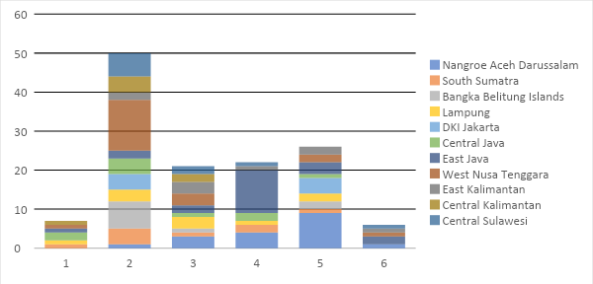
Source: HWDI, 2019
- The slow process of legal actions for women with disabilities victims of violence due to stigma and reluctance among police officers and family, for their incapable legally and unable to testify. Moreover, professional assistants such as psychologists or psychiatrists are not always available.
- The poor legal protection for women with disabilities is also depicted from the Law on Legal Aid that does not prioritise women with disabilities. Moreover, the said law does not include women with disabilities as a special group that is entitled for a special treatment, the legal aid provides service only for perpetrators, while the legal aid for victims is not regulated. According to LBH Apik The legal aid requested the most is for victims.
- In terms of data, even though the data for legal aid receivers are segregated between men and women, the data available in the Ministry of Law and Human Rights are not segregated by the types of disability, including women with disabilities. As a consequence, there is no legal aid available for women with disabilities who are facing legal matter, such as providing them with a sign language interpreter or an aide.
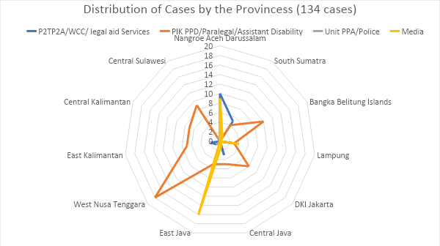
Source: HWDI, 2019
- On the other hand, the Bill of the Elimination of Sexual Violence has not yet been passed by Parliament. Whereas, this bill regulates special protection for women with disabilities who are prone to become a victim of sexual violence. The Article 45 of the Bill ensures that persons with disabilities have equal legal rights in testimonies and as witness in a trial.

The Proposed List of issues
        - There are many instances of sexual violence cases against persons with disabilities in Indonesia. How does Indonesian Government deal with it? How many cases of sexual violence against women with disabilities that have been filed? How many cases that have been processed, sent on trial with fair sentencing; how many perpetrators that managed to escape from punishment? Do victims receive legal remedies and compensation for their loss and suffering due to the crime?
        - How does Indonesian Government ensure the fulfillment of access to justice for women with disabilities? What steps that have been taken or being carried out; what are the targets that the Government tries to achieve? Does Indonesian Government have measurable plans to ensure that all components of law enforcers (police force, attorneys, and judges) have a disability perspective in handling the case?
        - How the Government of Indonesia ensure that the legal aid is accessible for persons with disabilities without discrimination? Within several years after the enactment of the Law on Legal Aid, please elaborate the number of women and children with disabilities that have received legal aid!

Marriage and family relations
- Article 23 of CRPD is adopted in Article 8 of Law No. 8/2016. There are challenges remaining in implementing this article due to social protection in the household is still weak. One of the significant problems are women with disabilities are still stigmatised and a stereotype that deems women with disabilities are not capable of handling domestic issues, let alone the public ones. This stigmatisation or stereotyping has lead to the occurrence of physical, psychological, economical and sexual violence against women with disabilities, committed by the spouse, family members, or society members. Mrs. MH, blind, lives in Jakarta and is married to a blind man, after having a child, the parents of MH took over the custody of the child, forbidding the couple to raise their child on their own.
- One case happened in East Kalimantan, where a 24-year old woman with intellectual disability and hearing disabilities was injected with contraception by force because her husband and family members were worried for her to get a child inflicted with the similar impairment.
- There is also a strong indication that many parents are ashamed to have a child with disabilities, so they are mostly hidden from the public, do not go to school, abandoned, or dumped. Such a case happened in East Java, where a woman was abandoned by her husband because she gave birth to a baby with facial cleft tessier hydrocephalus myelomeningocele.
- The Law No. 23/2004 concerning Domestic Violence protects family including children with disabilities from abandonment, however the law unabled to protect girls and wives with disabilities within the family. The cases of violation monitored by HWDI in Central Sulawesi, Bangka Belitung, Lampung, South Sumatera, and East Kalimantan.

Proposed List of issues:
What your country would do in the absence of a regulation that ensures the protection of women and children with disabilities who are in a marriage institution/in a family, especially in relation to abandonment, denial of rights, and exploitations?

Profil of Indonesian Association of Women with Disabilities (HWDI)

Contact person: Maulani A Rotinsulu - Chairperson
Address : Menteng Square Office & Apartement , Tower A, unit AR 01;
Jl. Matraman Raya No. 30E, Jakarta Pusat, Jakarta - Indonesia
Phone/Fax : +62 21 29614294;
email: rotinsulu.maulani@gmail.com; hwdi@hotmail.co.id; hwdi.info@gmail.com
Website: www.hwdi.org

A study by HWDI 2018-2019 on accessibility and reasonable accommodations in police services.
Article 5 number (2) of Law No. 8/2016 mentions: “Beside the rights of Persons with Disabilities mentioned in number (1), women with disabilities have the right to: a. health reproduction; b. agree or refuse to use contraception; c. receive extra protection from multiple discrimination;[1] and d. to receive extra protection from violence, including sexual violence and exploitation”.
Article 125 stipulates the provision of information service and quick response unit for women with disabilities who become a victim of violence; Article 126 stipulates the Central and Regional Government obligation to give a special protection; and Article 127 stipulates the provision of safe houses provided by the Government for women with disabilities who become a victim of violence.
Article 4 number (2) of the Law No. 1 Year 1974 on Marriage.
Article 39 of the Law No. 1 Year 1974 on Marriage.
There are various forms of violence against women with disabilities. It could manifest in the form of physical violence which in this report is categorised as rape; murder; battery; torture; abandonment; and sexual harrassment; psychological violence in this report is devided into stigmatisation, bullying, stereotyping, etc. Forms of discrimination among others are denied by school, requirements in the employment recruitment, etc. Exploitation can take the form of fraud and domestic violence.
The Government is allegedly reluctant to set up an independent commission that operates outside the Ministry of Social Affairs. The latest draft of Presidential Regulation on the Establishment of KND places the Commission under the purview of the Ministry of Social Affairs; DPOs oppose the plan arguing that KND will not operate independently if put under the Ministry. The Ministry, however, insists on executing the plan because of the budget cuts that make it difficult to set up a new, independent institution. The Government does not seek out other options to ensure the independence of KND and the institution’s future budgeting.
Report by Sentra Advokasi Perempuan Disabilitas dan Anak (SAPDA) year 2017
Research conducted by HWDI on October – December 2015 found that there are 85 cases of sexual violence against persons with disabilities in 22 provinces, with the following typology: 35% (36 cases) against persons with psychosocial disability, 7.08 % (6 cases) against blind persons (sensory disability), 27.06% (23 cases) against deaf persons, 8.24% (4 cases) against people with physical disability, 10.59 % (9 cases) against people with multiple disabilites, and 4.71 % (4 cases) against people whose type of disabilities are unidentified. Research conducted by HWDI in 2015
North Maluku Province Government Regulation No.5 year 2013, on the Protection and Services for women and children who become victims of violence Article 6, 8, and 11; East Kalimantan Province Government Regulation No. 1 year 2018, Pasuruan Municipality Government Regulation No. 4 year 2018 on the Empowerment and Protection of Women and Children, East Java Governor Regulation No.93 year 2018 on the Regional Action Plan for Gender Mainstreaming in East Java Province year 2018-2019.
It was discovered that the problems in handling the victims of violence and exploitation cases lay in the investigation process, which was caused by the lack of accessible facilities such as mobility, information and communication facilities. Whereas, in terms of service, there are four (4) aspects that have yet been fulfilled; assistance for the victim; the value of the testimony given by persons with disabilities (which is often deemed as legally incapable or is not qualified as a testimony); the rehabilitation of victims with disabilities; and institution. Report conducted on 2015 by ASEAN Disability Forum research on Sexuality & reproductive health of Persons with Disabilities
To this day, the case is being processed in the Palembang City Court.
Once it was uncovered, the victim’s mother reported this case to the police, but her husband (the perpetrator) took off and his whereabouts is still unknown.
The data from PIK PPD, HWDI Siodarjo
https://radarbromo.jawapos.com/2018/09/10/remaja-disabilitas-dikerjai-hingga-hamil-warga-lurug-polsek/
Another regulation related to disability education is Minister of Education Decree No. 34/2006 on Care Management of Children with Special Needs, Government Regulation No. 19/2005 on National Education Standards, Circular Note Director General Elementary and Secondary Education No. 380/C.C6/MN/2003 that encourages every regent to provide inclusive schools in their respective region. Minister of Education Regulation No. 16/2007 on Teacher Standards and Competency, where the standards of various competencies and skills of teachers in inclusive education institution are matched with their responsibilities as a class teacher, a councilor, and special teaching staff.
Case in point, the Minister of National Education Regulation No. 46 Year 2014 on Special Education and Services in higher education is not widely communicated, rendering the lack of implementation of this regulation and a fast number of higher education that are not accessible for different types of disability.
As an example, in a region in Central Sulawesi, in the appendix of the Regulation No. 10 Year 2017 on the Tuition Fee and Contribution to High Schools, Vocational Schools, and Special Schools stipulates the amount of tuition fees for special school students. It means that children with disabilities cannot have their education for free.
A student was denied entry to a vocational school not because she was not capable, but because she was deaf. Nevertheless, she was eventually accepted on the instruction of the Acting Governor’s wife. The mother’s victim together with PDOs in Aceh worked on the case. The case eventually reached and was responded by Acting Governor’s wife, so the victim could take the test to her favourite vocational school. She passed the test. The case occurred in July 2019.
Other known cases are as follows: - In Semarang,Central Java, 2019, rude and discriminatory treatment also happened to a deaf woman in a supposedly inclusive school, such treatment was committed by the teacher and headmaster. On top of that, her classmates also bullied her. Unfortunately, the school administration did not take any remedial actions and simply ignored the case. - In Central Lombok, West Nusa Tenggara, a mother of daughter with intellectual disability (slow learner) had to transfer her child to a special school because the administration in the previous school said that “she does not belong in this school”, because of this harsh comment, the the student refused to go to school because she was embarrassed and lost confidence - In Banda Aceh - 2016, a 10-year old girl with physical disability suffered from bullying and sexual harassment committed by her classmates until she had to leave the school. The perpetrator inserted his dirt-covered fingers to her vagina, which caused her pain and infection. She was taken to the local community health centre.
The case has been advocated by DPOs in Aceh. The victim’s parents had tried to explain the school administration concerning inclusive school and its obligation to accept their child. However, the school remained adamant.
HWDI continues to assist the victim and family with this case until she can go back to school again.
Findings from the observation conducted by HWDI Main Office and 15 regional offices in 2019. The case was handled by the police in collaboration with an advocacy NGO. The perpetrator was sentenced to 7-year imprisonment and ordered to pay restitution to the family of the victim.
“Disabled dentist finally appointed civil servant in West Sumatra”, 7 August 2019, https://www.thejakartapost.com/news/2019/08/07/disabled-dentist-finally-appointed-civil-servant-in-west-sumatra.html; see also, “Dentist in Sumatra finds dream crushed because of disability”, 10 July 2019, accessed from https://www.thejakartapost.com/news/2019/07/10/dentist-in-sumatra-finds-dream-crushed-because-of-disability.html
Case documented on November 2019 by HWDI Central Java
According to the information from the victim’s mother, when the incident struck, the victim worked as a laundress at many households in the neighbourhood, but she did not know who the perpetrator was because she didn’t suspect anyone because her daughter served many houses. Also the victim could not tell her family. Her mother did not see anything suspicious in the beginning because her belly looked normal. But when she was 5 month pregnant, the mother realised that her daughter was raped and got pregnant. Case documented on Oktober 2019 by HWDI team and the information was obtain from the victim’s mother.
There are also some hospitals that do not charge medical expenses for women with disabilities who become victims of violence such as Police Hospital and Lampung Regional Hospital. The limited hospital facilities for childbirth services for women with unstructured deformity. Another problem is the lack of communication skill among medical personnel to talk to persons with disabilities. Most Puskesmas buildings are not accessible.
Based on HWDI’s study 2014-2015 in Jakarta on teenage girls with disabilities awareness on health reproduction, involving 100 teenagers with disabilities as the respondents. A confession of the Director of Mental Rehabilitation Centre in East Jakarta in a training facilitated by HWDI.
Local House of Parliament or DPRD is willing to eliminate the protection for women with disabilities, with argumentation that there's no need any specification for the women with disabilities because it is just the same as the men with disabilities. On the other side, Local Regulation on Disabled Person in South Sulawesi eliminate the aspect of women with disabilities with the arguments that it has been regulated on the Local Regulation on Women and Girls, whereas this sectoral Local Regulation does not regulate disabilities issues.
A study by HWDI 2018-2019 on accessibility and reasonable accommodations in police services.
Several cases that can be collected are as follows: - In Pasuruan, East Java, 2018: a 20-year old woman with intellectual disability was raped repeatedly by her three neighbours until she was impregnated. The victim’s family initially settled the case conservatively by marrying her to the perpetrator. However, the perpetrator fled. The case was reported, however police found difficulties to get her testimony, the process took longer time. Similar case happened in Jember, East Java. The case was filed to the police department in May 2019, within six months the preliminary hearing was not accomplished. - In Central Java, a deaf-mute woman in Surakarta was raped and mugged by six men. During the investigation process, the police hired a sign language interpreter, which was different from that of the victim’s kind of sign. Moreover, the victim was not allowed to be assisted by any other parties. As a consequence, the testimony was misinterpreted and the police concluded that it was consensual, then the perpetrator charged for robbery only. - A similar case also happened in Bireun Aceh, May 2019 the case is still in process, a deaf-mute girl raped by her father’s friend in the perpetrator’s home, It happened repeatedly at different locations and the case is still being processed, however the progress is slow due to victim keep changing her testimony.
http://www.lbhapik.org
b. To start a family and to continue the family line through an official marriage; c. Respect for home and family.
Based on the Report by the National Commission on Women 2018.
Report by HWDI East Kalimantan office; case is documented in 2017.
The cases of violation monitored by HWDI in Central Sulawesi, Bangka Belitung, Lampung, South Sumatera, and East Kalimantan. - Such case happened in Central Sulawesi, where a 5-year old child with physical disability (paralysis) was abandoned by her father; her mother soon also left her to work abroad. At present, the child is under the care of the grandmother who raise the child without receiving financial support from both parents. (The grandmother’s victim reported this case to the provincial Social Service Offices. It provided her with supports, while the victim remained under her care. This case was found out in 2019). - The case of abandonment also occurred in Bangka Belitung Province against women with intellectual disability who was suffering from depression because her family has committed violence against her. She fought back by attacking her mother but she ended up being confined in a cage next to her house. She was not properly fed and had to urinate and defecate in the cage by digging the dirt. When it was found out, the PDO brought the case to the Social Office in the province. The organisation arranged a national health insurance (BPJS) for her. The parents of the victim denied responsibility, whereas the mental hospital could not accept her because she still had a family. She died a few years later (Victim is a mentee of an PDO in Bangka Belitung). - Married women with disabilities are also prone to violence and exploitation in the home. A case happened in South Sumatera, where a housewife (SS) became physically disabled due to an accident. She was 38 years old with one son. Her husband repeatedly beat her up and did not give her any money to buy daily needs. SS had to take odd jobs while her husband was unemployed. NN, a 35-year old women with physical disability was once married, got divorced, and returned to her family. She no longer received maintenance from her husband and must work hard in her family (The case was documented in 2017 by HWDI South Sumatera). - In Lampung, a 65-year old women who was blind must lived in an uninhabitable house because her own house was sold by her adopted child without her consent (The findings of HWDI Lampung observation in 2019) - An exploitation case against a child occurred in Samarinda, East Kalimantan, in 2018. The victim was the third child of seven siblings. He was a deaf-mute. The victim’s mother is a single parent dan did not have a fix job. He was forced to work as a parking attendant in a market to meet the family’s needs. From 6 children, he was the only one who was sent to school because of his disability (this case is handled in collaboration with several PDOs and education institutions. He is now back in school and the family was aware of the importance of his education.)

