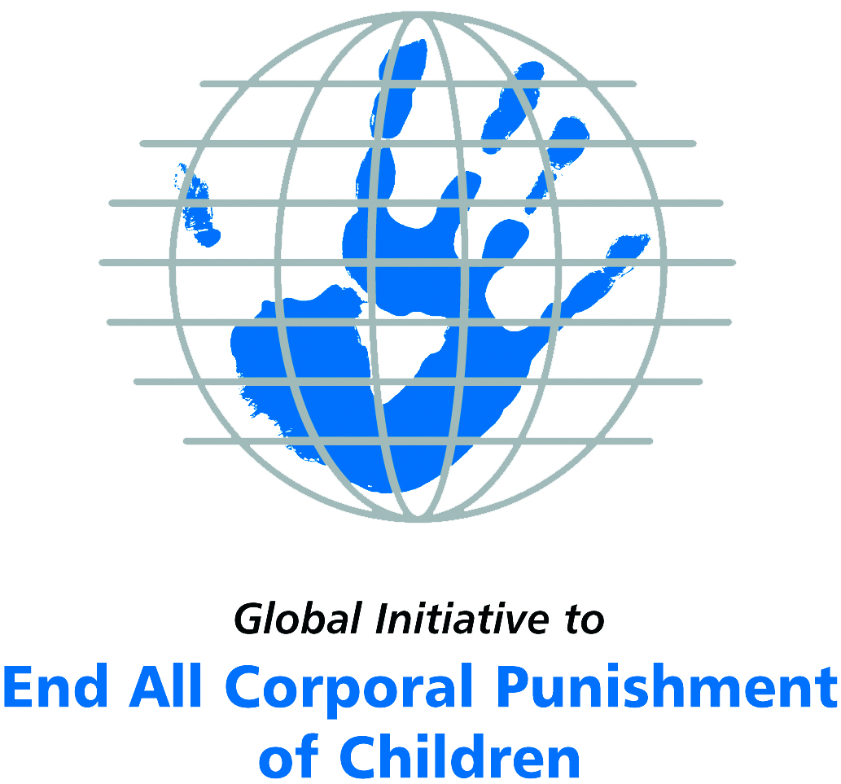
Briefing on Oman for the Committee on the Rights of Persons with Disabilities, 8th Pre-Sessional Working Group, September 2017
From the Global Initiative to End All Corporal Punishment
of Children, July 2017

(a) About the Global Initiative to End All Corporal Punishment of Children
1. The Global Initiative (www.endcorporalpunishment.org) promotes universal prohibition and elimination of corporal punishment in fulfilment of states’ obligations under the UN Convention on the Rights of the Child and other international treaties. Our aims are supported by UNICEF, UNESCO, human rights institutions and international and national NGOs. Since 2002, the Global Initiative has regularly briefed the Committee on the Rights of the Child on this issue, and since 2004 has similarly briefed the Committee Against Torture, the Committee on the Elimination of Discrimination Against Women, the Committee on Economic, Social and Cultural Rights, the Human Rights Committee and the Human Rights Council; we have briefed the Committee on the Rights of Persons with Disabilities since the beginning of its work.

(b) Summary
2. Corporal punishment of children in Oman is unlawful in schools and as a sanction for a crime, but it is not yet prohibited in the home, in alternative care and every day care setting, and in penal institutions, in violation of the fundamental right of all children to protection from corporal punishment and other cruel or degrading forms of punishment.
3. With reference to articles 7, 15, 16 and 17 of the Convention on the Rights of Persons with Disabilities, and in light of the particular vulnerability of children with disabilities to corporal punishment by adults, the jurisprudence of the UN treaty bodies, the emphasis on eradicating this form of violence given by the UN Secretary General’s Study on Violence against Children and the importance of the issue to achieving target 16.2 on ending violence against children in the 2030 Sustainable Development Goals, we hope the Committee on the Rights of Persons with Disabilities will:
- include the issue of corporal punishment in its List of Issues for Oman, in particular asking: “what steps have been taken to ensure that domestic legislation in Oman fully protects all children from violent punishment and explicitly prohibit its use in all settings including the home?”;
- recommend to the Government of Oman, in the Committee’s concluding observations on the initial report, that “prohibition of corporal punishment of all children in all settings is drafted and enacted as a matter of priority and that measures are put in place to ensure the law is properly implemented”.

(c) Detailed briefing
The right of children with disabilities not to be subjected to corporal punishment
4. The Convention on the Rights of Persons with Disabilities confirms that children with disabilities should enjoy all human rights and fundamental freedoms on an equal basis with other children (art. 7). The Convention also states that all persons have the rights to freedom from torture or cruel, inhuman or degrading treatment or punishment (art. 15), to freedom from exploitation, violence and abuse within and outside the home (art. 16) and to respect for their physical and mental integrity (art. 17). The jurisprudence of treaty monitoring bodies, led by the Committee on the Rights of the Child monitoring the Convention on the Rights of the Child, is clear that these rights put an obligation on states parties to prohibit and eliminate all corporal punishment of children, including within the family. However, the issue is not addressed in Oman’s initial state party report.
5. As confirmed in the UN Secretary General’s Study on Violence against Children, children with disabilities are particularly vulnerable to violence, including corporal punishment, and corporal punishment is a significant cause of impairment among children. Yet the obligation to prohibit corporal punishment is frequently ignored or evaded by governments. The near universal acceptance of violence in childrearing together with deeply held views that parents and other adults have a “right” to physically punish children can challenge efforts to achieve prohibition. It also means that corporal punishment – at least to some degree – is not readily perceived as violence in the same way as, for example, sexual and other socially unacceptable forms of violence.
6. The newly adopted Sustainable Development Goals under the 2030 Agenda include target 16.2 on ending all forms of violence against children. Violent punishment is the most common form of violence against children: ending it through the adoption and implementation of legislation prohibiting it in all settings including the home is critical.

The legality of corporal punishment of children with disabilities in Oman
7. Corporal punishment of children in Oman is unlawful in schools and as a sanction for a crime, but children with disabilities may lawfully be subjected to physical punishment in the home, in alternative care settings, in most day care settings and in penal institutions.
8. Corporal punishment is lawful in the home. Article 38 of the Penal Code 1974 states: “The following shall not be deemed a crime: … (2) Types of punishment imposed on children by their parents or teachers, within the limit of public customs….” Provisions against violence and abuse in the Basic Law 1996, the Code of Criminal Procedure 1999 and the Child Law 2014 are not interpreted as prohibiting corporal punishment in childrearing. In 2015, the Government reported to the Committee on the Rights of the Child that “protection of the child from corporal punishment is evident from the enactment of a considerable amount of penal legislation banning all forms of physical and mental violence against children, including corporal punishment, deliberate abuse and harm, mistreatment, neglect or exploitation to which children may be exposed in the family or foster family environment or in other types of care in public and private institutions, such as prison and school”. But as noted above, legislation not only lacks comprehensive prohibition of corporal punishment but specifically allows for punishment of children “within the limit of public customs”.
9. Corporal punishment is lawful in alternative care settings. There is no prohibition of corporal punishment in alternative care settings, where it is lawful as for parents. Children have limited protection under article 7 of the Child Law 2014.
10. Corporal punishment is lawful in early childhood care and in day care for older children, including for children with disabilities. There is no prohibition of corporal punishment in early childhood care and in day care for older children. Children have limited protection under article 7 of the Child Law 2014. Corporal punishment is possibly prohibited in preschools under education law. Regulation for kindergartens were adopted in 2012 (Ministerial Decree No. 212/2012): we have yet to see the text but have seen no indications that they prohibit corporal punishment.
11. Corporal punishment is unlawful in schools under the Organisational Statutes of the General Education Schools, which also state that students cannot be insulted or treated harshly. The only punishments permitted in schools are those allowed in Ministerial Decree No. 91/99, which does not include corporal punishment.
12. Corporal punishment is lawful as a disciplinary measure in penal institutions. There is no explicit prohibition of corporal punishment as a disciplinary measure in penal institutions. Special protection measures for juveniles deprived of their liberty are provided by the Prison Regulation System No. 28/94, but we have no details of its provisions. Children have limited protection under article 7 of the Child Law 2014.
13. Corporal punishment is unlawful as a sentence for crime. It is not a permitted sanction under the Code of Criminal Procedure 1999 and the Basic Law 1996 prohibits torture and degrading treatment. However, the Basic Law 1996 also states that Sharia is the “basis for legislation” (art. 2) and we have yet to confirm that this does not include judicial corporal punishment for children in conflict with the law. According to article 54 of the Child Law 2014, children in conflict with the law are dealt with under the Juvenile Accountability Law. The Government has reported that the Juvenile Accountability Law 2008 excludes corporal punishment as a sentence for crime but we have yet to confirm that juveniles cannot be sentenced to corporal punishment under Shari’a law.

Recommendations by human rights treaty monitoring bodies and during the UPR
14. The Committee on the Rights of the Child first raised the issue of corporal punishment of children in Oman in its concluding observations on the initial state party report in 2001, recommending that it be prohibited in the family and other settings. In 2006, the Committee reiterated its recommendations. Most recently in 2016, the Committee recommended that the Child Act 2014 be amended to include explicit prohibition of corporal punishment of children in all settings, and that the legal defence contained in the Penal Code be repealed.
15. During the Universal Periodic Review second cycle examination in 2015, the Government accepted a recommendation to explicit prohibit all corporal punishment of children in all settings including the home, adding that the recommendation was “in conformity with the Constitution, the teachings of the Islamic Sharia and the Omani society and culture”.

Briefing prepared by the Global Initiative to End All Corporal Punishment of Children
www.endcorporalpunishment.org; info@endcorporalpunishment.org

Pinheiro, P. S. (2006), World Report on Violence against Children, Geneva: United Nations. See also Krug E. G. et al (eds) (2002), World Report on Violence and Health, Geneva: World Health Organisation
28 January 2015, CRC/C/OMN/3-4, Third/fourth state party report, para. 76
Royal Decree No. 2008/30
28 January 2015, CRC/C/OMN/3-4, Third/fourth state party report, para. 78
6 November 2001, CRC/C/15/Add.161, Concluding observations on initial report, paras. 35 and 36, 47 and 48
29 September 2006, CRC/C/OMN/CO/2, Concluding observations on second report, paras 33, 34 and 35
21 January 2016, CRC/C/OMN/CO/3-4 Advance Unedited Version, Concluding observations on third/fourth report, paras. 6, 35 and 36
23 March 2016, A/HRC/31/2 Advance unedited version, Draft report of the Human Rights Council on its 31st session, para. 752

