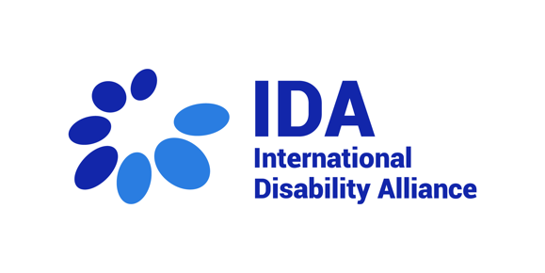
Opening 26th session of the CRPD Committee - 7 March 2022

Statement by Yannis Vardakastanis, Chair of International Disability Alliance

Distinguished members of the CRPD Committee, Ladies and Gentlemen:
I am pleased to deliver this statement as President of the International Disability Alliance.
Let me begin by referring to the current situation in Ukraine. The International Disability Alliance has made public its statement expressing our deep concern about persons with disabilities who are facing multiple barriers to access safe evacuation and humanitarian assistance. We cannot emphasize it more strongly: Military actions must end, all actors involved must respect and comply with their obligations under international humanitarian law and international human rights law, in particular Article 11 of the CRPD, to ensure protection and safety for persons with disabilities in Ukraine. This simply cannot wait!
Let me continue by applauding the efforts of the CRPD Committee for carrying out this 26th session in this hybrid format to ensure a full-time session. IDA does its best to adapt its support to national OPDs to online work.
We regret, however, the delays and uncertainties in decision making followed by very short timeframes for preparation and participation in the last period. We understand the this has been the impact of Covid-19 pandemic. Now the time has come for the Committee to consider the adoption of a fixed calendar coordinated with other Treaty Bodies and address the negative impact of the pandemic on its work. IDA is eager to learn about any plans by the OHCHR to support the Committee in recovering the time lost, especially of the session cancelled in March 2020, and about additional contingency measures to address the current backlog of State reviews. The Office of the High Commissioner needs to increase its efforts to ensure the necessary resources for the Committee, including sufficient human resources at the Secretariat.
Regarding the “digital shift”, reflecting for post-Covid19 times, IDA agrees that “State Party reviews should always be held in-person.” We also stress the need for ensuring, as the Committee has been doing, that there is always official time, with international sign and language interpretation, allowing for the participation of organizations of persons with disabilities in person, which could be complemented with online participation if needed.
Since the outbreak of the pandemic, the CRPD Committee has only reviewed three States. During this session, five States will be reviewed, and seven List of Issues will be adopted. Still, IDA believes the Committee should seek to increase country specific work in order to regain contact with more States and their national contexts and OPDs. Thus, fully reactivating and giving visibility to the procedure to Follow up to Concluding Observations.
IDA has great expectations on the upcoming General Comment on Article 27 of the CRPD, on work and employment. We encourage the Committee to work thoroughly to adopt the best document possible in a reasonable timeframe. Similarly, we understand the CRPD Committee will be reviewing the draft Guidelines on deinstitutionalization of persons with disabilities, including in emergencies, towards their adoption. Together with IDA’s members and other organizations, IDA looks forward to providing written inputs on the draft.
As the Committee has done, since 2018, and understanding that the European Disability Forum and other organizations might address this point, IDA would like to insist today and call States of the Council of Europe to fully respect CRPD standards prohibiting forced hospitalization and treatment and to take seriously the views of persons with disabilities and withdraw the proposal of an Additional Protocol to the Oviedo Convention.
Committee members,
To end on a positive note, the Global Disability Summit, co-hosted by the IDA and the Government of Norway in February, has been a great success. It included the participation of the Secretary-General of the United Nations and high-level representatives from UN member states. All regions of the world were represented.
Finally, we express once more our commitment to continuously support the work of the CRPD Committee, hoping for an in-person session in August.
I wish you a very productive 26th session.

Thank you.

