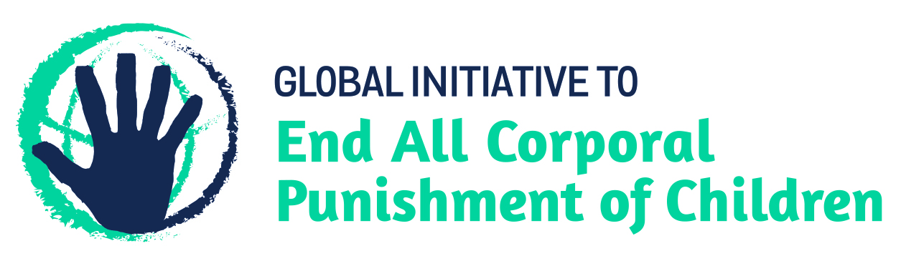
BRIEFING ON CANADA FOR THE COMMITTEE ON THE RIGHTS OF THE CHILD, SESSION 87 PRE-SESSIONAL WORKING GROUP – June 2020
From the Global Initiative to End All Corporal Punishment of Children, February 2020
This briefing describes the legality of corporal punishment of children in Canada. In light of the Committee’s General Comment No. 8 on “The right of the child to protection from corporal punishment and other cruel or degrading forms of punishment”, its repeated recommendations on the issue, the importance of eradicating this form of violence given by the UN Secretary General’s Study on Violence against Children, the recommendations to prohibit all corporal punishment made during the Universal Periodic Review in 2013 and 2018, and the global commitment to ending all violence against children in the context of the 2030 Agenda for Sustainable Development, we hope the Committee will:
- in its List of Issues for Canada, raise the issue of corporal punishment of children, in particular asking why the Government failed to support the Bill to prohibit all corporal punishment of children which was in discussion in the Senate between 2015 and 2019; and,
- in its concluding observations on the fifth/sixth report of Canada, recommend that legislation is immediately drafted and enacted to explicitly prohibit corporal punishment of children, in all settings including the home and throughout the territory, and repeal section 43 of the federal Criminal Code, as a matter of priority.

1 The report of Canada to the Committee on the Rights of the Child
  - In reply to the Committee’s previous recommendations on corporal punishment, Canada’s fifth/sixth state party report states that the federal Criminal Code and the province/territory level Child Protection Acts provide children with protection from violence. The report also acknowledges that section 43 of the federal Criminal Code provides a defence for parents and persons standing in the place of parents to use “reasonable force” against children, including for disciplining purposes.
  - The Government of Canada has given no indications of supporting law reform to prohibit all corporal punishment of children – a Bill to do so by repealing the defence (Bill S-206), which was first introduced in December 2015, failed when Parliament was prorogued in 2019. Canada committed to ending all forms of violence against children when it became a Pathfinder country with the Global Partnership to End Violence Against Children in February 2018. The state has an obligation under human rights law to enact legislation which protects children from all forms of violence, including all corporal punishment.
2 The legality and practice of corporal punishment of children in Canada
2.1 Summary: Corporal punishment of children is unlawful in schools and in the penal system in Canada. It is still lawful in homes and in alternative care and day care settings in some provinces/territories.
2.2 Home (lawful): Corporal punishment is lawful in the home. Section 43 of the Criminal Code 1985 (“Protection of Persons in Authority”) states: “Every schoolteacher, parent or person standing in the place of a parent is justified in using force by way of correction toward a pupil or child, as the case may be, who is under his care, if the force does not exceed what is reasonable under the circumstances.” A Supreme Court ruling on 30 January 2004 stated that this section justifies only “minor corrective force of a transitory and trifling nature” and that it rules out corporal punishment of children under the age of two years or over the age of 12 years, as well as degrading, inhuman or harmful conduct, discipline using objects such as rulers or belts and blows or slaps to the head.
2.3 In Quebec, the right to use “reasonable and moderate correction” on children was confirmed in the Civil Code 1866 (art. 245); the Civil Code 1977 stated that “the person having parental authority has a right to correct the child with moderation and within reason” (art. 245b). This article was repealed in 1980, but section 43 of the federal Criminal Code applies nevertheless.
2.4 In 2015, the report of the Truth and Reconciliation Commission of Canada, which aims to redress the legacy of residential schools and advance the process of Canadian reconciliation, calls on the Government of Canada “to repeal Section 43 of the Criminal Code of Canada”. The summary report of the Commission states: “Although it is employed much less frequently now, corporal punishment is still legally permissible in schools and elsewhere under Canadian law…. The Commission believes that corporal punishment is a relic of a discredited past and has no place in Canadian schools or homes.” In 2016, the Government stated that section 43 “provides a limited defence for parents who use minor corrective force toward a child under their care, if that force does not exceed what is reasonable under the circumstances” and added that without this defence, “parents who carry a child to their bedroom for a “time-out” could risk being convicted of assault”.
2.5 Numerous bills which would repeal section 43 of the Criminal Code have been introduced but failed to progress through Parliament. The latest, a private member’s bill to repeal section 43 of the federal Criminal Code (Bill S-206) passed second reading in the Senate in 2018 but did not progress further before prorogation of Parliament in 2019. Canada became a Pathfinder country with the Global Partnership to End Violence Against Children in February 2018. This commits the Government to three to five years of accelerated action towards the achievement of Target 16.2 of the Sustainable Development Goals. Despite this commitment, the Government noted recommendations to enact an explicit prohibition brought forward during the Universal Periodic Review in 2018.
2.6 Alternative care settings (partially lawful): Corporal punishment is prohibited in foster care in Alberta, British Columbia, Manitoba, Ontario and Quebec. There is no explicit prohibition in foster care in New Brunswick, Newfoundland, Northwest Territories, Nova Scotia, Nunavut, Prince Edward Island, Saskatchewan and Yukon. Corporal punishment is prohibited in state provided care in Alberta, British Columbia, Manitoba and Yukon. In Ontario, it is prohibited in provincially-licensed childcare programmes and foster homes, and for all children receiving services from a child protection agency or other service provider licensed or approved by the province.
2.7 Day care settings (partially lawful): Corporal punishment is prohibited in child care in all provinces and territories except Quebec.
2.8 Schools (unlawful): The 2004 Supreme Court judgement stated that teachers may not use corporal punishment, although they may use reasonable force to remove a child from a classroom or to secure compliance with instructions. This prohibition is not reflected in the laws of all provinces and territories. Corporal punishment is prohibited by law in state schools in British Columbia (School Act 1973), New Brunswick (Schools Act 1990), Newfoundland (Schools Act 1997), Northwest Territories (Northwest Territories and Nunavut Education Act 1995), Nova Scotia (Education Act 1989), Nunavut (Northwest Territories and Nunavut Education Act 1995), Prince Edward Island (School Act 1993), Quebec (Education Act 1997), Saskatchewan (Education Act 2005), Yukon (Education Act 1990) and Ontario (Education Act 2009). There is no legal prohibition in Alberta and Manitoba, though policy in many school boards states that corporal punishment should not be used.
2.9 Penal institutions (unlawful): Corporal punishment is unlawful as a disciplinary measure in penal institutions. We have no details of applicable law but in Quebec and presumably other provinces/territories prohibition is not explicit.
2.10 Sentence for crime (unlawful): Corporal punishment is unlawful as a sentence for crime under the Criminal Code. The relevant provisions were repealed in 1972.

3 Recommendations by human rights treaty bodies and during the UPR
3.1 CRC: The Committee on the Rights of the Child has three times expressed concern at corporal punishment of children in Canada and recommended it be explicitly prohibited in the home – in its concluding observations on the state party’s initial report in 1995, on the second report in 2003 and on the third/fourth report in 2012.
3.2 UPR: During the Universal Periodic Review of Canada in 2013, the Government rejected the recommendation to criminalise corporal punishment of children, defending the legal provision of a defence “in cases where minor corrective force of a transitory or trifling nature is used”. The Government noted recommendations to enact an explicit prohibition of corporal punishment in 2018, stating that “abusive conduct against children is prohibited under Canada’s Criminal Code”.

Briefing prepared by the Global Initiative to End All Corporal Punishment of Children
www.endcorporalpunishment.org; info@endcorporalpunishment.org

[2019], CRC/C/CAN/5-6, Fifth/sixth report, para. 68
Canadian Foundation for Children, Youth and the Law v Canada (Attorney General), file no. 29113
Truth and Reconciliation Commission of Canada (2015), Truth and Reconciliation Commission of Canada: Calls to Action, Call to Action No. 6
Truth and Reconciliation Commission of Canada (2015), Honouring the Truth, Reconciling for the Future: Summary of the Final Report of the Truth and Reconciliation Commission of Canada, page 144
13 September 2016, CAT/C/CAN/7, Seventh report, para. 213
18 September 2018, A/HRC/39/11/Add.1 Advance unedited version, Report of the Working Group: Addendum, para. 21
20 June 1995, CRC/C/15/Add.37, Concluding observations on initial report, paras. 14 and 25
27 October 2003, CRC/C/15/Add.215, Concluding observations on second report, paras. 4, 5, 32, 33 and 45
6 December 2012, CRC/C/CAN/CO/3-4, Concluding observations on third/fourth report, paras. 7, 8, 44 and 45
17 September 2013, A/HRC/24/11/Add.1, Report of the working group: Addendum, para. 24
11 July 2018, A/HRC/39/11, Report of the Working Group, paras. 142(213) and 142(214); 18 September 2018, A/HRC/39/11/Add.1 Advance unedited version, Report of the Working Group: Addendum, para. 21

