Submission to the UN Committee on Economic, Social and Cultural Rights (CESCR) for the review of the sixth periodic report by Italy
For-profit actors’ involvement in healthcare during the COVID-19 pandemic and its impact on the right to health in Italy
By the Global Initiative for Economic, Social and Cultural Rights
29 August 2022
Reliance on the private sector and market-based approaches to healthcare delivery in the region of Lombardy, Italy, contributed to the regions’ poor response to the COVID-19 pandemic, amongst other factors. Privatisation of services made it more difficult for Italy to protect the right to health at times of public health emergency.

Introduction
The Global Initiative for Economic, Social and Cultural Rights (GI-ESCR) is an international non-governmental human rights advocacy organisation. Together with partners around the world, GI-ESCR works to end social, economic and gender injustice using a human rights approach. We thank the Committee on Economic, Social and Cultural Rights for the opportunity to present this submission for your consideration.
A 2021 report by GI-ESCR entitled ‘Italy’s Experience during COVID-19: the Limits of Privatisation in Healthcare’, analyses how the characteristics of the healthcare system in Lombardy, Italy have influenced the region’s weak response to the COVID-19 pandemic.
The report summarises how successive regional governments have focused on increasing the role of private actors in healthcare while divesting in public healthcare provision under a market-oriented management approach. This also meant disinvestment in sectors that are comparatively less remunerative yet fundamental to protect the right to health, such as prevention, community-based healthcare services, family medicine, acute care and emergency care. For instance, Lombardy, one of the wealthiest regions in Italy and Europe, is one of the regions with fewer family doctors in Italy, with one family doctor for every 1,413 inhabitants against a national average of 1,232.
GI-ESCR’s report reflects on how these decisions in health policymaking influenced the pandemic response and health outcomes, with connected impacts on the right to health, which is enshrined in Article 32 of Italian Constitution as well as under Article 12 of the International Covenant on Economic, Social and Cultural Rights, which Italy ratified in 1978. The analysis is conducted through a comparison of the situation in Lombardy with the neighbouring region of Veneto, similar in terms of socioeconomic development, which was impacted by COVID-19 in the same month and yet fared significantly better in its pandemic response.

Context
In Europe, the first COVID-19 positive patient was found in the hospital of Codogno, Northern Italy, on 21st February 2020. Only one month later, Italy had already become one of the most affected countries worldwide, with more than 400,000 confirmed cases and 36,000 COVID-attributed deaths as of mid-October 2020. Within Italy, the pandemic severely hit Northern regions, while Southern ones were less impacted as Figure 1 (below) shows.
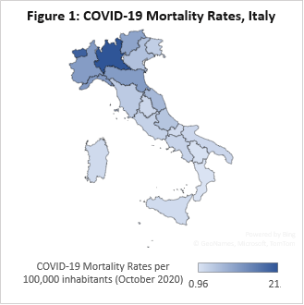
Lombardy, one of the wealthiest regions in Italy and Europe, struggled to cope with the pandemic. Military trucks were used to take coffins out of the region, which was struggling to deal with the sheer number of people dying from COVID-19. Medical staff described how Italy’s wealthiest region resembled a ‘world war’ scenario amidst the pandemic: patients flocked to public hospitals, healthcare frontline workers were left unprotected in war-like triages, and funerals took place without the bereaved. Meanwhile, the regional government paid private care homes to host COVID-19 patients, which had the collateral effect of spreading the virus amongst the elderly, a population at high-risk of contracting the virus.

Source: Italian Institute for Health data, available here at page 21. Own elaboration by Rossella De Falco, GI-ESCR.

A year later, Lombardy’s case fatality rate was the highest in Italy (5.7%), more than double the national fatality rate (2.4%) and significantly more than that of the neighbouring Veneto region (3.0%).

Italy’s obligations under the right to health
Article 32 of the Italian Constitution protects health as “a fundamental right of the individual” as well as a “collective interest”, guaranteeing “free medical care to the indigent”. Article 38 of the Constitution further warrants that: “workers shall be entitled to adequate insurance for their needs in case of accident, illness, disability, old age, and involuntary unemployment.”
At international level, Italy has signed and ratified the International Covenant on Economic, Social and Cultural Rights (ICESCR) whose Article 12 obliges States, inter alia, to take steps towards “the prevention, treatment and control of epidemic, endemic, occupational and other diseases”. Italy has thus a legal obligation to respect, protect and fulfil the right to health by ensuring quality health care services for all to the maximum of its capacities and available resources as per Article 2 of the ICESCR.
At regional level, Italy is also a party of the European Social Charter (1961, revised in 1966) which relates to healthcare in several articles, including Article 3 on health and safety at work, Articles 7 and 17 on the health of children and young adults, Article 8 and 17 on maternal health and Article 11 on public health.

The negative impacts of the growth of the private sector in healthcare delivery in Italy
The Italian National Health System (Servizio Sanitario Nazionale in Italian, hereinafter Italian NHS) was founded in 1978. The Italian NHS is financed through general taxation and provides healthcare services free of charge at the point of use. Based on the principle of solidarity, universality and financial protection from healthcare costs, the system translates into automatic universal access to healthcare services for all citizens, foreign residents and migrants holding residence permits. Access to the Italian NHS also includes a family doctor for each adult and a paediatrician for every child, free of charge. The package of benefits provided by this public healthcare system is very large ranging from inpatient to outpatient services within the country for both physical and mental health conditions. This includes, for instance, public health promotion, prevention, family medicine, general and specialised treatments in hospitals and clinics, emergency care (including ambulance services) as well as rehabilitation and long-term residential care.
The Italian Constitution grants legislative autonomy to the regions for the management of healthcare, leaving the central State responsible for collecting and allocating healthcare funds as well as establishing essential levels of guaranteed medical assistance. In 1992, a national law also introduced the system of ‘accreditamento’ in healthcare, allowing regional authorities to set a criteria that enabled the transfer of public funds to eligible private healthcare facilities. Patients would then pay different levels of co-payment depending on the accredited health facility they would choose. Private providers enjoy different levels of freedom regarding the services they deliver and the roles they play depending on the specific regions where they operate. As a result of these policies, the share of private hospital beds as a proportion of the total hospital beds in the country increased by 3.5% in 10 years, between 2007 and 2018. In 2018, 26% of healthcare services in Lombardy were provided by private institutions, 22% by accredited private institutions, and 52% (the lowest in Italy) by public institutions.²¹
The growth of private healthcare providers has been more notable in certain regions in Italy, such as Lombardy or Lazio, than in others, such as Veneto or Emilia-Romagna, reflecting different policy choices between regions. Lombardy started to deregulate its health system in 1997, allowing private providers to freely choose which services to deliver and to compete with public facilities for public funds. In contrast, the region of Veneto focused more on strong public governance, and ensuring publicly coordinated collaboration between providers rather than free market competition. This difference in approach has resulted in a stark difference in the organisation of the healthcare systems: in 2019, the private healthcare sector in Lombardy represented 41% of the total publicly funded health care services, as opposed to 30% in Veneto.

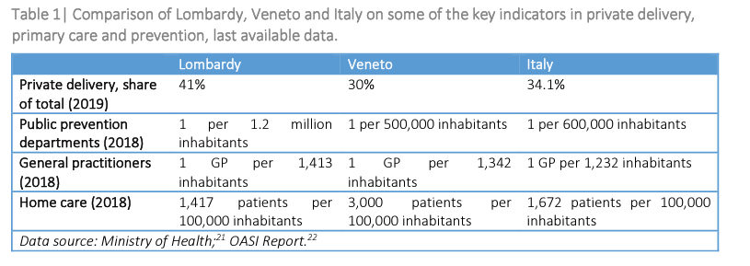

Lombardy’s health care system focuses more on market incentives, favouring income-generating and low-risk sectors, such as long-term residential care, at the expense of sectors considered less profitable such as home care. Home care enables patients to avoid paying for residential facilities and proved crucial in helping COVID-19 patients isolate at home without spreading the virus. However, home care, is difficult to manage and not financially rewarding. This may explain why in the more privatised region of Lombardy, home care reached only 1,417 patients per 100,000 inhabitants, compared to 3,000 in Veneto.
Similarly, Veneto has one public department of prevention for 500,000 inhabitants, compared to only one for 1.2 million inhabitants in Lombardy. The difference is even greater when it comes to public health laboratories, which are essential for analysing new viruses. In Lombardy, there is only one public laboratory for every three million inhabitants, while in Veneto, there is one public laboratory for 500,000 inhabitants. Lombardy is also one of the regions with fewer family doctors, with one family doctor for every 1,413 inhabitants against a national average of 1,232.

Comparing COVID-19 outcomes in Lombardy and Veneto: The different response when commercial actors are involved
Lombardy fared worse than Veneto both in terms of COVID-19 outcomes and health policy responses (see Table 1 above). In April 2020, Lombardy had a COVID-19 case fatality ratio almost three times higher than Veneto and registered 14% of infections among frontline healthcare workers, in contrast to 4% in Veneto.
Regarding COVID-19 testing, between 1st March and 28th April 2020, Veneto tested 7% of the population, while only 4% were tested in Lombardy. By 30th April 2020, the number of people tested in Veneto was 4.7% of the overall population compared to the national average of 2.1%. In July 2020, 21.6 tests per each positive case were performed in Veneto against 5.5 in Lombardy. Veneto’s epidemiological strategy, supported by public governance and provision and involving mass testing and collaboration between general practitioners and patients, was praised by international scientific literature.

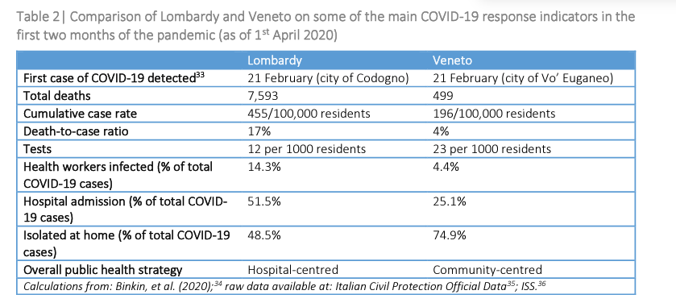

The connection between marketisation in healthcare and a weak response to the COVID-19 pandemic
Lombardy’s focus on treating patients in large hospitals while neglecting testing and tracking, proved to be a significant error. Studies in Vo and Veneto determined that testing and tracking were some of the most important strategies to contain the pandemic. However, as observed above, by July 2020, only 5.5 tests for every positive case were carried out in Lombardy compared to 21.6 in Veneto. Likewise, in Lombardy only 43.5% of patients were treated at home, compared to 74.9% in Veneto.
In addition, Lombardy entrusted much of its public health care system to private, profit-making companies while failing to coordinate their services. These private healthcare providers invested in lucrative specialties neglecting family medicine and public health. The region was then forced to spend a lot of time re-negotiating contracts with its private providers, which account for 40% of all healthcare delivery.
Finally, Lombardy mobilised only 14 acute-care beds per 100,000 inhabitants, below the Italian average of 15 (Veneto had 20 per 100,000). This finding is also associated with the legacy of privatisation in Lombardy because acute-care beds tend to correspond to less-remunerative treatments.

Questions and Recommendations to Italy
In light of the above, we urge the Committee to pose the following questions to Italy:
- Did Italy undertake ex-ante and post-facto human rights impact assessments of health policies aimed at increasing private actors’ involvement in healthcare delivery, and reliance on market mechanisms in the governance of healthcare in Lombardy, and if not, why?
- Why are the sectors of family medicine, preventative care, home care and acute care underdeveloped in Lombardy, despite their foundational importance for the enjoyment of the right to health, and what are the plans to develop these crucial sectors using the maximum available resources towards the realisation of the right to health in light of the impact of the pandemic?
- Is Italy planning to investigate the impacts of market-based approaches to healthcare on the capacity to prevent, respond and control public health emergencies such as the COVID-19 pandemic and future ones in Lombardy?
We propose the following recommendations be made to Italy:
- Ensure that the healthcare system in all regions in Italy is built on a strong, quality, coherently regulated non-commercial public sector, and any commercial private actor may only supplement and not supplant the public actors.
- Ensure that the involvement of private actors in healthcare does not compromise Italy’s capacity to respond to future crises or pandemics with the highest level of protection of the right to health for everyone under its jurisdiction

For more information, access our report: Global Initiative for Economic, Social and Cultural Rights, ‘Italy’s Experience during COVID-19: the Limits of Privatisation in Healthcare’ (June 2021), available here.

Contacts
Rossella De Falco, Programme Officer on the Right to Health, Global Initiative for Economic, Social and Cultural Rights, rossella@gi-escr.org
Ashina Mtsumi, Programme Officer for Public Services and Africa Representative, Global Initiative for Economic, Social and Cultural Rights, ashina@gi-escr.org

Global Initiative for Economic, Social and Cultural Rights, ‘Italy’s Experience during COVID-19: the Limits of Privatisation in Healthcare’ (June 2021) available at: Link.
Italian Ministry of Health, ‘Annuario Statistico del Servizio Sanitario Nazionale 2018’ (2018).
Milano Today, “Milano, primi casi di coronavirus accertati in Lombardia: 38enne ricoverato a Codogno” Milano Today (21 February 2020, accessed 6 April 2022) available at: Link.
Chirag Modi et al. “Estimating COVID-19 mortality in Italy early in the COVID-19 pandemic” (2021) 12 Nature Communications 2729.
Johns Hopkins Coronavirus Resource Center, “COVID-19 Map” (accessed 25 April 2022) available at: Link.
Istituto Superiore di Sanità, Case fatality rate of SARS-CoV-2 infection at regional level and across different phases of the epidemic in Italy. Version of January 20, 2021, (2021) Report ISS COVID-19 n. 1/2021 (in Italian). Available at: Link.
Ben Munster, ‘What made Italy’s wealthiest region so vulnerable to coronavirus’ (19 April 2020) New Statesman, available at: Link.
ANSA, ‘Coronavirus: Army takes Bergamo coffins out of Lombardy’ (19 March 2020) ANSA, available at: Link.
Peter S. Goodman, Gaia Pianigiani, ‘Why Covid caused such suffering in Italy’s wealthiest region’, (10 November 2020) The New Yorker available at: Link.
Maria Tavernini, Alessandro Di Rienzo, ‘The “massacre” of Italy’s elderly nursing home residents’, TRTWORLD. Availabe at: Link.
Istituto Superiore di Sanità (ISS), ‘Rapporto ISS COVID19’ (2020) available at: Link ; Mario Uselli. ‘The Lombardy region of Italy launches the first investigative COVID-19 commission’ (2020). The Lancet, 396(10262), e86-e87.
Constitution of the Italian Republic (drafted in 1946, entered into force in 1948), art. 32 [hereinafter Italian Constitution].
Italian Constitution, art. 38.
International Covenant on Economic, Social and Cultural Rights (ICESCR) (adopted 16 December 1966, entered into force 3 January 1976) 999 UNTS 3.
ICESCR, Art. 2.
Italy ratified the 1961 European Social Charter on 22/10/1965 and the Revised Social Charter on 5/07/1999, accepting 97 out of 98 paragraphs.
Law “Istituzione del Servizio Sanitario Nationale” No. 833 of 1978.
For more information on healthcare in Italy, see: WHO Europe, “Italy” (accessed 25 April 2022) available at: Link.
Italian Constitution, Title V, art. 117.
Essential levels of medical assistance guaranteed for free or with a co-payment by the Italian NHS are called: “Livelli Essenziali di Assistenza” (LEA).
Cecilia Quercioli, Gabriele Messina, Sanjay Basu and others, ‘The Effect of Healthcare Delivery Privatisation on Avoidable Mortality: Longitudinal Cross-Regional Results from Italy, 1993–2003’ (2013) Journal of Epidemiology and Community Health 67 2 132,138.
Julian Le Grand, ‘Quasi-Markets and Social Policy’ (1991) The Economic Journal 101 no. 408 1256. Elenka Brenna, ‘Quasi-market and Cost-containment in Beveridge Systems: The Lombardy Model of Italy’ (2011) Health Policy 103 2-3 209,218.
Stefano Neri, La regolazione dei sistemi sanitari in Italia e in Gran Bretagna (2006); Emanuele Pavolini, ‘Governance regionali: modelli e stime di performance’ (2008) La Rivista delle Politiche Sociali 3 149,177; Cristiano Gori, Il welfare delle riforme? Le politiche lombarde tra norme ed attuazione (2018).
Regional Law n.31, 11 July 1997.
Federico Toth, Mattia Casula and Andrea Terlizzi, ‘I servizi sanitari regionali alla prova del COVID-19’ (2020) Rivista Italiana di Politiche Pubbliche 15 307,336.
Camilla Costa ‘L’evoluzione dei sistemi sanitari regionali. Un’analisi degli assetti di governance e degli ambiti territoriali in veneto; Toscana; Lombardia ed Emilia-Romagna’ (2016) IRES- Istituto di – Ricerche Economiche e Sociali Veneto Novembre.
Osservatorio di diritto sanitario (OASI), ‘Rapporto OASI 2020’ (2020) Cergas Bocconi ss accessed 31 May 2021, p. 148.
Italian Ministry of Health, ‘Annuario Statistico del Servizio Sanitario Nazionale 2018’, p. 28, available at: Link.
Ibid, p. 21.
Nancy Binkin, Federica Micheletto, Stefania Salmaso, and others, ‘Protecting Our Health Care Workers While Protecting Our Communities during the COVID-19 Pandemic: A Comparison of Approaches and Early Outcomes in Two Italian Regions’ (Preprint, 2020) Public and Global Health.
Italian Ministry of Health, note 27, p. 22.
Ibid.
Alta Scuola di Economia e Management dei Sistemi Sanitari (ALTEMS), Università cattolica del Sacro Cuore, Analisi dei modelli organizzativi di risposta al Covid-19: Focus su Lombardia, Veneto, Emilia-Romagna, Piemonte, Lazio e Marche (2020).
Giacomo Mugnai and Claudio Bilato, ‘Covid-19 in Italy: Lesson from the Veneto Region’ (2021) European Journal of Internal Medicine 77 161,62.
Enrico Lavezzo et al., ‘Suppression of a SARS-CoV-2 Outbreak in the Italian Municipality of Vo’’, (2020) Nature 584 7821 425,29.
Ibid.
Nancy Binkin, Federica Micheletto, Stefania Salmaso, and others, ‘Protecting Our Health Care Workers While Protecting Our Communities during the COVID-19 Pandemic: A Comparison of Approaches and Early Outcomes in Two Italian Regions’ (Preprint, 2020) Public and Global Health.
Ibid.
Peter S. Goodman and Gaia Pianigiani, Why COVID caused such suffering in Italy's wealthiest region (10th Nov 2020) The New Yorker, available at: Link.
Maria Elisa Sartor, ‘Niente è in grado di sostituire la sanità pubblica, nemmeno in Lombardia: note sulla prima settimana di emergenza available at: Link ; See also Peter S. Goodman and Gaia Pianigiani, Why COVID caused such suffering in Italy's wealthiest region (10th Nov 2020) The New Yorker, available at: Link.
Federico Toth, Mattia Casula and Andrea Terlizzi, ‘Regional Health Services and the Challenge of COVID-19’ (2020) The Italian Platform for the Humanities and Social Sciences, 15 307,336.

