Abortion in the UK - United Nations International Covenant on Economic, Social and Cultural Rights Submission

A response from members of the We Trust Women coalition

Background
  - We are a group of clinical organisations that provide abortion services, produce clinical guidance for the provision of abortion care, and are professional organisations for clinicians providing abortions.
  - We advocate for the rights of women, girls and people who can become pregnant to access abortion care, and for changes to the law to better reflect the provision of safe, up to date abortion services across the UK and beyond.
  - Abortion (or Termination of Pregnancy) has been referenced by the UK Government in their May 2022 submission to the 7th Periodic Report (para 158-161) with regards to Northern Ireland and the Isle of Man, where – as a result of intervention by non-government Parliamentarians, in conjunction with campaigners – abortion has been legalised since the last period review. Similar progress has been made in Gibraltar, another British Overseas Territory. Progress towards full realisation of abortion rights, such as by the decriminalisation of women or the removal of required waiting times has been made in Guernsey and Jersey, two more British Overseas Territories.
  - We remain concerned, however, about the operation of abortion law within the UK, most particularly regarding (1) the criminalisation of women and medical professionals, (2) the ability to access and provide care free from targeted harassment, and (3) the comprehensive provision and funding of abortion care services in Northern Ireland. The failure of the UK Government to act on these measures, we believe, contravenes Article 3, Article 4, and Article 12 of the International Covenant on Economic, Social and Cultural Rights.

Abortion in the UK
  - Abortion is the most common gynaecological procedure in the world – one in three women will access abortion care in their lifetime. Circa 230,000 abortions are provided across the UK every year.
  - Despite this, abortion care still remains marginalised, stigmatised, and separate from other forms of comparable healthcare. Specialist organisations - like BPAS and MSI Reproductive Choices - continue to provide high quality, dedicated care, but abortion’s positioning outside the rest of the health sector acts as a message to women that abortion is not a part of standard women’s healthcare. This message has been further embedded amongst the sector in recent times through the near exclusion of abortion from the UK government’s Women’s Health Strategy and the absence of a Sexual and Reproductive Health Strategy.
  - We firmly believe that abortion is a cornerstone of reproductive healthcare and should be treated as such. Ultimately, the primary barriers we face today surround the limits placed on clinical provision and innovation by the Abortion Act 1967 and the underlying Offences Against the Person Act 1861. This has paved the way towards a campaign calling for full decriminalisation of abortion across the UK in order to remove the procedure from the criminal justice system – a place reserved for no other healthcare procedure but abortion.
  - In addition to this, other barriers include harassment from anti-abortion groups towards service users and clinic staff at the gates of clinics across the UK, as well as a chronic lack of provision in Northern Ireland. Despite clinicians’ repeated attempts to provide much-needed abortion care in Northern Ireland , the failure to commission services in the country forces dozens of women each month to travel to England for care, even though abortion is now legal in Northern Ireland.

Legal position

England and Wales
    - In England and Wales, abortion is governed by the Abortion Act 1967, managed by Westminster. This law made abortion legal in specific fixed circumstances.
    - The underlying law consists of s58 and s59 of the Offences Against the Person Act 1861 (throughout pregnancy), and s1 of the Infant Life (Preservation) Act 1929 (post-28 weeks) – both of which provide for the criminalisation of anybody, including clinicians and women, who end a pregnancy. In practice, this only applies where abortions are undertaken outside the provisions of the Abortion Act 1967.

Scotland
    - In Scotland, abortion is governed by the Abortion Act 1967, control over which has been devolved to the Scottish Parliament at Holyrood. This law placed a framework for abortion provision on top of underpinning common law, under which causing or procuring abortion remains a criminal offence.Northern Ireland

Northern Ireland
    - In Northern Ireland, abortion was decriminalised up to 28 weeks as a result of the Northern Ireland (Executive Formation Etc) Act 2019, which repealed s58 and s59 of the Offences Against the Person Act 1861 in the province. Abortion is now legal without condition in Northern Ireland up to 12 weeks. After that, it is legal in specific circumstances that broadly align with the Abortion Act 1967 (in operation across the rest of the UK).
    - The UK government in Westminster was placed under a legal obligation to ensure that abortion in Northern Ireland, up until then legal only to preserve a woman’s life (R v Bourne [1938]), was available and accessible. Without delivering on this obligation, the UK would continue to violate the rights of women and girls in Northern Ireland as established by the Committee on the Elimination of Discrimination against Women (CEDAW) in its 2018 inquiry.
    - The Abortion (Northern Ireland) Regulations (No.2) 2020 completed the removal of women and medical professionals from the criminal law by disapplying s25 of the Criminal Justice Act 1945 which criminalises abortion beyond 28 weeks, as well as provided a legal framework for provision.

Decriminalisation in England, Scotland, and Wales
  - Abortion remains a criminal offence under the Offences Against the Person Act 1861 (and similar common law provisions in Scotland). This means that having or providing an abortion remains a crime that carries a maximum penalty of life imprisonment, and is legally equivalent to rape, child-stealing, and blowing someone up with gunpowder.
  - Under the Abortion Act 1967 women can access abortion care, but only if it is signed off by two doctors, takes place in a hospital, premises approved by the Secretary of State for Health, or – as a result of Parliamentary amendment to the law in 2022 – at a woman’s home prior to 10 week’s gestation, and meets one of the seven criteria that allows abortion. Any woman who undergoes an abortion without the permission of two doctors – for example by ordering pills online – can be prosecuted and receive a life sentence as her abortion takes place outside of the Act. As it stands, not wanting a child is not a legal reason for having an abortion in Great Britain.

The law in action
  - As of January 2023, there are three women in England who are facing charges under the law related to abortion. We are further aware of multiple instances where women have been investigated by the police, detained in police stations, and at least once case where a woman was arrested in hospital while recovering from surgery .
  - When women end pregnancies under these circumstances they are often extremely vulnerable, making tough choices within a very complex set of personal circumstances, and they often experience mental health issues.
  - The current law means that these women are being criminalised when they are in need of support.
  - Examples of cases include:
    - Gloucestershire, 2023 – A couple were charged in January 2023 with a series of offences under abortion law dating back to 2018 for allegedly ending a pregnancy when they were both 18 years old with illegally obtained medication, and concealing the foetal remains. The case has been committed to the Crown Court for hearing.
    - Oxford, 2021 – A migrant woman self-administered medication that is used in abortions and induction of labour. She was taken to hospital where the doctors performed a successful emergency C-section, and then reported her to the police because they found the remnants of abortifacient medication in her vagina. She is now a parent to a toddler, but was set to be prosecuted for attempted procurement of a miscarriage until charges were dropped in December 2022.
    - London, 2020 – A woman was admitted to hospital in need of a surgical procedure to empty her uterus after a stillbirth at 24 weeks as a result of abortion care sought within the formal healthcare system. While on the ward post-procedure, she was arrested by police, taken to the police station, and kept in a police cell for 36 hours. In July 2022 the investigation into her was re-opened.
    - England, 2020 – A 15-year-old girl was investigated by the police after a stillbirth at 28 weeks, accused of illegal abortion. It only concluded when the coroner found that the pregnancy had ended as a result of natural causes.

Proposals
  - It is our strong belief that there is no public interest in the prosecution of women under abortion law, and indeed a detrimental impact on the provision of safe, legal abortion and post-abortion care while abortion remains within the criminal law.
  - It is our opinion that the existing law contravenes women’s Article 8 (Private and Family Life) and Article 14 (Non-Discrimination) rights, and places medical professionals who provide this care at enhanced risk of criminalisation. The criminalisation of women is out of step with best practice, human rights standards, and countries across the world, including even the USA, Poland, and Saudi Arabia – and the potential life sentence carried by the archaic legislation is the harshest sentence in the world.
  - One woman who was jailed for two years for ending her own pregnancy in England reported to the press in 2022 ‘“I felt I had no other choice than to [plead guilty]” she says. “The prosecution said if I didn’t plead guilty, they would charge me with child destruction, and I would likely go to prison for life.”’
  - Criminalising abortion care forces clinicians to choose between the best interests of the person they are treating, and the law. It restricts access and limits treatment options. For example, nurses cannot administer medicines for abortion despite administering the exact same medicines regularly for other forms of healthcare, such as miscarriage treatment.
  - We therefore support the full decriminalisation of abortion. Removing consensual abortion from the criminal law means it would be subject to the same laws and regulations that govern all healthcare procedures and would be regulated in the same way as maternity care, for example.

Safe access zones
  - In recent years, increased anti-choice activity has become more common outside abortion clinics. This problem is widespread, organised, and persistent, with individuals and groups seeking to dissuade or deter access to, or the provision of, abortion care.
  - Across the UK, at least 60 clinics and hospitals have been targeted by anti-abortion groups in recent years, affecting more than 100,000 women who attend an abortion clinic every year.
  - Clinic harassment describes activity used by anti-abortion groups across the UK to deter or prevent women accessing abortion care. This takes many forms, including the display of graphic images of dismembered foetuses, large marches that gather outside the clinic, the filming of women and staff members, following women down the street, sprinkling sites with holy water, and large gatherings of people who sing hymns and recite dedicated anti-abortion prayers loudly enough to be heard inside clinics. Even solitary and silent vigils can be distressing, especially to vulnerable women and those with mental health issues.
  - This activity can last several hours a day over a number of weeks or months. In several cases around the country, this activity has continued for many years. Even seemingly innocuous behaviour such as handing out leaflets has a negative impact, as leaflets routinely contain false medical information such as that abortion causes breast cancer, leads to suicidal ideation, and can lead to child abuse. None of these claims are substantiated by any credible clinical evidence. The activity is widespread and affects a large number of clinics.
  - 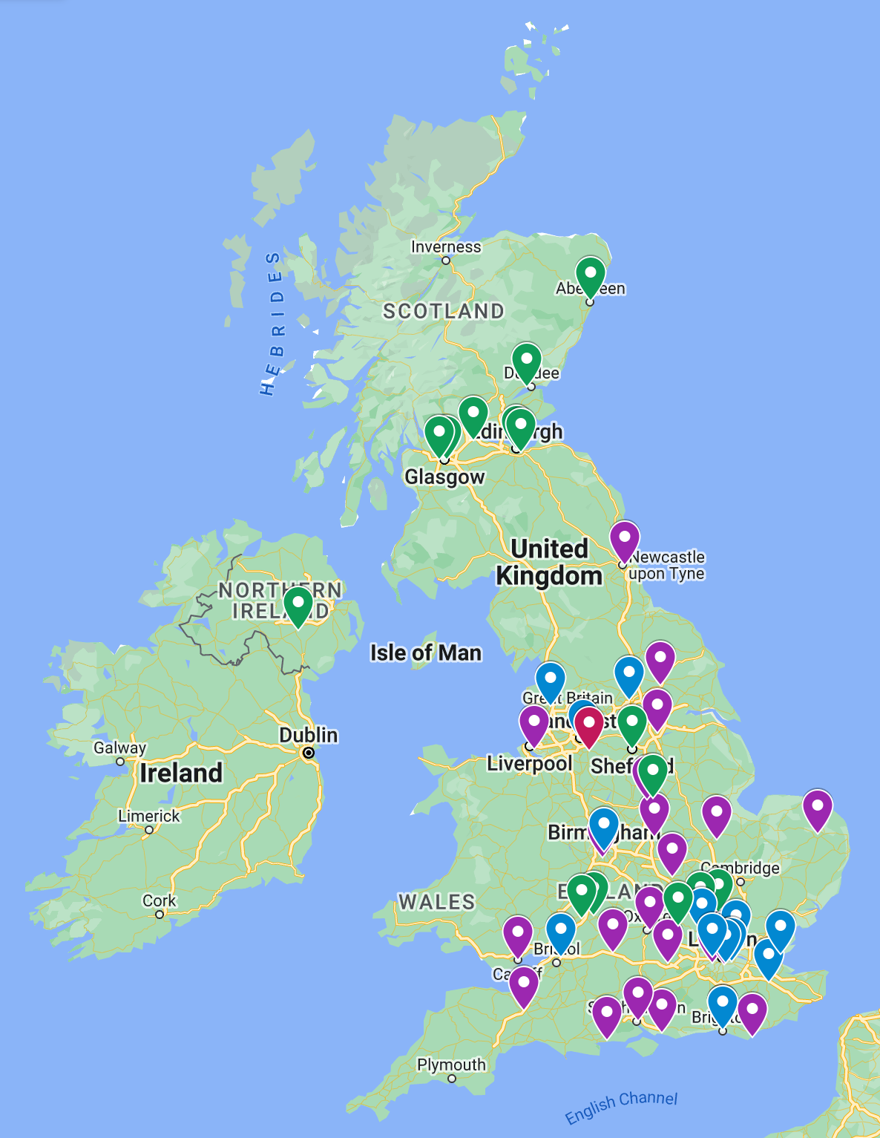
Figure 1 - Map of clinical sites reporting presence of anti-abortion groups, 2018-2022

  - Recently, groups have been handing out advertisements for medication to ‘reverse’ an abortion even though it can have significant side-effects and there is no evidence that it is effective, despite costing women huge sums. This is an issue that is only getting worse. Accounts from women and staff affected by this harassment include:
    - “They came over twice and we said ‘no thank you’. She was very pushy, in your face… it has left me anxious as I suffer from poor mental health. When we walked past she said ‘Your baby wants to live’. We had driven for 7.5 hours and did not expect this at all.” – Bournemouth, April 2022
    - “They were hurling abuse as I came out of the clinic, saying I’m a disgrace, that I’m a horrible person and what I’m doing is an abomination.” – Liverpool, December 2021
    - “She watched me driving around and looking for a space, then approached me and was saying ‘do not kill your baby’ and something about God. It made me feel emotional and scared. I was already worried and unprepared to be approached. I was crying and it affected my mental health. I was scared to go in.” – Birmingham, October 2021
    - “She told me that I should let God decide – that it will torture me for the rest of my life and don’t let them do it. She told me her daughter couldn’t have kids and I’m wrong for killing a baby…” – Liverpool, February 2021
    - “There was a man in the entrance lobby – my colleague didn’t know what to do. He wouldn’t leave. He asked if this is the place where ‘you kill babies’, if I ‘agree with murdering babies’, and whether I was ‘happy to murder foetuses’.” – Staff member, Brighton, October 2020

Current actions
  - At the current time, there is a patchwork of different laws to enable protection for women accessing abortion care:
    - England and Wales – five clinics (of 50 affected) have in place a geographical buffer to prevent anti-abortion harassment immediately outside. These are obtained through local councils using anti-social behaviour legislation, are limited in scope, and have to be renewed every three years. The first of these zones was upheld in full throughout the court system in England and Wales, but each zone is also subject to legal challenge from anti-abortion groups who disagree with their individual introduction. This is hugely costly for councils and acts as a disincentive to take action.
    - Scotland – There is currently no law in place in Scotland to address anti-abortion harassment although First Minister Nicola Sturgeon has committed to finding a solution and held a summit focused on addressing the challenges.
    - Northern Ireland – There is currently no law in place in Northern Ireland to address anti-abortion harassment. A law was passed by the previous Assembly prior to dissolution, and was challenged in the UK Supreme Court by the Northern Ireland Attorney General. The Supreme Court upheld the law in full in December 2022, but it has not yet been implemented.

Proposals
  - To combat this issue, we support the introduction of safe access zones. A ‘Safe Access Zone’ (sometimes known as a buffer zone) is an area in which it is illegal to harass or intimidate someone in relation to a healthcare procedure they are undertaking. These zones stop activity taking place directly outside clinics and hospitals, but do not have any impact on protests or activity anywhere else. They would apply equally to pro- and anti-choice groups, ensuring that those accessing abortion care (or indeed any other forms of healthcare, at premises which also provide abortion) are not harassed.
  - National legislation for buffer zones at all facilities ensures consistency of approach and mitigates possible postcode lottery situations for patients and staff, as well as any possibility of protestors moving from one area to another which can happen under a local approach.
  - There has been progress made in each part of the UK towards the introduction of buffer zones. These measures, however, have all had to be brought about by non-government parliamentarians, with patchy government support and – in the case of Westminster – active government opposition. The passage, implementation, and legal defence of these zones remains an active concern for abortion providers and pro-choice advocates.

Abortion care in Northern Ireland
  - In October 2019, abortion in Northern Ireland was decriminalised as a result of a law passed by the Westminster Parliament. When in operation, the Northern Irish government has refused to progress with the commissioning or delivery of abortion services, leaving Westminster’s Secretary of State for Northern Ireland to deliver on his legal responsibilities to ensure the availability and accessibility of abortion in Northern Ireland.
  - At the current time, Early Medical Abortion services up to 10 weeks are available across the province, with minimal access beyond this point. There is a heavy reliance on a small number of conscientious providers who have sought to provide services without sustainable funding and often in the face of both governmental and administrative opposition. Services have in recent years been precarious, and in some parts of the province ceased for prolonged periods.
  - As a result, hundreds of women each year are still required to travel to other parts of the UK to access their legal right to abortion care.
  - Abortion care providers are concerned by uncertainty about the permanency of the service, some are operating abortion services single-handed, and post-Covid restoration of other services has reduced their capacity to provide care.
  - At the same time, Northern Ireland remains the only part of the UK where administration of mifepristone – the first medication in an Early Medical Abortion – is not legally allowed outside a licensed healthcare setting, making access for women unreasonably difficult.

Proposals
  - Although undeniable progress has been made in Northern Ireland, its maintenance and expansion is heavily reliant on Westminster and sympathetic ministers. At the current time, the Northern Ireland Assembly is not sitting, which has enabled progress to be made regarding commissioning and funding – however, when the Assembly sits again, there is a very real risk that anti-abortion sentiment in government will halt or reverse progress.
  - Recommendations should be made to the Northern Irish government that progress must be supported from within the province, and that the Minister responsible for roll-out must not be a roadblock to realisation of women’s rights there.

Recommendations
  - The Westminster and Scottish Governments must fully decriminalise abortion in England, Scotland, and Wales. Decriminalisation must:
    - repeal s58, s59 and s60 of the Offences Against the Person Act 1861, and the Infant Life (Preservation) Act 1929 in England and Wales
    - legislate to nullify common law that criminalises abortion in Scotland
    - provide for a new crime of intentionally or recklessly causing non-consensual abortion, expanding the current provisions of law that are applied to violent partners and family members who use violence, coercion, or poisoning to end a pregnancy against the woman’s will
    - issue a moratorium on all ongoing investigations and prosecutions under the current law related to abortion where the woman involved consented to the abortion
    - free any women currently serving prison sentences for ending or attempting to end their own pregnancies, and
    - commence a comprehensive pardon scheme for all women who have been cautioned or found guilty under the laws in (a) and (b) to remove contravention of this law from their criminal records
  - Governments across the UK must introduce legislation for and/or implement the provision of safe access zones around all sites that provide abortion care, including fully defending any resultant court challenges from anti-abortion groups
  - The Westminster and Northern Irish governments must ensure improved access to abortion care in Northern Ireland, including but not limited to:
    - issuing regulation immediately to allow the provision of telemedical abortion services,
    - the comprehensive commissioning of abortion services across Northern Ireland,
    - a sustainable funding settlement for the provision of care via the NHS,
    - the continued funding of travel to other parts of the UK where abortion care is unavailable in Northern Ireland,
    - governmental support from within the province for provision of the service.

Signatories
  - British Pregnancy Advisory Service (BPAS)
  - British Society of Abortion Care Providers (BSACP)
  - Faculty of Sexual and Reproductive Healthcare (FSRH)
  - MSI Reproductive Choices
  - Royal College of Obstetricians and Gynaecologists (RCOG)

https://www.legislation.gov.uk/ukpga/1967/87
https://www.legislation.gov.uk/ukpga/Vict/24-25/100/crossheading/attempts-to-procure-abortion
Infant Life (Preservation) Act 1929 https://www.legislation.gov.uk/ukpga/Geo5/19-20/34
A Practical Treatise on the Criminal Law of Scotland, 5th edn, J Walker and D J Stevenson (1948) p114
https://www.legislation.gov.uk/ukpga/2019/22/section/9/enacted
Report of the inquiry concerning the United Kingdom of Great Britain and Northern Ireland under article 8 of the Optional Protocol to the Convention on the Elimination of All Forms of Discrimination against Women, CEDAW/C/OP.8/GBR/1. 23 Feb 2018.
https://www.legislation.gov.uk/uksi/2020/503/made
https://www.legislation.gov.uk/apni/1945/15/section/25
https://www.oxfordmail.co.uk/news/20083264.woman-24-court-accused-procuring-abortion/
https://www.thesun.co.uk/news/11690506/police-probe-death-of-unborn-baby-after-woman-has-illegal-abortion-by-post-at-28-weeks-four-weeks-past-limit/
https://www.gloucestershire.police.uk/news/gloucestershire/news/two-charged-in-connection-with-searches-made-in-cirencester-and-swindon-in-2020/
https://www.nationalworld.com/news/crime/abortion-uk-police-investigate-women-illegal-abortions-england-wales-us-states-bans-3749526
https://www.independent.co.uk/news/uk/home-news/woman-police-custody-stillborn-birth-b2111991.html
https://www.thetimes.co.uk/article/lauras-story-jailed-for-having-an-abortion-in-britain-0m06nzrlx

