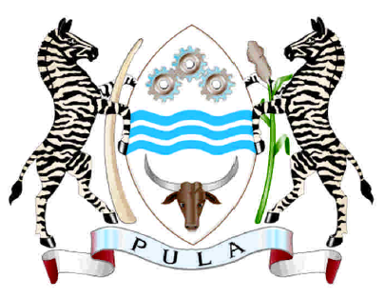

REPUBLIC OF BOTSWANA

Note No. 02/2019- GEN/E/106 II (10) FS II

The Permanent Mission of the Republic of Botswana to the United Nations Office and other International Organisations at Geneva presents its compliments to the Office of the High Commissioner for Human Rights and has the honour to submit a delegation list for Botswana’s participation at the 72nd Session of the Committee on the Elimination of Discrimination against Women scheduled from 18 February to 8 March 2019 as follows:

- Honourable Ngaka Ngaka - Head of Delegation
Minister of Nationality, Immigration and
Gender Affairs

- Dr. Athaliah Molokomme - Alternate Head of Permanent Representative Delegation
Permanent Mission of Botswana to the
United Nations, Geneva

- Mr. Dittah Molodi - Delegate
General Counsel
Ministry of Presidential Affairs, Governance
and Public Administration

- Mr. Motse Otlhabanye - Delegate
Deputy Permanent Secretary
Ministry of Nationality, Immigration and
Gender Affairs

- Ms. Hellen Kgotlhang - Delegate
Director, Department of Social Protection
Ministry of Local Government and
Rural Development

- Ms. Phemelo Maiketso - Delegate
Deputy Director
Ministry of Nationality, Immigration and
Gender Affairs

- Mr. Gaumakwe Phologo - Delegate
Deputy Permanent Representative
Permanent Mission of Botswana to the
United Nations, Geneva

- Ms. Lesego Mokganya - Delegate
Principal Health Officer II
Ministry of Health and Wellness

- Ms. Sophie Mautle - Delegate
Minister Counselor
Permanent Mission of Botswana to the
United Nations, Geneva

- Mr. Michael S. Keorapetse - Delegate
Counselor-Labour
Permanent Mission of Botswana to the
United Nations, Geneva

- Mr Collen Diane - Delegate
Senior International Affairs Officer
Minister of International Affairs and
Cooperation

- Mr. Bolokang Motshwane - Delegate
First Secretary
Permanent Mission of Botswana to the
United Nations, Geneva

- Ms. Bokani Sesinyi - Delegate
First Secretary
Permanent Mission of Botswana to the
United Nations, Geneva

The Permanent Mission of the Republic of Botswana to the United Nations Office and other International Organisations at Geneva avails itself of this opportunity to renew to the Office of the High Commissioner for Human Rights the assurances of its highest consideration.

11 February 2019
GENEVA

Office of the High Commissioner for Human Rights
GENEVA

