Appendix 1:
Translation by the Ministry for Foreign Affairs

GOVERNMENT OF ÅLAND 8 May 2014

Ministry for Foreign Affairs
Legal Service
P.O. Box 176
00023 Government

STATEMENT IN RESPONSE TO THE ADDITIONAL QUESTIONS MADE BY THE COMMITTEE ON ECONOMIC, SOCIAL AND CULTURAL RIGHTS RELATING TO THE SIXTH PERIODIC REPORT OF FINLAND ON THE IMPLEMENTATION OF THE INTERNATIONAL COVENANT ON ECONOMIC, SOCIAL AND CULTURAL RIGHTS

On 19 March 2014 the Ministry for Foreign Affairs requested a statement of the Government of Åland (Ålands landskapsregering) concerning the additional questions made to Finland by the Committee on Economic, Social and Cultural Rights after considering the sixth periodic report of Finland on the implementation of the International Covenant on Economic, Social and Cultural Rights. In reply to the request the Government of Åland states the following:

The International Covenant on Economic, Social and Cultural Rights contains provisions that fall within the competence of the Province of Åland. According to the Act on the Autonomy of Åland ("the Autonomy Act", ÅFS 1991:71) the province has legislative powers in respect of, inter alia, the officials of Åland, the collective agreements on the salaries of the employees of Åland (section 18(2)), health care and medical treatment (section 18(12)), social welfare (section 18(13)), and education and culture (section 18(14)).

When the Åland Parliament (Ålands lagting) accepted the entry into force in the province of the act to bring into force the provisions of a legislative nature of the Optional Protocol to the International Covenant on Economic, Social and Cultural Rights (FFS 108/2014), the Parliament declared at the same time that it also accepts the entry into force in Åland of the decree to bring into force the Covenant (FFS 6/1976).

The States Parties to the Covenant are obliged to report continually on the national implementation of the Covenant to the Committee on Economic, Social and Cultural Rights. Finland submitted its sixth periodic report to the Committee in July 2011. The report covers a period of five years as from 1 July 2005. After considering the report the Committee has made some additional questions to Finland.

The Government of Åland points out that its statement issued to the Ministry for Foreign Affairs in July 2010 for the sixth periodic report of Finland was omitted from the final report sent to the Committee. Therefore, none of the additional questions now presented concerns Åland. Nevertheless, the Government of Åland answers the additional questions in respect of the province, as a follow-up to its statement of July 2010. The questions falling within the competence of the State are not answered. Neither does the Government of Åland answer those questions for which no information or statistics are available.

Article 1 – self-determination

The Constitution of Finland guarantees the autonomy of the Province of Åland to its residents on the basis of the (contemporary) system of government. The autonomy is also guaranteed by international law, in accordance with the resolutions of the League of Nations of 24 and 27 June 1921: the Åland Agreement of 27 June 1921 stipulates that Finland is "resolved to assure and to guarantee to the population of the Aaland Islands the preservation of their language, of their culture, and of their local Swedish traditions".

On the basis of the Autonomy Act, the Province of Åland has far-reaching autonomy, which includes legislative and administrative powers delegated from the national Parliament and Government. The legislative powers are divided between the national Parliament and the Åland Parliament in accordance with the Constitution and the Autonomy Act. The State cannot amend legislation in areas falling within the autonomy.

Article 2 – anti-discrimination

3. Please provide updated information concerning the process of adopting comprehensive anti-discrimination legislation which would afford the same level of protection and access to an independent equality body with regard to different grounds of discrimination in line with article 2 of the Covenant (E/C.12/FIN/6, paras.12–16).

The Åland Parliament enacted new anti-discrimination legislation in 2005. In December 2005 the Parliament enacted a provincial act on the prevention of discrimination in the Province of Åland (ÅFS 2005:66) and a provincial act on the Discrimination Ombudsman (ÅFS 2005:67). It appears from the texts of both acts that the purpose of the legislation is to combat and prevent discrimination based on ethnic origin, religion or other conviction, disability, age, sexual orientation or comparable reasons. Furthermore, the Discrimination Ombudsman has supervisory duties related to gender discrimination.

Section 6 of the provincial act on the Discrimination Ombudsman (ÅFS 2005:67), as last amended (by act ÅFS 2007:81), stipulates that the Ombudsman supervises compliance with the provincial act on the prevention of discrimination in the Province of Åland (ÅFS 2005:66). The supervision covers those areas which fall within the legislative powers of the province.

According to section 6 of the provincial act on the Discrimination Ombudsman, the Ombudsman has the following mandate:
1) through advice and in other ways, to contribute to the person who is subjected to discrimination being able to pursue complaints and in other ways exercise his/her rights,
2) to carry out independent investigations and publish independent reports on discrimination,
3) to give recommendations on issues concerning discrimination,
4) to monitor practice, collective agreements, policy documents and statutes regarding the terms of employment for civil servants,
5) to hold a dialogue with Åland’s non-governmental organisations with an interest in preventing discrimination,
6) to provide information on provisions regarding discrimination, and
7) to strive to effect reconciliation between parties if the reconciliation can be expected to have a deterring effect for the purpose of preventing future discrimination.

According to section 2 of the provincial act on the Discrimination Ombudsman, the Ombudsman is an independent authority headed by the Province of Åland.

Article 3 – gender equality

6. What follow-up and monitoring mechanisms are in place to effectively implement gender equality policies and programmes throughout the State party?

The Government of Åland prioritises the promotion of gender equality in all its activities and has adopted a framework programme for related activities in the province for the years 2012–2015. The overall objective of the promotion is to give women and men the same freedom and the same powers to build society and their own lives. The priorities in the promotion of gender equality are education, employment, bodily integrity of women, power, norms and identity.

Moreover, the Government of Åland has set up an expert council on gender equality to develop the gender equality policy in the province and to follow up the framework programme for gender equality.

Statistics disaggregated by gender provide facts and information describing the conditions and circumstances of girls/women and boys/men, and are a precondition for implementing the gender equality objectives. The Government of Åland publishes annually an annex on gender equality funds to the budget of the province.

The Government of Åland has started to promote gender equality systematically in the field of child day care. In 2010 and 2011, the staff concerned built up their awareness of gender equality and tested different methods of making current attitudes, expectations and work practices visible from a gender perspective. The Government of Åland is now mainstreaming the launched approach throughout all child day care activities in the province in order to build high and equal quality for both girls and boys.

Furthermore, in 2014 the Government of Åland launched a project targeted at young people and focusing on the question how the social norms for maleness can be challenged and changed. In the long run, the promotion of gender equality among young people serves to prevent violence.

Article 10 – protection of families, mothers and children

13. Please provide updated information on the cases of human trafficking for sexual exploitation and forced labour during the reporting period, including the number of cases brought before the courts and the outcome of court cases in terms of remedies provided to victims and sanctions imposed against perpetrators.

So far, no cases on human trafficking have been brought before the courts in Åland. According to section 27(22) and section 27(23) of the Autonomy Act, criminal law and the administration of justice fall within the legislative powers of the State.

The Government of Åland is responsible for spreading information and working actively on values and attitudes with a preventive purpose, and for being prepared to help possible victims of trafficking. In October 2013 the Government of Åland decided to set up a network of authorities to combat prostitution and human trafficking for sexual exploitation in 2013–2015 in accordance with the framework programme for the promotion of gender equality in Åland 2012–2015. The network exchanges experience of combating prostitution and human trafficking for sexual exploitation and constitutes a strategic resource for developing, and increasing the efficiency of, related co-operation, above all the co-operation among different authorities but also between authorities and volunteer organisations. Co-operation, knowledge and awareness of the different aspects of human trafficking for sexual exploitation are the fundamental prerequisites for identifying victims and perpetrators of trafficking and for developing a professional and emphatic approach to the victims.

14. Please provide updated statistics concerning acts of violence against women, including domestic violence.

The latest available statistics on violence against women are from 2012. In 2012, the police in Åland received a total of 147 reports on assaults. In 64 of these reports, i.e. in 43.5% of them, the victim was a woman.

Regarding the scene for the assaults against women, the statistics show the following:
Petty assault: 5 in dwellings 15 elsewhere
Assault: 24 in dwellings 15 elsewhere
Aggravated assault: 3 in dwellings 2 elsewhere.

In 2012, the total number of reported sexual offences was 8, of which 2 were committed in dwellings and 6 elsewhere.

During the current electoral period, the Government of Åland has prepared an overall strategy for work on the bodily integrity of women in the province. The purpose is to translate the existing practice and knowledge based research information on the impacts of violence on children, women and men into target-oriented measures to ensure that those in need of support and assistance are in fact supported and assisted.

The committee on the bodily integrity of women has the following mandate:
• to make society take measures to support and protect persons vulnerable to violence in close relationships
• to make society undertake preventive work and identify those values and norms which maintain violence
• to make an inventory of the duties and responsibilities of the authorities and actors concerned in the work against violence in close relationships
• to make an inventory of the needs of different actors for co-operation and collaboration partly within their own activities and partly between their activities.

In 2014, a new resource and know-how centre against violence in close relationships is planned to start operating in Åland. The centre will provide co-ordinated expert assistance to victims of violence in close relationships.

Articles 13 and 14 – the right to education

21. Please provide statistical data on school dropout rates at primary and secondary levels of education, disaggregated by gender and ethnicity.

All children domiciled in the Province of Åland are subject to compulsory schooling. A child of compulsory school age must attend basic education or obtain knowledge corresponding to the basic education syllabus at another school or at home. Compulsory schooling ends when the child has completed the basic education syllabus or when ten years have passed since the schooling begun. For children with disabilities, compulsory schooling ends 11 years after its beginning. The duration of upper secondary education in the Province of Åland is three years. Both general upper secondary education and vocational upper secondary education are available. The upper secondary education is based on basic education and is open for all on application. The Government of Åland determines the admission requirements at this level of education.

The dropout rates in upper secondary education in Åland in recent years are shown below:

Dropouts in three-year upper secondary education programmes in Åland in 2010–2013
Year Students Dropouts Female Male
total total
2010 | 1,146 | 36 | 14 | 22
2011 | 1,135 | 45 | 25 | 20
2012 | 1,104 | 39 | 19 | 20
2013 1,073 62 27 35
______________

Source: Statistics and Research Åland. The figures do not contain adult education.

22. Please provide information on equal access to education by Roma, Somali, migrant, refugee and asylum-seeking children.

All children subject to compulsory schooling in the Province of Åland are offered an opportunity to complete the compulsory schooling in a comprehensive school or a corresponding school for children with hearing or sight impairments. Every school pupil has the right to attend the comprehensive school for his or her own school district. Thus, all children domiciled in the province have equal access and equal right to basic education.

The language of tuition in the comprehensive schools in Åland is Swedish. Pupils who have moved to the province from elsewhere may, at the beginning, have problems with school because of their deficient knowledge of Swedish. The schools, for their part, try to help pupils moving from elsewhere adjust to the new circumstances.

Pupils identified with problems are offered remedial teaching of Swedish. This teaching is intended for pupils who have moved to the province at most five years ago. For this purpose, the local authorities allocate a sufficient number of lessons and choose teachers who can provide the pupils with the necessary and adequate remedial teaching of Swedish. The Government of Åland supports the local authorities financially in organising the remedial teaching.

23. With regard to the school curricula, please indicate what measures are being taken to teach the culture and history of the Sámi and of national minorities in schools in a holistic manner throughout the State party.

According to the core curriculum for basic education in Åland, the comprehensive school has an important role in ensuring that the pupils learn to respect other population groups and linguistic groups. Human rights and civil rights are discussed during lessons in civics, in particular.

Article 15 – cultural rights

24. Please provide information on the availability of media outlets (newspapers, television and radio) in languages other than Finnish, including Russian and other ethnic minority languages.

It is problematic for the monolingual Province of Åland that the scope of application of copyright treaties is often delimited territorially by state. Therefore, the province cannot receive all parts of the broadcasting from Sweden via television and the Internet. Linguistic minorities need access to cultural information and news in their own language from other countries, but the current territorial limits set by international copyright law hamper the access.

The broadcasting from the 2014 Olympics in Russia is an example of the impossibility of receiving Swedish broadcasts in Åland. Because the Finnish Broadcasting Company YLE transmitted all in-depth reports, interviews and analyses in Finnish, people in Åland could not follow the broadcasts from the Olympics in their entirety in the same manner as the Finnish-speaking population in Finland. The situation seems to remain the same for the Summer Olympics of 2016, unless a special solution can be worked out with the Swedish holder of the broadcasting rights and YLE.

Another problem for Åland relating to access to the Swedish media is that individual consumers in the province cannot have access to free or paid Swedish applications for mobile telephones and tablet computers, because of the so-called geo-blocking. Similarly, teachers in Åland have no access to different pedagogical tools and other pedagogical material in Swedish on the Internet. It is a major disadvantage for Åland both pedagogically and culturally that the province has no access to such material from Sweden.

The Government of Åland is concerned about the proposal to amend the Value Added Tax Act (1501/1993) which the national Government submitted to the national Parliament recently. According to the proposal, value added tax would be imposed on imported newspapers and magazines subscribed to. The proposed amendment makes it more costly to subscribe to newspapers and magazines in Åland, because all subscriptions are delivered over the taxation boundary. The purpose of the Autonomy Act is to guarantee the population of Åland its Swedish language, culture and local customs and to ensure that the population can arrange its circumstances independently within the limits of the constitutional position of the province. The proposed amendment of the Value Added Tax Act is not in line with these purposes, because the opportunity to subscribe to Swedish newspapers and magazines is important for the population of the province as a means for maintaining and using their Swedish language and Swedish culture. The Government of Åland considers that the proposal, in practice, amounts to discrimination against the Swedish-speaking population in Åland compared to the Finnish-speaking population in the Finnish mainland when it comes to opportunities of access to publications in one's own native language.

26. Please provide information on the measures taken by the State party to ensure affordable access to the benefits of scientific progress and its applications for everyone, including disadvantaged and marginalized groups. Please also indicate the measures taken for the conservation, development and diffusion of science and culture and to encourage and develop international contacts and cooperation in the scientific and cultural fields.

As to the right of everyone to enjoy the benefits of scientific progress, the Government of Åland considers it problematic that two standard publications consulted frequently by health care professionals in Finland – entitled Current Care Guidelines and Pharmaca Fennica – are available only in Finnish.

The Current Care Guidelines publication consists of national evidence-based clinical practice guidelines covering important issues related to Finnish health, medical treatment and prevention of diseases. The guidelines are intended as a basis for treatment decisions, and can be used by physicians, healthcare professionals and citizens. The Current Care Guidelines are commonly used as reference for the diagnostics and treatment of a large number of diseases in Finland.

Pharmaca Fennica provides essential information on the dosage, interaction and side-effects of medicines. Corresponding information is not available in a clinically usable manner in any other form. Consequently, when searching information for the prescription of medicines, Finnish-speaking health care professionals do not follow any other common procedure besides consulting Pharmaca Fennica. The Ministry of Social Affairs and Health trusts the commercial publishing of information of the Pharmaca Fennica type in Finland. As a result, such information is published only in Finnish, because the Swedish-speaking target group in the country is too small for the profitable publishing of related commercial products in Swedish. Åland has, since 2005, drawn the attention of the Ministry to the problems caused by the lack of a Swedish Pharmaca Fennica.

The Government of Åland estimates that the prevailing situation not only prevents health care professionals in Åland from enjoying the benefits of scientific progress and its applications within the meaning of article 15 of the Covenant but also amounts to a security risk for patients.

The Government of Åland will supplement its comments on the additional questions if considered warranted later.

Roger Nordlund
Deputy Premier

Wille Valve
Minister

Appendix 2: A summary of Social Guarantee for Young People Working Group
The Government Programme includes implementation of a social guarantee for young people, requiring that each person younger than 25 years and each recent graduate under 30 years of age be offered work, a traineeship, or a study, workshop or labour market rehabilitation place within three months of becoming unemployed.
Lauri Ihalainen, Minister of Labour, has appointed a working group to prepare proposals enabling the full entry into force of the social guarantee for young people from the beginning of 2013.

Goals

The social guarantee for young people requires wide-ranging collaboration between different actors in the society. The broad-based working group is seeking solutions to how all young people can be provided with the competencies needed in working life, how to recognise the need for support, and how to ensure that employment services meet the challenges posed by the social guarantee for young people.
In this, the working group’s aim is to find ways of enabling graduates to find employment which corresponds to their skills, and to make employers eager to help young people enter work. In addition, measures are being sought to promote entrepreneurship among young people. The working group is also preparing proposals for enhancing working life in a way which places a greater emphasis on the meaning of work to young people.
The Social Guarantee for Young People Working Group is chaired by Director-General Tuija Oivo of the Ministry of Employment and the Economy. Working group members represent different ministries, the Social Insurance Institution Kela, the Association of Finnish Local and Regional Authorities, Finnish Youth Cooperation – Allianssi and labour market organisations.
Appendix 3: Labor discrimination cases reported to the police
Year | Labor discrimination Reports to police for pre-trial investigation (all areas of responsibility together) | Labor discrimination  Statements to police/prosecutor  (all areas of responsibility together)
2010 | 41 | 75
2011 | 59 | 80
2012 | 48 | 94
2013 | 62 | 92

Appendix 3a: Labor discrimination cases
Number reported | 2005 | 2006 | 2007 | 2008 | 2009 | 2010 | 2011 | 2012 | 2013
DISCRIMINATION | 43 | 61 | 50 | 57 | 45 | 37 | 51 | 43 | 46
LABOR DISCRIMINATION | 47 | 59 | 69 | 63 | 54 | 74 | 93 | 81 | 70
EXTORTIONATE LABOR DISCRIMINATION | 5 | 14 | 14 | 13 | 44 | 31 | 31 | 39 | 29
Total | 95 | 134 | 133 | 133 | 143 | 142 | 175 | 163 | 145

Appendix 4: Human trafficking cases
Human trafficking cases in pre-trial investigation by police and Finnish Border Guard | 2005 | 2006 | 2007 | 2008 | 2009 | 2010
HUMAN TRAFFICKING | 4 | 2 | 1 | 5 | 2 | 11
AGGRAVATED HUMAN TRAFFICKING | 1 | 1 | 0 | 2 | 0 | 1

Appendix 4a: Number of cases of trafficking in lower courts 2010-12

Penal code 25:3§1-2 Trafficking in human beings
2010 -
2011 -
2012 6

Penal code 25:3a§1-2 Aggrevated trafficking in human beings
2010 -
2011 1
2012 1

Penal code 17:8§1 Organising illegal entry to the country
2010 40
2011 32
2012 34

Penal code 17:8a§ Aggrevated organising illegal entry to the country
2010 5
2011 6
2012 2

Penal code 20:8§1-2 Abuse of a victim of sex trade
2010 5
2011 -
2012 -

Penal code 20:9§1 Pandering
2010 21
2011 5
2012 4

Penal code 20:9a§1 Aggrevated pandering
2010 6
2011 -
2012 2

Penal code 47:3a§ Extortion-like discrimination in the labour market
2010 4
2011 3
2012 8

Penal code 47:6a§ Employment of illegal foreign labour
2010 5
2011 3
2012 2
Appendix 4b:

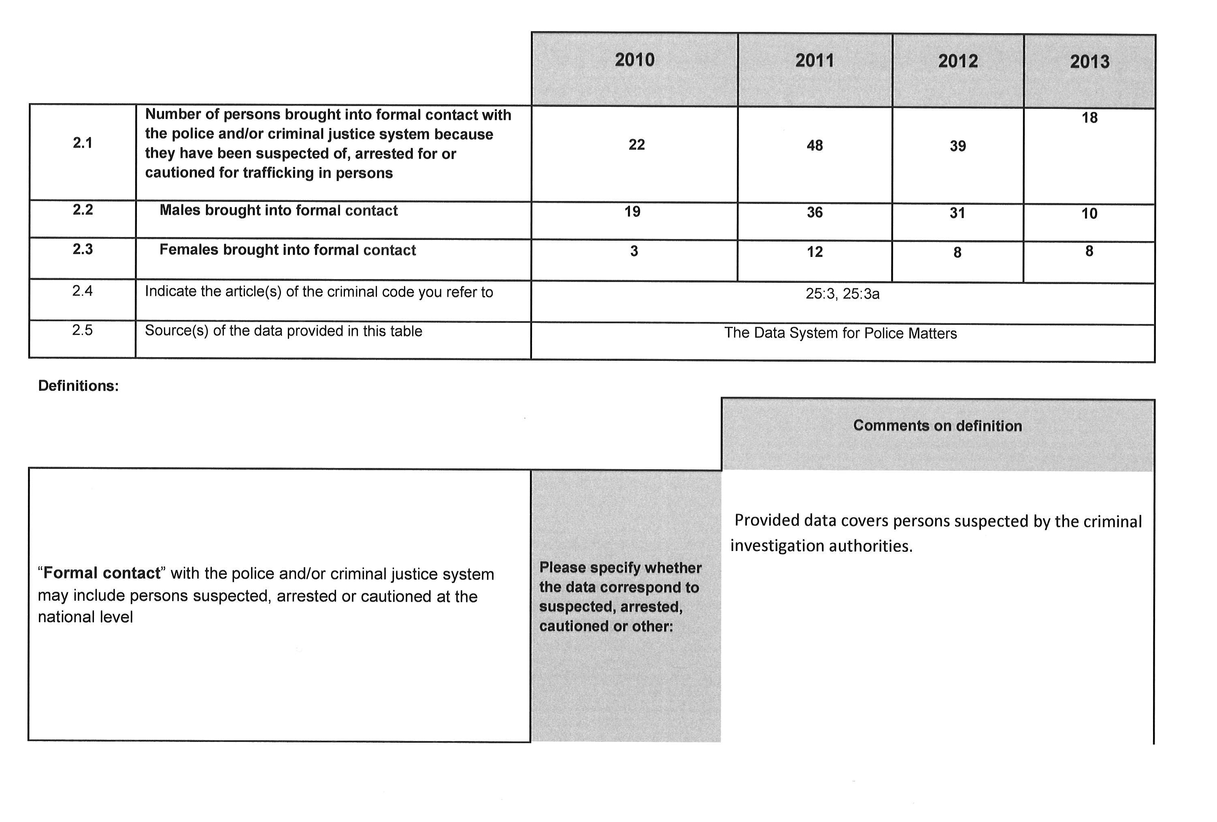

Appendix 5:
Relationship between the parties in homicides against women between 2007 and 2013 (Source: Homicide database of the National Research Institute of Legal Policy, Homicide survey 2014)
Relationship between victim and perpetrator | 2007 | 2008 | 2009 | 2010 | 2011 | 2012 | 2013*
Spouse | 10 | 11 | 12 | 0 | 11 | 7 | 9
Cohabitant | 4 | 5 | 5 | 7 | 3 | 2 | 3
Partner | 10 | 6 | 5 | 5 | 2 | 3 | 1
Ex-spouse/partner | 2 | 3 | 2 | 4 | 6 | 5 | 4
Total | 48 | 44 | 34 | 26 | 40 | 41 | 26
*Preliminary data
65% of adult female victims had been killed by a spouse, partner or an ex-partner, while in 10% of cases the killer was another close relative. Six per cent of men had been killed by a spouse, partner or an ex-partner, less than one per cent by a same-sex partner and seven per cent by another close relative. The data are based on homicides committed between 1 January 2003 and 31 December 2012 that had been registered in the homicide monitoring system by 20 January 2014.

Appendix 5a: 24 April 2014

CRIMINAL CASES DECIDED BY DISTRICT COURTS IN 2012 AND 2013
 | 2012 | 2013
Assault¹ | 8,310 | 7,955
Aggravated assault² | 791 | 741
Minor assault³ | 429 | 351
Negligent homicide, grossly negligent homicide⁴ | 102 | 101
Negligent bodily injury, grossly negligent bodily injury⁵ | 237 | 246
Sexual abuse of a child, aggravated sexual abuse of a child⁶ | 397 | 515
Employment offenses⁷ | 143 | 159
Total | 10,409 | 10,068
1) includes the following titles of offense: assault and attempted assault
2) includes the following titles of offense: aggravated assault and attempted aggravated assault
3) includes the following titles of offense: minor assault
4) includes the following titles of offense: negligent homicide and grossly negligent homicide
5) includes the following titles of offense: negligent bodily injury and grossly negligent bodily injury
6) includes the following titles of offense: indecency against a child, sexual abuse of a child, attempted sexual abuse of a child, gross indecency against a child, aggravated sexual abuse of a child and attempted aggravated sexual abuse of a child
7) includes the following titles of offense: extortionate labor discrimination, unauthorized use of foreign labor, working hours offense, labor discrimination and work safety offense

Appendix 5b:
CRIMINAL CASES DECIDED BY DISTRICT COURTS IN 2012 AND 2013 WHERE THE INJURED PARTY OR PLAINTIFF WAS A FEMALE
 | 2012 | 2013
Assault¹ | 4,110 | 3,790
Aggravated assault² | 303 | 277
Minor assault³ | 301 | 251
Negligent homicide, grossly negligent homicide⁴ | 91 | 85
Negligent bodily injury, grossly negligent bodily injury⁵ | 128 | 152
Sexual abuse of a child, aggravated sexual abuse of a child⁶ | 373 | 483
Employment offenses⁷ | 22 | 35
Total | 5,328 | 5,073

1) includes the following titles of offense: assault and attempted assault
2) includes the following titles of offense: aggravated assault and attempted aggravated assault
3) includes the following titles of offense: minor assault
4) includes the following titles of offense: negligent homicide and grossly negligent homicide
5) includes the following titles of offense: negligent bodily injury and grossly negligent bodily injury
6) includes the following titles of offense: indecency against a child, sexual abuse of a child, attempted sexual abuse of a child, gross indecency against a child, aggravated sexual abuse of a child and attempted aggravated sexual abuse of a child
7) includes the following titles of offense: extortionate labor discrimination, unauthorized use of foreign labor, working hours offense, labor discrimination and work safety offense

Appendix 5c:
 | Classification: Victim, gender, violent offenses / classification of reports on domestic violence
 | Source: Police result data system
 | Updated on 26 March 2014
Number of cases |  | 2012 |  |  | 2013
 |  | Male | Female | Gender | Male | Female | Gender
Offense type | Homicide offenses | 14 | 23 | 37 | 11 | 15 | 26
 | Violent offenses | 1 658 | 3 655 | 5 313 | 1 786 | 4 360 | 6 146
 | Rape offenses | 0 | 44 | 44 | 1 | 35 | 36
 | Violent offenses | 1 672 | 3 722 | 5 394 | 1 798 | 4 410 | 6 208
Number of cases |  | 2012 |  |  | 2013
 |  | Male | Female | Gender | Male | Female | Gender
Offense type | MURDER | 1 | 6 | 7 | 0 | 3 | 3
 | ATTEMPTED MURDER | 3 | 0 | 3 | 0 | 0 | 0
 | MANSLAUGHTER | 0 | 3 | 3 | 1 | 1 | 2
 | ATTEMPTED MANSLAUGHTER | 10 | 14 | 24 | 10 | 11 | 21
 | Homicide offenses | 14 | 23 | 37 | 11 | 15 | 26
Number of cases |  | 2012 |  |  | 2013
 |  | Male | Female | Gender | Male | Female | Gender
Offense type | AGGRAVATED ASSAULT | 74 | 73 | 147 | 58 | 71 | 129
 | ATTEMPTED AGGRAVATED ASSAULT | 14 | 12 | 26 | 13 | 16 | 29
 | ASSAULT | 1 051 | 2 535 | 3 586 | 1 189 | 3 094 | 4 283
 | ATTEMPTED ASSAULT | 16 | 12 | 28 | 15 | 17 | 32
 | MINOR ASSAULT | 503 | 1 023 | 1 526 | 511 | 1 162 | 1 673
 | Assault offenses | 1 658 | 3 655 | 5 313 | 1 786 | 4 360 | 6 146
Number of cases |  | 2012 |  | 2013
 |  | Male | Female | Gender | Male | Female | Gender
Offense type | AGGRAVATED RAPE | 0 | 2 | 2 | 1 | 4 | 5
 | RAPE | 0 | 25 | 25 | 0 | 24 | 24
 | ATTEMPTED RAPE | 0 | 5 | 5 | 0 | 2 | 2
 | COERCION TO SEXUAL INTERCOURSE | 0 | 12 | 12 | 0 | 5 | 5
 | Rape offenses | 0 | 44 | 44 | 1 | 35 | 36

Appendix 6: Sexual abuse of children:
Aggravated sexual abuse of children (Criminal Code of Finland, Chapter 20, Section 7), enforceable sentences 2000–2007.

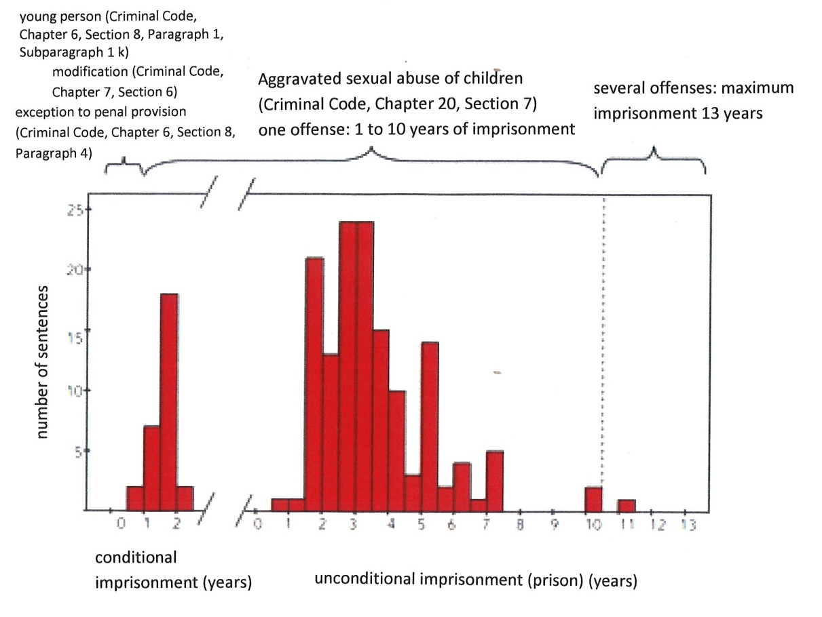

Appendix 6a:
Victim’s age at the onset of offense (in years).
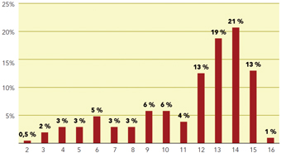

Appendix 7 : Homelessness in Finland

Appendix 8: Alcoholic beverage consumption in pure alcohol per capita (15+ years) between 1960 and 2012


