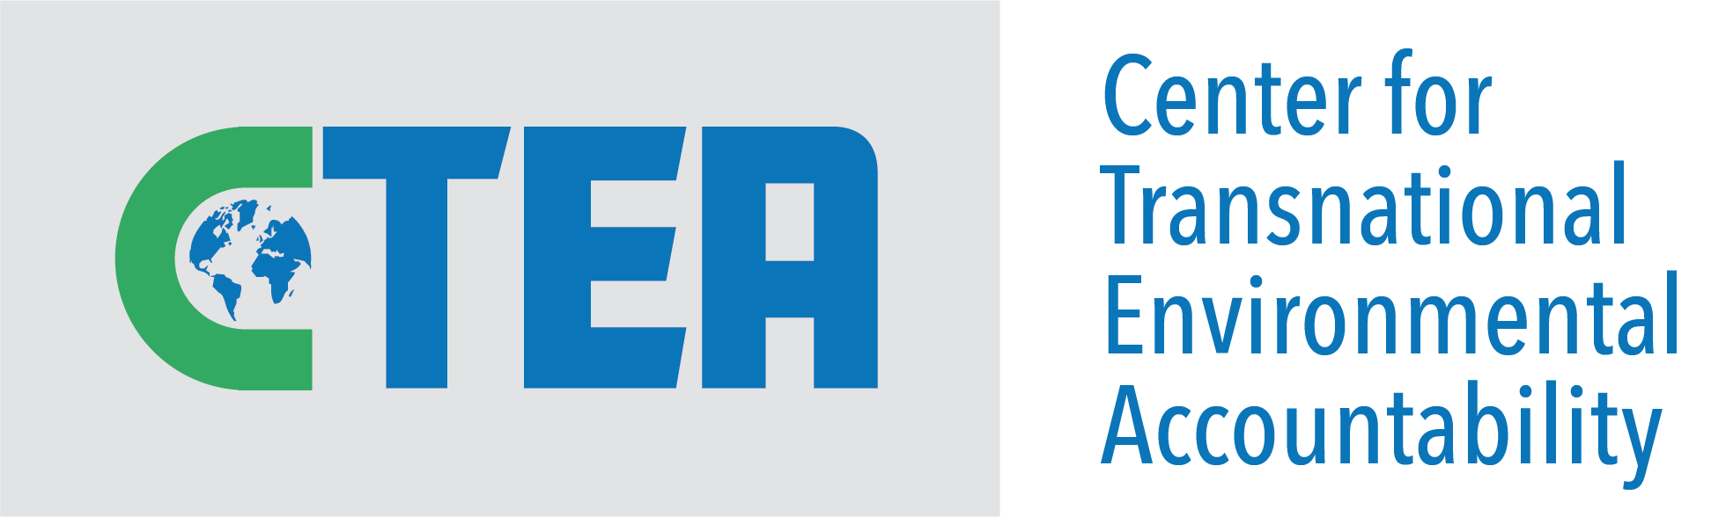
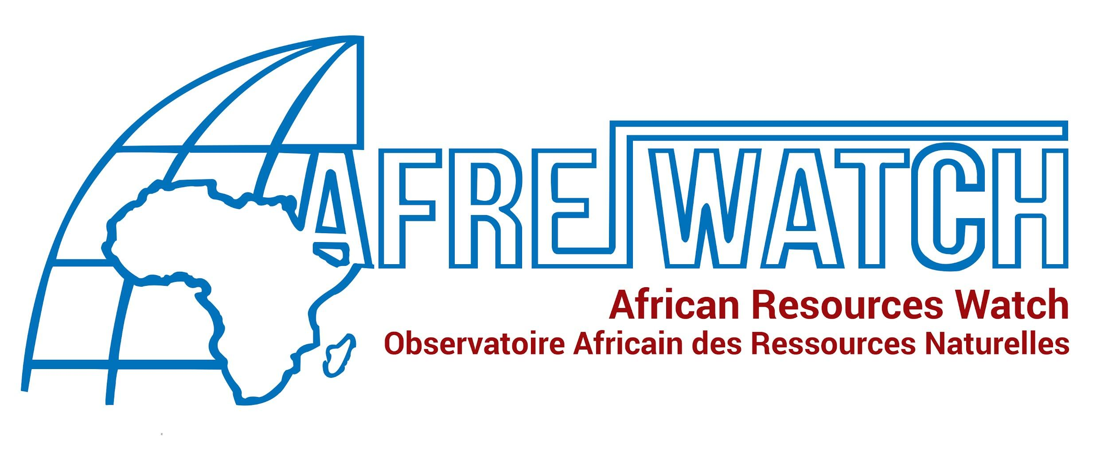
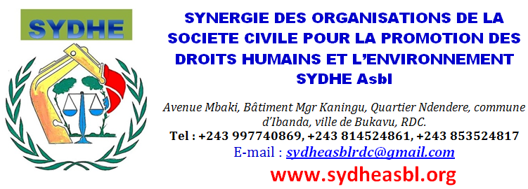

Joint Submission by African Resources Watch, the Center for Transnational Environmental Accountability, and Synergie des Organisations de la Société Civile pour la promotion des Droits Humains et de l’Environnement to the Committee on the Elimination of Discrimination against Women

90th Session
Consideration of State Report
4 February 2025

Submitted 6 January 2025

Democratic Republic of the Congo

African Resources Watch
792 avenue Lufira, Q/ Makutano, co/ de Lubumbashi, Haut-Katanga, RDC
afrewatch.org/contact

Center for Transnational Environmental Accountability
500 W Baltimore St, Baltimore MD, USA 21201
un-mechanisms@ctea.earth

Synergie des Organisations de la Société Civile pour la promotion des Droits Humains et de l’Environnement
Avenue Mbaki, Batiment Mgr Kaningu, Q/ Ndendere, co/ d’Ibanda, Bukavu, RDC
sydheasblrdc@gmail.com

Introduction

- African Resource Watch (AFREWATCH) is a civil society organization based in the Democratic Republic of the Congo (DRC) that advocates for a just and equitable use of the country’s natural resources, focusing on mining, hydrocarbons, and water. AFREWATCH’s work covers the following cross-cutting issues: human rights, environmental pollution, questions related to good governance, and land use.

- The Center for Transnational Environmental Accountability (CTEA) is a non-profit legal organization incorporated in the United States of America. CTEA pursues transparency and accountability related to the human rights, environmental and climate impacts of international investments and ensures communities and individuals’ rights to a clean, healthy and sustainable environment are protected.

- Synergie des Organisations de la Société Civile pour la promotion des Droits Humains et de l’Environnement (SYDHE) is a non-profit association under Congolese law. It brings together organizations concerned with human rights, health, local and participatory governance, rational management of natural resources, and the environment to find locally-driven sustainable solutions.

- Pursuant to the anticipated consideration of the report of the Democratic Republic of the Congo by the Committee on the Elimination of Discrimination against Women (“the Committee”) at its ninetieth session, the coalition of African Resources Watch and the Center for Transnational Environmental Accountability (“the stakeholders”) submit this written report providing information on the implementation of the substantive articles of the Convention on the Elimination of All Forms of Discrimination against Women (“the Convention”) in the State party.

- The stakeholders are aware that the Committee, in its eighty-sixth and eighty-seventh sessions, took decisions to request this State report from the Democratic Republic of the Congo on an extraordinary basis to address a list of issues related to the armed conflict in the State and its effect on women. The stakeholders respectfully provide the information contained in this submission relevant to our competences in order to inform important aspects of the substantive social, economic, and environmental context affecting the enjoyment of all human rights by women and girls in the State.

- The Democratic Republic of the Congo signed the Convention on the Elimination of All Forms of Discrimination against Women on 17 July 1980 and ratified the Convention on 17 October 1986.

- The stakeholders recall with appreciation that the Committee has, in previous reporting cycles, posed oral and written inquiries and made recommendations to the State on the human rights situation of women working in and otherwise affected by the mining sector. During the eighth periodic report, these included recommendations of paragraph 41(e) to address “the specific needs of rural women [...] regarding the allocation of mining concessions and ensure their consultation and participation in the decision-making process,” and of paragraph 47(a)-(d) regarding, in summary, the protection of women and girls from exploitative and hazardous conditions of work, their representation in decision-making processes, and consideration of environmental and health damages resulting from industrial exploitation of Frontier Mine near Sakania, including reparations and compensation to women and girls, and protection of women and girls working in artisanal mines from sexual violence.

Relevant Developments

- Since its previous reporting cycle, the Democratic Republic of the Congo has seen an intensification in development of its mining sector, particularly fuelled by the global energy transition and the requisite material needs of technology used in growing renewable energy manufacturing sectors, such as copper and cobalt, for which the State is among the world’s largest producers.

Eastern DRC

- Serious human rights problems for at-risk populations connected to the linkages between armed conflict and mineral exploitation in the conflict-affected eastern DRC persist.

- In spite of the legal prohibition on pregnant women and children working in mines and new international efforts to ensure traceability of minerals, the human rights situation of women and girls remains deeply concerning. As the Committee will know, the periodic reports to the Security Council by the Group of Experts on the Democratic Republic of the Congo, which concluded its work in 2024, regularly and extensively documented armed groups’ illicit control and exploitation of mines and trade routes in conflict-affected areas.

- A 2024 UN Women-supported study by Initiative des Femmes entrepreneurs pour le développement durable (IFEDD) of seven gold mining sites around the Nizi river in the Djugu territory of Ituri province found that even in areas of the eastern DRC where the local security situation had recently stabilized due to the proximity of State forces, control and management of mining sites (including over land, water, revenue, etc.) drove conflicts between individual miners, parastatal mining administrators, and local cooperatives. Sexual violence and gender-based discrimination linked to these conflicts were common, including a case of illicit seizure of a mining claim from a woman. Tensions also arose from the recent arrival of Chinese miners along the Nizi river who seized artisanal mine sites with the assistance of violent “Gardes Industriels,” and used heavy dredging methods causing water pollution and damage to land without paying compensation or conducting mitigation.

- The stakeholders underscore that women and girls living and working in the region continue to be exposed to exploitative and dangerous conditions and were exposed to industrial pollutants such as mercury, causing short- and long-term harm to human health including reproductive disorders, labor-related rights violations, and sexual violence and abuse, among others. Women working in artisanal mining are typically engaged in low-paying “intermediary” category work, such as breaking, crushing, cleaning, and carrying ore-bearing stones. This work is frequently vulnerable to wage discrimination and irregularities, physical violence, and problems with sexual abuse from employers and others in positions of authority, in spite of efforts by the State to supervise artisanal mining. Conflict-affected mining areas are also susceptible to persistent dynamics where women and girls are victims of human trafficking and sexual slavery by armed groups fuelled by revenue from trade in minerals.

Southern DRC

- In the copper and cobalt mining regions of southern DRC (Haut-Katanga and Lualaba provinces), industrial-scale mining activities threaten, and are inflicting widespread and long-term harm to the right to enjoyment of, the highest attainable standard of health, with particularly negatively impactful and discriminatory effects on at-risk populations, including women and girls. “Beneath the Green,” a major 2024 study of 25 fenceline (i.e., mine-adjacent) localities around five major industrial-scale copper and cobalt mines in Haut-Katanga and Lualaba provinces by AFREWATCH and RAID showed widespread health impacts associated with community reliance on polluted water. The five mines examined in the study are majority owned by international corporations: Tenke Fungurume (CMOC (China)), Metalkol (Eurasian Resources Group (Luxembourg/multinational)), COMMUS also known as Musonoïe (Zijin (China)), Kamoto, and Mutanda (Glencore (Switzerland/multinational)), with varying degrees of partial ownership by the State-owned mining enterprise, Gécamines.

- These industrial copper and cobalt mines generate environmental pollution, including surface water and groundwater pollution in various forms, as disclosed by each operator’s environmental impact assessments. Underground freshwater sources may be affected both by contamination by pollutants such as copper, cobalt, lead, arsenic, cadmium, uranium, manganese, mercury, and acids, and by excessive exploitation by mining operations. Frequently, airborne particulate emissions and wastewater runoff from mining operations, among other vectors, can discharge metals into local watercourses.

- Women and girls’ role in domestic life often involves responsibility for household water collection and management, exposing them to disproportionate harm to health. Researchers conducting 172 interviews with local residents, lawyers, engineers, scientists, medical personnel, and government authorities found that in addition to increasing incidences of “dermatological, ophthalmological and respiratory issues, [and] impaired digestion,” local women across age groups reported worsening gynecological and reproductive disease such as irregular or hemorrhagic menstruation, vaginal infections, and miscarriages, among others, which respondents associated with reliance on contaminated surface and well water. 72% of interview respondents reported that contact with water from multiple local watercourses led to “itching, spots, rashes, and white patches” on skin.

- Preliminary surface water testing of lakes and rivers close to Mutanda, Metalkol, and Tenke Fungurume showed results of high water acidity rendering rivers unfit for survival of fisheries and toxicity for human and animal health. Local communities have also observed the impact of mining operations on their access to food, with 99% of respondents relying on fisheries and agriculture noting a reduction in fish and crop yields.

- Negative environmental effects have not been limited to direct impacts on water, food, and health. Majorities of local households reported a range of socioeconomic problems including but not limited to loss of income reducing their ability to pay for children’s education, meals, and healthcare services.

- The 2024 findings corroborate an extended pattern of similar problems reported in the copper and cobalt mining regions of the State. Among other previous studies, AFREWATCH conducted environmental sampling and interviews in the villages of Yenge and Kapanga in Lualaba province in 2021. These villages, with a combined population of around 1800 inhabitants, are near a 11.5 square kilometer copper and cobalt mine owned by a consortium of Chinese and Congolese private and public entities operating as Sicomines (Sino-Congolaise des Mines). Both villages are inhabited by large populations of women and children reliant on agriculture, fisheries, and artisanal mining.

- Environmental pollution in the form of airborne emissions and discharge of contaminants into the Kalemba river and well water has continuously affected the area despite the communities’ reliance on this water for fulfillment of basic needs. Local inhabitants reported a high prevalence of respiratory, reproductive, and dermatological illnesses in the community associated with reliance on water drawn from the Kalemba river. Indeed, external laboratory analyses of sampled water, soil, and exposed metal surfaces found elevated levels of pollutants throughout the affected area: water contained high acidity levels, and amounts of dissolved substances including mercury and selenium well above WHO guidelines for human health; soil samples showed significant concentrations of cobalt also in excess of WHO standards; and metal surface samples showed high levels of chlorine, fluorine, nitrates and sulfates indicative of atmospheric dispersion of particles from heavy industry.

- In the copper and cobalt-rich south, including around the COMMUS/Musonoie mine in Kolwezi discussed above, artisanal operations and trading have also emerged alongside large-scale industrial mining. In artisanal cobalt mines such as those at Chabula and Kapata, hundreds of women are engaged in low-paying labor at intermediate links in the processing chain such as cleaning ore-bearing stones and are excluded from higher-paying but male-dominated underground work. This intensive labor, often done without protective equipment, potentially exposes workers to toxicity from radioactive elements such as uranium and thorium that occur naturally in copper ores, also linked to many of the serious hazards for physical health outlined above.
Conclusion and Recommendations for Dialogue

- The stakeholders respectfully submit the foregoing information to the Committee which bear upon women and girls’ right to a clean, healthy and sustainable environment, right to enjoyment of the highest attainable standard of health, freedom from discrimination in economic and social life, and regarding impacts on rural women, to which article 14 of the Convention calls particular attention, among the international human rights issues which the Committee may consider.

- This submission is not confidential and may be published on the OHCHR website for public information purposes.

- The stakeholders respectfully request that Committee members pose relevant inquiries to the State delegation, including asking what concrete actions investors are taking to remedy environmental pollution in communities close to copper and cobalt mines, and make recommendations to the delegation regarding the following themes:

- Establish mandatory reporting and monitoring of water and soil quality in the mining sector nationwide in order to support enforcement of environmental laws and policies particularly concerning discharges of mining industrial waste;
- Require international corporations engaged in mining activities to make and disclose their gender-related corporate policies, including labor rights, workplace standards and healthcare;
- Formulate and promote gender equality policy in the mining sector by encouraging the inclusion of women in better-paid positions of responsibility and create training programs while guaranteeing safe and fair working conditions;
- Adopt measures to sensitize and train mining police and security personnel on the specific risks faced by women, including providing for penalties against complicity in violence or exploitation;
- Consider reforms of mining concession allocation processes to recognize and protect women’s equal right to enjoy, administer and dispose of property, such as development of guidelines for land acquisition that prohibit discrimination and prioritize the land rights of women-led households; and,
- Mandate the inclusion of women in land and resource allocation processes, including community- and national-level resource governance committees.

AFREWATCH, La vie intenable aux villages Yenge et Kapanga: Les problemes socio-environmentaux causes par l’exploitation miniere de SICOMINES au Lualaba (Feb. 2022), https://afrewatch.org/wp-content/uploads/2022/02/Rapport-sur-SICOMINES2.pdf, 7-8.
Id. at 8.
Id. at 9.
Id. at 9-10.
Id. at 10, 12-14.
Denise Maheho & Didier Makal, En RDC, l’exploitation miniere menace la sante reproductive des femmes, Mongabay (Nov. 18, 2024), https://fr.mongabay.com/2024/11/en-rdc-lexploitation-miniere-menace-la-sante-reproductive-des-femmes/.
Committee on the Elimination of Discrimination Against Women, U.N. Doc. CEDAW/C/COD/CO/8 (9 July 2019).
Id. at 15.
Id. at 16-17.
Id. at 54.
Id. at 19.
Id. at 32.
Id. at 41.
Id. at 42-3.
Id. at 52.
Id.; Bashwira, supra note 9.
RAID & AFREWATCH, Beneath the Green (Mar. 2024), https://raid-uk.org/wp-content/uploads/2024/03/Report-Beneath-the-Green-DRC-Pollution-March-2024.pdf.
Id. at 1.
Valentin Migabo, Dans les mines du Congo, des femmes enceintes et des enfants vivent dangereusement, The Conversation (Sept. 27, 2021), https://theconversation.com/dans-les-mines-du-congo-des-femmes-enceintes-et-des-enfants-vivent-dangereusement-164273.
Security Council, Reports of the Group of Experts submitted in accordance with paragraph 6 of resolution 2688 (2023), https://main.un.org/securitycouncil/en/sanctions/1533/panel-of-experts/expert-reports (last accessed 2 Jan 2025). See generally Rep. of the Group of Experts on the Democratic Republic of the Congo (2024), transmitted by Letter dated 31 May 2024 addressed to the President of the Security Council, U.N. Doc. S/2024/432 (May 31, 2024).
Migabo, supra note 3.
For an explanation of the labor and human rights situation based on a field survey of 225 women working at three major mines in eastern DRC, see Marie-Rose Bashwira, Dettes et travail de la femme dans l’artisanat minier de l’or en RD Congo, Dynamiques 15 at 3, 5 (Oct. 2021), https://www.carhop.be/revuescarhop/wp-content/uploads/2021/12/BASHWIRA_DEF_27_10.pdf.
Id. at 7; Sud-Kivu: exploitation abusive des demmes dans les mines artisanales, Radio Okapi (Mar. 24, 2022), https://www.radiookapi.net/2022/03/24/actualite/societe/sud-kivu-exploitation-abusive-des-femmes-dans-les-mines-artisanales.
See generally Jerry Dunia, L’exploitation sexuelle des filles mineures dans les zones minieres de la province du Sud-Kivu en Republique Democratique du Congo, CEADHO & IPIS (May 2017), https://ipisresearch.be//wp-content/uploads/2017/06/Voices-CEADHO.pdf.
Emmanuel Munyali, Rapport de Mission d’Evaluation des Sites Miniers et des Parties Prenantes en Territoire de Djugu, Province de l’Ituri, IFEDD-ONUFEMMES, 8-9.
Id. at 10.
Id.
U.N. Treaty Collection Depositary, Convention on the Elimination of All Forms of Discrimination against Women (last accessed Jan. 6, 2025), https://treaties.un.org/pages/viewdetails.aspx?src=treaty&mtdsg_no=iv-8&chapter=4&clang=_en; Convention on the Elimination of All Forms of Discrimination against Women, Dec. 18, 1979, 1249 U.N.T.S. 13.

