SUMMARY
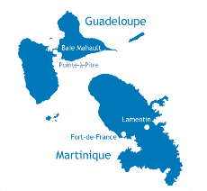
This report informs Issues 3, 9 and 22 of the List of Issues established by the United Nations Committee on Economic, Social and Cultural Rights (CESCR) regarding the review of France's 5th periodic report, concerning Guadeloupe and Martinique (French West Indies).
The Caribbean population is disproportionately affected by poverty and by limited access to employment and basic services, in particular access to safe drinking water and sanitation, as well as to housing, education, health, and communications.
In 2023, the 2017 “Law for real equality in French Overseas territories and other provisions in social and economic matters” has obviously still not found effective application. In law as in practice, the French overseas people largely remain "left behind".
In this context, the health, human and environmental scandal of chlordecone weakens an already vulnerable population and undermines its confidence in the French state.
It is urgent that the State remedy this situation by adopting an approach based on human rights, i.e. by recognizing the Antilleans as full holders of rights and by assuming its role of duty bearer by fulfilling its obligations of respecting, protecting and fulfilling their rights in accordance with the International Covenant on Economic, Social and Cultural Rights (ICESCR).
In doing so, rather than continuing to move away from them, France will get closer to achieving many of the Sustainable Development Goals for 2030 in its so-called overseas departments and regions (‘DROM-COM’).

Table of contents and main proposed recommendations
Issue 3 : Please provide information on any assessment made of the measures taken by the State party in its overseas departments and regions to: (a) significantly reduce unemployment; (b) reduce poverty and extreme poverty; (c) improve access to high-quality education; (d) improve access to housing and to reduce the number of people living in informal settlements; (e) improve access to high-quality health-care services and to reduce child and maternal mortality; and (f) improve Internet access.

MEASURES IN OVERSEAS TERRITORIES: TARGETING AND ACHIEVING EQUALITY  - Strengthen and effectively implement the 2017 Law for real equality in the Overseas Territories, in particular actions against the high cost of living and for access to safe drinking water;  - Ensure the applicability of all international standards and regional human rights instruments accepted by France, in particular the Revised European Social Charter of the Council of Europe and its protocols, to French overseas territories. | Pages 2-3
Issue 9: Please describe the steps taken to provide redress and compensation to communities affected by environmental degradation, including soil contamination by chlordecone in the French West Indies […]. Please also provide information on any reparation provided for environmental damage in these cases.

CHLORDECONE IN GUADELOUPE AND MARTINIQUE: A STATE SCANDAL  - Guarantee justice, truth, reparation and effective compensation to the entire population impregnated with chlordecone (90% of the population of the two islands), including children, and not only to workers who can demonstrate an occupational disease caused by pesticides. | Pages 4-7
Issue 22: Please describe the measures taken by the State party to guarantee a decent standard of living in […] in its overseas departments and regions, including through the provision of water, [electricity] and sanitation services. Please describe the measures taken to prohibit the practice of some local authorities of cutting off water [and electricity] supplies [to informal settlements].

SAFE DRINKING WATER IN GUADELOUPE: THE CARIBBEAN “ERIN BROCKOVICH” CASE  - Take emergency measures to supply the population of Guadeloupe with safe drinking water pending the complete repair of the water and sanitation systems ;  - Grant reparation and compensation to all users impacted both by water cuts and water contamination caused by the failing sanitation system and by various pesticides, including chlordecone. | Pages 8-13

ISSUE 3:
MEASURES IN OVERSEAS TERRITORIES: TARGETING AND ACHIEVING EQUALITY

- Principle of non-discrimination

The law for real equality in French Overseas Territories was adopted on February 14, 2017 to reduce inequalities between Continental France and its Overseas territories, and to strengthen the local economy and the rights of overseas citizens.
In 2023, inequalities remain glaring between France and the DROM-COM, as revealed in particular by the publications of national human rights institutions, including the National Consultative Commission on Human Rights (CNCDH) and the Defender of Rights, as well as by the National Institute of Statistics and Economic Studies (INSEE).
INSEE notes in particular that:
- Unemployment: “The halo around unemployment is 2.5 to 5 times more present in the overseas departments than in metropolitan France.”

- Poverty: “In 2022, prices will remain higher in the overseas departments than in mainland France, in particular for food products: from 9% in Réunion to 16% in Guadeloupe. For all the overseas departments, the price differences have increased compared to 2015. The differences are above all explained by the high cost of goods and in particular of food products, for which the prices paid by households are from 30% to 42% higher."

- Extreme poverty : “Severe poverty is 5 to 15 times more frequent in the overseas departments (DOM) than in metropolitan France. It is also much more intense there. »

- Education : “In Guadeloupe, 27% of young people aged 15 to 29 are neither in employment, nor in studies, nor in training, i.e. twice as many as in metropolitan France. The Defender of Rights specifies in particular that the number of teaching days in the Antilles is lower than in France (In Guadeloupe, up to 20% of class days were lost in 2021, without being made up for), and that the failure and cost of school transportation and school catering are barriers to access to education.

- Housing : “Housing rents, maintenance and repairs are higher in the overseas departments.”
- Healthcare : “Getting treatment costs up to 17% more in the overseas departments.”
- Communications : “Communications (telephone, internet and post office/delivery) are also more expensive than in mainland France, up to more than +35% in Guadeloupe, Martinique and French Guiana.”
Covid-19 and the underlying economic crisis have undeniably deepened already significant structural gaps.
In response, state measures aimed at achieving real equality are non-existent, insufficient, or ineffective.
For example :
- While, aware of these discrepancies, the French State pays monthly to its civil servants working in the DROM-COM a cost-of-living allowance of 40%, the minimum wage remains the same in the DROM as in mainland France, aggravating the poverty and thus deepening locally the socio-economic inequalities between citizens;
- Economic and commercial monopolies persist;
- The implementation of social pricing of public services such as water and other social measures such as the application of the immediate tax credit advance mechanism (effective since 2022 in France but not yet effective in Guadeloupe) is delayed in the DROM-COM, where they are the most needed.
In conclusion:
While basic services in the DROM-COM are often failing, their cost is paradoxically much higher than in mainland France, even when they do not involve any particular import measures.
While the DROM-COM should be the subject of priority measures because of their multiple economic and social vulnerabilities, they are in fact most often "left behind".

- Applicability of international and regional human rights instruments in the DROM-COM
As indicated in the “Core document forming part of the reports presented by France” to the Committee, France has long signed and ratified most international and regional instruments relating to economic, social and cultural rights.
In particular, in 1973, France ratified the European Social Charter of 1961 (ETS No. 035) and, in 1999, the revised European Social Charter of 1996 (ETS No. 163) as well as the Additional Protocol to the Charter providing for a Collective Complaints System of 1995 (ETS No. 158).
However, France has not made the necessary declaration for the revised European Social Charter and its protocols to apply to non-metropolitan French territories. As a result, in 50 years, the DROM-COM and New Caledonia have almost never been covered in France's periodic reports on ESCR to the Council of Europe and they have never benefited from a collective complaint before the European Committee of Economic and Social Rights of the Council of Europe.

3. Links between issue 3 and issues 9 and 22
The right to safe drinking water is a core element of the right to an adequate standard of living and of the fight against extreme poverty, as well as of the rights to education, adequate housing, and health. From the violation of the right to safe drinking water and sanitation in the French West Indies detailed under issue 9 (chlordecone) and under issue 22 (water and sanitation system) therefore also follows the violation of the aforementioned rights.

RECOMMENDATIONS :
Through this report, F.W.I. civil society asks the Committee to kindly recommend that France:
- Strengthen and effectively implement the 2017 Law for real equality in the Overseas Territories, in particular actions against the high cost of living and for access to drinking water;
- Ensure the applicability of all international standards and regional human rights instruments accepted by France, in particular the Revised European Social Charter of the Council of Europe and its protocols, to French overseas territories.

ISSUE 9 :
CHLORDECONE IN GUADELOUPE AND MARTINIQUE: A STATE SCANDAL

FACTS : Guadeloupe and Martinique, « sacrifice zones »
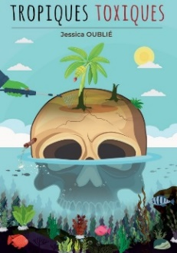
“Some communities suffer from environmental injustices whereby the exposure to pollution and toxic substances is so extreme in the areas in which they live that they are described as “sacrifice zones” […] Water and soil in Guadeloupe and Martinique, France, are contaminated by unsafe levels of the pesticide chlordecone. […] Residents are still exposed to chlordecone through drinking water and the food that they grow because of the pesticide’s persistence in the environment. Ninety per cent of people living in Guadeloupe and Martinique have been found to have chlordecone in their blood, raising their risk of cancer.”
The right to a clean, healthy and sustainable environment: non-toxic environment
Report of the Special Rapporteur on the issue of human rights obligations relating to the enjoyment of a safe, clean, healthy and sustainable environment, David R. Boyd, 2022

- Use: Chlordecone was used in the F.W.I. as a pesticide in banana plantations from 1972 to 1993 despite knowledge of its extreme toxicity to support improved rates of agricultural production. Although its manufacture and use were banned in 1975 in the United States, and the World Health Organization (WHO) warned in 1979 of the dangerousness of this product, it was only banned in France in 1990 and continued to be used in the F.W.I. by ministerial derogation until 1993.

- Affected environment: today, chlordecone is still present in the soil, water and food. The entire food chain is contaminated. In his report, the United Nations Special Rapporteur on the right to the environment, David Boyd, lists Guadeloupe and Martinique among the "sacrificed areas" by France because of the extreme pollution of these territories with chlordecone. « The Special Rapporteur describes the ongoing toxification of people and the planet, which is causing environmental injustices and creating “sacrifice zones”, extremely contaminated areas where vulnerable and marginalized groups bear a disproportionate burden of the health, human rights and environmental consequences of exposure to pollution and hazardous substances.”

- Affected population: 95% of Guadeloupeans and 92% of Martiniquais are impregnated, according to the National Public Health Agency and the National Agency for Food, Environmental and Occupational Health Safety.

- Direct and visible consequences on health:
  - Men: In 2019, a French study confirms the carcinogenic potential of chlordecone and its link with prostate cancer: the latter is twice as common, twice as severe, and three times more likely to recur in the FWI than in continental France. Martinique has the highest rate in the world.
  - Women: In 2022, a study recalls the link between exposure to chlordecone, recognized as an endocrine disruptor, and the occurrence of chronic diseases and mortality, such as breast cancer and cancer of the uterus.
  - Pregnant women and children: Several studies have shown that exposure to this neurotoxin increases the risk of prematurity and impacts the cognitive and behavioral development of children. Fine motor skills and recent memory are affected in the more than 500 West Indian children followed since 2004.
  - Indirect and invisible consequences on health: This ultratoxic organochlorine insecticide is likely to be the cause of many other pathologies or their aggravation. Its consequences on the lives and health of Antilleans are inevitably under-documented. During the scandal that led to the banning of chlordecone in the United States in 1975, studies already demonstrated its negative effects on the neurological and reproductive systems, as well as on the liver, skin, and eyesight.

VIOLATIONS OF ECONOMIC, SOCIAL AND CULTURAL RIGHTS
From the long and massive use of chlordecone in Guadeloupe and Martinique stems a series of serious violations of the human rights of the populations of the two islands, in particular the right to life and the right to a safe, clean, healthy and sustainable environment, as well as that the following rights guaranteed by the International Covenant on Economic, Social and Cultural Rights, ratified by France on November 4, 1980:
• Article 2 – right to non-discrimination
• Article 7 b) – right to safe and healthy working conditions
• Article 11 – right to an adequate standard of living (including the right to food)
• Article 12 – right to health (physical and mental)

ACTIONS: Reparation without sanctions or compensation = impunity
« 52. The Human Rights Committee has made it clear that States must investigate situations of serious pollution or release of toxic substances and impose sanctions where violations occur. Failing to prevent foreseeable human rights harms caused by exposure to pollution and toxic substances or failing to mobilize the maximum available resources in an effort to do so, could constitute a breach of States’ obligations. States must also make full reparation to victims and other community members for harms suffered, including through adequate compensation, take all necessary measures – in close consultation with the community – to remedy the environmental degradation, and prevent similar transgressions in the future.
The right to a clean, healthy and sustainable environment: non-toxic environment
Report of the Special Rapporteur on the issue of human rights obligations relating to
the enjoyment of a safe, clean, healthy and sustainable environment, David R. Boyd, 2022

Investigation :
- In 2019, a parliamentary inquiry was opened, i.e. 26 years after the ban on the use of chlordecone in the West Indies, 40 years after the WHO alert, and 44 years after its ban in the United States following the poisoning of employees who made it in Hopewell, Virginia.
- After 6 months of investigation, the Commission of Inquiry concludes in a report made public on December 2, 2019 that a "health and environmental disaster" for which the State is the "primary responsible".
- Among the 150 personalities interviewed, a former inter-ministerial chlordecone delegate and executive of the Regional Health Agency in Martinique reveals with emotion to the investigators that, while until 2001 the State maintained that there was no presence of chlordecone in the water consumed by West Indians, analyses by the health school laboratory dating from 1991 proved the presence of chlordecone for at least 10 years.

Sanctions: no effective remedy to date
- In 2022, complaints against former ministers, filed by several associations, were declared inadmissible by the Court of Justice of the Republic.
- On January 2, 2023, in criminal proceedings aimed at holding distributors liable for poisoning, the judges dismissed the case after 16 years of investigation. Recognizing a "health scandal" and "environmental damage", the judges denounced the actions of the State and the industrialists, but dismissed their criminal liability on the basis, on the one hand of the prescription of the facts and, on the other hand, of the ignorance of science and the public authorities at the time as to the consequences of chlordecone on human health. Yet, in April 2023, investigative journalists revealed that eight years of archives establishing that alerts on the dangerousness of this molecule had taken place as early as 1981, are missing from the judicial file. Reminder: the product had been banned in the United States since 1975 based on documented studies and declared as a carcinogen by the WHO since 1979. An appeal has been filed.
- On June 27, 2022, the Paris administrative court found the State guilty of “wrongful negligence” for having authorized the marketing of chlordecone under different names “beyond the legally prescribed deadlines in the event of withdrawal of approval”. However, the administrative court refused to compensate the 1,240 plaintiffs, who were claiming compensation for the prejudice of anxiety, on the grounds that the applicants did not mention "any personal and detailed element allowing the prejudice of anxiety on which they claim". The prejudice of anxiety is defined by the Council of State as "the awareness of the high risk of developing a serious pathology, and of having a reduced life expectancy". An appeal has been filed.

Prevention, Reparation, Compensation:

- In 2008, the State activated the first “Chlordecone Plan” to try to reduce the exposure of the population to the insecticide. Since then, the State has adopted a series of preventive measures aimed at "protecting the health of populations" and "moving towards "zero chlordecone in food".
- In 2018, the President of the Republic announced that "The State must take its share of responsibility" for the chlordecone pollution in the West Indies and "move forward on the path to repair". However, he adds that the state of scientific knowledge (...) does not make it possible to certify "the dangerousness of the molecule for human health, although we "assume the link with premature births, developmental delays cerebral and other pathologies". He concludes that it "would not be responsible to say that there is individual compensation for all", but that it is on the other hand "possible to make further progress on the question of occupational diseases for people particularly exposed to the molecule." He announced that the procedure for opening the register of occupational diseases will be initiated by the government from October 2019. However, it was not until December 22, 2021 that prostate cancer linked to overexposure to chlordecone was officially included in the list of occupational diseases. This is an essential development that opens the way to individual compensation for farmers and farm workers and their children, but which remains insufficient in practice and with regard to the contamination of the whole population.
- To date, while almost the entire population of the Caribbean is impregnated with chlordecone, the pesticide compensation fund is only open to people who can demonstrate their occupational exposure to chlordecone and suffer from a disease listed in the table of occupational diseases, or who can demonstrate that their child, suffering from an illness or deformity, was exposed in utero to pesticides as a result of their professional activity.
- However, the procedure remains unknown and difficult to access: victims must provide proof of activities sometimes dating back more than 20 years. At the end of 2022, only 14 people were compensated in the Antilles.

- In 2023, the authorities are rolling out the 4th Chlordecone pollution control plan, the Chlordecone Plan IV for the period 2021-2027. Less than a month after the adoption of the Recommendation of the UN Committee on the Rights of the Child (June 2, 2023) urging France to grant reparation and compensation to children harmed by chlordecone water pollution, the Minister Delegate for Overseas France traveled to Martinique and in Guadeloupe on June 27 and 28, 2023 to recall the actions undertaken, announce financial aid, the strengthening of 4 key measures and the adoption of 4 new measures, in particular 'Preventing and reducing the exposure of women and children', 'Amplify and facilitate recourse to the compensation fund for pesticide victims' and 'Act together with elected officials and actors from the associative world to protect the most vulnerable'. The measures announced can be viewed at the following link: « Vivre sans « risque chlordécone » et réparer par l’action ». In his interventions, the Minister emphasized the importance of prioritizing redress through action over compensation.

CONCLUSION : No redress without compensation
• For FWI civil society, the absence of an effective remedy is a denial of justice:
- The impunity that characterizes this environmental and human injustice does not make it possible to obtain the expected rehabilitation, nor to adequately repair the damage suffered (both physical and moral), nor to 'prevent the occurrence of similar transgressions in the future';
- Despite their gradual strengthening, the measures of prevention, reparation and compensation announced by the state remain slow and insufficient.

- In its Concluding Observations dated 2 June 2023, the UNCRC indicates that it ‘remains concerned about the limited access to safe drinking water and water pollution with chlordecone in some parts of the overseas territories, in particular in Guadeloupe, contributing to the public health emergency’. (…) Furthermore, ‘The Committee draws attention to target 1.3 of the Sustainable Development Goals and recommends that France provide children both in metropolitan France and overseas territories with adequate standards of living, (…) and urgently supply the population of Guadeloupe with drinking water pending the effective and complete repair of the water and sanitation systems and grant redress and compensation to all children harmed, in particular children affected by chlordecone contamination.’ ;

RECOMMENDATIONS :
- Through this report, FWI civil society asks the CESCR to kindly consider echoing the UNCRC Recommendation and extending its scope, beyond water and children, to 95% the population of Guadeloupe and the 92% of the population of Martinique impregnated with chlordecone due to the pollution of water, soil and food;

- In practice, in addition to the strengthening of prevention and compensation measures, it is particularly a matter of extending the compensation fund - currently not very operational and open only to agricultural workers who are victims of occupational disease and their children - to all of the impregnated population. The amount of compensation received should be proportional to the seriousness of the individual harm suffered, and therefore increased for victims of an illness or malformation due to their occupational or prenatal exposure to chlordecone.

- The reparation measures must include both human reparation measures (in particular the intensification of free screening for all West Indians, including those residing in France) and "ecological reparations" (based in particular on a refined mapping of contaminated areas).

- In accordance with the examples of good practice presented in David Boyd's report, these reparation and compensation measures should be based on legislation applying the ‘Polluter Pays Principle’ and respecting the European Green Deal as well as the EU “Chemicals strategy for sustainability: towards a toxic-free environment”.

ISSUE 22 :
SAFE DRINKING WATER IN GUADELOUPE : THE CARIBBEAN ‘ERIN BROCKOVICH’ CASE
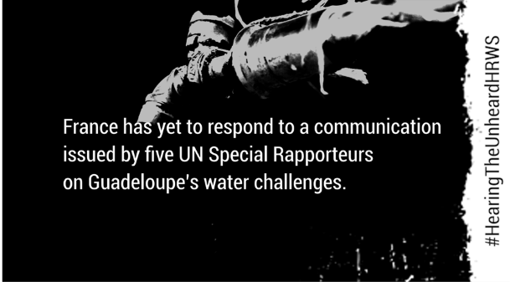
This video (1’49) amplifies the voice of a Guadeloupean household directly affected by severe water cuts and unsafe drinking water at home and at the hospital. This average household is composed of a mixed couple (ethnic diversity) parenting a 3-year-old girl living with disabilities. It describes how water challenges tremendously impact their daily life and the treatment of their daughter, thereby illustrating the common challenges faced by most Guadeloupeans, in particular by the most vulnerable groups. They express what they expect from the authorities and from the UN to improve access to safe drinking water in Guadeloupe.
This video was selected among some 100 videos worldwide and was among the 6 videos screened at a side-event of UN Water Conference on 23 March 2023. It is part of the ongoing HearingTheUnheardHRWS digital campaign led by EndWaterPoverty.

FACTS : Behin the postcard
Availability

- Access to safe drinking water in Guadeloupe has been problematic for over 30 years and has become a vital issue since the Covid-19 crisis.
- Up to 80% of the water produced is lost due to leaks in the networks.
- Water cuts occur daily and affect some 400,000 people.

Quality
- When available, water is not safe in Guadeloupe due to combined causes, including:
- the failure of water systems that have not been properly maintained for nearly 30 years;
- the failure of sanitation systems: 80% of the wastewater treatment plants do not comply with regulations
- the use of pesticides: the water is also polluted with various pesticides including glyphosate and particularly chlordecone (see issue 9), an extremely toxic pesticide, recognized carcinogen and endocrine disruptor, which has even deliberately authorized by the government for agriculture purposes despite knowledge of its toxicity and which has even been found in local bottled water.
- There are no effective judicial remedies to this situation and France remains deaf to UN accountability mechanisms: a Communication from 5 UN Special rapporteurs on human rights on the topic is being left unanswered since July 2021.
- It is also a discrimination issue that affects most of the French overseas territories v continental France.

Accessibility
- Physical accessibility: Failing infrastructures result in water contamination and health hazards at home, at school, and at the hospital, as well as at sea and by the river.
- Economic accessibility: Water in the tap as in the supermarket is the most expensive in France.
- In 2021, the average price of water and collective sanitation in Guadeloupe was 6.52 euros/m³ against 4.3€/m3 nationally. Its cost is skyrocketing. In addition, operators overcharge individual users based on estimates rather than actual water consumption and exert pressure on the population by demanding sometimes exorbitant amounts through the Public Treasury (especially when uncontrolled leaks occur) within untenable deadlines.
- Many households have to buy a water recovery tank (about 3000 EUR) to compensate for water cuts;
- Many households must buy bottled water, two to three times more expensive than in continental France to compensate for the non-drinkability of water.
- These costs are unaffordable for a large part of the population, a third of whom live below the poverty line.

- Non-discrimination: This problem affects most of the overseas territories, mostly populated by Afro-descendants, in a way that has no common measure with mainland France. The most vulnerable people pay the heaviest price, including pregnant women, children, the elderly and people living with disabilities.
- Information: Some municipalities sometimes issue decrees announcing work or a ban on water consumption - even for cooking or brushing one’s teeth - due to water pollution but fail to systematically inform the population in real time. of the causes and duration of these failures, as well as of the response measures which they should be entitled to.
- All figures and statements are based on official data, in particular an inter-ministerial audit which, in 2018, already concluded to a major public health and public safety crisis, as well as to an environmental scandal.

Real story : In 2020, Isabelle, 32, rents a house in a rural area. She and her partner are expecting a child. Due to the Covid-19 outbreak, the government has decided a national confinement which will last from March 16 to May 11, 2020. During these 56 days, Isabelle and her companion will have no water at home for 40 consecutive days. Three months pregnant, Isabelle is forced to go back and forth to her mother’s – who lives over 30 km away – about twice a week to wash her clothes, to clean her dishes, to take showers, to fetch water, and to meet her basic personal hygiene needs. During this period, a thin trickle of water is restored for two nights between 11 p.m. and 5 a.m. Her partner and she spend most of these nights filling many bottles with water as well as cleaning the floors and toilets. Isabelle alerts the failing operator and the local authorities of the logistical and financial constraints (purchase of mineral water, oil, etc.), but also of all the stress that this situation is causing her. The authorities replied that, aware of the needs of the population in this emergency context, water tanks have been distributed in the areas most affected by the water cuts. The closest to Isabelle's house was installed in a primary school 2km away from her home. People line up there in long lines under the sun, cans in their hands which they fill with unsafe water intended for their essential non-drinking needs. In her condition, Isabelle cannot, nor does she want to fetch water in these conditions, notably for fear of exposing herself to an increased risk of contamination with Covid-19. She therefore continues to go back and forth to her mother's house and decides, with her companion, to move out. The day before moving, on May 29, 2020, Isabelle is urgently hospitalized and sadly, at 19 weeks of pregnancy, loses the baby. The doctors concluded that the death of the child was due to a bacterium.
VIOLATIONS OF ECONOMIC, SOCIAL AND CULTURAL RIGHTS: deathdrop
The continued violation of the right to water and sanitation in Guadeloupe has resulted in a series of serious violations of the human rights of the population of Guadeloupe, in particular the right to a safe, clean, healthy and sustainable environment, as well as the rights guaranteed by the International Covenant on Economic, Social and Cultural Rights, ratified by France on November 4, 1980, and on General Comment No.15 on the right to water adopted by the Committee on Economic, Social and Cultural (CESCR) in 2002:
- Article 2 – right to non-discrimination
- Article 7 b) – right to safe and healthy working conditions
- Article 11 – right to an adequate standard of living (including food and housing)
- Article 12 – right to health
- Article 13 – right to education

Example : In Guadeloupe, schools close on average 1.5 months a year for lack of water, in violation of the right to education of children guaranteed by Article 13 of the ICESCR.

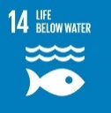
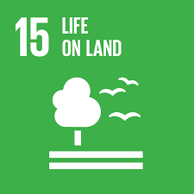
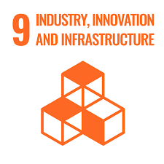
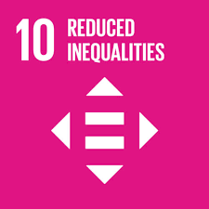
Remedying such situations would contribute to the achievement of many Sustainable Development Goals, including: :
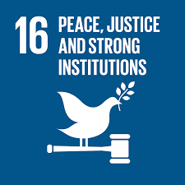
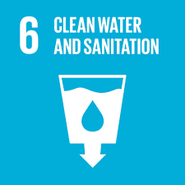
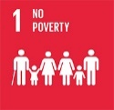
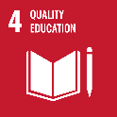
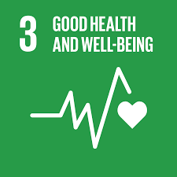
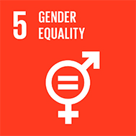

ACTIONS: Let us not leave the Guadeloupean population behind
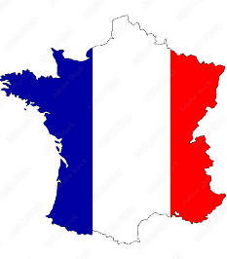
Authorities
- Guadeloupe is naturally rich in water. The cause of this situation is thus entirely human and is mainly due to the poor governance of operators, municipalities, and the State.
- Local and state authorities, constantly alerted on this situation, have taken some responsive measures, yet without managing to put in place effective, fair and lasting solutions, or to grant compensation to users for the harm suffered.
- The various water stakeholders sporadically distribute bottles of water to residents due to pollution or power cuts. Unfortunately, these emergency measures are not sufficient nor transparent and generate unequal treatment between users.
- The judicial response to the water problem in Guadeloupe is not effective, in that it grants neither redress and compensation for damages suffered by users, nor emergency solutions to put an end to the violation of their right to water and sanitation as well as the other human rights violations resulting from it.
Civil society
The Guadeloupean civil society has notably:
- informed and sensitized local and national authorities, including national human rights institutions;
- transmitted information to special procedures in November 2020;
- initiated and contributed to the submission of written and oral contributions to UPR France in 2022 and 2023;
- supported the training and selection of a national coalition of water NGOS as a speaker in UPR 43 France pre-session in April 2023;
- produced a video for End Water Poverty's #HearingTheUnheardHRWS digital campaign and side event at the 2023 UN Water Conference (March 23, 2023);
- filed in February 2023 a collective criminal action joined in 4 months by 150 plaintiffs, including the French League of Human Rights, and represented pro bono by Vigo law firm.

United Nations
- A joint communication was sent to France in July 2021 by five United Nations Special Rapporteurs on human rights but remains unanswered to date;
- The Special Rapporteur on the environment identified Guadeloupe and Martinique as “sacrifice zones” in his Report on the question of human rights obligations relating to the means to benefit from a safe, clean, healthy environment sustainable development of 2022 (A/HRC/49/53, para. 41);
- The UN Committee on the Rights of the Child examined France on May 8, 2023. In its Concluding Observations dated 2 June 2023, the CRC indicates that it ‘remains concerned about the limited access to safe drinking water and water pollution with chlordecone in some parts of the overseas territories, in particular in Guadeloupe, contributing to the public health emergency’. (…) Furthermore, ‘The Committee draws attention to target 1.3 of the Sustainable Development Goals and recommends that France provide children both in metropolitan France and overseas territories with adequate standards of living, (…) and urgently supply the population of Guadeloupe with drinking water pending the effective and complete repair of the water and sanitation systems and grant redress and compensation to all children harmed, in particular children affected by chlordecone contamination.’» ;
- France remains unresponsive to UN mechanisms: the Communication of 5 United Nations Special Rapporteurs on human rights on the subject has remained unanswered since 2021 and France has not yet adopted the emergency measures that the Committee on the Rights of the Child urged the State to take on June 2, 2023.

CONCLUSION
- Re the obligation to respect, protect and fulfill the right to water
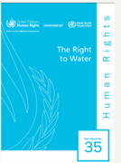
The state and the French courts often argue that the management of water and sanitation falls within the competence of local authorities, and not that of the state.
Yet, “In its general comment No. 15, the Committee underlined that, where the provision of water has been delegated to regional or local authorities, the State should ensure that these authorities do not discriminate and have sufficient resources to maintain and extend the supply and quality of their water services”.

This is why it is critical that the Committee remind France that “the primary obligation for promoting and protecting the right to water rests with the national Government, which is responsible for monitoring local authorities’ performance and enabling them to perform their duties by providing them with adequate powers and resources”.
- Re the technical and financial support from the State

As part of its universal periodic review (May 1, 2023) and its examination by the Committee on the Rights of the Child (May 8, 2023), France has highlighted the technical and financial strengthening of its Overseas Water Plan ("Plan Eau Dom - PEDOM”) to support the creation and modernization of new infrastructures.
However, the Overseas Water Plan:
- is experiencing little success: in 2023 the situation is visibly worse than when the Plan was launched in 2016, and continues to worsen. For example, in 2020, 70% of wastewater treatment plants were not up to standard. In 2023, 80% of these stations are not up to standard.

- has an insufficient budget: in 2018, a priority action plan of 71.4 million euros was approved for carrying out emergency work on the networks to which were added, in 2020, in full sanitary confinement, 5.6 million euros to finance the actions of the State and the requisitions. According to the authors of the 2021 parliamentary inquiry, the necessary budget would rather amount to 1.5 to 2 billion euros.

- has to face tremendous technical difficulties, so that even if all the political, human and financial means were met, the water stakeholders would not be able to keep to the announced provisional schedule. For example, in 2020, out of the repair of 5,000 leaks announced for October 2020, as of September 15, 2020, only half of the leaks (about 2,500) had been identified and only a quarter had been repaired (source: Prefecture of Guadeloupe). It will therefore take many years to carry out the total and sustainable repair of the water and sanitation networks: the population cannot continue to be deprived of drinking water for another decade.

- provides only mid- and long-term measures : the situation has reached the health emergency threshold requiring the immediate application of emergency measures pending the total and lasting repair of the water and sanitation networks.

- Sur la réparation et l’indemnisation du préjudice subi : l’exemple du Canada

In Canada,
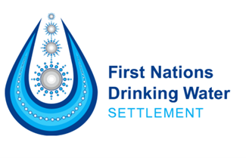
- 330,000 people live in more than 600 communities of Aboriginal peoples called “First Nations”.
- Canada’s colonial history has had a profound impact on Indigenous peoples and their governance .
- In 2019, First Nations initiated a class action against the Canadian state for lack of adequate access to safe drinking water.

- In 2021, under court auspices, the State has committed to an $8 billion Settlement including:
- $1.8 billion in compensation to individuals and Impacted First Nations;
- An additional $50 million for eligible individuals who experienced Specified Injuries;
- $6 billion to support construction, upgrading, operation, and maintenance of water infrastructure by 2030 ;
- A renewed commitment to Canada’s Action Plan;
- Planned modernization of Canada’s First Nations drinking water; and
- The creation of a First Nations Advisory Committee on Safe Drinking Water
In Guadeloupe,
- Over 380 000 people reside in the archipelago;
- Just like in Canada, France’s colonial history has had profound repercussions on the local population and its governance, and throughout the DROM-COM.
- Many legal actions, individual and collective, have been filed in domestic civil, administrative and criminal law.
- Unfortunately, the judicial response to the water problem in Guadeloupe is not effective, in that it grants neither reparation, nor compensation for damages suffered by users, nor emergency solutions to put an end to the violation of their right to water and sanitation as well as other human rights violations that result from it.
This is why it is critical that the Committee bring to the attention of France this precedent as well as its duty to fulfill, like Canada, its obligation to repair and compensate all users for the damage suffered as a result of the failure of safe drinking water and sanitation systems in Guadeloupe, as well as in the other DROM.

RECOMMENDATIONS
Through this report, Caribbean civil society asks the Committee to kindly recommend that France take:
- EMERGENCY MEASURES: to immediately supply the population with drinking water pending the effective and complete repair of the water and sanitation systems provided for under the Overseas Water Plan, namely:
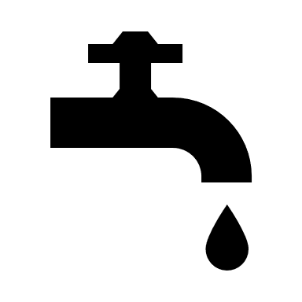 | To respond to WATER CUTS: by June 30, 2024, free distribution and connection of duly equipped WATER TANKS for all homes, schools and health structures in Guadeloupe - or reimbursement at real cost to users and structures that have already been equipped with cisterns by their own means - according to a schedule established in a transparent manner, taking into account a clear and concerted hierarchy of needs, duly communicated to the population, respected and providing for means of verification and remedies in the event of non-compliance;
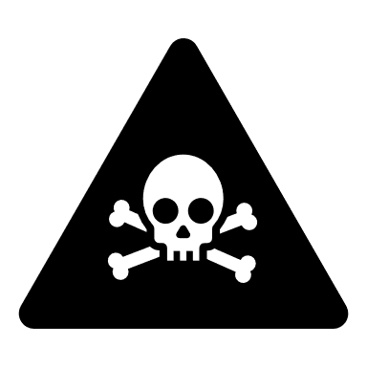 | To respond to the NON-POTABILITY of water: Free and immediate distribution to all households of a DOMESTIC WATER FOUNTAINS (once) and reusable and recyclable mineral water bottles or filtration mechanisms, in a quantity proportional to the size of the household for at least one year from January 1, 2024 and until the normal and effective restoration of the drinking water supply;
 | To compensate for the COSTS of water and the over-billing of individuals: Cancellation of all bills for a drinking water service not provided; establishment of a solidarity fund for housing and/or other SOCIAL WATER PRICING measures, and reduction of bills in the event of water leaks, in application of the 2013 Brottes Law.
 | To protect PUBLIC HEALTH: INFORMATION of the population and socio-professional actors, in a clear, transparent manner, and in real time of the non-drinkability of water in order to better protect all the public from the risks involved.
- MID- AND LONG TERM MEASURES: to provide a lasting solution to the water crisis in Guadeloupe and guarantee the human right to safe drinking water to the entire population of Guadeloupe at least following the same standard as in mainland France by 2030.
 | Infrastructures :  - Integral repair of the drinking water network  - Integral repair of sanitation structures  - On the model of Canada, allocate an adequate budget for this purpose (2 billion Euros)
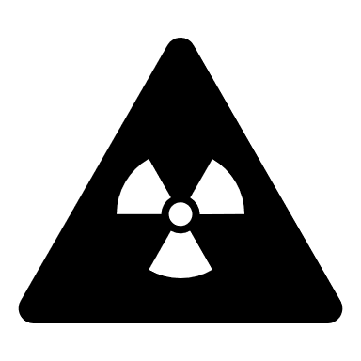 | Ecological reparation:  - Refined mapping of contaminated areas  - Total depollution of tap water from chlordecone and other pesticides
 | Justice :  - Effective investigation of ongoing criminal complaints  - Establishment of a compensation fund for all users  - Additional compensation and free medical follow-up for all victims of the absorption of non-potable water, in particular - but not only - chlordecone
 | Reporting :  - Reply to the joint Communication of the Special Rapporteur on the right to water and sanitation, the Special Rapporteur on the right to education, the Special Rapporteur on the right to the environment, the Special Rapporteur on the right to housing, and the Special Rapporteur on extreme poverty, sent to France in July 2021.  - Submit progress reports on the State Action Plan re the realization of the right to drinking water and sanitation of Guadeloupeans to an Advisory Committee of the Guadeloupean population, including representatives of users, local elected officials, the Defender of Rights and the CNCDH; as well as before the UN treaty mechanisms, in particular before the Committee on Economic, Social and Cultural Rights (CESCR), the Committee on the Rights of the Child (CRC), the Committee on the Elimination of Discrimination against women (CEDAW), the Committee on the Elimination of Racial Discrimination (CEDR), as well as within the framework of the Universal Periodic Review (UPR).

Kimbe red, pa moli pou dwa moun!
(Creole proverb meaning "Stand up, don't give up the fight for human rights »)
Author
 | Sabrina Cajoly. I am a French citizen of Martinican and France mainland descent, long anchored in Guadeloupe. I am a human rights defender with a legal background. I have worked over 15 years for international and regional organizations in Europe, Africa and the Caribbean. Back in Guadeloupe a few years ago, I have been advocating for the past 3 years before the United Nations for the vital right to water and sanitation of my community - and the other human rights that flow from it – on a 100 % voluntary and independent basis.  Follow me or contact me on LinkedIn
Guadeloupe without water is like a butterfly without wings. *

* Guadeloupe island has a shape resembling that of a butterfly.

Le halo autour du chômage, 2,5 à 5 fois plus présent dans les DOM qu’en France métropolitaine - Insee Focus - 303
En 2022, les prix restent plus élevés dans les DOM qu’en France métropolitaine, en particulier pour les produits alimentaires - Insee Première - 1958
La grande pauvreté bien plus fréquente et beaucoup plus intense dans les DOM - Insee Focus - 270
En Guadeloupe, un quart des jeunes de 15 à 29 ans ne sont ni en emploi, ni en études, ni en formation - Insee Analyses Guadeloupe - 63
Rapport - Services publics aux Antilles : garantir l’accès aux droits | Défenseur des Droits (defenseurdesdroits.fr)
Ibid. 4
Ibid. 4
Ibid. 4
Article L ("Territorial application") of this basic text provides that the Charter applies only to the metropolitan territory of the State party, unless there is an express declaration by the latter designating the non-metropolitan territories to which it extends. the scope of the Charter.
A/HRC/49/53, résumé, page 1
Etude Kannari, IMPRÉGNATION DE LA POPULATION ANTILLAISE PAR LA CHLORDÉCONE ET CERTAINS COMPOSÉS ORGANOCHLORÉS EN 2013/2014, Santé Publique France, 2018
Chlordécone aux Antilles : les risques liés à l’exposition alimentaire | Anses - Agence nationale de sécurité sanitaire de l’alimentation, de l’environnement et du travail
Etude de Laurence HUC, toxicologue (décembre 2022), p.6
Etude Inserm du 27 février 2023 dans Environmental Health Prenatal and childhood chlordecone exposure, cognitive abilities and problem behaviors in 7-year-old children: the TIMOUN mother–child cohort in Guadeloupe | Environmental Health | Full Text (biomedcentral.com),
Voir également le Rapport d’évaluation du 3ème Plan chlordécone et propositions, 2020
The Kepone Environmental Disaster - Encyclopedia Virginia
L’Etat, « premier responsable » du scandale du chlordécone aux Antilles selon la commission d’enquête parlementaire (lemonde.fr)
Pollution au chlordécone aux Antilles : deux plaintes d’associations jugées irrecevables - Le Parisien
Antilles : la décision de non-lieu dans l’affaire du chlordécone n’épargne ni l’Etat ni les industriels (lemonde.fr)
Ce que disent les archives disparues du procès du chlordécone (radiofrance.fr)
ENQUETE. Chlordécone : les scientifiques alertaient sur les risques de cancer depuis les années 80, selon des archives retrouvées (francetvinfo.fr)
Exposition à l’amiante : le Conseil d’État précise les règles de réparation du préjudice d’anxiété (conseil-etat.fr)
Rapport - Services publics aux Antilles : garantir l’accès aux droits | Défenseur des Droits (defenseurdesdroits.fr), page 31
Par. 41 and 42: CRC/C/FRA/CO/6-7
Ibid. 15
Ibid.1, par. 81 et 82
Gestion de l'eau : la Cour des comptes alerte sur "la situation alarmante" des territoires ultramarins - Guadeloupe la 1ère (francetvinfo.fr)
Eau potable : dans quelle région de France est-elle la plus chère ? | vie-publique.fr
En 2017, le prix moyen de l'eau et de l'assainissement collectif en Guadeloupe était de 4,89€/m3 contre 3,56€/m3 au niveau national Source : Les entreprises de l’eau, communiqué de presse du 28 novembre 2017
Sources : INSEE (voir point 3). Voir également : Pourquoi une bouteille d'eau peut coûter deux à trois fois plus cher aux Antilles que dans l'Hexagone ? - Outre-mer la 1ère (francetvinfo.fr)
The victim's name has been changed to respect confidentiality.
Rapport de la Commission d'enquête relative à la mainmise sur la ressource en eau par les intérêts privés et ses conséquences - N° 4376, p.17-18.
Ibid. 15
en vertu de l’article L. 2224-7-1 du code général des collectivités territoriales
OHCHR, Fact sheet No. 35: Right to Water, p.32
Les 53 mesures du plan eau | gouvernement.fr
Le Quotidien — La population autochtone continue de croître et est beaucoup plus jeune que la population non autochtone, malgré un ralentissement de son rythme de croissance (statcan.gc.ca)

