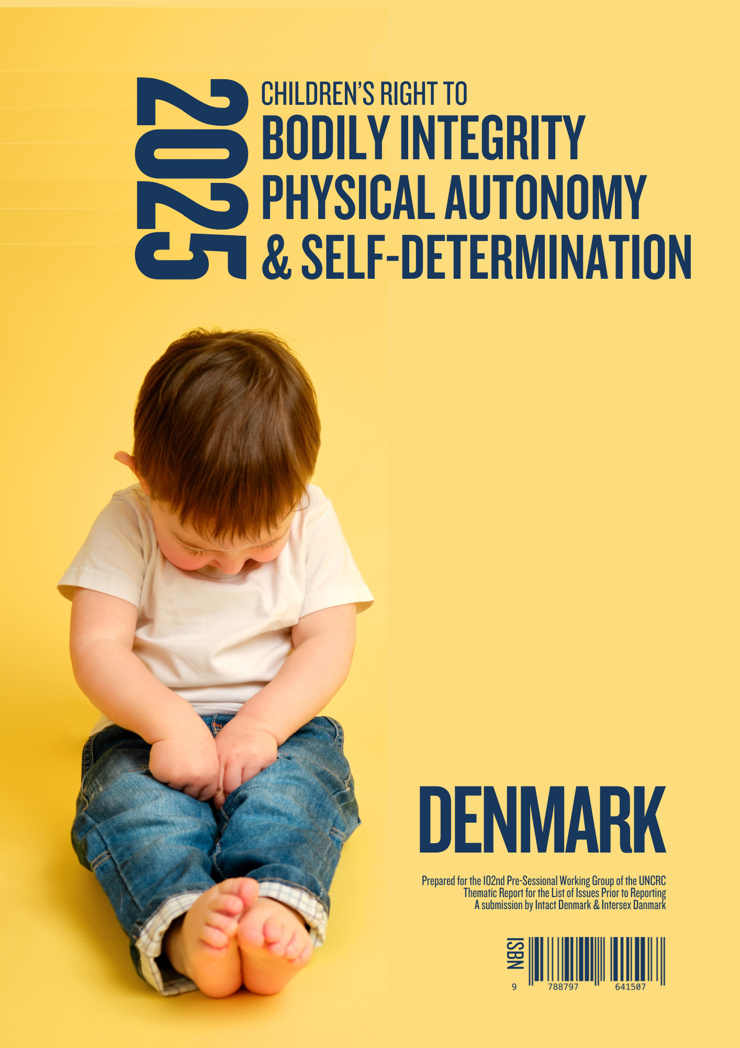
2025 Children’s Right to

Bodily Integrity, Physical Autonomy & Self-determination

DENMARK

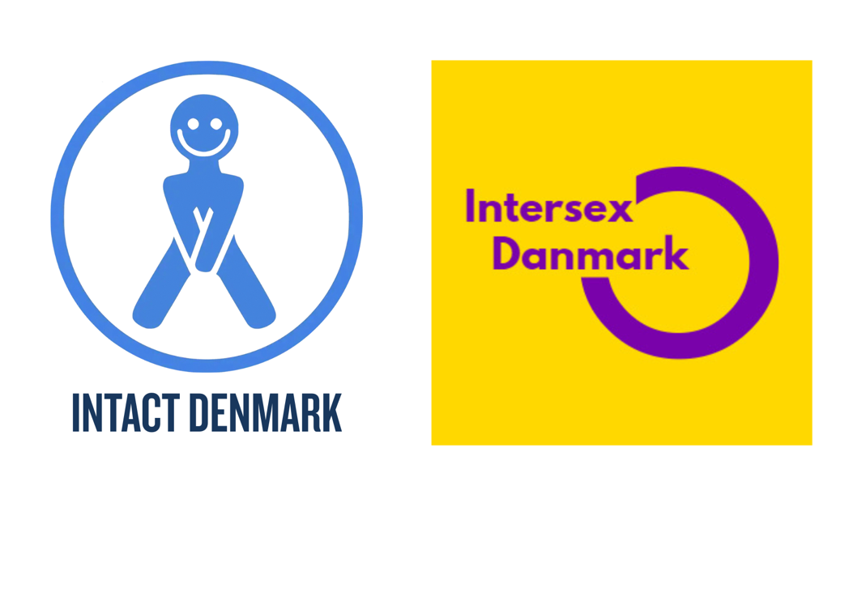

Prepared for the 102nd Pre-Sessional Working Group of the UNCRC
Thematic Report for the List of Issues Prior to Reporting
A submission by Intact Denmark & Intersex Danmark

Submission date
1st August 2025

Authors
Lena Nyhus, Inge Toft Thapprakkon & Mikael Aktor

Copyright
© 2025 Intact Denmark & Intersex Denmark
Photographer Zhuravlev Andrey

All rights reserved. Quotation allowed, provided appropriate credit is given to Intact Denmark & Intersex Denmark.

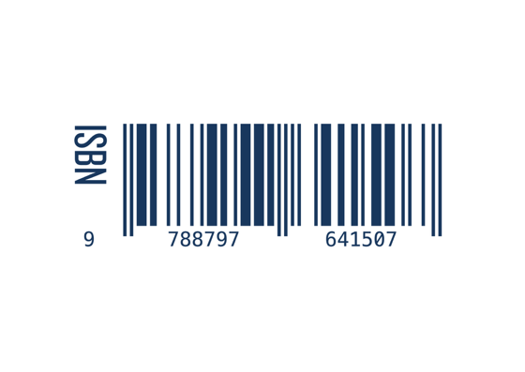
Publisher
Intact Denmark
ISBN 97887-976415-0-7
Table of Content

Executive Summary 5
Overall Context 5
Routine Violations of Children’s Bodily Integrity 5
Preserving Children’s Bodily Integrity Protects the Individual’s Right to Bodily Autonomy and Self-Determination 7
Transgressions Against Male Children Newly Enshrined in Hard and Soft Law 9
Transgressions Against Intersex Children 9
Danish Ministers Reject Investigation of Intersex Rights Violations 10
The Danish Institute for Human Rights Neglects Important Intersex Violations 10
Call for Immediate Abolition of Harmful Practices 11
List of Issues – in The State of Denmark 12
Sex-based disparity in access to legislative protection 12
Initiatives to Protect Intersex Children 12
Initiatives to Ensure Fully Informed Consent to Intersex Surgeries 12
Rights-based Information to Parents of Intersex Children 12
Misclassification of Intersex Children as Trans-persons 12
Investigations of Medical Mistreatment 12
Removal of the I From LGBT+ Action Plan 13
Access to Redress 13
Statistical Registration of Intersex Variations 13
Prescriptions of Glucocorticoids in Utero 13
Rights-based Information to Parents and Medical Personnel 13
Guideline for Non-Therapeutic Circumcision of Boys 13
Circumcisions Causing Risks to Life and Health 14
Legislative Protection from Prosecution for Rights Violations 14
Wilful Dismissal of Child’s Best Interest 14
Recognition of Children’s Rights and Dismantling of Violations 14
Annexes 15
Annex I - Authors and Organisations 15
Authors 15
Organisations 15
Annex II - Additional Data or References 16
Glossary of Terms 16
Joint Statement to Reinstate the I in the LGBTI+ Acronym 22
Rejection to Reinstate the I in the LGBTI+ Acronym 24
Answer to Request for Investigation of Rights Violations of Intersex People 26

Sources available at the end of the document

Executive Summary

Preserving children’s bodily integrity protects the individual’s right to bodily autonomy and self-determination.

By protecting children from unnecessary, irreversible interventions, we ensure that permanent decisions are postponed until the individual - who must live with the consequences - has the age, maturity, and capacity to make an informed, voluntary choice.
This protects the individual’s right to give consent free from coercion or undue influence.

Protection of the child’s bodily integrity is a prerequisite for upholding the individual’s fundamental right to bodily autonomy and self-determination.

This report examines the extent and consequences of human rights violations arising from unnecessary surgeries and circumcisions performed on intersex and male infants and minors.

Overall Context

This report explores the extent of human rights violations in the context of unnecessary surgeries and circumcisions of intersex and male infants and minors, whether performed for religious, cultural and traditional reasons or as medical interventions that could alternatively have been safely postponed or treated with less invasive methods.

The consequences of these interventions, intersex surgeries as well as circumcisions, are lifelong and varied and can affect and, in some cases, irreversibly define a range of aspects of the affected individual's life, including but not limited to health, legal gender, sexuality, religion, cultural affiliations and sense of identity, while also shaping other’s perceptions of the individual as belonging to a specific gender, religion, etc.

Routine Violations of Children’s Bodily Integrity

In Denmark, children’s rights to bodily integrity, physical autonomy and self-determination are routinely disregarded, when male children are circumcised without medical indication for religious, cultural, or traditional reasons. Boys are also frequently subjected to therapeutic procedures in contexts where less invasive treatments have not been. These surgeries subject the affected children to not insignificant risks to life and health,.

Furthermore, intersex children are subjected to unnecessary and irreversible medical interventions and surgeries to make their bodies conform to a binary paradigm. These procedures are carried out under the guise of medical necessity, despite lack of quality evidence documenting necessity, safety, or benefit for the child.

Irreversible and non-therapeutic genital surgeries on male and intersex children are not prohibited under the Danish Criminal Code, although they are comparable in nature, invasiveness, consequences and possible complications to bodily violations of females, rightfully called female genital mutilation (FGM).

Paradoxically The State of Denmark encourages so-called gender reaffirming surgeries on intersex children to facilitate a binary perception of gender and sex, while denying similar interventions to trans children with the argument that non-therapeutic, irreversible procedures should be postponed until age and maturity allows fully informed consent and understanding of personal identity.

Furthermore, the FGM-legislation not only prohibits non-therapeutic genital cutting on female children, but adults as well, stripping the adult woman of her bodily autonomy regarding elective genital procedures, while simultaneously denying the male or intersex person bodily autonomy, by allowing irreversible procedures, before they are able to protest, defend themselves, or even give meaningful, informed consent. Thus, creating a discriminatory, sex-based hierarchy of access to protection.

The UN has consistently maintained that “Infants and young children are holders of all rights enshrined in the Convention on the Rights of the Child as well as other international human rights treaties”, including but not limited to: The rights to bodily integrity, physical autonomy and self-determination; the right to be free from discrimination; the right to highest attainable standard of health, including reproductive health,; the right to privacy and to the development and preservation of identity,; the right to be free from harmful practices, ill-treatment and torture;,,, and finally the right to redress. The UN has furthermore affirmed that “an adult’s judgment of a child’s best interests cannot override the obligation to respect all the child’s rights under the Convention”.

In conclusion genital surgeries on intersex, male and female children all constitute violations of the bodily integrity if performed without solid evidence of immediate medical need, therefore they should all be termed genital mutilations; intersex (IGM), male (MGM) and female (FGM).

Legislative protection from genital mutilation should be accessible regardless of sex.

Preserving Children’s Bodily Integrity Protects the Individual’s Right to Bodily Autonomy and Self-Determination

By protecting children from unnecessary and irreversible interventions, we ensure that decisions of a permanent nature are postponed until the individual - who must live with the consequences - has the age, maturity, and capacity to make informed, voluntary choices.

This approach respects the individual’s right to give consent free from coercion or undue influence.

Protection of the child’s bodily integrity is a prerequisite for upholding the individual’s fundamental right to bodily autonomy and self-determination.

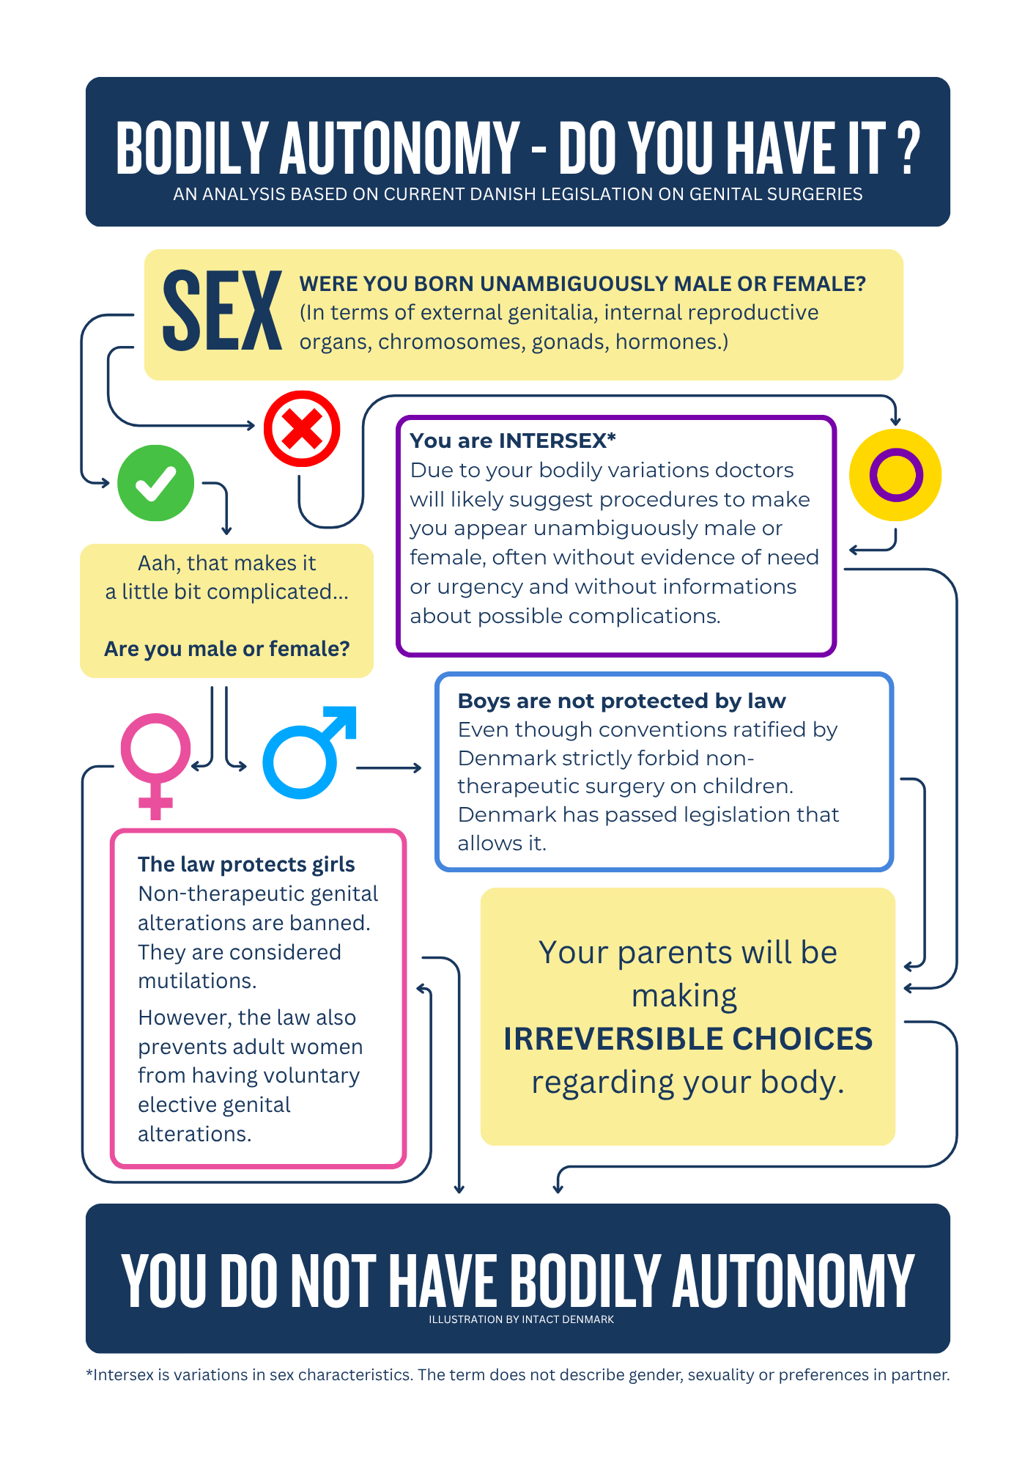

Transgressions Against Male Children Newly Enshrined in Hard and Soft Law

Examples of rights violations include the legal authorisation granted to medical professionals to perform non-therapeutic circumcisions on male children; legislation introduced in 2024 and the official Guideline for Non-therapeutic Circumcisions of Boys, describing that “Circumcision of boys is considered a surgical procedure under the Danish Authorisation Act and is therefore restricted to licensed medical doctors. In connection with the procedure, a doctor–patient relationship is established between the physician and the boy, although the boy is healthy.”

The Guideline states that “In cases of non-therapeutic circumcision, the usual requirements for due care and conscientiousness are heightened, particularly with regards to the use of assistants, obtaining of informed consent, and the provision of information. This is due to the procedure being a surgical intervention performed without medical indication.” This constitutes a blatant violation of the child’s right to bodily integrity, as it may only be dismissed when immediate medical interventions for the direct and unequivocal benefit of the child are needed.

Importantly, the guideline was developed without participation of any of the six invited medical and health societies, as none wished to be involved.

Organisations representing the Danish medical community as well as Nordic children’s rights organisations recommend that non-therapeutic procedures are not performed on minors for reasons of their unethical, harmful and potentially dangerous nature.

However, the then Minister of Justice, Nick Hækkerup, declared that:

"What has been most decisive for us is not the interests of the child, although that is an important consideration, nor foreign policy interests, which are also important. What has mattered most to us is that Jewish people must be able to live a life in Denmark. We believe we have a historical obligation to support that”, cementing the deliberate disregard for the rights of the affected children in direct violation of the UNCRC,.

Transgressions Against Intersex Children

In May 2017 Amnesty International launched the report “First Do no harm, ensuring the rights of children with variations in sex characteristics in Denmark and Germany”. The report documents how the treatment of individuals with variations of sex characteristics in Denmark violates international human rights law, particularly the UNCRC. Amongst other, they violate the rights to the highest attainable standard of health; to private life; to bodily integrity, to live free from ill treatment and torture; the rights to freedom from discrimination, and the elimination of practices based on gender stereotypes.
Removal of the I from the LGBTI+ Acronym Led to Invisibilisation
When The State of Denmark in 2022 launched the 2nd LGBT+ action plan “Room for Diversity in the Community” the letter I for “Intersex” had been removed from the LGBTI acronym in all political contexts, and all intersex specific topics had been removed too. The direct and inevitable consequence of the invisibilisation is an increase in discrimination and othering of intersex people.

The removal was addressed by Organization Intersex International (OII) in a press release stating that “this removal constitutes a grave backsliding in the rights of intersex people, and actively contributes to their invisibilisation.”

In October 2024, Intersex Denmark sent a statement to the Minister of Equality, cosigned by 12 Danish LGBTQIA+ organizations and supported by OII Europe and Ilga Europe requesting that the I for intersex be reinserted in the acronym in all political contexts, and for the Danish Government to start working on a holistic and human rights based legislation securing the rights of intersex people.

The Minister of Equality rejected the request.

Danish Ministers Reject Investigation of Intersex Rights Violations

In conflict with the obligation to investigate possible human rights violations, the Ministers of Equality and Health in 2024 rejected a request by Intersex Danmark, to ensure independent and in-depth investigation into the repeated indications of violations of intersex rights in medical settings, although such violations are categorized by the EU, UN, and the Parliamentary Assembly of the Council of Europe as harmful practices, ill-treatment and torture, and equated to genital mutilations such as FGM and non-therapeutic circumcisions of male minors (MGM).

In 2023 the HRC stated that “there can be no effective torture prevention if the same authorities against whom allegations are being made are themselves investigating their peers, subordinates or superiors.” Therefore, the rejection raises grave concerns, as we have reason to believe that no independent sources were consulted.

The Danish Institute for Human Rights Neglects Important Intersex Violations

The Danish Institute for Human Rights holds a mandate from the Danish Parliament, to promote, evaluate and monitor the rights and conditions of LGBTI+ people in Denmark, however, the LGBT+ Barometer monitoring the situation for intersex persons in Denmark, lacks essential information, including but not limited to: Documenting cases of treatment with Dexamethasone in utero as well as documentation whether unnecessary surgeries on intersex infants are taking place in Denmark.

By omitting important points this paints an extremely distorted picture of Denmark as a country meeting its human rights obligations with regards to intersex people.

Call for Immediate Abolition of Harmful Practices

When considering the rights in relation to listed practices, it becomes evident that there is an ongoing systemic maintenance and protection of harmful practices as defined in the CEDAW and CRC in direct violation of children’s fundamental rights.

As State parties are under strict obligation to undertake “all appropriate measures” to fully implement these rights for all children, as it is obvious, that the disparity in protections afforded female children, intersex children, and male children is untenable and must be amended immediately.

List of Issues – in The State of Denmark

Sex-based disparity in access to legislative protection

Please, confirm whether it is correct that girls’ right to bodily integrity is protected by a penalty framework of up to six years of imprisonment, while intersex individuals and boys are not afforded equal protection? If so, what does the State of Denmark intend to do to remedy this inequality?

Initiatives to Protect Intersex Children

Please, provide information on what steps, if any, are being taken by the government bodies to ensure that necessary legislative, administrative, and other measures are implemented guaranteeing respect for the physical integrity and autonomy of intersex persons, and ensuring that Denmark lives up to the obligation to prohibit, prevent, investigate, combat impunity, and provide full access to adequate redress for physical and psychological suffering, caused by unnecessary non-therapeutic medical practices during infancy or childhood, and to ensure that such practices are offences under criminal law.

Initiatives to Ensure Fully Informed Consent to Intersex Surgeries

Please, provide information on what steps, if any, are being taken by the government bodies to ensure the individual’s full and free consent is provided in all cases where surgical interventions on an intersex individual are considered.

Rights-based Information to Parents of Intersex Children

Please, provide information on what steps, if any, are being taken to inform parents of intersex children of the consequences of unnecessary treatments and surgeries, and the fact that these are categorized by the UN as harmful practices, ill-treatment and torture, and by the EU is equated to female genital mutilation.

Misclassification of Intersex Children as Trans-persons

Please, provide information on what steps, if any, are being taken to ensure that intersex individuals who do not identify with the legal sex they were assigned at birth, are not mistakenly classified as transgender, if they disagree with the assigned sex, seek treatment, incl. hormone replacement therapy and surgeries in line with their gender identity.

Investigations of Medical Mistreatment

Please, provide information on what steps, if any, are being taken by government bodies to undertake investigation of incidents of surgical and other medical treatment of intersex children without the individual's prior informed consent. The Ministries of Health and Equality have refused to undertake such an investigation, despite clear human rights obligation to do so, on what grounds?

Removal of the I From LGBT+ Action Plan

Please, explain why the Danish Government has chosen to remove the I for intersex from the acronym in all political context, and all intersex specific topics from the current LGBT+ Action plan.

Access to Redress

Please, provide information on what steps, if any, are being taken to ensure adequate redress for the physical and psychological suffering caused, is being provided in an accessible manner to intersex persons and persons subjected to non-therapeutic circumcisions.

Statistical Registration of Intersex Variations

Please, clarify whether it is correct that the State of Denmark does not include several intersex variations in its official statistics (cf. definition), thereby artificially misrepresenting the number of intersex-related surgical interventions taking place.

Prescriptions of Glucocorticoids in Utero

Please, provide information on whether Denmark recommends the use of high doses of Glucocorticoids (Dexamethasone) in utero, to prevent the virilization of girls with CAH, despite limited evidence, and the fact that studies point to impaired cognitive development in the children exposed to the drug in utero?

Rights-based Information to Parents and Medical Personnel

Please, explain what steps The State of Denmark takes to ensure that medical personnel and parents are educated on intersex rights, the range of sexual and related bodily diversity, and the consequences of unnecessary surgical and medical interventions, to ensure that all decisions are made on an evidence-based foundation.

Guideline for Non-Therapeutic Circumcision of Boys

Please, confirm whether it is correct that The State of Denmark has introduced a Guideline for Non-Therapeutic Circumcision of Boys? If so, please, explain how that does not violate the children’s rights, and the obligation to protect children from interventions that are not evidence-based and urgently required?

Circumcisions Causing Risks to Life and Health

Please, confirm whether it is correct that the official Guideline on Non-therapeutic Circumcision of Boys, based on the Memorandum on Non-Therapeutic Circumcisions of Boys, acknowledges the risk of serious complications, including death, and requires clinics to have life-saving equipment available during the procedure. If so, The State of Denmark is requested to explain how this guidance is compatible with, for example, the right to life.

Legislative Protection from Prosecution for Rights Violations

Please, clarify whether The State of Denmark has introduced legislation which actively exempts medical doctors from prosecution, when violating the bodily integrity of boys during non-therapeutic circumcisions?

Wilful Dismissal of Child’s Best Interest

Please, confirm whether Minister of Justice, Nick Hækkerup, has stated that "What has been most decisive for us is not the interests of the child – although that is an important consideration – nor foreign policy interests – which are also important. What has mattered most to us is that Jewish people must be able to live a life in Denmark. We believe we have a historical obligation to ensure that”? If so, please explain how that corresponds with the obligation to always make the child’s best interest the primary obligation as ratified by Denmark in UNCRC art. 3.

Recognition of Children’s Rights and Dismantling of Violations

Please, clarify whether The State of Denmark will recognise children’s right to bodily integrity, bodily autonomy, as well as self-determination, and take steps to dismantle all forms rights violations?

K. Zillén, J. Garland & S. Slokenberga. The Rights of Children in Biomedicine: Challenges posed by scientific advances and uncertainties, p. 43, para 2. Report commissioned by the Committee on Bioethics of the Council of Europe. https://rm.coe.int/16806d8e2f
The Danish Patient Safety Authority. Memorandum on Non-Therapeutic Circumcision of Boys Notat om ikke-terapeutisk omskæring af drenge https://stps.dk/media/9531/C08D154EE830415BBEA6EB17669979BC.pdf
Thorup, J., Thorup, S. C., & Ifaoui, I. B. R. (2013). Complication rate after circumcision in a paediatric surgical setting should not be neglected. Danish Medical Journal, 60(8), A4681. https://researchprofiles.ku.dk/en/publications/complication-rate-after-circumcision-in-a-paediatric-surgical-set-2
Heiberg, I.L., Nebrich, L. & Pedersen, P. (2015) Generalised Seizures and Respiratory Arrast as a Complication Associated with Local Anaesthesia During Circumcision Universelle kramper og respirationsstop som komplikation i forbindelse med lokalanalgesi som komplikation i forbindelse med lokalanalgesi ved circumcisio https://ugeskriftet.dk/videnskab/universelle-kramper-og-respirationsstop-som-komplikation-i-forbindelse-med-lokalanalgesi
The Danish Criminal Code § 245a https://danskelove.dk/straffeloven/245a § 246 https://danskelove.dk/straffeloven/246
Special Rapporteur on the right of everyone to the enjoyment of the highest attainable standard of physical and mental health, Dainius Puras. Right of everyone to the enjoyment of the highest attainable standard of physical and mental health, p. 9, 35. United Nations General Assembly Seventieth Session, item 73 (b) of the provisional agenda. https://docs.un.org/en/A/70/213
UNCRC, Art. 2, sub-section 1. Convention on the Rights of the Child (1989) https://www.ohchr.org/sites/default/files/crc.pdf
Committee on the Rights of the Child General comment No. 15 (2013) on the right of the child to the enjoyment of the highest attainable standard of health (art. 24) https://docs.un.org/en/CRC/C/GC/15
Committee on Economic, Social and Cultural Rights General comment No. 22 (2016) on the right to sexual and reproductive health (article 12 of the International Covenant on Economic, Social and Cultural Rights) https://docs.un.org/en/E/C.12/GC/22
UNCRC, Art. 16 Convention on the Rights of the Child (1989) https://www.ohchr.org/sites/default/files/crc.pdf
United Nations International Covenant on Civil and Political Rights (1966), at article 17 https://www.un.org/en/genocideprevention/documents/atrocity-crimes/Doc.4_iccpr.pdf
OHCHR, press-release End violence and harmful medical practices on intersex children and adults, UN and regional experts urge https://www.ohchr.org/en/press-releases/2016/10/intersex-awareness-day-wednesday-26-october
A/HRC/22/53. “Report of the Special Rapporteur on torture and other cruel, inhuman or degrading treatment or punishment, Juan E. Méndez”, para 15 and 20. https://docs.un.org/en/A/HRC/22/53
CEDAW/C/GC/31-CRC/C/GC/18. “Joint general recommendation No. 31 of the Committee on the Elimination of Discrimination against Women/general comment No. 18 of the Committee on the Rights of the Child on harmful practices”, para 15. https://docs.un.org/en/CEDAW/C/GC/31/CRC/C/GC/18
A/HRC/29/23. “Discrimination and violence against individuals based on their sexual orientation and gender identity Report of the Office of the United Nations High Commissioner for Human Rights”, para 38. https://docs.un.org/en/A/HRC/29/23
United Nations, “Convention against Torture and Other Cruel, Inhuman or Degrading Treatment or Punishment”, article 14. https://www.ohchr.org/sites/default/files/cat.pdf
CRC/C/GC/13. “The right of the child to freedom from all forms of violence”, para 61. https://www2.ohchr.org/english/bodies/crc/docs/CRC.C.GC.13_en.pdf
ETS No. 164. Convention for the protection of Human Rights and Dignity of the Human Being with regard to the Application of Biology and Medicine: Convention on Human Rights and Biomedicine https://rm.coe.int/168007cf98
Aligned with the UN Convention on the Rights of the Child, including General Comment No. 12 (2009) on the right of the child to be heard and General Comment No. 20 (2016) on the rights of the child during adolescence. https://www.refworld.org/legal/general/crc/2009/en/70207 https://www.refworld.org/legal/general/crc/2016/en/115419
Act on Authorization of Health Professionals (Autorisationsloven), section 74, subsection 5. https://www.retsinformation.dk/eli/lta/2024/1008
The Danish Patient Safety Authority Guideline for Non-therapeutic Circumcision of Boys (Vejledning om Ikke-terapeustisk omskæring af drenge) https://www.retsinformation.dk/eli/retsinfo/2020/9813
Intact Denmark List of Danish medical societies, children’s rights organisation and others with policies called for an end to non-therapeutic circumcisions of minors. https://www.intactdenmark.dk/andre-imod/
Joint statement from the Nordic Ombudsmen for Children and pediatric experts Let the boys decide on circumcision https://www.barneombudet.no/vart-arbeid/brev-og-innspill/felles-uttalelse-fra-de-nordiske-barneombudene-og-barnemedisinske-eksperter-om-omskjaering-av-gutter
Minister of Justice, Nick Hækkerup Interview with the Danish Broadcasting Corporation (DR) https://www.dr.dk/nyheder/politik/kun-hver-tiende-dansker-er-enig-med-frederiksen-og-ellemann-i-omskaering-af-drenge
UNCRC, Art. 16, art. 3.1. Convention on the Rights of the Child (1989) https://www.ohchr.org/sites/default/files/crc.pdf
CEDAW/C/GC/31-CRC/C/GC/13, Para 17, 37 & 61 https://www2.ohchr.org/english/bodies/crc/docs/CRC.C.GC.13_en.pdf
Amnesty First do no harm, report https://amnesty.dk/wp-content/uploads/media/3078/first-do-no-harm.pdf
Ministry of Transport, Department of Equality Room for Diversity in the Community (Plads til forskellighed i fællesskabet LGBT+ handlingsplan 2022-2025) https://www2.mim.dk/Udgiv/Ligestilling%202022/plads-til-forskellighed-i-faellesskabet-lgbtplus-handlingsplan-2022-2025-a.pdf
OII Europe OII Europe comment on worrying attacks against intersex rights by former Danish Minister for Gender Equality https://www.oiieurope.org/worrying-attacks-on-intersex-rights-in-denmark/
Documentation included in Annex
Documentation included in Annex
Communication from the Commission to the European Parliament, the Council, the European Economic and Social Committee and The Committee of the Regions, item 2.4 https://eur-lex.europa.eu/legal-content/en/txt/?uri=celex:52020dc0698
Parliamentary Assembly of the Council of Europe Children’s Right to Physical Integrity, resolution 1952 (2023) https://assembly.coe.int/nw/xml/XRef/Xref-XML2HTML-en.asp?fileid=20174
CEDAW/C/GC/31/CRC/C/GC/18, para 15 & United Nations Press Release End violence and harmful medical practices on intersex children and adults, UN and regional experts urge https://docs.un.org/en/CEDAW/C/GC/31/CRC/C/GC/18 https://www.ohchr.org/en/press-releases/2016/10/intersex-awareness-day-wednesday-26-october
A/63/175, para 47 & A/HRC/29/23, paras 38 & 39 https://documents.un.org/doc/undoc/gen/n08/440/75/pdf/n0844075.pdf https://docs.un.org/en/A/HRC/29/23
P8_TA(2017)0028. European Parliament Resolution “Promoting gender equality in mental health and clinical research,” paras BB, BC & 61. https://www.europarl.europa.eu/doceo/document/TA-8-2017-0028_EN.pdf
A/HRC/52/30. “Good practices in national criminalization, investigation, prosecution and sentencing for offences of torture”, paras 61 and 63. https://docs.un.org/en/A/HRC/52/30
Danish Institute for Human Rights LGBT+ Barometer https://www.humanrights.dk/lgbt-barometer
CEDAW/C/GC/31/CRC/C/GC/18.
CRC/C/GC/13, para 37. https://docs.un.org/en/CRC/C/GC/13
Definition of necessary surgeries. ”The Rights of Children in Biomedicine, Challenges posed by scientific advanced and uncertainties”; page 40 para 1, p. 43 para 2 and p. 44 para 3 https://rm.coe.int/16806d8e2f
Including but not limited to: Surgeries for hypospadias, epispadias, cryptorchidism and urogenital sinus, to separate the vagina and urethra.
Law no. 9453 of 27/06/2014 on cosmetic surgeries, does not apply in cases of intersex surgery, as unnecessary surgeries on intersex individuals are performed based on questionable studies, tainted by views of what is best for the children, and under the guise of being beneficial, and thus necessary for the child's health, despite the lack of quality evidence to the benefits, necessity, or safety of these interventions.

