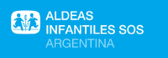
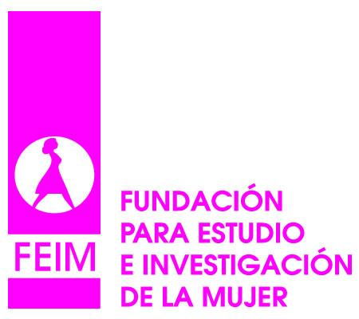
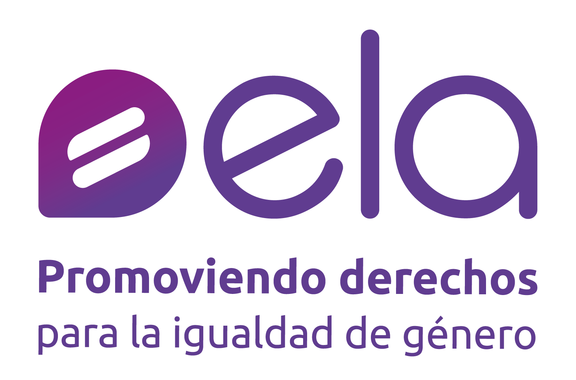
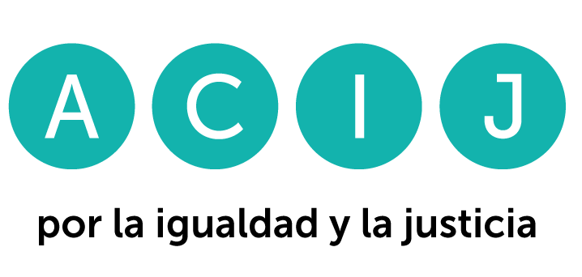
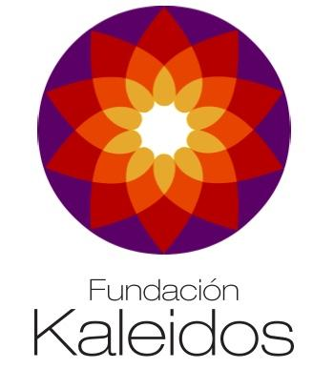
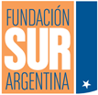


WRITTEN CONTRIBUTIONS TO THE STATUS REPORT

98TH PRE-SESSION
COMMITTEE ON THE RIGHTS OF THE CHILD

ELABORATED BY THE COLLECTIVE OF ORGANIZATIONS "CHILDHOOD IN DEBT" (INFANCIA EN DEUDA)

THE SITUATION OF THE RIGHTS OF CHILDREN AND ADOLESCENTS IN ARGENTINA

- Introduction
Infancia en Deuda is a coalition of organizations dedicated to the defense of the human rights of children and adolescents. Since 2015 we have been working as a network in public advocacy actions for the promotion and protection of the rights of children and adolescents.
During the 78th session, we submitted an alternative report to the Committee on the Rights of the Child regarding the situation of children and adolescents in Argentina, who still live in critical conditions. In addition to the List of Priority Issues submitted in 2022, address again the Committee in order to submit our written contributions to the State's report.
- Methodology
This document seeks to inform the Committee about the main debts that Argentina has with the rights of children and adolescents. For this purpose, we have taken into the recommendations of the "Concluding Observations on the combined fifth and sixth periodic reports of Argentina" (CRC/C/ARG/CO/5-6), Argentine regulations, public budgets, official public information, documents prepared by international and local organizations and universities that analyze the situation of children and adolescents and, finally, the reports prepared by the organizations that are members of the coalition.
- General measures of implementation
  - Comprehensive policies and strategies
    - The situation of the rights protection system
The Committee requested the Argentine State to provide information on the "steps taken by provinces and municipalities to adapt their legislation with regard to the national legal framework relating to children’s rights, in particular the national act on the comprehensive protection of children and adolescents (Act No. 26,061) ". In this regard, Argentina indicated that "a strong regulatory framework has been established in 23 of the 24 jurisdictions in addition to the existing national laws and laws with constitutional hierarchy. However, the province of Formosa is still in the process of enacting its bill". This information is incorrect. The province of San Luis did not formally adhere to Law 26.061 either. This province only adhered by Law 1-0007 to the Convention on the Rights of the Child.
In our country, the Convention on the Rights of the Child has constitutional hierarchy under the terms of article 75, paragraph 22 of the National Constitution. In compliance with the Convention, the State enacted Law 26.061 in 2005. In a federal country, the obligation to adapt domestic legislation also falls on the provincial jurisdictions. Consequently, after more than 18 years, it is imperative that all provinces, and by derivation their municipalities, adhere to the national law in order to guarantee a minimum level of rights for children and adolescents throughout the country.
Regarding the exceptional measures (that is, those that are adopted when the best interests of the child cannot remain in their family environment), it is observed that there are no minimum standards that must be guaranteed at the time when the institutionalization of a child is decided. In this regard, it is noted with concern that there are jurisdictions in which there are "children and adolescents without control of legality housed in some type of residential or family facility" .
On the other hand, the Committee requested the Argentine State to provide information on the implementation and evaluation of the National Plan for the Rights of Children and Adolescents 2016-2019, and on the measures taken to develop a new plan. In response, the State indicated: "it is necessary to mention that it is the Federal Council and the Secretariat for Children who are responsible for carrying out the task of evaluating and reformulating the National Plan, with a view to planning the next period, which was compromised by the Pandemic, having to address the health emergency, guaranteeing the rights of NNYA throughout the country. Nevertheless, guidelines were agreed upon for the approach of: National Training Plan on Childhood and Family; National Early Childhood Plan; National Program for the Reduction of Non-International Pregnancy in Adolescents; Adolescent Forums Promotion of the Child's Lawyer; promotion of the Right to Identity, Addictions; Child Labor....".
In a country with high levels of poverty and extreme poverty, the lack of a medium and long-term National Plan has a direct impact on the development and quality of life of children and adolescents. In addition, in recent years other emerging issues have emerged that, due to their urgency, require strategies that include criteria that go beyond plans that address specific issues. For example, in the words of the Ombudswoman for the Rights of Children and Adolescents, "After two years of pandemic (...) the emotional suffering of children and adolescents became visible" . In this context, there is no doubt that the State must, more than ever, adopt policies that ensure access to humanized, comprehensive, community-based and quality mental health care, as will be seen below.
    - Family environment and alternative care
The National Census of Residential Care Facilities for Children and Adolescents of December 2022, carried out by the National Undersecretariat for Children, Adolescents and the Family (SENNAF), surveyed housing capacities, infrastructure characteristics, human resources, access to public services and technological devices, the existence of protocols and other regulatory standards in relation to alternative care facilities. It is worth noting that of the 605 facilities participating in the Census, more than half are located in the provinces of Buenos Aires, Santa Fe and Córdoba. A total of 54.2% have accommodation capacity of up to 14 places, 37.2% from 15 to 29, 6.6% from 30 to 44 and 2% with more than 45 places. 23.1% of the facilities are overcrowded. There were 9,062 children, adolescents and young adults housed, of whom 1,645 (18.1%) were between 0 and 5 years old, 3,186 (35.2%) between 6 and 12 years old and 3,174 (35%) between 13 and 17 years old.
As a result of this diagnosis, the State decided to advance in the development of quality standards. Although the "Quality Guide for the Care of Children and Adolescents with exceptional measures in family-type facilities" was approved at the 47th session of the Federal Council for Children, Adolescents and the Family (COFENAF), the protocol for its application and evaluation of its operation are unknown. On this point, the lack of a national framework for coordination between administrations and institutions of the System for the Protection of the Rights of Children and Adolescents at the different levels of government is highlighted. The lack of official statistics that show the current situation is also evident. Since the last report presented by Infancia en Deuda, the Census has been the only source of indicators.
At the same time, there is an absence of programs implemented in accordance with the legal requirements of exceptionality and temporality, given that in 83.3% of the jurisdictions, the length of stay of children and adolescents in residential or family care arrangements exceeds the legal term of 180 days. In addition, there are no concrete actions to guarantee the right to have the child's lawyer when they are part of the judicial process that may lead to progress towards adoption. The lack of spaces for the participation of children and adolescents leads to the direct violation of their rights.
Another central problem regarding the constitution of the protection system is the deficit of technical training of workers, the lack of public, open and transparent competitions, and the low remuneration of personnel.
Recommendations
- The provinces of San Luis and Formosa be urged to adhere to Law 2.061.
- The State be urged to establish a National Plan for the Rights of Children and Adolescents in accordance with Law 26.061.
- The State be urged to adopt the necessary measures, both at the normative and factual levels, to strengthen the capacities of the rights protection system and to ensure full respect for the rights of children and adolescents during the institutionalization process and during the judicial processes that have an impact on their lives.

  - Allocation of resources
The Argentine State has a constitutional (art. 75, inc. 22, National Constitution), conventional (art. 4, CRC) and legal (law 26.061) commitment to the maximum use of available resources to ensure investment in the rights of children and adolescents. Its regulations are in line with what the Committee has stated, which indicates "that States parties do not have the power to decide whether or not to fulfill their obligation to adopt appropriate administrative, legislative and other measures to give effect to the rights of the child, such as measures relating to public budgets" . Thus, Law 26.061 has a series of articles that limit the discretion of State powers in matters of investment in children. On the one hand, Article 5 obliges to ensure a "privileged allocation of resources", while Article 72 establishes that "the budget may in no case be lower than the highest execution of previous fiscal years. The funds allocated to children and adolescents established in the national budget shall be intangible".
Although budget obligations are clear, the Argentine State has been steadily decreasing its investment in the rights of children and adolescents. In addition, in recent months there has been a worrying disinvestment in health and education. The State has not justified these adjustments according to international law standards. On the contrary, it maintains tax expenditures that represent a significant loss in terms of revenue, as we will see below.
Prior to the analysis, it is worth noting that the information presented here comes from the Ministry of Economy itself, which in 2021, 2022 and 2023 labeled and identified in the national budget those items intended for children and adolescents in the areas of health, social security, education, food, protection and defense of rights, infrastructure, culture, among others.
    - The year-on-year decline in investment
Investment in the rights of children and adolescents in Argentina has not stopped decreasing since 2021. The situation for the year 2024 is especially worrisome, when there will be no budget law by decision of the National Executive Power. This generates that in a country with very high levels of inflation, the budget items will be completely outdated and there will be a considerable adjustment on investment. In addition, the Legislative Branch loses its power to fix the spending priorities and to establish the limits it deems necessary to the use of resources by the Executive Branch.
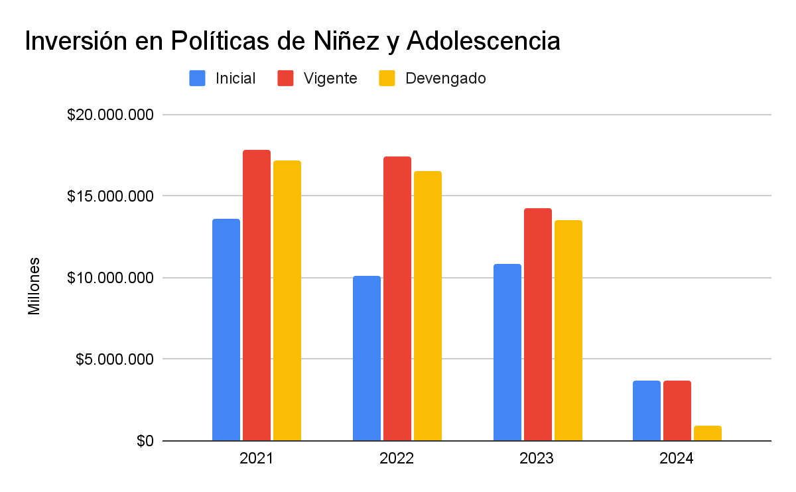
Source: Prepared by the authors based on information from the Ministry of Economy, the National Institute of Statistics and Census (INDEC) and the Central Bank of Argentina (BCRA).

Specifically, as can be seen in the following table, the actual budget for children and adolescents' rights, if the current appropriation for 2024 is taken, is 72.7% lower than that executed in 2023 and 78.5% lower than that executed in 2021. In the opinion of UNICEF Argentina, this marked reduction implies that "there will necessarily be a pronounced decrease in the coverage and quality of key services for the guarantee of the rights of children and adolescents in the country. It will also imply non-compliance with the Law for the Protection of the Rights of Children and Adolescents (Law No. 26.061)" .

Year | Initial budget (Budget Law and extension for 2024) | Current budget (with increases or deviations) | Budget executed
2021 | $13.581.484 | $17.806.258 | $17.213.431
2022 | $10.095.050 | $17.406.832 | $16.549.791
2023 | $10.801.845 | $14.272.584 | $13.558.141
2024 (as of March) | $3.675.354 | $3.699.345 | $938.535
Values are expressed in millions of pesos, adjusted for inflation to constant pesos as of February 2024.
Source: Prepared by the authors based on information from the Ministry of Economy, the National Institute of Statistics and Census (INDEC) and the Central Bank of Argentina (BCRA).
The reduction of investment in children and adolescents can also be seen in the share of this investment in the total budget of the National State. As shown in the graph below, the resources allocated to guarantee the rights of this group have lost more than 1% of the overall budget in recent years, which shows that this group has not been prioritized in the allocation of resources.
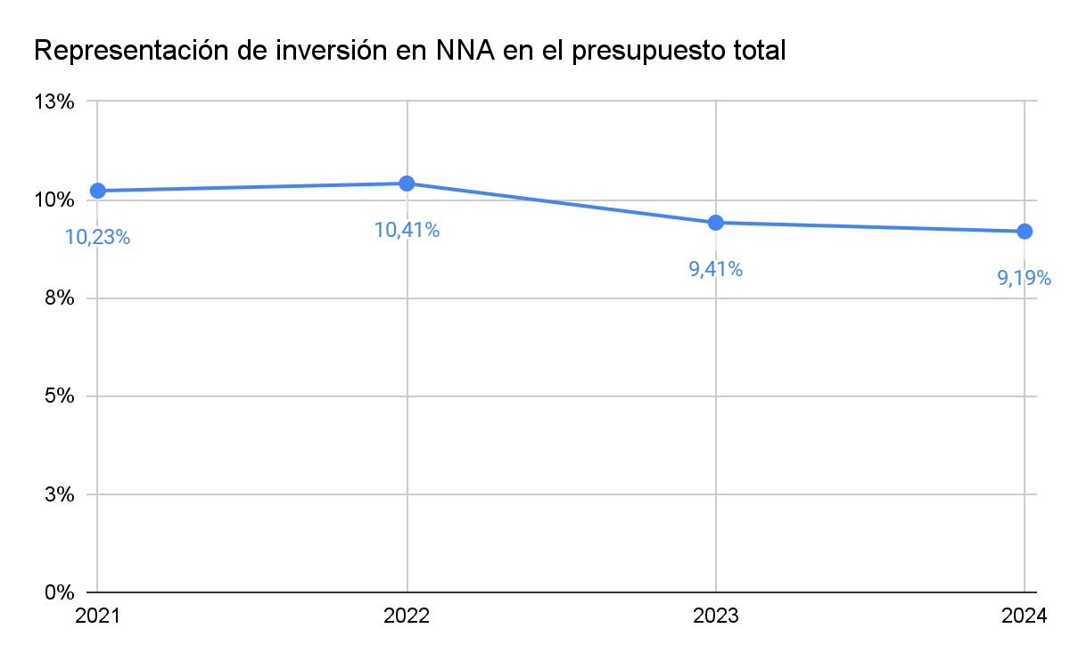
Source: Compilation based on information from the Ministry of Economy, the National Institute of Statistics and Census (INDEC) and the Central Bank of Argentina (BCRA).
    - Disinvestment in health and education
From Childhood in Debt (Infancia en Deuda) we also note with particular concern the very low levels of execution of specific programs for children and adolescents in the areas of health and education. In particular, we highlight the following:
- With regard to health, if we take the programs for children and adolescents, which include care for children up to 17 years of age, medicines, specific diseases, sexual and reproductive health, among others, we can see that after three months of the year only 7.66% of the current budget has been executed.
- With regard to education, among the programs aimed at children and adolescents, which include the entire spectrum of the educational process, from the payment of teachers, connectivity, construction of kindergartens and schools, information and improvement of the quality of education, among others, it can be seen that after three months, only 8.9% of the total has been executed and that some programs show a total lack of execution.

Right to health programs for children and adolescents | Outstanding loan 2024 (in millions of pesos) | Execution as of March 2024 (in millions of pesos) | % of execution
Life Course (population 0-17) | $7.555 | $283 | 3,76%
Access to Drugs, Supplies and Medical Technology | $13.452 | $540 | 4%
Sexual Health and Responsible Procreation Development | $7.929 | $507 | 6,40%
Prevention and control of endemic diseases | $124 | $0 | 0%
Prevention and control of communicable and immune-preventable diseases | $60.567 | $5538 | 10,9%
Response to HIV, sexual transmission, Hepatitis, Tuberculosis and Leprosy. | $44 | $0,13 | 0,3%
Total | $89.671 | $6.868,13 | 7,66%

Right to education programs for children and adolescents | Outstanding loan 2024 (in millions of pesos) | Execution as of March 2024 (in millions of pesos) | % of execution
Teacher training actions | $8.328 | $0 | 0%
Conectar Igualdad (provision of connectivity and devices for education) | $105.146 | $5.621 | 5,35%
National Teacher Incentive Fund | $347.350 | $46.611 | 13,4%
Construction of kindergartens | $28.464 | $28 | 0,1%
Strengthening of Educational Organizations | $2.116 | $0 | 0%
Educational Management and Socio-Educational Policies | $96.415 | $6.615 | 6,86%
Educational Scholarships | $102.306 | $18.847 | 18,4%
Educational Information and Evaluation | $8.085 | $24 | 0,3%
Educational infrastructure and equipment | $59.486 | $10 | 0,02%
Innovation and Technological Development | $37.227 | $596 | 1,6%
Improvement of educational quality | $77.622 | $0 | 0%
Total | $872.545 | $78.352 | 8,9%

    - Lack of justification for the adjustment measures
In the opinion of this Committee, "retrogressive measures can only be considered when all other options have been evaluated and ensuring that children, particularly those in vulnerable situations, will be the last to be affected by such measures" . In a similar vein, the Committee on ESC rights has stated that States should prove that the measures are temporary, legitimate, reasonable, necessary (which implies that all alternative funding measures have been comprehensively examined and exhausted) and proportionate. They must also prove that they are neither directly nor indirectly discriminatory (in that they give priority attention to vulnerable groups), that they protect the minimum core content of rights, and that they are based on transparency and genuine participation of the affected groups in the review of the measures and their alternatives, and are also subject to meaningful review and accountability procedures.
These requirements have not been accredited by the National State, which determines the invalidity of the expenditure reductions in accordance with international human rights law. On the contrary, the State has for years sustained tax expenditures, which are resources that the State forgoes to benefit activities, areas, taxpayers and/or consumption. Some of them have a redistributive purpose (such as the reduction of taxes on food), but many of them are unfair. According to ECLAC, they generate a system prone to evasion and corruption and have a negative impact on equality by mostly benefiting high-income sectors and forcing their compensation through regressive taxes. The existence of this type of unfair benefits violates the standard of maximum available resources in terms of the state's duty to mobilize funds, including through taxes and other non-tax revenues .
In the Argentine case, they are so large that the Ministry of Economy itself estimated that by 2024 they would be equivalent to 4.72% of GDP . Particularly questionable are: (i) the tax exemption from the payment of income tax to judges (representing 0.16% of GDP); (ii) the exemption from the payment of personal property taxes to rural real estate, a focus of great economic concentration (representing 0.48% of GDP); (iii) the exemption from payment of value added tax on the fees of company directors, who are very high-income individuals (equivalent to 0.29% of GDP); (iv) the exemption of companies located in Tierra del Fuego (an Argentine province) (representing 0.33% of GDP). All these tax expenditures were the subject of public discussion during the last few years, but the State has not taken measures to reduce them.
Recommendation
The State be urged to increase investment in children and adolescents and to improve revenue collection by eliminating unfair tax expenditures.

  - Independent supervision
The Committee requested the State to inform whether "the Ombudsman's Office, created in 2020, has the human, technical and financial resources necessary to fulfill its mandate...". In this regard, the State indicated: "the Ombudsman's Office as of August 2023 has a highly professionalized staff, reaching 72% of the staff with university degrees (...) it has availability of financial resources in time and form to provide for the fulfillment of the missions and functions entrusted by law. Numerous recommendations have been made to various agencies and on various topics. In addition, numerous pronouncements and annual reports have been issued".
The functions of the Ombudsman's Office are clearly established in Article 55 of Law 26.061, which obliges the institution to promote advocacy actions as well as instances of protection for the defense of rights. Among them are the promotion of actions "in any trial, instance or court" (art. 55, inc. b), the promotion of extrajudicial measures, the interposition of sanctions for infractions committed and the supervision of public and private entities dedicated to the care of children and adolescents (art. 55, incs. c, d and e).
Consequently, the dissemination of recommendations and pronouncements does not seem to be sufficient to comply with the functions established by law. The State's response is incomplete on this point, as it does not account for the use of other strategies aimed at protecting -and not only promoting- the rights of children and adolescents. This is evidence of a restricted vision of the role of this agency.
Recommendation
The State be urged to provide resources and generate the conditions for the promotion of actions for the enforceability and protection of rights by independent organizations.

- Standard of living
  - Poverty situation of children and adolescents
    - Very high levels of poverty and extreme poverty
The socioeconomic situation of children and adolescents in Argentina has acquired absolutely critical and alarming dimensions in recent years, to the point that it turns out to be the most serious since the State has been evaluated by the Committee on the Rights of the Child. In 2018, this body had already expressed its serious concern about the high levels of child poverty , which today are even higher.
UNICEF Argentina estimates indicate that in 2024, 70.8% of children will be poor and 34.4% will grow up in extreme poverty , as they would not be able to cover a Total Basic Food Basket (CBT) or a Basic Food Basket (CBA), respectively. This implies that out of a total of 12.2 million children and adolescents living in our country, 8.6 million would be poor and 4.1 million would be indigent, that is, without even access to a minimum food, which translates, according to the international organization, into a "deep crisis with great repercussions not only on current well-being but also in the long term, through the so-called intergenerational transmission of poverty" .
In the following table and graph it is possible to visualize the evolution of child poverty in our country. Since the last evaluation carried out by the Committee, more than 3.5 million children and adolescents (almost 30% of the total) became poor and more than 3.1 million became indigent (almost 26% of the total). All this in only 6 years. It should be noted that the numbers "-1" and "-2" below indicate the semester of the year to which each figure corresponds.
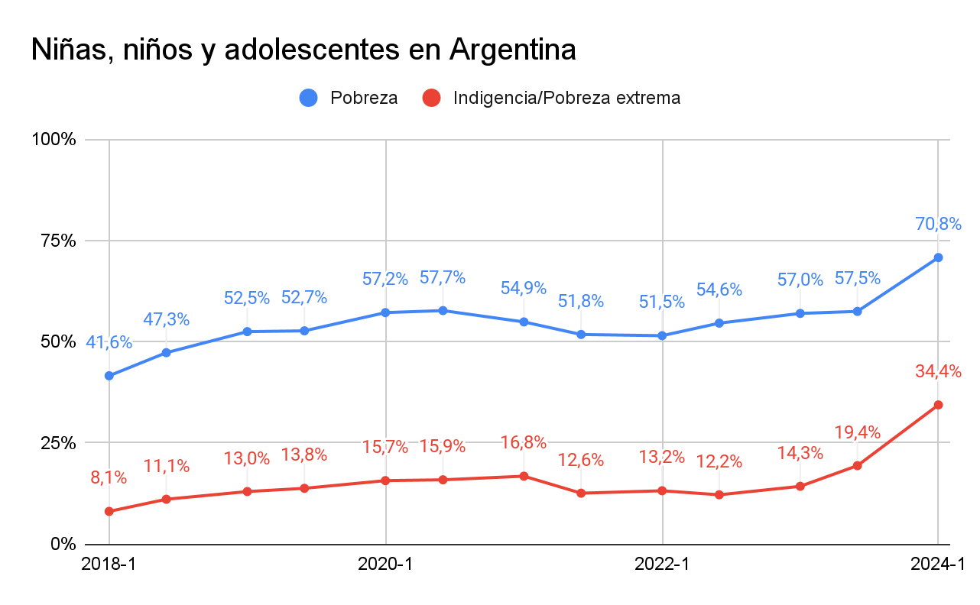

Year and semester | Child poverty | Indigence/Extreme child poverty
2018-1 | 41,6% | 8,1%
2018-2 | 47,3% | 11,1%
2019-1 | 52,5% | 13,0%
2019-2 | 52,7% | 13,8%
2020-1 | 57,2% | 15,7%
2020-2 | 57,7% | 15,9%
2021-1 | 54,9% | 16,8%
2021-2 | 51,8% | 12,6%
2022-1 | 51,5% | 13,2%
2022-2 | 54,6% | 12,2%
2023-1 | 57,0% | 14,3%
2023-2 | 57,5% | 19,4%
2024-1 | 70,8% | 34,4%
Source: Prepared by the authors based on official data from the National Institute of Statistics and Census of Argentina (INDEC) and UNICEF Argentina for the second half of 2023 and the first half of 2024.

This occurs in a context of significant deterioration of family incomes, as a result of the policies adopted by the Argentine State in recent years and aggravated in recent months. According to data from the National Ministry of Economy and the INDEC, the loss of purchasing power in January 2024 alone was 16%, leaving wage levels in the economy at their lowest level in the last 20 years . UNICEF Argentina warned in 2023 about the serious consequences of the loss of income for households with children and adolescents. In addition to the high levels of indebtedness to banks, credit cards and businesses, it estimates that "around 3.5 million children and adolescents had to stop eating some of their main meals or modify the portions consumed or the quality of their diets" .
    - Social protection policies
As explained by the Argentine State in its report, in order to ensure the right to social security, there is a system of economic transfers to children and adolescents divided according to the labor situation of their families. The two main policies for the protection of children and adolescents in poverty are the Universal Child Allowance (AUH) -aimed at low-income families in informal labor situations- and the Alimentar Benefit (Prestacion Alimentar) -a specific food reinforcement for children and adolescents who receive the AUH and are up to 14 years old-. In this sense, although the AUH and the subsequent incorporation of the Alimentar Benefit from 2021 are important advances, they require priority attention from the Committee.
There are two critical aspects that are relevant to bring to light in this review process. The first is the loss of the value of these transfers. As shown in the graph below, since 2019 the AUH has been decreasing its income protection capacity. On average, in that year it covered 61% of a Basic Food Basket and 24% of a Total Basic Basket. As of February 2024, four years later, it only covers 40% and 18%, respectively. Even though the amounts of these transfers have increased in 2024 and this allowed a slight recovery, the figures are still far from those reached in previous years, and they are still minimum percentages considering that we are talking about absolutely basic reference parameters. This shows the urgent need for a much greater injection of resources than what has been done so far if the aim is to bring the children and adolescents of our country closer to an adequate standard of living. Otherwise, it implies naturalizing and legitimizing the fact that in Argentina children can live without reaching a Basic Food Basket. Contrary to what the Argentine State stated in its report, the data show that it is incorrect that the benefit has increased in value in recent times. This is explained by the fact that the successive updating formulas or discretionary increases regularly lose out against the high levels of inflation. In the opinion of UNICEF Argentina: "if the AUH amounts are not updated at the pace of inflation, the purchasing power of the benefit will continue to decrease..." .
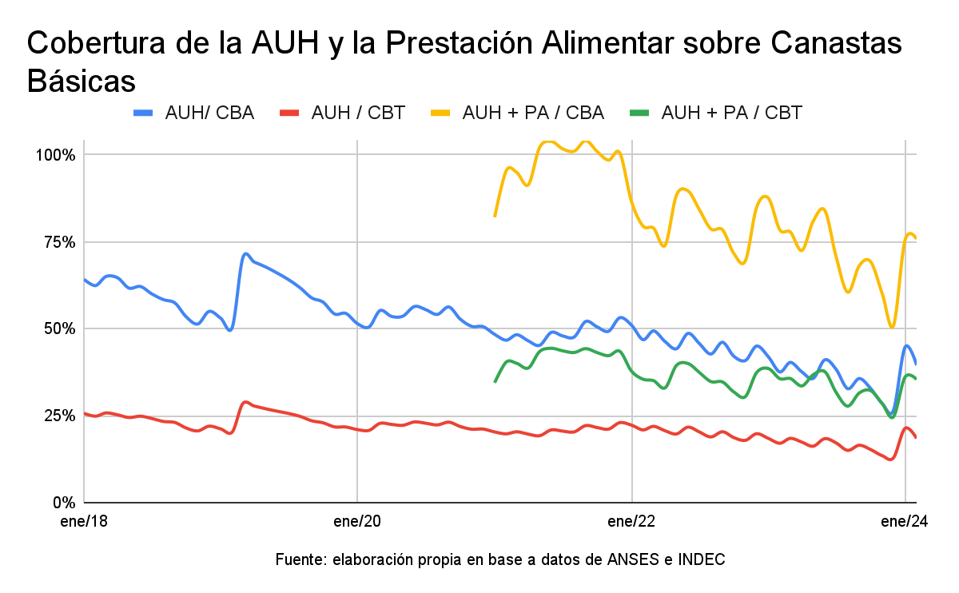
Year | AUH/BFB (extreme poverty) | AUH/BTB (poverty) | AUH + P.A. /BFB (extreme poverty) | AUH + P.A. / BTB (poverty)
2019 | 61% | 24% | - | -
2020 | 53% | 22% | - | -
2021 | 49% | 21% | 98% | 42%
2022 | 46% | 20% | 80% | 36%
2023 | 36% | 16% | 72% | 33%
2024 (February) | 40% | 18% | 75% | 35%
Source: Prepared by the authors based on data from INDEC and ANSES. The data presented are annual averages, with the exception of 2024, which presents the latest data as of February.

Those children and adolescents who also receive Alimentar Benefit have greater income protection from the State. However, this benefit has also been losing its value, especially due to the fact that it does not have an updating formula, but rather the increases are discretionary and always below inflationary levels. Those who received money from AUH and Alimentar were able, in 2021, to cover 98% of a BFB and 42% of a BTB. Now they receive 75% and 35%, respectively. The Alimentar Benefit, in addition to the difficulties mentioned for the AUH, has an additional problem: it is not regulated by law, so it could be cancelled by the Executive Power anytime.
The second point we seek to submit to the Committee's consideration is the exclusion of adolescents aged 15-17 years from the Alimentar Benefit. Due to the age limitation of the Program, 558,118 adolescents only receive the AUH and only cover 40% of a minimum food requirement. Adolescents "...were twice as likely to experience severe food insecurity than peers receiving Alimentar" . This has an impact on access to other social rights: due to the scarcity of income in their households, there are those who must assume work and/or domestic responsibilities, and this has repercussions on educational continuity .
    - Food policies
In Argentina, in addition to income transfers per family, Law 25,724 created the National Nutrition and Food Program, which obliges the State to guarantee the right to food for all citizens (art. 1), particularly for those up to 14 years of age (art. 2).
In order to comply with this duty, five lines of action were established, complementary to the Alimentar Benefit, which send money or food to organizations, school canteens and all those that provide a direct and free food service. There are thousands of spaces spread throughout the national territory and of large numbers of children and adolescents depends on them. According to UNICEF Argentina and La Poderosa, these organizations form a "dense network of containment in the face of the effects of the recurrent economic crises affecting Argentina, with the recognition of the problem of structural poverty and the new poverty" . As they explain, most families can only afford one large meal a day and these institutions are a central element in supplementing the feeding of children and adolescents.
Since 2024, the Argentine National State has decided to drastically and untimely reduce assistance to this type of institutions. So far, neither the causes of the interruption nor the solutions that will be provided to cover the existing demand have been clearly explained. Although it is always desirable to review public policies in order to move towards greater levels of transparency in the allocation of resources (the State made a generic allegation of irregular handling of funds and food), reform processes can in no case imply the suspension of food assistance in emergency contexts such as the one described above. By denying the effective possibility of feeding a large number of children and adolescents, this decision results in a very serious violation of their human rights, putting their health and development at risk and wiping out a basic need for a dignified life. As mentioned above, the law mandates the prioritization of the best interests of the child as well as the privileged allocation of public resources to guarantee their rights (art. 5, Law 26.061). However, when reviewing the execution data as of March 26, 2024 reported by the Ministry of Economy, there are worrying levels of under-execution in several food policies.
Programs | Outstanding loan 2024 (in millions of pesos) | Execution as of 3/26/24 (in millions of pesos) | % of execution
Feeding the community | - | $44 | -
Soup kitchens and picnic areas | $34.338 | $10.854 | 31%
School Lunchrooms | $47.802 | $0 | 0%
Food Supplement | $86.411 | $6.779 | 8%
Targeted Projects - Social Vulnerability Situation | $7.547 | $15 | 0,2%
Total | $176.100 | $17.649 | 10%

The state's shift of funding and implementation of these policies was rejected by different civil society organizations defending the rights of children and adolescents. It also led to legal actions by the National Ombudsperson's Office for the Rights of Children and Adolescents and other organizations.
Recommendations
- The State be urged to increase the benefits until they reach at least the Basic Food Basket, to provide for an updating formula that prevents its loss of value in the context of inflation, to recognize the Alimentar Benefit by law and to include in its collection young people between 15 and 17 years of age.
- The State be urged to ensure the continuity and funding of direct food assistance programs.

  - Right to care
Care is one of the indispensable activities to meet people's needs, both basic health and physical safety needs, as well as the development of cognitive, physical and emotional skills . Although childhood is a particularly demanding period, access to care and education services for children and adolescents in Argentina is deficient, with uneven quality coverage and public policies developed without a comprehensive and inclusive perspective. Only 19.1% of children between 0 and 3 years of age have access to care and education services, with strong disparities by region (25% in the Pampas region and 7% in the North East regin) and by income level (39% in the highest socioeconomic quintile and 12% in the lowest) .
In addition, the combination of the need for adults to generate income and the deficit in child care policies (insufficient and heterogeneous licenses, low supply of education and child care services, among others) generates that, in 21% of households with children, situations of inadequate care are observed: that is, children are left alone or in the care of their sisters and brothers under 18 years of age when the adults in the household go out to work. The flip side of this situation are adolescent brothers, and mostly sisters, acquiring responsibilities that are not appropriate for their age and that threaten their leisure time and their completion of their education. Ensuring adequate care policies contributes not only to greater gender equity, but also makes it possible to guarantee the exercise of children's rights, which has an impact both on their present quality of life and on the future of society .
Care is a shared social responsibility, as it involves the participation of different actors in society. However, the current social organization of care falls disproportionately on families and, in particular, on women. Of the total number of households with a population in need of care, 7 out of 10 resolve it only through the unpaid work of one or more members of the household itself. High inflation rates and economic stagnation for more than a decade have had an impact on the real fall in the population's purchasing power, increasing poverty and indigence rates and further overburdening caregivers. The households most affected by poverty are those headed by single women -single-parent households- which today represent 1 out of every 10 households in Argentina, where 57% of these households are poor and 15.5% are indigent . And, although half of the households in 2023 received at least one income transfer from the State, 60% of the households with children and adolescents indicated that these income supports were scarce and did not cover the basic needs of children and adolescents .
Currently, 7 out of every 10 adults who, in addition to working, are in charge of household chores, are women and in households where there is a demand for care, they spend 8.59 hours, while men spend 4.36 hours . This has a negative impact on the socioeconomic situation of women and is reflected in lower participation in employment, higher hourly underemployment, greater labor informality and greater indebtedness to cover household expenses and meet the basic needs of children , and is worsened by the fact that in 56% of these households, mothers do not receive the food quota . This, added to the fact that among the 40% of the poorest population, 60% are women , perpetuates the insufficient care received by children and adolescents.
Recommendation
The State be urged to implement a comprehensive care policy that guarantees quality services for children and adolescents, ensures gender equality and reinforces the role of the State as a care provider.

- General principles
  - Right to life, survival and development
    - The situation of groups in special situations of vulnerability
      - The situation in the province of Salta
The children and adolescents of the native communities in the north of the province of Salta live in a situation of absolute violation of their human rights. According to the United Nations Resident Coordinator in Argentina, who carries out a constant survey of the situation in Salta, "...historically there is a weak state presence. In the three departments live more than 350 indigenous communities in conditions of extreme poverty, without major employment possibilities or sustainable livelihoods, dependent on social programs that do not cover all their basic needs or all the people who require social assistance, with precarious housing, without access to safe water or sanitation, and with limited access to health services" .
As a result of the death of indigenous children due to malnutrition or related diseases and the worsening of the health of hundreds of children in similar conditions, the Province of Salta declared a socio-sanitary emergency in the departments of San Martín, Rivadavia and Orán , still in force at the moment. Although the State was obliged to direct its greatest efforts to correct structural aspects in order to guarantee the basic human rights of children and adolescents in these territories, including all budgetary resources, the situation continues to be critical. The infant mortality rate, which at the national level decreased to 8.4% by 2020, is much higher in regions where most of the native communities live. Such is the case of La Poma (41.7%), Morillo (26.6%), Nazareno (19.2%) and Rivadavia (18.9%) of deaths of children under one year of age, per 1000 live births . On the other hand, the same statistical source shows the lack of data related to 14 operational areas of the province , an omission that is alarming in itself. According to the provincial information, in recent years 108 children died in 2020, 64 in 2021 and 44 in the first three months of 2022.
All this reveals a manifest failure to comply with the recommendations made by the Committee in 2018, when it urged to redouble efforts to eradicate infant mortality, especially in the most vulnerable families, particularly those living in indigenous communities and remote areas (para. 16, subpara. a).
The nutritional risk situation is also critical. For the second quarter of 2021, 7,543 children aged 0 to 5 years presented nutritional risk, 470 underweight and 44 very underweight . According to the Red Cross, "23% of children, and therefore their families, do not have access to a drinking water network yet, so they are dependent on distributions, rainfall and other unsafe and constant water sources" .
Although the national government claims that the expansion of the National Food and Nutritional Security Plan with the issuance of the Alimentar Benefit was a success, this plan faced numerous difficulties in its implementation in the communities of the native peoples of Salta. The head of the Reference Center (CdR) of that province in the National Ministry of Social Development duly reported the delay in the delivery of the cards in the municipalities farthest from the capital of Salta where the largest number of native communities reside. And there were not only inconveniences in the distribution of the cards, but also in the scarce distribution of devices in the stores that accept payment through their use. This has been acknowledged by the State itself when evaluating the policy .
It is relevant to mention that the State has not published recent statistics, reports or official communications that allow us to know the exact infant mortality rate. The only official information available was produced by the Directorate of Maternity and Childhood of the Ministry of Public Health of Salta, on April 11, 2022, where it was reported that at least 108 children had died in the province in 2020, 64 in 2021 and 45 in 2022. And only in the first months of 2024, there are reports of the death of five Wichí children, four of them due to severe malnutrition .
Numerous native communities of the Chaco Salteño are also at critical risk due to the absence of safe drinking water. This is suggested by studies carried out by the State itself , physicochemical and bacteriological studies by the Ministry of Health and statements by the local authorities themselves . This information warns that communities of the Wichí ethnic group within Rivadavia Banda Norte do not have access to drinking water, being forced to resort to untreated and unsafe sources or to travel significant distances just to get a small amount . Furthermore, local authorities and community leaders recognized in the course of 2024 the large increase in cases of diarrhea and gastroenteritis .
      - The situation in Santiago del Estero
In the last three population censuses, the province of Santiago del Estero was among the 5 provinces with the highest poverty index. In this territory, there is evidence of a marked precariousness in access to health, employment, basic housing services and education.
A priority issue is the lack of information produced by provincial government agencies on how children grow up in this province. Haciendo Camino, together with the Universidad Católica Argentina, carried out a study (soon to be published), to collect information that could shed light on the problem. According to the data obtained, more than half of the families (57%) suffer from food insecurity, although 93% of the families receive the Universal Child Allowance (AUH) and in most of the cases the Alimentar Benefit. Ninety-seven percent (97%) do not have sewage and natural gas connections in their homes and 91% do not have storm drains in their house block.
These factors have a direct and disproportionate impact on children. According to the census, there are 324,752 children under 18 living in Santiago del Estero: 160,331 girls (49.4%) and 164,421 boys (50.6%). Girls and boys represented 30.6% of the total population of the province in 2022. In the province, the competent agencies do not usually provide effective responses, due to the lack of suitable or sufficient personnel and/or the lack of tools to respond to the needs of children and adolescents. A clear example of the lack of arrival of the State is chronic malnutrition, which affects 31% of children under 5 years of age, according to the Ministry of Health of Santiago del Estero. The same happens with alternative care institutions such as group homes, which should function as transit spaces, but are usually taken as permanent homes, without monitoring the different situations, without knowledge of the state of children and adolescents and without contributions neither economic nor relevant services to promote their welfare.
Recommendation
The Argentine State and the provincial States be urged to articulate efficiently and urgently all the necessary measures to put an end to infant mortality in all the provinces of the country and to ensure that children and adolescents have access to decent living conditions, adequate food and safe water, and to set aside resources for this purpose in public budgets.

- Violence against children
  - For gender-related reasons
In Argentina, Law 26.485 regulates different manifestations and spheres in which violence against women, girls and adolescents occurs. Many public efforts have focused on domestic violence, particularly that which occurs in the context of intimate partner relationships, which has a disproportionate impact when it occurs in families where children and adolescents live together. In addition, there are other types of violence that have a concrete impact on the lives of children and adolescents, such as economic violence. Although this situation has been addressed to some extent by the Argentine State, there is still a lack of policies with an intersectional approach that take into account the reality of women, girls and adolescents.
In February 2024, the Domestic Violence Office of the Supreme Court of Justice of the Nation published a report on its work during the third quarter of 2023 in which it reported on the 3,350 people who consulted and were affected by domestic violence, of which 38% corresponded to children and adolescents and 53% to adult women . During January 2024, the DVO assisted 1,631 people and 1,237 were affected by the phenomenon. Forty-seven percent (47%) of these people were young and adult women and 37% were children and adolescents .
It should be reiterated that the monthly income restrictions of many mothers affect and condition the lives of children in Argentina. According to UNICEF, in 41% of the households where children and adolescents live (more than 2.5 million) the monthly income was insufficient to cover their current expenses. Income restrictions affect vulnerable households more intensely, especially those benefiting from the AUH, larger households and single-parent households. In 2023, 56% of mothers in these households did not receive the food quota, reaching 67% in cases of irregular receipt . This form of economic violence affects 2 out of 10 women in the wealthiest 40% of households .
Research on gender-based economic violence conducted in the Autonomous City of Buenos Aires shows that lack of resources and economic independence act as barriers that make it difficult for women to leave violent relationships and place them at greater risk of suffering economic violence. Regarding violence against women and children, these are not independent phenomena, but are interconnected. The sons and daughters of the women interviewed for the aforementioned research were witnesses to the aggressions and in some cases were their direct victims. Finally, the debt of the child support quota stands out as an assumption of high conflict and violence that also has repercussions on the well-being of this group.
The production of information on violence against children and adolescents continues to be a challenge for policymaking. With respect to femicides, for example, there is a disparity of criteria for producing information from the national and provincial states. According to data from the National Registry of Femicides of the Argentine Justice, during 2022, there were 252 registered cases of lethal victims of gender-based violence throughout the country. In total, all these victims had 227 children and adolescents in their care, 14 of them were girls and adolescents and 6 of them were pregnant . Although as of March 2024 the official data for 2023 has not yet been published, records from civil society organizations agree that the figures range between 254 and 339 cases .
There is still a need for coordination between justice, health and social development programs that deal with violence against women, girls and adolescents. There is still a need to know the tasks they carry out, the budget allocation they have and how they will guarantee the mechanisms to meet the existing demand (human resources, interdisciplinary teams, subsidies, licenses, day care centers or other spaces for care, accompaniment and continuity in treatment). The deficit in the comprehensive approach is also seen in the lack of sustained economic support policies for women, girls and adolescents who report acts of violence.
In 2022, the former Ministry of Women, Gender and Diversity of the Nation (MMGyD) presented a new version of the National Action Plan against Violence (PNA). The NAP announced a 3-year budget, made up of items to be executed directly by the MMGyD, on its own or with the participation of other agencies of the National Public Administration, and which would support the actions of the Ministry in relation to the construction of the Territorial Centers for Gender and Diversity Policies throughout the country and the implementation of programs such as Acompañar. As of March 2024, and having dissolved the MMGyD, no information has been published on the resources to be contributed by the national ministries involved in the actions contemplated by the NAP. Nor have any details been provided on how the training, education and supervision of the technical teams will be ensured, which agency will monitor and control them and how the payment of their salaries will be guaranteed.
  - Family (corporal and abuse)
The Committee requested the State to provide information on measures taken to "Implement and monitor the prohibition of corporal punishment of children in all settings, develop and implement awareness-raising campaigns, improve parenting skills, take other measures and hold perpetrators of corporal punishment accountable". In this regard, Argentina indicated that article 647 of the National Civil and Commercial Code expressly prohibits corporal punishment and ill-treatment. It also added that: "Law 27.709 (...) establishes the creation of the Federal Training Plan on the Rights of Children and Adolescents".
On the other hand, the Committee requests information regarding the creation of "complaint channels accessible to all children, especially those in shelters and detention centers". However, the State does not generate or provide evidence on the possibility that those living in shelters or detention centers can use it, nor that after the call, mechanisms for the protection of rights are activated. Nor does it provide evidence that they can effectively access the child's lawyer.
Finally, regarding the consultation on the status of investigations and prosecution of all complaints of torture, violence, harassment and abuse against children and adolescents, there is no record of publicly available statistical reports that show the percentage of cases filed with or without resolution in proportion to the number of complaints filed. On the contrary, the General Database of Children and Adolescents of the Supreme Court of Justice concentrates information on children and adolescents involved in judicial cases in conflict with criminal law, but not on their situation as victims.
Recommendations
- The State be urged to design and implement policies with an intersectional approach to prevent, address, investigate and punish the different forms of violence faced by children and adolescents.
- The State be urged to design and implement sustained economic support policies for women, girls and adolescents who report acts of gender-based violence.
- That the State be urged to produce and publish sufficient, updated and reliable information on the forms of violence faced by children and adolescents in order to enable the construction of reliable diagnoses and inform public policies.

- Disability
  - Inclusive education
Beyond the fact that Resolution 311/2016 of the Federal Education Council meant a normative advance in guaranteeing the right to inclusive education (in particular, the right to equal qualifications) and a few advances at the provincial level, to date the Argentine State has not sanctioned comprehensive legislation or implemented specific programs to ensure equality of children with disabilities in the educational environment.
As a result, this group continues to see its rights violated: some children with disabilities are completely excluded from the education system, others remain segregated in special schools (according to official data from 2022, there are still 103,108 children in special schools and out of the total number of people with disabilities attending school, 35% still attend these institutions) and others attend general schools, but without receiving the support they need to learn, participate and progress under equal conditions.
In Argentina, children with disabilities still face systematic rejection of enrolment in public and private regular schools, and are frequently referred to special schools without governments effectively exercising their powers of prevention, control and sanction. In those cases, in which they manage to enter regular schools, the lack of adequate policies to ensure full accessibility of school facilities, communication systems, curricula, and teaching and assessment methods is an obstacle. Existing support services tend to be scarce, fragmented, discontinuous and based on a medical model. Other forms of discrimination are also observed in schools, such as the resistance to elaborate personalized pedagogical projects in due time and form, the imposition of reduced school days and repetitions, and the reluctance to deliver diplomas accrediting the completion of education levels that are compulsory according to the National Education Law. In addition, due to the prevalence of enabling prejudices, people with disabilities are permanently confronted with views that reveal low expectations about their learning possibilities, which ends up legitimizing a lower quality education than the one received by children without disabilities.
  - Institutionalization for mental health reasons
Although in Argentina the National Mental Health Law and its regulatory decree provided for the definitive replacement of psychiatric hospitals by a community-based system that avoids all forms of confinement and institutionalization by 2020, the asylum model is still the predominant one. In fact, there are still 162 institutions with monovalent internment in Argentina and, according to the latest official information, not counting addiction care facilities, there are 266 children and adolescents residing there , many of them in jurisdictions far from where their families live. We note with great concern the absence of family strengthening strategies, home-community interventions and alternative care arrangements to hospitalization.
Recent research indicates that the psychiatric institutionalization of children showed an increase with a significant progressive trend in recent times. In addition, it is observed that children and adolescents with a diagnosis in the field of mental health go through an institutional circuit of multiple referrals, discrimination and exclusion both in the educational and health fields, and face processes of medicalization and asylum approaches aimed at control and social normalization . In addition, they are subjected to multiple forms of violence, such as the use of physical and chemical restraints, isolation, excessive or improper use of medication and mistreatment by workers, among other cruel, inhuman and degrading treatments, which in turn are favored by the separation of children from their primary family nucleus and their emotional references.
This diagnosis is confirmed by the National Mental Health Review Body, which in its last report of 2023 pointed out that the internment of children and adolescents exceeds 30 days and that more than 25% of them exceed 90 days, and expressed its concern for the continuity of a dynamic based on institutionalization, for the lack of exhaustion of less restrictive measures and for the cases of children and adolescents without family company or other referents. It also identified the absence of actions related to educational inclusion, which has as an effect the loss of the school cycle for most of the children and adolescents who are in prolonged hospitalization and the violation of the right to opinion and informed consent of children and adolescents .
In 2018, this Committee urged the State to adopt measures to accelerate the process of deinstitutionalization of children, to promote the formulation of a mental health policy for this group and to develop alternative approaches to medication, so that it is prescribed only as a measure of last resort . However, nothing has changed since then, and the lack of protection of this group is obvious.
Recommendations
- The State be urged to carry out all the necessary reforms, both normative and factual, to transform special schools into inclusion support centers or general schools, transferring all human and budgetary resources from one modality to the other.
- The State be urged to implement technical and financial assistance programs to strengthen the capacities of teachers and public and private schools.
- The State be urged to close the single-sex institutions that house children with disabilities as a matter of urgency and to guarantee alternative services to internment that avoid their confinement and guarantee their right to family and community life, reserving the necessary budgetary allocations for this purpose.
- The State be urged to guarantee mental health care at the first level and in all public and private general hospitals, as well as the availability of accessible and quality social and family re-connection and social inclusion mechanisms, always respecting the center of life of children and adolescents and ensuring that those who work in these spaces receive training with a human rights approach.
- The State be urged to ensure the right to participation of children and adolescents with disabilities in all decisions that affect their rights.

- Education
  - Integral Sexual Education
October 2024 marks the 18th anniversary of the enactment of Law 26,150, which created the National Program of Comprehensive Sexual Health, better known as ESI. This Law establishes the right of students to receive training in sexual and reproductive health from a human rights and gender equity approach, in all public educational establishments in the country, both state and privately managed. Since its implementation, the Program has been operating continuously, and there are many examples that show the importance and impact it has on children and adolescents.
A study carried out in 2020 by the Public Guardianship Ministry of the Autonomous City of Buenos Aires revealed that between 70% and 80% of children and adolescents between 12 and 14 years old who went through the Specialized Interview Room of the agency were able to understand that they were abused after receiving Comprehensive Sexual Education (ESI) classes. According to official statistics on child sexual abuse in Argentina , 53% of the abuses take place in the victim's home, 18% in the aggressor's home and 10% in a relative's home. These data reflect the importance of sustaining the program in schools and its positive impact on children and adolescents.
Likewise, since 2017, Argentina has had the Plan for the Prevention of Unintended Pregnancy in Adolescence (ENIA Plan), which seeks to prevent unintended pregnancies in adolescence in conjunction with the National Ministries of Health, Social Development and Education. In particular, it is aimed at guaranteeing the rights of adolescents to contraceptive methods, comprehensive sexual education and counseling in schools, sexual and reproductive health counseling and community promotion activities, prevention of forced pregnancies and access to termination of pregnancy.
Statements from UNFPA on data published from the National Ministry of Health reflect that between 2019 and 2020 the late adolescent fertility rate (15 to 19 years old) went from 40.7 to 30.3 births per thousand adolescent women, while the early fertility rate (girls under 15 years old) decreased from 1.1 to 0.7.
The "2021 Birth Rate and Infant Mortality" report , published by the National Ministry of Health, highlights that that year there was a decrease in the adolescent fertility rate with respect to 2020, while the general fertility rate remained at similar figures in the same period. The adolescent fertility rate went from 15.4 per thousand women aged 10-19 in 2020 to 13.7 per thousand in 2021. That represents a decline of 1.7 points from one year to the next. As stated in the report, "sustaining the decline in late adolescent fertility is reinforced by the strategy of implementing public policies to prevent unintended pregnancy in adolescence and free contraceptive methods, especially long-acting ones" . The latest publication of the National Ministry of Health showed a rate of 13.7 per thousand women aged 10 to 19 years, which means that, for every thousand young women aged 10 to 19 years, 14 gave birth. This represents a decrease of 57% since 2005, the year in which the official published series began.
The quarterly monitoring report of the ENIA Plan July-September 2023 showed that in that period 199,926 students carried out at least one ESI-ENIA activity in both cycles during the first quarter of 2023, thus showing the scope and reach of the activities to children and adolescents in different jurisdictions of the country, being the most worked topics during the period contraceptive methods and sexual and reproductive rights-ILE (54.4% and 54.0% respectively).
Regarding maternal deaths due to abortion, data of significant relevance are also presented. According to the latest official data published by the National Ministry of Health, these decreased from 23 in 2020 to 13 in 2021. This reflects that the implementation and access to Law 27,610 on the Voluntary Interruption of Pregnancy generated conditions for safe access to abortion and resulted in a decrease in maternal mortality due to abortion in the first year of implementation of the law .
The results published in March 2024 of the National Population, Household and Housing Census conducted in 2022, show that the average number of children per woman (between 14 and 49 years old) dropped from 1.7% in 2001 to 1.4% in 2022, and that the reduction is greater in the case of adolescents: the percentage of people between 15 and 19 years old with daughters and sons dropped by 50%, from 13.1% in 2010 to 6.4% in 2022.
Although adolescent pregnancy shows a decreasing trend, important regional gaps still persist, with the highest rates in the Northwest Region. In particular, it continues to be extremely high in Formosa (twice the national rate and almost six times higher than that of the City of Buenos Aires). Misiones and Chaco show rates of the same order. The significance of the decrease was different depending on whether they are provinces with departments in which the National Plan for the Prevention of Unintended Pregnancy in Adolescence is implemented. In this sense, since 2016 the drop in the total adolescent fertility rate has been greater in provinces with ENIA Plan than in those without .
Despite progress, much remains to be done. 7 out of 10 pregnancies in adolescents between 15 and 19 years of age have been unintentional, while in girls under 15 years of age the number rises to 8 out of 10, mostly as a consequence of abuse and sexual violence. To complete this picture, the Perinatal Informatics System (SIP), which surveys 80% of the country's public maternity wards, indicates that 29% of adolescents had a child for the second or third time before the age of 20. The incidence of adolescent pregnancy and unintended pregnancy is markedly higher in the northern provinces of the country.
At this point, we believe it is necessary to warn about the fact that different referents of the National Executive Power have pronounced themselves against laws such as ESI and Voluntary Interruption of Pregnancy, and that day by day programs that since their implementation have done nothing but prove to be effective are being defunded.
Recommendation
The State be urged to support, prioritize and strengthen with sufficient and adequate budgetary allocations the laws and policies of Comprehensive Sexual Education, prevention of unintended pregnancy and access to voluntary interruption of pregnancy.

- Special protection measures
  - Administration of juvenile criminal justice
The Committee requested the Argentine State to report on "the measures adopted to repeal Decree-Law No. 22.278 and to approve a comprehensive law on juvenile justice that complies with the Convention" . However, in the provincial regimes, alternative measures to deprivation of liberty have been promoted, based on a specialized justice system for dealing with children and adolescents in conflict with criminal law".
The failure to repeal Decree 22.278 does not comply with the reiterated observations of this Committee and the rulings of the Inter-American Court of Human Rights . In the period analyzed, there was not even a single bill presented by the Executive Branch in this regard. In addition, the use of juvenile criminal procedure laws of each province was not productive. Legally, the provinces cannot change a substantive law, which is reserved to the National Congress. Likewise, judges can and usually do apply Decree-Law 22.278.
On the other hand, the Committee requested the Argentine State to report on "the measures adopted to ensure that deprivation of liberty is only a measure of last resort and lasts the shortest time possible and that it is not used as a protective measure for minors under 16 years of age". In this regard, the Argentine State indicated that it is illegal to deprive minors under 16 of their liberty, that a course "Perspectiva de niñez en las prácticas policiales" (Childhood perspective in police practices) was created for security forces and that SENNAF implements "devices of penal measures in territory (...) around 80% of adolescents in compliance with a judicial measure of a criminal nature, do so in a device of penal measure in territory. The results of the surveys also show a constant decrease in the juvenile criminal population between 2015 and 2022".
At this point, we must point out that the State provides a vague response, confusing the criminal sphere with that of protective measures that are regulated by a civil law. Official data show that the illegal practice of deprivation of liberty or punishment of non-punishable persons because of their age continues to be carried out . In the year 2021 there were 743 persons under 16 years of age deprived of liberty or criminally sanctioned . This number is the sum of those housed in specialized detention centers (663), those serving a criminal sentence in the territory (89) and those in detention centers (30). Likewise, this report indicates that in the juvenile penal facilities there were, for the same period, 119 persons under 16 years of age deprived of liberty or serving criminal sanctions. This last figure should be taken with caution, since the same report indicates 108 persons, for whom there is no age data (persons who may be under 16 years of age), which could imply a much higher number than reported.
At the same time, the State continues to make arrests in police stations. The Specialized Detention Facilities, created to avoid the deprivation of liberty of persons under 18 years of age in police stations and refer them in less than 12 or 24 hours, are only operating in 5 jurisdictions throughout the country. However, adolescents are housed in these facilities for guardianship reasons without the alleged commission of any crime . The length of time spent in these facilities far exceeds the regulatory maximums, in some cases reaching months. In the case of persons under 16 years of age deprived of liberty in police stations or police facilities, reliable information is not even produced.
The percentage drop of persons under 18 years of age, which the State points out, contains a methodological error. Since 2016 persons in the aforementioned police stations for minors are not considered within the juvenile penal scheme for the authors of the reports. In addition, the remarkable proliferation of very high sentences to persons who committed crimes when they were under 18 years old accounts for the low effectiveness of the measures adopted by the State to ensure deprivation of liberty is of last resort and lasts the shortest possible time.
Finally, the Committee asked the State to report on alternative measures to sentencing. Although training has been carried out, the implementation of the restorative justice matrix is fragmented and disjointed. The continuity of Decree 22.278, which suspends the sentence until the accused reaches the age of 18 and allows the judge's discretion until that age, hinders any attempt to establish restorative tools, which in this scenario of low legal intensity lose their original function. Likewise, the increase in the use of criminal mediation and remission responds to the need of the justice system to decongest the flow of legal work and not to a decision to guarantee the rights of children and adolescents.
Recommendation
- The State be urged to modify the law on juvenile criminal administration to bring it into line with the parameters of the Convention on the Rights of the Child.
- The State be urged to set aside budget allocations for the creation of alternatives to the imposition of criminal sanctions.
- The State be urged to produce and publish sufficient, updated and reliable information on rights violations faced by children and adolescents in the penal system in order to enable the construction of reliable diagnoses and inform public policies.

Asociación Civil por la Igualdad y la Justicia (ACIJ), Aldeas Infantiles S.O.S. Argentina, Equipo Latinoamericano de Justicia y Género (ELA), Fundación para Estudio e Investigación de la Mujer (FEIM), Fundación Kaleidos, Fundación SUR Argentina and Haciendo Camino.
This emerges from the Seventh Periodic Report under Article 44 of the Convention by the Argentine Republic, on page 30. In addition, in at least one jurisdiction, the Judiciary still has the power to decide whether or not an exceptional measure is appropriate (Article 32 of Law 2,302 of the Province of Neuquén). In accordance with the provisions of Law 26.061, it is the local protection authority who decides whether or not an exceptional measure is appropriate, with a subsequent legality control.
Pronunciamiento N°17 de la Defensora de los derechos de niñas, niños y adolescentes, "Salud mental de niñas, niños y adolescentes en la pospandemia", 2023. Available at: https://ladefe.gob.ar/images/2024/DOCUMENTOS/PRONUNCIAMIENTO%2017%20-%20Mayo%202023.pdf (last accessed on 02/25/2024).
Committee on the Rights of the Child, General Comment No. 19 on public budgeting for the realization of children's rights (art. 4), CRC/C/GC/19, 21 July 2016, para. 18.
UNICEF Argentina, Análisis del Presupuesto Nacional 2024 con foco en niños, niñas y adolescentes, 2024, p. 5.
Committee on the Rights of the Child, General Comment No. 19 on public budgeting for the realization of children's rights (art. 4), CRC/C/GC/19, 21 July 2016, para. 31.
Committee on Economic, Social and Cultural Rights, Public debt, austerity measures and the International Covenant on Economic, Social and Cultural Rights, E/C.12/2016/1, 2016.
ECLAC, Fiscal Panorama of Latin America and the Caribbean, p. 131 et seq. Available at: https://repositorio.cepal.org/server/api/core/bitstreams/ea7ed8d0-776b-496e-ad0d-1014a2142fda/content.
Committee on the Rights of the Child, General Comment No. 19 on public budgeting for the realization of children's rights (art. 4), CRC/C/GC/19, 21 July 2016, paras. 28 and 74.
Ministry of Economy, Separata de gastos tributarios. Disponible en: https://www.ambito.com/adjuntos/239/documentos/041/079/0041079200.pdf?0000-00-00-00-00-00.
According to the information published on the Ombudsman's Office website, nine (9) recommendations were made between July 2020 and July 2023; twenty-two (22) pronouncements were made between June 2020 and November 2023. In addition to this, there are what is called Comunicados (14) and La Defe Propone (The Ombudsman's Office Proposes).
Committee on the Rights of the Child, Concluding observations on the combined fifth and sixth periodic reports of Argentina, CRC/C/ARG/CO/5-6, October 1, 2018, para. 35.
UNICEF Argentina, Pobreza monetaria y privaciones vinculadas a derechos en niñas y niños, 2024, p. 7.
Ibid.
Based on official data from the National Institute of Statistics and Census of Argentina (INDEC).
UNICEF Argentina, Pobreza monetaria y privaciones vinculadas a derechos en niñas y niños, 2024, p. 14.
Ibid., p. 7.
Data based on the Average Taxable Remuneration of Stable Workers (RIPTE - Ministry of Economy) and INDEC. Analysis available at: https://mateconomia.com.ar/infomate/2023/febrero-2024/.
UNICEF Argentina, Situación de niñas, niños y adolescentes, 2023 - Séptima Ronda, pp. 4 and 5.
UNICEF Argentina, Capacidad de protección de las políticas de transferencias de ingresos, March 2024, p. 10.
ANSES (2023), Social Security Statistics, September 2023. Available at: https://www.anses.gob.ar/estadisticas-de-la-seguridad-social.
Tuñón, Ianina et. al, New setbacks in developmental opportunities for children and adolescents. Trends before and during the COVID-19 pandemic. Statistical document. Agenda for Equity Series (2017-2025), Observatorio de la Deuda Social Argentina, Barómetro de la Deuda Social de la Infancia. 1st ed. Ciudad Autónoma de Buenos Aires, Educa, 2021, p. 14. Available at https://repositorio.uca.edu.ar/handle/123456789/12060 (last accessed June 29, 2022).
"One third of the population between 16 and 17 years of age carries out at least one productive activity (32%), that is, they perform tasks for the market, for self-consumption and/or high intensity domestic activities (...) The development of productive activities by adolescents has an important association with school dropout situations. The levels of non-attendance at school of adolescents aged 16 and 17 who perform productive tasks in urban areas are three times higher than those who do not perform this type of activity". Ministerio de Educación de la Nación, Evaluación de la educación secundaria en Argentina 2019, Ciudad Autónoma de Buenos Aires, 2020, pp.40-45. Available at https://www.argentina.gob.ar/educacion/aprender2019.
A georeferenced map of some of these institutions is available. Ver: https://mapa.poblaciones.org/map/173801/#/@-37.694989,-64.248047,0z/l=390501!v0!w0,0,0.
UNICEF and La Poderosa, La situación de la pobreza en barrios populares, 2023, p. 48. Available at: https://www.unicef.org/argentina/media/17071/file/Estudio%20cualitativo:%20la%20situaci%C3%B3n%20de%20la%20pobreza%20en%20barrios%20populares.pdf.
See, for example: https://www.pagina12.com.ar/710087-la-utep-vuelve-a-reclamar-alimentos-para-los-comedores-comun, https://lapoderosa.org.ar/2024/02/comedores-en-crisis/, http://infanciaendeuda.org/la-respuesta-a-la-crisis-alimentaria-infantil-no-puede-esperar/ https://episcopado.org/ver/4092 and https://www.pagina12.com.ar/712471-caritas-pide-que-le-entreguen-alimentos-a-las-organizaciones.
"DEFENSORÍA DE LOS DERECHOS DE LAS NIÑAS NIÑOS Y ADOLESCENTES C/ ESTADO NACIONAL - MINISTERIO DE CAPITAL HUMANO S/MEDIDA CAUTELAR (AUTÓNOMA)", Expediente 445/2024.
"UNIÓN DE TRABAJADORES DE LA ECONOMÍA POPULAR C/ EN-M CAPITAL HUMANO-RESOL 13/24 S/AMPAROS Y SUMARISIMOS", File 935/2024.
ELA, ¿Cómo se cuida en Argentina: definiciones y experiencias sobre el cuidado de niños y niñas, 2014, p. 13. Available at: https://ela.org.ar/wp-content/uploads/2023/07/2014-Como-se-cuida-en-Argentina.pdf.
UNICEF Argentina, National Survey of Children and Adolescents (MICS) 2019-2020. Informe temático: Acceso a servicios de educación y cuidado en la primera infancia, 2023, pp. 15-17.
UNICEF Argentina and La Poderosa, La situación de la pobreza en barrios populares, 2023, p. 36. Available at: https://www.unicef.org/argentina/media/17071/file/Estudio%20cualitativo:%20la%20situaci%C3%B3n%20de%20la%20pobreza%20en%20barrios%20populares.pdf.
INDEC, National Time Use Survey 2021. Available at: https://www.indec.gob.ar/indec/web/Nivel4-Tema-4-31-117.
INDEC, Incidence of poverty and indigence in 31 urban agglomerates. First semester of 2023 Living conditions, 2023.
UNICEF Argentina, Situación de niñas, niños y adolescentes, 2023 - Séptima Ronda, p. 4. Disponible en: https://www.unicef.org/argentina/media/19501/file/Situaci%C3%B3n%20de%20ni%C3%B1as,%20ni%C3%B1os%20y%20adolescentes%20-%20S%C3%A9ptima%20ronda.pdf.
INDEC, Incidence of poverty and indigence in 31 urban agglomerates. First semester of 2023 Living conditions, 2023.
INDEC, Encuesta Nacional de Uso del Tiempo 2021, Available at: https://www.indec.gob.ar/indec/web/Nivel4-Tema-4-31-117.
UNICEF Argentina, Situación de niñas, niños y adolescentes, 2023 - Séptima Ronda, pp. 4 and 5. Available at: https://www.unicef.org/argentina/media/19501/file/Situaci%C3%B3n%20de%20ni%C3%B1as,%20ni%C3%B1os%20y%20adolescentes%20-%20S%C3%A9ptima%20ronda.pdf .
UNICEF Argentina, Situación de niñas, niños y adolescentes, 2023 - Séptima Ronda, pp. 4 and 5. Available at: https://www.unicef.org/argentina/media/19501/file/Situaci%C3%B3n%20de%20ni%C3%B1as,%20ni%C3%B1os%20y%20adolescentes%20-%20S%C3%A9ptima%20ronda.pdf.
INDEC, Incidence of poverty and indigence in 31 urban agglomerates. First semester of 2023 Living conditions, 2023.
United Nations Resident Coordinator in Argentina, Avances del Plan de Respuesta Humanitario Internacional en respuesta a la emergencia socio-sanitaria. Available at: https://acij.org.ar/wp-content/uploads/2022/07/gacetilla-salta..pdf (last accessed October 23, 2022).
Necessity and Urgency Decree No. 140/2020 Converted into Law No. 8185 Declares the State of Social and Health Emergency in the Departments of San Martín, Orán and Rivadavia. Enacted on January 29, 2020 and published in the Official Gazette No. 20733 on May 4, 2020.
Salta Ministry of Economy (2019), Anuario Estadístico de la Provincia de Salta 2018-2019, 1st ed. adapted, Salta, 2019, p. 118. Available at http://estadisticas.salta.gov.ar/web/anuarios-estadisticos.
Ibid.
Defensoría de Derechos de Niñas, Niños y Adolescentes (2021) Acción de amparo colectivo en favor de la totalidad de niñas, niños y adolescentes de comunidades de pueblos indígenas que habitan y viven en los departamentos de Rivadavia, Orán y San Martín, November 2021, p. 14. Available at: https://defensoraderechosnnya.gob.ar/documento/accion-de-amparo-colectivo-en-favor-de-la-totalidad-de-ninas-ninos-y-adolescentes-de-comunidades-de-pueblos-indigenas-que-habitan-y-viven-en-los-departamentos-de-rivadavia-oran-y-san-martin/.
Argentine Red Cross, "Estudio de campo - Salta", 2021, p. 12.
Página 12, "El Norte, con beneficios demorados, sin bolsones ni Tarjeta Alimentar"), April 3, 2020. Available at: https://www.pagina12.com.ar/257213-el-norte-con-beneficios-demorados-sin-bolsones-ni-tarjeta-al.
"Evaluation of the Tarjeta Alimentar - Final Report," Buenos Aires, 2022, p. 60. Available at: https://drive.google.com/file/d/1_mOKem13WONQkT_sDGWefrP8yOpWEnSh/view.
La Nación, "Cinco niños de la comunidad wichi murieron en una semana en el norte de Salta," March 22, 2024. Available at: https://www.lanacion.com.ar/comunidad/cinco-ninos-de-la-comunidad-wichi-murieron-en-una-semana-en-el-norte-de-salta-nid22032024/?utm_medium=Echobox&utm_source=Twitter#Echobox=1711177220
"Access to Water in Indigenous and Creole Communities in the Municipality of Rivadavia Banda Norte, Case Study: National Route No. 81.
General Directorate of Epidemiological Coordination of the Ministry of Health of the Province of Salta.
El nuevo Diario de Salta, March 4, 2024. Available at: https://www.nuevodiariodesalta.com.ar/noticias/provinciales-2/la-municipalidad-de-tartagal-denuncia-falta-de-asistencia-alimentaria-86232.
"Access to Water in Indigenous and Creole Communities in the Municipality of Rivadavia Banda Norte, Case Study: National Route No. 81".
Interview with the Mayor of Santa Victoria Este - Rogelio Neron. Available at: https://www.youtube.com/watch?v=X4N_OqZ1TFw.
National Census of Population, Homes and Housing, 2022. Available at: https://censo.gob.ar/.
Domestic Violence Office. Supreme Court of Justice of the Nation. Informe estadístico 2023, Tercer trimestre, 2024. Available at: https://www.ovd.gov.ar/ovd/archivos/ver?data=8397.
Domestic Violence Office. Supreme Court of Justice of the Nation. Available at: https://www.ovd.gov.ar/ovd/novedades/detalle/7927.
See: https://www.unicef.org/argentina/informes/encuesta-r%C3%A1pida-sobre-la-situaci%C3%B3n-de-la-ni%C3%B1ez-y-adolescencia-2023
Op. cit.
Op. cit.
Equipo Latinoamericano de Justicia y Género (ELA), Avon Foundation for Women, United Nations Population Fund (UNFPA) & Dirección General de Estadística y Censos del GCBA, Cadenas invisibles: Un análisis de las manifestaciones e impacto de la violencia económica en la vida de las mujeres, 2023. Available at: https://ela.org.ar/publicaciones-documentos/cadenas-invisibles/ .
https://www.csjn.gov.ar/omrecopilacion/omfemicidio/homefemicidio.html
https://www.pagina12.com.ar/700865-tres-relevamientos-denuncian-un-aumento-de-femicidios-en-202
The Database was created in 2004 by Resolution 1674/04. Available at: https://www.csjn.gov.ar/bgd/institucional.
In this regard, the experience of the province of La Pampa is noteworthy for its high rates of schooling of people with disabilities in the general education system.
Educational Statistical Yearbook 2022. Available at: https://www.argentina.gob.ar/educacion/evaluacion-informacion-educativa/anuarios
These data correspond to the results of the First National Census of Persons Admitted for Mental Health Reasons, carried out in 2019 by the Ministry of Health and Social Development of Argentina. It should be noted that the survey did not include institutions with exclusive internment for addictions or homes for children and adolescents, but only institutions with monovalent internment for mental health.
Barcala A., and Faraone S. (2020). A diez años de la sanción de la Ley Nacional de Salud Mental: coordenadas para una cartografía posible (1st ed.), Ciudad Autónoma de Buenos Aires: Teseo. Available at: https://www.editorialteseo.com/archivos/18485/a-diez-anos-de-la-sancion-de-la-ley-nacional-de-salud-mental/.
Barcala, A. (2018). "Niñez e Institucionalización psiquiátrica: violencias en contextos de encierro. Salud Mental, políticas públicas y derechos humanos", in P. Vommaro, A. Barcala and L. Rangel, Infancias y juventudes: diversidades, prácticas y perspectivas en derechos y políticas. Buenos Aires: CLACSO; Bogotá: Fundación Centro Internacional de Educación y Desarrollo Humano CINDE; Manizales: Universidad de Manizales. Available at: http://biblioteca.clacso.edu.ar/clacso/se/20181102011124/Derechos_politicas_infancias.pdf.
The National Mental Health Review Body is an entity created by Law 26.657 within the Public Defender's Office to promote compliance with the law and to protect the rights of users of mental health services.
National Review Body, Annual Management Report 2023, available at: https://www.mpd.gov.ar/pdf/publicaciones/Libro%20IA%202023.pdf, p. 256.
Committee on the Rights of the Child, Concluding observations on the combined fifth and sixth periodic reports of Argentina, CRC/C/ARG/CO/5-6, October 1, 2018, para. 31.
See: https://mptutelar.gob.ar/la-esi-permiti%C3%B3-que-el-80-por-ciento-de-los-ni%C3%B1os-y-ni%C3%B1as-abusados-pudieran-contarlo
Ministerio de Justicia y Derechos Humanos de la Nación and UNICEF, Report prepared by the Program "Las víctimas Contra las Violencias", 2021. Available at: https://www.unicef.org/argentina/media/12506/file/Factsheet%20Nro.9%20-%20Serie%20Violencia%20contra%20ni%C3%B1os,%20ni%C3%B1as%20y%20adolescentes.pdf
See: https://argentina.unfpa.org/es/news/c%C3%B3mo-hizo-argentina-para-reducir-la-tasa-de-fecundidad-adolescente
Birth Rate and Infant Mortality Report 2021. Available at: https://www.argentina.gob.ar/sites/default/files/natalidad_mortalidad_infantil_2021.pdf. See also https://chequeado.com/el-explicador/por-septimo-ano-consecutivo-disminuyeron-los-embarazos-adolescentes/
Birth Rate and Infant Mortality Report 2021, p. 6. Available at: https://www.argentina.gob.ar/sites/default/files/natalidad_mortalidad_infantil_2021.pdf.
Quarterly Monitoring Report. Enia Plan, July-September 2023. Available at: https://bancos.salud.gob.ar/sites/default/files/2023-07/Monitoreo_Plan_Enia_1er_trim_2023_110723.pdf
Press Release. Ministry of Health of Argentina, February 6, 2023. Available at: https://www.argentina.gob.ar/noticias/el-ministerio-de-salud-de-la-nacion-anuncio-el-valor-mas-bajo-de-mortalidad-infantil-en-la.
Fertility results. Censo Nacional de Población, Hogares y Vivienda Argentina, 2022. Available at: https://www.indec.gob.ar/ftp/cuadros/poblacion/censo2022_fecundidad.pdf.
UNICEF and Sociedad Argentina de Pediatría, "Situación de la población adolescente en Argentina", 2022. Available at: https://www.sap.org.ar/uploads/archivos/general/files_informe-especial-del-observatorio-de-la-infancia-y-adolescencia-final-11-22sap-unicef_1668805381.pdf.
The Inter-American Court of Human Rights (hereinafter IACHR Court) urged the Argentine State on two occasions to adapt its domestic juvenile criminal law to the international provisions on the matter: Bulacio case, 2003 and Mendoza, 2013. Specifically in the Mendoza case, the IACHR Court stated that "Law No. 22.278 contains provisions contrary to the American Convention and international standards applicable to juvenile criminal justice" and that "Argentina must adjust its legal framework to the international standards on juvenile criminal justice mentioned above and design and implement public policies with clear and scheduled goals, as well as the allocation of adequate budgetary resources for the prevention of juvenile delinquency through effective programs and services that promote the comprehensive development of children and adolescents" (IACHR. Mendoza et al. v. Argentina).
The Inter-American Court of Human Rights (hereinafter IACHR Court) urged the Argentine State on two occasions to adapt its domestic juvenile criminal law to the international provisions on the matter: Bulacio case, 2003 and Mendoza, 2013. Specifically in the Mendoza case, the IACHR Court stated that "Law No. 22.278 contains provisions contrary to the American Convention and international standards applicable to juvenile criminal justice" and that "Argentina must adjust its legal framework to the international standards on juvenile criminal justice mentioned above and design and implement public policies with clear and scheduled goals, as well as the allocation of adequate budgetary resources for the prevention of juvenile delinquency through effective programs and services that promote the comprehensive development of children and adolescents" (IACHR. Mendoza et al. v. Argentina).
National Survey of Juvenile Penal Facilities and their Population, year 2021, SENAF. The reports prepared by the State do not allow for a rigorous analysis of the statistical situation regarding the state of the juvenile penal system in Argentina, due to numerous methodological problems. The lack of regularity in the publications, the fact that not all jurisdictions in the country provide the data, the lack of uniformity in data collection and above all the fact that the disaggregated data are not public, make these publications a mere approximation to the real situation of the state of juvenile criminal justice in Argentina.
In Argentina, according to Article 1 of Decree 22.278, persons under 16 years of age are not punishable and, in practical terms, are not subject to criminal liability because of their age.
See pp. 62, 71 and 72 of the 2021 report.
The authors of the reports state that the juvenile penal system is the totality of juvenile penal systems, whether they are penal measures in the territory or deprivation of liberty in penal institutions. It is striking that detention centers are considered outside the juvenile penal universe.
An example of the continuity of tutelary practices, which are contrary to the law, can be seen in the information in Graph 2.5 of the aforementioned report, which shows admissions to specialized detention facilities for alleged commission of a crime (January - June 2021), where one of the reasons for apprehension is: "Procedural circumstances without determination of the crime". This definition escapes any serious legal analysis and shows the repressive tutelary situation faced by persons under 18 years of age and those under 16 years of age in particular in Argentina and the absence of due process in apprehensions.
The lack of reliable quantitative information on the matter led Fundación Sur Argentina to request access to public information under National Law No. 27,275. According to data from the National System of Statistics on Sentence Execution (SNEEP) in 2020, "there were about 25 people under 18 years of age who are sentenced to more than 15 years of custodial sentences, which from a human rights perspective in line with what was previously resolved in the "Mendoza" ruling, Article 37 inc. b of the Convention on the Rights of the Child and Beijing Rule No. 19, presupposes a punishment of a merely retributive nature.

