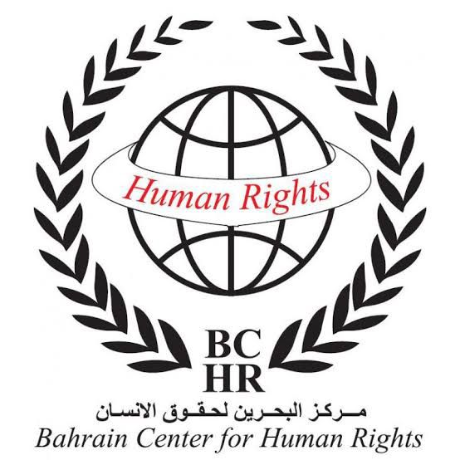 | 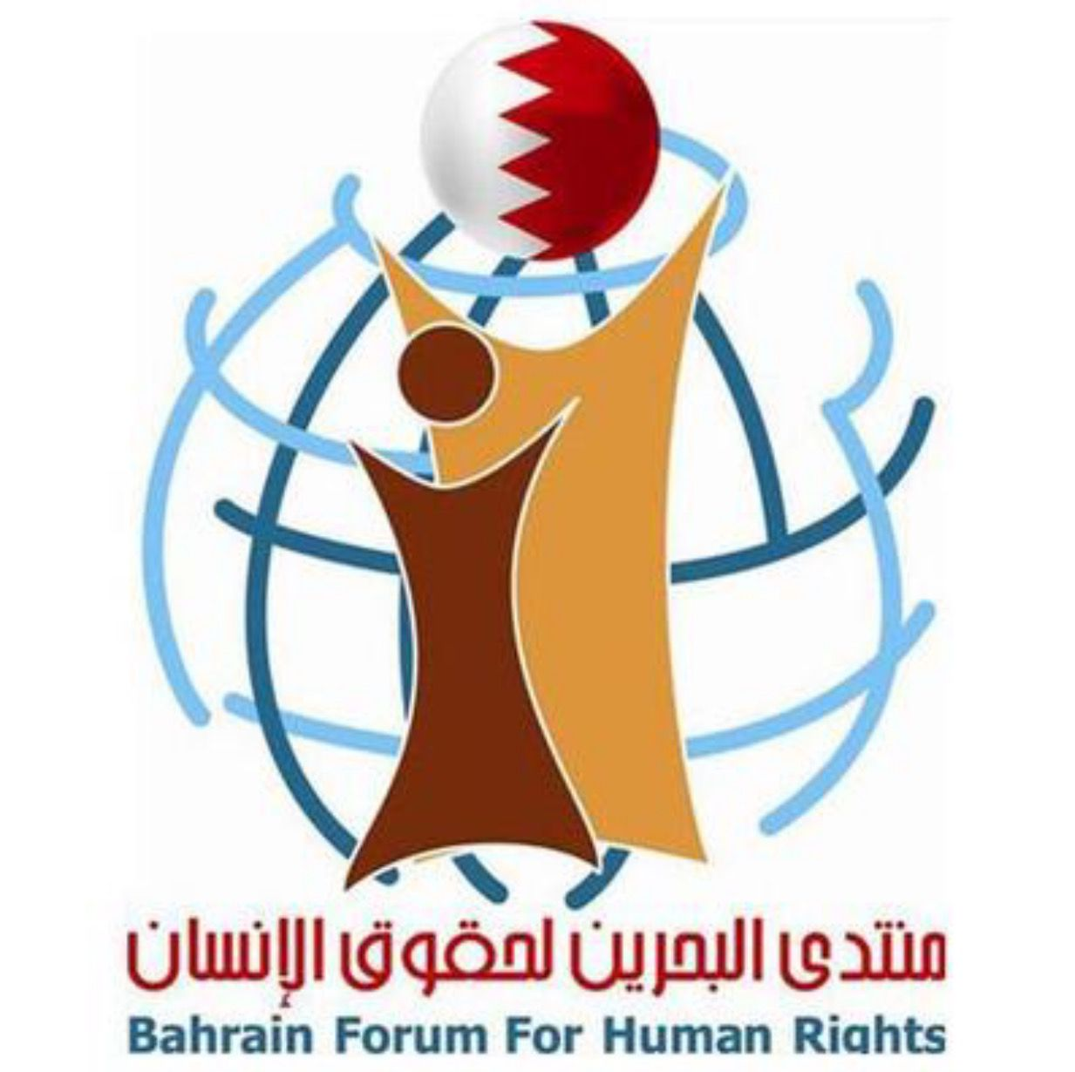 | 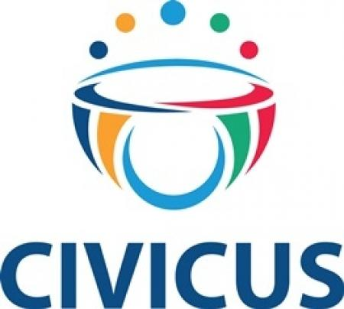 | 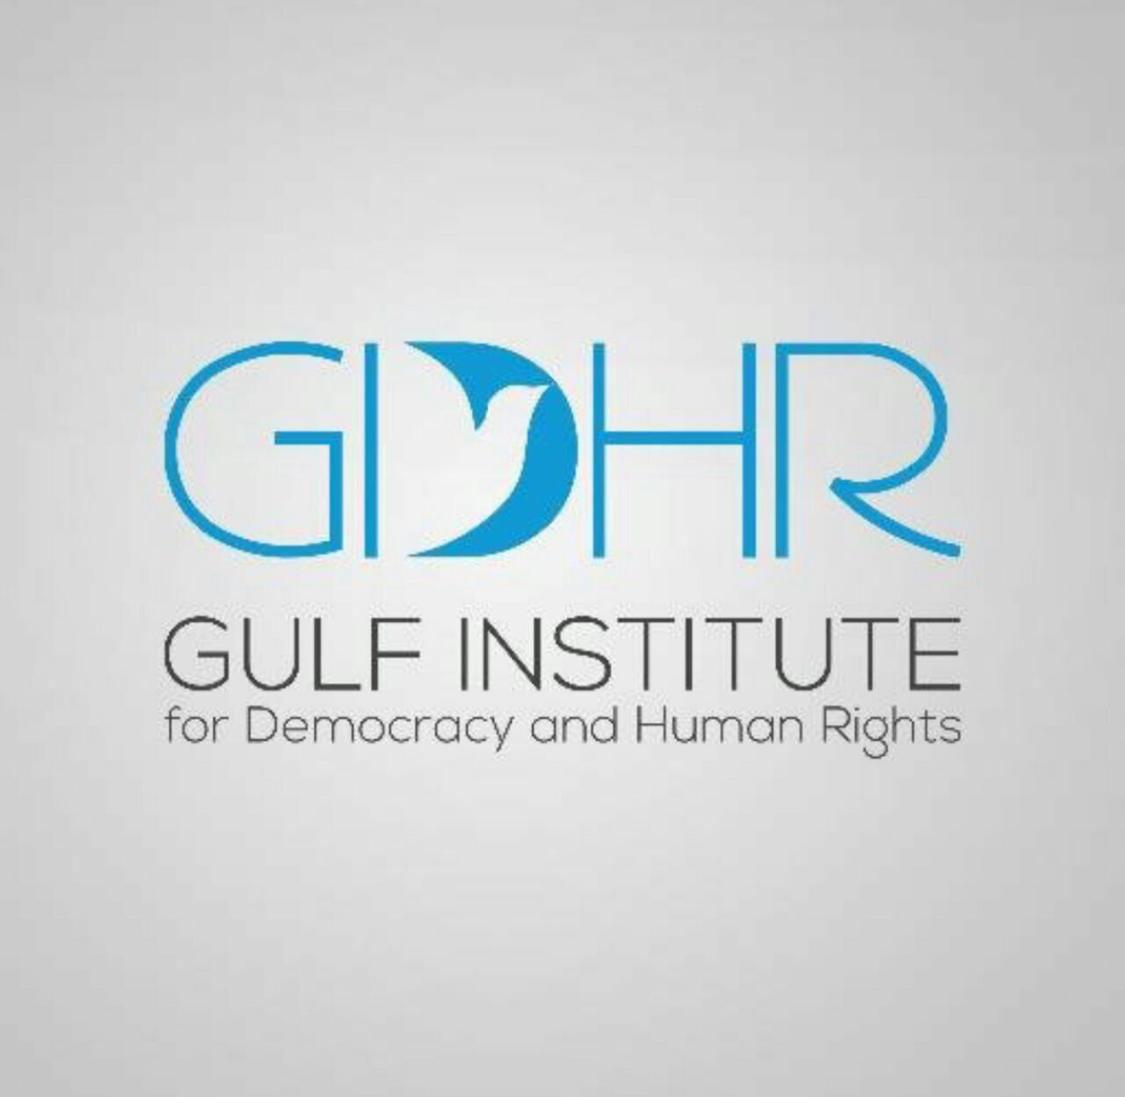
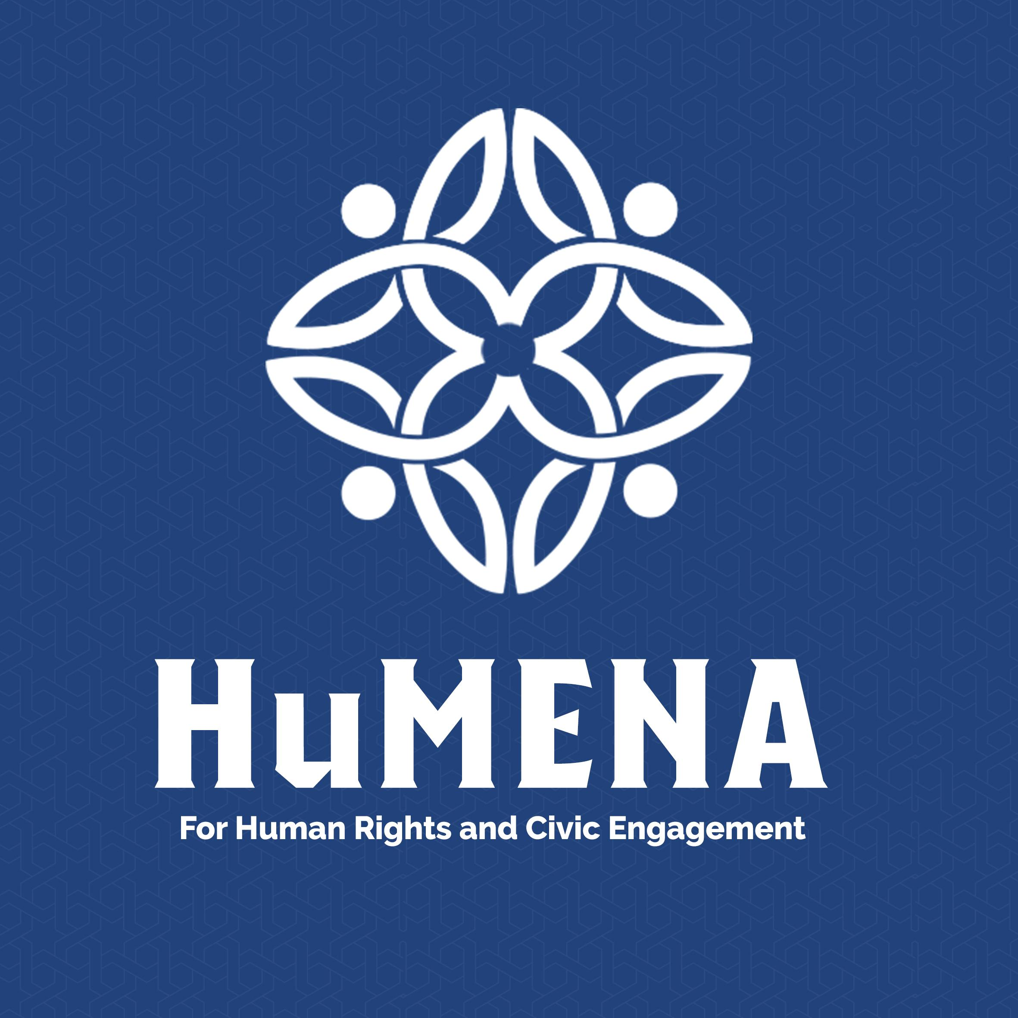 | 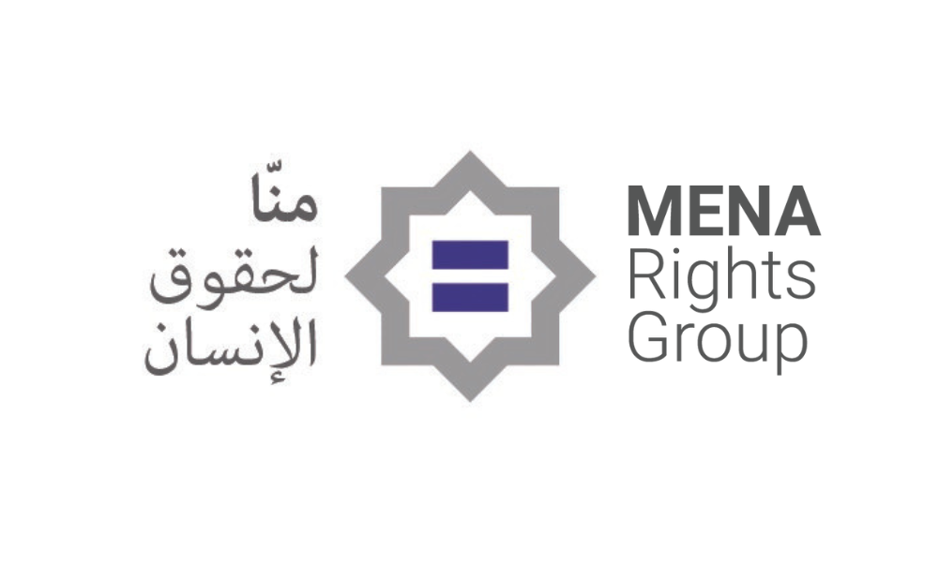 |  | 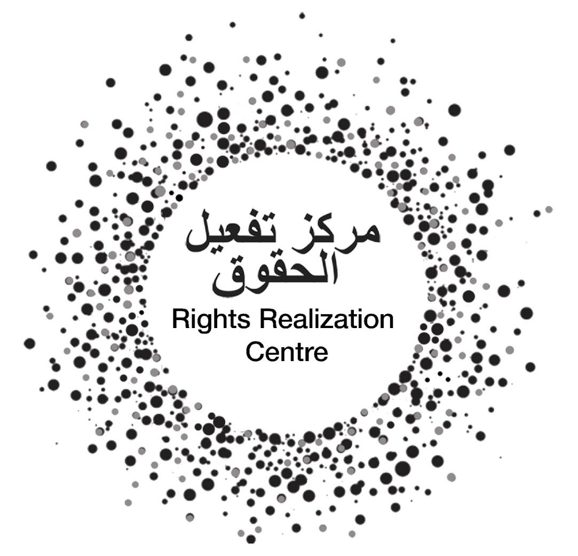
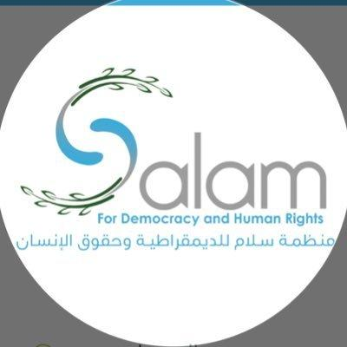 |  | 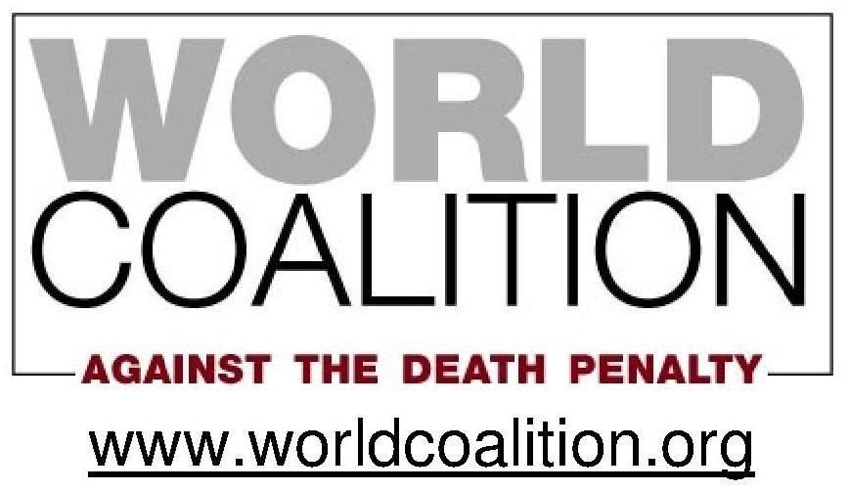

Joint Alternative Report - 11 organisations
Committee against Torture (CAT)
Review of the fourth periodic report of Bahrain (CAT/C/BHR/4)
At its 83rd session (10 Nov 2025 - 28 Nov 2025)

Submission Summary 3
Recent instances of excessive use of force in the context of peaceful gatherings 3
Prison conditions, deaths in custody and evidence of ongoing challenges 4
Mass prison releases: 2024-5 7
Transnational repression and generalised adherence to international human rights law 7
Death penalty - flawed and contested trials exemplify need to abolish 8
The spectre of torture or ill-treatment in death penalty cases 9
Contested case of Mohammed Ramadan and Hussain Moosa 10
Long standing cases of concern 11
Abdulhadi al-Khawaja (AlKhawaja), 64 12
Hassan Mushaima, 77 12
Dr Abdel-Jalil al-Singace, 63 12
Sheikh Mohamed Habib al-Muqdad, 62 12
Government human rights oversight bodies, lack of effective accountability and redress, including in relation to 2011 unrest and related developments 13
Whither redress for Jawad Fairooz? 13
A Step Forward? The 2025 Kathmandu Declaration 15
Putting accountability beyond reach - migrant workers and the case of Martin Buregyeya from Uganda 15
No place for civil society in the prevention of torture 17
Observations 20
On performative gestures 20
On the death penalty 21
On civil society and its role in the prevention and accountability for acts of torture and ill-treatment 21
Summary recommendations to end torture, promote accountability and ‘closure’ for events in and since 2011 21
Appendix 1: Chronology and background of The “Bahrain 13” 22
Appendix 2: Summary chronology of implementation of the death penalty in Bahrain up to 2017 24
Separate document (1): Jawad Fairooz - My Journey of Adversity for Defending Human Rights in Bahrain: testimony provided to the Survivor Hearing, involving the Special Rapporteur on torture and other cruel, inhuman or degrading treatment or punishment, Jill Edwards; International Rehabilitation Council for Torture Victims (IRCT), TPO Nepal and the World Organisation Against Torture (OMCT) 25
Separate document (2): African Centre for the Treatment and Rehabilitation of Torture Victims (ACTV) - Medico-legal report (MLR) of its investigation into the case of Uganda national Mr. Martin Buregyeya 25

Submission Summary

A total of 11 Bahraini, regional, international and thematically-focused non-governmental organisations submit this report ahead of the Government of Bahrain (GoB)’s November 2025 review before the Committee Against Torture (the Committee). In alphabetic order based on the English versions of their names, these organisations are: (1) Bahrain Center for Human Rights; (2) Bahrain Forum for Human Rights; (3) CIVICUS; (4) Gulf Institute for Democracy and Human Rights; (5) HuMENA for Human Rights and Civic Engagement; (6) MENA Rights Group; (7) Rights Realization Centre; (8) SALAM for Democracy and Human Rights (SALAM DHR); (9) The Advocates for Human Rights; (10) World Coalition against the Death Penalty and (11) World Organisation Against Torture

The methodology for this report broadly adheres to the approach adopted by the GoB in its fourth periodic report submitted on 26 May 2021,in which the GoB addresses the list of issues (LoI) set out by the Committee. Like the state party’s report, it examines the practical implementation of Bahrain's obligations under the Convention against Torture and Other Cruel, Inhuman or Degrading Treatment or Punishment (CAT, the Convention). Accordingly, this report does not follow a strict article-by-article structure in line with the Convention.

Like the state party’s report, this text examines specific and emblematic cases to illustrate systemic patterns and broader trends in the administration of justice and treatment of detainees. The cases and issues highlighted in this report are representative of practices that interrogate the GoB’s adherence to its CAT obligations and the effectiveness of safeguards against torture and ill-treatment in Bahrain. It responds to the claims made by the State Party and dispels the GoB’s claims by addressing concerns across multiple provisions of the Convention.

The Committee's guidelines state that “The information should not contain names of victims except if related to public cases or if the consent of the victims or their families is obtained.” Save one, at least one organisation, and often multiple ones have repeatedly raised all names and incidents set out below. They are generally and widely known. The experience of one, a Ugandan migrant worker, Martin Buregyeya, has never been public prior to this report. He gave express permission to cite his experience in this text.

Recent instances of excessive use of force in the context of peaceful gatherings

In the days leading up to, during and after the 4-5 July 2025 ‘Ashoura (Muharram) religious commemoration, GoB security forces reportedly deployed excessive force to restrict gatherings, after having removed religiously-based banners. On 25 June 2025 in the town of Duraz, residents reportedly gathered and peacefully condemned government conduct. One report stated that “security forces used tear gas, sound bombs, and rubber bullets to disperse the crowd.”

Multiple, independent reports state that a member of the security forces struck a man, walking slightly apart from others, holding an ‘Ashoura banner, with a sharp object. Hasan al-Anfooz “fell to the ground, writhing and kicking his legs, bleeding heavily from his head. He was left unattended for several minutes before being dragged along the ground, during which he suffered a skull fracture and severe cerebral hemorrhage”. Officials then sent him to a hospital. Following treatment, the hospital reportedly discharged him on 3 July 2025 but it re-admitted him on 10 July 2025, “in critical condition and partially comatose”. He underwent a further operation on 14 July 2025.

Following a complaint, the authorities claimed to have carried out an investigation and suggested that participants in the demonstration may have struck Hasan al-Anfooz. Footage on social media appeared to contradict the authorities’ assertions but on 10 July 2025, the Special Investigation Unit (SIU) publicly exonerated officials from any responsibility for the injuries. One report countered that:

“The SIU’s statement made no reference to the circumstances surrounding his arrest and ignored the existence of clear documentation of the brutal beating inflicted on the unarmed youth. This undermines the credibility of the investigation’s findings and reinforces the Bahraini government’s policy of impunity to protect perpetrators and cover up violations.”

The July 2025 report by Americans for Democracy and Human Rights in Bahrain (ADHRB) detailed other, subsequent alleged use of excessive force and instances of arbitrary arrest in northern Bahrain in the course of the 2025 ‘Ashoura commemorations.

Prison conditions, deaths in custody and evidence of ongoing challenges

Subsequent to the state party’s 2021 report, in which it asserted that the GoB adhered to the highest possible custodial standards, a variety of NGO and IGO sources repeatedly expressed concern over this very issue.

Paragraph 72 of the GoB’s 2021 report asserts that:

“National legislation has been enacted to establish monitoring bodies tasked with guaranteeing the rights of detainees and prisoners, reducing the incidence of any ill-treatment in places where persons are deprived of their liberty and eliminating impunity for such offences.”

The report states that these bodies include the SIU; Office of the Ombudsman, National Institute for Human Rights, Prisoners and Detainees Rights Commission and Human Rights Committee at the Ministry of the Interior.

However, the UN Special Rapporteur on torture and other cruel, inhuman or degrading treatment or punishment, the Special Rapporteur on the right to food and the Special Rapporteur on the right of everyone to the enjoyment of the highest attainable standard of physical and mental
health issued an urgent appeal on 12 August 2024, detailing “deteriorating conditions of detention of prisoners held in various buildings of the Jau prison”, which they deemed “to fall below international standards”, which “may severely affect prisoners’ health status, exacerbating fragility and vulnerability [...]”

An excerpt of the 12 August 2024 Urgent Appeal states:

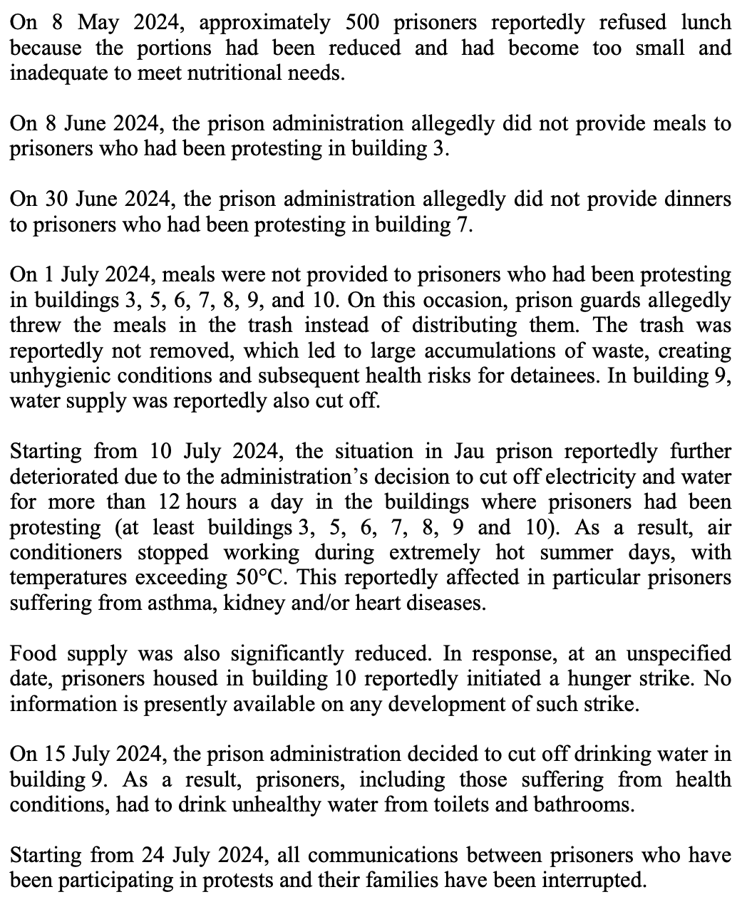

The appeal details the attempts by family members of detainees to have prison conditions addressed by way of the:

- National Institution for Human Rights (NIHR);
- Prison Detainees Rights Commission; and
- Ombudsman Office.

They also contacted several members of the House of Representatives. In July 2024, its Financial and Economic Affairs Committee, submitted a complaint to the Minister of Interior regarding electricity and water outages and denial of medical care in buildings 7, 8, 9, and 10 of Jau Prison.

The government ignored them all. No one person was ever held accountable to collective or individual abuses of detainees.

Further, the existence of the five human rights oversight bodies could not prevent the 25 March 2024 death in custody of Hussein Khalil Ibrahim at Jau Prison.

Following his death, prisoners protested. The authorities, however

“[...] Responded harshly, depriving prisoners of breakfast and dinner, and cutting off air-conditioning, exposing prisoners to extreme heat at a time when temperatures exceeded 50 degrees Celsius. While prison authorities [...] negotiated with protesting prisoners and addressed abuse against them in some cases, many prisoners [did] not have access to electricity, and prison authorities continue [d] to deny detainees adequate access to healthcare [...]”

On 5 December 2024, Hussain Aman, 41, died at Jau Prison. One report stated that he collapsed in the yard of Building 11, having previously been “convicted to life imprisonment and stripped of his nationality in a mass trial amid allegations of torture.” An ambulance reportedly arrived after 7-8 minutes, prior to which there was no other medical intervention.

Prior to his death, but especially following, prisoners in different buildings and parts of the facility again protested prison conditions and treatment. On 10 December 2024, a statement attributed to Families of the Political Prisoners stated that the authorities cut their contact with detained family members. Prior to this, the Families stated that on 8 December, security forces forcibly entered Building 6, amongst others, “resulting in injuries to three prisoners, one of whom sustained a head injury.” They reported that:

“security forces stormed Building 10, using tear gas, sound bombs, and directly spraying pepper spray in the prisoners’ faces. Excessive force was also used, leading to further injuries among the prisoners. The prisoners reported that the prison administration cut off electricity and water and stopped distributing meals a day before the attack.”

On the same day they stated that “forces moved to Building 9, where the sit-in was dealt with in the same violent manner” and that one prisoner permitted to contact his family informed them that “conditions are extremely poor, with prisoners being restrained at all times, denied hygiene supplies, and deprived of any means to pass the time, such as books or television, in locked cells.”

Our organisations believe that the UN Working Group on Arbitrary Detention’s successive opinions exemplify the ongoing challenge faced by the GoB in respect to ensuring human rights-compliant treatment to detainees, including in relation to the detention of minors.

Mass prison releases: 2024-5

On 15 December 2024 the GoB released 896 prisoners on the occasion of the country’s National Day. It included those who had part-served sentences and others under ‘alternative sentencing’ but did not include political prisoners or at least 12 sentenced to death. On 28 March 2025, the GoB released a further 630 detainees but no political prisoners. On 9 April 2025, the GoB released 1584 people, “including some serving life sentences and others convicted on charges related to protests that occurred in 2011.” They included those serving under the 2017 “alternative sentences” provisions, by which those who had served more than half of their sentence could complete it outside of custodial conditions, including by way of community service, rehabilitation courses and electronic surveillance. A report stated that “about 65% of those released were convicted on charges related to riots”, without specificing what this meant.

Transnational repression and generalised adherence to international human rights law

Our organisations are concerned that the GoB exerts or seeks to exert pressure on other, specific governments in relation to their domestic conduct where the GoB may arguably receive negative media coverage.

For example, some human rights activists, notably in the United Kingdom (UK) are concerned that the GoB exerted pressure on the UK government in relation to the conferral of nationality to a UK-based Bahraini activist, who faced cruel, inhuman and degrading treatment by the GoB, whose wait for citizenship after having been granted asylum exceeded the time normally considered under this process: granted asylum in 2012, the UK government did not grant him citizenship until 2024. A June 2024 newspaper report, citing an exchange of emails between the UK’s Home and Foreign Office, indicated that the Foreign Office referred to “the implications arising from granting him British citizenship” but reportedly refrained for further comment when learning that the exchanges could become public.

Death penalty - flawed and contested trials exemplify need to abolish

In 2017, Bahrain ended a seven-year de facto moratorium by executing three individuals, followed by another three in 2019.

In advance of the December 2022 United Nations General Assembly’s 9th resolution for a moratorium on the use of the death penalty, in contravention of express recommendations of the government-supported National Institute for Human Rights, the Government of Bahrain (GoB) voted against the resolution.

Our organisations assert that a growing body of evidence indicates that even when compliant with international fair trial standards, the process for handing down a death sentence can itself constitute cruelty amounting to torture. Data from the World Organisation Against Torture’s Global Torture Index illustrates that executions are not a standalone practice but part of broader systems rooted in torture. In countries like Bahrain where executions persist, torture risks remain high across all areas.

Paragraph 3 of the 2021/2022 state party’s report states:

“While the death penalty is not prohibited per se under international law, a broad set of restrictions and criteria are in place concerning its use. The practice in the Kingdom of Bahrain is consistent with the safeguards guaranteeing protection of the rights of those facing the death penalty, as set out in the annex to United Nations Economic and Social Council resolution 1984/50, adopted on 25 May 1984. Accordingly, the death penalty is imposed only for the most serious crimes against society for which it is specifically prescribed.”

Paragraphs 4-7 assert that administration of justice in regard to the application of the death penalty in Bahrain adheres to safeguards that minimise its application

Our organisations do not possess objectively verifiable information relating to the exact number of people currently on death row. The last confirmed information that SALAM DHR was able to obtain indicated that there were at least 12 people on death row; unconfirmed information suggests that there are currently 27 individuals at risk of execution, including at least one Bengali, convicted in connection with the alleged murder of a Kuwaiti national. The last confirmed, known cases are as follows:
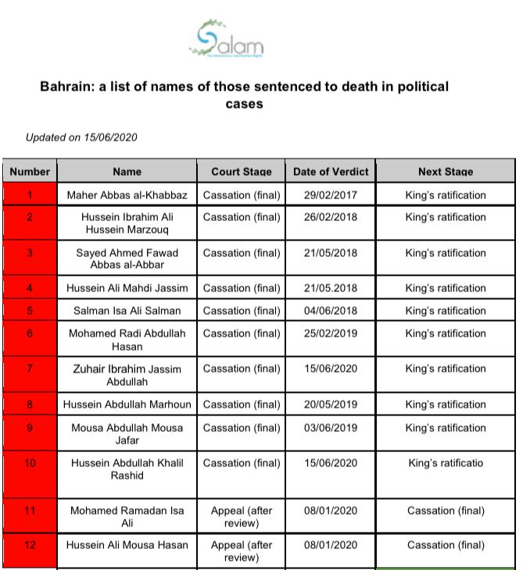

The spectre of torture or ill-treatment in death penalty cases

On 17 May 2020, SALAM DHR wrote to the Office of the Ombudsman by email. The organisation set out concerns in relation to eight death penalty cases where the Court of Cassation had upheld convictions.
On 7 February 2019, the government of Bahrain provided information about these cases to the UN's High Commission for Human Rights. On the basis of that letter, SALAM DHR expressed concern that the convictions rested on:

- Maher Abbas al-Khabbaz - “confession”, which at the appeal stage, the government termed 'statements during the investigation' . SALAM DHR asked whether his lawyer was present when he made these 'statements' as well as the exact date when the lawyer first had effective representation of the accused.
- Hussein Ibrahim Ali Hussein Marzouq - torture: on 13 October 2016 the SIA received a complaint from the lawyer of the accused in which she claimed that her client had been tortured by the police. The SIA reportedly requested the complainant to provide details of the complaint but the examination by a forensics physician failed to reveal any injuries consistent with this allegation and concluded that he did not face ill treatment.
- Sayed Ahmed Fawad Abbas al-Abbar and
- Hussein Ali Mahdi Jassim - ill-treatment: the mother of the former and lawyer of the latter both alleged that both men faced ill-treatment in pre-trial detention. Officials conducted an examination and found that "no injuries consistent with his allegation were found" so "the unit completed its investigation by questioning members of the public security forces who had interacted with the complainant and they denied the allegation."

In respect to

- Salman Isa Ali Salman
- Mohamed Radhi Abdullah Hasan
- Hussein Abdullah Marhoun
- Mousa Abdullah Jafar

SALAM DHR asked the Ombudsman’s Office when the accused obtained effective legal representation in respect to the serious criminal charges each man faced.

SALAM DHR requested of the Ombudsman’s Office, in respect to the cases of (1) Maher Abbas al-Khabbaz, (2) Hussein Ibrahim Ali Hussein Marzouq, (3) Sayed Ahmed Fawad Abbas al-Abbar and (4) Hussein Ali Mahdi Jassim that independent organisation such as Freedom From Torture (UK), or the International Rehabilitation Council for Torture Victims (Denmark), or indeed the UN Special Rapporteur on Torture and Other Cruel, Inhuman or Degrading Treatment or Punishment be authorized to review the forensic assessment.

On 16 July, 2020, SALAM DHR wrote to the Ombudsman but received the following reply:

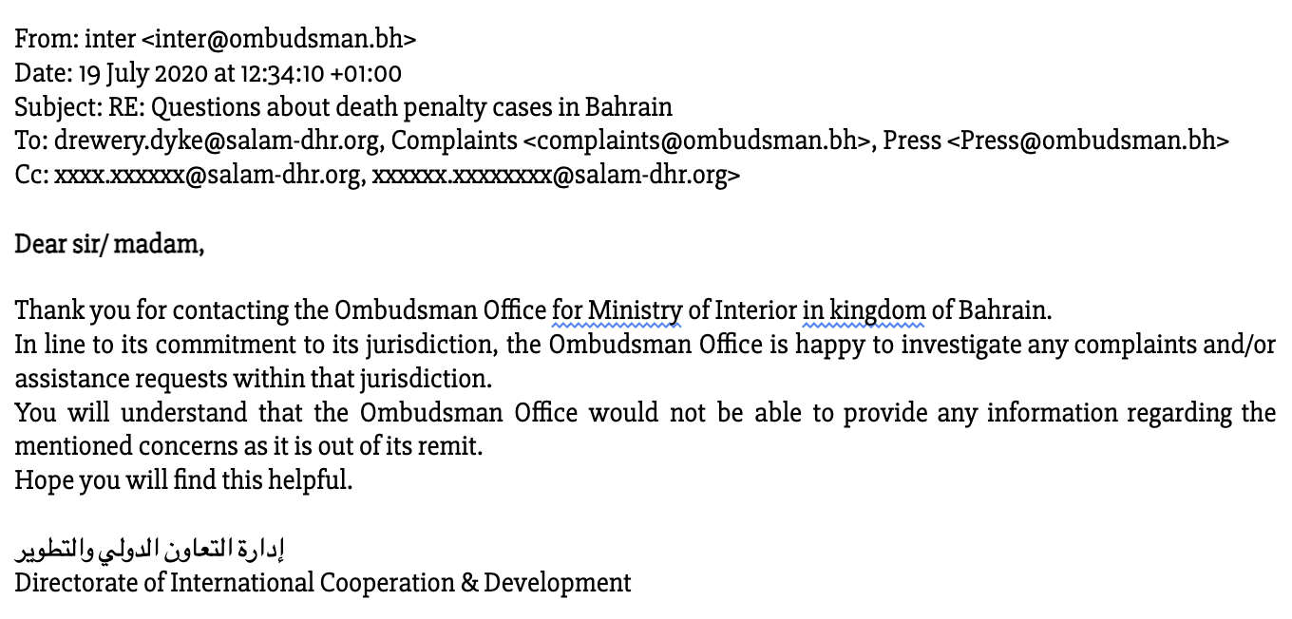

Contested case of Mohammed Ramadan and Hussain Moosa

In its 2017 assessment of the GoB’s adherence to the Convention against Torture and Other Cruel, Inhuman or Degrading Treatment or Punishment, the United Nations’ Committee against Torture (CaT) expressed its “grave concern” about the 2017 resumption of the death penalty; and that “Reports that the trials of the three men convicted of killing three police officers in 2014 were based on confessions obtained under torture, and the fact that the reports were not properly investigated by the competent authorities”. The CaT further expressed concern about “the situation of Mohammed Ramadhan and Hussain Ali Moosa, who face the death penalty and are said to have been convicted on the basis of confessions extracted under torture.”

Paragraphs 28-35 of the state party’s 2021 report state that (28) the Court of Cassation upheld the sentence on 13 July 2020. Paragraph (29) states that the Court of Cassation upheld the conviction on 16 November 2015 but that in 2016, the men made the allegations of torture; (30) states that investigations lasted alomost four years. Paragraph (32) asserts that the injuries claimed by Mohammed Ramadan were sustained after questioning for evidence and interrogation by the public prosecution; and that in the case of Hussain Moosa, “injuries to his hands were as a result of restraint. X-rays showed that he has a congenital defect in his lumbar and sacral vertebrae that is long-standing in nature and has no implications as far as his statements are concerned.” Accordingly, paragraphs 33 and 34 assert that the trial conformed to legal standards; that (34) the “convictions were, in both cases, based on evidence other than their confessions as documented in the reports on the evidence-gathering and the investigations of the public prosecution.” As a result, they both remain on death row.

Many human rights activists remain incredulous in respect to the GoB’s assertions regardingMohammed Ramadan and Hussain Moosa. Even if such assertions are credible, the spectre of torture continues to hang over the administration of justice in this instance. For that reason, our organisations once again echo the February 2020 appeal by the OHCHR to the GoB to quash convictions in these two cases. We likewise remind the GoB of the appeal to clemency made by 53 Members of the European Parliament in a letter to Hamad bin Isa al-Khalifa, Office of the King, dated 23 July 2020.

Long standing cases of concern

The state party’s submission to the Committee, including its appendices, cite a wide range of specific cases. By way of response, our organisations provide the following observations on a sample of these cases.

For chronological and contextual information relating to those named as connected to the ‘Bahrain 13’, please see Appendix X. The concerns set out below address only relatively recent developments in each case or theme. While many of the matters and cases below have been repeatedly raised by a wide range of NGOs and IGOs, on 12 May 2025, a coalition of NGOs specifically called on the GOB to take action before the 59th Session of the Human Rights Council; the GoB ignored this latest appeal.

Abdulhadi al-Khawaja (AlKhawaja), 64

One of the ‘Bahrain 13’, he is a co-founder of the Bahrain Center for Human Rights whose activism dates from arrests in 2004 and 2007 prior to events in 2011. He is an award-winning human rights defender, prisoner of conscience and Bahraini-Danish national who has been arbitrarily detained since 2011. On 9 April 2025, UN Special Rapporteur on Human Rights Defenders Mary Lawlor stated that “he has been tortured, he has been stigmatized, and he has been cut off from his family” and urged the Danish Prime Minister to call for al-Khawaja’s release with her Bahraini counterpart directly.

In its appendix to the state party’s report, file name INT_CAT_ADR_BHR_44965_A, the GoB sets out the medical and other examinations that Abdulhadi al-Khawaja received, but it closes with the observation that “As there was no misconduct conducted by any MOI personnel and the inmate is having his rights related to access to health care, the Ombudsman Office closed all the above cases.”

As set out repeatedly in this text, the structure and effective independence of the Ombudsman is such that this conclusion is generally understood by Bahraini activists as the perpetuation of impunity and the effective impunity of the authorities.

Hassan Mushaima, 77

One of the ‘Bahrain 13’, he is General Secretary of the Haq Movement for Liberty and Democracy; one of the leading figures of rights-based activities from the 1980s through to the 1990s. He is a Bahraini opposition leader and Bahrain’s oldest political prisoner, arbitrarily detained since 2011. He and Dr. al-Singace have been held in prolonged solitary confinement since 2021 at a medical centre in Bahrain, where they continue to be denied adequate medical care, sunlight and ventilation.

Dr Abdel-Jalil al-Singace, 63

One of the ‘Bahrain 13’, is an award-winning human rights defender, blogger, and respected academic, arbitrarily detained since 2011. He has repeatedly protested against what he has believed to be unfair or ill treatment. In its appendix to the state party’s report, file name INT_CAT_ADR_BHR_44965_A, the GoB sets out the medical and other examinations which Dr Abdel-Jalil al-Singace refused to attend, but also those that he attended, but it likewise closes with “As there was no misconduct conducted by any MOI personnel and the inmate is having his rights related to access to health care, the Ombudsman Office closed all the above cases.” As set out above and below, the lack of effective independence and transparency of the oversight body concerned renders the conclusion empty.

Sheikh Mohamed Habib al-Muqdad, 62

A dual Swedish-Bahraini national and a religious figure and social activist in Bahrain. Similar to al-Khawaja, al-Singace and Mushaima, he was arbitrarily and violently arrested, forcibly disappeared and subjected to severe physical, sexual, and psychological torture for his prominent role in the 2011 uprising.

Government human rights oversight bodies, lack of effective accountability and redress, including in relation to 2011 unrest and related developments

“Perpetrators, no matter who they are, should be constantly reminded that they are not immune from justice. Bahrain’s killers and torturers should not sleep easily. The law could, one day, catch up with them.”
Brian Dooley, Human Rights First, 22 September 2025

In 2012, following the 2011-2 social upheaval in Bahrain, the GoB established human rights oversight bodies. Paragraphs 120-1 of the state party’s report assert that the

“Special Investigation Unit is independent and impartial in holding to account government officials who have committed acts in violation of the law or who, by their negligence, have caused the death, torture or ill-treatment of civilians. In so doing, its aim is to take legal and disciplinary action against such persons, including civilian and military personnel in positions of leadership to whom the principle of “leadership responsibility” firmly applies, in accordance with international standards.”

Paragraph 121 exemplifies the culture of restriction, stating that the GoB believes that it is “[...] the right of all citizens to claim compensation for any harm inflicted on them [...]”, language suggesting exclusion of, for example, migrant workers.

The state party’s responses to Observation No. 18 (a), in paragraphs 228-232, asserts the integrity and probity of the government’s oversight bodies; 233 their independence; 39-40 details how they “ensure that allegations are investigated.”

Our organisations welcome reports of accountability, such as a May 2025 report that states that the SIU received 17 complaints in the first quarter of 2025; that they interviewed 49 officials and referred seven complaints to the Forensic Medicine and Psychiatry Department; and that “disciplinary sanctions were issued against two members of the Public Security Forces in two cases”, though the report did not state what these sanctions were.

The GoB’s assertions and the limited, vague accountability measures have not assuaged a deep and unquenched need for justice, redress and accountability arising from social upheaval and human rights violations that thousands of Bahrainis experienced from 2011-2 onwards. Bahraini and international activists welcomed the 2011 creation of the Bahrain Independent Commission of Inquiry (BICI) but there is no enduring or transparent evidence as to who was held accountable or for what.

Moreover, as early as November 2016, Amnesty International found that in respect to their mandates– independence and impartiality, confidentiality, effectiveness, promptness and adequacy, transparency, and public confidence–the Ombudsman and SIU were flawed. Lawyer Mohamed al-Tajer noted that “Complaining to the SIU is a waste of time.” They seem, in fact, to perpetuate impunity.

Whither redress for Jawad Fairooz?

In Jawad Fairooz’s testimony, entitled My Journey of Adversity for Defending Human Rights in Bahrain, and sent separately to the Committee, the former parliamentarian and director of SALAM DHR details his arrest and torture over May-June 2011 and subsequent, unfair trial between June 2011 and November 2012. Jawad Fairooz’s case highlights the connection from arbitrary arrest and torture to deprivation of citizenship and exile. There is no legal or effective scope for him to seek redress from the GoB, whose officials tortured him.

Exemplary of the discrimination and inhumanity meted out in the 2011-2 period, Jawad Fairooz writes that during a medical examination during his arrest:

“The person taking my blood pressure told me I didn’t deserve treatment or medical care and that I would eventually no longer live in Bahrain. During this medical check-up, I could hear screams coming from other parts of the clinic. As I was being examined, the clinician described the torture I would face if I didn’t cooperate with the authorities.”

In his testimony, he set out his vision for justice and redress. He recommends:

- Restoration of rights and an effort to return the victim to their situation prior to the violation [...]
- Appropriate financial and non-financial compensation to cover damages, including medical expenses, loss of income, and opportunities [...]
- Comprehensive rehabilitation and provision of medical, psychological, legal and social services, to enable the victim’s integration and participation in society [...]
- Satisfaction and the right to know the truth by investigating incidents of torture, revealing the truth, restoring dignity and rights, imposing penalties on the perpetrators and holding them accountable, offering a public apology, and commemorating the victims.
- Taking preventive measures to combat impunity and ensure that torture is not repeated. Adhering to international standards of due process [...]
- Ratification of the Optional Protocol to the United Nations Convention against Torture and Other Cruel, Inhuman or Degrading Treatment or Punishment [...]

He describes the GoB’s policy shift from physical torture to what he terms “soft torture”, outside the scope of the treaty, but insofar as human rights may be indivisible and interlocking, he notes that “Despite its lack of visible blood and marks, its destructive consequences on individuals and society are no less dangerous than physical violence.”

These measures are:
- Deprivation of civil rights after release, namely:
  - Banning employment in both the public and private sectors;
  - Hindering the acquisition of official documents or certificates of good conduct [required for employment];
- Restrictions on travel, or obtaining housing and basic services;
- Ongoing social and political surveillance, including:
  - Monitoring individuals' movements and activities, even after their sentence has ended or they have been acquitted;
  - Frequent issuance of security summons without legal justification; and
- Indirect Threats, through intermediaries or veiled messages, aimed at breaking the will and imposing silence.

Jawad Fairooz concludes that GoB “Repression did not stop; rather, it changed its form. It has become more hidden, harder to document, but no less harmful than physical violence. Its effects last much longer and undermine individuals' ability to restore their normal lives.”

A further example of the unmet need for redress is exemplified by, amongst others, the 2019 report Anatomy of a Police State / Systematic Repression, Brutality and Bahrain’s Ministry of Interior and the December 2024 report, Who Holds Bahrain’s Torture Princes Accountable?, both by the US-based Americans for Democracy and Human Rights in Bahrain (ADHRB), amongst others.

A Step Forward? The 2025 Kathmandu Declaration

Over 6-8 May 2025, individuals with lived experience of torture and affected communities of 10 Asian countries, including Jawad Fairooz, met in Kathmandu, Nepal, to share their experiences with the UN SR against Torture, Dr Alice Edwards. The resultant Kathmandu Declaration represents, in some sense, possible measures for states and others to take.

Putting accountability beyond reach - migrant workers and the case of Martin Buregyeya from Uganda

The experience in 2018-19 of Ugandan migrant worker, Martin Buregyeya (MB), who has given our organisations express permission to refer publicly to his experience, exemplifies the power imbalance and lack of operational independence inherent in Bahrain’s criminal justice system and in respect to its human rights oversight bodies, and the inaccessibility of justice to and for those in similar situations.

Prior to considering this section, our organisations urge members of the Committee to review at least pages 4-6 of the May 2022, medico-legal report (MLR) prepared by the African Centre for the Treatment and Rehabilitation of Torture Victims’ (ACTV), which concerns this man’s experience.

In 2016, MB arrived in Bahrain for work. In October 2018, officials detained him and accused him and others of criminal conduct. According to an email that the NIHR sent to SALAM DHR on 22 December 2022, with information from the SIU, a simplified timeline of MB’s experience is as follows:

- 08.09.18 - MB Detained
- 18.09.18 - Checked and asked if ill treated
- 23.09.18 - Officials interrogated him;
- 25.09.18 - Forensic doctor met him and no complaint of ill treatment;
- 11.03.19 - Sentenced to five years’ imprisonment on three charges of internationally recognisable criminal conduct;
- Mid to end 2019, appeal upheld conviction
- 10.20 - released amidst Covid and returned to Uganda

The SIU asserted, by way of the 22 December 2022 email from the NIHR to SALAM DHR that officials provided MB with 29 medical examinations between 8 September 2018 and 13 October 2020.

MB asserts - and the African Centre for the Treatment and Rehabilitation of Torture Victims’ (ACTV) May 2022 medico-legal report (MLR) appears to evidence - that officials tortured him in pre-trial detention. Assuming this is the case, it made his trial and conviction unfair.

In October 2020, during the Covid pandemic, the GoB returned him to Uganda. In 2022, MB approached SALAM DHR to seek redress for what he believed to be injustice faced in Bahrain. On 29 October 2022, the Uganda-based Chapter Four Uganda raised his case with the NIHR. In the absence of a response, on 12 December 2022, SALAM DHR sought information from the NIHR in relation to the case. On 22 December 2022, the NIHR responded. It conveyed the assessment from the SIU. The SIU asserted that MB never raised any complaints; that medical professionals examined him and did not find any problem. In respect to the MLR conducted by ACTV, the SIU dismissed it,concluding that:

“[H]is report is not based on any clinical or medical manifestations or any proper psychological examination and evaluation, that weakens the validity of the report. The SIU forensic doctor found no signs of injuries that could be relied upon to confirm the validity of the complainant's narration.”
The SIU concluded that he could seek damages in the court system. In January 2023, SALAM DHR asked MB for his reaction to the SIU’s assessment. In an email, he wrote:

As per the medical legal Report (MLR) that was done by African center for Treatment & Rehabilitation of Torture Victims it’s based on accuracy for what happened to me while in Bahrain detentions for 40days in jau maximum prison (Torture chambers) there was no one i could run to because I was told not once not twice if I dared told any one be it doctors or my inmates they will torture me till I die in prison. Yes! I met many doctors but I was always escorted by CID [] officers or police officers purposely not to engage myself with the doctor but I was always in an excruciating pain.

One time I met a Sudanese doctor who was in his early 50’s in Jau [Prison] and for him being a black doctor I knew it was my time to tell him but to my surprise the CID officer told me if you get in the room with the doctor simply tell him you’re very fine,unless if you don’t want to live the next day I did what he asked me to do & as if I wasn’t enough they came to my room and told me they will watch over me till we’re taken to Dry Dock (Ashri) in Hidd [another detention centre]. That even if I told anyone in Dry Dock no one will ever believe me because whatever happens in Jau remains in Jau and after all no one cares about black people and even they didn’t understand why I went in Bahrain in the first place.

They told me if I wanted to see my family & my country again then I have to play on their tunes [sic], everyone loves his family so I had to do whatever they asked for me to survive but back in my mind I knew I would seek for justice once am out & it’s precisely what I did/ what am doing?

Why would someone who is very fine go to the hospital twenty nine times and it’s not a routine it’s me who was always pestering/ asking them I wanted to see the doctor because I was in pain always. One Indian lady by then she was pregnant they had taken me for the Scan after the scan I asked her what was wrong with me she told me she can’t tell me but they will give me medicine but I guess it was Spinal Tuberculosis because when I returned and went for the scan that’s what they discovered?

Last but not least at dry dock Hidd a certain Indian doctor in his late 30’s I tried to engage him on what had happened to me in Jau he told me he knows everything that happens there but he can’t help me that also spoke volumes.

Lastly I would suggest if we’re writing to them again let’s put a paragraph specifically for my items that was taken by the CID ( public Prosecution).

In the event that Committee members are not able to peruse the MLR sent separately, we provide the following, brief excerpt of the report:

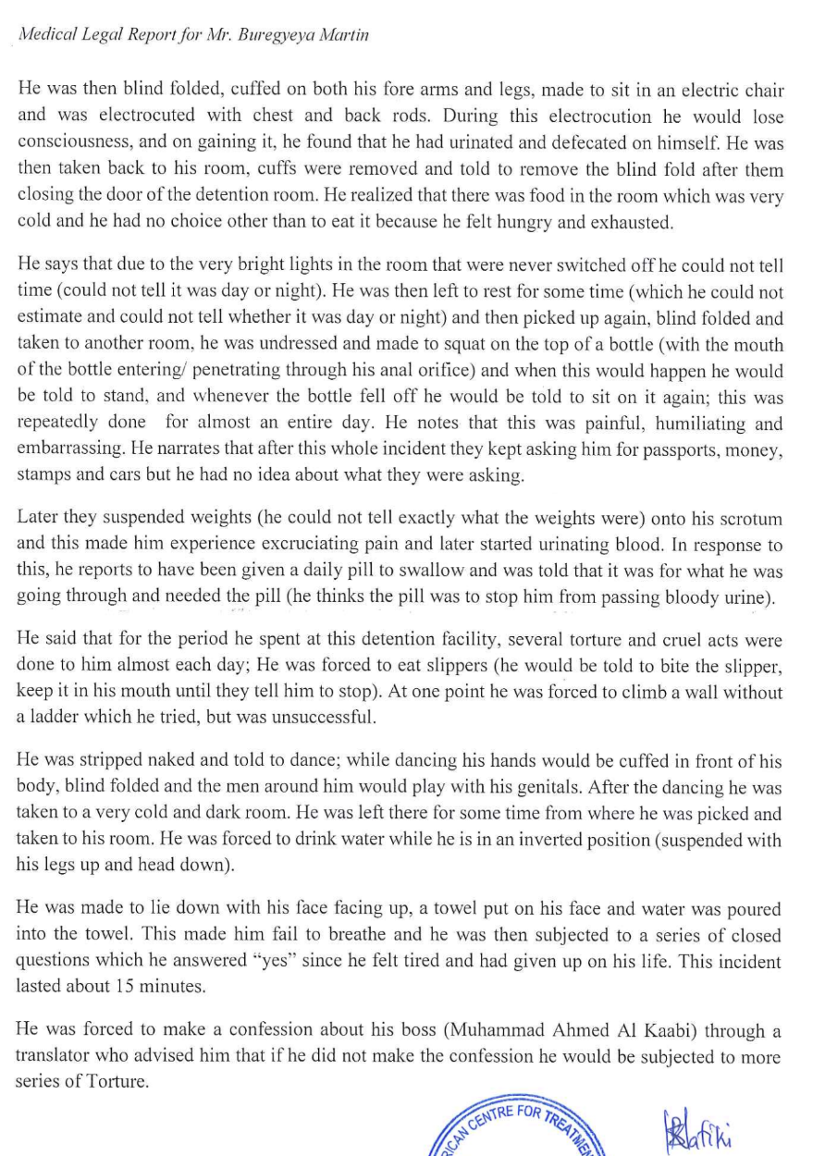

No place for civil society in the prevention of torture

While paragraph 141 (and others) of the state party’s report recognises the role of civil society in the provision of protection services in instances of domestic violence, laws and practices of the GoB prevent or restrict the discussion or torture, ill-treatment or accountability by independent, media and civil society organisations, including non-governmental organisations and those engaged in electoral politics: the government has banned them and activists associated with them, marginalising and silencing them.

In 2017, the Ministry of Information (MoI) forcibly and arbitrarily closed the last independent news platform, al-Wasat. The MoI asserted that it published “material inciting division within society and affecting the Kingdom of Bahrain’s relations with other countries”.

Law 25 of 2018 (25/2018), the Political Rights Law prevented, generally on arbitrary grounds, scores of citizens from running for office or voting in the 2018 and subsequent elections. Article 1 (of the 2-article law) prohibited from being nominated to stand for the House of Representatives those who have been:

- Sentenced to a felony, even if they were pardoned or rehabilitated [in reference to politically-motivated criminal charges and unfair trials that the government carried out following socio-political unrest in 2011];
- Sentenced to more than six months’ imprisonment for intentional offences, even if they were pardoned [as above]; Leaders and members of political associations dissolved by final ruling for serious violation of the provisions of the Kingdom’s Constitution or any of its laws; and
- Anyone who has deliberately harmed or disrupted the course of constitutional or parliamentary life or who has terminated or left parliamentary work or whose membership was dropped for the same reasons.

The subsequent Law 36 of 2018 (36/2018), enacted four months before the late-2018 elections, “tightened the law to prevent those banned from political participation from playing a legal role in civil society, by amending its statute on non-governmental organizations to make it a requirement that any NGO board member must ‘be in full enjoyment of his civil and political rights’.” The amended Associations and Clubs law established new requirements for candidates who wish to join associations and clubs.

A further set of regulations, assessed by Amnesty International, issued by the Ministry of Municipalities Affairs in September 2022 outlawed election content “infringing on the Islamic creed or the unity of the people, or that incites division or sectarianism between citizens”. The regulations forbid candidates from electioneering activities, “including organizing and holding meetings and giving election speeches” in “houses of worship”, “public places reserved for public services”, all public and private universities and educational institutes, and at the sites of “statues… and historic buildings”. A final clause further forbids any electioneering speech or activity that “infringes on public security or public morals or religious beliefs or the customs prevalent in society”. These vague and overly broad restrictions are not compatible with the guarantees of freedom of expression and peaceful assembly.

Taken together, these provisions comprise what many in Bahrain term political isolation laws, that is, legislation designed to exclude from civil society those who could effectively hold the government to account, including in relation to the prevention of torture and accountability for its alleged use.

By way of 25/2018, the GoB has excluded thousands of Bahrainis from the right to vote or run for political office, notably people convicted of criminal acts in Bahraini law that do not constitute internationally recognisable criminal conduct, such as participation in peaceful marches and gatherings and protesting issues such as interference with freedom of speech and expression. The government excluded thousands of ordinary citizens from the right to take part in public life, to hold the government to account over allegations of ill-treatment.

By way of 36/2018, the Bahraini Ministry of Labor and Social Development (MLSD) excluded dozens of applicants for the management of charities and civil society associations. In January 2020, the GoB’s MLSD told NGOs that “going forward ‘there will be a security check of candidates for board[s] of directors’ in order to exclude those not “in full enjoyment of [their] civil and political rights”, including members of the banned opposition parties.

For example:

- January 2020 - MLSD excluded Zainab al-Durazi and Safia al-Hasan, whom members of the Bahrain Women’s Union had elected to their board in September 2019, on the basis of their previous political associations. The MLSD ordered the Union to dismiss them since they did not “enjoy all their civil and political rights”, given that they were members of the outlawed party Wa‘d.
- November 2021 - MLSD initially rejected the candidacy of 14 out of 16 members who applied for positions on the board of the Sarr Charity Fund for 2022-23. On 2 December 2021, the Sarr Charity Fund received a letter from the MLSD stating that four other candidates had been approved, bringing the total number of people accepted to stand for election to 6 out of 16 candidates.
- January 2022 - MLSD excluded three members of the Bahrain Human Rights Society from candidacy for the board of directors because they had been members of Wa‘d. They were lawyer Isa Ebrahim and Mohsen Matar and head of the board, AbdulJalil Yusuf.

The legislation is contrary to at least three articles of Bahrain’s Constitution, namely:

- Article 4: Justice is the basis of Government. Cooperation and mutual respect provide a firm bond between citizens. Liberty, equality, security, trust, knowledge, social solidarity, and equality of opportunity for citizens are pillars of society guaranteed by the State.
- Article 18: People are equal in human dignity, and citizens are equal before the law in public rights and duties. There shall be no discrimination among them on the basis of sex, origin, language, religion or creed; and
- Article 31: The public’s rights and freedoms stated in the present Constitution may only be regulated or limited by or in accordance with the law, and such regulations or limitations may not prejudice the essence of the right or freedom.

Taken together, these two laws violate the right to freedom of association and aspects of the ICCPR, to which Bahrain is a state party. They impede the GoB from being able to fulfill Articles 2 and 10 of the CAT by restricting civil society from engaging in and promoting a culture in which the treaty-bound prohibition of torture is widely and generally understood and in which security officials strictly adhere to its ban in customary international law.

Observations

On performative gestures

On 5 April 2021, a prisoner in Jau Prison, Abbas Mal Allah, died after reportedly being denied timely access to essential health care. A statement issued by the OHCHR on 30 April 2021 observed that “the lack of health care in the overcrowded Bahraini prisons has been an issue for years [and became] a chronic problem during the COVID-19 pandemic.” As a result, prisoners in the prison undertook a peaceful - or generally peaceful - sit-in. On 17 April, however, the authorities forcibly ended the peaceful action.

The 30 April 2021 OHCHR statement expressed concern over “the use of unnecessary and disproportionate force by police special forces to dismantle a peaceful sit-in in Bahrain’s Jau prison”. The OHCHR noted that “forces threw stun grenades and beat detainees on their heads, badly injuring many of them”; that the authorities “took 33 protestors to another building in the prison, where they held them incommunicado, unable to make contact with families or lawyers, in violation of both national and international law.”

By way of reaction, the GoB orchestrated carefully managed visits in May 2021 by members of the diplomatic corps based in Manama to Jau Prison (“Jaw Correctional and Rehabilitation Centre”). Paragraph 11 of the state party’s report details these visits and which officials took part.

Scores of visits by, amongst others, members of the Working Group on Arbitrary Detention (WGAD) have repeatedly shown that pre-arranged, curated visits by non-specialist yet symbolic personnel do nothing to address the substance of a human rights challenge but are, rather, a bad-faith attempt to misdirect from the issue at hand.

Our organisations decry the performative gesture of the staged and government-managed May 2021 visit by diplomatic personnel to Jau Prison. We urge the GoB to address the substance of concerns expressed by the international community and change the conduct addressed rather than misuse the presence of non-specialists in order to mask human rights violations.

Likewise, paragraphs 15-20 of the state party’s 2021/2 report emphasise the role of domestic and international training in ensuring the highest possible policing and related standards. The GoB’s and the NIHR’s 2023 association with, for example, the UK’s Sheffield Hallam University, and initiative to establish “a joint mechanism for cooperation with regard to institutional building represented in the promotion and dissemination of a culture of human rights [...]” appears not to have helped with the 2024 unrest in Jau Prison, deaths in custody or the objectively verifiable, systemic improvement in the conduct of police and security officials, such as those at Jau Prison.

Rather than asserting the establishment of good practice by suggesting that foreign training results in improved conduct, the authorities themselves need to facilitate the provision of independent information that reflects reform, such as by way of independent civil society. Bahrain’s score is suppressive based on OMCT’s Global Torture Index evaluation of the country’s current level of transparency and access to information.

On the death penalty

In order to avoid the taint of torture or ill-treatment, frequently encountered in death penalty cases in Bahrain, our organisations echo a longstanding appeal, like Salam DHR’s 2023 call for the GoB to:
- Immediately restore a moratorium on executions, pending a full review to identify death sentences handed down in reliance on torture-tainted evidence or other human rights violations; and
- Commute the death sentences of all individuals on death row for non-lethal offences, with a goal of moving towards commuting the sentences of all persons on death row.

On civil society and its role in the prevention and accountability for acts of torture and ill-treatment

Our organisations call on the GoB to Repeal Law No. 36 of 2018 by amending Article 43 of the Law on Associations, Social and Cultural Clubs, special bodies working in the field of youth, sports and private institutions issued by Decree No. 21 of 1989, which stipulates that members of the Board of Directors should enjoy their civil and political rights.

Summary recommendations to end torture, promote accountability and ‘closure’ for events in and since 2011

Our organisations, in keeping with the methodology of shadowing the State Party’s report to the Committee, eschew detailed article-by-article recommendations. We urge the GoB instead to initiate the following measures before the end of 2025:

- Invite to Bahrain and private unrestricted access to the UN SR on Torture, to inspect and assess prison conditions, and hear current and past detainees' testimonies, including allegations of torture;
- Launch a project to redress physical and psychological impacts and provide justice to torture victims, beginning with official recognition of torture cases, many of which have been documented by prison surveillance cameras.
- Hold government officials accountable for the alleged torture and/or ill treatment of detainees, before fair trials and an independent judiciary;
- Initiate programmes rehabilitate torture victims, both psychologically and physically;
- Reform and amend domestic legislation to ensure that it aligns with legally binding international treaties and customary international law;
- Implement effective and independent oversight;
- Provide express legal guarantees to prevent these incidents from recurring under any circumstances, in order to preserve citizens' rights to exercise their civil liberties without fear of arbitrary prosecution and torture.

Appendix 1: Chronology and background of The “Bahrain 13”

The 13, originally far more, included human rights defenders, political leaders, clerics and bloggers. The government detained at least four of them in August 2010, before their renewed detention amidst the unrest in early 2011. The case remains an ongoing blemish on the administration of justice in Bahrain. Detained in March and April 2011, during the peak of the 2011 unrest, the GoB unfairly tried them in a military court. The individuals involved were:

(1) Abdulhadi al-Khawaja (see main text);
(2) Shi’a cleric, Abdulhadi al-Mukhodher;
(3) Abduljalil al-Miqdad;
(4) Abduljalil al-Singace (see main text);
(5) Abdulla al-Mahroos;
(6) Abdulwahab Hussain (see main text);
(7) Hasan Mushaima (see main text);
(8) Ibrahim Sharif;
(9) Mohamed Habib al-Miqdad;
(10) Mohamed Hasan Jawad;
(11) Mohamed Ismail; (12) Sa’eed al-Nuri; and
(13) Salah al-Khawaja.

A summary chronology of aspects of the Bahrain 13 case could include the following points:

- 17 March - 9 April 2011 - Arbitrary arrest of the majority of the Bahrain 13. According to the Bahrain Centre for Human Rights, officials did not present arrest warrants when arresting any of them. Officials reportedly beat many of the detainees during their arrest and subjected them to ill treatment and torture during pre-trial solitary confinement.
- March / April - 28 November 2011 - The GoB held them at the al-Qurain military prison until 28 November 2011, when they transferred them to Jau Prison.
- 8 May 2011 - First hearing of the “Bahrain 13” before a military court. All denied the charges set out:“setting up terror groups to topple the royal regime and change the constitution” / “plotting a coup against the government”; “collaborating with a foreign state” / “having links to a terrorist organization abroad”. Other charges included “insulting the army, inciting hatred, disseminating false information and taking part in rallies without notifying the authorities.” The GoB denied access to the proceedings to observers from international human rights groups. None of the charges amounted to internationally recognisable criminal offenses. The GoB asserted that officials had not tortured or ill-treated any of them, and claimed that information from the Military Hospital and the Salmaniya Medical Complex showed that neither hospital had admitted or treated any of the detainees. At the hearing, the accused saw their families for the first time since their arrest and it was their first meeting with lawyers.
- 22 June 2011 - The court sentenced seven of the defendants to life imprisonment; four to fifteen years in prison; two to five years and one to two years. Those sentenced to life imprisonment included: Hussain Mushaima, Abdulhadi al-Khawaja, Abduljalil al-Miqdad, Abduljalil al-Singace, Mohammed Habib al-Miqdad, Saeed al-Nouri and Saeed al-Shehabi.
- 6 September 2011 - A military appeal court hears appeal.
- 28 September 2011 - Military appeal court upholds verdicts.
- November 2011 - The Bahrain Independent Commission of Inquiry (BICI) asked for a retrial in civilian courts on account of conviction in a military court.
- 29 January 2012 - The 13, along with human rights activist Mohamed al-Maskati and then a further +/- 150 prisoners undertake hunger strike to demand an end to the national, ongoing political repression; to protest against the conduct of the trials and call for the release of prisoners of conscience. Abdulhadi al-Khawaja subsequently embarked upon a renewed, 110-day hunger strike.
- April 2012 - Authorities transfer Abdulhadi al-Khawaja to hospital.
- 30 April 2012 - A court announced that the thirteen other defendants would be retried by a (civilian) criminal court of appeal, but they were not released from prison, in line with the principle of presumption of innocence.
- 22 May 2012 - First hearing before the High Criminal Court of Appeal. Authorities brought Abdulhadi al-Khawaja, on the ninetieth day of his hunger-strike, into court in a wheelchair. All defendants pleaded not guilty. Al-Khawaja and Abdulwahab Hussain stated that officials tortured them in the first weeks of their detention.
- 19 June 2012 - Lawyers for the accused called on the court to disregard “confessions” that the BICI report had suggested that officials extracted under torture; the public prosecutor insisted on their inclusion as evidence. According to the Bahrain Centre for Human Rights, these confessions were the sole evidence submitted to the court. At the same session, cleric Mohamed Habib al-Miqdad described torture he faced. Upon conclusion of the session, the judge stated that subsequent sessions would be held in camera and banned media coverage of the case. He cited reasons of “national security”. As a result, in protest, the thirteen asked their defense lawyers to stop representing them. The court appointed new lawyers and the judge asserted that he would render a judgement even if the defendants refused to attend.
- 4 September 2013 - Civilian appeal court upholds all verdicts.
- 7 January 2013 - Bahrain’s highest court, its Court of Cassation, upholds all sentences. As a result, the only avenue that remains for release is a royal pardon.

Several of these individuals, such as Ibrahim Sharif and Salah al-Khawaja have now served their sentences and have been released. The GoB has never provided any form of compensation for the human rights violations they experienced. As unresolved human rights violations, their cases remain a current concern.

Appendix 2: Summary chronology of implementation of the death penalty in Bahrain up to 2017

Bahrain executed three persons in 2003; one person each in 2008 and 2010. In 2017, Bahrain ended its de facto moratorium: the GoB executed three individuals in 2017 and another three in 2019, for vaguely-worded offences against external and/or internal ‘state security’ arising from large-scale social unrest in 2011.

Courts had initially sentenced tens of people to death arising from the unrest. Each of the defendants in these cases alleged torture. Defendants in most of the cases in which courts have handed down death sentences have also alleged that GoB officials tortured them. In 2019, SALAM DHR recorded that courts ‘reconsidered’ two death sentences; changed 10 to life imprisonment, while a further three were passed to to the Court of Cassation, the highest court, and that eight persons were thought, then, to be at imminent risk of execution, pending ratification by the King.

In respect to non-Bahrainis on death row, “of the 13 foreign nationals who received a death sentence from 2011 to the end of 2020, 62% were Bangladeshi nationals.” Moreover, “of the executions that took place between 2011 and 2021, the only foreign national to be executed was a Bangladeshi national and Bangladeshi nationals represent nearly 30% (8 out of 26) of the individuals currently on Bahrain’s death row facing imminent execution.”

In 2018, the GoB sentenced individuals to death for non-lethal drug offences. While the GoB claims that it imposes the death penalty in accordance with international law and UN human rights standards, in 2021, 12% of individuals facing imminent execution were convicted of non-lethal drug offences. No one has yet been executed for a non-lethal drug offence. Moreover, between 2011 and 2021, 29% of individuals sentenced to death for terrorism-related offences were convicted of non-lethal offences.

Separate document (1): Jawad Fairooz - My Journey of Adversity for Defending Human Rights in Bahrain: testimony provided to the Survivor Hearing, involving the Special Rapporteur on torture and other cruel, inhuman or degrading treatment or punishment, Jill Edwards; International Rehabilitation Council for Torture Victims (IRCT), TPO Nepal and the World Organisation Against Torture (OMCT)

Separate document (2): African Centre for the Treatment and Rehabilitation of Torture Victims (ACTV) - Medico-legal report (MLR) of its investigation into the case of Uganda national Mr. Martin Buregyeya

Separate document (3): Global Torture Index 2025: Bahrain Factsheet, World Organisation Against Torture in collaboration with SALAM for Democracy and Human Rights (SALAM DHR)

Office of the High Commissioner for Human Rights - Press briefing notes, 30 April 2021, at: https://www.ohchr.org/en/press-briefing-notes/2021/04/press-briefing-notes-bahrain accessed 5 October 2025
United Nations, Committee against Torture - Fourth periodic report submitted by Bahrain under article 19 of the Convention pursuant to the optional reporting procedure, due in 2021; received 26 May 2021; English translation issued 21 March 2022; reference CAT/C/BHR/4, accessible via landing page at: https://tbinternet.ohchr.org/_layouts/15/treatybodyexternal/Download.aspx?symbolno=CAT%2FC%2FBHR%2F4&Lang=en
For more on the issues set out in this section, see: Salam for Democracy and Human Rights: Bahrain Government Exercises Civil Isolation After Political Isolation, 23 December 2021, at https://salam-dhr.org/salam-for-democracy-and-human-rights-bahrain-government-exercises-civil-isolation-after-political-isolation/ and
Human Rights Watch - Bahrain: Only Independent Newspaper Shut Down / Al Wasat Suspension Follows Banning of Political Party, 18 June 2017, at https://www.hrw.org/news/2017/06/18/bahrain-only-independent-newspaper-shut-down
See: قانون رقم ( ٢٥) لسنة ٢٠١٨ بتعديل المادة الثالثة من المرسوم بقانون رقم (١٤) لسنة ٢٠٠٢ بشأن مباشرة الحقوق السياسية Or: Law No. 25 of 2018, Amending Article 3 of Decree-Law No. 14 of 2002, Concerning the Exercise of Political Rights, at: https://www.legalaffairs.gov.bh/PDF/K2518.pdf
Amnesty International - Bahrain: Elections but no civic space, ref.: MDE 11/6124/2022, 10 November 2022, at https://www.amnesty.org/en/wp-content/uploads/2022/11/MDE1161242022ENGLISH.pdf
Amnesty International - Bahrain: Elections but no civic space, ref.: MDE 11/6124/2022, 10 November 2022, at https://www.amnesty.org/en/wp-content/uploads/2022/11/MDE1161242022ENGLISH.pdf
Amnesty International - Bahrain: Elections but no civic space, ref.: MDE 11/6124/2022, 10 November 2022, at https://www.amnesty.org/en/wp-content/uploads/2022/11/MDE1161242022ENGLISH.pdf
Amnesty International - Bahrain: Elections but no civic space, ref.: MDE 11/6124/2022, 10 November 2022, at https://www.amnesty.org/en/wp-content/uploads/2022/11/MDE1161242022ENGLISH.pdf
X (Twitter) - Bahrain Human Rights Society (BHRS), 31 January 2022, at: https://x.com/BHRS2001/status/1488036486603853828
United Nations - Convention against Torture and Other Cruel, Inhuman or Degrading Treatment or Punishment, General Assembly resolution 39/46, 10 December 1984, at: https://www.ohchr.org/en/instruments-mechanisms/instruments/convention-against-torture-and-other-cruel-inhuman-or-degrading Article 2: (1) Each State Party shall take effective legislative, administrative, judicial or other measures to prevent acts of torture in any territory under its jurisdiction. Article 10: (1) Each State Party shall ensure that education and information regarding the prohibition against torture are fully included in the training of law enforcement personnel, civil or military, medical personnel, public officials and other persons who may be involved in the custody, interrogation or treatment of any individual subjected to any form of arrest, detention or imprisonment. (2) Each State Party shall include this prohibition in the rules or instructions issued in regard to the duties and functions of any such person.
Bahrain’s NIHR - NIHR and Sheffield Hallam University Discuss Strengthening Cooperation, 18 January 2023, at https://www.nihr.org.bh/EN/newsAndEvents/News/18Jan2023.aspx
United Nations, Committee against Torture - Fourth periodic report submitted by Bahrain under article 19 of the Convention pursuant to the optional reporting procedure, due in 2021; received 26 May 2021; English translation issued 21 March 2022; reference CAT/C/BHR/4, accessible via landing page at: https://tbinternet.ohchr.org/_layouts/15/treatybodyexternal/Download.aspx?symbolno=CAT%2FC%2FBHR%2F4&Lang=en Paragraph 72 states that: The Special Investigation Unit, was established by the Attorney General pursuant to Decision No. 8 of 2012 and investigates and handles all allegations of killing, torture and ill-treatment made against law enforcement officials; that the Office of the Ombudsman was established pursuant to Decree-Law No. 27 of 2012; that the National Institute for Human Rights was established by Act No. 26 of 2014; that the Prisoners and Detainees Rights Commission was established by Act No. 61 of 2014 and that the Human Rights Committee at the Ministry of the Interior was established by Decision No. 92 of 2018.
United Nations - OHCHR - Special Procedures: Urgent Appeal, referenced UA BHR 4/2024, issued by the mandates of the (UN) Special Rapporteur on torture and other cruel, inhuman or degrading treatment or punishment; the Special Rapporteur on the right to food and the Special Rapporteur on the right of everyone to the enjoyment of the highest attainable standard of physical and mental health, 12 August 2024, at: https://spcommreports.ohchr.org/TMResultsBase/DownLoadPublicCommunicationFile?gId=29261
Human Rights Watch - World Report / Events of 2024: Bahrain, at https://www.hrw.org/world-report/2025/country-chapters/bahrain
Bahrain Institute for Rights and Democracy (BIRD): Bahrain: Tragic Death of Political Prisoner Exposes Emergency Response Failures, 6 December 2024, at https://birdbh.org/2024/12/bahrain-tragic-death-of-political-prisoner-fuels-fears-of-unrest-in-the-prison/
X (Twitter) - Sayed Ahmed AlWadaei, 10 December 2024, at: https://x.com/SAlwadaei/status/1866589089295700428
X (Twitter) - Sayed Ahmed AlWadaei, 10 December 2024, at: https://x.com/SAlwadaei/status/1866589089295700428
Bahrain Institute for Rights and Democracy (BIRD): Bahrain: Royal pardon for 896 inmates on Bahrain’s National Day excludes political prisoners, 15 December 2024, at: https://birdbh.org/2024/12/royal-pardon-for-896-inmates-on-bahrains-national-day-excludes-political-prisoners/
Bahrain Institute for Rights and Democracy (BIRD): Bahrain: Bahrain: Royal pardon for 630 prisoners on Eid al-Fitr excludes political prisoners, 28 March 2025, at: https://birdbh.org/2025/03/bahrain-royal-pardon-for-630-prisoners-on-eid-al-fitr-excludes-political-prisoners/
New Arab - Bahrain releases 1,584 prisoners after pardon / The tiny Gulf kingdom of Bahrain has pardoned and released over a thousand prisoners, including some who were serving life sentences, 9 April 2024, at: https://www.newarab.com/news/bahrain-releases-1584-prisoners-after-pardon
Americans for Democracy and Human Rights in Bahrain (ADHRB) - Ashura 2025 in Bahrain: Religious Persecution and Restrictions on Freedom of Worship and Belief, 16 July 2025, at:https://www.adhrb.org/2025/07/ashura-2025-in-bahrain-religious-persecution-and-restrictions-on-freedom-of-worship-and-belief/
Americans for Democracy and Human Rights in Bahrain (ADHRB) - Ashura 2025 in Bahrain: Religious Persecution and Restrictions on Freedom of Worship and Belief, 16 July 2025, at:https://www.adhrb.org/2025/07/ashura-2025-in-bahrain-religious-persecution-and-restrictions-on-freedom-of-worship-and-belief/
Americans for Democracy and Human Rights in Bahrain (ADHRB) - Ashura 2025 in Bahrain: Religious Persecution and Restrictions on Freedom of Worship and Belief, 16 July 2025, at:https://www.adhrb.org/2025/07/ashura-2025-in-bahrain-religious-persecution-and-restrictions-on-freedom-of-worship-and-belief/
The SIU: تحقيقات وحدة التحقيق الخاصة تنفي مسئولية أعضاء قوات الأمن العام عن إصابة أحد الأشخاص بمنطقة الدراز Or: Investigations by the Special Investigation Unit deny that members of the Public Security Forces were responsible for injuring a person in the Diraz area, 10 July 2025, at: https://siu.gov.bh/ar/news/%D8%AA%D8%AD%D9%82%D9%8A%D9%82%D8%A7%D8%AA-%D9%88%D8%AD%D8%AF%D8%A9-%D8%A7%D9%84%D8%AA%D8%AD%D9%82%D9%8A%D9%82-%D8%A7%D9%84%D8%AE%D8%A7%D8%B5%D8%A9-%D8%AA%D9%86%D9%81%D9%8A-%D9%85%D8%B3%D8%A6%D9%88/
Americans for Democracy and Human Rights in Bahrain (ADHRB) - Ashura 2025 in Bahrain: Religious Persecution and Restrictions on Freedom of Worship and Belief, 16 July 2025, at:https://www.adhrb.org/2025/07/ashura-2025-in-bahrain-religious-persecution-and-restrictions-on-freedom-of-worship-and-belief/ and Salam for Democracy and Human Rights - Bahrain: Recurring Patterns of Ashura Violations / Banning Banners, Censoring Historical Facts, Investigating Elegies, and Prosecuting Religious Scholars, 2 August 2025, at https://salam-dhr.org/bahrain-recurring-patterns-of-ashura-violations/
The Independent / Holly Bancroft - Bahrain human rights activist granted British citizenship after three year delay / Foreign Office accused of allowing relationship with Bahraini government to impact citizenship decision, 26 June 2024, at: https://www.independent.co.uk/news/uk/home-news/bahrain-human-rights-activist-british-citizenship-b2569113.html
For more detail on these and other cases, see Salam for Democracy and Human Rights - Briefing [to the European External Action Service, or EEAS]: Human Rights Situation in Bahrain, November 2020, at https://salam-dhr.org/wp-content/uploads/2020/12/2020.10.10-EEAS-Human-Rights-Situation-in-Bahrain-overview-FINAL.pdf and Bahrain: Joint Letter on Human Rights Situation to Member and Observer States of the United Nations Human Rights Council / Re: Upcoming 59th Session of the Human Rights Council and Eid al-Adha, 12 May 2025, at: https://salam-dhr.org/bahrain-joint-letter-on-human-rights-situation-to-member-and-observer-states-of-the-united-nations-human-rights-council/
Bahrain: Joint Letter on Human Rights Situation to Member and Observer States of the United Nations Human Rights Council / Re: Upcoming 59th Session of the Human Rights Council and Eid al-Adha, 12 May 2025, at: https://salam-dhr.org/bahrain-joint-letter-on-human-rights-situation-to-member-and-observer-states-of-the-united-nations-human-rights-council/ The join signatories called on the GoB to: (1) Issue a statement at the upcoming United Nations Human Rights Council session publicly calling on Bahrain to immediately and unconditionally release Dr. Abduljalil al-Singace, Abdulhadi al-Khawaja, Hassan Mushaima, Sheikh Mohamed Habib al-Muqdad and Sheikh Ali Salman and cease persecuting activists and critics. We also urge you to call on Bahrain to release death row inmates Mohamed Ramadan and Hussain Moosa, commute all outstanding death sentences, and establish an official moratorium on executions; and (2) Address these concerns with the special rapporteurs and independent expert for freedom of expression, peaceful assembly and association, summary executions, health, and independence of judges and lawyers.
For additional information, see Frontline Defenders, Case Summary: https://www.frontlinedefenders.org/en/case/case-history-abdulhadi-al-khawaja#case-update-id-1205
SALAM DHR is aware that his son, Ali, is in direct contact with EEAS. We nevertheless include his case here as it remains of concern to our organisation as well. Information provided by Ali can be expected to be newer and more ‘direct’ while the information here is intended only to support him and his father.
X (Twitter) - حـســـن الــسـتري 🇧🇭🇦🇺/ @hassanabdalnabi - مدافع عن شعبي ووطني بروحي ودمي-أعشق وطني البحرين واهله الشرفاء- اتشرف بكل أحرار العالم 25 June 2025, at: https://x.com/hassanabdalnabi/status/1937807190326403527
Instagram - Lua Lua English, 14 July 2025, at: https://www.instagram.com/p/DMGUSG7IdFJ/ (note: possibly sensitive image)
The landing page for Bahrain’s NIHR is at: https://www.nihr.org.bh/EN/ In a report dated November 2022, on the occasion of the Fourth Cycle of the Universal Periodic Review (UPR), a UN human rights mechanism under the auspices of the United Nations Human Rights Council, Bahrain’s own National Institution for Human Rights (NIHR) stated that it “calls and strives for the implementation of the United Nations resolution for a moratorium on the use of the death penalty”. At the 9th resolution on the moratorium, on 15 December 2022, 37 voted against the moratorium; there were 22 abstentions and 9 state representatives were absent. On the eight occasions since 2007 when the UNGA has debated and voted to suspend the implementation of the death penalty, in half of them the GoB has abstained (2008, 2010, 2014, 2016). For seven years, between 2011-2017, the GoB maintained a de facto moratorium on the implementation of the death penalty.
United Nations, Committee against Torture - Fourth periodic report submitted by Bahrain under article 19 of the Convention pursuant to the optional reporting procedure, due in 2021; received 26 May 2021; English translation issued 21 March 2022; reference CAT/C/BHR/4, accessible via landing page at: https://tbinternet.ohchr.org/_layouts/15/treatybodyexternal/Download.aspx?symbolno=CAT%2FC%2FBHR%2F4&Lang=en
The cases were: (1) Maher Abbas al-Khabbaz - 29/02/2017 overturned; 29/01/2018 confirmed; (2) Hussein Ibrahim Ali Hussein Marzouq - 26/02/2018; (3) Sayed Ahmed Fawad Abbas al-Abbar -21/05/2018; (4) Hussein Ali Mahdi Jassim - 21/05.2018; (5) Salman Isa Ali Salman - 04/06/2018; (6) Mohamed Radhi Abdullah Hasan - 25/02/2019; (7) Hussein Abdullah Marhoun - 20/05/2019 and (8) Mousa Abdullah Jafar - 03/06/2019
United Nations / Convention against Torture and Other Cruel, Inhuman or Degrading Treatment or Punishment: Concluding observations on the second and third periodic reports of Bahrain, 29 May 2017, at: https://docstore.ohchr.org/SelfServices/FilesHandler.ashx?enc=6QkG1d%2FPPRiCAqhKb7yhsqYPuFZC34VM6MoD0MvS%2BS%2BhcJl3TUrOvvF%2FGuWWUtDMNTj4lYASRqLw7nbC8IcS25V04LGI8FMQttufqvlxyVSqBsgx3LVglkkCx%2BAgXg%2BL
United Nations, Committee against Torture - Fourth periodic report submitted by Bahrain under article 19 of the Convention pursuant to the optional reporting procedure, due in 2021; received 26 May 2021; English translation issued 21 March 2022; reference CAT/C/BHR/4, accessible via landing page at: https://tbinternet.ohchr.org/_layouts/15/treatybodyexternal/Download.aspx?symbolno=CAT%2FC%2FBHR%2F4&Lang=en
UN, OHCHR - UN experts urge Bahrain to quash death sentence against two men, 12 February 2020, at https://www.ohchr.org/EN/NewsEvents/Pages/DisplayNews.aspx?NewsID=25543&LangID=E , accessed 7 October 2025.
See, amongst others, European Centre for Democracy and Human Rights, at https://www.ecdhr.org/?p=998, accessed 7 October 2025.
Akhbar al-Khaleej - «التحقيق الخاصة» تباشر 17 ادعاء بسوء المعاملة خلال الثلث الأول من العام Or: The Special Investigation Department investigated 17 allegations of ill-treatment during the first third of the year, 5 May 2025, at https://akhbar-alkhaleej.com/news/article/1400439
Amnesty International - Bahrain: Window-dressing or pioneers of change?: An assessment of Bahrain’s human rights oversight bodies, Ref.: MDE 11/5080/2016, 21 November 2016, at https://www.amnesty.org/en/documents/mde11/5080/2016/en/ See page 36 for the lawyer’s comment.
ADHRB - Anatomy of a Police State, 2019, at https://www.adhrb.org/wp-content/uploads/2019/03/ADHRB_MOI_0319_Web.pdf , and Who Holds Bahrain’s Torture Princes Accountable?, 2024, at https://www.adhrb.org/2024/12/who-holds-bahrains-torture-princes-accountable/
International Rehabilitation Council for Torture Victims (IRCT) - Kathmandu Declaration / Network of torture survivors in Asia, June 2025, at https://irct.org/wp-content/uploads/2025/06/Kathmandu-Declaration-v1-HM-06-06-25.pdf
With respect to the detention of minors, see the report on eight men detained as children between 2013 and 2019 and who were released between 2019 and 2024. It includes interviews with four mothers whose sons were detained after October 2023 either while participating in protests in support of Palestinian rights or because they had been perceived as protesting. It is: Human Rights Watch - Bahrain: Authorities Violate Detained Children’s Rights / End and Remedy Abuses, Ensure Due Process, 10 March 2025, at https://www.hrw.org/news/2025/03/10/bahrain-authorities-violate-detained-childrens-rights . As one example of WGAD’s opinions, see Americans for Democracy and Human Rights in Bahrain (ADHRB) - UN WGAD finds the detention of four Bahraini prisoners arbitrary and subjected to enforced disappearance, torture, coerced confessions, unfair trials, reprisals, and medical neglect, 26 November 2024, at https://www.adhrb.org/2024/11/un-wgad-finds-the-detention-of-four-bahraini-prisoners-arbitrary-and-subjected-to-enforced-disappearance-torture-coerced-confessions-unfair-trials-reprisals-and-medical-neglect/ and United Nations Working Group on Arbitrary Detention - Opinion search, at https://wgad-opinions.ohchr.org/search/results/1
SALAM DHR - Bahrain - The death penalty means torture: on 10 October 2023, the 21st World Day Against the Death Penalty, declare a moratorium on its use, 10 October 2023, at https://salam-dhr.org/bahrain-the-death-penalty-means-torture-on-10-october-2023-the-21st-world-day-against-the-death-penalty-declare-a-moratorium-on-its-use/
These four were: Mohamed Habib al-Miqdad, Abdulla al-Mahroos, Abdulhadi al-Mukhodher and Mohamed Hasan Jawad.
He was a Shi’a representative on Bahrain’s Ulama Council until resigning in 2005, and later a political rights activist; a co-founder of the Al-Wafa’ group.
A religious rights and political activist, he was vice president of al-Zahra Society for Orphans; he was often critical of the government.
He is a cousin of Abduljalil al-Miqdad (3); likewise a religious and political rights activist, and president of al-Zahra Society for Orphans. He reportedly holds Bahraini and Swedish citizenship.
A human rights activist, he is an uncle of renowned human rights defender, Nabeel Rajab; and father of Hussain Jawad, likewise a human rights defender.
Mohamed Ismail was a political rights activist and associate of Abdulwahab Hussain.
A political rights activist, he was a member of Al Wafa’.
In January 2017 Bahrain executed Sami Merza Mushaima, 42; Abbas Jamil al-Samea, 27 and Ali AbdulShahid al-Singace, 21. The authorities had arrested them and seven others, who received life sentences, in connection with the death of three police officers. In 2015, they were all convicted in an unfair trial which used evidence extracted through torture. Despite this, Bahrain proceeded to execute the three men on 15 January 2017. See: Bahrain: Open appeal to His Majesty, King Hamad bin Isa Al Khalifa, Kingdom of Bahrain, 11 August, 2020, at: https://salam-dhr.org/bahrain-open-appeal-to-his-majesty-king-hamad-bin-isa-al-khalifa-kingdom-of-bahrain/ The three executed in 2019 included: Ali al-Arab and Ahmad al-Malali. See Human Rights Watcdh’s 2021 annual report at https://www.hrw.org/world-report/2021/country-chapters/bahrain
Courts handed down one death sentence in 2011; and another in 2012; three in 2014; nine in 2015; one in 2016; 18 in 2017; 10 in 2018; five in 2018 and three in 2020. See: From uprising to executions / The death penalty in Bahrain, ten years on from the Arab Spring, Reprieve and the Bahrain Institute for Rights and Democracy (BIRD), 2022, at: https://reprieve.org/wp-content/uploads/sites/2/2022/01/Reprieve_BahrainDeathPenalty_28.01.2022_Pages-1.pdf
See: Bahrain: Five executed and eight at imminent risk of execution, 9 October 2019, at https://salam-dhr.org/bahrain-five-executed-and-eight-at-imminent-risk-of-execution/
See: From uprising to executions / The death penalty in Bahrain, ten years on from the Arab Spring, Reprieve and the Bahrain Institute for Rights and Democracy (BIRD), 2022, at: https://reprieve.org/wp-content/uploads/sites/2/2022/01/Reprieve_BahrainDeathPenalty_28.01.2022_Pages-1.pdf
World Organisation Against Torture (OMCT), Global Torture Index: Bahrain, see: https://www.omct.org/en/global-torture-index?country=bahrain
World Organisation Against Torture (OMCT), The Death Penalty: Torture by Design, 10 October 2025, at: https://www.omct.org/en/resources/blog/death-penalty-torture-by-design

