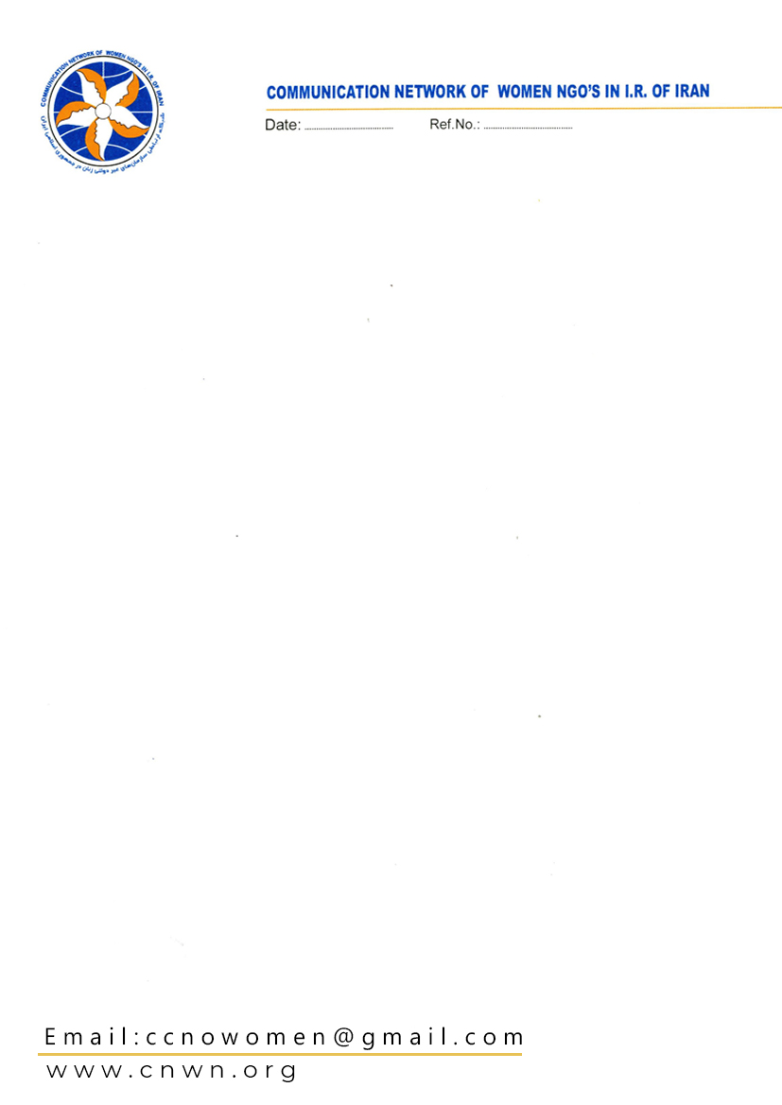

Intersectional Discrimination Against South Asian Migrant Women in Kuwait

Introduction
Kuwait’s large South Asian migrant workforce – overwhelmingly in low-wage construction, service, and domestic sectors – faces structural discrimination. 2025–2026 reforms (a new Foreigners’ Residence Law, mandatory exit permits, and new health insurance regulations) have tightened employer control and imposed new costs on expatriates. Employers retain passports, and labor inspections do not cover domestic workers (mostly South Asian women) housed in private homes. As a result, many migrant women face barriers to seeking medical care (e.g. no agency to seek help if withheld by employer, lack of documentation, high fees) even as hazardous work (extreme heat, long hours) exacerbates health needs. This report documents these intersecting vulnerabilities – nationality/ethnic (South Asian) plus gender – and shows how they violate CERD’s mandate.
Background and Legal Context
Kuwait’s economy relies on >70% foreign labor, largely from South/Southeast Asia. In early 2025 Kuwait enacted a new Foreigners’ Residence Law giving sponsors wide powers over workers. For example, Article 19 prohibits any migrant from changing jobs or sector without original employer approval. In mid-2025, Kuwait reintroduced the exit permit: as of 1 July 2025, all private-sector expatriates must get employer-approved permission before leaving the country. According to Human Rights Watch, this reinforces the restrictive kafala system, shifting greater control to employers and increasing the risk of exploitation. The Public Authority for Manpower (PAM) and press releases confirm the July 1 start date and online procedure.
Meanwhile, Kuwait’s health policy for non-citizens has tightened. In late 2025 the Ministry of Health issued implementing regulations (Decision 306/2025, Official Gazette 21 Dec 2025) for the 1999 “Law

on Health Insurance for Foreigners.” As of December 23, 2025, all expatriates must pay health insurance fees (linked to visa duration) as a condition for visa issuance/renewal. Fees were raised (e.g. annual fee

~KD100, and KD10 for certain low-wage categories). Only narrow exemptions exist (e.g. foreign women married to Kuwaitis, and up to three domestic workers per family). Thus, most migrant women must buy insurance and pay out-of-pocket healthcare fees.
Labor inspections remain minimal. Notably, Kuwait does not inspect private homes where female domestic workers live. A 2025 NGO briefing notes that inspection mandates exclude the homes of employers, meaning “migrant domestic workers…remain without effective protection”. In practice, domestic servants (mostly South Asian women) are “trapped in employer homes” and cannot independently seek medical care. Large-scale passport confiscation (not yet criminalized) further prevents workers from leaving to seek care abroad. In sum, Kuwait’s legal-institutional framework deeply restricts migrants’ freedom and reinforces ethnicized control by employers.
Barriers to Healthcare Access
Multiple sources document how these controls translate into healthcare discrimination for migrant women:
- Employer Control and Documentation: With employers controlling mobility and often holding passports, many workers (especially domestic women) cannot independently access clinics or hospitals. The Coalition on Labor Justice reports that “passport retention by employers was not criminalized… and the majority of workers had identity documents retained,” hindering any interactions with hospitals or legal aid. Over half of surveyed low-wage migrants in Kuwait reported being denied or discouraged from seeking care due to lack of employer-sanctioned ID.

- Costs and Fees: Expatriates must pay multiple fees at public health facilities. According to civil society research, non-citizens pay consultation fees (e.g. KD2–10) and must buy medications and tests, unlike citizens who often get free services. (In earlier reforms migrants faced new “dispensation” fees per prescription, though this exact measure dates to 2023.) Mandatory private insurance adds costs: as of late 2025, a migrant worker pays ~KD100/year (minimum) which employers are supposed to cover but often do not. Combined with low wages, these costs force many women to delay care or forgo treatment.
- Discrimination in Practice: Field studies reveal overt bias. A major research partnership (Vital Signs) found that many Gulf health workers consider migrant patients “not important,” and 25% of surveyed migrants in Kuwait reported experiencing racial discrimination (e.g. being denied treatment). Discrimination is particularly acute for South Asians. One Filipino respondent noted she felt “we are not important when we go to the hospital,” with 25% of those facing racial bias saying they were outright refused care. Similarly, a coalition of NGOs highlights that discriminatory policies (e.g. exclusive access to certain medicines or vaccines for citizens) and a lack of language support further impair migrant women’s ability to navigate the health system.
- Gendered Aspects: Female migrants – especially domestic workers – face unique hurdles. NGO testimony (2022) described a Bangladeshi maid in Kuwait physically abused and then denied medical attention until she collapsed; by then her condition was severe. While we lack a 2025 study duplicating that case, the same patterns persist. Domestic workers cannot travel to clinics without employers’ written permission, and their long hours mean they often only reach emergency care. Moreover, cultural or linguistic barriers (e.g. being less likely to be English literate) heighten isolation. The overall labor market exclusion of domestic help (excluded from labour law) means there is often no mechanism to report a sponsor’s denial of medical treatment.

- Occupational Health Risks: Extreme working conditions worsen health needs. HRW (June 2025) warns that Gulf migrants face a “health and safety catastrophe” from extreme heat and poor protections. Chronic dehydration and injuries are common, meaning migrants (often South Asian) have higher baseline health risks even before discrimination. Yet their limited access to preventive or follow-up care (given the barriers above) means treatable conditions can turn deadly. (HRW’s heat report cites kidney failure and chronic illness as now routine for overexposed migrants.)
In sum, South Asian migrant women in Kuwait confront a double bind: employers’ ex ante controls and ex post discrimination impede healthcare access, while high-cost, insurance-based healthcare leaves them financially strained. The Amesty International report on Kuwait notes that such exploitative dynamics reintroduced the worst elements of kafala, trapping workers “at risk”. This intersectional disadvantage – based on foreign origin and gender (many sectors barred to them) – meets the definition of prohibited discrimination under CERD’s Article 1 (race, nationality, descent).
Findings and CERD Relevance
- Race/National Origin Discrimination: Kuwait’s policies explicitly differentiate citizens versus foreigners. Migrant women (most from India, Bangladesh, Nepal, Philippines, Sri Lanka) are treated as a class. For instance, excluding non-nationals from subsidized care or imposing extra fees constitutes de facto nationality discrimination. Reports confirm “priority for citizens” in vaccines and medicines. Thus foreign workers form a protected class by national origin under CERD, suffering systemic exclusion from services.
- Gender Intersection: Female migrants carry additional burdens. Patriarchal family law in Kuwait denies them independent residency (they are visa-tied). Discriminatory nationality laws (treating foreign wives differently than foreign husbands) also intersect. Because most domestic workers are women, lack of workplace protections effectively singles out women for medical neglect. Although CERD does not explicitly cover sex, the principle of intersectionality (per CERD practice) means double discrimination (gender and race/nationality) can be raised.
- Violations of Right to Health: Under CERD Article 5(e)(iv), states must guarantee equal rights to public health. In practice, Kuwait’s health system is not “equal”: non-Kuwaitis pay higher fees and face barriers while citizens are exempt or subsidized. The World Health Organization notes that the right to health includes equitable access for all residents. By these standards, Kuwait’s policies (e.g. post-2025 health insurance scheme) effectively deny equal treatment. Combined with anecdotal evidence of refusals and delay, this is actionable discrimination.

- Legal/Policy Context: New laws and decrees in 2025 deepen discrimination. The restoration of the exit permit and new residency controls (Foreigners’ Law) have been criticized as violating international norms (e.g. freedom of movement in the CMW). These measures are motivated, in part, by rhetoric of protecting “Kuwaiti interests,” implicitly framing migrant workers (often South Asian) as outsiders. In short, the legal context codifies an employer-centric system that undermines migrants’ rights, aligning with CERD themes of controlling minority populations.
Recommendations
Based on the above, we urge the Committee to call on Kuwait to:
- Abolish restrictive mobility controls. Revoke the exit-permit requirement and related kafala elements. Migrant workers, especially women, should have freedom to change jobs and travel without arbitrary sponsor consent (CERD Art. 5).
- Ensure equal healthcare access. Amend health insurance regulations to guarantee free or affordable emergency care for all, eliminate any nationality-based fees, and provide interpretation/language support. In line with CERD guidance, Kuwait should subsidize essential health services for low-income migrants and monitor discrimination in healthcare delivery.
- Extend labor protections. Include all migrant domestic workers under the labor code (as per ILO C189) and permit labour inspections in private homes. Treat passport confiscation as a punishable offense. These steps would empower female workers to seek medical help without fear.
- Enforce non-discrimination. Launch training for healthcare providers on migrants’ rights, and establish a complaint mechanism for healthcare discrimination cases. Public authorities should collect data on service access by nationality and sex, to ensure compliance with CERD.
- Facilitate remedies. Kuwait should ratify the UN Migrant Workers’ Convention and streamline complaint processes for abuse. The Committee can recommend that Kuwait accept cases brought by NGOs on behalf of migrant women (e.g. facilitate confidential reporting).
Recent sources confirm that Kuwait’s intersectional discrimination against South Asian migrant women in healthcare is severe and systemic. A CERD shadow report can use this evidence to press for reforms ensuring “treatment of all foreigners is equal” (as Kuwait itself pledged in UPR) and that migrants’ race/national origin not bar them from essential health services.

Coalition on Labor Justice for Migrants in the Gulf. (2025, February). Kuwait UPR pre-session briefing. https://laborjusticegulfmigrants.org/wp-content/uploads/2025/03/Kuwait-UPR-Pre-Session_Briefing_Feb-2025.pdf
Human Rights Watch. (2025, June 1). Gulf states: Protect workers from extreme heat. https://www.hrw.org/news/2025/06/01/gulf-states-protect-workers-extreme-heat
Amnesty International. (2025). Kuwait report. https://www.amnesty.org/en/location/middle-east-and-north-africa/middle-east/kuwait/report-kuwait/
Khaleej Times. (2025, June 11). Kuwait require employer okay for foreign staff leave. https://www.khaleejtimes.com/world/gulf/kuwait-require-employer-okay-foreign-staff-leave
Human Rights Watch. (2025, June 15). Kuwait’s exit permit requirement puts migrant workers at risk. https://www.hrw.org/news/2025/06/15/kuwaits-exit-permit-requirement-puts-migrant-workers-at-risk
International Institute for Democracy and Electoral Assistance. (2025, June). Kuwait. https://www.idea.int/democracytracker/report/kuwait/june-2025
HFW. (2026, January 8). New decisions issued in Kuwait under the Ministry of Health. Lexology. https://www.lexology.com/library/detail.aspx?g=83fdb03a-42e7-4a03-87a3-d2f93dc45f9d
Coalition on Labor Justice for Migrants in the Gulf. (2025, February). Kuwait UPR pre-session briefing. https://laborjusticegulfmigrants.org/wp-content/uploads/2025/03/Kuwait-UPR-Pre-Session-Briefing_Feb-2025.pdf
FairSquare. (2022). New report links lack of healthcare access to migrant worker deaths in the Gulf. https://fairsq.org/new-report-links-lack-of-healthcare-access-to-migrant-worker-deaths-in-the-gulf/
Amnesty International. (2025). Kuwait report. https://www.amnesty.org/en/location/middle-east-and-north-africa/middle-east/kuwait/report-kuwait/
Coalition on Labor Justice for Migrants in the Gulf. (2025, February). Kuwait UPR pre-session briefing. https://laborjusticegulfmigrants.org/wp-content/uploads/2025/03/Kuwait-UPR-Pre-Session-Briefing_Feb-2025.pdf
FairSquare. (2022). New report links lack of healthcare access to migrant worker deaths in the Gulf. https://fairsq.org/new-report-links-lack-of-healthcare-access-to-migrant-worker-deaths-in-the-gulf/
Business & Human Rights Resource Centre. (2023, February 13). Kuwait: New govt. measure to charge non-citizens medication dispensation fee—latest “discriminatory obstacle” for migrant workers to access health care. https://www.business-humanrights.org/en/latest-news/kuwait-new-govt-measure-to-charge-non-citizens-medication-dispensation-fee-latest-discriminatory-obstacle-for-migrant-workers-to-access-health-care/
HFW. (2026, January 8). New decisions issued in Kuwait under the Ministry of Health. Lexology. https://www.lexology.com/library/detail.aspx?g=83fdb03a-42e7-4a03-87a3-d2f93dc45f9d
FairSquare. (2022). New report links lack of healthcare access to migrant worker deaths in the Gulf. https://fairsq.org/new-report-links-lack-of-healthcare-access-to-migrant-worker-deaths-in-the-gulf/
Business & Human Rights Resource Centre. (2023, February 13). Kuwait: New govt. measure to charge non-citizens medication dispensation fee—latest “discriminatory obstacle” for migrant workers to access health care. https://www.business-humanrights.org/en/latest-news/kuwait-new-govt-measure-to-charge-non-citizens-medication-dispensation-fee-latest-discriminatory-obstacle-for-migrant-workers-to-access-health-care/
FairSquare. (2022). New report links lack of healthcare access to migrant worker deaths in the Gulf. https://fairsq.org/new-report-links-lack-of-healthcare-access-to-migrant-worker-deaths-in-the-gulf/
Coalition on Labor Justice for Migrants in the Gulf. (2025, February). Kuwait UPR pre-session briefing. https://laborjusticegulfmigrants.org/wp-content/uploads/2025/03/Kuwait-UPR-Pre-Session-Briefing_Feb-2025.pdf
Human Rights Watch. (2025, June 1). Gulf states: Protect workers from extreme heat. https://www.hrw.org/news/2025/06/01/gulf-states-protect-workers-extreme-heat
Business & Human Rights Resource Centre. (2023, February 13). Kuwait: New govt. measure to charge non-citizens medication dispensation fee—latest “discriminatory obstacle” for migrant workers to access health care. https://www.business-humanrights.org/en/latest-news/kuwait-new-govt-measure-to-charge-non-citizens-medication-dispensation-fee-latest-discriminatory-obstacle-for-migrant-workers-to-access-health-care/
Americans for Democracy & Human Rights in Bahrain. (2025, July 29). Kuwaiti seeks to bolster human rights. https://www.adhrb.org/2025/07/kuwaiti-seeks-to-bolster-human-rights/

