Assessment of Economic and Social Rights Fulfilment in Zimbabwe
Submission from the Human Rights Measurement Initiative to the United Nations Committee on Economic, Social and Cultural Rights for the 78th Pre-Sessional Working Group, September 2025.
I. Reporting Organisation
1. The Human Rights Measurement Initiative (HRMI) measures the human rights performance of countries, including Zimbabwe. HRMI is an independent, not-for-profit NGO with its primary base of operations in New Zealand, and a second base in the United States of America at the University of Georgia’s Center for the Study of Global Issues (GLOBIS).
II. Assessment Methodology
2. HRMI uses the award-winning and peer-reviewed SERF Index methodology to measure the fulfilment of economic and social rights (ESRs).
3. This methodology uses bellwether indicator data from international organisations—such as the World Health Organization and UNICEF—and compares each country’s achievement to what other countries at the same level of income have achieved. In this way, HRMI measures progressive realisation of economic and social rights as defined in the International Covenant on Economic, Social and Cultural Rights (ICESCR). A country’s ‘income adjusted’ HRMI score is a measure of how well its government is converting its resources into good human rights outcomes for its people.
4. HRMI supplements these scores with qualitative information sourced from a secure, online survey of on-the-ground human rights experts, such as NGO researchers, journalists, and human rights advocates. For more details on HRMI’s methodology, please refer to the resources on our website.
5. All HRMI’s data are published annually on the Rights Tracker and are freely available for non-commercial use under a Creative Commons License. HRMI’s Rights Tracker is a certified Digital Public Good with the Digital Public Good Alliance.
III. Overview of Economic and Social Rights Fulfilment in Zimbabwe
6. HRMI’s most recent ESR scores for Zimbabwe measure its achievement as of 2022 and indicate a significant margin for improvement. They are shown in the graph below.
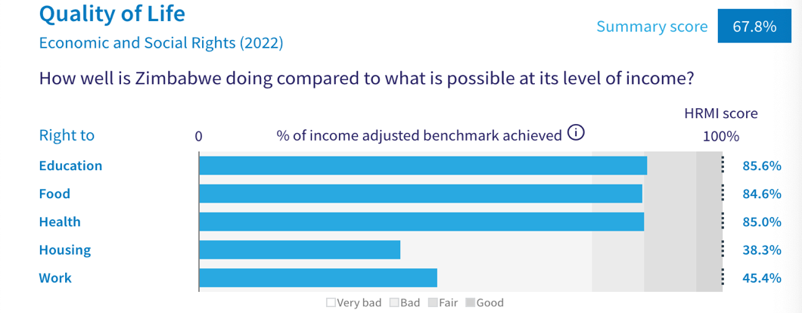
7. Zimbabwe’s scores for 2022 are as follows:
- Overall Quality of Life score = 67.8% (in the ‘very bad’ range)
- Right to education = 85.6% (‘fair’)
- Right to food = 84.6% (‘bad’)
- Right to health = 85.0% (‘fair’)
- Right to housing = 38.3% (‘very bad’)
- Right to work = 45.4% (‘very bad’)
8. Zimbabwe scores 67.8% on overall ‘Quality of Life’ when scored against the 'income adjusted' benchmark. This score takes into account Zimbabwe's resources and how well it is using them to make sure that the ‘Quality of Life’ rights of its people are fulfilled.
9. This score tells us that Zimbabwe is only doing 67.8% of what is possible to achieve with its existing level of resources for fulfilment of these rights. On an ‘income adjusted’ benchmark, any score less than 100% indicates that the country is underperforming and not meeting its current obligations under international human rights law. Therefore, our assessment is that Zimbabwe has a long way to go to meet its immediate economic and social rights obligations.
IV. Right to Education
10. HRMI defines the right to education in accordance with ICESCR Article 13 and CESCR General Comments 11 and 13. For low- and middle-income countries such as Zimbabwe, HRMI breaks down the right to education into three areas of measurement: primary school enrolment, secondary school enrolment, and quality of education. Our scores show significant challenges especially in secondary education, which lies in the ‘very bad’ range. However, the primary education score is in the ‘fair’ range, and quality of education score is in the ‘good’ range, adjusted for Zimbabwe’s income level.
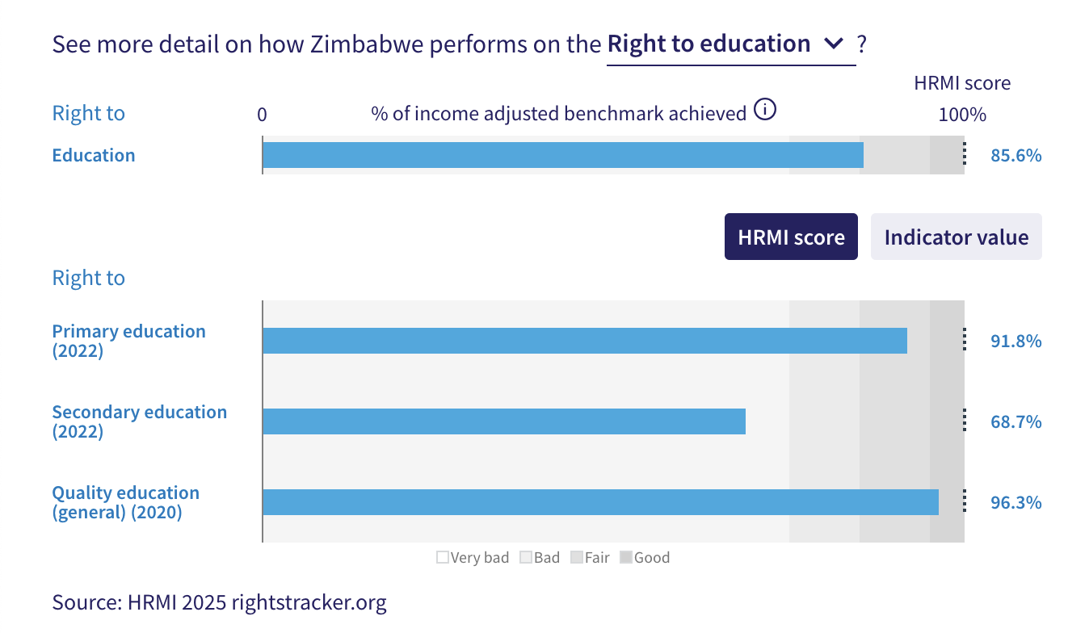
11. Zimbabwe’s score for primary school education (adjusted for income) has improved from 76.9% in 2017 to 91.8% in 2022. The score draws on indicator data from UNESCO showing that 94.4% of primary school-aged children in Zimbabwe were enrolled in school in 2022.
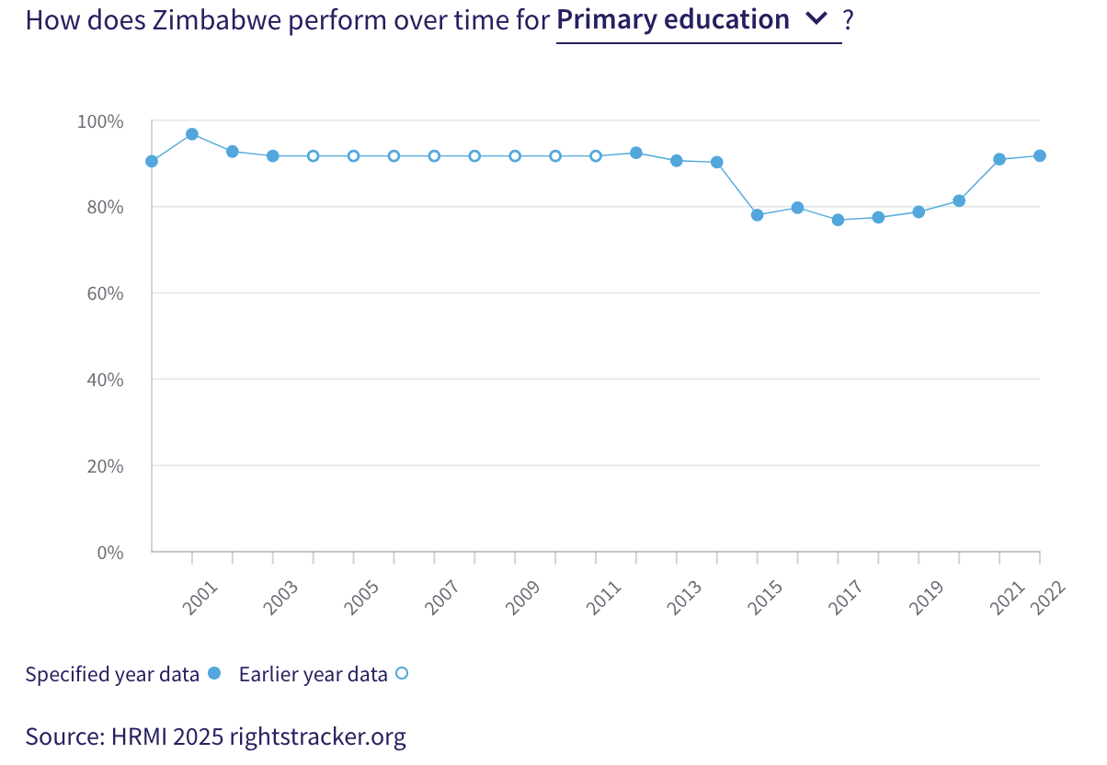
12. Our scores indicate that immediate action is needed to address the right to secondary education, with only 52.2% children being enrolled in upper secondary education in 2022. While this score has improved gradually from 51.5% in 2000 to 68.7% in 2022, it remains in the ‘very bad’ range.
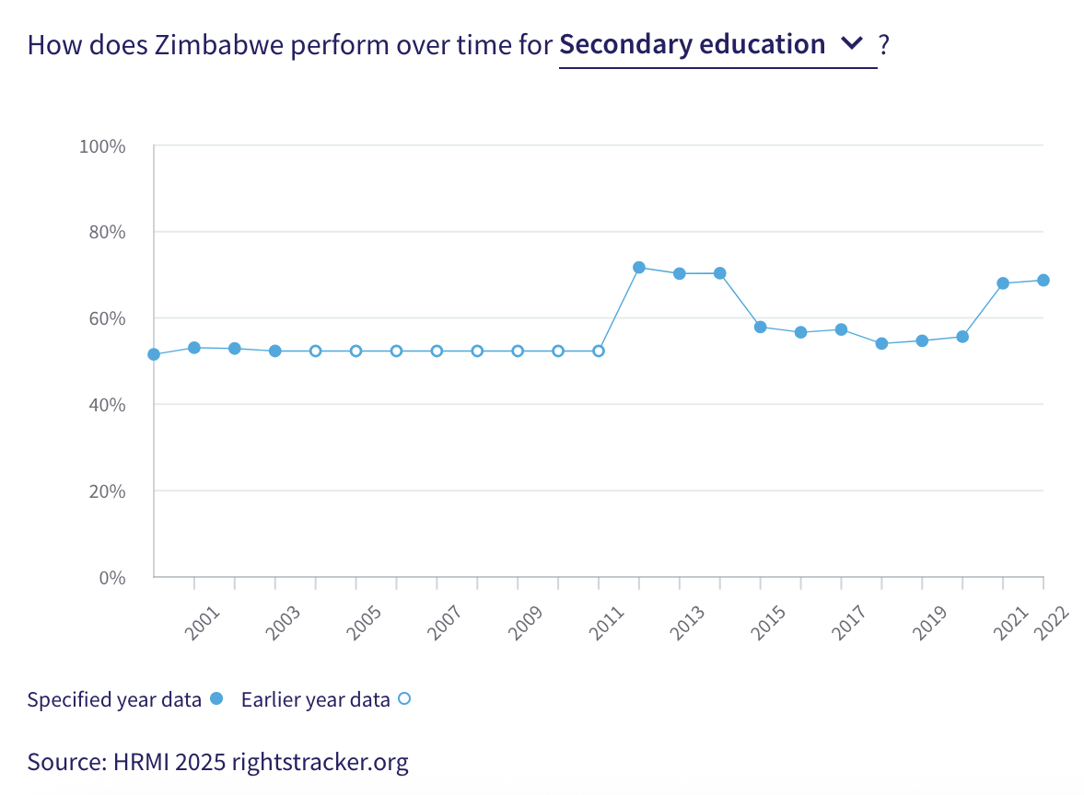
13. The quality of education score falls in the ‘good’ range. Zimbabwe is achieving 96.3% of what we calculate is possible in terms of quality education. However, there has been a slight decline on this score since 2010, when Zimbabwe achieved an income adjusted 100% for quality education. Among the countries in Sub-Saharan Africa, Zimbabwe ranks ninth on this right.

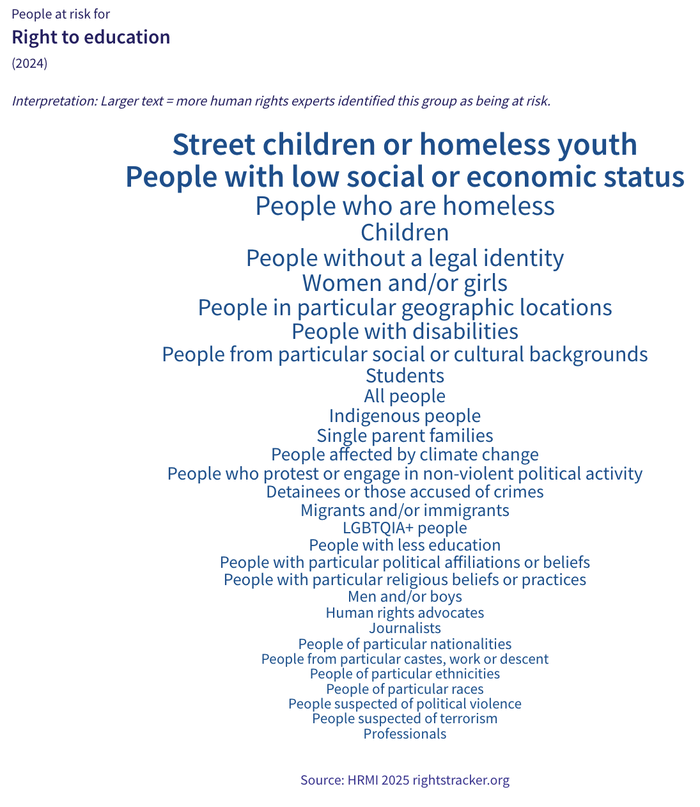
14. Many of our surveyed human rights experts identified ‘street children or homeless youth’ as being at extra risk of not enjoying their right to education. Other prominently identified groups were ‘people with low social or economic status’ and ‘people without a legal identity’. Experts said that “people with low economic status are unlikely to enjoy this right due to high fees for secondary and higher education.”
V. Right to Food
15. HRMI defines the right to food in accordance with ICESCR Article 11 and CESCR General Comment 12. For low- and middle-income countries such as Zimbabwe, HRMI uses a bellwether indicator of how many children in the country are growing well (are not stunted). Zimbabwe’s score for the right to food is 84.6%, which means that it is doing 84.6% of what is possible with its existing resources to ensure the right to food for its people. This score draws on the indicator data on child stunting rates from the UNICEF-WHO-World Bank: Joint child malnutrition (JME) database.
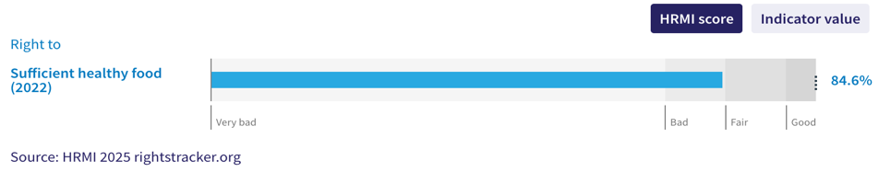
16. This score of 84.6% reflects gradual improvement from a HRMI score of 64.2% in 2000, indicating that Zimbabwe is making progress and is close to achieving a ‘fair’ HRMI score.
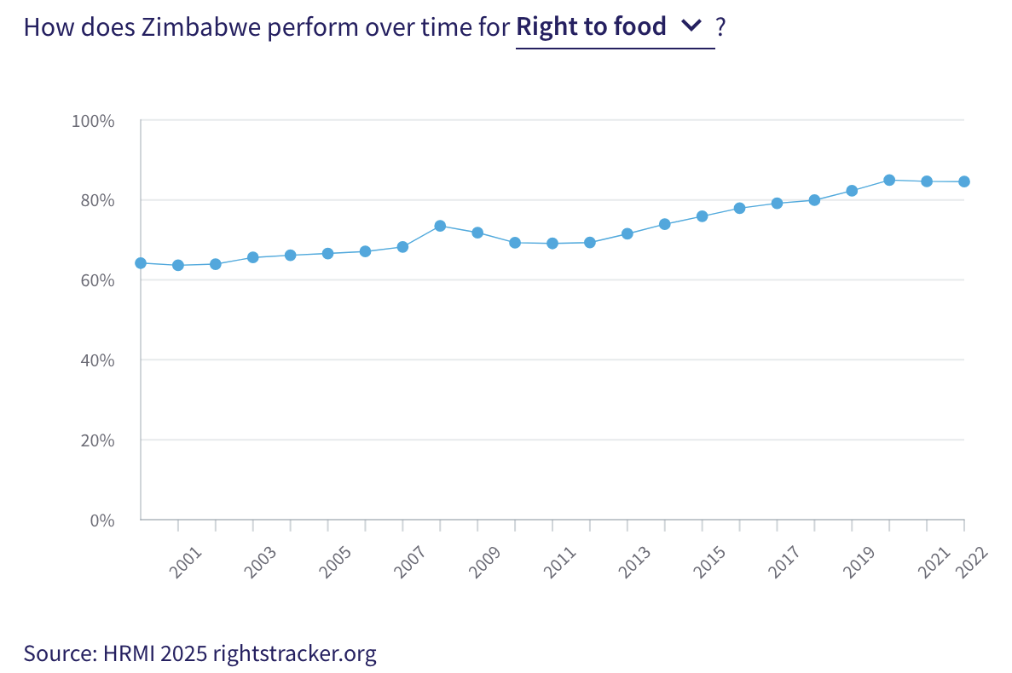
17. A large number of our surveyed human rights experts identified ‘street children or homeless youth’ as being at greater risk of having their right to food violated. Other prominently identified groups were ‘people with low social or economic status’ and ‘people with particular political affiliations and beliefs’. Experts noted that “people affected by climate-related disasters such as floods or droughts, especially in remote areas in Chimanimani, Chilonga, and Binga, as well as in Ntalale and Halisupi in Matabeleland South, are unlikely to have access to adequate food.”
VI. Right to Health
18. HRMI defines the right to health in accordance with ICESCR Article 12.1 and CESCR General Comment 14. In the case of low- and middle-income countries such as Zimbabwe, HRMI uses three indicators to measure the country’s achievement on the right to health, i.e., child health, adult health, and reproductive health. Zimbabwe’s score on the right to health is 85.0%, and it has been on a steady rise improving from a HRMI score of 50.1% in 2001.
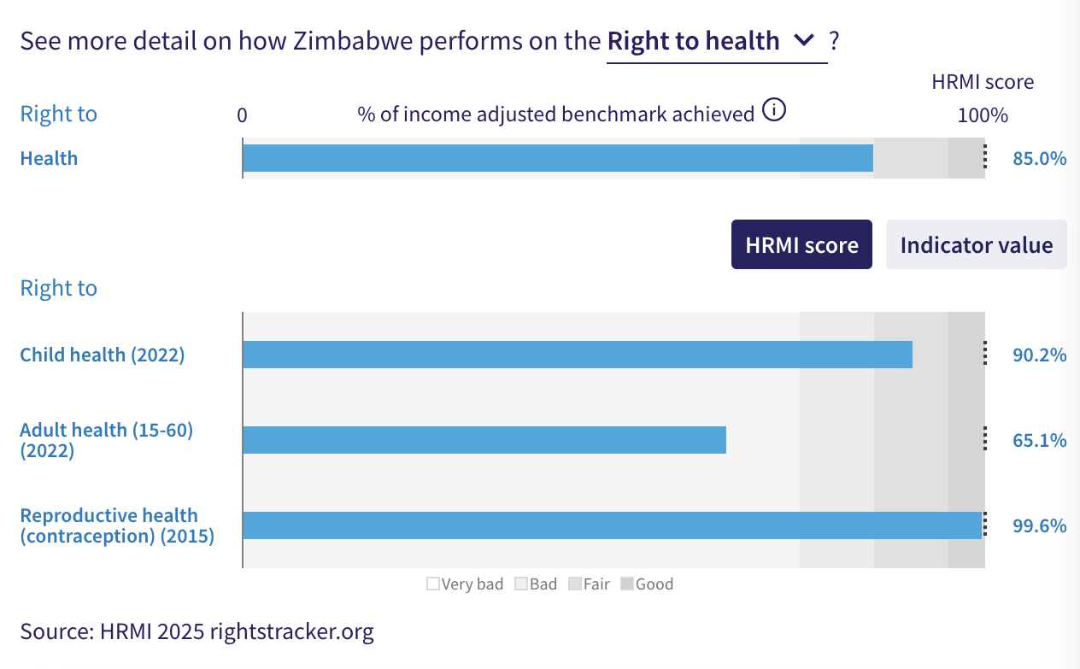
19. For low- and middle-income countries, HRMI measures the right to child health using the indicator of survival to age five. In Zimbabwe, child health has been improving gradually over the 2000-2022 period, reaching a peak HRMI score of 90.2% in 2022.
20. Adult health in Zimbabwe has seen major improvement over the past two decades, with the HRMI score improving rapidly from 3.3% in 2001 to 65.1% in 2022. While the upward trend indicates substantial progress in recent years, this score still falls in the ‘very bad’ range.
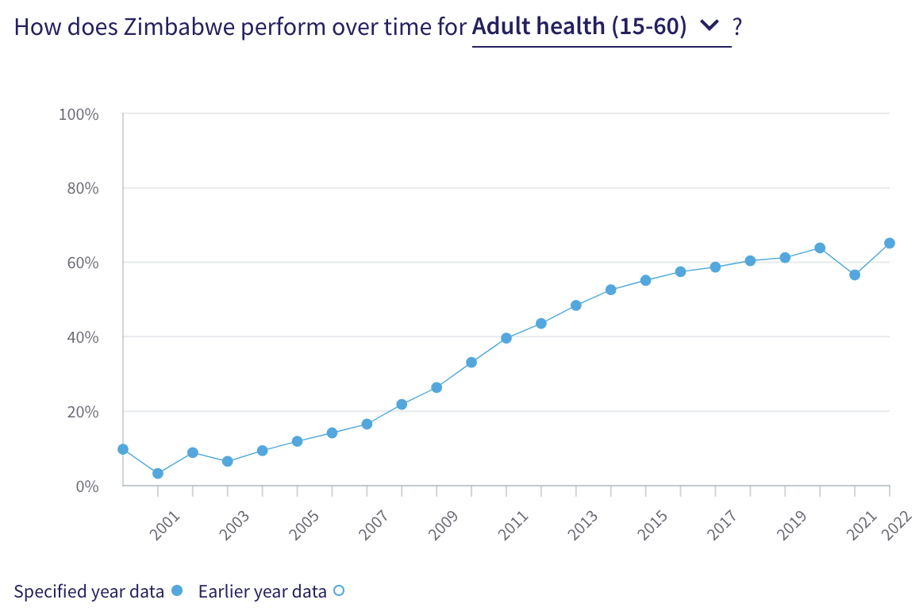
21. Human rights experts identified several groups as being at risk of not being able to enjoy their right to health, including ‘people who experience homelessness’, ‘people from low social or economic status’, ‘street children or homeless youth’, ‘women and girls’, and ‘people with disabilities’. Experts added that “people in rural areas, particularly Chiredzi, Binga, Mbire, Makwe, Mashaba, and Nyamapanda were at greater risk of not being able to enjoy their right to health due to underfunded and under-resourced hospital facilities.”
VII. Right to Housing
22. HRMI defines the right to housing in accordance with ICESCR Article 11.1 and CESCR General Comment 4. For low- and middle-income countries such as Zimbabwe, HRMI measures this right using the indicators of access to water on premises and access to basic sanitation (each household having its own improved toilet facilities). Zimbabwe has a HRMI score of 38.3% for the right to housing based on these indicators.
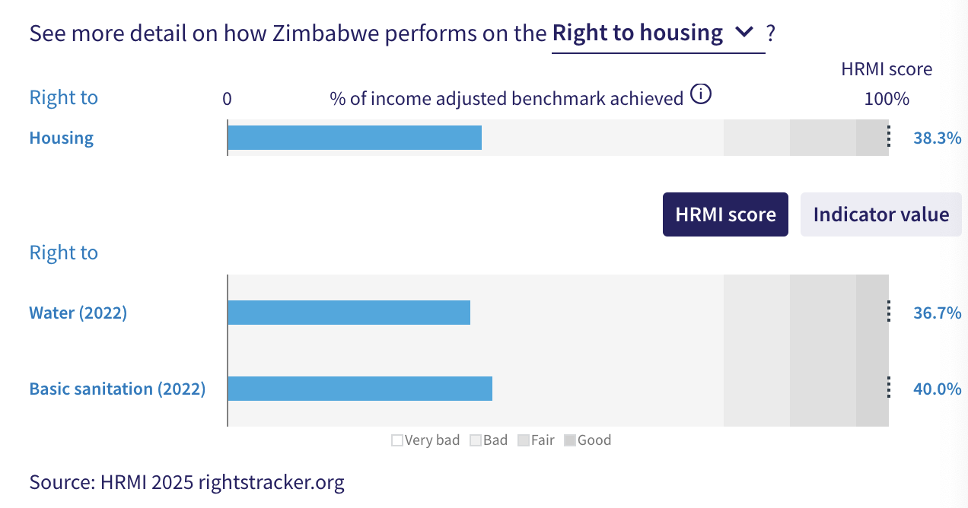
23. The WHO UNICEF Joint Monitoring Project (JMP) data show that only 30.1% of households in Zimbabwe have access to water on premises. Given what other countries with the same level of income have shown to be possible, Zimbabwe’s HRMI score for the right to water is 36.7%, which falls within the ‘very bad’ range. The HRMI score for this right has shown a significant decline since 2008, where it peaked at 63.6%.

24. Zimbabwe’s score for basic sanitation is deeply concerning, falling well within the ‘very bad’ range. While some improvement was observed between 2000 and 2008 — reaching a peak HRMI score of 65.7% — the score declined steeply thereafter, falling to 40% in 2022.
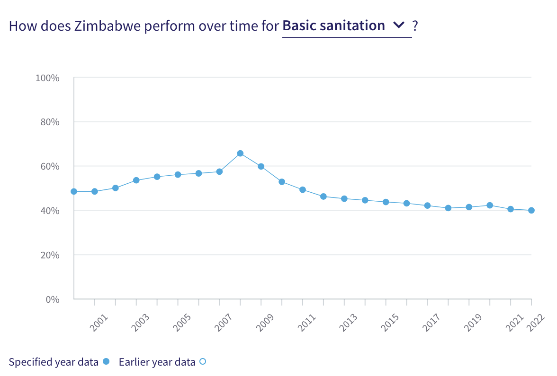
25. Other than ‘people experiencing homelessness’, experts most prominently identified ‘street children and homeless youth’ as being at extra risk of violation of this right. Other groups identified by a significant number of experts were ‘people with low social or economic status’, ‘people without a legal identity’, and ‘people affected by climate change’. Experts outlined factors such as high rental costs, unlawful demolitions of housing, and displacement by natural disasters and mining projects, as responsible for violations of the right to housing in Zimbabwe.
VIII. Right to Work
26. HRMI measures the right to work in accordance with ICESCR Articles 6 and 7. For low- and middle-income countries such as Zimbabwe, HRMI uses a subsistence income indicator to measure this right. According to World Bank PovcalNet data, only 35.5% of people in Zimbabwe were classified as ‘not absolutely poor’ in 2019. This translated to a HRMI score of 45.4% on this right.
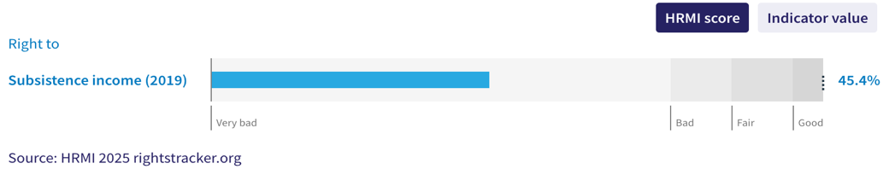
27. There has been a notable decline in the HRMI score for this right since 2011. A sharp drop was observed in 2017, with the score falling from 72.0% to 48.4%. The current score stands at 45.4%, indicating that significant progress is needed for Zimbabwe to surpass its 2017 peak and to fulfil its immediate obligations.
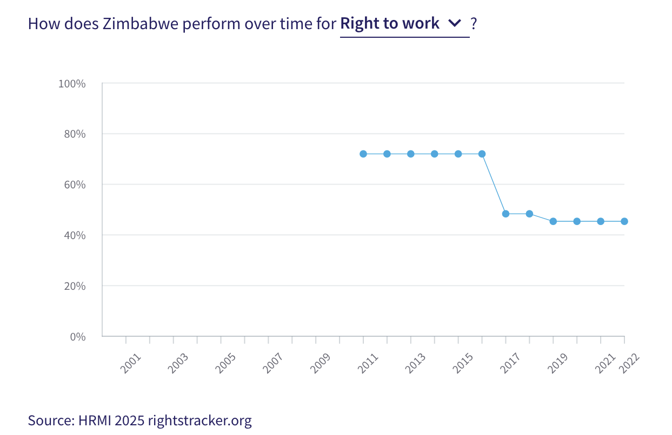
28. Human rights experts identified several groups as being at risk of having their right to work violated. The more commonly identified groups were ‘people with less education’ and ‘people without a legal identity’. Notably, 36% of the surveyed experts identified ‘all people’ to be at risk of being unable to enjoy their right to work, and added that this is due to “limited access to jobs and high unemployment”. Experts added that “people with disabilities lack accommodations in workplace, especially those who are visually challenged and those living in rural areas”.
IX. Vulnerable Groups
29. ‘People who experience homelessness’, ‘street children and homeless youth’, ‘people with low social or economic status’, ‘people with disabilities’, ‘people from particular geographic locations’, and ‘women and girls’ were the groups most commonly identified as being at risk.
30. People with ‘low social or economic status’ were consistently recognised as a group that was at greater risk of not having access to basic economic and social rights, with over 50% human rights experts placing them as an at-risk group across all rights.
31. ‘People with disabilities’ were also identified as being especially vulnerable. Human rights experts noted that people with disabilities have inadequate accessibility to attend schools, reach food distribution centres, and at workplace, especially in rural areas.
32. ‘People living in particular geographic locations’, especially in rural areas, were identified to be at risk of violations of their economic and social rights. Human rights experts noted that people in rural areas face difficulties in accessing educational resources, quality food and food distribution, healthcare facilities, adequate housing, and work.
X. Concluding Remarks
33. Zimbabwe’s best ‘income adjusted’ HRMI scores are for quality of education and for modern contraceptive use rate, while its most concerning scores are for the right to housing, including access to water and basic sanitation, as well as the right to work based on subsistence income.
34. Many vulnerable groups in Zimbabwe face compounded challenges in the enjoyment of their economic and social rights, with some groups consistently identified as being at heightened risk.
35. Our analysis is that Zimbabwe is not constrained by resources from making significant improvements in the areas with low scores. Rather, it has the income available, and can prioritise to put it to use to improve the economic and social rights of its people.
36. We recommend that the Committee assure the State Party concerned that it has the available resources to make significant improvements, especially in the areas of water, sanitation, subsistence income, and upper secondary school enrolment.
37. We also recommend the following questions:
- What steps will the State take to halt the decline in access to basic sanitation?
- What steps will the State take to lift access to at least subsistence income?
- What steps will the State take to improve access to water?
- What steps will the State take to improve upper secondary school enrolment rates?
38. HRMI respectfully submits its data and findings on the fulfilment of economic and social rights in Zimbabwe. We hope that this submission will serve as a useful resource to the Committee on Economic, Social and Cultural Rights for drafting specific and meaningful questions to Zimbabwe during the CESCR’s 78th Pre-Sessional Working Group.

Visit HRMI’s website to learn more about our mission and work: https://humanrightsmeasurement.org/.
This content represents the opinions of the Human Rights Measurement Initiative. It carries no endorsement of the University of Georgia.
See HRMI’s methodology for measuring economic and social rights: https://humanrightsmeasurement.org/methodology and https://rightstracker.org/page/methodology.
Ibid.
HRMI 2025 Rights Tracker: https://rightstracker.org/
See Human Rights Measurement Initiative (HRMI) Digital Public Good Certificate, https://app.digitalpublicgoods.net/a/11781 The Digital Public Goods Alliance is endorsed by the UN Secretary General’s “Roadmap for Digital Cooperation,” https://www.un.org/en/content/digital-cooperationroadmap/assets/pdf/Roadmap_for_Digital_Cooperation_EN.pdf.
HRMI 2025 Rights Tracker, https://rightstracker.org/country/ZWE
The labels on the country charts of good, fair, bad, and very bad are used to give a general indication of how to understand the scores. HRMI’s income adjusted Quality of Life scores can be broadly interpreted as showing the percentage of the country’s obligation it has met, compared to what the best performing countries have achieved at each income level. A country scoring below 75% with a label of “very bad” is failing to put in place the kinds of structures and policies that help people claim the right concerned, but the structures and policies in place most likely prevent many people from claiming their rights. See HRMI’s methodology for measuring human rights, https://rightstracker.org/page/methodology.
HRMI 2025 Rights Tracker, https://rightstracker.org/country/ZWE?tab=report-esr.
HRMI 2025 Rights Tracker, https://rightstracker.org/metric/education.
HRMI 2025 Rights Tracker, https://rightstracker.org/country/ZWE?tab=report-esr&qolFdScore=indicator
HRMI 2025 Rights Tracker, https://rightstracker.org/metric/tot-sec-enrol
HRMI 2025 Rights Tracker, https://rightstracker.org/metric/educqual
HRMI 2025 Rights Tracker, https://rightstracker.org/country/ZWE?tab=atrisk
HRMI 2025 Rights Tracker, https://rightstracker.org/country/ZWE?tab=report-esr&qolFdScore=hrmi
HRMI 2025 Rights Tracker, https://rightstracker.org/metric/not-stunted
HRMI 2025 Rights Tracker, https://rightstracker.org/country/ZWE?tab=report-esr&qolFdScore=hrmi
HRMI 2025 Rights Tracker, https://rightstracker.org/country/ZWE?tab=atrisk
HRMI 2025 Rights Tracker, https://rightstracker.org/country/ZWE?tab=report-esr&qolFdScore=hrmi
Ibid.
HRMI 2025 Rights Tracker, https://rightstracker.org/country/ZWE?tab=atrisk
HRMI 2025 Rights Tracker, https://rightstracker.org/country/ZWE?tab=report-esr&qolFdScore=hrmi
Ibid.
Ibid.
HRMI 2025 Rights Tracker, https://rightstracker.org/country/ZWE?tab=atrisk
HRMI 2025 Rights Tracker, https://rightstracker.org/country/ZWE?tab=report-esr&qolFdScore=hrmi
Ibid.
HRMI 2025 Rights Tracker, https://rightstracker.org/country/ZWE?tab=atrisk
Ibid.

