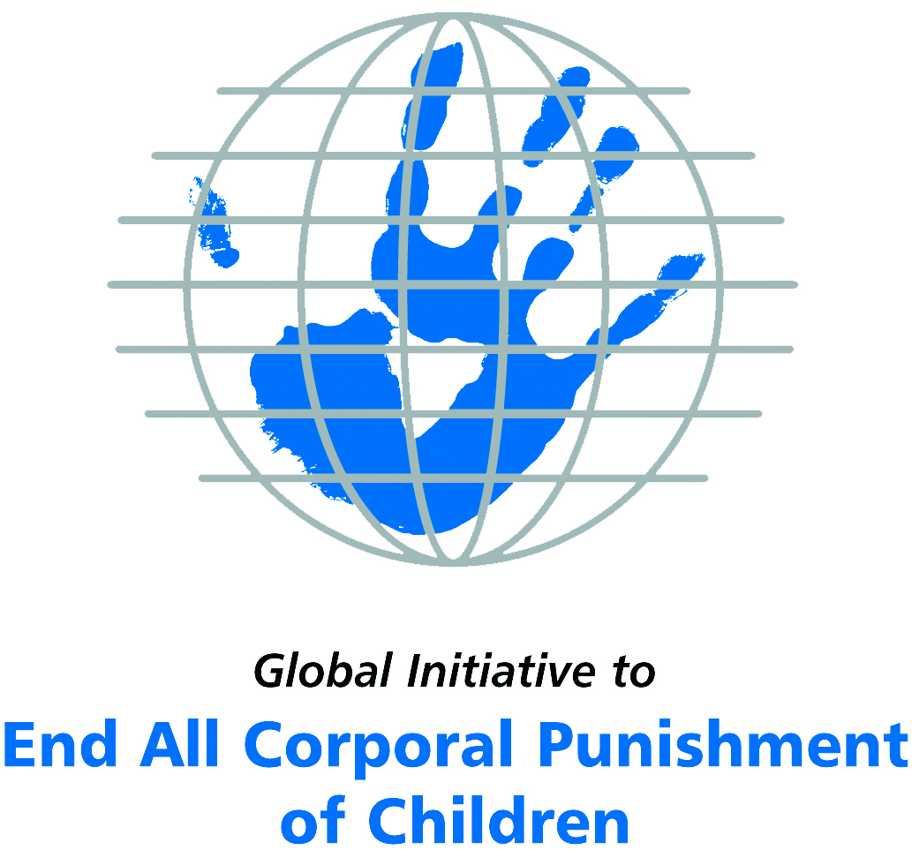
Briefing on Seychelles for the Committee on the Rights of Persons with Disabilities, 8th Pre-Sessional Working Group, September 2017
From the Global Initiative to End All Corporal Punishment
of Children, July 2017

(a) About the Global Initiative to End All Corporal Punishment of Children
1. The Global Initiative (www.endcorporalpunishment.org) promotes universal prohibition and elimination of corporal punishment in fulfilment of states’ obligations under the UN Convention on the Rights of the Child and other international treaties. Our aims are supported by UNICEF, UNESCO, human rights institutions and international and national NGOs. Since 2002, the Global Initiative has regularly briefed the Committee on the Rights of the Child on this issue, and since 2004 has similarly briefed the Committee Against Torture, the Committee on the Elimination of Discrimination Against Women, the Committee on Economic, Social and Cultural Rights, the Human Rights Committee and the Human Rights Council; we have briefed the Committee on the Rights of Persons with Disabilities since the beginning of its work.

(b) Summary
2. Corporal punishment of children in Seychelles is unlawful as a sentence for a crime, but it is not yet prohibited in the home, in alternative care and day care settings, in schools and in penal institutions, in violation of the fundamental right of all children to protection from corporal punishment and other cruel or degrading forms of punishment.
3. With reference to articles 7, 15, 16 and 17 of the Convention on the Rights of Persons with Disabilities, and in light of the particular vulnerability of children with disabilities to corporal punishment by adults, the jurisprudence of the UN treaty bodies, the emphasis on eradicating this form of violence given by the UN Secretary General’s Study on Violence against Children and the importance of the issue to achieving target 16.2 on ending violence against children in the 2030 Sustainable Development Goals, we hope the Committee on the Rights of Persons with Disabilities will:
- include the issue of corporal punishment in its List of Issues for Seychelles, in particular asking: “what steps have been taken to ensure that domestic legislation in Seychelles fully protects all children from violent punishment, explicitly prohibits its use in all settings and repeals the right to inflict “reasonable chastisement”?”;
- recommend to the Government of Seychelles, in the Committee’s concluding observations on the initial report, that “legislation prohibiting corporal punishment of children in all settings and repealing the right to inflict “reasonable chastisement” is drafted and enacted as a matter of priority and that measures are put in place to ensure the law is properly implemented”.

(c) Detailed briefing
The right of children with disabilities not to be subjected to corporal punishment
4. The Convention on the Rights of Persons with Disabilities confirms that children with disabilities should enjoy all human rights and fundamental freedoms on an equal basis with other children (art. 7). The Convention also states that all persons have the rights to freedom from torture or cruel, inhuman or degrading treatment or punishment (art. 15), to freedom from exploitation, violence and abuse within and outside the home (art. 16) and to respect for their physical and mental integrity (art. 17). The jurisprudence of treaty monitoring bodies, led by the Committee on the Rights of the Child monitoring the Convention on the Rights of the Child, is clear that these rights put an obligation on states parties to prohibit and eliminate all corporal punishment of children, including within the family. However, Seychelles’ state report does not address this obligation and does not mention corporal punishment.
5. As confirmed in the UN Secretary General’s Study on Violence against Children, children with disabilities are particularly vulnerable to violence, including corporal punishment, and corporal punishment is a significant cause of impairment among children. Yet the obligation to prohibit corporal punishment is frequently ignored or evaded by governments. The near universal acceptance of violence in childrearing together with deeply held views that parents and other adults have a “right” to physically punish children can challenge efforts to achieve prohibition. It also means that corporal punishment – at least to some degree – is not readily perceived as violence in the same way as, for example, sexual and other socially unacceptable forms of violence.
6. The newly adopted Sustainable Development Goals under the 2030 Agenda include target 16.2 on ending all forms of violence against children. Violent punishment is the most common form of violence against children: ending it through the adoption and implementation of legislation prohibiting it in all settings including the home is critical.

The legality of corporal punishment of children with disabilities in Seychelles
7. In Seychelles, corporal punishment of children is unlawful as a sentence for a crime, but children with disabilities may lawfully be subjected to physical punishment in all other settings: the home, alternative care, day care, schools and penal institutions.
8. Corporal punishment is lawful in the home under the common law right to inflict “reasonable chastisement” on children. Article 70 of the Children Act 1982 prohibits cruelty to children, but states: “(7) Nothing in this section affects the right of a parent, guardian, teacher or other person having the lawful control or charge of a child to administer proper punishment to him if that punishment does not contravene subsection (1).” Subsection (1) prohibits assault and ill-treatment which causes or is likely to cause “unnecessary suffering, moral danger or injury to health” but does not prohibit all corporal punishment in childrearing. Provisions against violence and abuse in the Family Violence (Protection of Victims) Act 2000, the Penal Code 1955 and the Constitution 1993 are not interpreted as prohibiting corporal punishment in childrearing.
9. Corporal punishment is lawful in alternative care settings under the right “to administer proper punishment” in the Children Act 1982 (art. 70). Establishments provided and maintained under the Children Act include children’s homes for initial or temporary care of children under 16 and children’s homes for children who are orphaned or abandoned (art. 100). The Act provides for the Minister to make regulations for “the conduct of residential and other establishments and for securing the welfare of persons residing or accommodated in them, including … (iii) specifying the occasions on which corporal punishment may be given to children in those establishments and the persons who may give it” (art. 107). We do not know if such regulations have been adopted. The Children (Adoption) Rules and the Children Act (Foster Care) Regulations do not provide for corporal punishment, but they do not explicitly prohibit it.
10. Corporal punishment is lawful in early childhood care and in day care for older children, including for children with disabilities under the right “to administer proper punishment” in the Children Act 1982 (art. 70). Establishments provided and maintained under the Children Act include day care for children under 4 (art. 100). The Act provides for the Minister to make regulations on corporal punishment (art. 107). We do not know if such regulations have been adopted.
11. Corporal punishment is lawful in schools. The Government has stated that corporal punishment is prohibited in schools in the Children Act 1982. However, the Act does not explicitly prohibit corporal punishment; rather it provides for the right of teachers “to administer proper punishment” (art. 70). The Education (Amended) Bill 2015 includes prohibition of corporal punishment. The Bill had been expected to be enacted in 2015; in reporting to the Universal Periodic Review in 2016, the Government confirmed that the amendment of the Education Act has not yet been achieved but that the revised Act would include prohibition of corporal punishment. We have yet to establish whether or not the Bill repeals the right of teachers to “administer proper punishment”.
12. Corporal punishment is lawful as a disciplinary measure in penal institutions under the right “to administer proper punishment” in the Children Act 1982 (art. 70). Establishments provided and maintained under the Children Act include juvenile centres (residential training establishments, attendance centres, residential re-orientation centres and youth residential treatment centres) (art. 100). Article 107 of the Children Act authorises the use of corporal punishment under certain regulatory conditions (see above). The Children Act (Juvenile Court) Rules do not provide for corporal punishment, but they do not prohibit it. There is no prohibition of corporal punishment in the Prisons Act 1991.
13. Corporal punishment is unlawful as a sentence for crime. It is not among the permitted sanctions in the Children Act 1982 (art. 95) or the Penal Code 1955 (art. 25), though it is not explicitly prohibited. The Constitution 1993 prohibits torture and cruel, inhuman or degrading treatment or punishment (art. 16).
14. Opportunities for achieving prohibition of corporal punishment. In 2016, the Government accepted recommendations made during the Universal Periodic Review of the Seychelles to prohibit corporal punishment of children, including through repealing the right “to administer proper punishment” in the Children Act 1982. In accepting the recommendations, the Government stated that the rights of the child is the highest priority in the national agenda and it is in this light that the recommendations on corporal punishment were accepted. The Civil Code and the Penal Code are being reviewed, and the Ministry of Social Affairs has drafted a Domestic Violence Bill and amendments to the Children Act 1982 which are pending in the Attorney General’s office.

Recommendations by human rights treaty monitoring bodies and during the UPR
15. In examining the initial report of the Seychelles in 2002, the Committee on the Rights of the Child was led to believe that corporal punishment was prohibited: the Committee went on to express concern at the widespread use of corporal punishment and recommend proper implementation of the prohibition. Following re-examination of the state party in 2012, the Committee noted the absence of explicit prohibition of corporal punishment in law and the existence of the right to inflict “reasonable chastisement” on children, and recommended that corporal punishment be prohibited in law in the home and other settings.
16. At the first cycle Universal Periodic Review in 2011, the recommendation to establish a de jure moratorium on the use of corporal punishment was made to the Seychelles. The Government appeared to have accepted the recommendation in its general acceptance of recommendations concerning protection of children. In 2016, the Government accepted recommendations made during the Universal Periodic Review of the Seychelles to prohibit corporal punishment of children, including through repealing the right “to administer proper punishment” in the Children Act 1982.

Briefing prepared by the Global Initiative to End All Corporal Punishment of Children
www.endcorporalpunishment.org; info@endcorporalpunishment.org

Pinheiro, P. S. (2006), World Report on Violence against Children, Geneva: United Nations. See also Krug E. G. et al (eds) (2002), World Report on Violence and Health, Geneva: World Health Organisation
2 March 2011, A/HRC/WG.6/11/SYC/1, National report to the UPR, para. 59
National Council for Children, correspondence with the Global Initiative, 1 September 2015; see also 16 December 2015, A/HRC/WG.6/24/SYC/1, National report to the UPR, para. 30; 8 April 2016, A/HRC/32/13, Report of the working group, paras. 29 and 82
9 June 2016, A/HRC/32/13/Add.1, Report of the working group: Addendum
8 April 2016, A/HRC/32/13, Report of the working group, paras. 120(42) and 120(43); 9 June 2016, A/HRC/32/13/Add.1, Report of the working group: Addendum
8 April 2016, A/HRC/32/13, Report of the working group, paras. 29, 64, 82, 108, 120(42) and 120(43)
National Council for Children, correspondence with the Global Initiative, 1 September 2015; see also 1 September 2015; see also 16 December 2015, A/HRC/WG.6/24/SYC/1, National report to the UPR, paras. 41 and 158
30 October 2002, CRC/C/15/Add.189, Concluding observations on initial report, paras. 5, 32 and 33
23 January 2012, CRC/C/SYC/CO/2-4, Concluding observations on second to fourth report, paras. 42 and 43
11 July 2011, A/HRC/18/7, Report of the working group, para. 100(49)
18 November 2011, A/HRC/18/2, Report of the Human Rights Council on its eighteenth session, para. 339
8 April 2016, A/HRC/32/13, Report of the working group, paras. 120(42) and 120(43); 9 June 2016, A/HRC/32/13/Add.1, Report of the working group: Addendum

