MAU Written Inputs to LOIPR: Violence against Child and Digital Rights

3. Please provide information about measures taken:
(a) To explicitly prohibit in law all forms of discrimination, and to prevent and address discrimination faced in particular by children belonging to minority and Indigenous groups, including Orang Asli children, asylum-seeking, refugee, migrant, unaccompanied and separated, and stateless children, children with disabilities, children living in poverty and lesbian, gay, bisexual, transgender and intersex children;
It must be reiterated that most marginalised children mentioned in paragraph 3(a) of the LOI are children out of formal education. Apart from revoking Malaysia’s reservations to the UNCRC, another area that must be investigated is the State’s inability and lack of political will to implement Article 12 of the UNCRC across all child-related laws.
There is a systemic erasure of marginalised and discriminated groups, including Indigenous children, asylum-seeking and refugee children, children living in migration and stateless children. These groups of children are excluded from the national education system, and as a result, are absent from any official documentation.
Currently, most opportunities afforded to children are limited to those who “exist on paper”. Though the Ministry of Education, the Women, Children and Community Development Ministry, and town councils including Malaysia’s NHRI, SUHAKAM, each have their respective children representative councils, the standards of child participation they adopt and practice have yet to be meaningfully evaluated. We remain far from fully embracing the Lundy Model of Participation, as many of these councils include only one (1) token representative from a minority group.
Therefore, if marginalised children are severely underrepresented even in supposedly ‘child-friendly’ spaces, their concerns and perspectives are even less likely to reach formal decision-making spaces such as Parliament and policy-making working groups at the ministerial and agency levels. As a result, laws will continue to fail marginalised children as their lived realities will never reach those responsible for shaping those laws.
Malaysia only has one Act that specifically mentions child participation, namely Section 4 of the Human Rights Commissions of Malaysia (Amendment) Act 2024. Paragraph (ea) of Section 4 provides that:

in respect of children;
(i) to receive any communication from children either directly or through any person or authority relating to the children's complaints and needs and to act upon such complaints and needs; and
(ii) to establish and adopt mechanisms and procedures in promoting the participation of children in matters that concern them.
Considering that SUHAKAM is empowered by law to ensure that Article 12 is realised, we seek to understand the following critical considerations:
- Whether the State has allocated adequate resources for SUHAKAM to implement Article 12
- Whether the State has allocated adequate resources for SUHAKAM’s staff and commissioners to be trained on child participation and child participatory approaches to implement Article 12
- Whether there has been any monitoring, evaluation and learning (MEL) of previous child participation initiatives organised by the ministries and related agencies. If no, what form of MEL will be administered to establish a baseline of Malaysia’s Article 12 implementation (or lack thereof)
Discrimination against children can slowly but surely be prohibited only if and when children are at the table during these decision-,making processes
6. Please provide information about the measures taken:
(a) To prevent and address all forms of violence against children in all settings, including the implementation of relevant guidelines developed for hospitals and schools; the strengthening and expansion of Child Protection Teams, the social services workforce and support services, including the enactment of the bill on the social work profession and the operation of helplines for children; the enforcement of relevant laws, such as the Evidence of Child Witness Act 2007 (Act 676) and the Sexual Offences against Children Act 2017 (Act 792), as both amended up to 2024; and the operation of the special courts for sexual offences against children since 2017;
In response to para 6(a) of the LOI, we are wary of the Government’s lack of awareness and sensitivity on gender-based violence against LGBTI children, commonly perpetrated by adults in schools themselves. The Ministry of Education of Malaysia has issued guidelines to address bullying in schools which apply to all schools registered under the Ministry of Education. Within the document, one particular section titled ‘Causes of Bullying’, lists various contributing factors, one of which being “gender confusion” (kecelaruan jantina in Bahasa Melayu). As the list does not provide any further elaboration, one can assume two interpretations:
- Interpretation 1 - A child who bullies others is most likely experiencing confusion about their gender identity
- Interpretation 2 - A child who is exploring their gender, whether through expression or identity, is framed as a primary cause of bullying.
This overly simplified and prejudiced assumption reflects the Government’s lack of understanding of SOGIESC exploration and realisation amongst children. Though statistics do show that LGBTI children are more vulnerable to bullying in school, listing gender as a causal factor reinforces the stereotype that children who present themselves beyond the gender binary are predestined to becoming victims of bullying.
In addition, the document does not provide adequate support to teachers and school administrators who are the main implementers of the guideline. Such a limited list neither encourages nor trains implementers to respond to bullying cases through a child-rights-based and survivor-centred approach. Cases from communities have shown enough that the current system enables teachers to punish children who are assumed to be LGBTI.
It must be emphasised that this is a case analysis of one specific guideline published by the Government involving children. A broader, unresolved challenge that is yet to be addressed is the lack of consultation and open dialogue in the development of such guidelines, which undermines the best interests of the children affected.
Recommendations
- Revamp the guidelines to addressing bullying and sexual offences in schools by consulting children from diverse groups, CSOs who work with marginalised groups, and other lived reality experts
- Strengthen the guidelines and other relevant policies involving children by institutionalising Article 12 of the UNCRC to safeguard students’ right to meaningfully participate in decision-making in schools
8. Please provide information about measures taken:
(c)To ensure the provision for children of mental health services that are of high quality, confidential and accessible without parental consent; to provide appropriate sexual and reproductive health services and support, including to pregnant adolescents and adolescent mothers; and to provide education on such topics in primary and secondary schools, including information for and about lesbian, gay, bisexual, transgender and intersex children;
From consultations carried out with stateless children in Kota Kinabalu, Sabah in December 2024, we learnt that they do not have access to mental health resources and psychosocial support, unless they are provided by their alternative schools. Their mental health is significantly impacted by their lack of status and documentation as they have to assume adult roles as early as nine years old. Most of them survive in unlivable conditions without any access to safe places for play and recreation. Their only and nearest playground is the Internet through a shared device at home.
In an interview on access to CSE and mental health for stateless children in Sabah, a Sabahan community partner shared with us that one of the largest hospitals in Kota Kinabalu has posted a sign at its entrance stating that any patients without documentation will be reported to immigration. This is a gross violation to persons’ right to access affordable healthcare as it creates fear and pushes people away from seeking the treatment they require. The Ministry of Health may assert that their laws and policies are non-discriminatory but we must unravel the systemic discrimination and human rights violations occurring within public hospital grounds.
In correlation to this, many adolescents do not feel safe going to the hospital or clinic in their neighbourhoods as they are concerned about their privacy being violated when it comes to seeking information about their SRHR. From conversations with young people, they report feeling safest with trusted teachers or friends. In certain special circumstances, they may also turn to community NGOs that have built a rapport with them and disseminated information about relevant medical concerns relating to them.
Regarding pregnant adolescents, there is still no law or policy that guarantees their right to attend schools. During several consultations in Pengerang, Johor, Malaysia in 2025, public school teachers shared with us that their standard of procedure involving pregnant students is to ask them to leave school for a year, and only return if and when they are ready after giving birth. This is justified as a way to ‘preserve the student’s dignity’ and protect them from bullying. However, this gendered response mirrors the protectionist approach often taken by the Education Ministry in the name of ‘child protection’. The real harm, however, is that it strips adolescents of their agency to make decisions for themselves. Meanwhile, male students involved very rarely face any social consequences, in stark contrast to the visibly pregnant female students.
Recommendations
- To aggressively amplify national campaigns on children and adolescents’ mental and sexual and reproductive health
- To provide mobile clinics for service providers on mental health and SRHR for children and adolescents from rural and marginalised communities
- To institutionalise rights-based approaches in healthcare settings
10. Please provide information on: (c) The measures taken to effectively prevent and address bullying in schools and in the digital environment;
In collaboration with UNICEF Malaysia, MAU engaged over 25 children and young persons as advisors to consult them on young people and their understanding of sexual extortion in digital environments. One important learning from the youth advisors is that there is a correlation between bullying in schools and sexual extortion happening online. Many offenders are young people themselves who use social media platforms such as Instagram, WhatsApp, Telegram and TikTok. They shared with us that a victim of sextortion would most likely be bullied in school once the material has been circulated to schoolmates.
However, the current guidelines, as mentioned above, fail to respond to such an intricate situation as there is still a strong culture of victim blaming and sexual shaming within schools. Even teachers and school administrators participate in bullying by reprimanding victims openly without care and compassion.
Bullying in the form of sexual harassment and sexual extortion is very common amongst school-going adolescents as they spend more time in school than at home. Consent education and CSE are absent in school, making children more vulnerable to unhealthy relationships and risky online behaviours.
Additional Recommendations on Children’s Best Interest in Digital Environments
In collaboration with UNICEF Malaysia and Innocenti, MAU consulted stateless and urban poor adolescents in Kota Kinabalu, Sabah and Johor Bahru, Johor on their understanding of the principle of best interest.
Below are findings from the consultations in March and May 2025:-
“What do you like or dislike about the Internet?”  To them, their ‘best interest’ includes what they like and don’t like about their digital lives | “I use TikTok to watch movies.” Nathan, Secondary school goer, Johor Bahru  “I like Youtube because the content is more educational as compared to TikTok” Ariana, Lower secondary school goer, Penampang  “I don’t like people using sexy stickers on Telegram.” Jojo, Primary school goer, Penampang  The young people were clear on what they liked and disliked about the Internet. In our conversations with them, the concept of best interest showed up as what gave them joy and how the Internet adds value to their lives.  This reminds us about the concept of evolving capacities prescribed under the UNCRC. It tells us that children are in fact capable of forming their own opinions as they develop into older teenagers. We learned that these young people form their likes and dislikes through how the Internet makes them feel; whether such platforms make them feel uncomfortable, whether online games make them feel excited, and many other instances.
“In an ideal digital environment, what do you want or don’t want?”  To them, their ‘best interest’ includes what they want and don’t want in their digital lives | What the young people saw as their best interest was also informed about what they want in an ideal digital environment.  “I want my digital space to have sign language interpretation made accessible for me and my Deaf friends.”  There may be room to distinguish their wants and needs, but more often than not, many children want reasonable things such as accessibility and inclusion. These are the bare minimum accommodations that ought to be fulfilled by the Tech Industry, including regulators, as having meaningful access to digital technologies can support children to realise the full range of their civil, political, cultural, economic and social rights.
What do you use the Internet for?”  To them, a digital environment that is in their best interest is one that can bring benefits to their lives | “I use Google Translate to help translate Bahasa Melayu to Tamil so that I can do my homework.” Ana, Johor Bahru  “I like Youtube because I can learn how to do gardening.” Ardin, Penampang  One of the teachers we engaged with from the stateless community in Kota Kinabalu, Sabah shared that gadgets are the children’s lives, but not in a bad way.  We were curious to know how the children spent their evening; would they go to a playground? Would they hang out with their friends at the park? The teacher told us then that the neighbourhoods that they live in do not have access to public parks and playgrounds. Children resort to their phones and gadgets to be entertained, have a social life online, and have opportunities to learn new things from the world wide web.  This suggests that it is in children’s best interests, especially those from systemically marginalised communities, to have access to a digital environment, which may be their only means of exploring the world.  Note: Names are pseudonyms

Who is accountable?
An important point emerged during the discussion about who is responsible for ensuring that the digital environment serves children’s best interests. While several of the young people consulted called for accountability from adults, such as those in the Tech Sector, policymakers, and parents, most of them ultimately saw themselves as the ones responsible first, before anyone else.

What does this tell us?

The double edged sword:
1. Young people recognise their role in co-creating a better and safer digital environment.
2. Young people also take it up on themselves to be responsible if anything goes wrong.
Why is this more harmful than inspirational?

This tells us that young people may internalise blame if they engage in online behaviours that might harm them, especially if it is stigmatising and looked down upon, such as sexting, self-generating sexual content, and other such examples. This burden may discourage young people from speaking up, seeking help and eventually, engaging in social support services for their own safety.

This also tells us that they may not know that adults hold the primary responsibility for protecting their rights, including ensuring that their digital lives are safe, age-appropriate, supportive of social skills development, and connected to the resources they need for their overall wellbeing.

There is a huge gap in awareness about the fact that those in positions of power, such as the Tech Sector, policymakers, and the Government, are the ones responsible for ensuring that the digital environment serves the best interest of the child. For many young people from systematically underserved, marginalised, and discriminated-against communities, the decisions made by these large institutions feel distant and disconnected from their everyday realities.

Changes that Young People Want
Tech Industry  - Affordable internet and digital gadgets  - More language interpretation  - Make sign language interpretations available | Law and policymakers  - Protection from financial scams and data theft  - Make sure that there are regulations to protect them from online predators
Community  - For family members to have conversations on their digital rights  - For communities to respect their boundaries and privacy in the pursuit of protecting their rights | Self and Peers  - For more young people, to bravely share their thoughts on social media  - For them to continue learning as much as they can using digital technologies

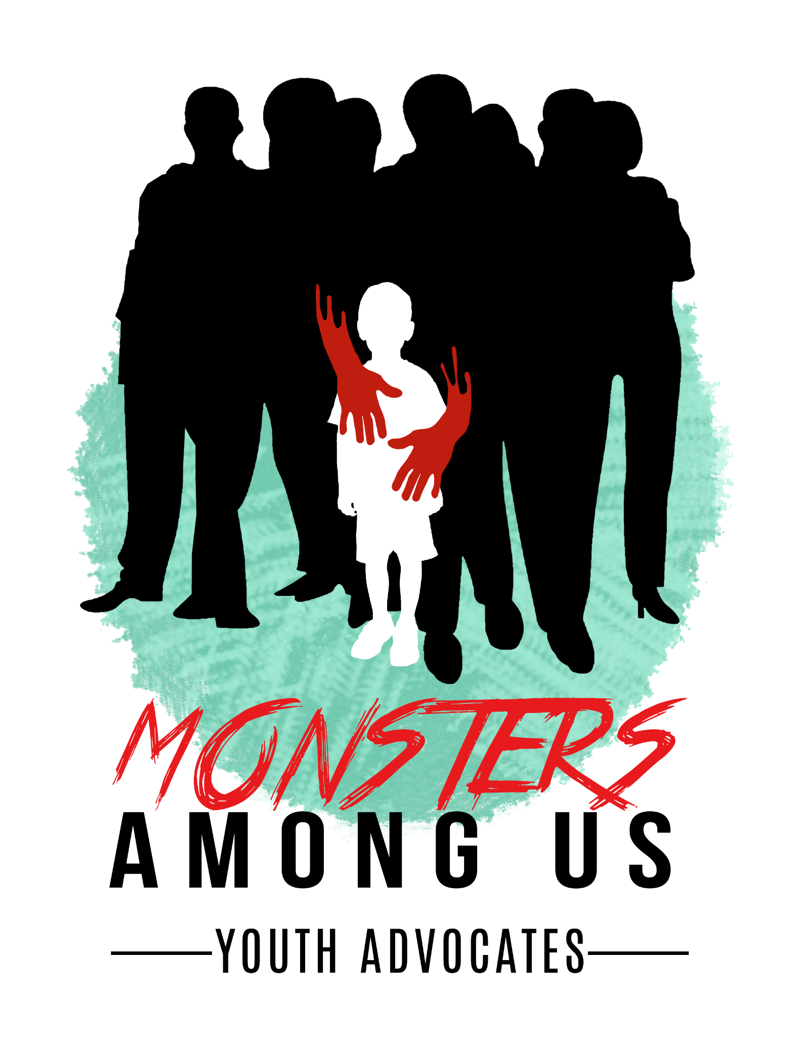

About MAU (Malaysia)

MAU was established in 2017 as a youth-led organisation advocating for the end of systemic violence against children in Malaysia. Founded by a youth herself, MAU centres Article 12 of the UNCRC in their work to ensure safe and meaningful spaces for children and young people to participate in safeguarding their rights.

MAU has implemented activities in partnership with UNICEF Malaysia on digital rights, the principle of the best interest of the child. One of their staple programmes is My Body My Rules, a comprehensive sexuality education tailored for communitiy capacity building and resilience.

Written Input to CRC for 100th Session Jan 2026
Malaysia State Review
By Monsters Among Us (MAU)

Written by:
Firzana Binti Raduan @ Redzuan
Founder, Advocacy and Strategy Lead
Monsters Among Us (MAU)

https://resourcecentre.savethechildren.net/collection/sexual-orientation-gender-identity-expression-sex-characteristics-sogiesc-resources
CRC/C/GC/25 - General comment No. 25 (2021) on children’s rights in relation to the digital environment

