European Union Agency for Fundamental Rights, selected passages on the rights of persons with disabilities from published reports related to Slovenia
fra.europa.eu

February 2017, Vienna
Contents
1 Annual reports 2
1.1 Fundamental Rights Report 2016 2
2 Thematic reports on the rights of persons with disabilities 2
2.1 Violence against children with disabilities: legislation, policies and programmes in the EU report (2015) 2
2.2 Implementing the UN CRPD: An overview of legal reforms in EU Member States (2015) 6
2.3 The right to political participation for persons with disabilities: human rights indicators (2014) 7
2.4 Legal capacity of persons with intellectual disabilities and persons with mental health problems (2013) 9
2.5 Involuntary placement and involuntary treatment of persons with mental health problems (2012) 10
2.6 The legal protection of persons with mental health problems under non-discrimination law (2011) 10
2.7 The right to political participation of persons with mental health problems and persons with intellectual disabilities (2010) 11

Annual reports

Fundamental Rights Report 2016
For more detailed information: http://fra.europa.eu/en/publications-and-resources/publications/annual-reports/fundamental-rights-2016.
“For example, the job of the Secretary of the Council for Persons with Disabilities, the Slovenian Article 33(2) body, is performed as an additional task by an official working full time at the Ministry of Labour, Family, Social Affairs and Equal Opportunities. An initiative to set aside further resources to carry out this task has received widespread support – including from the President, the President of the National Assembly, and most ministries – but the allocation of further resources will be determined only during the next budget period.” (p.193)

Thematic reports on the rights of persons with disabilities

Violence against children with disabilities: legislation, policies and programmes in the EU report (2015)
The report includes extensive information regarding Slovenia, these excerpts are just a selection. For more detailed information: http://fra.europa.eu/en/publication/2015/children-disabilities-violence. Also available in easy-to-read: http://fra.europa.eu/en/publication/2015/violence-against-children-disabilities.
“Not all Member States prohibit corporal punishment in all settings. The European Committee of Social Rights has received complaints regarding corporal punishment in Belgium, the Czech Republic, France, Italy, Ireland and Slovenia.” (p.35)
“Some EU Member States include a victim’s disability as a ground for criminalising a hate crime. As of October 2014, 13 EU Member States explicitly recognise, in one form or another, a disability-bias motivation in their criminal laws: Austria, Belgium, Croatia, Finland, France, Greece, Hungary, Lithuania, the Netherlands, Romania, Slovenia, Spain, and the United Kingdom.” (p.38)
“Turning to the responses of the stakeholders interviewed for this research, it is worth mentioning that only respondents from five countries – Denmark, the Netherlands, Sweden, Slovenia and the United Kingdom – raised the issue of hate crime and its link to violence against children with disabilities.” (p.39)
”[I]f we talk about the Criminal Code, it is a general norm on considering all of the circumstances, also subjective ones, motive and so on of the offender when determining the sentence. And here we lack a provision determining that if the purpose, the motive is hostility or discrimination, the sanction has to be more aggravating. Now, there is a space for judges to do this, but it’s not necessary that they will.” (NHRB member, Slovenia)(p.39)
“FRA research reveals that all Member States except for Germany, Malta and the Netherlands have legislation obliging professionals who work with children to report child abuse, neglect and violence […] Only 15 of the 25 Member States who have such a reporting obligation impose it on all professionals (Bulgaria, Croatia, Denmark, Estonia, France, Hungary, Ireland, Lithuania, Luxembourg, Poland, Romania, Slovenia, Spain, Sweden and the United Kingdom).” (p.40)
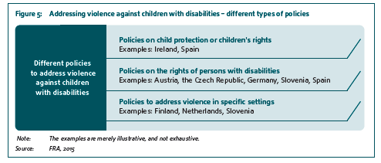 (p.41)
“A second group of Member States, which includes Bulgaria, Germany, the Netherlands and Slovenia, has policies addressing the protection of children from violence that refer generally to children with disabilities, some of them recognising their particular vulnerability. However, they do not contain specific measures addressing violence against children with disabilities in particular.” (p.42)
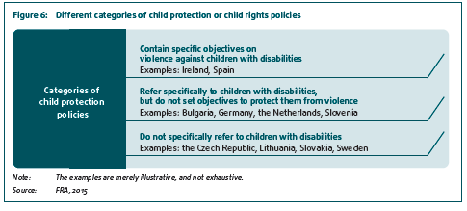(p.42)
“A number of Member States have policies addressing the rights of persons with disabilities and their protection from violence: Austria, the Czech Republic, Finland, Germany, Italy, Portugal, Slovenia and Spain.” (p.43)
“Some EU Member States – such as Austria, the Czech Republic, Germany, Slovenia and Spain – have disability policies or action plans that set out […] The Slovenian ‘Action programme for persons with disabilities 2014–2021’, aims to raise awareness about violence against children with disabilities, collect statistical data, and provide assistance to persons with disabilities to detect, resolve and prevent violence. Children with disabilities are identified as a particularly vulnerable group, along with women and elderly persons with disabilities.” (p.43)
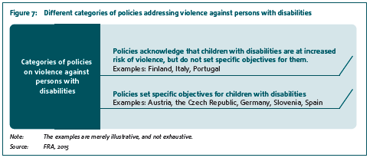(p.43)
“Several EU Member States, such as Finland, the Netherlands and Slovenia, have adopted policies that address violence in different settings, such as family or care institutions, and refer to persons or children with disabilities. The Slovenian ‘National program for preventing family violence 2009–2014’ recognises that special programmes to support and assist persons with disabilities who are victims of family violence have to be set up. Similarly, the ‘Resolution on a national plan on the prevention and combating of crime 2012–2016’ also recognises that special attention should be given to setting up support networks for persons with physical disabilities and “persons with special needs” who are victims of family violence.” (p.44)
“For these children in Slovenia, I’d say, you do not have professionals to be able to conduct interviews with them, which is the most important thing in recognising abuse. […] You know, sadly it’s going in two extreme directions. One extreme occurring lately is that in some cases they do not carry out an interview at all, they won’t work with such a young child. But you will not hear that, they do not say this out loud. And the other extreme is that of course they report on how they are equipped to conduct an interview with a three year old. You know, I was there myself and I know what it means.” (NGO representative, Slovenia) (p.47)
“A Slovenian NGO representative drew particular attention to mothers, who are often most overburdened with care and cannot devote any attention to other family members. This can lead to different forms of family violence, for example, hostile reactions by the mother towards the child with disability, violence by the father towards the mother, or neglect of the siblings because there is a child with disability in the family.” (p.67)
“Some stakeholders, notably in Bulgaria, Lithuania and Slovenia, identified the isolation of children with disabilities in institutional care as a form of violence. They further indicated that there is a general lack of awareness about certain forms of violence and neglect, such as segregation and refusal of care, which also significantly affect children’s development.” (p.76)
“Respondents – notably in Austria, the Czech Republic, Italy, Slovenia and Poland – argued that inspections of facilities for children with disabilities are often a mere formality, and do not adequately focus on monitoring the quality of care and on preventing abuse […]A public authority representative from Slovenia raised similar concerns, noting that inspections predominantly focus on bureaucracy.” (p.77)
“Finally, some respondents pointed out that the monitoring mechanisms lack independence, and fall short of fulfilling their obligation to provide effective monitoring by independent institutions. For example, a representative from Slovenia pointed out that the national inspectorates tasked with monitoring institutions in the country operate under the auspices of a ministry. “None of the inspectorates are independent. Also, on the appellate level, if they build some sort of measures and a person, institution or anyone appeals, the measure can be repealed by the ministry.” (NHRB representative, Slovenia) (p.78)
“Many respondents, notably from Austria, Denmark, Italy, the Netherlands, Slovenia, Sweden and the United Kingdom, identified gender as an important factor increasing the vulnerability of children with disabilities and their risk of violence. Specifically, respondents noted that girls with intellectual or psychosocial disabilities are at risk of becoming victims of sexual abuse.” (p.83)
Table 3: Examples of awareness‑raising programmes, projects and campaigns
Name of programme | Description | Reference and link
Tackling stereotypes and prejudice against people with disabilities in schools | The Slovenian DPO ‘Association for the Theory and Culture of Handicap’ carried out an awareness raising campaign in schools and kindergartens, promoting diversity and mutual respect from early age and countering stereotypes and prejudice against people with disabilities.  Trainers with disabilities carried out workshops, drawing on their personal experiences with discrimination, stereotypes and prejudice. In their evaluations, teachers indicated that, for many of the children, this was their first contact with a person with disability and noted that such activities foster understanding of disability. | Slovenia, Association for the Theory and Culture of Handicap (Društvo za teroijo in kulturo hendikepa), campaign ‘Botonček’ (Bontonček), see: http://www.yhd-drustvo.si/bontoncek-166.html. (p.87)
“Respondents – in the Czech Republic, Denmark, Lithuania, the Netherlands, Poland, Portugal, Slovenia, Sweden and the United Kingdom, for example – identified child helplines as a common form of help and support service.” (p.91)
Table 6: Family support programmes
Name | Description | Reference and link
House of Trust  victims of  violence | This programme offers protection to women with disabilities who are victims of (family) violence and carries out awareness‑raising activities relating to violence against persons with disabilities. ‘House of Trust’ is the only provider offering services specifically tailored to the needs of women with disabilities who are victims of family violence. | Slovenia, Association of Persons with movement impairments of Slovenia -Vizija (Društvo oseb s fizičnimi ovirami Slovenije – Vizija), see: http://drustvo-vizija.si/. (p.93)
“[Children with disabilities] often do not have anyone else except a teacher or a doctor outside family to turn to. And if these [professionals] do not know what they are authorised for and what their duties are and where to turn, who to call immediately, then this is just another unnecessary burden.” (Public authority representative, Slovenia). (p.96)
“Aside from formalised cooperation efforts between different actors, respondents – in Austria, Bulgaria, Croatia, the Czech Republic, Italy, Lithuania, Slovenia and Sweden, for example – raised concerns about the lack of coordination and cooperation among different institutions and bodies involved in child protection.” (p.98)
“Educational counsellors and counselling for both children and parents are available in Croatia, Denmark, the Czech Republic, Lithuania, Poland, Slovenia and Sweden.” (p.101)
“Respondents in Bulgaria, Croatia, the Czech Republic, Lithuania, Poland and Slovenia often mentioned NGOs as the main providers of support and help services to children.” (p.101)
“Respondents also noted that social services provide support services for children with disabilities and their families – in Austria, Croatia, Denmark, Italy, Lithuania, the Netherlands, Poland, Slovenia, Sweden and the United Kingdom.” (p.101)

Implementing the UN CRPD: An overview of legal reforms in EU Member States (2015)
The report includes extensive information regarding Slovenia, these excerpts are just a selection. For more detailed information: http://fra.europa.eu/sites/default/files/fra-2015-focus-05-2015-crpd_en.pdf.
“The National Assembly of Slovenia, for example, adopted in 2010 the Act on equal opportunities for people with disabilities, which prohibits discrimination in access to goods and services available to the public. It also sets out the obligation to provide appropriate accommodations and to remove physical, information and communication barriers that prevent access by people with disabilities to goods and services.” (p.8)
“Other Member States have introduced mandatory quotas for employees with disabilities. […] Bulgaria, Hungary and Slovenia105 introduced similar quota systems which apply to all companies which have at least 50, 25 and 20 employees respectively.” (p.12-13)

The right to political participation for persons with disabilities: human rights indicators (2014)
The report includes extensive information regarding Slovenia, these excerpts are just a selection. For more detailed information: http://fra.europa.eu/en/publication/2014/right-political-participation-persons-disabilities-human-rights-indicators.
“Finally, the analysis indicates that in a further four EU Member States, Greece, the Netherlands, Poland and Slovenia, there is no national disability action plan or strategy.”(p.39)
“In Slovenia, the legal test for judges deciding whether to restrict the right to vote is whether the person with a disability is capable of understanding the meaning, purpose and effect of elections.” (p.41)

“Hungary, Latvia, Lithuania, Slovakia and Slovenia also provide for polling stations at long-term institutions but require an individual application or notification to use such a polling station in advance, which could act as a barrier to exercising the right to vote.” (p.44)
“In a further seven Member States – Bulgaria, Croatia, the Czech Republic, Denmark, Italy, Slovenia and the United Kingdom – only public media providers are obliged to ensure that their broadcasts are accessible to persons with disabilities.” (p.47)

“No information was given in the report on accessibility standards in force for new and existing buildings in Slovenia, and there were no rapporteurs or national experts identified to provide information for Bulgaria, Croatia, Estonia and Latvia.” (p.49)

“Similarly, in Austria and Slovenia, electoral law requires that each municipality or voting district must have at least one accessible polling station.” (p.50)

“In 15 EU Member States, Croatia, Cyprus, the Czech Republic, Denmark, Finland, Germany, Hungary, Ireland, Poland, Portugal, Slovakia, Slovenia, Sweden and the United Kingdom, assistance in voting is available to persons with physical, visual and intellectual disabilities, subject to the authorisation of the election authorities.” (p.50)

“In all other Member States training for election authorities and officials on these issues is not required by law. However, in 15 EU Member States – Belgium, Bulgaria, Cyprus, the Czech Republic, Finland, France, Germany, Greece, Ireland, Italy, Lithuania, Poland, Slovenia,
Spain and the United Kingdom – the research indicates that training material or specific instructions on how to ensure non-discrimination on the ground of disability and accessibility in voting procedures is provided. In Finland, the Ministry of Justice issues instructions to all election committees that include information on accessibility, while in Lithuania and Slovenia the central election authority provides training during election campaigns, where election rights, accessibility and necessary accommodations to exercise the right to vote for all, including persons with disabilities, are covered.” (p.52)

“In the first group of Member States, people who are prevented from voting because they have been deprived of their legal capacity are denied access to redress regarding problems experienced in the voting process. This is the case in Denmark, Estonia, Greece, Ireland, Lithuania, Poland, Slovenia and Slovakia. In these situations, the law requires that a person deprived of his or her legal capacity first challenge this decision. Only once his or her legal capacity is restored, can the person seek redress for being deprived of the right to vote.” (p.53)
“A second group of EU Member States, Austria, Belgium, Bulgaria, Finland, Hungary, Latvia, the Netherlands, Portugal, Slovenia and the United Kingdom, provide information on complaint procedures regarding political participation in a format that is partially accessible.” (p.60)
“In Slovenia, the Constitutional Court in 2010 rejected a complaint challenging the requirement to submit an application to use an accessible polling station three days before elections as unfounded. In his application, the claimant had specifically mentioned the principle of non-discrimination on the grounds of disability and the right to political participation on an equal basis with others outlined in the CRPD.” (p.62)
“In Malta, Slovenia and Spain, this research found cases linked to the accessibility of information regarding elections, specifically for persons with visual and hearing impairments. […]Following the 2011 parliamentary elections in Slovenia, the Advocate of the Principle of Equality received a complaint concerning the lack of information provided by the National Electoral Commission on how persons with disabilities could exercise their right to vote. Following an investigation, the advocate produced an opinion stating that the information provided by the commission was not accessible to people with disabilities, which amounted to indirect discrimination on the ground of disability”. (p.63)
“The National Electoral Commission (Državna volilna komisija) in Slovenia, for example, provided FRA data indicating that out of 3,337 polling stations for the 2012 presidential elections, all polling stations had stencils available to assist persons with visual impairments, 1,148 (34 %) were free of ‘architectural barriers’ preventing access for persons with physical disabilities, and only 30 polling stations were officially designated accessible polling stations with a voting machine to assist persons with visual or physical disabilities.” (p.71-72)
“In a second group of six EU Member States, Hungary, Lithuania, Portugal, Romania, Slovenia and Sweden, some data on the proportion of public authority buildings that are accessible for persons with disabilities were found from unofficial sources such as research undertaken by NGOs.” (p.72)
“Data from Bulgaria, Croatia, Cyprus, Greece, Italy, Lithuania, Luxembourg, Poland and Slovenia indicate that no political parties produced their manifestos in accessible formats for the last elections.” (p.80)

Legal capacity of persons with intellectual disabilities and persons with mental health problems (2013)
The report includes extensive information regarding Slovenia, these excerpts are just a selection. For more information: http://fra.europa.eu/en/publication/2013/legal-capacity-persons-intellectual-disabilities-and-persons-mental-health-problems. Also available in easy-to-read: http://fra.europa.eu/en/publication/2013/laws-about-being-able-make-important-decisions-yourself.
“Slovakia, Slovenia and Poland have two degrees of restriction – either for all legal acts or just for certain legal acts – which reflect the two models of guardianship.” (p.30)
“In Italy, Greece and Slovenia the court delivers a single judgment, deciding that the person’s legal capacity is restricted and that he or she will be placed under a protective measure.” (p.33)
“In Slovenia, a centre for social work or a public attorney as well as the spouse, another person who lives with the person, a relative or close family member can initiate the procedure. The affected person can also initiate the procedure if a court finds that he or she is able to understand its meaning and consequences.” (p.35)
“About half of EU Member States explicitly provide in their national legal frameworks for the person concerned to request a restriction of his or her legal capacity. This is the case in Austria, Denmark, Estonia, Finland, France, Germany, Greece, Italy, Luxembourg, Slovakia, Slovenia, Spain, Sweden and the United Kingdom.” (p.35)
“Legislation in several other EU Member States does not oblige the guardian to consider the person’s wishes when taking decisions about his or her life. In Slovenia, decisions taken for a person under full guardianship need not consider the adult’s wishes.”(p.36)
“The comparative analysis shows that in the majority of EU Member States a guardianship measure is in principle instituted for an unlimited period of time and is not subject to periodic review. […] Other Member States without a statutory maximum duration include Belgium, Cyprus, the Czech Republic, Greece, Ireland, Lithuania, the Netherlands, Poland, Portugal, Slovenia and Spain.” (p.38)

Involuntary placement and involuntary treatment of persons with mental health problems (2012)
The report includes extensive information regarding Slovenia, these excerpts are just a selection. For more information: http://fra.europa.eu/en/publication/2012/involuntary-placement-and-involuntary-treatment-persons-mental-health-problems.
“In 13 Member States two criteria – the risk of harm and the need for treatment – are listed alongside having a mental health problem. This is the case in Denmark, Greece, Finland, France, Ireland, Latvia, Poland, Portugal, Romania, Slovakia, Slovenia, Sweden and the United Kingdom.”(p.31)
“Article 39 of the Slovenian Mental Health Act allows for lawful detention if the described threats cannot be prevented by using other less intrusive means, such as: treatment in an open department of a psychiatric hospital, ambulant treatment or treatment under medical surveillance.” (p.33)
“Article 763 (4) of the Spanish Civil Procedure Act likewise regulates the termination of involuntary placement as a medical decision, which should immediately be notified to the competent court. A similar provision is found in Article 99 (1) of the Greek Law 2071/1992 and Article 71 of the Slovenian Mental Health Act 77/08.” (p.38)
“The FRA findings show that this requirement is reflected in the vast majority of EU Member States’ laws, which provide for free legal support either in certain circumstances or automatically. In addition, in several Member States, comprehensive legal aid provisions require that a lawyer be automatically appointed (see for example Belgium, Bulgaria, Hungary, the Netherlands or Slovenia).”(p.39)
“In some Member States regular reviews of placement measures take place every three months (Bulgaria, Portugal), every six months (Finland, France, Latvia, Lithuania), after one year (Estonia, Slovenia), or after two years (Belgium, Luxembourg).” (p.40)

The legal protection of persons with mental health problems under non-discrimination law (2011)
The report includes extensive information regarding Slovenia, these excerpts are just a selection. For more detailed information: http://fra.europa.eu/en/publication/2011/legal-protection-persons-mental-health-problems-under-non-discrimination-law.
“In another group of Member States where the transposing legislation provides no common understanding of the term disability, definitions can be found in other non-discrimination laws. In general, these definitions can be interpreted so as to include persons with mental health problems. This is the case for Bulgaria, Italy, Latvia, Luxembourg, Poland, Romania and Slovenia. […]The Slovenian Act on equalisation of opportunities for persons with disabilities uses the following definition: “Persons with disabilities shall mean those who have long-term physical, mental or sensory impairments that in interaction with various barriers may hinder their full and effective participation in society on an equal basis with others.”(p.24)
“In five EU Member States (France, Germany, Hungary, Slovenia and Spain), the scope of the duty to provide reasonable accommodation is not the same as the scope of the prohibition of discrimination on the grounds of disability.” (p.26)

The right to political participation of persons with mental health problems and persons with intellectual disabilities (2010)
The report includes extensive information regarding France, these excerpts are just a selection. For more detailed information: http://fra.europa.eu/en/publication/2010/right-political-participation-persons-mental-health-problems-and-persons
“The situation in Slovenia is somewhat particular. National legislation used to proscribe participation in the electoral process by persons deprived of legal capacity. However, in 2003, the Slovenian Constitutional Court found the relevant provisions unconstitutional. According to the Court, capacity to vote should not be equated with legal capacity. Parliament amended the legislation in 2006. According to the amended Act, in order to restrict the right to vote of an individual, a court needs 1) to decide on the prolongation of parental rights, which in Slovenia is a specific form of guardianship, and 2) to confirm that the individual is unable to understand the meaning, purpose and effect of the elections.’” (p.18)
Annex
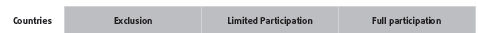
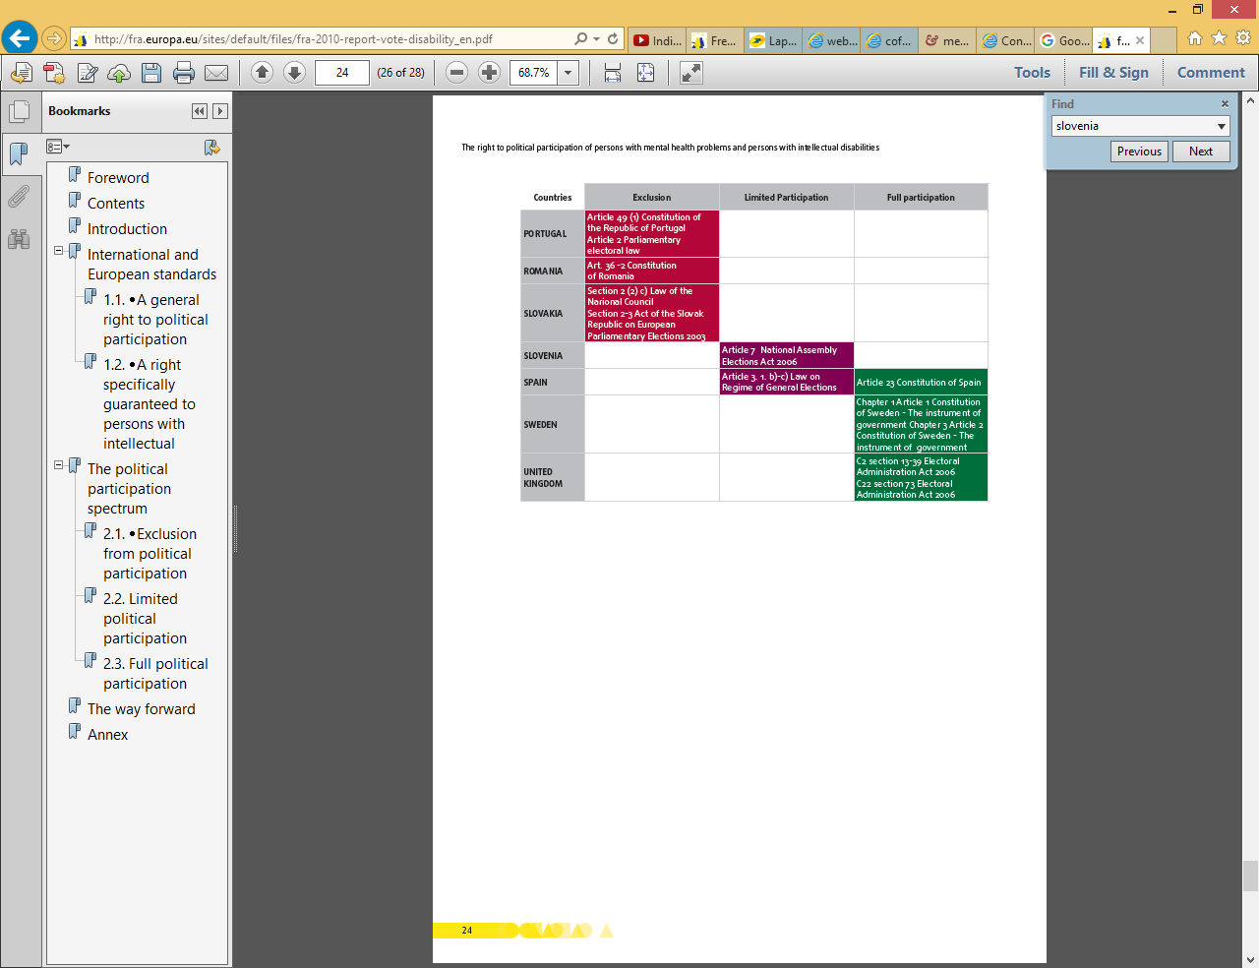 (p.24)

