CEDAW REPORT
Coalition of Women's NGOs of Venezuela
Unilateral Coercive Measures and Women's Human Rights in Venezuela
- The following Venezuelan organizations: Círculos Femeninos Populares, Corazones Violeta, Corriente Revolucionaria Bolívar y Zamora, Fundación Casa de la Mujer "Lilian Cabrera", Frente Cultural de Izquierda, Frente Feminista "Yo soy mujer", Fundación Género con Clase, Fundación Reviresco, Fundación Violeta, la Quinta Ola Venezuela, Movimiento Feminista Popular "Lydda Franco Farías", Movimiento Heroínas sin barreras, Movimiento de Mujeres Junt@s, Movimiento de Pobladores y Pobladores, and Trabajadoras Residenciales por Venezuela, whose mandates are linked to the defense and protection of women's human rights; to the organization and promotion of women workers, peasants, community women, young women, women with disabilities, in urban and rural areas, as well as in border areas; to the struggle for non-sexist communication, for a life free of any form of patriarchal violence, for sexual rights and full reproductive rights, we present the following coalition report to the Committee of Experts of the CEDAW.
Introduction
- In Venezuela, the struggle for the human rights of women and girls has been a constant of the feminist movement that has allowed progress in substantive aspects such as an advanced legal framework with a gender perspective, a significant institutional framework for the guarantee of their rights and quality of life; elements that transformed the daily life of Venezuelan society from the redistribution of wealth focused on social justice from the Constitution of the Bolivarian Republic of Venezuela (CRBV) in 1999, which served as a framework along with the Law on Equal Opportunities for Women of 1999; the Organic Law on the Right of Women to a Life Free of Violence of 2007 (reformed and extended in 2014 and 2021); the Law for the Protection of Families, Maternity and Paternity (2007); the Organic Law on Labor, Male and Female Workers (2012); and other legal instruments, to gradually institutionalize the main rights of the female population, turning the country at various times during the period 1999-2014 into a reference in various areas related to women's rights.
- Translated with www.DeepL.com/Translator (free version)However, in 2015, as a result of Executive Order 13692 that declared Venezuela an unusual and extraordinary threat to the national security of the United States, the scale of application of Unilateral Coercive Measures (MCUs) was deepened and The national economy begins to be impacted in an increasingly accelerated way, radically influencing the route of promotion and conquest of rights, affecting access to resources and the quality of life of the population. These impacts will have differentiated effects in specific sectors according to pre-existing vulnerabilities, putting fundamental rights and, in many cases, people's lives at risk. Hence the importance of systematizing and analyzing from a gender and feminist approach the main effects that the MCU have had on the exercise and enjoyment of the human rights of Venezuelan women and girls; to evidence with figures and qualitative data, the restriction of women's rights by the action of third countries.
- This report is the result of a methodological triangulation that includes documentary tracking of data and figures from government institutions, academic works, contributions of experiences and testimonies from feminist and human rights organizations and the application of two digital surveys (the first developed between the month of October and November 2020; the second between July and August 2021) in which 909 women were consulted first, and subsequently 1,008 people (95.43% women and 4.37% men) respectively, from different age groups from 18 years, from the 23 states and the Capital District. On the other hand, 32 in-depth interviews were conducted with women from various social sectors.
I. Context
- The application of the MCUs has become for almost a decade a breeding ground for the deterioration of the quality of life of Venezuelan women, generating the appearance of unconventional social, economic and political phenomena. At this point, it is noteworthy that the deterioration of the health and nutrition of the population, the deterioration of quality and access to public services, human mobility, xenophobia, migration of institutional technical capacity, human trafficking, especially of women and girls, among other phenomena, was largely caused or exacerbated by the conditions generated by the application of these criminal measures that violate International Law. It is not by chance, in this order, that in the digital survey "Negative effects of the economic blockade on the human rights of women and girls in Venezuela" carried out in 2021, the results of the consultation yielded the following:
Do you consider that the application of the economic blockade is a violation of human rights and the right to peace? | Total
In agreement | 12,43%
In disagreement | 0,99%
Strongly agree | 85,09%
Strongly disagree | 1,49%
Grand Total | 100,00%
Source: self made FUNDAGCC, 2021
- The effects on the lives of Venezuelan women and girls for reasons of gender have been more serious than in other social sectors, due to the unequal distribution of power and resources that have continued to prevail as a result of the patriarchal culture. Additionally, the fact of belonging to other discriminated groups accentuates the affectations, as occurs with girls, older adults, women with disabilities, indigenous people, in conditions of mobility, among others. According to the aforementioned digital survey, the following data stands out:
Do you consider that Venezuelan women and girls (regardless of their personal, social or legal status) are the main affected by the economic blockade? | Total
In agreement | 22,37%
In disagreement | 1,89%
Strongly agree | 74,85%
Strongly disagree | 0,89%
Grand Total | 100,00%
Source: self made FUNDAGCC, 2021
- The following data and experiences demonstrate the correlation between the entry into force of the MCUs and the impact on the human rights of women and girls enshrined in international and national norms, and the generalized deterioration in their quality of life.
II. Part I of the Convention

Violence against women
- While it is true that there is no mechanical relationship between poverty and gender-based violence, since the latter is transversal to all segments of society, including the most privileged. It is a proven fact that when a family nucleus is more burdened by the contraction of income, tensions and pressures on each of the members of the family increase, that is, an environment more conducive to the emergence of various forms of violence is created. Therefore, when we speak of gender gaps, it is easily identifiable that the MCUs are an instrument for deepening the structural inequalities that sustain patriarchy, by generating higher levels of economic dependency, generating more vulnerabilities and thus contributing to reproduce the cycle of gender-based violence.
- On the other hand, the MCUs have generated a weakening of the institutional structures of social care, which has deepened the vulnerability of women. One of the hardest hit instances are those aimed at social protection, especially for the most vulnerable sectors, such as children, women, people with some type of disability and the elderly. In this context, gender-based violence is exacerbated by the fact that women are responsible for filling the vacuum of social care provided by the State, and are therefore immersed in a scenario of over-exploitation of their capacities, which are increasingly concentrated on care. This implies an impairment of their economic independence, which makes them more vulnerable to toxic emotional relationships or precarious jobs where scenarios of labor violence, harassment, among other abuses, prevail.
- In this regard, in the digital survey "Negative effects of the economic blockade on the human rights of women and girls in Venezuela", the persons consulted had the following perception:

In the last (2) years, what do you think are the main effects faced by Venezuelan women and girls as a result of the economic blockade? Maximum two (2) options | Total
Gender-based violence, Multiple daily shifts | 6,66%
Gender-based violence, Forced mobility | 6,66%
Gender-based violence, labor or sexual exploitation | 11,93%
Gender-based violence, Difficulties in specialized physical and mental health care services, Labor or sexual exploitation, Forced mobility, Multiple daily shifts | 2,09%
Gender-based violence, Difficulties in specialized care services in physical and mental health | 19,09%
Gender-based violence | 1,79%
Forced mobility, Multiple daily shifts | 2,39%
Labor or sexual exploitation, Multiple daily shifts | 2,88%
Difficulties in specialized care services in physical and mental health, Multiple daily shifts | 11,33%
Difficulties in specialized care services in physical and mental health, Forced mobility | 11,53%
Difficulties in specialized care services in physical and mental health, Labor or sexual exploitation | 6,06%
Difficulties in specialized care services in physical and mental health | 3,68%
Made by FUNDAGCC, 2021

- The MCUs have had an impact on psychic and emotional stability, since their impact on the lives of the population causes anguish and suffering.
- Finally, there is evidence of an increase in the incidence of crimes of violence against women, especially femicides and sexual crimes, with a limited institutional response, in many cases inefficient and with high levels of revictimization; despite formal advances.
- We especially highlight the second partial reform of the Organic Law on the Right of Women to a Life Free of Violence (2021) that broadens the forms of violence, increases penalties for sexual crimes and creates a National Commission for the guarantee of the right to a life free of violence; however, there are still several obstacles in the implementation of the Law, with emphasis on socio-cultural barriers and prevailing prejudices that generate gaps for its effectiveness. These MCU have also weakened the institutional framework responsible for addressing this social problem.
- However, special mention and recognition should be made of the incorporation of community defenders of women's rights in the second partial reform of the Organic Law on the Right of Women to a Life Free of Violence; the extinction of parental rights of those who commit femicide and sexual crimes as accessory penalties, and the prohibition of revictimization. It also highlights the mandatory incorporation of gender, feminist, human rights, intercultural, intergenerational, comprehensive and holistic approaches. Intergenerational, comprehensive and intersectional (Article 4).

Trafficking and exploitation of prostitution
- One of the most significant consequences of the implementation of the MCUs since 2014 has been the economic migration that has mobilized Venezuelan men and women in search of a better quality of life. The deterioration of material conditions, the decrease in purchasing power, the affectation in the access to food or medicines, among other phenomena, has propitiated for the first time in national history a substantial migratory flow to different countries.
- Similarly, in the case of some border areas, one of the new forms of international siege is the infiltration and control of armed drug trafficking structures and criminal gangs from the prevailing conflict in Colombia, which have caused anxiety among mothers due to threats, Forced displacements resulting from evictions from their homes and productive spaces that force them to leave the territory, the recruitment of their children for illicit activities associated with the war, and in many cases their daughters becoming victims of trafficking, prostitution and forced labor.
- Faced with this scenario, leaving the Venezuelan jurisdiction without information and safe routes further exacerbates the conditions of risk, stripping women of a set of rights that radically impact their lives, making them easy targets for organized crime networks, especially for sexual and labor exploitation.
- Until recently, Venezuela was considered a transit country and in some cases a receiving country for human trafficking, a reality that has been drastically transformed in recent years due to the context of precarious economic conditions, which exacerbates the vulnerability of the population. Although there are no official data, the practice and accompaniment of victims allows us to affirm that we have become a country of origin of human trafficking, exacerbated by stigmas of all kinds, among which xenophobia and discrimination stand out. To illustrate the above, it should be noted that in 2019 the Venezuelan Government reports through the Return to the Homeland Plan, the return by air, sea and land of 26,407 people (Sures, 2021b), of which 60% are women, and 27% children and adolescents. This report also stated that among the reasons for which people return to the country, the following stand out as the main reasons: 64% due to economic problems and the impossibility of obtaining decent employment and 54% stated as an additional reason for return the constant harassment in the receiving country, denouncing strong episodes of xenophobia, exploitation, labor and social mistreatment.
- An element that should be investigated in depth in order to generate relevant public policies is the diversification of modalities and emerging forms of human trafficking, where the use of information and communication technologies become a means for the commission of these crimes.
- The majority of the migrant population does not have legal advice, access to decent employment and medical attention, being more vulnerable to insecurity, robbery, discrimination and xenophobia, elements to which they are exposed when they leave the country without information, in a disorderly manner, and forced by an economic situation exacerbated by the MCUs. It should be noted that in addition to the drama suffered by migrant women, there is also a drama on the part of women whose family members migrated. The psychological impact on the population, on the families, has deep wounds in Venezuelan society. Mothers who have been left alone because their sons and daughters migrated; mothers-grandmothers whose daughters and sons left them their granddaughters and granddaughters to finish raising them (often with great economic difficulties); women-mothers who suffer the destructuring of their families with the consequent psychological traumas that this entails (depression, sadness, etc.); mothers who have lost the economic protection of their daughters and sons when they are left alone and these, due to the precarious conditions where they are, are not in a position to send remittances, among other dramatic phenomena.
- The human dimensions of migration are consequences that, although not quantifiable, must be valued among the most painful wounds that have been generated in the civilian population by the MCUs.

III. Part II of the Convention
Health
Access to health care services
- The MCUs have substantially affected the human right to access to health, due to restrictions on imports of medical equipment, spare parts, medicines, reagents, vaccines, contraceptives, among other resources required by the country. Access to personal hygiene and menstrual hygiene supplies such as sanitary pads and menstrual cups, have become widespread problems in female sectors, especially those in general poverty and multidimensional poverty, being among the main demands and concerns of Venezuelan women. The results of the 2021 Digital Survey express the following:

What items do you consider the most affected for Venezuelan women and girls by the economic blockade? Maximum (2) answer options | Total
Contraceptives and condoms, High-cost drugs for chronic diseases | 6,96%
High-cost drugs for chronic diseases, Technical and/or financial aid | 6,16%
High-cost drugs for chronic diseases, Medical and surgical equipment | 13,92%
High-cost drugs for chronic diseases, Production materials and equipment | 6,96%
High-cost drugs for chronic diseases, Financial resources | 16,30%
Menstrual hygiene products, Contraceptives and condoms | 3,28%
Productos de Higiene menstrual, High-cost drugs for chronic diseases | 8,55%
Menstrual hygiene products, Financial resources | 1,69%
Made by FUNDAGCC, 2021
- Another drama that the country has suffered as a result of the MCUs has been the full access to the vaccines it needs, especially those destined to the immunization of children. In the Venezuela in Figures Report, the Ministry of Popular Power for Planning (2021) publishes the following chart, which shows a decrease in the coverage of essential vaccines such as BCG, Pentavalent and SRP:
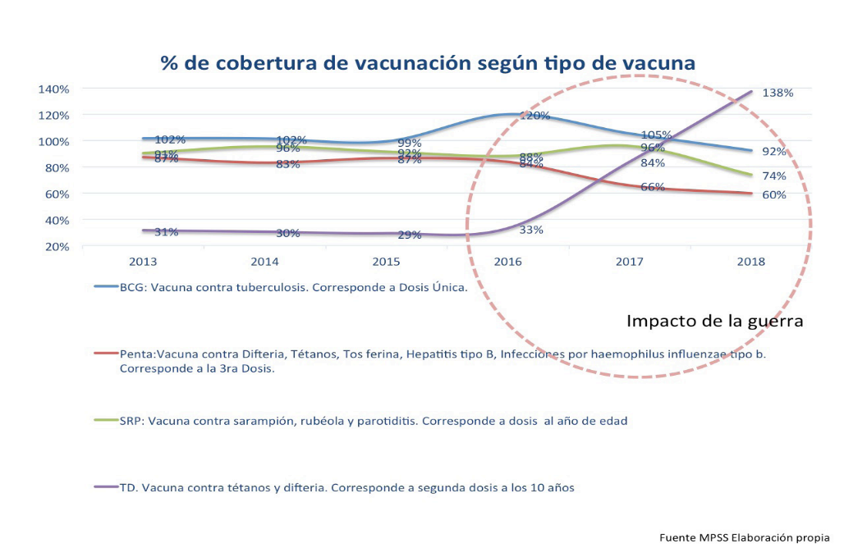

- Similarly, as of 2017, the MCUs have hindered the acquisition, and subsequent universal free distribution of Antiretroviral Therapy (ART) essential for the treatment of HIV, generating an alarming level of vulnerability for the lives of this population. The MCUs have also made it difficult to acquire the necessary reagents for viral load monitoring tests, which should be performed at least twice a year in all patients. This situation impacts women, taking into account that they represent 32.3% of HIV cases in the population aged 20 to 49 years, the most affected by this scourge in the country (CEDAW Report, 2021).
- Given this reality, gender differences have worsened, taking into account that factors such as gender-based violence, stigmas surrounding sexuality and STIs, and the impact on health services, as well as the increase in the possibilities of contagion and prevalence, taking into account the economic limitations to access barrier methods (condoms) and patriarchal myths regarding their use, which relate unprotected sexuality with romantic love and trust, increase the vulnerability of women and adolescents, deepening the inequalities that exist among women and adolescents.
- The right of women to enjoy comprehensive health is a universal human right, which goes beyond purely biological factors, and obeys bio-psycho-social elements that affect the place they occupy in society, and the ability to access material and symbolic resources to live a dignified life, with equal opportunities and free of violence; that is why the following are fundamental concerns to demand the cessation of coercive economic measures that limit the human rights of this population.

Combating maternal mortality
Sexual and reproductive rights
- Despite important advances, legislation and public policies in favor of sexual and reproductive rights, there are still problems in Venezuela that must be solved in order to guarantee the materialization of article 76 of the National Constitution, which recognizes these rights, as well as the best quality of these rights. Material impediments to the acquisition and purchase of supplies, especially medical supplies, have severely limited the possibilities of advancing in this direction.
- Robust public policies must be developed to guarantee that women as subjects of rights can freely make informed decisions about their sexual and reproductive rights. The efforts to articulate a national strategy for the prevention of early and adolescent pregnancy, such as the PRETA Plan, and against maternal mortality, such as the Humanized Childbirth Plan, are recognized; however, they require the provision of sufficient economic resources to achieve a more substantive impact.
- However, in vital aspects for the exercise of sexual and reproductive rights, such as the decriminalization of abortion, no substantive progress has been made to guarantee women's right to decide.
Access to contraceptive methods
- Between 1999 and 2014, access to safe and quality contraceptive methods achieved practically universal access in the country, because the high purchasing power of the Venezuelan population allowed it. Even when the National Public Health System, covered only 22.16% of the coverage, including emergency contraception recognized in the Official Standard for sexual and reproductive health care, according to figures from the Ministry of Health (2012).
- One of the aspects in which the effects of coercive measures against Venezuela became evident very early on was precisely the shortage of contraceptives and their high prices, which alarmingly limit the access of the population, especially those of reproductive age, to them. The lack of autonomy over sexuality has an impact on integral health and places women in a situation of particular vulnerability to gender-based violence.
- The limited access to contraceptive methods is alarming because of its incidence in the increase of sexually transmitted infections, particularly HIV, the increase of unwanted pregnancies, with special attention to adolescents, and its relation to unsafe clandestine abortions, which violate sexual rights to the extent that: 1) they limit the exercise of a safe and pleasurable sexuality, and 2) they limit reproductive rights by preventing real control of fertility, even putting women's lives at risk.
- In the digital survey carried out in 2020, women indicated that 47.63% of them have been affected or very affected, representing about 65% of women of reproductive age of the universe of respondents, in terms of access to contraceptives.
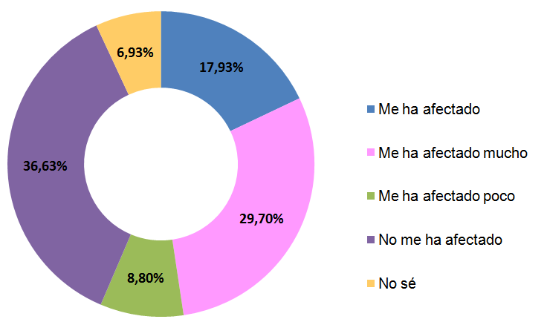

Source: self made FUNDAGCC, 2020
Maternity
- The Government presents in the Ninth Report to CEDAW (2021), the behavior of maternal mortality, which remained between 2005 and 2012 at 63.77 on average per 100,000 live births. In 2012, this figure stood at 63.57, and more than 96% of deliveries took place in health facilities, attended by qualified personnel. From the evaluation reference date, the average began to increase, reaching 101 deaths per 100,000 live births between 2014 and 2020. In this period, 2016 stands out as the year with the highest number of maternal deaths, with a downward trend between 2018 and 2020, returning to the average close to the conditions prior to the imposition of the MCUs.
- The positive impact of the Humanized Childbirth Plan is recognized, but it is necessary to deepen the actions that guarantee a more substantial decrease in maternal mortality, fully guaranteeing the reproductive rights of women, avoiding any risk and preventable death, as well as forms of obstetric violence, making greater efforts to ensure differentiated and quality services, as well as adequate training of health personnel.
Economic empowerment of women
- Female unemployment is around 8% according to government figures, however, the deterioration of purchasing power has been drastic, due to inflation correlated to the de facto economic blockade implied by the application of the MCUs and the consequent drop in oil income, imports and industrial production in general. Similarly, the CEDAW Report (2021) points out that these MCUs have negatively impacted the functioning of the national credit system, which is why there has been a decrease in the absolute volume of credits as of 2018, especially by the Private Bank.
- In a context where the economic factor has become the structural basis for the violation of rights, the economic autonomy of women is fundamental to be able to overcome vulnerabilities, even though an enormous capacity for resistance and resilience on the part of diverse social sectors must be recognized, especially women from the popular sectors.
- On the other hand, regarding the use of women's time, the in-depth interviews conducted show that women have had to spend more time on tasks related to care, due to the deterioration of the national economy and the family economy. They have had to spend more time searching for food and medicines at more accessible prices or because at some times (especially between 2015-2018) they were scarce in commercial establishments having to go through several stores.
- For its part, the Covid-19 pandemic increased the time dedicated to parenting due to the paralyzation of the face-to-face activities of day care centers and schools. They have had to take on more work days, for example, two paid jobs (in some cases one in person and another in telework) because a single salary does not cover basic needs; combine a paid job with an economic micro-enterprise; assume more care work, or because it is not possible to pay the costs of a day care center, or the case of retired grandmothers who have had to assume the raising of grandchildren because their mothers and fathers have migrated, among other reasons.
- The increase in care and reproductive work at home and outside the home generates discrimination in the political, social and cultural spheres, because it restricts women's equal participation in political, educational and working life. We see then that most women assume a double or triple workday, where men's support is still very limited, a structural phenomenon that unfortunately the MCUs have aggravated.

Women with disabilities
- An intersectional look at the most vulnerable groups makes it necessary to pay special attention to women and girls with some type of disability, since the situation has had a differential impact on this population and has put a large part of Venezuelan women and men at risk of suffering some form of disability due to the lack of accessibility to treatment for chronic diseases. Among the elements of greatest concern that show how the MCUs violate the rights of persons with some type of disability, especially women and girls, the following stand out:
- One of the most serious aspects of the impact of the MCUs on women with disabilities or caregivers of persons with disabilities is the difficulty of accessing the medical treatments that each person must take, depending on their disability. Many of them must take permanent medication to keep themselves in minimum conditions and use certain supplies on a constant basis. There are testimonies from organizations of women with disabilities that report the death of women with disabilities because they do not have the necessary supplies to treat conditions such as bedsores or decubitus ulcers, in the case of people who use wheelchairs on a permanent basis and/or are diabetic.
- In spite of the fact that the Venezuelan State in the last ten years maintained programs for the provision of these supplies free of charge through instances such as the Health Care Program for Persons with Disabilities; however, as the MCUs have worsened, they have also aggravated their impact on women and girls with disabilities, since these programs no longer have the same national response capacity required, and in some cases their access is not permanent. The technical aids that had been guaranteed by the Venezuelan State have been limited, making access to supplies such as canes, wheelchairs, diapers, catheters, urine bags, special glasses, anti-scarf mattresses, among others, more precarious and impossible. In this sense, the precariousness of the economic conditions generated has a fundamental weight, as it prevents them from accessing them by private means, generating higher levels of dependence, reduction of their autonomy and greater suffering.
- Despite the fact that social protection policies have been sustained to mitigate the effects and impact of the MCUs on the civilian population, in the area of health, the violations are particularly serious, since the shortage of specific medicines for the population with some type of disability that were previously distributed regularly by the National Public Health System, puts this population at a disadvantage due to the limited mobility conditions that in most cases they have to face, making the possibilities of obtaining medicines and health services more inaccessible for them.
- In the lives of Venezuelan women, the context described above has had serious consequences, resulting, among other aspects, in a deterioration of the quality of life, and in a climate of uncertainty that has serious psychological effects on Venezuelan families, especially on women with disabilities or women who are responsible for persons with some type of disability. Among the exacerbated vulnerabilities is the increase in gender-based violence among this population, especially sexual violence and emerging forms of human trafficking.
- On the other hand, the MCUs against Venezuela, by depriving the population of fundamental rights, also increase the risk of suffering some type of disability that could be preventable if timely access to medicines, basic services and food is guaranteed, for example, in the risk of a stroke that hypertensive people have if they cannot access their daily pharmacological treatment.
Right to food
- It should be noted that MCUs have affected such sensitive aspects of a society as access to food. Venezuela, as an oil country, lost in the first half of the twentieth century a good part of its agricultural vocation, becoming dependent in many items on imports, especially of cereals, in this context of vulnerability of food sovereignty, the MCU have caused substantial damage, because food imports decreased from 10 billion dollars in 2014 to less than one billion dollars in 2019, a shocking drop of more than 90%.
- To give a precise idea of the impact, it is important to present a table published by the Ministry of People's Power for Planning (2021), which clearly shows the Index of Prevalence of Under-Alimentation (IPS) during the period 1990-2019:
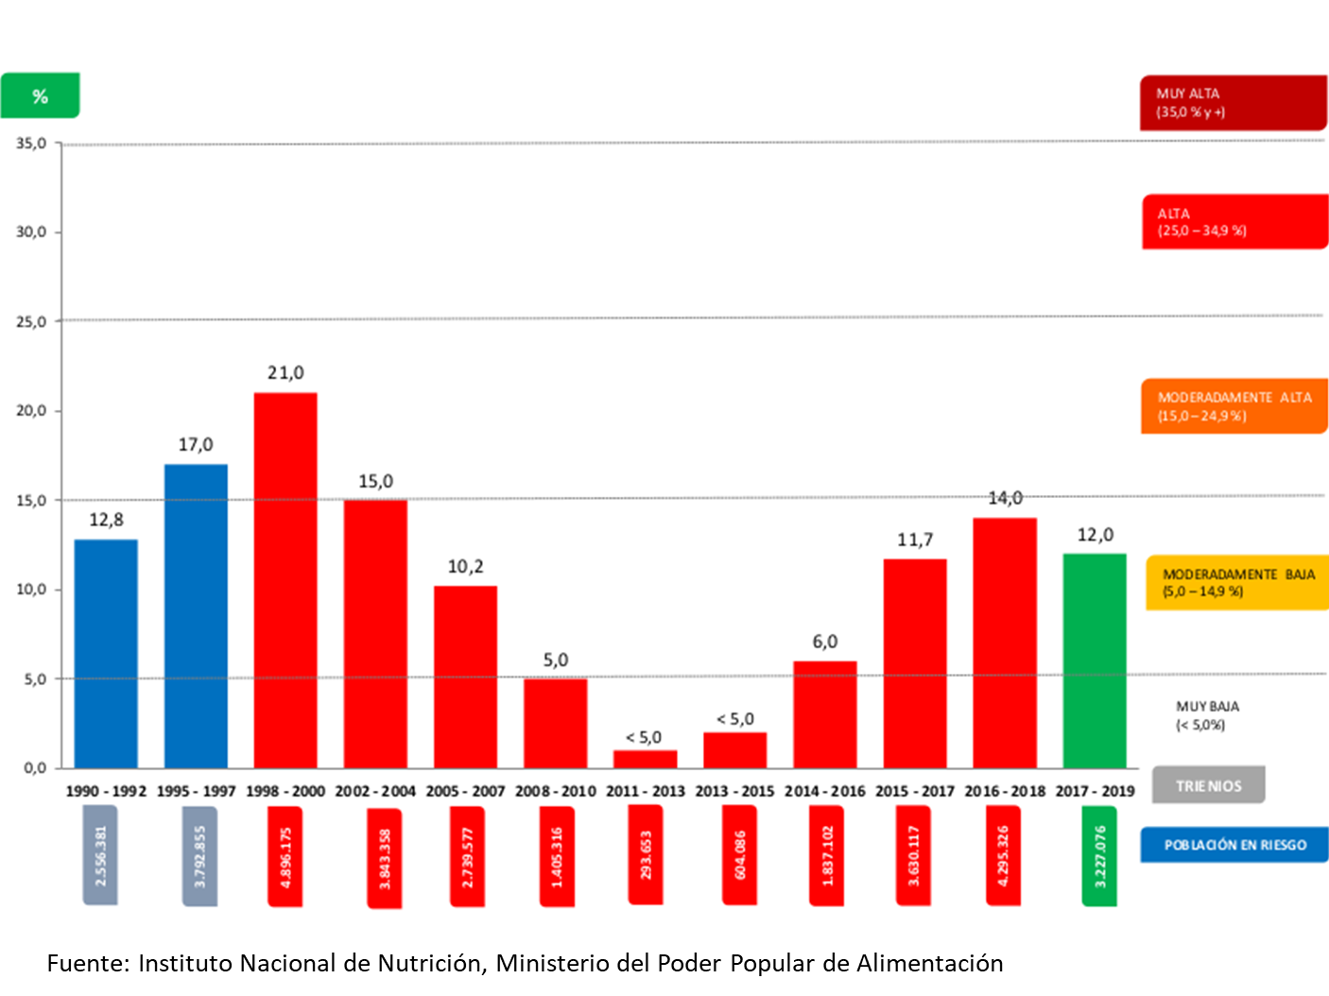
- This table evidences that between 2011 and 2013, food insecurity barely affected between 1% and 2% of the Venezuelan population, substantially increasing the undernourishment prevalence Index to 14% in 2018, we are talking about an increase ranging between 500% and 700%, in relation to 2011 where Venezuela practically reached the goal of being a country of 0 Hunger.Another data, indicates that the amount of grams of protein available per day decreased from 88.5 in 2014 to 55.1 in 2020.
- This situation, which affected the most vulnerable social sectors, was more serious in the case of women, taking into account that Venezuela, like the rest of the world, is marked by the feminization of poverty. Let us take into account that about 65% of poor households in the country are headed by a single woman-mother, who has to take care of the maintenance of her children in the absence of a father or man to share the work of upbringing and care. As a result, access to food depends mostly on them, and their search for food in these conditions represents a significant investment of time, effort and stress to ensure the feeding of the family, especially children.
Conclusions: MCUs are a Crime Against Humanity
- As has been noted, the restrictions imposed with the Unilateral Coercive Measures have a serious negative impact on the enjoyment and full exercise of human rights of the population, exacerbating pre-existing inequalities and opening inequality gaps that have impacted the quality of life of the population, being the most vulnerable sector in this context, women, girls, adolescents and within them women, girls and adolescents with some type of disability. There is no doubt that this is a crime against humanity perpetrated against the Venezuelan people, in accordance with the provisions of Article 7, paragraph K, of the Statute of the International Criminal Court, contemplated as different types of grave inhumane acts that meet two requirements: "the commission as part of a widespread or systematic attack against a civilian population, and with knowledge of such attack".
- According to the UN Special Rapporteur on the negative impact of unilateral coercive measures on the enjoyment of human rights, Alena Douhan (2021), the sectoral and selective MCUs imposed on Venezuelans and third-country nationals and companies have had a devastating effect on the entire population, especially those living in poverty, women, children, the elderly, persons with disabilities or with chronic or life-threatening illnesses, and indigenous peoples. By negatively impacting the enjoyment of economic, social, civil and cultural rights, MCUs undermine the right to development of the entire Venezuelan society, especially its most vulnerable sectors and strata.
- Therefore, the application of the MCUs imposed by the United States and other countries, beyond hindering the public and political functions of the representatives and officials of the Venezuelan State, have had a totally negative effect on the Venezuelan population and those residing in it. Human rights such as food, health, transportation, education, medical assistance, lack of basic medicines have been violated. One of its greatest impacts and effects has been to harm the material stability of women.
- During these six years, women's emotions have been attacked and affected, particularly those of women, who, having this link with the care of life, their concern and anxiety in the face of the limitations to protect it, are increased. For women, the deepening of the sexual division of labor is expressed in the poverty of time to take care of reproductive life, caring for the family and the community, children, sick and disabled people, or even worse, suffering from this disability as a woman head of household, extremely violate the fundamental rights of women, generating a generalized crisis that is part of the global crisis of care.
- The consequences of the economic and financial blockade on the exercise of human rights are alarming and have had a negative impact on the lives of the population, particularly women. In this sense, it is necessary to point out that the struggle of women has been pushed back to an elementary struggle for survival, for rights and basic services. However, in the face of these adversities, women redouble their efforts, they do not abandon their territorial responsibilities, on the contrary, in these times voluntary work has increased, they manage all the health cases in their communities, distribute food, manage the solution of problems in their neighborhoods and communities, showing multiple forms of resistance, of reinventing themselves and of resilience. However, it is essential not to idealize these tasks, since despite being imbued with heroism in this context to defend the right to life, they also constitute forms of exploitation that deny women's right to leisure, recreation and a good life, demobilizing them in some cases from their leadership and more substantive political participation.
- Respect for Venezuela's right to self-determination and the cessation of the MCUs that violate the fundamental human rights of the civilian population cannot be postponed. In this regard, the action of the competent international organizations is essential, and we urge the Committee of Experts of the CEDAW to play a belligerent role in requesting the cessation of these measures that violate the rights of women and impose greater discrimination.
Recommendations
- Create a National Plan against Femicides.
- Immediately activate the National Commission for the right of women to a life free of violence with the participation of social organizations and civil society.
- Guarantee sufficient resources for the effective implementation of the National Plan for the Prevention and Reduction of Early and Adolescent Pregnancy and the National Plan for Humanized Childbirth.
- Enact the Regulation of the Organic Law on the Right of Women to a Life Free of Violence to strengthen the timely access of violated women to the justice system.
- Enact a Comprehensive Law against Trafficking in Persons, which especially protects women, girls, and children, create the National Institute for Comprehensive Attention to Victims of Trafficking with a victim-centered approach.
- Guarantee access to data and statistical information that allows for the construction of indicators and public policies that are relevant to the current reality.
- Incorporate contraceptives in the list of essential medicines for prioritized purchases and their mass distribution to the population, with specialized sexual and reproductive health services.
- Create a National Plan against violence against women.
- Generate effective training policies and control and promotion mechanisms that guarantee the sensitization and training of personnel with competence in guaranteeing the right of women to a life free of violence.
- Implement a judicial policy to eliminate institutional, social, economic, technological and other barriers that hinder women's access to justice and provide adequate human, financial and technical resources, as well as indicators and a supervisory mechanism to monitor its application, with emphasis on strengthening the technical and criminal investigation capacities of the officials of the bodies receiving complaints.
- Create a comprehensive care policy that guarantees the redistribution of care, with an emphasis on a greater burden of responsibility on the part of men, infrastructure measures that guarantee the care of dependent persons by the State, and measures that encourage the reconciliation of work and family life with a gender perspective.
- Guarantee gender-sensitive budgets, with a specific percentage of 2% in State policies to guarantee the sustainability of structural and special temporary policies with a feminist and intersectional approach.
- Decriminalize abortion by repealing articles 430, 431, 433 and 434 of the Penal Code; recognizing and decriminalizing it in the basic grounds, especially rape and incest, guaranteeing the conditions for its exercise.
- Create and strengthen public policies with an intersectional approach aimed at girls, indigenous women, women of African descent, peasant women, older women, migrant women, women of sexual diversity, young women, women with disabilities, women with HIV/AIDS, and older women.
- Ensure that the media favor the eradication of all types of violence and strengthen the dignity of women, assuming communication policies with an inclusive and diverse approach.
- Design methodological strategies to measure poverty with a gender and human rights perspective and focus public policy actions on the economic empowerment of women, as temporary affirmative actions.
- Understanding the needs of rural and peasant women, establish technical training plans (technical food processing, costing, etc.) to promote family production units and other solidarity economy enterprises.

Sures (2021b). Ida y vuelta, N°4, Año 2. Caracas.
República Bolivariana de Venezuela (2021). Noveno informe periódico que la República Bolivariana de Venezuela debía presentar en 2018 en virtud del artículo 18 de la Convención sobre la Eliminación de Todas las Formas de Discriminación contra la Mujer (CEDAW). (Disponible en: https://tbinternet.ohchr.org/_layouts/15/treatybodyexternal/Download.aspx?symbolno=CEDAW%2fC%2fVEN%2f9&Lang=en)
Douhan, Alena (2021b). Visit to the Bolivarian Republic of Venezuela. Report of the Special Rapporteur on the negative impact of unilateral coercive measures on the enjoyment of human rights. Informe de la Relatora Especial de la ONU sobre el impacto negativo de las medidas coercitivas unilaterales en el disfrute de los derechos humanos. Disponible en: https://reliefweb.int/sites/reliefweb.int/files/resources/A_HRC_48_59_Add.2_AdvanceUneditedVersion.pdf

