NON CONFIDENTIAL REPORT TO THE 99TH SESSION OF THE COMMITTEE ON THE RIGHTS OF CHILDREN

Monitoring Cycle: Brazil
Civil Society Organization Sender: NGO Minha Criança Trans
Object of the Report: Observations on the replies of Brazil to the list of issues in relation to its combined fifth to seventh periodic reports

PRESENTATION OF THE ORGANIZATION
Minha Criança Trans is the first organization in Brazil - and in Latin America - dedicated exclusively to the rights, health, well-being, and public policies concerning transgender children and adolescents.
The organization currently represents over 650 families across all Brazilian states and 65 Brazilian families abroad. These families are diverse in terms of race/ethnicity, social class, education, religion, and vulnerabilities.
The work of Minha Criança Trans is structured into five main areas:
1. Care Support
The organization offers emotional support to families who have a trans child or adolescent. This includes individual guidance, information sharing and inclusion in therapeutic support groups. It conducts around 20 individual sessions per month and 12 therapeutic groups: 1 national; 1 for families abroad; 9 regional/state-based; 1 for trans youth aged 12 to 18. There are also monthly online meetings for parents to discuss challenges, exchange experiences and receive updates on rights and support services.
2. Mental Health
Minha Criança Trans works to train and support mental health professionals who care for trans youth and their families. It also provides free or subsidized psychological services for families in vulnerable economic situations. Currently, 38 families receive free therapy and 80 families receive therapy at socially adjusted rates.
3. Political Advocacy and Strategic Litigation
The organization actively participates in policy discussions and public advocacy at municipal, state, and federal levels, seeking the recognition and protection of the rights of trans youth. Key achievements include: Organizing the “Crianças e Adolescentes Trans Existem” bloc at the São Paulo LGBTI+ Pride Parade in 2022 and 2023, the largest LGBTI+ visibility event in the world; Filing a representation that led to Civil Inquiry No. 1.30.001.002354.2021-27, through the Federal Public Ministry, to assess legislation on trans children’s rights; A historic hearing at the Inter-American Commission on Human Rights (IACHR/OAS) on November 7, 2023, the first ever to address the rights of trans children and adolescents; Ongoing dialogue with international organizations like UNESCO, UNAIDS and UN Women to expand awareness and action globally; Partnership with Itinerant Justice to legally rectify names/genders of trans youth (from August 2021 to September 2023, 198 cases were handled); Formal engagement with the National Council of Justice, which led to a favorable legal opinion to review regulations affecting trans minors.
4. Training
The organization provides lectures, workshops, and trainings for public institutions, companies, legal bodies, and educational organizations to help them understand and support trans youth. Examples include: Training 250 professionals from shelters and care networks in Rio de Janeiro in partnership with the state’s first Children’s Court; Educational sessions for the Public Defender's Office and Public Ministry in Rio de Janeiro; Workshops for guardianship counselors in the Federal District. These initiatives promote informed, respectful, and inclusive environments for trans children and their families.
5. Mediation of Family and School Conflicts
To safeguard the rights and well-being of trans youth, Minha Criança Trans mediates disputes between families and educational institutions. In 2023 alone, the organization mediated: 95 conflicts involving schools and 37 conflicts involving family members.

OBSERVATIONS ON THE REPLIES OF BRAZIL TO THE LIST OF ISSUES IN RELATION TO ITS COMBINED FIFTH TO SEVENTH PERIODIC REPORTS
- INTRODUCTION
In this report, we present brief considerations on the responses submitted by Brazil to the list of issues, specifically as they relate to the organization's field of activity.
We identified two paragraphs in the list of issues involving the rights of trans children and adolescents, specifically in relation to the rights not to be discriminated against in educational spaces and in society in general; and in relation to the right to health.
By way of introduction, we point out that Brazil has broad protection for the rights of children and adolescents through the Statute of the Child and Adolescent (ECA) . The ECA represented a milestone in legislation on the protection of children and adolescents, establishing a doctrine of comprehensive protection.
However, the ECA does not expressly mention the rights of trans children and adolescents. This issue, therefore, still lacks regulation in the legislative sphere. In this sense, our observations will focus on the need for Brazil to establish public policies that effectively guarantee the rights of this group, preferably with provision in legislation and with budgetary and execution provisions that guarantee real implementation.
We would also like to highlight our concern at the fact that Brazil has submitted responses to the List of Issues that contain untrue information or that are not directly related to the questions asked, as detailed below. It is essential that the State seeks to engage in this review process in good faith, providing accurate and adequate information for the Committee's assessment.
- COMMENTS ON PARAGRAPH 3 OF THE LIST OF ISSUES
In paragraph 3 of the List of Issues, the Committee asked Brazil to:
3. Please provide information on initiatives and programs to prevent and combat homophobia, xenophobia, transphobia and racism against children in school and in society.
In response to this paragraph, Brazil mentioned:
18. [...]. The Pluriannual Plan (PPA) 2024-2027 and the National Strategy to Combat Violence Against LGBTQIA+ Persons (Ordinance No. 756/2023) reinforce these efforts by creating safe educational environments, addressing violence, and strengthening protection networks. Furthermore, Resolution No. 2/2023 of the National Council for the Rights of LGBTQIA+ Persons provides guidelines to ensure access, retention, and protection of LGBTQIA+ individuals in schools.
19. In parallel, the Federal Police launched the "Guardians of Childhood" Program (2024) to prevent sexual abuse and combat racist, homophobic, transphobic, and xenophobic attitudes in educational settings. Within a few months, the program conducted 135 lectures, including 89 for adolescents, 18 for family members, 16 for teachers, and 12 for other stakeholders. These efforts have trained 4,222 adolescents, 817 family members, 616 teachers, and 311 professionals, including guardianship council members, administrators, and educational assistants. By integrating education, law enforcement, and social policies, these initiatives strengthen inclusive education, human rights protections, and the fight against discrimination in schools and communities.
The measures mentioned in paragraph 18, although positive, represent normative acts of a lower hierarchy than a law, and which therefore have a fragile character in the legal system and can be repealed by occasional majorities. In addition, they provide no concrete implementation measures. The program mentioned in paragraph 19, in turn, does not have the scope described by Brazil in its response. According to information on the Federal Police's own social networks, the program is specifically aimed at preventing sexual exploitation and abuse against children and adolescents in the virtual environment. Therefore, the measure bears little relation to the question in paragraph 3.
- REMARKS CONCERNING PARAGRAPH 8, i OF THE LIST OF ISSUES
In paragraph 3 of the List of Issues, the Committee asked Brazil to:
8. Please provide information on the following:
(i) Availability of health services for children with autism spectrum disorders and vulnerable children, such as transgender children.
In response to this paragraph, Brazil said:
68. Additionally, the Specialized Health Care Program for the Transgender Population (PAES-PopTrans) aims to enhance health services for transgender children and adolescents within the SUS. Taking an intersectoral approach, the program establishes structured care pathways and proposes the creation of two types of Specialized Outpatient Clinics (SA) and three types of Surgical Services (SC). These measures seek to expand accessibility and provide comprehensive, specialized support for transgender youth, reinforcing Brazil's commitment to inclusive health care.
It should be noted, however, that the PAES-PopTrans program has not yet been approved by the responsible bodies and has not begun to be implemented. In the last months, there has been no official statement from the authorities confirming that the program will be implemented. The media even claims that Brazil's new Minister of Health, who took office on March 10, is "blocking" the publication of the ordinance that would approve the program and that members of parliament are mobilizing to seek the removal of trans children and adolescents from the program's scope.
- RECOMMENDATIONS
In view of the above, we respectfully request this Committee to recommend to the State:
- The adoption of legislation in the strict sense that guarantees the protection of the rights of trans children and adolescents in Brazil, including the rights to non-discrimination, education and health;
- The development of public policies with a budget and a clear implementation plan to ensure that trans children and adolescents can live free from violence and discrimination in schools and in society in general;
- The approval of the PAES-PopTrans program as currently described, with the express provision of policies aimed at trans children and adolescents.

Brazil, April 15th,

Thamirys Nunes
President of the NGO Minha Criança Trans

Carlos Nicodemos
OAB/RJ 75.208

Lucas Arnaud
OAB/RJ 237.418

Co-signed by the following organizations:


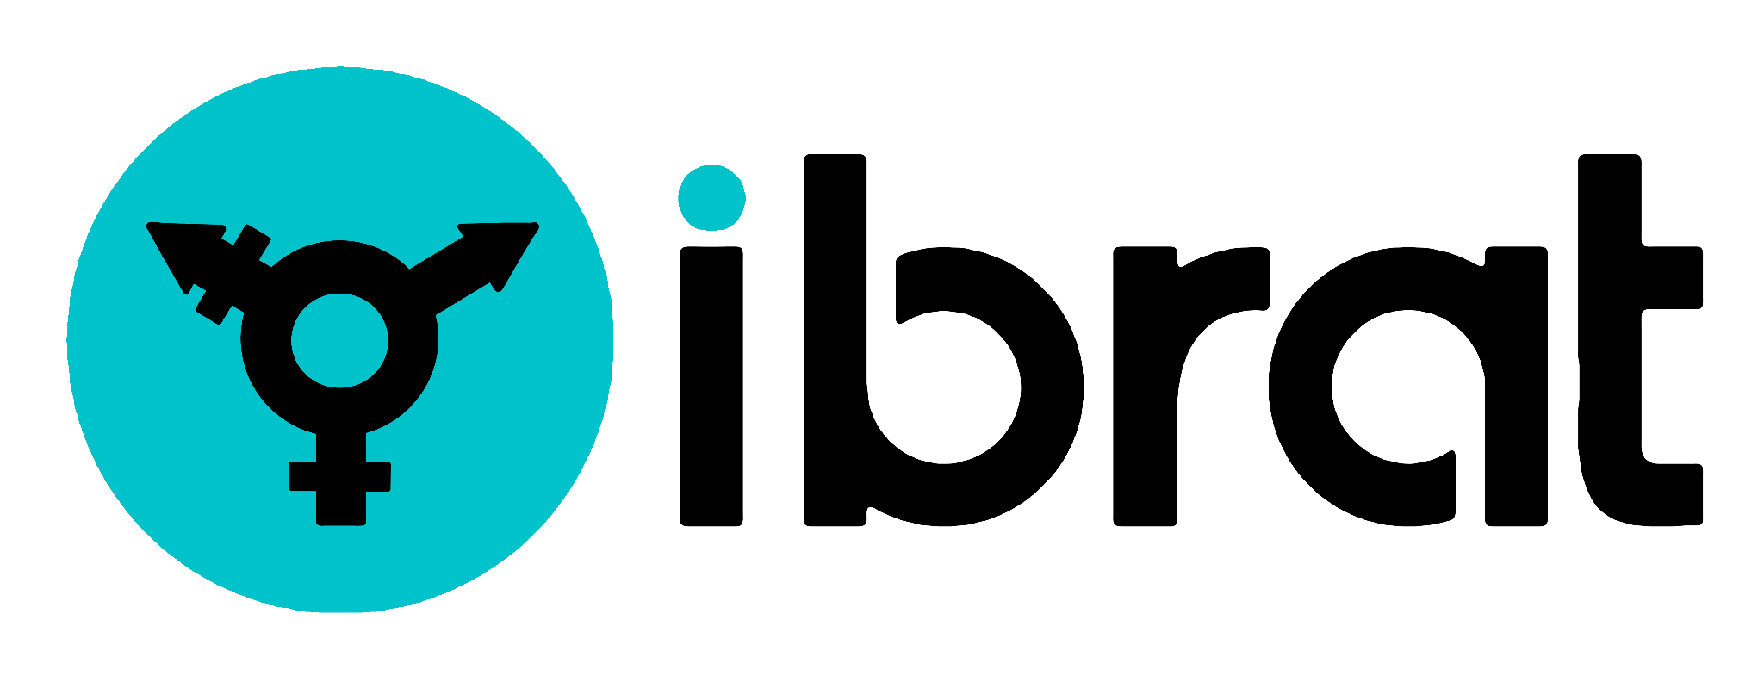
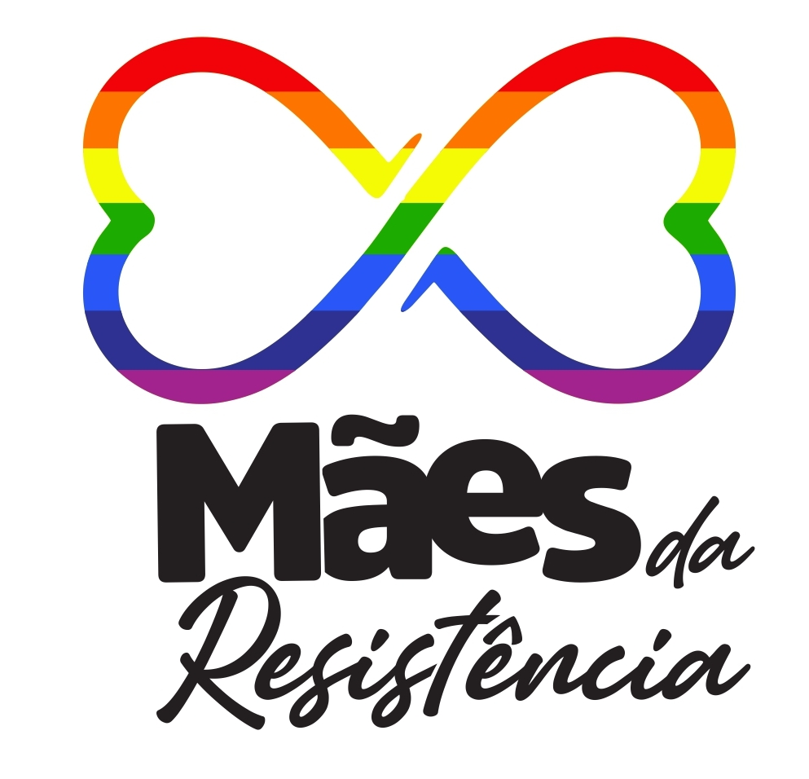


Available at: https://www.planalto.gov.br/ccivil_03/leis/l8069.htm, last accessed on April 08, 2025.
Available at: https://x.com/policiafederal/status/1879917782545858936/photo/1, last accessed on April 08, 2025.
Available at: https://www.brasildefato.com.br/2025/03/31/ampliacao-de-atendimento-a-pessoas-trans-no-sus-esta-parada-ha-tres-meses/, last accessed on April 08, 2025.

