REPORT FOR THE VIII CYCLE OF THE STATE OF CHILE TO CEDAW

Situation of Women's Rights in Chile, with emphasis on educational spaces in the Biobío Region.

Individual alternative report

Friday, August 30, 2024, Concepción and Santiago, Chile

Prepared by: Cecilia Ananías and Karen Vergara of ONG Amaranta
(hola@amarantas.org, voces@amarantas.org)
This document can be published on the OHCHR website.

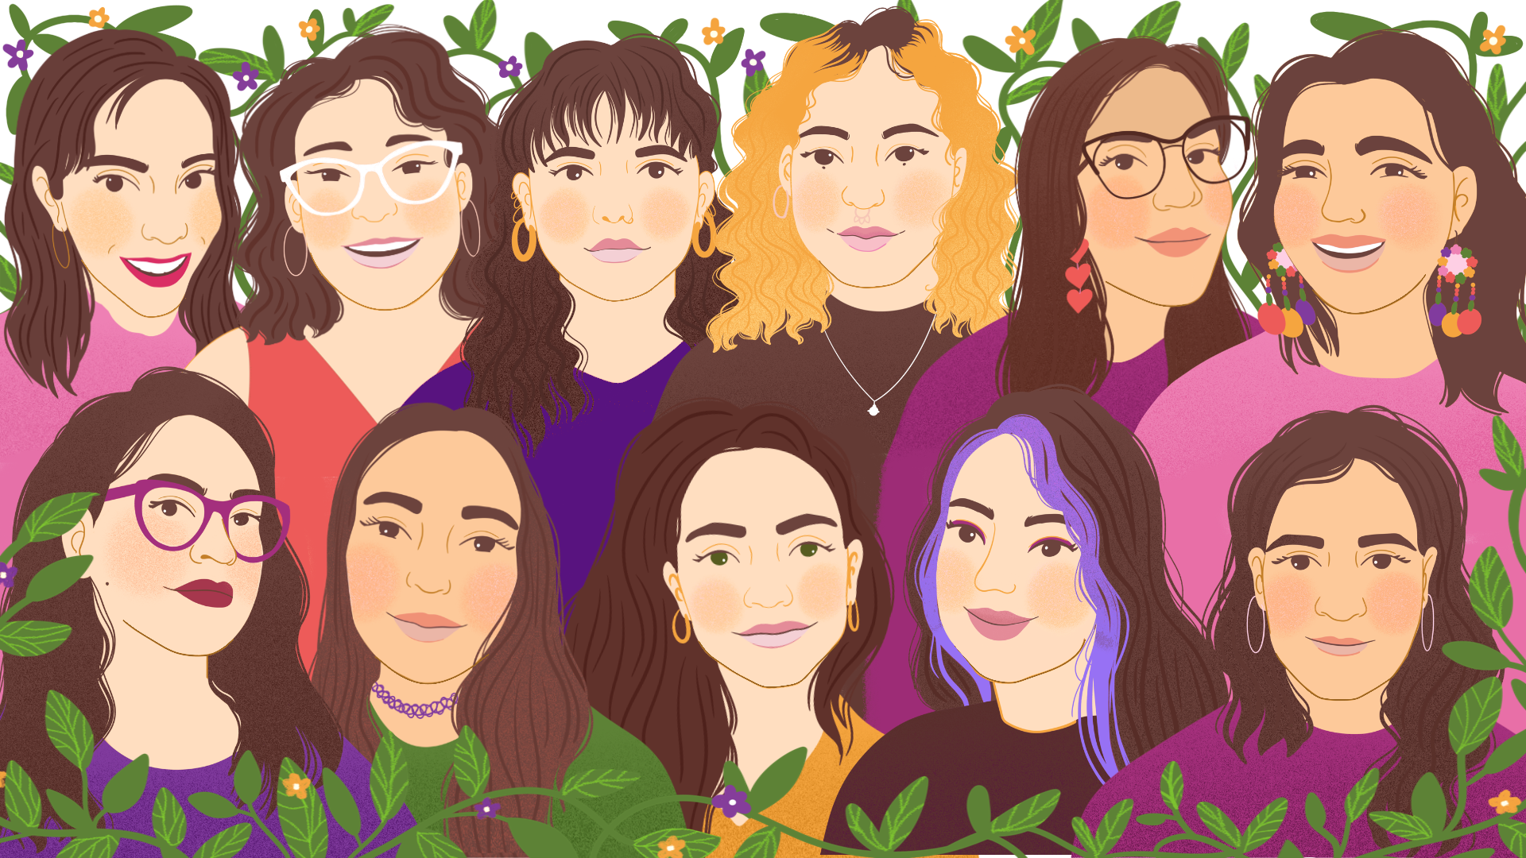

Organization Data: ONG Amaranta is a space for feminist work, activism and research against violence and inequalities. The organization was founded in Concepción, Chile, in March 2018; today, it is made up of 11 compañeras and, although its roots remain in Concepción, it is also nourished by the work of compañeras who are in Chillán, Linares and Santiago.

We carry out feminist popular education to prevent and address gender-based violence with multiple communities and territories; along with this, we carry out research with a feminist perspective; we advocate for the creation of intersectional laws and public policies; and we use different means and trades to bring knowledge and struggles horizontally to the communities. The NGO applied for ECOSOC consultative status, but its application is still under review.

INTRODUCTION

This report reports on the main difficulties faced by women, young women and girls in living a life free of discrimination in Chile, with emphasis on the Biobío Region. In addition, it formulates recommendations to advance in their respect and guarantee based on the latest participations and reports of the State of Chile before the CEDAW.

It should be noted that the main source of information for this report is the Lilén Program Report , which analyzes and summarizes two years working in high schools in Biobío. This information will be complemented by other studies that the organization has conducted in the area of Technology and Gender, in addition to the observations made based on a cycle of workshops on gender violence facilitated by technology in the Jorge Otte special school in the commune of San Joaquín, Metropolitan Region, focused on Deaf and Deaf girls and boys .

The Lilén program was a project implemented between 2022 and 2024 in public high schools in Biobío. Its main objectives were: to identify, prevent and address gender violence and inequity at the school level, facilitate access to comprehensive sexual education, address cases of discrimination and harassment, and encourage civic participation among young people. Its methodological basis was a cycle of face-to-face educational workshops, with tools from popular education. The Lilén Program directly benefited approximately 1,800 students and 180 teachers and support staff. Indirectly, the materials, graphic campaign and contents have been shared by more than 5 thousand people. For the preparation of the final report, data was collected based on the reports, reflections and analysis of the workshop facilitators.

Article 3: Ensuring the full development and advancement of women

As stated in Article 3 of CEDAW, States Parties shall take in all fields, in particular in the political, social, economic and cultural fields, all appropriate measures, including legislation, to ensure the full development and advancement of women, for the purpose of guaranteeing them the exercise and enjoyment of human rights and fundamental freedoms on a basis of equality with men.

Among the different situations that we can observe as workshop leaders and facilitators of educational instances within the Lilén program, and the cycle of workshops at the Jorge Otte special school, is the lack of accessibility to specific information on what to do when faced with violence experienced in the context of intimate partner relationships, and also by strangers, both in person and digitally . In deaf girls, and in general, in women with disabilities, these types of situations are not identified at first sight, noting the absence of public and educational policies aimed at raising awareness of the different forms of violence, and how they can be named and identified, considering the language barrier.

Recommendations
- Strengthen legislation and public policies for the protection and promotion of the rights of women with disabilities.
- Create and implement educational and awareness programs on gender-based violence, both in face-to-face and digital environments, that are accessible to Deaf women and girls, ensuring the use of sign language and other inclusive means of communication.
- Implement specific training programs for teachers in the area of disability. These programs should focus on identifying and responding to different forms of gender-based violence, with special attention to language and communication barriers faced by women with disabilities.

Article 5: Changing socio-cultural patterns

- As indicated in Article 5 of CEDAW, States Parties must take measures to modify the sociocultural patterns of behavior of men and women in order to move towards gender equity; at the same time, this article indicates that family education should aim at co-responsibility for child-rearing and care work.

- One of the first problems we identified during the execution of the Lilén Program , is that there is an ageist conception that the new youth are devoid of gender stereotypes just because they are young; however, adolescents are permeated by society, reproducing long-standing biases and inequalities at a cultural level in our country. Therefore, during the implementation of this project, several reflections that correspond to what we call "conservative thinking" were detected.

- This conservative thinking is manifested in the normalization of the fact that domestic and care work falls only on women. In fact, there were already female students who were housewives or who had to take care of their younger siblings at home. For example, in a high school in the semi-rural area of Arauco: "when discussing sexism, reticence is observed, repeating discourses that seek to reduce the structural inequality between men and women to the personal decisions of the latter. For example, ideas such as 'women stay at home because they want to', despite the figures presented on this subject".

- The Lilén Program also gave workshops on Non-Sexist Education and Non-Discrimination to more than 180 teachers from three different educational establishments, corroborating that teachers also replicate biases. In general, we found that the teachers were quite conservative, with no training in gender perspective and who had misconceptions about feminism and gender violence, as well as resistance to learning about the subject. It was common that they did not know concepts such as "sexual education", "gender violence" and concepts associated with the LGBTIAQ+ community. In a high school in Penco, for example, myths about feminism prevailed and they felt that gender inequality and stereotypes had already been overcome, despite the fact that these problems were reflected daily in their students.

- Although we are facing a government with a self-styled feminist policy that has tried to incorporate the gender perspective in certain aspects -such as research, studies and applications for funds and scholarships-, to date there is no program that transversely addresses the changes in socio-cultural patterns to advance towards equity. On the contrary: between the advance of conservative discourses in social networks (where the concept of "traditional wives" and "women of value" has been popularized) and the affectations in access to work suffered by women during the COVID-19 pandemic, we can speak of setbacks. Therefore, the State has not complied with what is stated in the fifth article of the CEDAW.
- In terms of co-responsibility for childrearing, although the State has programs such as Chile Crece Contigo, which offers comprehensive and personalized attention to pregnant women and their companions at different stages of the childrearing process, the parental or male postnatal leave is insufficient -5 working days and, if it is to be extended, days must be subtracted from the mother's postnatal leave, which has been requested in 0.2% of cases -, which means that childrearing and care continue to fall on women, with the economic inequalities and the physical and psychological effects that this entails.
- Currently, there is no educational material focused on girls and adolescents that is accessible and focused on addressing gender gaps and how they impact the reproduction of the spiral of violence. To a large extent, it depends on the individual actions of the teaching staff to install these topics in an accessible way, without having specific material at the educational level. This is directly related to point 11, since if there is no gender perspective and non-sexist education in the teacher, biased and/or sexist behaviors will continue to be replicated.

Recommendations

- Incorporate gender training into the teaching career in a transversal and measurable way. It should not be addressed only in an isolated or particular way (as is the case with the current seminars, non-sexist education workshops or complementary modules of voluntary participation), but should be mainstreamed both for teachers in training and those who have already graduated.

- Establish a working group that will result in the implementation of public policies in the short, medium and long term in conjunction with state universities and members of the CRUCH, to ensure the incorporation of the gender perspective and non-sexist education in teaching careers and training studies such as master's and doctoral degrees associated with education.
- Generate public policies and communication campaigns aimed at changing sociocultural patterns in a transversal and systematic manner in Chilean society, with special emphasis on rural or peripheral territories, which tend to be left behind.

- Facilitate training and discussion spaces, both at school and citizen level, to rethink gender stereotypes and inequalities in Chilean society, especially in the peripheries of the territories, decentralizing access to education on the subject.
- Develop and implement accessible and gender-sensitive educational materials for girls and adolescents. These materials should be available to girls and adolescents at all educational levels and should be accompanied by adequate training for teachers to ensure gender-sensitive and non-sexist teaching. This will ensure that education actively contributes to the transformation of behaviors and stereotypes, reducing the reproduction of the spiral of violence from an early age.

- Modify the current Law 20.545 that modifies the norms on maternity protection, so that there is an ethical male postnatal leave, which allows a true co-responsibility of the care and domestic work involved in raising a son or daughter, especially in the first months of life.

Article 10: Elimination of stereotyped concepts

As stated in Article 10 of CEDAW, States Parties must take measures to eliminate stereotyped concepts of male and female roles at all levels and in all forms of education (item C).

However, as mentioned in the previous article, during workshops in the Biobío Region we met teachers who were not trained in gender perspective and who replicated inequalities and stereotypes in their teaching.

On the one hand, there was a rather complex experience in a high school in Concepción, where, during the workshop, there were teachers who constantly interrupted the facilitators and were defiant with them, questioning the use of non-sexist and inclusive language, the teaching of Sex Education and Circular 182 -which addresses the rights of trans students in Chile-; subsequently, this experience resulted in some teachers trying to hinder the implementation of workshops with a gender perspective that were being offered in the establishment to students.

While in another educational center in Arauco -a semi-rural area-, although there was greater openness to dialogue on the subject, there were teachers who admitted that they treated women and men differently in their areas, especially in masculinized technical careers such as metallurgy, and there was even a teacher who stated that trans people were victimized when they reported discrimination. In general, there was resistance and ignorance about concepts of sexual diversity in this area.

In addition, in another high school in Penco, many myths about feminism and the gender perspective were also detected in teachers during the workshops, although the most serious case was that of a teacher with racial bias, who at the end of a workshop declared that "the black race had always been slaves", inferiorizing people of this origin
.

In the case of the students, not only were gender inequalities and stereotypes normalized, but they had already been transformed into violence. Of the 21 courses or groups of volunteer students with whom we worked, there was not one in which we did not identify a case of gender-based violence. The most frequent were sexual harassment against female students - on the street and also within the establishment by peers -, slut-shaming - humiliation of female students by their peers just for living their sexuality -, cases of rape/grooming, non-consensual dissemination of intimate images and cyber-bullying through confession groups on social networks. In general, there was a feeling of abandonment, of not being able to do anything about these situations or not knowing how to report them.

In addition, we highlight that in 2 of the 8 high schools with which we worked there were recent cases of femicides of former female students. And in one of them a student was kidnapped while we were executing the project. This speaks of how gender stereotypes have not been eradicated and, as a result, the bodies of girls, adolescents and women continue to be an "object in dispute" to be conquered, humiliated and violated.

It should be noted that female students were more aware of these issues, but it was very difficult for men to participate in the workshops (by attending and/or speaking), which maintains the unequal structures that sustain these forms of violence.

This problem is also transferred to the digital space. During the pandemic, ONG Amaranta conducted research on technology-facilitated gender violence, surveying more than 500 women in the 16 regions of Chile, the results of which are summarized in a scientific article . Of these, 73.8% had suffered some form of violence in the digital space, the most frequent attacks being harassment (25.8%) and threats of sexual assault or death (22%).

In general, in the digital space there is a ridiculing of the struggles for women's rights, so that if a woman writes from this discourse or claims to be a feminist, she will receive aggressive mockery, humiliation, threats and other attacks. Violence is often hidden under "jokes", such as sending women "to the kitchen, where they belong", reproducing gender stereotypes. Among multiple testimonies, one of the respondents declared having been treated as a "whore" and "easy" for being a feminist woman who uploads images of her body for artistic purposes; while another declared having a second profile on social networks in which she uses the photo of a mother and her children and just for using this "traditional" image, she received much less hate than if she had the same opinion with her real photograph.
Recommendations

- Generate a National Plan that transversally addresses non-sexist education and communication, in order to move towards a more gender-equitable society. This plan should cover gender stereotypes and inequalities and be linked to a National Comprehensive Sex Education Plan, in order to promote healthy sex-affective relationships free of violence.
- Ongoing training and sensitization of teachers and school communities in general on gender and non-discrimination issues.
- Through programs or campaigns, promote women's access to traditionally male-dominated areas of work or knowledge, including technical education
.
- Generate and promote programs that educate about digital security and coexistence, with a gender perspective and from a non-adult-centric perspective, especially when dialoguing with children and youth.
- Enact the Digital Violence Law, which has been stuck in Congress since 2021, despite the fact that it was given urgent status, and incorporate into it the new forms of violence that have arisen since then, such as the case of deep fakes -generation of false sexual material of women through the use of artificial intelligence-.

Article 10 and 16: Family Planning Education

Both Article 10(H) of CEDAW and Article 16 indicate that States Parties must provide access to specific information materials that contribute to ensuring the health and well-being of the family, including information and advice on family planning and access to information, education and the means to enable them to decide freely and responsibly on the number and spacing of their children and to have children.

Although sexual anatomy, reproduction and sexually transmitted infections are discussed in Chilean school education, this is still done from a biologicist approach, without correct tools and methodologies, which does not solve all students' doubts and falls short of comprehensive sexual education.
- In several schools, students did not handle basic sex education concepts such as "coitus", "oral sex", "vulva", "pleasure" and "consent". Meanwhile, in a high school in Concepción, it was common for male students to throw away or abandon the educational material on menstruation due to embarrassment, disgust or rejection of the subject.

- From the students, there was much interest in topics such as contraception (including the use of emergency contraception methods), body diversity (including the diversity of penis and vulva shapes and the genitalia of intersex people) and to learn about other barrier or care methods, such as thimbles, vagina condoms, lubricants and mouth masks.
- Another topic that attracted their attention and that came up in several workshops was abortion, given that in their environment they already knew of cases of spontaneous abortions, as well as clandestine abortions. In general, they did not know about the current Chilean Three-Case Abortion Law, since it has a clause that prevents the dissemination of information about it.

It should be noted that, although their schools talk about sexually transmitted infections, there are still many doubts and myths about HIV/AIDS, which we even detected in their teachers. In fact, none of the high schools knew how retroviral treatments, pre-exposure prophylaxis (PrEP) or the concept of undetectable and untransmissible HIV worked.

Another point that caught the attention of the LILEN Program team is that those establishments where there was more resistance to receive the program were also the ones that had more problems. For example, a high school in Coronel asked to review all the workshops focused on Sexual Education before they were held, for fear of complaints from tutors; but when the program was finally given the green light, the facilitators found that there were high school students who were already fathers and mothers and who had problems reconciling their maternity and paternity with their studies; in other words, they were late in educating about sexuality
.
Recommendations

- Promote as a matter of urgency the National Policy on Comprehensive Sex and Affective Education. This policy should not only cover the education of children and young people, but also the whole school community, including teachers, para-teachers, administrative staff, mothers, fathers and other guardians.

- Promote communication and educational strategies to raise awareness among the population of existing laws on harassment (sexual harassment in the workplace and street harassment), so that complaints are received effectively. In addition, train police and prosecutors for an effective and non-revictimizing attention.
- Facilitate spaces for literacy in comprehensive sexual education for adults who have not had access to it.
- Modify the section of the current Chilean Three-Case Abortion Law that prevents the dissemination and education of this law, so that the population knows in which situations to resort to this law and how it works
.
- Regulate the complete decriminalization of abortion in Chile and eliminate obstacles to access this sexual and reproductive right, such as the indiscriminate use of conscientious objection, used by entire public hospitals to refuse to perform abortions even under the current legal grounds (see alternative report by Corporación Miles).

Sepúlveda, Paulina (October 20, 2021). Postnatal parental leave law turns a decade old and only 0.23% of men have used it: Why are fathers not involved in the care of their newborns? La Tercera: https://www.latercera.com/que-pasa/noticia/ley-de-posnatal-parental-cumple-una-decada-y-solo-023-de-hombres-lo-ha-usado-por-que-los-padres-no-se-involucran-en-cuidado-de-sus-hijos-recien-nacidos/FL2J7OF36RCUHMP4CVESWZ6SR4/#
Ananías, Cecilia (August 9, 2024). After two years of implementation of the Lillén Program in Biobío: Lessons learned, problems and pending challenges. Amarantas: https://amarantas.org/wp-content/uploads/2024/08/gran-informe-de-cierre-de-lilen.pdf
Ministry of Labor and Social Security (2011). Law 20545. Modifies the norms on maternity protection and incorporates the postnatal parental leave: https://www.bcn.cl/leychile/navegar?idNorma=1030936&buscar=ley%2B20.545
Ibidem
Ananías, Vergara, Monsalve, and Barra (2023) Gendered digital violence in Chile: a study during the COVID-19 pandemic. Sexuality, Health and Society: https://doi.org/10.1590/1984-6487.sess.2023.39.e22306.a.es
Vergara, Karen (August 26, 2024). Gendered digital violence and hearing impairment: How do we name what is not taught? Derechos Digitales: https://www.derechosdigitales.org/24330/violencia-digital-de-genero-y-discapacidad-auditiva-como-nombramos-lo-que-no-se-ensena/
Ibidem

