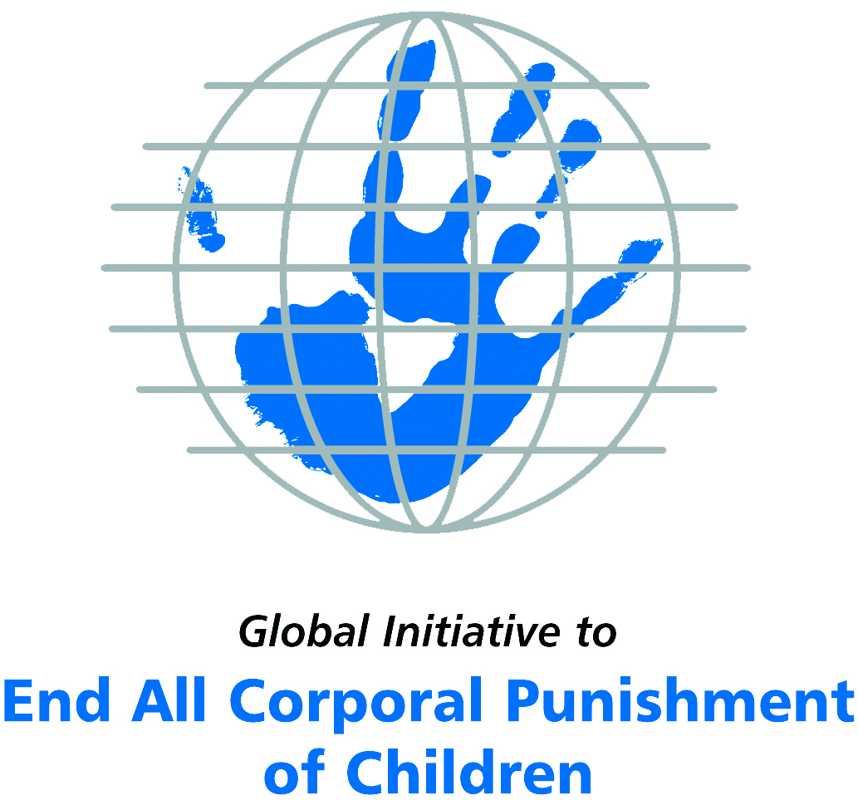
Briefing on Sudan for the Committee on the Rights of Persons with Disabilities, 8th Pre-Sessional Working Group, September 2017
From the Global Initiative to End All Corporal Punishment
of Children, July 2017

(a) About the Global Initiative to End All Corporal Punishment of Children
1. The Global Initiative (www.endcorporalpunishment.org) promotes universal prohibition and elimination of corporal punishment in fulfilment of states’ obligations under the UN Convention on the Rights of the Child and other international treaties. Our aims are supported by UNICEF, UNESCO, human rights institutions and international and national NGOs. Since 2002, the Global Initiative has regularly briefed the Committee on the Rights of the Child on this issue, and since 2004 has similarly briefed the Committee Against Torture, the Committee on the Elimination of Discrimination Against Women, the Committee on Economic, Social and Cultural Rights, the Human Rights Committee and the Human Rights Council; we have briefed the Committee on the Rights of Persons with Disabilities since the beginning of its work.

(b) Summary
2. Corporal punishment of children in Sudan may be unlawful as a sentence for a crime, but it is not yet prohibited in the home, in alternative care and day care settings, in schools and in penal institutions, in violation of the fundamental right of all children to protection from corporal punishment and other cruel or degrading forms of punishment.
3. With reference to articles 7, 15, 16 and 17 of the Convention on the Rights of Persons with Disabilities, and in light of the particular vulnerability of children with disabilities to corporal punishment by adults, the jurisprudence of the UN treaty bodies, the emphasis on eradicating this form of violence given by the UN Secretary General’s Study on Violence against Children and the importance of the issue to achieving target 16.2 on ending violence against children in the 2030 Sustainable Development Goals, we hope the Committee on the Rights of Persons with Disabilities will:
- include the issue of corporal punishment in its List of Issues for Sudan, in particular asking: “what steps have been taken to ensure that domestic legislation fully protects all children from violent punishment and explicitly prohibit its use in all settings?”;
- recommend to the Government of Sudan, in the Committee’s concluding observations on the initial report, that “prohibition of corporal punishment of all children in all settings is drafted and enacted as a matter of priority and that measures are put in place to ensure the law is properly implemented”.

(c) Detailed briefing
The right of children with disabilities not to be subjected to corporal punishment
4. The Convention on the Rights of Persons with Disabilities confirms that children with disabilities should enjoy all human rights and fundamental freedoms on an equal basis with other children (art. 7). The Convention also states that all persons have the rights to freedom from torture or cruel, inhuman or degrading treatment or punishment (art. 15), to freedom from exploitation, violence and abuse within and outside the home (art. 16) and to respect for their physical and mental integrity (art. 17). The jurisprudence of treaty monitoring bodies, led by the Committee on the Rights of the Child monitoring the Convention on the Rights of the Child, is clear that these rights put an obligation on states parties to prohibit and eliminate all corporal punishment of children, including within the family. However, Sudan’s state report does not address this obligation and does not mention corporal punishment.
5. As confirmed in the UN Secretary General’s Study on Violence against Children, children with disabilities are particularly vulnerable to violence, including corporal punishment, and corporal punishment is a significant cause of impairment among children. Yet the obligation to prohibit corporal punishment is frequently ignored or evaded by governments. The near universal acceptance of violence in childrearing together with deeply held views that parents and other adults have a “right” to physically punish children can challenge efforts to achieve prohibition. It also means that corporal punishment – at least to some degree – is not readily perceived as violence in the same way as, for example, sexual and other socially unacceptable forms of violence.
6. The newly adopted Sustainable Development Goals under the 2030 Agenda include target 16.2 on ending all forms of violence against children. Violent punishment is the most common form of violence against children: ending it through the adoption and implementation of legislation prohibiting it in all settings including the home is critical.

The legality of corporal punishment of children with disabilities in Sudan
7. Corporal punishment of children in Sudan may be unlawful as a sentence for a crime, but children with disabilities may lawfully be subjected to physical punishment in all other settings: the home, alternative care, day care, schools and penal institutions.
8. Corporal punishment is lawful in the home. Sudan did not declare independence from the UK until 1956, so the English common law defence of “reasonable chastisement” is applicable. Provisions against violence, inhuman and degrading treatment and abuse in the Child Act 2010, the Interim National Constitution of the Republic of the Sudan 2005 and other laws are not interpreted as prohibiting all corporal punishment in childrearing. In 2012, Rules under the Child Act were being drafted: we have no further information. At state level, all states have adopted constitutions which provide for child protection. Specific child legislation has been adopted in the states of the Red Sea, Kassala, South Kordufan, West Darfur and South Darfur; in 2010 child bills were under discussion in the states of Blue Nile, North Darfur and Gezira.
9. Corporal punishment is lawful in alternative care settings. There is no explicit prohibition of corporal punishment: it is lawful as for parents.
10. Corporal punishment is lawful in early childhood care and in day care for older children, including for children with disabilities. Corporal punishment is lawful as in the home.
11. Corporal punishment is partially lawful in schools. At federal level, the Child Act prohibits “cruel penalties” in school (art. 29(1)) but does not explicitly prohibit all corporal punishment. Article 29(2) of the Child Act calls for the Ministry of Instruction and General Education to specify the sanctions for contravening article 29(1), but as of February 2017 this requirement had not yet been fulfilled. Corporal punishment is explicitly prohibited in schools in Khartoum State under Decree No. 10 (2010).
12. Corporal punishment is lawful as a disciplinary measure in penal institutions. The Criminal Procedure Act 1991 states that an arrested person “shall be treated in such a way, as may preserve the dignity of the human being” and shall not be hurt physically or mentally (art. 83), but there is no explicit prohibition of corporal punishment in this or the Child Act 2010. In 2010, legislation on juvenile justice was being developed.
13. Corporal punishment is unlawful as a sentence for crime. The effect of the Child Act 2010 on the legality of corporal punishment as a sentence for crime is unclear. In sentencing a child the court must “give due regard” to the principle that “the sentence of whipping is not inflicted on the child” (art. 77), but it is not clear that giving “due regard” amounts to prohibition of judicial whipping in all cases, including as hudud. The Act does not prohibit other forms of corporal punishment, such as amputation and wounding as retribution, which may be imposed for hudud offences under the Criminal Code 1991 (e.g. see arts. 28, 29, 30, 31, 32 and 168). The Child Act 2010 states that it prevails over any other law where there is inconsistency (art. 3), which was confirmed by the Supreme Court in relation to the provision prohibiting sentencing children to the death penalty.
14. However it is not clear that this prevalence principle applies to hudud offences. In 2014, Human Rights Watch reported that girls and women continue to be subjected to judicial flogging and other humiliating punishments. In 2015, girls aged 17 were reportedly among those facing whipping of 40 strokes for the crime of “indecent dress” under article 152 of the Criminal Code 1991. In reporting to the Human Rights Committee in 2014, the Government defended the legality of judicial corporal punishment, including flogging and amputation, stating that these punishments “stem from the national belief and creed” and are “imposed in accordance with the law for legitimate public and private interests and safeguarded by all the means of due process of law”.

Recommendations by human rights treaty monitoring bodies and during the UPR
15. The Committee on the Rights of the Child has raised concerns about corporal punishment of children in Sudan and recommended it be prohibited four times – twice in 1993, again in 2002 and most recently in 2010.
16. The Human Rights Committee has three times recommended abolition of corporal punishment in Sudan – in 1997, 2007 and 2014.
17. In 2014, the African Committee of Experts on the Rights and Welfare of the Child recommended to Sudan that corporal punishment of children be prohibited in all settings.
18. During the Universal Periodic Reviews of Sudan in 2011 and 2016, the Government rejected recommendations to prohibit corporal punishment.

Briefing prepared by the Global Initiative to End All Corporal Punishment of Children
www.endcorporalpunishment.org; info@endcorporalpunishment.org

Pinheiro, P. S. (2006), World Report on Violence against Children, Geneva: United Nations. See also Krug E. G. et al (eds) (2002), World Report on Violence and Health, Geneva: World Health Organisation
Information provided by the Child Rights Institute, February 2017
Human Rights Watch (2014), World Report 2014, NY: HRW
Reported in The Guardian, 14 July 2015, http://www.theguardian.com/world/2015/jul/14/sudan-christian-women-40-lashes-trousers, accessed 23 July 2015
12 May 2014, CCPR/C/SDN/Q/4/Add.1, Reply to list of issues, para. 16
18 February 1993, CRC/C/15/Add.6, Preliminary observations on initial report, para.7; 18 October 1993, CRC/C/15/Add.10, Concluding observations on initial report, paras. 4 and 17; 9 October 2002, CRC/C/15/Add.190, Concluding observations on second report, paras. 35, 36 and 70; 22 October 2010, CRC/C/SDN/CO/3-4, Concluding observations on third/fourth report, paras. 39 and 40
19 November 1997, CCPR/C/79/Add.85, Concluding observations on second report, para. 9; 29 August 2007, CCPR/C/SDN/CO/3, Concluding observations on third report, para. 10; [July 2014], CCPR/C/SDN/CO/4, Concluding observations on fourth report, para. 16
[December 2014], Concluding observations on initial report, para. 23
16 September 2011, A/HRC/18/16/Add.1, Report of the working group: Addendum, paras. 23 and 24; 11 July 2016, A/HRC/33/8, Report of the working group, para. 141; 9 September 2016, A/HRC/33/8/Add.1, Report of the working group: Addendum, para. 140(20)

