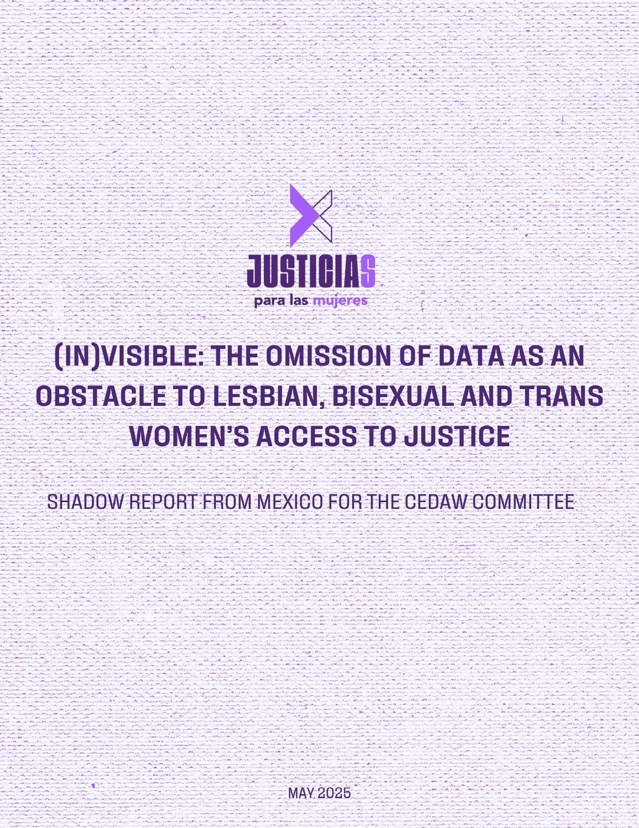

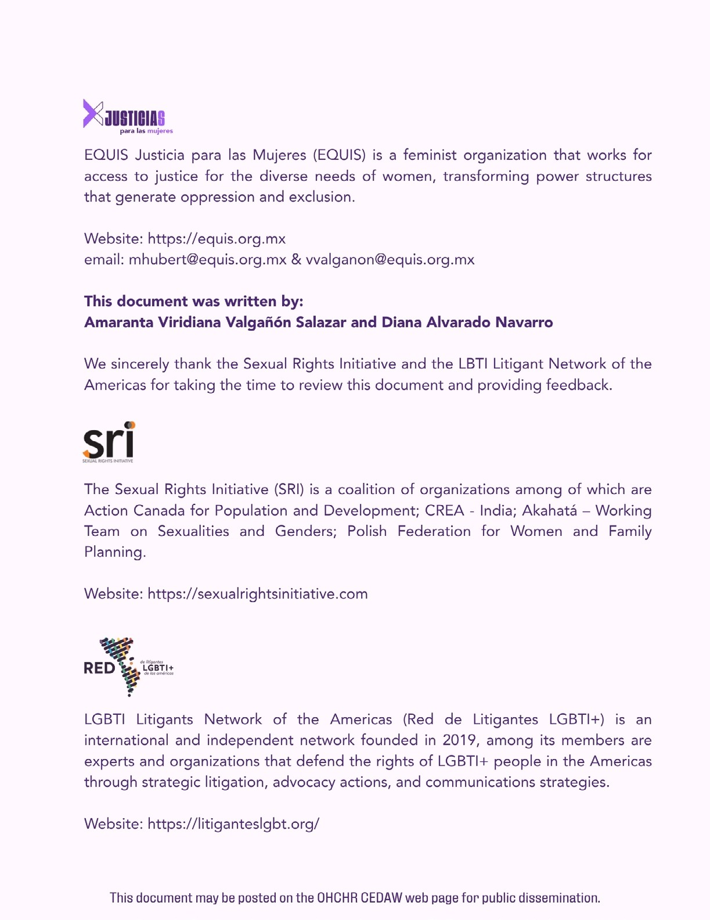



Introduction 1
Absence of regulations on the collection of LBT women’s data wi-
thin the judiciary 4
Data protection concerns as a barrier to identifying LBT women 5
Lack of disaggregation of LBT data in criminal justice and family law 7
The lack of filters in the search systems for LBT-related rulings 9
The uncertainty surrounding the “absence” of LBT-related rulings 10 The absence of standardized criteria for cases involving LBT women 11
Recommendations 13

Introduction
- EQUIS Justicia para las Mujeres is a feminist civil society organization based in Mexico City. Since 2011, it has worked to advance access to justice for diverse groups of women by promoting the transformation of the structures that produ- ce oppression and exclusion. Our work is structured around three core thematic areas: (i) prevention and protection from gender-based violence; (ii) the crimina- lization of women and punitive policies; and (iii) justice with equality and without discrimination.

- The information we submit for your consideration concerns the implementa- tion of Article 2 of the Convention on the Elimination of All Forms of Discrimina- tion against Women (CEDAW) in Mexico, particularly regarding the State’s obli- gation to adopt appropriate measures to eliminate gender-based discrimination in all its forms.This report specifically focuses on the lack of data production, disaggregated statistics, and information by the Mexican judicial system that would allow for the identification, recognition, and addressing of the barriers to access to justice faced by lesbian, bisexual, and transgender (LBT) women in the country.

- In accordance with the provisions of Article 2, paragraphs (b) and (c) of the CEDAW, the Mexican State is obligated to adopt appropriate measures to pro- hibit discrimination against women and to establish legal protection through national courts and other institutions against all acts of discrimination.

- On the other hand, General Recommendation No. 28 establishes that, in or- der to understand the scope of States’ obligations, the approach should be ba- sed on an intersectional perspective and on legal instruments that help combat discrimination and violence against women:

Intersectionality is a fundamental concept for understanding the scope of States’ general obligations under Article 2. Discrimination against women on the grounds of sex and gender is inseparably linked to other factors that affect women, such as race, ethnicity, religion or beliefs, health, status, age, class, caste, sexual orientation, and gender identity. [...] States parties must recognize and prohibit these intersecting forms of discrimination in their legal instruments, as well as their combined negative impact on the women affected.1

- Similarly, within the same General Recommendation No. 28, it is emphasized that States parties must establish indicators to assess the progress and effectiveness of women’s human rights, through the design and implementation of disaggregated databases, and ensure sufficient measures to eradicate discrimination based on evidence. Specifically, the CEDAW, in its concluding observations on Mexico’s ninth periodic report, expressed concern over the lack of mechanisms to eliminate discrimination against LBT women:

b) The lack of effective mechanisms and the insufficiency of state budgets allocated for the implementation of laws on gender equality, women’s right to live free from violence, and their monitoring, have failed to end discrimination, particularly in its intersectional forms, and especially against lesbian, bisexual, and transgender women, as well as intersex persons;2

- In this regard, one of the preliminary issues raised by this Committee, prior to the submission of Mexico’s tenth periodic report, emphasizes the need for statistical and disaggregated data to understand the situation of women; however, the Mexican State limited its response to the following, without addressing the production of data concerning LBT women:

Mexico is a regional leader in statistics and in the integration of a gender and intersectional perspective in the production, analysis, and dissemination of data, contributing to public policies on gender equality.3

1 General Recommendation No. 28 on the core obligations of States parties under Article 2 of the Convention on the Elimination of All Forms of Discrimination against Women, CEDAW/C/GC/28, December 16, 2010, para. 18.
2 Final Observations on the Ninth Periodic Report of Mexico, CEDAW/C/MEX/CO/9, July 25, 2018, para. 11, subpara. b.
3 Tenth periodic report that Mexico was required to submit in 2024 pursuant to Article 18 of the Convention, CEDAW/C/MEX/10, para. 6.

- In this context, it is not enough to merely meet the declarative level for the application of a gender and intersectional perspective. On the contrary, data collection and disaggregation must be carried out with a human rights-based statistical approach (HRBSA) as established by the Office of the United Nations High Commissioner for Human Rights (OHCHR):

  - Participation. The formulation, collection, dissemination, and analysis of data must involve the population group in question (LBT women), adopting a human rights-based approach that integrates a gender perspective.4
  - Data disaggregation. It is essential to implement actions for the collection
and dissemination of disaggregated data, enabling the analysis and identifi- cation of the various interrelated forms of inequality and discrimination.5
  - Self-identification. Data collection must adhere to the principle of “do no harm,” ensuring that the State guarantees the reasonable collection, safe- guarding, and use of personal information for the benefit of the affected population.6
  - Transparency. The collected information must be clear and easily acces- sible, particularly for Civil Society Organizations (CSOs), to monitor and en- sure the State’s compliance with its responsibility to protect human rights.7
  - Privacy. The State must ensure that information is protected, private, and confidential, alongside access to information. It is the State’s duty not to dis- close individuals’ personal characteristics.8
  - Accountability. The collected, disaggregated, and analyzed data should serve to uphold and demand human rights, by both the State and Civil So- ciety Organizations (CSOs).9

- According to a decision by the Supreme Court of Justice, judicial authorities in Mexico are required to publish all their rulings through public versions.

4 See Office of the United Nations High Commissioner for Human Rights, Human Rights-Based Data Approach, 2018, p. 6.
5 See Op. cit., p. 8.
6 See Op. cit., p. 11.
7 See Op. cit., p. 14
8 See Op. cit., p. 16
9 See Op. cit., p. 18

This obligation is crucial under CEDAW, as it allows for the generation of information to collect, disaggregate, and analyze data on judicial actions in cases involving LBT women, while also strengthening citizen monitoring, transparency, and accountability within the judicial system.

- As addressed in this document, and contrary to what the State has stated, EQUIS has documented the lack of effective mechanisms for requesting and collecting disa- ggregated data on LBT women’s access to justice within the judicial system. This alig- ns with what the Inter-American Commission on Human Rights (IACHR) reported in 2018, when it highlighted the absence of data on the discrimination faced by LGBT+ individuals in Member States.10 Additionally, in its report on Violence against LGBTI persons, the IACHR pointed out the scarcity of data collection mechanisms that could
shed light on the violence faced by LGBT+ individuals.11 Together, these issues have created a structural barrier that hinders the visibility of discrimination and violence faced by LBT women. Below are the key findings:

Absence of regulations on the collection of LBT women’s data within the judiciary

- From our analysis of the 32 fundamental laws of the state and federal judiciaries in Mexico—including the respective transparency regulations—we identified that there is no explicit requirement within the Mexican legal framework for the judiciary to co- llect disaggregated data based on gender identity and sexual orientation.

- This represents an omission in complying with Article 2 of CEDAW, which requi- res the adoption of legislative measures to eliminate discrimination, as well as with General Recommendation No. 28, which calls for adequate actions to address discri- mination against LBT women. protecting women in all their diversity, particularly LBT women.

10 See Recognition of the Rights of LGBTI Persons, OAS/Ser.L/V/II.170, December 7, 2018, para. 263
11 See Violence Against LGBTI Persons, OAS/Ser.L/V/II.rev.2, November 12, 2015, para. 99.

Additionally, following the concluding observations on Mexico’s ninth periodic report, the State must address the absence of measures to protect the dignity and integrity of LBT women, with the active involvement of civil society.12

- In the list of issues and questions prior to the submission of Mexico’s tenth perio- dic report, the CEDAW Committee emphasized that access to justice for LBT women must be guaranteed without discrimination. This includes ensuring accountability in the administration of justice, which requires knowing how many cases involving LBT women are addressed by the judiciary through the systematic collection of data.13

- We draw attention to this issue because the absence of a national legal framework requiring judicial authorities to collect and disaggregate data by sexual orientation and gender identity results in several concerning consequences: (i) the invisibility of the discrimination and violence faced by LBT women; (ii) the difficulty in identifying patterns of such discrimination and violence, which limits the State’s ability to imple- ment evidence-based public policies; and (iii) the inability to build a judicial system that addresses cases from a gender-sensitive and intersectional perspective—one grounded in both quantitative and qualitative data, and capable of recognizing and protecting women in all their diversity, particularly LBT women.

Data protection concerns as a barrier to identifying LBT women

- In addition to the absence of regulatory frameworks, Equis questioned what pre- vents judicial authorities from collecting and disaggregating data. To that end, infor- mation requests were submitted through the National Transparency Platform (PNT) to the 32 state-level judiciaries, with the objective of identifying the number and type of cases involving LBT women. In response, at least five entities asserted that they do not collect such data, citing the protection of sensitive personal information. Some further argued that inquiries regarding gender identity or sexual orientation could themsel- ves constitute a discriminatory practice.

12 Final observations on Mexico’s ninth periodic report, CEDAW/C/MEX/CO/9, July 25, 2018, para. 24, subparagraph f.
13 List of issues and questions prior to the presentation of Mexico’s tenth periodic report, CEDAW/C/MEX/QPR/10, November 14, 2023, para. 4, subparagraph b.

- It is important to underscore that the rationale cited by judicial authorities is un- founded. National legislation does not prohibit the collection of sensitive data, as long as it serves to uphold or protect the rights of the individuals concerned—in this case, LBT women.14

- Under Mexican law, collecting information on sexual orientation and gender iden- tity is both justified and aligned with human rights standards, as it is essential to identify the structural inequalities faced by this population. Such efforts do not viola- te rights or amount to discriminatory practices; rather, they help uncover and make visible the barriers encountered in accessing justice, including cases of violence or bias reported to the judicial system. International standards further affirm that the collection of sensitive data is permissible, provided it respects individuals’ privacy and does not disclose their identity, either directly or indirectly.15 Likewise, we consider that judicial authorities must ensure confidentiality by safeguarding any data they co- llect in accordance with international privacy standards, and by preventing its misuse. Notably, the Federal Judiciary in Mexico has already implemented privacy protections in the publication of court rulings, particularly through its Protocol for the Preparation of Public Versions of Judgments and Decisions of Judicial Bodies in Electronic Case Management Systems.16

- Additionally, international standards establish that data collection must respect the principle of self-identification. This means that LBT women must be actively invol- ved in the process of identifying themselves, rather than being categorized through external attribution or assumptions.17

- Thus, judicial authorities that adopt a restrictive interpretation—assuming that collecting sensitive data such as sexual orientation and gender identity is inherently discriminatory18—reveal a lack of understanding of national regulations, which in fact allow the collection of such data when it serves to recognize or uphold a right.

14 Ley General de Protección de Datos Personales en Posesión de Sujetos Obligados, Section IV, Article 16.
15 See United Nations Office of the High Commissioner for Human Rights, Human Rights-Based Data Approach, 2018, p. 16.
16 See: https://www.cjf.gob.mx/transparencia/resources/proteccionDatos/ProtocoloVersionesPublica.pdf
17 See Op. cit., p. 13
18 Michoacán, Guerrero, Chiapas, Colima and Veracruz.

In this context, data collection enables access to information and justice for LBT wo- men by making visible the scope, patterns, and characteristics—regional, structural, legal, and more—of the violence and discrimination they face. It also supports the development of audits and assessments by both the State and civil society organiza- tions, and the design of public policies aimed at preventing and eliminating violence and discrimination through a gender and intersectional lens.

- It is concerning that, despite the fact that data collection is an obligation of the Mexican State under Article 2 of the CEDAW and General Recommendation No. 28 from the Committee, the State justifies its institutional inaction by appealing to a restrictive interpretation of its laws. Refusing to collect sensitive data when there is a justified reason to do so, such as the guarantee of rights, perpetuates the non-re- cognition and invisibilization of LBT women in accessing justice and defending their human rights.

Lack of disaggregation of LBT data in criminal justice and family law

- As highlighted in this report, the absence of regulations requiring judicial autho- rities to collect and disaggregate data directly impacts the administration of justice. To illustrate this, we analyzed two areas: criminal and family law, using data from the 2023 National Census on State Administration of Justice (CNIJE), which aims to gene- rate statistical and geographic information on the management and performance of the judiciary in each federal entity19.

- The findings show that in criminal matters, only 30 entities reported disaggrega- ted information by sex and crime type, from the start of the procedure to the oral trial stage. However, this data does not include sexual orientation or gender identity. In family law matters, the situation is even more concerning, as only 17 states collect sex-disaggregated data, and none disaggregate data by sexual orientation or gender identity.

- This omission by the state judiciaries contradicts Article 2 of the CEDAW, as well as General Recommendations No. 28 and No. 35 of the Committee, which instruct

19 TSee Información de Gobierno, Seguridad Pública e Impartición de Justicia, n.d., Censo Nacional de Impartición de Justicia Estatal 2022.
7

State parties to implement measures to collect data on LBT women from an intersec- tional perspective, in order to identify, prevent, and combat the discrimination and violence they face. Finally, this contradicts the information reported by the Mexican state in its tenth periodic report to the CEDAW Committee, where it states that the National Institute of Statistics and Geography collects data disaggregated by sexual orientation and gender identity—an assertion that is not reflected in the most recent CNIJE report from 2022.20

- It is also important to highlight that, in the concluding observations on Mexico’s ninth periodic report, it was pointed out that the Mexican State must have effective mechanisms for the systematic collection of data—which should include sexual orien- tation and gender identity—in order to prevent and eradicate gender-based violence against women.21 However, in the absence of this information, as civil society, we are unable to assess what the Mexican State is doing to protect LBT women, which vio- lates the principle of due diligence22. Additionally, this lack of data limits the ability to develop tools for raising awareness, both among the general population and the public officials responsible for ensuring access to justice, as the necessary data is nei- ther collected nor disaggregated to provide the evidence needed to achieve these objectives.

- In this regard, it is important to highlight the international standard for disaggre- gation in line with the Human Rights-Based Statistical Approach (HRBSA)23 in terms of understanding what is being collected. Thus, the OHCHR’s Human Rights-Based Data Approach report states that:

When possible, data should be published in a format that allows for the identification and analysis of the multiple interrelated forms of disparity and discrimination. Individuals may experience discrimination and inequality in various dimensions simultaneously (for example, in gender and disability). Analyzing data at the subgroup level allows for a better understanding of the existence of multiple and interrelated inequalities.24

20 Tenth periodic report that Mexico was due to submit in 2024 under Article 18 of the Convention, CEDAW/C/MEX/10, para. 8.
21 Concluding observations on the ninth periodic report of Mexico, CEDAW/C/MEX/CO/9, 25 July 2018, paras. 24 (f) and (g).
22 General Recommendation No. 28 of the CEDAW Committee, paras. 9 and 13.
23 Human Rights-Based Approach (HRBA).– For more information, see: Office of the United Nations High Commissioner for Human Rights (OHCHR), “Human Rights-Based Approach”.
8
24 Office of the United Nations High Commissioner for Human Rights, A Human Rights-Based Approach to Data, 2018, p. 8.

- It is not enough to include variables on sexual orientation and gender identity in data collection and disaggregation; this must be accompanied by training to ensure that public servants understand these variables and carry out statistical work with a gender-sensitive, intersectional, and human rights-based approach. In this sense, data disaggregation must include not only sexual orientation and gender identity, but also acknowledge the existence of multiple, interrelated inequalities in order to understand the patterns of human rights violations that women face in Mexico, as well as how dis- crimination and violence against LBT women manifest depending on contextual factors such as geography, culture, institutions, and legal frameworks.

- Consequently, in terms of Article 2(c) of CEDAW25, the lack of available disaggre- gated data hinders effective legal protection and access to justice for LBT women in Mexico’s national courts.

The lack of filters in the search systems for LBT-related rulings

- In the absence of effective mechanisms for data collection and disaggregation, we analyzed the availability of rulings involving LBT women. To do so, we reviewed public rulings on the digital platforms of the 32 state judicial branches and the Federal Judi- ciary Council (CJF). We found that none of the 32 states offer filters that allow users to locate decisions involving LBT women. In the case of the CJF, only seven rulings related to LBT women were identified using keyword searches. However, this number does not reflect the total number of rulings involving LBT women at the federal level, nor does it exempt the authorities from their obligation to ensure accessibility through specific filters that facilitate the identification of such cases.

- This contrasts with what is stated in Mexico’s Tenth Periodic Report, in which the State claims that there has been an improvement in the ruling search systems.26 Howe- ver, contrary to the Mexican State’s claims, the legal search engines of judicial branches do not include specific filters to identify cases involving LBT women.

25 Article 2. States Parties condemn discrimination against women in all its forms, agree to pursue by all appropriate means and without delay a policy of eliminating discrimination against women, and, to this end, undertake to: [...] (c) Establish legal protection of the rights of women on an equal basis with men and ensure, through competent national tribunals and other public institutions, the effective protection of women against any act of discrimi- nation.
26Tenth periodic report that Mexico was due to submit in 2024 under Article 18 of the Convention, CEDAW/C/MEX/10, para. 32.

As a result, it becomes difficult for citizens to monitor the State’s compliance with its obligation to establish mechanisms to eliminate discrimination against women, as set forth in Article 2(c) of CEDAW and in the concluding observations on Mexico’s ninth periodic report27, thus perpetuating the exclusion of LBT women from the justice sys- tem, particularly by preventing public insight into how courts interpret and apply laws that affect them.

- This situation is concerning, as the lack of data collection mechanisms and infor- mation filters reveals a structural failure within Mexico’s judiciary. It reflects the absen- ce of institutional measures to identify, record, and disaggregate information related to sexual orientation and gender identity—particularly in the case of LBT women. This amounts to a denial of the right to access information, especially in terms of govern- ment transparency, and hinders the proper dissemination and accessibility of key data that various stakeholders need for monitoring, accountability, and the development of inclusive public policies28.

- This is particularly concerning because it reveals a lack of proper accountability from the State. On one hand, it contributes to the invisibilization of discrimination and violence against LBT women within the justice system; on the other, it prevents citizen audits aimed at monitoring, evaluating, and verifying whether the State is complying with international human rights standards in this area.

The uncertainty surrounding the “absence” of LBT-related rulings

- The lack of regulations requiring the collection and disaggregation of data rela- ted to gender identity and sexual orientation within the justice system, the ongoing refusal by judicial authorities to gather such information, and the absence of filters to identify cases based on these variables do not necessarily mean that rulings involving LBT women do not exist. However, this data gap prevents the recognition and visibi- lity of their experiences within the justice system

27 Concluding observations on the ninth periodic report of Mexico, CEDAW/C/MEX/CO/9, 25 July 2018, para. 24, subparagraph (f).
28 Cf. Office of the United Nations High Commissioner for Human Rights, A Human Rights-Based Approach to Data, 2018, p. 19.

- For this reason, we submitted access to information requests through the National Transparency Platform (PNT) to determine how many rulings involving LBT women had been issued by state and federal judicial authorities. We found that only two sta- tes provided rulings related to LBT women, and that just 18 rulings were identified nationwide. This highlights the State’s serious failure to meet its obligations regarding access to information.

- This omission highlights that judicial authorities have an obligation to identify and classify rulings involving LBT women, in accordance with Article 2 of CEDAW and General Recommendations No. 28 and No. 35 of the Committee, which require effec- tive protection against all forms of discrimination and violence. Likewise, in the list of issues and questions prior to the submission of Mexico’s tenth periodic report, the Committee emphasizes the obligation to end discrimination against women in access to justice. This includes the duty to publish and make all rulings accessible, and, in turn, to be accountable for the number of cases involving LBT women.

- In the current context, judicial authorities in Mexico do not have systematized information on rulings involving LBT women. This makes it impossible to identify the shortcomings, gaps, and areas of opportunity within the Mexican judicial system to en- sure the effective application of gender and intersectional perspectives in the process of access to justice for these women. This is particularly concerning, as the absence of such information prevents the identification of patterns of violence and discrimination faced by LBT women in the justice system, and hinders the State’s ability to conduct a proper diagnosis and produce statistical evidence to address these issues.29

The absence of standardized criteria for cases involving LBT women

- To identify the tools available to address cases involving LBT women, we submit- ted access to information requests to the 32 state-level judicial authorities to determi- ne which protocols are used in the resolution of such cases.

29 List of issues and questions in relation to the tenth periodic report of Mexico, CEDAW/C/MEX/QPR/10, 14 November 2023, para. 4(b).

- Article 2 of CEDAW requires States Parties to adopt all appropriate measures— including legislative, administrative, and judicial—to eliminate all forms of discrimi- nation, including those based on sexual orientation and gender identity. In addition, judicial authorities have a duty to ensure effective legal protection for all women, without discrimination.

- Article 2 of CEDAW requires States Parties to adopt all appropriate measures— including legislative, administrative, and judicial—to eliminate all forms of discrimi- nation, including those based on sexual orientation and gender identity. In addition, judicial authorities have a duty to ensure effective legal protection for all women, without discrimination.

- In this regard, the lack of standardized national protocols for properly addressing cases involving LBT women within the judiciary is concerning. The absence of such protocols means that the handling of these cases often depends on the discretion of individual judges or on each justice operator’s personal understanding of gender and intersectional perspectives. This increases the risk of discriminatory, revictimizing, and/or stigmatizing judicial decisions.

Recommendations

- In light of the above, we recommend that the Committee urge the United Mexi- can States to adopt the following measures:

- Amend the fundamental laws of the state-level judicial branches and the federal judiciary to establish the obligation to collect, disaggregate, and analyze data based on sexual orientation and gender identity variables, using a human rights-based statistical approach, with the highest standard of personal data protection, and with the aim of making visible the situation of LBT women in access to justice across all areas of law.
- Amend the transparency and public access to information regulations of local and federal entities in accordance with the principle of maxi- mum publicity and a human rights-based statistical approach, to establish the obligation for the judicial branches to collect, disaggregate, and analyze data based on sexual orientation and gender identity, with the aim of making visible the situation of LBT women in access to justice across all areas of law.
- Issue standardized guidelines for the collection and processing of sen- sitive data in the judiciary, based on a human rights statistical approach related to gender identity and sexual orientation, with the highest standard of personal data protection, adopting an intersectional and human rights approach, ensuring respect for confidentiality and the protection of personal and sensitive data.
- Collect, disaggregate, and analyze data in the judiciary aimed at making visible the violence and discrimination faced by LBT women, as well as identifying patterns and trends related to these issues, without being un- derstood as a discriminatory practice, but rather as an indispensable tool for the recognition and defense of human rights.
- Require ruling search systems to incorporate filters that allow for the identification of cases involving LBT individuals, based on intersectional criteria, without compromising personal data protection, in order to streng- then transparency and citizen monitoring.
- Establish gender-focused citizen observatories at the federal and state levels, with the participation of civil society organizations (CSOs), to monitor compliance with the obligations of data collection and disaggregation by the judiciary. These observatories should operate under a human rights-based statistical approach.

- Create monitoring, evaluation, and accountability mechanisms to ensu- re compliance with these obligations by the judiciary, including specific indicators on access to justice for LBT women and intersex individuals, and ensure that the design includes the active participation of civil society.
- Train the personnel responsible for the proper handling of sensitive data related to sexual orientation and gender identity, ensuring that interna- tional standards are respected with a human rights-based approach.
- Establish specialized and binding protocols for handling cases involving LBT women, applicable across all federal entities, with a gender, human ri- ghts, and sexual diversity perspective.



