

MALAYSIA
SUBMISSION TO THE UN COMMITTEE ON THE ELIMINATION OF DISCRIMINATION AGAINST WOMEN
86th Pre-Sessional Working Group, 27 Feb 2023 - 3 Mar 2023
list of issues
Amnesty International is a global movement of more
than 10 million people who campaign for a world
where human rights are enjoyed by all.
Our vision is for every person to enjoy all the rights
enshrined in the Universal Declaration of Human Rights
and other international human rights standards.
We are independent of any government, political
ideology, economic interest or religion and are funded
mainly by our membership and public donations.

contents
INTRODUCTION 4
LIMITED DATA ON THE USE OF THE DEATH PENALTY 4
the disproportionate impact of the death penalty on women and foreign nationals 4
wOMEN ON DEATH ROW: A COMMON STORY OF COERCION AND DECEIPT 6
FAIR TRIAL concerns 7
RIGHT TO PARDON 8

RECOMMENDATIONS 9

INTRODUCTION

Amnesty International submits this document in advance of the adoption of the list of issues ahead of the upcoming review of Malaysia by the UN Committee on the Elimination of Discrimination against Women. It is based on the organization’s research report Fatally Flawed: Why Malaysia Must Abolish the Death Penalty published in 2019. This submission specifically focuses on women who face the death penalty, particularly for drug-related offences, violations of their right to a fair trial, and the opacity and secrecy of the pardon process. It should not be seen as an exhaustive record of the organization’s concerns on the implementation of the Convention on the Elimination of Discrimination against Women in Malaysia.
The death penalty has been a part of Malaysia’s legal system since before the country’s independence in 1957. It is currently retained under nine laws for a total of 33 offences, including 12 for which it is imposed as the mandatory punishment. The scale of problems related to the use of the death penalty in Malaysia is significant, and women are highly overrepresented on death row. In recent years, the death penalty has been used mostly for murder and drug trafficking, and in fewer cases for firearms-related offences. Malaysia is among only 11 countries in the world where the death penalty was known to have been imposed or carried out for drug-related offences in 2021.
There is, however, an important opportunity for change. In October 2022, the government tabled amendments in Parliament to abolish the mandatory death penalty but elections were held before they could be voted on. In December 2022, a new government stated it would re-table the reforms in 2023. Amnesty International opposes the death penalty in all cases and without exception and continues to campaign for its full abolition in Malaysia and globally.

LIMITED DATA ON THE USE OF THE DEATH PENALTY
There has been some effort by present and recent governments to make publicly available more information on those held on death row in Malaysia, including on the number of women who have been sentenced to death. However, the enduring lack of transparency, including on the number of death sentences imposed and commuted through the pardon procedure, has made it impossible to adequately and independently monitor the death penalty’s implementation and fully understand its impact over the years.
Limited information occasionally released by Malaysian authorities does not fulfil their duty to be transparent in the use of the death penalty. International human rights law recognizes the importance of making public information on decisions in criminal matters and protects the right to seek, receive and impart information. UN expert mechanisms have stressed the importance of the right of access to information held by public bodies, including information on public affairs. This includes information on important public policy matters, such as the use of the death penalty, which is necessary to analyse whether this punishment is applied in a fair and non-discriminatory manner.

The disproportionate impact of the death penalty on women and foreign nationals
Amnesty International analysed information on the death row population of Malaysia based on information it received as of 22 February 2019. The picture that emerged suggested the majority of those under sentence of death by then were convicted of drug-related offences, despite the fact that such offences do not meet the threshold of “most serious crimes” to which the use of the death penalty must be restricted under international law and standards. Moreover, Amnesty International found that a disproportionate number of those on death row (44% of the total) were foreign nationals with a particular overrepresentation of women foreign nationals. According to numbers available to Amnesty International in 2019, 86% of all women sentenced to death – and 90% of women sentenced to death for drug trafficking – were foreign nationals.
Limited available information also suggested that a large proportion of those on death row came from less advantaged socio-economic backgrounds. This is particularly relevant given that safeguards in death penalty cases are especially lacking, both in law and in practice, and particularly for foreign nationals and people convicted under the Dangerous Drugs Act. Despite recent amendments to the Dangerous Drugs Act and a new legal aid scheme established in 2012 that provides legal support at the time of arrest, the vast majority of those currently on death row have not been able to benefit from these new mechanisms since they were convicted before the amendments came into effect or are denied access to such mechanisms due to their status as foreign nationals.
According to official data, by February 2019, 1,281 people were under sentence of death in Malaysia. This number increased to 1,337 by September 2022. Of all people under sentence of death, 141 were women (11% of total) and 82 of these were sentenced for drug-related offences (four Malaysian and 78 foreign nationals). These women were held in nine different facilities, the majority of them in Peninsular Malaysia with just eight of them detained in East Malaysia.
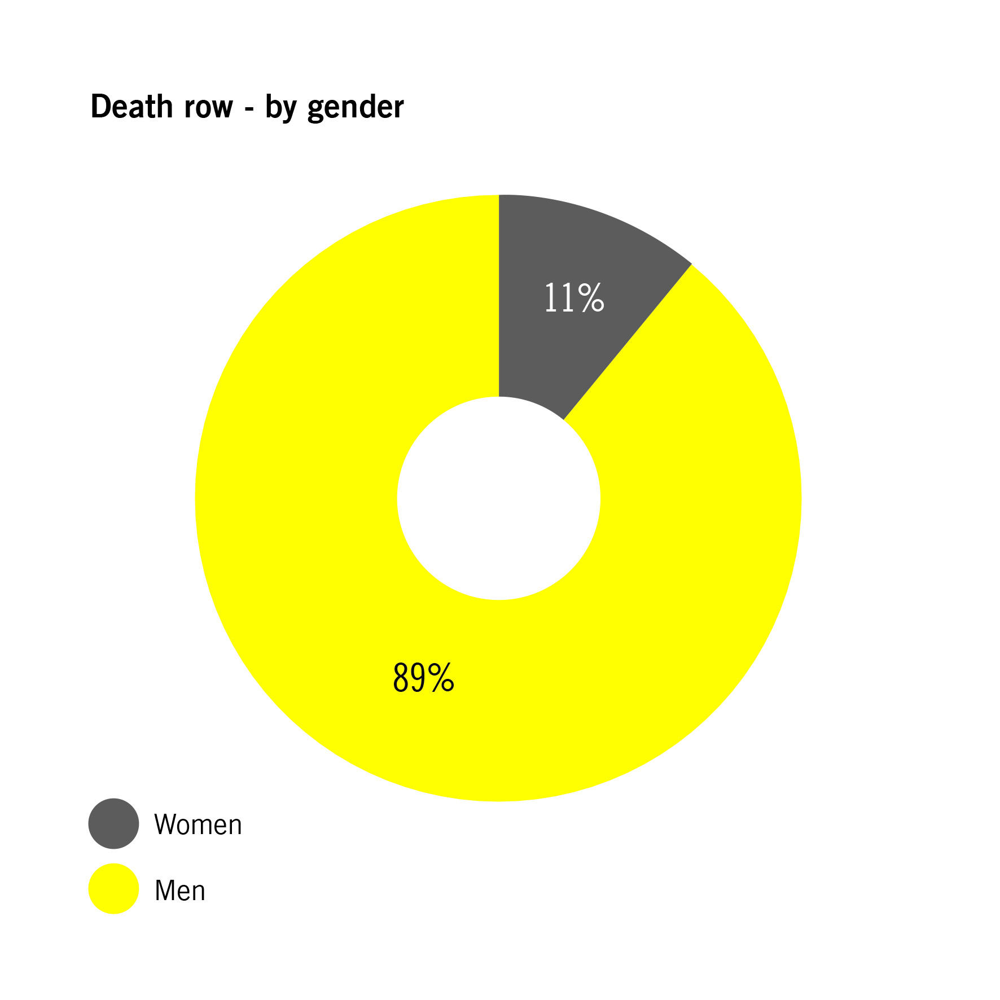
The great majority of people in death row (1,139, or 89%) were held across 17 prisons in Peninsular Malaysia, where more than two-thirds had been convicted of drug-related offences.
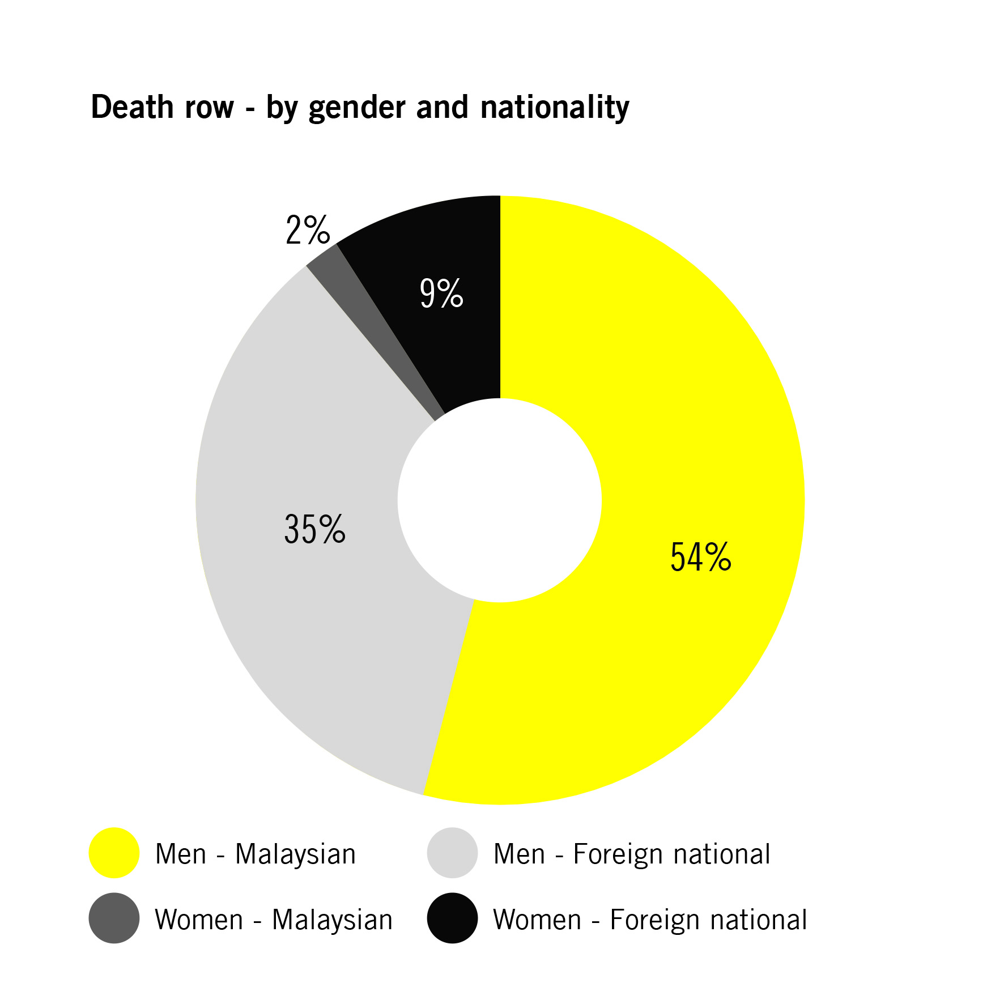
A startling 44% (568) of all those under sentence of death were foreign nationals, from 43 countries. Nationals from Nigeria made up 21% of this group, with those from Indonesia (16%), Iran (15%), India (10%), Philippines (8%) and Thailand (6%) following suit. The composition of the death row population across prisons seems to reflect this split by nationality, with limited variation.
The considerable proportion of foreign nationals assumes even greater significance when considered along the gender divide. Of the 1,140 men on death row, 39% were foreign nationals; while for women that increases to 86% (121).
A significant 73% of all those under sentence of death were convicted of drug trafficking under section 39(b) of the Dangerous of Drugs Act – an extremely high figure for an offence that does not even meet the threshold of the “most serious crimes” under international law and standards. A further 25% were convicted of murder and the remainder of offences related to use of firearms, robbery and waging war against the King or Ruler of a State, some of which are also non-lethal offences.
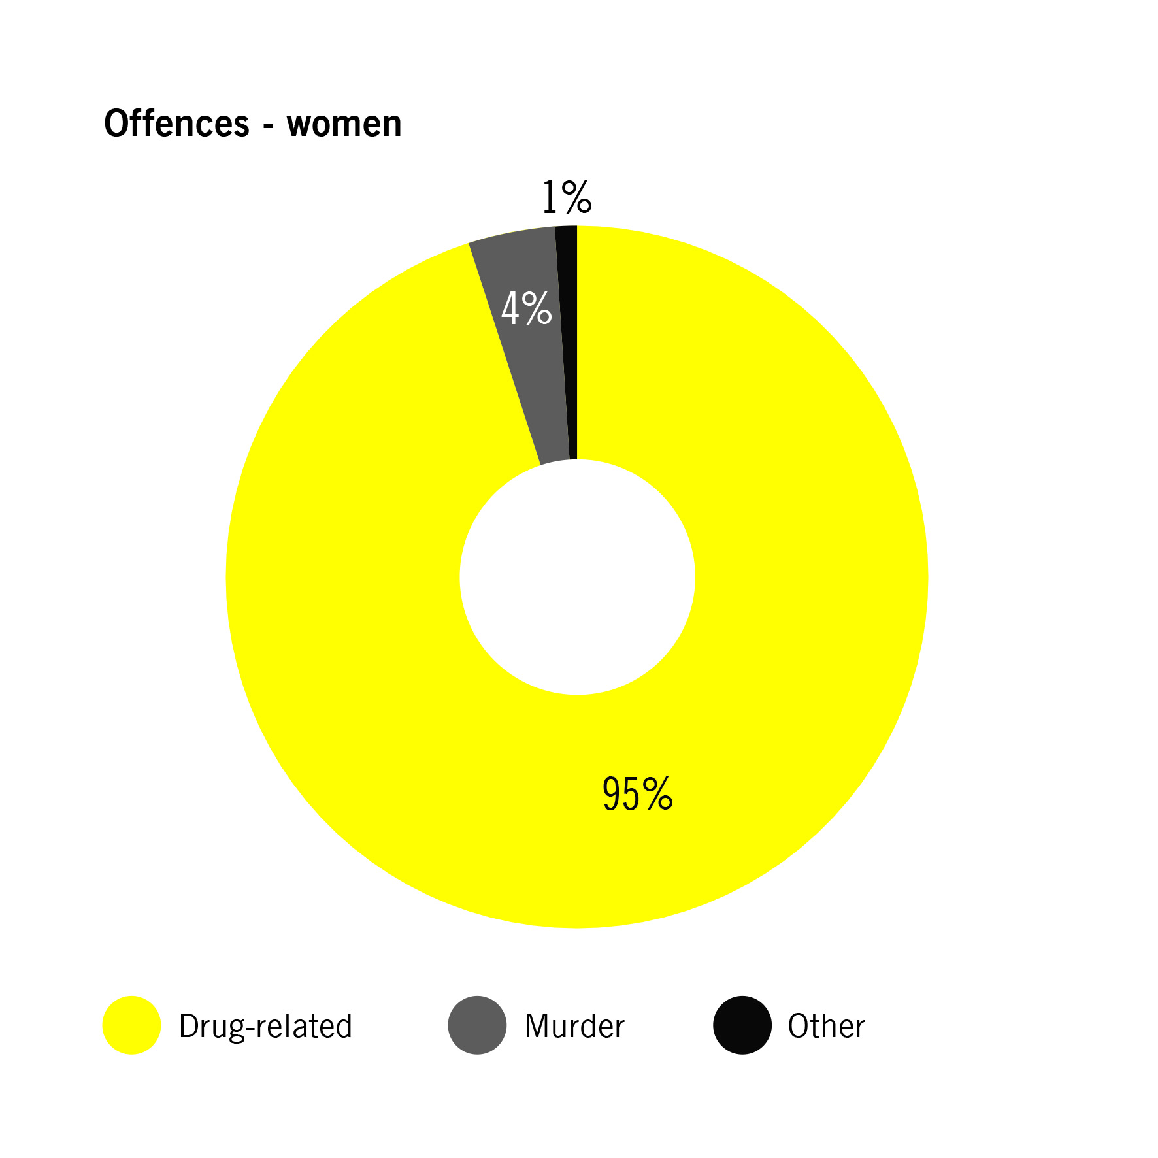
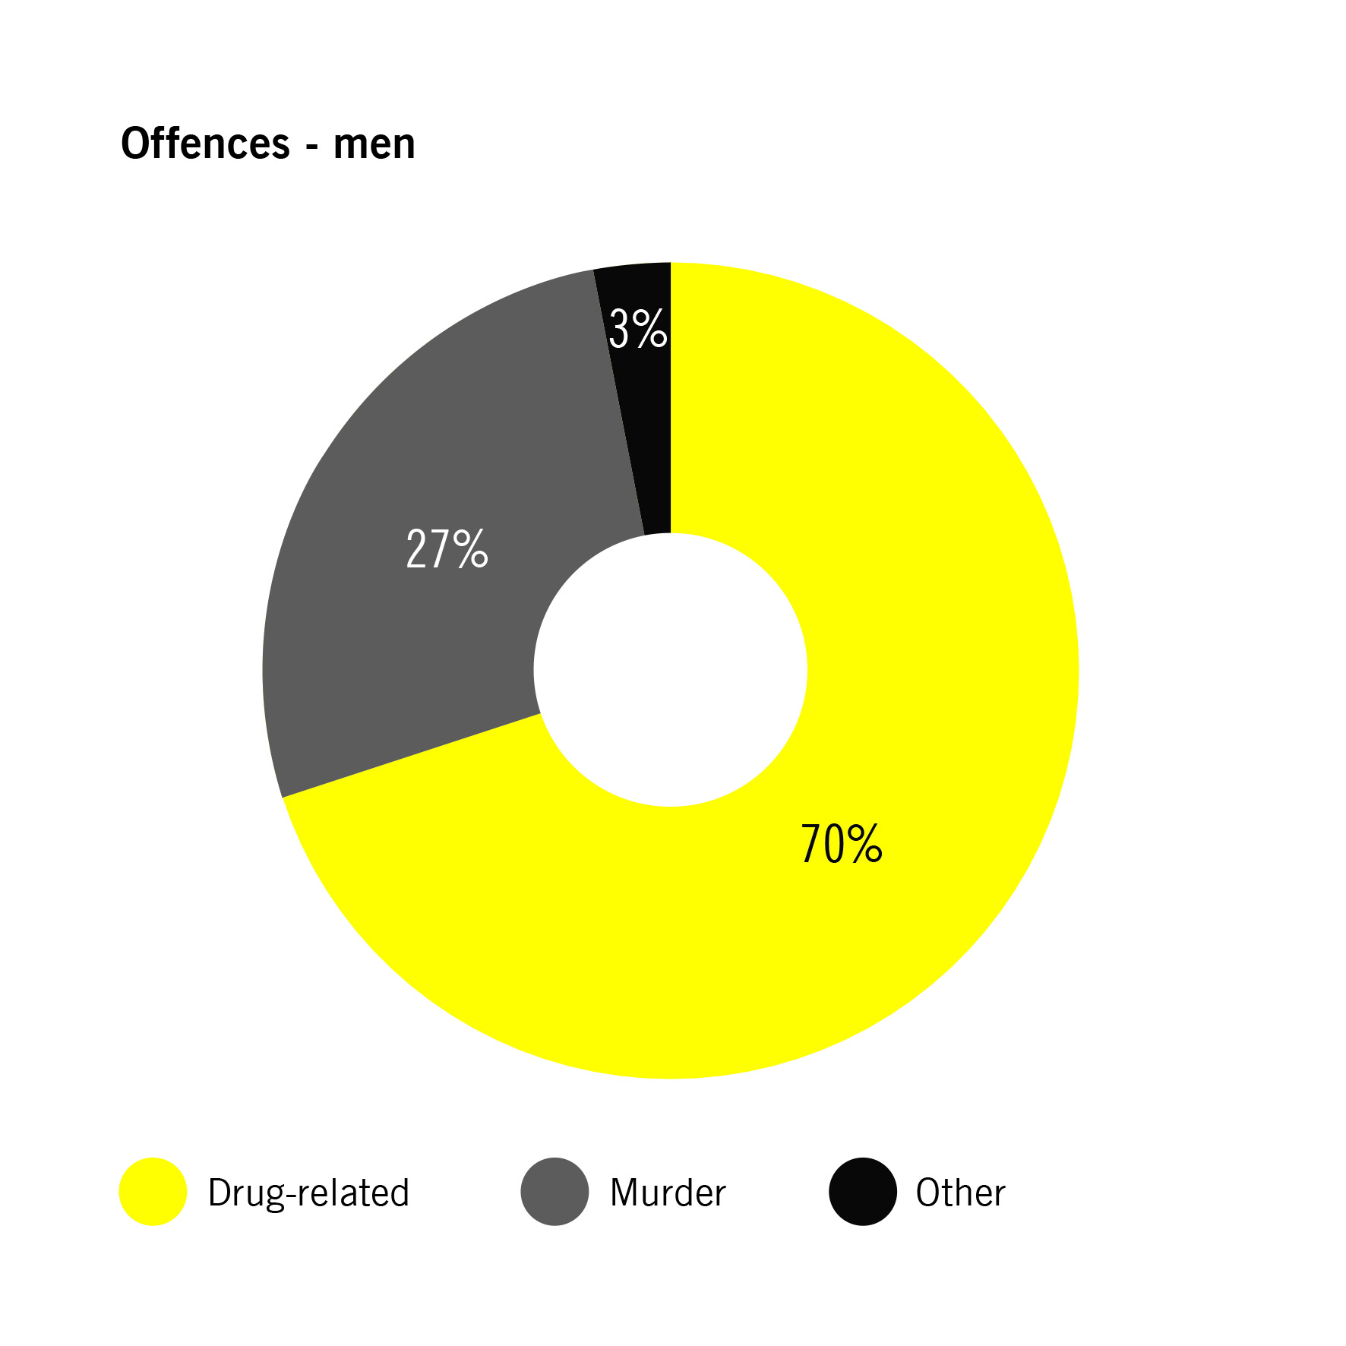
The division by offences appears markedly different when considering the gender of those convicted. While in the cases of men the number of those convicted of drug trafficking reflected the national total (70%), the use of the death penalty for this offence has a disproportionate impact on women, with 95% of the total of women under sentence of death for this reason. Of all male cases, 28% of those on death row were convicted of murder, but only 4% of women were.

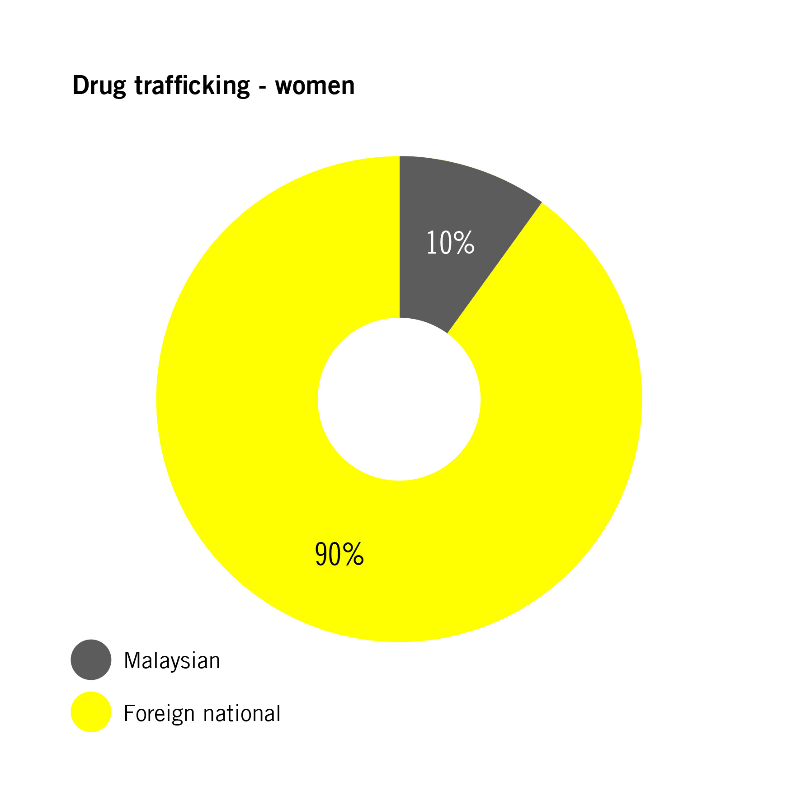
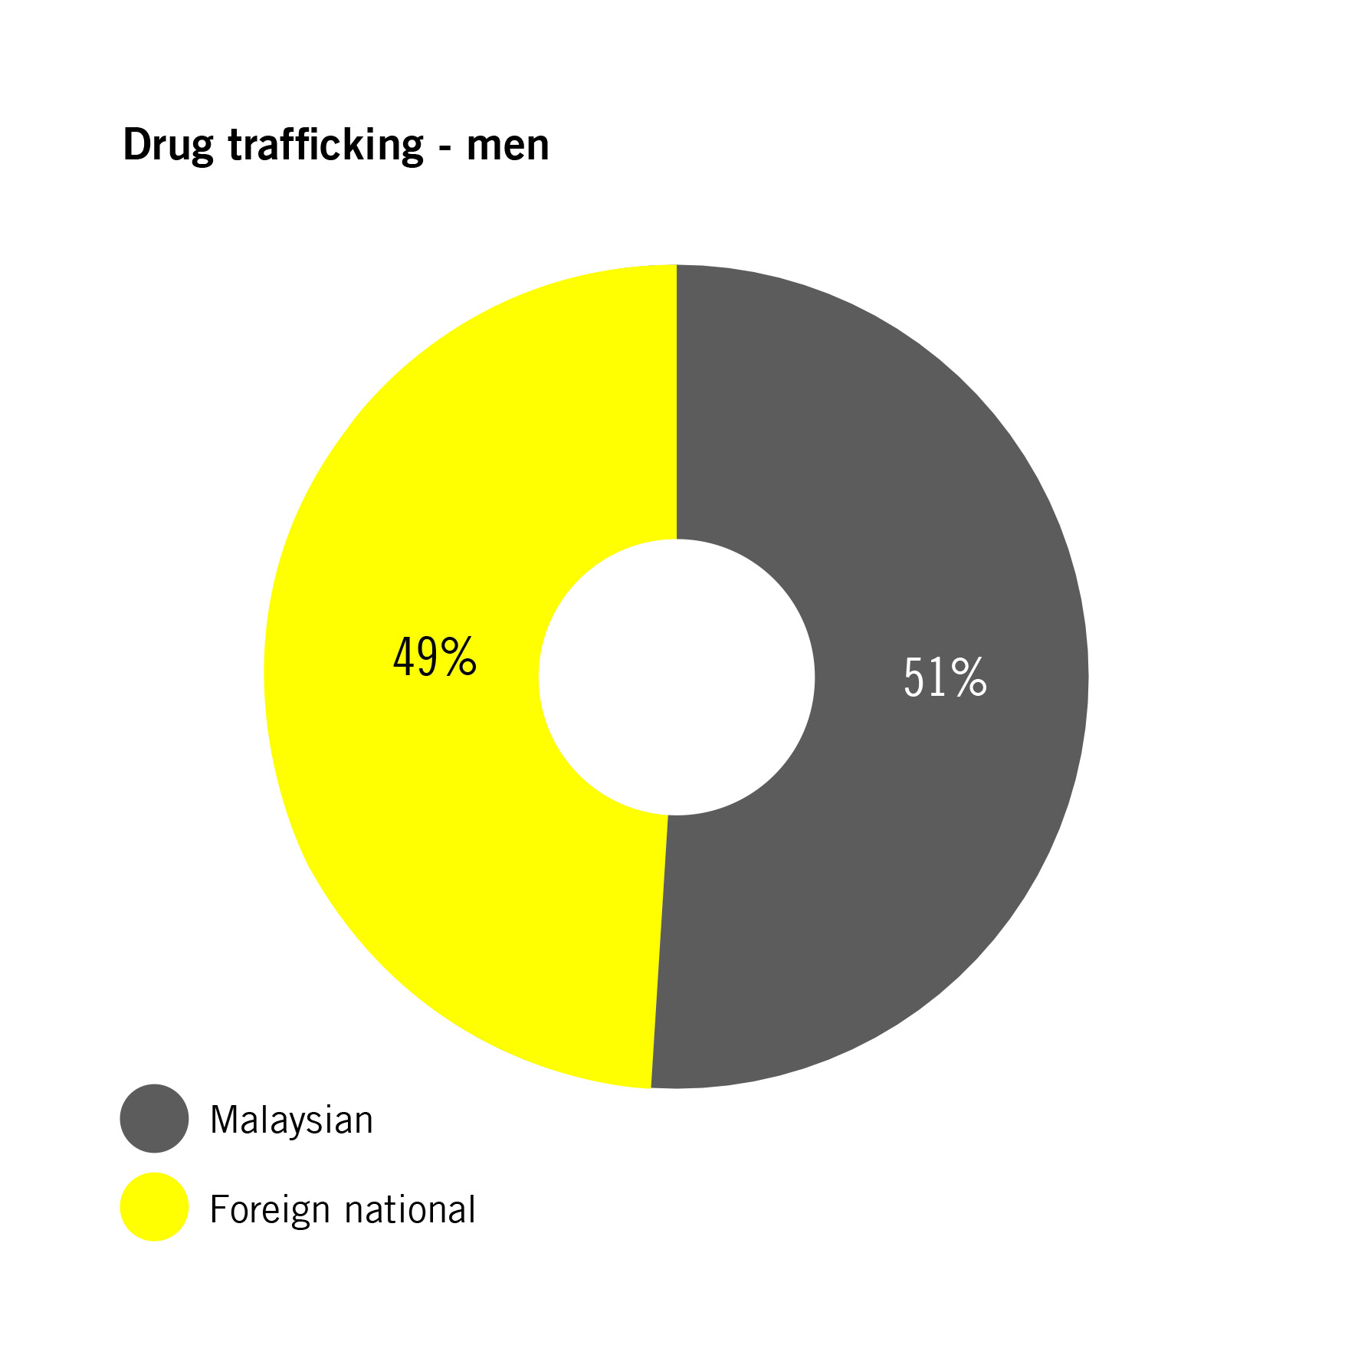
While overall the numbers of those convicted of drug-related offences were split almost equally between Malaysian (51%) and foreign nationals (49%), this division was again significantly different for the 134 women on death row for drug-related offences as 90% were foreign nationals.

Women on death row: a common story of coercion and deceit
In 2018 and 2019, Amnesty International selected and reviewed 30 cases of women on death row for drug trafficking at Kajang and Tapah prisons (three Malaysian and 27 foreign nationals). All cases were reviewed by the Federal Court.
Cases were selected based on proportionate representation by prison and nationality, as well as availability of written judgments. The organization also spoke to lawyers and representatives of embassies who have been involved in cases of women under sentence of death for drug trafficking. The information relating to their situation reveal some common patterns that recur frequently in cases of people convicted of drug trafficking more broadly.
In 25 of these cases, women were convicted of drug trafficking after they were caught trying to enter Malaysia at international airports. Drugs were mostly found in bags and, in some cases, these were tied to their bodies or found in capsules that had been swallowed. Substances and amounts varied, but among those caught with methamphetamine (25 people), for example, 11 were caught with quantities lower than 1kg (between 117 and 900 grams) and seven with amounts between 1,200 and 1,730 grams (the equivalent of five to 70 doses).
In most cases, women said that they were not aware they were carrying illicit drugs. During trial, some women argued that a person known to them asked them to carry a bag containing items for sale, such as clothes or shoes, and without obtaining any financial compensation. In other cases, women had agreed to travel to Malaysia to transport fashion items for a business contact or a known person in exchange of a small amount of money (in several cases it was indicated as the equivalent of approximately USD 500) but stated that they were not aware they were transporting drugs.
In other cases, those who requested these women to transport the package changed the plan at the last minute and left them alone to travel. Even those found with drugs tied to their bodies told the police and judges that they were not informed of the content and weight of the drugs found in the packages. In some cases, women claimed that they had gotten into financial trouble and were coerced to take the package, often aggravated by their socio-economic circumstances.
The application of the mandatory death penalty for drug trafficking, combined with a presumption of guilt under section 37 of the Dangerous Drugs Act, hinders the ability of judges to consider all these mitigating circumstances, including when it was suggested they did not commit these offences voluntarily or knowingly and when there were no other reasons to disregard the accounts put forward by women in their defence. While the application of the death penalty for drug-related offences is unlawful in all circumstances, this legal presumption of guilt under which defendants found with specified amounts of certain drugs or even simply in possession or in control of objects or premises in which prohibited substances are found, reverses the burden of proof in further contravention of international human rights standards, including of the right to presumption of innocence and other fair trial rights.

FAIR TRIAL concerns
Amnesty International has found numerous violations of the right to a fair trial at different points of the criminal justice process that leave defendants at risk of the imposition of the death penalty. Due to the combination of the mandatory death penalty for drug trafficking with presumptions of guilt under section 37 of the Dangerous Drugs Act, people facing the death penalty face several barriers to launch an adequate defence.
Under the Malaysian Constitution, detainees are supposed to be able to consult and be defended by the legal practitioner of their choice as soon as possible after arrest. There are currently three legal aid schemes concerning death penalty cases – one managed by the courts providing free representation at trial and appeals; another run by the National Legal Aid Foundation (NLAF) covering the pre-trial stage and the preparation of pardon applications, but is only available for Malaysian citizens; the third one is run by Lawyers with Bar Council Legal Aid Centre, a self-funded scheme by the Malaysian Bar, that also provides pro-bono representation at remand stage to support those in need of a lawyer when they appear before a magistrate court, regardless of the offence and nationality of the accused.
However, despite these programmes, lawyers and other representatives of people on death row told Amnesty International that those arrested for offences that could result in the death penalty and who could not hire a lawyer independently, often did not receive legal assistance upon arrest or during their time under police remand before charges are brought. Further, because of how legal aid is structured, no legal representatives are assigned to a case until the trial is due to start, leaving defendants without legal assistance during interrogation and for prolonged periods.
Other fair trial concerns include delays in notifying a person’s arrest to their family and lawyers, legal aid centres and foreign embassies, as well as concerns about the competence of legal representation in many cases. Moreover, Malaysian law guarantees interpretation in court but leaves many defendants without interpretation outside of courtrooms. Interpretation is often dependent on resources provided by their embassies, if any.
Malaysian law generally precludes the prosecution from using at trial self-incriminating statements, including those obtained under torture and other ill-treatment. However, when it comes to capital offences, these can be admissible as evidence under Section 37b of the Dangerous Drugs Act. Claims not presented by the defence at the first available opportunity, including those relating to coerced statements, are often regarded by judges as an “afterthought” that signals lack of consistency in their statements and is considered to their disadvantage.
Presumptions under Section 37 of the Dangerous Drugs Act by which defendants can be found guilty of drug trafficking without any further evidence linking them to the drugs effectively shift the burden of proof to the defendant, in violation of the presumption of innocence and other fair trial guarantees. These presumptions have also had the effect of lowering the threshold of evidence needed to secure a conviction in capital cases in which guilt must be proved beyond any reasonable doubt.
Malaysian law does not allow criminal cases to be reopened following a final judgment, even on the grounds of newly discovered facts, despite this being a critical safeguard especially in cases involving the death penalty.

RIGHT TO PARDON
Lack of safeguards in the pardons process, which is opaque and shrouded in secrecy, also exposes people to the risk of arbitrary decisions that could lead to execution.
In 2018, the Minister of Law in the Prime Minister’s Office stated that Pardon Boards would be a possible mechanism to decide alternative punishments for those already on death row once the mandatory death penalty is abolished. Such proposals have also been incorporated into recent bills filed in Parliament but not yet enacted. Pardon Boards risk transferring the power of sentencing from the judiciary to the executive and moving pronouncements into an opaque and arbitrary structure in which no further recourse is available, and where mitigating circumstances are not adequately presented and investigated.
The process for applying for a pardon is not defined in law in detail, nor does the law set out what criteria should be used for the decision or how the outcome should be communicated.
Contrary to international standards, Malaysian law does not guarantee the right to legal counsel for pardon application. Albeit limited, intermittent and poorly resourced pro-bono initiatives put in place to fill this gap, the government has continuously failed to take adequate measures to ensure this right.
The problem appears to be particularly acute for foreign nationals, who make up over half of those who have not filed a pardon application. Detained far away from their families and support networks, they appear to be at a disadvantage in preparing pardon petitions, particularly if they receive little or no support from their embassies.
Malaysian authorities have also failed to provide prompt information at all stages of the clemency process, as required under international standards. To this date, no official announcements on decisions about pardon petitions are communicated to prisoners or their representatives, and it is not clear how applications are prioritized. If the pardon is not granted, the petition can either be simply set aside to be reconsidered at the next sitting of the Pardon Board; or it can be rejected, in which case a notification would be sent back to the relevant trial court and prison officials to trigger the process of execution. The prisoner and their family would be notified of the rejection of their petition only days before the execution is carried out.

RECOMMENDATIONS
Pending full abolition of the death penalty, Amnesty International recommends that the government of Malaysia:
  - Continue to observe the moratorium on all executions, first established in July 2018, until the death penalty is fully abolished, and all death sentences are reviewed and commuted.
  - As a first step, table legislation to remove the mandatory death penalty for all crimes, including for drug trafficking, and mandate a judicial body to review all cases where people have been sentenced to death with a view to commuting the death sentences, and ensure that alternative punishments are in line with international law and standards.
- Remove all legal provisions that allow for the use of the death penalty for offences that do not meet the threshold of the “most serious crimes” or intentional killing, which have disproportionate impact on those with less advantaged socio-economic backgrounds, including women.
- Implement alternatives to the criminalization of minor and non-violent drug-related offences and ensuring that those sentenced to death, in particular for drug-related offences, have their sentences commuted accordingly.
- Repeal Section 37 of the Dangerous Drugs Act that allows a “presumption” of guilt, allowing the burden of proof to be reversed, which undermines the presumption of innocence and other fair trial guarantees.
  - Ensure that all persons facing the death penalty – including women and those from disadvantaged socio-economic backgrounds – are provided access to competent and independent legal assistance of their choice from the moment of arrest to appeals and other recourse procedures.
  - Establish transparent procedures for the exercise of the power to grant pardon applications, ensuring a meaningful safeguard of due process.
  - Regularly publish full and detailed information, disaggregated at least by age, gender, nationality and ethnic background, about the use of the death penalty, including number of persons sentenced to death and for what offences; number of prisoners appealing the sentences and at what level; location of detention; information on past and imminent executions; number of death sentences reversed or commuted on appeal; and number of instances in which pardon has been granted.
  - Put in place a wide set of gender-sensitive and holistic socio-economic protection measures to ensure that drug control laws and policies contribute to overcoming structural sources of vulnerability, stigma and discrimination, especially against women and those belonging to marginalized and disadvantaged communities.

Amnesty international
is a global movement
for human rights.
When injustice happens
to one person, it
matters to us all.

malaysia
SUBMISSION TO THE UN COMMITTEE ON THE ELIMINATION OF DISCRIMINATION AGAINST WOMEN
86th Pre-Sessional Working Group, 27 Feb 2023 - 3 Mar 2023, list of issues
Amnesty International submits this document in advance of the adoption of the list of issues ahead of the upcoming review of Malaysia by the UN Committee on the Elimination of Discrimination against Women. It is based on the organization’s research report Fatally Flawed: Why Malaysia Must Abolish the Death Penalty published in 2019. This submission specifically focuses on women who face the death penalty, particularly for drug-related offences, violations of their right to a fair trial, and the opacity and secrecy of the pardon process. It should not be seen as an exhaustive record of the organization’s concerns on the implementation of the Convention on the Elimination of Discrimination against Women in Malaysia.

Amnesty International, Fatally Flawed- Why Malaysia Must Abolish the Death Penalty (ACT 50/1078/2019), 10 October 2019, https://www.amnesty.org/en/documents/act50/1078/2019/en/
Drug trafficking still carries the mandatory death penalty when certain circumstances are not met.
Amnesty International, Death sentences and executions in 2021 (ACT 50/5418/2022), p.15.
Article 19 of the Universal Declaration on Human Rights; Article 19 of the International Covenant on Civil and Political Rights.
Human Rights Committee, General comment No. 34, Article 19: Freedoms of opinion and expression, UN Doc. CCPR/C/GC/34; and Toktakunov v Kyrgyzstan, Communication No. 1470/2006, UN Doc. CCPR/C/101/D/1470/2006. Report of the Special Rapporteur on Extrajudicial, Summary or Arbitrary Executions, UN Doc. A/67/275, 9 August 2012.
UN General Assembly, Report of the Special Rapporteur on Extrajudicial, Summary or Arbitrary Executions, UN Doc. A/67/275, para.107.
Unless otherwise specified, figures contained in this section are based on information received from official sources in February 2019, on file with Amnesty International.
The Star, “Alternative sentences to death penalty finalised, to be presented to Cabinet, says Wan Junaidi”, 13 September 2022, thestar.com.my/news/nation/2022/09/13/alternative-sentences-to-death-penalty-finalised-to-be-presented-to-cabinet-says-wan-junaidi
Kajang - Women, Kota Kinabalu - Women, Pengkalan Chepa, Pokok Sena, Puncak Borneo, Seberang Perai, Sibu, Sungai Udang, Tapah.
Alor Setar, Bentong, Johor Bahru, Kajang – Men, Kajang – Women, Kluang, Marang, Pengkalan Chepa, Perlis, Pokok Sena, Pulau Pinang, Seberang Perai, Simpang Renggam, Sungai Buloh, Sungai Udang, Taiping and Tapah.
Representatives of foreign embassies indicated that there is a discrepancy between figures held by the Malaysian authorities and their embassies, mostly linked to mistakes with the identification and attribution of nationality.
As prescribed by Article 6 of the International Covenant on Civil and Political Rights.
For more information see Amnesty International, Fatally Flawed- Why Malaysia Must Abolish the Death Penalty (ACT 50/1078/2019), sections 3 and 4.
Amnesty International, Fatally Flawed- Why Malaysia Must Abolish the Death Penalty (ACT 50/1078/2019), p.37-38.

