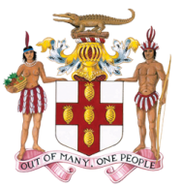

GOVERNMENT OF JAMAICA

WRITTEN RESPONSES:

CONSTRUCTIVE DIALOGUE WITH THE COMMITTEE ON THE ELIMINATION OF DISCRIMINATION AGAINST WOMEN (CEDAW)

12th October 2023

United Nations, Geneva
Part I:
Question:
The Ministry of Health and Wellness engages commercial sex workers in safe sex practices workshops, with care packages provided including condoms. Have steps been taken to decriminalize selling of sex services?
Government of Jamaica has no legislative agenda at this time to decriminalise commercial sex work.

PART II:
Article 7 - 8
Question:
Are there enough accessible and available childcare centres enabling women to participate in the labour force?
Jamaica has approximately 2306 early institutions that provide services for children between 0 to 6 years. The Government informs that, of that number, approximately 700 provide day care services; 129 of which are fully funded by the government.

PART III:
Question:
What provisions are there for healthcare for lesbian and trans women? Can the State Party provide any statistics on the services provided to lesbian and transwomen?
Lesbian and trans women do not readily self-identify when accessing healthcare services.
The LGBTIQ communities have been advocating for their rights, and have established civil society organizations that mobilize their communities, advocate for their civil rights and educate Jamaicans on their needs and circumstances. They conduct training sessions with healthcare providers, the police and other service providers on how to treat with and reduce stigma and discrimination.

Question:
When it comes to breast cancer and cervical cancer, and Jamaica, there is a lack of screening programs nationally, and breast screening. There is also a stigma for women with cancer and financial barriers that hamper the provision of health care services to try to tackle these two forms of cancer in women. There is a national strategic plan for the prevention and monitoring of cancer from 2013 to 2018, from the Government of Jamaica, and you have set a goal to reduce by 25% of morbidity and disability and disability connected accounts. How is this process going? Is appropriate care provided for women with disabilities in all spheres surrounding health?
The Government of Jamaica is currently finalising a new National NCD and Cancer Prevention and Control Plan, which seeks to improve our capacity to diagnose and treat priority cancers, i.e., breast, prostate, colorectal and cervical cancers. Efforts are being made to ensure that the new Plan will include a focus on persons with disabilities. This work is being led by a National Cancer Technical Working Group, and supported by the IAEA.
Progress is being achieved as incidences of cervical cancer and mortality are declining; cervical cancer is no longer among the top 10 leading causes of death. Jamaica is also strengthening cancer surveillance for improved evidence-based policy development, which will include improved services for persons with disabilities.
There are periodic screenings throughout the year for prostate and breast cancer, with additional focus on breast cancer in October.
There is no reported case of cancer-related stigma in the health sector. However, there is the fear of being diagnosed with cancer, which impacts the uptake of services, including those offered free of cost.
Question:
Is the third party considering developing a gender informed Social Security system, not only for shock situations that includes access to benefits, for example, pensions, and paid maternity benefits for Self Employed Women and for elderly women experiencing old age poverty due to discriminatory factors in their earlier reform.
The National Insurance Scheme (NIS) takes into account disaggregation by sex from registration. As contributors mature into the system and begin to access benefits, the system is designed to account for benefits provided to males and to females.
Costs towards the NIS are shared between employer and employee with the employer contributing 3% and the worker contributing 3% of earnings with a ceiling of $5 million.
Question:
Can the State Party provide statistics on the number of labour migrants, asylum-seekers and refugees, at present in the country, aggregated by sex and age?
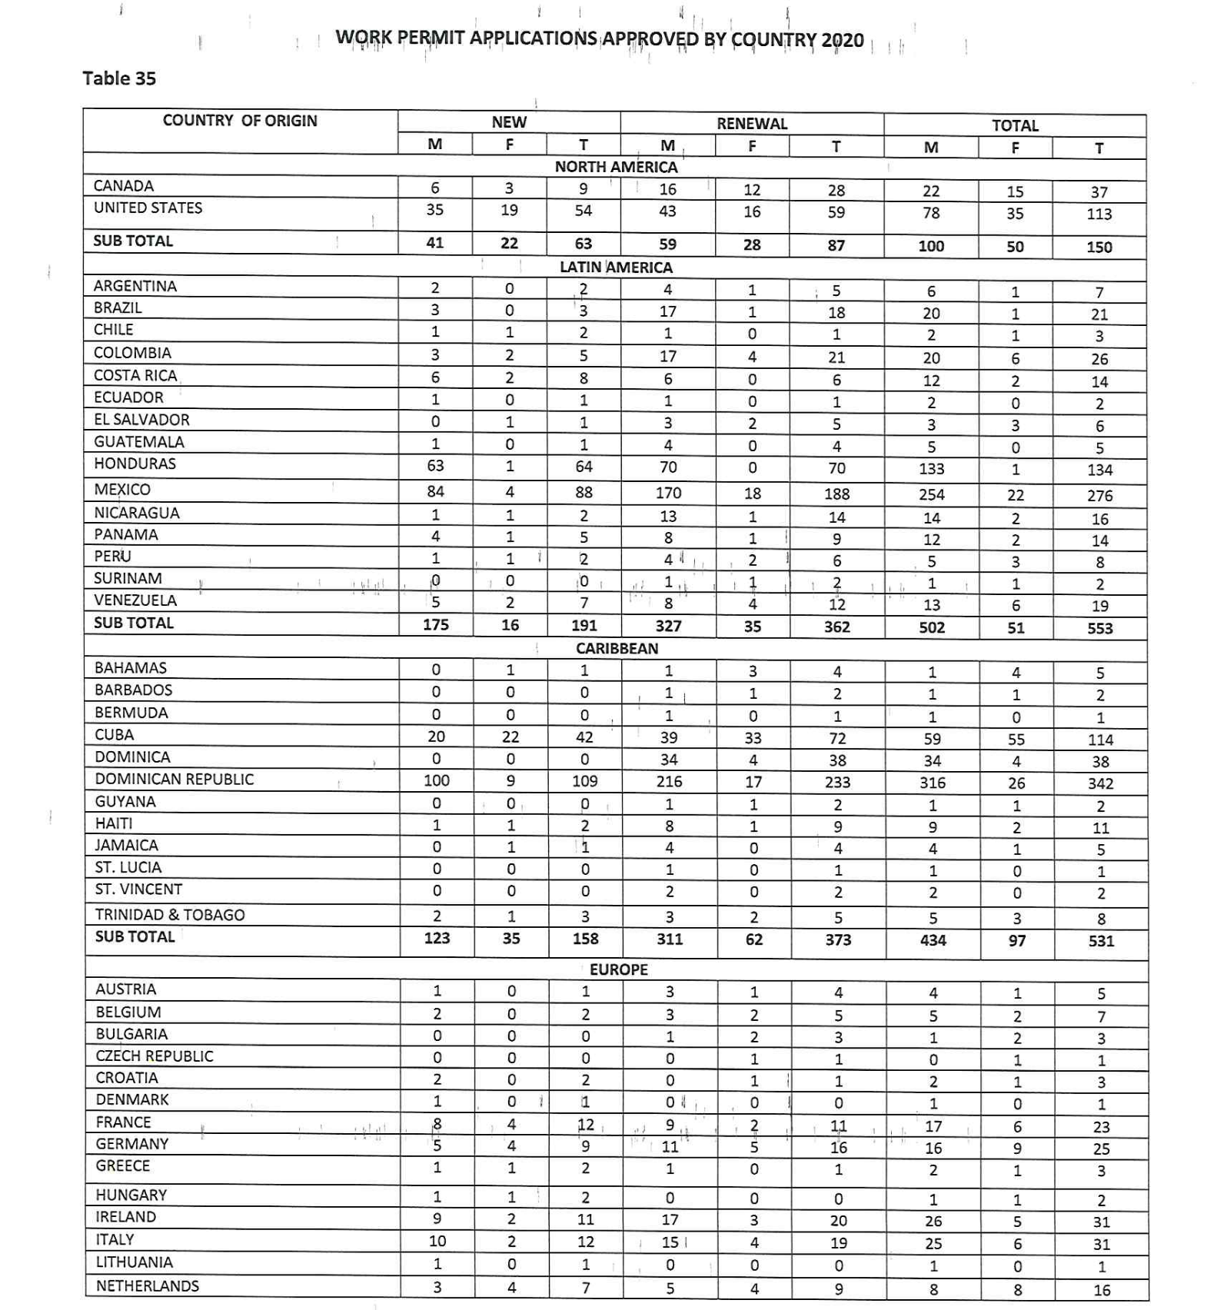
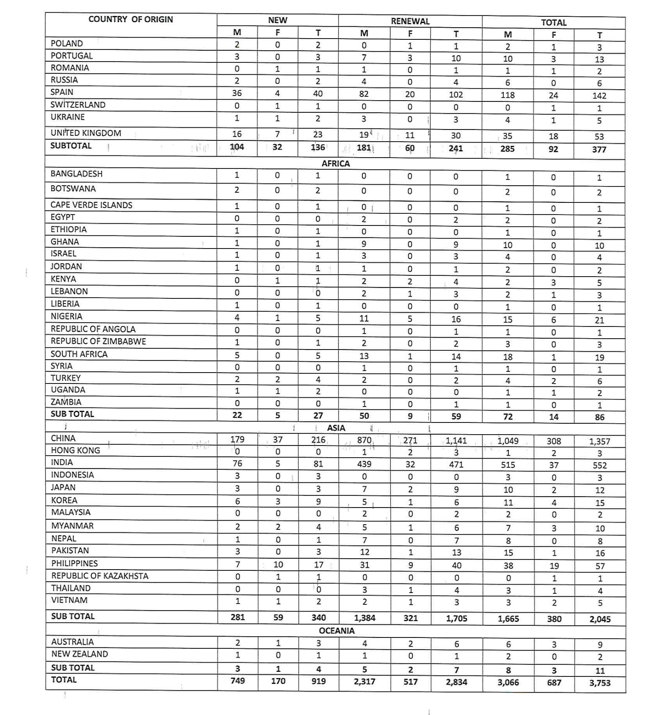
Question:
We received alarming reports that there are substantial barriers to asylum recognition in the State Party, especially for people from Haiti, who are at times sent back to danger without their case being examined. Please clarify if these reports are accurate, and if so, how does the State Party explain them, especially taking into consideration the impact of such a policy on women?
Jamaica received two groups of Haitian migrants in July and September 2023, respectively. The first group is currently awaiting a determination on their applications for asylum, which was made on their behalf by law firm Freedom Imaginaries. No application was made by the second group of migrants who were returned subsequent to being processed by immigration, health and law enforcement officials.
Question:
What percentage of asylum-seeking women are recognised as refugees each year? What rights are given to both women-asylum-seekers and refugees, and what percentage of them participated in the labour force? Has the Government adopted specific measures to enhance the functioning of the asylum system? Does the State Party intend to adopt complementary regulations such as Standard Operating Procedures for the asylum process? And how does the State Party ensure that refugee status determination procedures are fully gender-sensitive?
In particular, how are refugees and asylum-seeking women protected from discrimination based on sexual identity and orientation by first instance asylum officials, and throughout their interaction with state authorities?
Have specific normative provisions, programmes and/or initiatives been developed and implemented by the authorities to facilitate the local integration of refugees and asylum-seeking women, including information on refugees' access to fundamental rights.
In keeping with international refugee law and Jamaica’s Refugee Policy, Jamaica ensures that no person in Jamaica who requests asylum is returned to their country of origin until their application for asylum has been determined, unless one of the grounds for ineligibility in the Refugee Policy has been met, for example, persons who already have protected status from another country. Once it is ascertained that the person has entered the country illegally and is not applying for asylum, they are treated as an illegal immigrant.
The State also ensures that all persons applying for asylum are treated in accordance with internationally recognized human rights standards and the Refugee Policy expressly states that the Policy shall be applied to all asylum seekers without discrimination as to race, gender, religion, nationality or political opinion.

Question:
Government reports indicate that women in Jamaica play an important role in agricultural production and the blue economy in Jamaica, which are all vulnerable sectors to natural hazards and environmental degradation. What steps has the government taken to incorporate gender budgeting to strongly finance and encourage a sustainable blue economy that is fully inclusive of women and promotes women's empowerment?
In keeping with efforts to implement the Gender and Climate Change Strategy and Action Plan (GCCSAP), the climate change focal point network was established with members nominated from Ministries, Departments and Agencies and charged with prioritising, executing, monitoring, and reporting on gender responsive climate action with a view to incorporating more women in the implementation of the GCCSAP.
The Ministry of Economic Growth and Job Creation has been developing a Beneficiary Identification System (BIS) which will be used to support the provision of social water and ensure that vulnerable households receive assistance to meet basic water and sanitation needs. This will also address knowledge gaps on climate-induced water scarcity on the vulnerable rural and urban population (women, pregnant and lactating mothers, youth, elderly, disabled, and low income persons).
In the context of Jamaica, the blue economy offers the prospect of both strengthening existing growth drivers (tourism, fisheries) and allowing new industries to flourish. In May 2023, the World Bank in collaboration with the Government of Jamaica conducted a scoping study of the Blue Economy in Jamaica and made recommendations for the development of a Blue Economy Road Map for Jamaica. The study showed that the blue economy in 2020 contributed an estimated US$2.5 billion of gross value added for Jamaica. There were more than 500,000 jobs attributed to the sector and the blue economy contributed 37 per cent of the employed labour force. Jamaican women are active in the blue economy sectors such as in fisheries, aquaculture, coastal tourism activities, environmental conservation etc.
The recommendations from the study, which are currently under review, focused on ensuring that Jamaica harnesses the opportunities presented by the blue economy in an inclusive and fair manner, and that the benefits that are accrued are accessible to all, ensuring that gender mainstreaming and social equity are fully integrated.
Question:
Does Jamaica intend to decriminalize same sex conduct?
There is only one provision in law that expressly criminalizes same sex conduct, and there are no steps being contemplated at this time, in this regard.

Question:
Provide information on barriers that prevent mothers from obtaining maintenance.
There are currently no legislative or administrative obstacles impeding mothers from enforcing child maintenance obligations through the courts that have been identified. The Bureau of Gender Affairs continues to conduct public training and sensitization, including women and girls in vulnerable communities on legislative provisions for child and spousal maintenance and how it can be accessed through the courts, as part of the efforts for public education.

Question:
What does the State Party do to address elderly women? Any data on loneliness? What are care arrangements provided to elder women? And what is the allocation and how are they provided?"
The Economic and Social Survey of Jamaica (ESSJ 2021) reports the elderly population at 375,700 persons (13.9% of population) - 47.5% males and 52.5% females. The dependent elderly represent 9.6% of the population. A population census is currently being undertaken.
There are no gender-specific programmes in Jamaica for elderly women. However, elderly women benefit from general provisions for senior citizens (persons 60 years and older) in Jamaica. The revised National Policy for Senior Citizens (2021) establishes the Government’s commitment to broad inclusion of senior citizens in nation-building, recognizing the tremendous capacity and resources within the age cohort, and aligning programmes and initiatives to respond to the opportunities and challenges posed by population ageing. Within the framework of global commitments and national goals, the Policy envisages that by 2030: Senior Citizens live and participate actively in a society that guarantees their rights, promotes their responsibilities, recognizes their capabilities and contributions, and facilitates their enjoyment of a life of fulfilment, health and security.
The revised policy framework is on the premise that the value and worth of senior citizens to the country will be enhanced, while systems for the delivery of goods and services, and resource mobilization for programmes and initiatives will have a platform for prioritization and planning. All stakeholders, including individuals, family, community, private sector, civic organizations, and the Government can respect and respond to the needs of senior citizens. The Policy also serves as a framework for creating standards and protocols that facilitate the quality of life of senior citizens.
Provisions for the elderly which include elderly women are as follows:
- Healthcare. Senior citizens benefit from a no-user fee policy in the public health system. The National Health Fund and Jamaica Drugs for the Elderly Programme (NHF/JADEP) provided subsidies of medications, diagnostics and disposables for persons with any of 15 chronic illnesses. This includes annual screening tests for breast, cervical and prostate cancers. A home help service is provided by nurse aides (in 3 of 14 parishes) who assist elderly persons with chores, errands and basic health care needs.
- Pensions. The contributory National Insurance Scheme (NIS) pension provides a minimum guarantee for persons (64%) retiring from formal work. Funeral grants are also provided to offset such expenses. Occupational pension plans support approximately 13.2 % of elderly persons.
- Social Assistance Programmes. The Programme of Advancement through Health and Education (PATH) provides a conditional cash transfer to elderly persons who qualify. Poor Relief programmes target registered poor and provide benefits including food and clothing and shelter needs. The Social Pension Programme provides a cash grant to persons 75 years and older who do not receive a pension. The Meals on Wheels Programme provides cooked meals and food packages to needy shut-in elderly persons. Public Assistance Grants (compassionate and rehabilitation grants) are provided to elderly persons in need of emergency support or to support economic activities of elderly persons who qualify.
- Housing. The Government of Jamaica (GoJ) Social Housing Program provides homes to poor elderly persons who own property but need housing. Other NGO entities such as Food for the Poor provide low-income housing.
- Transportation. Elderly persons and persons with disabilities benefit from a 60% concessionary bus fare when they travel with state operated bus service.
- Education. Training is provided for senior citizens in digital and financial literacy, retirement planning, management of chronic illnesses, entrepreneurial and skills training.
No specific data is collected on loneliness. A 2012 Ageing Module Study from the Planning Institute of Jamaica (PIOJ) showed 44% of Jamaican elderly involved in at least one social organization. The vast majority (97%) of elderly persons in Jamaica reside in their communities.
Regarding care arrangements provided to elderly women and their provision, it is noted that Chronic disease is prevalent among the elderly with 72% having at least one chronic illness. Older persons are caregivers (20.4%) as well as recipients of care. Approximately 2% of elderly are in residential care homes, with the majority living in community settings. (PIOJ 2012).
Long-term residential care is provided by the state and through privately operated nursing homes. State operated homes provide medical and nursing care to elderly residents and address other social needs. Privately operated homes, day care, ambulatory care and respite services are regulated by the Ministry of Health and Wellness to ensure the standards of care are met. Palliative care services are provided in tertiary care mainly at hospitals.
Community care services are provided by multiple stakeholders including health and social services, non-profit organizations, faith-based and community-based organizations. Primary health care services are available through community health centers staffed with public health, mental health and medical staff and supported by Community Health Aides who conduct home visits to elderly persons, pregnant and lactating mothers. There are no specific gerontology services. Family members are the main providers of care to elderly persons with 69.1% of homes having at least one elderly person.

Budgetary allocation for Senior Citizens
The budgetary allocation to the National Council for Senior Citizens for FY 2023-2024 is $181,400,000.00. It is to be noted that support for senior citizens spans several government entities and programs including health, social security and social assistance services.

What is the comparative budget allocation to the Gender Portfolio?

Based on the 2021-2022 Budget Estimates, the Bureau of Gender Affairs and Women's Centre - was allocated J$550,133.0 Million from the overall budget of J$543,523,241.0 Billion. This represented 0.1% of the National Budget to address programmes for women under the aforementioned agencies of the Ministry of Culture, Gender Entertainment and Sport. This does not take into account other programmes specific to women and girls under the purview of other Ministries, Departments and Agencies of the Jamaican Government which is not reflected here.

Kindly provide data on sexual harassment in the workplace
The Office of the Public Defender is not in receipt of a compliant based on sexual harassment.

