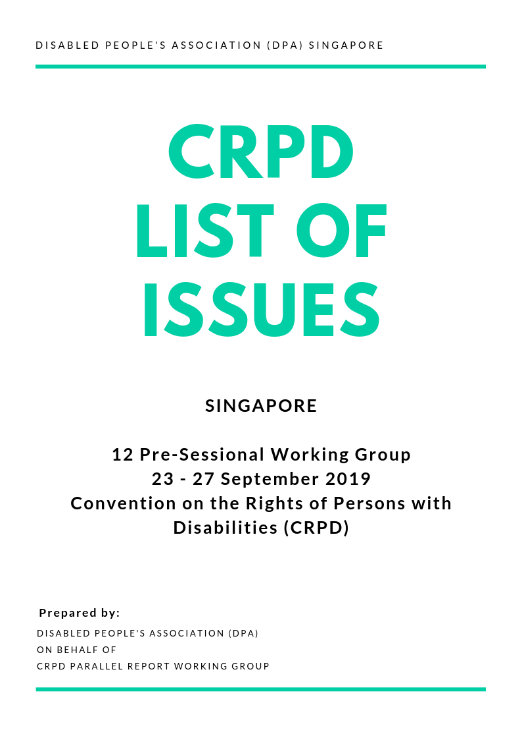

- Purpose and general obligations (arts. 1 – 4)

General obligations (art. 4)

- Please inform the Committee about:
  - Efforts made by the State Party to ensure that the concept of disability is fully in line with the social model of disability as set out in the Convention.
  - Measures taken by the State Party to ensure the full and equal involvement of persons with disabilities in decision-making processes and in the drafting of all disability-related legislation, policies, strategies, and action plans.
  - Steps taken to ratify the Optional Protocol to the Convention, and the time frame for such a ratification.

- Specific rights (arts. 5 – 30)

Equality and non-discrimination (art. 5)

- Please inform the Committee about:
  - Measures taken to guarantee to persons with disabilities equal and effective legal protection against discrimination on all grounds.
  - Measures taken to ensure that feedback channels such as REACH, OneService Mobile App, and government websites are reasonably accessible for all persons with disabilities.
  - Measures taken by the State Party to prevent, eliminate, and address multiple and intersectional discrimination on the grounds of disability, age, sex, ethnicity, religion, language, origin, nationality, migration status, intersex traits, sexual orientation and gender identity, in accordance with targets 10.2 and 10.3 of the Sustainable Development Goals.

Women with disabilities (art. 6)

- Please inform the Committee about:
  - How the Vulnerable Adults Act (VAA) and any other protections / reporting mechanisms make specific efforts to reach out to vulnerable women, including women with disabilities.
  - Access to information about reproductive health care and awareness programmes specifically for neurodivergent women, and women with intellectual disabilities.
  - Specific steps taken to increase cooperation, partnerships and synergies between organisations of women and girls with disabilities, women’s development, and human rights organisations in order to provide sustained and sustainable support for the empowerment of women with disabilities.
  - Measures taken to ensure the elimination of all forms of violence and discrimination faced by women and girls with disabilities, including but not limited to Physical, Sexual, Verbal/Emotional, Mental/Psychological, Financial/Economic, and Cultural/Identity, in accordance with target 5.2 of the Sustainable Development Goals, and articles in the Convention on the Elimination of All Forms of Discrimination against Women (CEDAW).
  - Plans to collect and publish more gender-segregated disability data, considering the multiple and intersecting forms of violence and discrimination faced experienced by women and girls with disabilities, which may not have been reported, documented and/or published.

Children with disabilities (art. 7)

- Please inform the Committee about:
  - Available mechanisms in place to ensure that the best interests of the child with disabilities are a primary consideration in any action concerning children with disabilities.
  - What disability and age-appropriate assistance have been implemented to ensure that children with disabilities are able to share their experiences and express their views freely on all matters affecting them (e.g. in juvenile delinquency cases).

Awareness-raising (art. 8)

- Please inform the Committee about:
  - What concrete steps have been taken to move away from the medical and/or charity model, especially on Government agency websites and in eligibility requirements for disability support schemes and subsidies, given that the Singapore Government has indicated that they are moving towards using the social model of disability.
  - Measures taken to bring people with intellectual disabilities and multiple disabilities into the fold of awareness-raising.
  - Beyond the Appropriate Adults Scheme, what other training programmes are targeted at members of the legal profession, public officials, and police officers to raise awareness on the social model of disability?

Accessibility (art. 9)

- Please inform the Committee about:
  - Steps taken to ensure official government legislation and information is accessible in Singapore Sign Language (SgSL), Easy Read, or Simple English formats so that they are accessible to everyone with and without disabilities.
  - Steps taken by the State Party to ensure that information about lift breakdowns/renovations in MRT stations, and other public spaces are shared in a timely manner with with those that need that information the most, including people with disabilities.
  - Measures taken to address discrimination against guide dog owners by strengthening the implementation of the Environmental Public Health Act.
  - Measures taken to raise awareness about legislation being extended to other forms of assistance dogs used by people with disabilities.
  - Steps taken to upgrade current public buses and bus stops with announcement systems to ensure that people with visual impairments are able to have a safe travel experience.
  - Steps taken to ensure that public services such as banking and finance matters are equipped with user-friendly features. This includes but is not limited to braille letters on online banking tokens, automated voice guides at ATMs, and accessible ATMs with standard user interface even across various banks.
  - Measures taken to ensure that all government websites are W3C compliant, and the time frame for such compliance.
Right to life (art. 10)

- Please inform the Committee about:
  - Provision of localised and easily accessible information about being pregnant with a foetus likely to have congenital disabilities and current support mechanisms available.
  - Steps taken to ensure that medical professionals do not provide wholly negative information about having a child with disabilities.

Situations of risk and humanitarian emergencies (art. 11)

- Please inform the Committee about:
  - Steps taken to ensure that official information about emergency services, and steps for safe evacuation are provided in Easy Read, or Simple English formats.
  - Measures taken to ensure that every family / resident living in HDB flats is informed about the evacuation routes and fire safety protocols. This also includes ensuring that evacuation routes are accessible to persons with disabilities in practice.
  - Information on any disaster risk reduction strategies developed in consultation with organizations of persons with disabilities, and the applicability of these strategies to different groups of persons with disabilities. In particular, please provide information on the extent to which persons with disabilities, participated in the design, implementation, evaluation, and monitoring of disaster and risk reduction strategies and policies.

Equal recognition before the law (art. 12)

- Please inform the Committee about:
  - Clarifying the types of support and subsidies currently available to persons with disabilities to ensure practical access to services available to them, and if such support and subsidies are easily accessible and publicised to persons with disabilities.
  - Steps taken to ensure that the state provides reasonable accommodation and universal design for public and private institutions providing services that relate to a person’s legal capacity.
  - What legal capacity a person with disability retains when judged to lose mental capacity, specifically in relation to the Mental Capacity Act.

Access to justice (art. 13)

- Please inform the Committee about programmes provided to professionals other than the police involved in the administration of justice, such as legal professionals, social workers and members of the judiciary to ensure that they are effectively trained to work with and handle cases of persons with disabilities.

Liberty and security of the person (art. 14)

- Please inform the Committee about:
  - Steps taken to ensure that if persons with disabilities are incarcerated or detained, reasonable accommodations are made, and they are treated in accordance with the objectives and principles present in the Convention.
  - Statistics about the disability population that are incarcerated, and availability of information broken down by disability group.

Freedom from torture or cruel, inhuman or degrading treatment or punishment (art. 15)

- Please inform the Committee about:
  - Necessary steps and measures taken to ensure that persons with disabilities, particularly persons with intellectual disabilities, are not 1) tortured, or 2) made to undergo research, and experiments without their free and full informed consent.
  - Measures in law, and in practice, to ensure that persons with disabilities, including children with psychosocial and/or intellectual disabilities, are not subjected to torture or to cruel, inhuman or degrading treatment, or punishment, including corporal punishment in educational institutions.
  - Steps taken to ensure that practices of restraints, seclusion, and forced drugging and electroconvulsive therapy in and outside psychiatric wards do not take place without the patient’s informed consent.

Freedom from exploitation, violence and abuse (art. 16)

- Please inform the Committee about:
  - Steps taken to provide information, and educate people with disabilities on avoiding, recognising, and reporting instances of exploitation and abuse.
  - Measures taken to encourage or provide easily accessible information on reporting and self-reporting of exploitation, violence and abuse of people with disabilities by their caregivers.

Protecting the integrity of the person (art. 17)

- Please inform the Committee about:
  - Dedicated services for persons with intellectual disabilities that provides information about their medical health in an accessible format.
  - Measures in place to protect the physical and mental integrity of persons with disabilities, especially persons with psychosocial and/or intellectual disabilities, regarding medical or other treatment without their prior, free and informed consent.

Liberty of movement and nationality (art. 18)

- Please share information on the policies, programmes, social support and accessible language provisions, including sign language, that aim to integrate foreigners with disabilities.

Living independently and being included in the community (art. 19)

- Please inform the Committee
  - about steps taken to streamline application processes for persons with disabilities when accessing community-based services, such as housing, schools, parks, banks, and health services, irrespective of their disability, age, language spoken, and place of residence.
  - The number of persons with disabilities in residential institutions, disaggregated by disability, sex, ethnicity, and age, and how far the Enabling Masterplan has been effective in implementing deinstitutionalisation.
  - Measures taken to ensure that persons with disabilities have the opportunity to choose their place of residence, and with whom they live, on an equal basis with others and are not obliged to live in a particular living arrangement (eg. in situations where decision making power is accorded to the guardian or care service provider).

Personal mobility (art. 20)

- Please inform the Committee about:
  - Steps taken to ensure that persons with disabilities do not fall through the gaps of means-tested funding schemes for the provision of assistive technology.
  - How access to high-quality mobility aids and services is ensured for persons with disabilities.

Freedom of expression and opinion, and access to information (art. 21)

- Please inform the Committee about:
  - Detailed information on policies and programmes to ensure the full access of persons with disabilities, especially persons with visual impairments, deaf / hard of hearing, and deafblind persons, to public information, including at public events, television, radio and the Internet.
  - The use and dissemination of Easy Read, and Simple English formats across all sectors of the population.
  - The steps taken to recognise Singapore Sign Language as an official language of the State Party.
  - Programmes and initiatives aimed to encourage the training of Sign Language Interpreters.

Respect for privacy (art. 22)

- Please inform the Committee about:
  - Steps taken to ensure that employers do not require interviewees or employees to disclose their disability status, as well as declare their psychiatric histories for medical insurance, or any other purposes when applying for jobs.
  - Measures taken to protect the privacy and confidentiality of adults with disabilities with regard to professional and personal communications, both online and offline.

Respect for home and the family (art. 23)

- Please inform the Committee about:
- Steps taken to empower persons with disabilities, particularly with intellectual disabilities, to enter into marriage and exercise family and parental rights on the basis of free and full consent of the intending spouses.
- Programmes and initiatives developed to encourage sexuality and reproductive education for adults with disabilities.
- Please indicate whether the State Party has adopted measures to address situations in which the family may become a barrier that hinders children with disabilities from fully participating in society on and equal basis with others, expressing their opinions and taking part in the decision-making process.

Education (art. 24)

- Please inform the Committee about:
  - Initiatives to provide reasonable accommodations for students with disabilities in mainstream schools, in particular, steps taken to ensure that students who are deaf, hard of hearing, and deafblind have access to adapted learning environments at all stages of the education system, from pre-school to tertiary education.
  - Measures taken to ensure that teachers, allied educators, and student support staff are not overwhelmed and or underprepared to support students with disabilities, and that they have the necessary qualifications, competencies and capabilities to raise awareness of students and parents of students with or without disabilities about inclusion in schools.
  - Steps taken to ensure that with the onset of the Compulsory Education Act (2019) adequate assistance is provided in all Government schools in Singapore. This includes but is not limited to having Singapore Sign-language interpreters or those proficient in Singapore Sign-Language in schools, ensuring alarms and announcements are accessible to all students, and having support mechanisms for teachers who have students with disabilities in their classrooms.
  - Programmes developed to encourage interaction between children in mainstream and special education (SPED) schools.
  - Steps taken to ensure that parents with children in SPED schools pay school fees that are equal or commensurate with what parents with children in mainstream Government schools pay.

Health (art. 25)

- Please inform the Committee about:
  - The full availability of accessible information, including Braille, sign language, Easy Read and alternative communication, on the rights of persons with disabilities within the healthcare system, especially regarding sexual and reproductive health rights.
  - Steps taken to ensure that the definition of disability encompasses mental health, given that such conditions can often have long-term and substantial effects on a person’s health and day-to-day life— much like physical and intellectual disabilities.
  - Measures taken to ensure that patients who are deaf, hard of hearing, and deafblind have access to sign language interpreters in order to facilitate communication with healthcare professionals.
  - Measures taken to provide training for health professionals and support personnel in order to enable them to understand the social model of disability and avoid discriminatory and negative attitudes against persons with disabilities, particularly with regard to persons with invisible disabilities, whose support needs may not be immediately apparent.

Habilitation and rehabilitation (art. 26)

- Please inform the Committee about steps taken to raise awareness about, and enable independent living as a realistic option for persons with disabilities.

Work and employment (art. 27)

- Please inform the Committee about:
  - The demographic of people with disabilities, disaggregated by sex, ethnicity, age, level of qualification, type of employment, and level of salary, indicating whether it is public or private sector employment, and whether it is in a segregated or an inclusive work environment.
  - Measures taken to prevent discrimination against persons with disabilities in work and employment; across the employment process from recruiting and hiring, to having accessible working conditions, as well as equal access to training and promotion opportunities.
  - Steps to ensure that people with disabilities are able to seek adequate recourse against employers who discriminate based on disability in the absence of an Anti-Discrimination Act, or an Equal Opportunities Act. Please indicate the percentage of such claims for which remedies have been granted and the nature of such remedies.

Adequate standard of living and social protection (art. 28)

- Please inform the Committee about:
  - The provision of independent living options available for different age groups of people with disabilities.
  - Policies and measures adopted to reduce income and class inequality and improve the standard of living of persons with disabilities.
  - Measures designed to ensure access by persons with disabilities to public housing programmes.

Participation in political and public life (art. 29)

- Please inform the Committee about:
  - Steps taken to withdraw State Party’s reservation on Article 29 so as to ensure that in the event of voting, people with disabilities are able to have someone they know and trust to assist with the voting process.
  - Measures taken to simplify voting instructions and ensure that people with intellectual disabilities are encouraged to vote in elections.
  - Measures taken to ensure that all polling booths have sign-language interpreters present to facilitate ease of communication between election officials and individuals who might be deaf, hard of hearing, or deafblind.
  - Information on the measures to ensure fully accessible voting procedures for all persons with disabilities, including through the provision of accessible polling stations and political information material.
  - Accessibility of information about polling on the Elections Board website.
  - Provision of sign language interpreters in all election rallies and public broadcasts.
  - Provision of specialised transport to polling stations for people with disabilities who may have difficulty travelling on the public transport system.
  - Provision of general information about elections, political system in Singapore, and the importance of voting to all persons with disabilities in Singapore Sign Language, Easy Read, or Simple English format (or equivalent for Mandarin, Malay and Tamil).

Participation in cultural life, recreation, leisure and sport (art. 30)

- Please inform the Committee about:
  - Measures taken to eliminate sociocultural/environmental barriers hindering the participation of persons with disabilities in cultural life, recreational and sports activities, television and films.
  - Steps taken to ensure that information in all museums, public spaces, and places of interest is in accessible format including but not limited to Singapore Sign Language, Braille, tactile-projections, audio descriptions, and Easy Read, or Simple English format.

- Specific obligations (arts. 31 – 33)

Statistics and data collection (art. 31)

- Please inform the Committee about:
  - The steps taken to ensure an official central registry of people with disabilities in Singapore, this also includes access to disaggregated data on gender, age, ethnicity, and type of disabilities.
  - The measures taken to ensure that information about disabilities is congruent with information found as part of other data sets (e.g. The categorisations of disability data on the Ministry of Social and Family Development (MSF) website is according to ages: “Student Population”, “18 – 49 years”, and “50 years and above”, whereas the official population categorisation of Singapore by the Department of Statistics is according to ages: “Below 20 years”, “20-64 years”, “65 years & Over”). This lack of congruency makes it difficult to understand the prevalence of persons with disabilities and if current programmes and schemes are sufficient in addressing their needs.
  - Information on statistics, indicators and benchmarks regarding persons with disabilities, guided by the Washington Group’s Short Set of Questions on Disability, to measure the impact of public policies designed to implement the Convention.
  - Measures taken to ensure that future databases take note and account for persons with disabilities who are residing in Singapore, but who are not Singapore Citizens, or Permanent Residents.

International cooperation (art. 32)

- Please inform the Committee about:
  - Measures taken to ensure the involvement of persons with disabilities in all stages of design and implementation of national initiatives such as the Enabling Masterplan.
  - Measures taken to mainstream a disability perspective into all development policies and programmes.

National implementation and monitoring (art. 33)

- Please inform the Committee about steps taken to ensure that civil society, in particular persons with disabilities and their representative organisations (led by a person with disability), is involved in the monitoring process.

