AIDDH submission to the
UN Human Rights Committee under the
International Covenant on Civil and Political Rights

Shadow Report in preparation of the List of Issues and the Fifth Periodic Report of Portugal

February 2020

AIDDH – Association for Investigation and Development of Human Rights is an independent, non-profitable, non-governmental organization that emerges with the aim of promoting and contributing to research, information and the promotion of Human Rights.

AIDDH services are free and directed to all citizens or entities that express a need or interest in the activity developed by the association, namely for information or study purposes. We also provide legal, psychological and social support.

AIDDH aims to monitor national and community legislation regarding Human Rights, in order to defend and protect citizens of any form of violation of human rights enshrined in the Portuguese Constitution and the International Convention on Human Rights.
AIDDH also intends to assess the appropriate application of the current law in the national territory, and collaborate with the public or private entities in order to guarantee the defense of human rights. In doing so, provide a favorably response to the needs identified for the application of the law.

It will also be within the scope of AIDDH to encourage and promote social solidarity; to encourage and sponsor research and studies on human rights; promote and participate in public opinion information and awareness programs, projects and actions; contribute to the adoption of legislative, regulatory and administrative measures for the defense of human rights; and establish contacts and collaborate with national and international bodies and entities that pursue similar purposes.

In response to the list of issues presented we are hereby reviewing the following:

Anti-corruption measures
In our opinion Portuguese officials and government representatives should have a larger period in which they wouldn’t be able to accept senior position in companies that they worked with during their governmental functions. This includes other companies with direct relations with primary company.

Non-discrimination
According to article 240, number 2, b), we consider that it refers to language since it includes defamation and insult or offence.
In reference to the court cases in which article 240 has been applied, it came to our knowledge of a case in the Lisbon Appeal Court. In this case a person was able to become an assistant in the criminal proceedings of a racial discrimination crime (arts. 189, n. 2 do CP de 1982 e 240, n. 2, do CP), since it was specifically pertaining to this specific citizen.
In the matter of discrimination we find important to reference article 246º of the Decree-Law n.º 48/95, altered by the nº1 da Law 59/2007, which states
“Whoever is convicted of a crime provided for in articles 240 and 243 to 245 may, in view of the concrete gravity of the fact and its projection in the agent's civic suitability, be unable to elect the President, the deputies to the Republic Assembly, the deputies to the European Parliament, the deputies to the Legislative Assemblies of the Autonomous Regions and the members of the organs of the local authorities, to be elected as such or to be sworn in, for a period of 2 to 10 years”.

Since it pertains discrimination we also find it noteworthy the following, Law n.º 39/2009, 30/07; Law n.º 93/2017, 23/08; Law n.º 18/2004, 11/05.

Equality between men and women
As stated by the replies of Portugal of the list of issues Law 26/2019, of 28 March, defines a minimum 40% threshold of women and men among top civil servants in public administration, and in public higher education institutions and public associations and Organic Law 1/2019, of 29 March, rises from 33.3% to 40% the minimum threshold of women and men in electoral lists to the national and European parliaments, elective bodies of municipalities, and members of the Parish Councils.
In reference to the impact of Law 62/2017, which establishes a minimum quota for woman in State-owned and listed companies, according to CIG, in 2018, the balanced representation data as of December 31 2018 was:
State Companies: 68% men and 32% women in administrative board; 63% men and 37% women executive; 67% men and 33% women non-executive; 67% men and 33% women in auditing bodies.
Local Companies: 65% men and 35% women in administrative board; auditing bodies
Listed Companies: 83% men and 17% women in administrative board; 92% men and 8% women executive; 76% men and 24% women non-executive; 80% men and 20% women in auditing bodies.

As for the Ministry of Foreign Affairs (MFA), in an interview made by Minister Augusto Santos Silva, to Publico, he stated that the general culture admission test was withdrawn in October 2015, because it was gender biased. Also the jury panel was consisted of three men (diplomats) and three women (college professors).

Violence against women, including sexual and domestic violence
In 2018 the police registered 22.423 domestic violence complaints.
It is necessary that the support technicians to the victim of domestic violence understand the need to provide different responses according to the needs presented. We also consider important to create and effectively implement a case manager who can provide the various responses to the victim without compelling her to go to different places to get different supports, telling the same story repeatedly.
It is important to have a better and greater dissemination among the population of the entities for victim support of this type of crime, privileging the different geographical places, and the dissemination should not be encapsulated only the most well-known, recognized or larger associations, but the associations that can respond effectively in the place of residence of the victim. This disclosure of entities should also be more disseminated among the various associations / institutions working in this area.
It is also important to understand if the number of cases of requests for shelter is correspondent with the number of vacancies provided by the shelters; and the support provided by these shelters. It is also important to understand whether these vacancies consider the availability presented by the national emergency number, 144.
In domestic violence crimes, we find it necessary to understand statistically what fails in the investigation, instruction, and in the processes that reach the trial stage that could explain the low number of conviction. An important approach to understand these low number of convictions is whether these processes fail due to lack of evidence, and the evidences provided.

Right to life, prohibition of torture and cruel, inhuman or degrading treatment, conduct of the security forces and treatment of persons deprived of their liberty
As stated by the replies of Portugal of the list of issues, the security forces receive several training. We believe that it is necessary to understand what more can be done in training the security forces in order to reduce reported cases of aggression and what other measures can be taken to protect prisoners and police.

Forced labour, contemporary forms of slavery and trafficking in persons
As stated by the replies of Portugal of the list of issues, “Only victims of a crime of trafficking in persons are able to explain the reasons why they have not complained to the authorities. Therefore, it seems extremely difficult, if not impossible, to assess the reasons - if any - for the low number of complaints.”
If Portugal considers that only victims of crime can explain the reasons why they have not complained to the authorities, then a study on this issue would be important. However, the crime itself explains the difficulty of identifying the victims and their capability to file a complaint, since they have movement restrictions, fear of reprisals and/or misunderstand their rights as victims of human trafficking. We wish to add that the crime of human trafficking is a public crime that can be reported by any person or institution and not the victim's complaint, which implies that anyone who identifies a situation as possibly being a traffic situation can report it anonymously to the authorities. Also the institutions and authorities themselves can refer a particular situation for investigation. Hence, it would probably be beneficial to provide training to the population or information programs on how to identify victims of human trafficking in order to better recognize these situations and know what they can do.
Also the existence of crimes with similar characteristics, the difficulty of collecting evidence makes it difficult to prosecute, which could explain why sometimes the prosecution opts for a less serious crime easier to prove, since arrests can vary between trafficking in persons, aid to illegal immigration and association of aid to illegal immigration
An example of this: “In this context, it is worth mentioning Operation“ Masline ”(olive in Romanian), which resulted in the largest operation to combat Human Trafficking (TSH) carried out by SEF in the Beja region, and which allowed the signaling of 26 presumed victims of TSH (eight of which were installed in reception and protection centers), the identification of 255 foreign citizens from Eastern Europe in situations of labor exploitation and the arrest and, subsequently, application of the preventive detention coercion measure of six foreign citizens indicted for the practice of crimes of trafficking in persons, aid to illegal immigration and association to aid illegal immigration. ”

Treatment of aliens, including refugees and asylum seekers
According to the Portuguese Refugee Council, the ISS information states that asylum seekers are mostly provided with private housing without prejudice to accommodation provided by relatives in Portugal and collective accommodation. SCML provision of housing consists mostly of accommodation in private rooms, hostels or inns in the Lisbon area, although a limited number of asylum seekers are sometimes referred to homeless shelters on a temporary basis to address specific vulnerabilities. Provision made by the ISS and SCML, in 2018, for private housing reached 1,043 people.
In the current reception system, adults and families with children are accommodated at CPR’s Refugee Reception Centre (CAR) or in private accommodation provided by CPR (rooms in private apartments or hostels) during admissibility (including Dublin) and accelerated procedures in the territory. In the case of unaccompanied children, CPR’s Refugee Children Reception Centre (CACR) offers age-appropriate housing and reception conditions during the regular procedure and at appeal stage.
In 2018, CPR provided reception assistance to a total of 1,171 asylum seekers of which only 26% were accommodated at CAR, 69% in alternative private accommodation, and the remaining 5% with friends / family. CPR informs that ensures accommodation until asylum seekers have an alternative accommodation is secured.
There were some difficulties with overcrowding due to a significant increase in the number of referrals from SEF, also CAR was partially closed for long due renovation works starting in the last quarter of 2018 and ending in March 2019, the transition into private accommodation provided by SCML as per the existing arrangements has experienced significant delays throughout the year, and difficulties faced by asylum seekers in finding private housing due to the lack of available properties and increased market prices. These factors are identified as contributors to stays in CPR’s CAR or private accommodation of up to 6 months.
The CACR, on the other hand, is an open reception house for unaccompanied asylum-seeking children located in Lisbon with official capacity stands at 13 places and in 2018 the CPR provided housing at CACR to a total of 61 unaccompanied children.
Following consecutive yearly increases in the number of asylum applications, CPR has developed a new reception center with a maximum capacity of 90 places, of which 30 for unaccompanied children, and aims to offer transitory accommodation to resettled refugees and address the chronic reception gap for asylum seekers currently eligible for accommodation at CAR and CACR. The new reception was inaugurated in December 2018 and came into operation in 2019.
In February 2016, the Lisbon Municipality inaugurated a Temporary Reception Centre for Refugees (Centro de Acolhimento Temporário para Refugiados, CATR) that provides transitory reception to relocated asylum seekers. The CATR has a capacity of 26 places and is complemented by temporary accommodation in private housing supervised by designated operational partners.
In this report CPR presented concerns regarding delays in the process of transition to the general support system and regarding the level of support provided, which was considered too low an income on which to survive. However, noted that such problems similarly affected Portuguese nationals.

We believe that the refugee status determination process provides guarantees of justice and transparency since it is possible to appeal to the administrative court; Central administrative court and the Supreme Administrative Court. Please regard the graphic bellow.
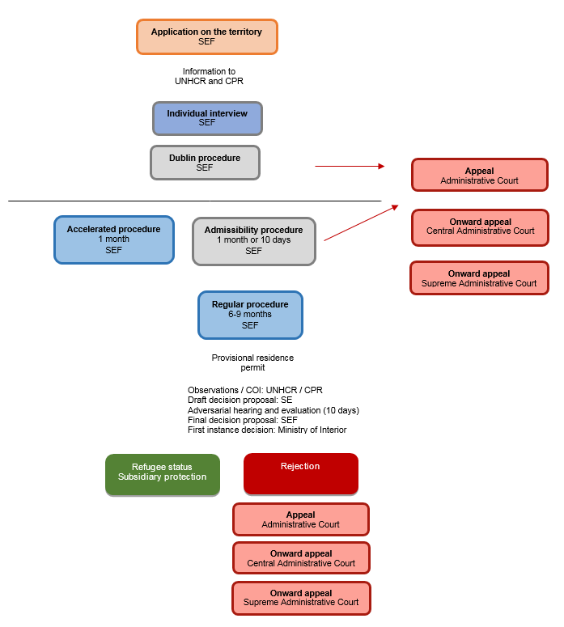

http://www.dgsi.pt/Jtrl.nsf/e6e1f17fa82712ff80257583004e3ddc/efe3139fa1ac40f98025680300048a4d?OpenDocument
Security and fight against racism, xenophobia and intolerance in sports spectacles: http://www.pgdlisboa.pt/leis/lei_mostra_articulado.php?nid=1326&tabela=leis
Establishes the legal regime for preventing, prohibiting and combating discrimination, due to racial and ethnic origin, color, nationality, ancestry and territory of origin: https://dre.pt/pesquisa/-/search/108038372/details/maximized
Principle of equal treatment: http://www.pgdlisboa.pt/leis/lei_mostra_articulado.php?nid=231&tabela=leis&ficha=1&pagina=1
https://www.cig.gov.pt/wp-content/uploads/2019/10/Relat%C3%B3rio-aplica%C3%A7%C3%A3o-da-Lei-n%C2%BA-62_2017.pdf
https://www.publico.pt/2019/01/04/politica/noticia/governo-abre-novo-concurso-diplomatas-pensar-2021-1856553
https://www.pordata.pt/Municipios/Crimes+registados+pelas+pol%c3%adcias+total+e+por+algumas+categorias+de+crime-600-2844
Relatório de Imigração, Fronteiras e Asilo, 2018. https://sefstat.sef.pt/Docs/Rifa2018.pdf
https://www.asylumineurope.org/reports/country/portugal/types-accommodation
https://www.asylumineurope.org/reports/country/portugal/flow-chart

