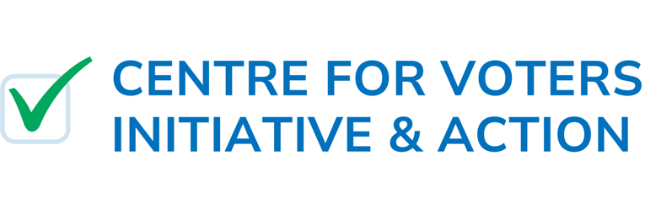
Mr. Jorge Araya
Secretariat, Committee on the Rights of Persons with Disabilities
Office of the United Nations High Commissioner for Human Rights (OHCHR)
8 - 14 Avenue de la Paix
CH-1211 Geneva (Switzerland)
Via E-mail: ohchr-crpd@un.org; jorge.araya@un.org
01 July 2025

NGO Report on Kiribati for the 33rd Session of the Committee on the Rights of Persons with Disabilities / Rapport des ONG sur Kiribati pour la 33ème session du Comité des droits des personnes handicapées

Table of Contents
Introduction 1
Legal Frameworks Facilitating the Denial of Suffrage 2
Inaccessible Infrastructure Undermining Electoral Participation 4
Incompliance with Legal Standards for Accessible Education 5
Physical Limitations Preventing Autonomous Voting 6
Lack of Access to Civic Education 7
Conclusion 8

Introduction
- The Centre for Voters Initiative & Action presents this report to the United Nations Committee on the Rights of Persons with Disabilities ahead of the 33rd session for the review of Kiribati. The Centre is a non-governmental organisation based in the Americas with an international focus.

- The Centre works with multiple international mechanisms to convey dialogue, conduct research, and bring awareness to the thematic issues of electoral engagement around the world. We closely follow and participate in the United Nations human rights mechanisms in Geneva and abroad to promote civil society participation in the public affairs process.

- Recognising the complex nature of the recent challenges Kiribati faces, the Centre hopes to provide valuable information to the Committee regarding the State’s compliance with issues exacerbating incompliance under Article 29.
- Indeed, this report is focused on the scope of Article 29, and we encourage Committee members to understand the nature of civic education as a tool to combat this contemporary turmoil; hopefully, the Committee will find this report valuable.

- This report focuses on four specific violations that hinder the rights of persons with disabilities on their participation in political life in Kiribati: (1) legal frameworks facilitating the denial of suffrage; (2) inaccessible infrastructure undermining electoral participation; (3) physical limitations preventing autonomous voting; and (4) a lack of access to civic education. Combined, these issues, contribute to an undermining of the rights of persons with disabilities in Kiribati under Article 29.

Legal Frameworks Facilitating the Denial of Suffrage
- Under Article 64(2) in Kiribati’s Constitution, one notable restriction on both voter registration and voting itself is for persons who are, as declared in section (b), “certified to be insane or otherwise adjudged to be of unsound mind under any law in force in Kiribati”.

- Article 29 guarantees that persons with disabilities enjoy political rights on an equal basis as others; as such, the disqualification ordained under Kiribati’s Constitution indeed undermines certain political rights. The provision leaves an avenue for many persons with disabilities to be denied their right to participate in the political life, often without strict scrutiny or opportunities for relief.

- Notably, the term “unsound mind” in and of itself is vague and archaic. It lacks a clear, rights-based definition and is often based on a court ruling or medical opinion, rather than a functional assessment. Furthermore, the language equates mental / intellectual disabilities with incompetence, hinting towards discrimination.

- In 2021, the Committee was concerned that persons with disabilities deemed ‘crazy persons’ or ‘persons who lost mind’ were excluded from suffrage under the Constitution of Laos. During the 2012 review of China and, the Committee flagged the exclusion of citizens with intellectual impairments from voting. In all such cases, it has been consistent that any legal disqualification based solely on mental capacity violates Article 29 and must be repealed or reformed. The Committee should reach the same conclusion in the instance of Kiribati.

Considering this information, the Committee should note that legal provisions denying suffrage on the basis of mental capacity severely undermine the political rights of persons with disabilities. The Centre hopes the Committee will urge Kiribati to reform, if not repeal, the unsound mind provision of Article 64(2) of Kiribati’s Constitution.
- Furthermore, limited data shows how and when this provision is applied, yet it remains an area of concern for the free political participation of persons with mental disabilities. Limited information also surrounds the process itself in deeming one mentally incompetent in Kiribati; remedies and appeals are not explicitly declared, raising concern that certain persons are simply denied the right to vote on unreasonable grounds.

Noting the lack of information on the implementation of Kiribati’s incompetence clause, the Committee should ask the State party what legal methods exist for persons with disabilities who want to restore their rights to vote after being declared incompetent.

In particular, the Centre takes special interest in the number of persons who have been denied electoral rights under this provision and hopes the Committee will request that information from the State party during the interactive dialogue.

- Unfortunately, the “unsound mind” provision goes beyond civil society as well, also implicating the election of members of Parliament. According to Article (56)1 of Kiribati’s Constitution, specifically sub-section (b), no person shall be qualified to be elected as a member of the Maneaba ni Maungatabu who has “been certified to be insane or otherwise adjudged to be of unsound mind under any law in force”.

- The Centre is deeply concerned by the notion that disabled persons – albeit those designated under a provision that does not fully encompass an empathy towards persons with disabilities – may not only vote, but also not serve in legislature. Disabled representation is critical for advancing accessibility policies, yet they remain impossible if one deemed ‘incompetent’ cannot even qualify to serve as a lawmaker.

Referring once again to the presence of persons with an “unsound mind” being denied not only the right to vote, but also serve in legislature, the Centre hopes the Committee will condemn this language and ask for it to be either modified or reformed to limit exclusion of persons with disabilities from the political life.

- Whilst Kiribati’s Constitution is an area for concern, the national laws are as well. In 1979, Kiribati passed the fundamental Elections Ordinance, creating a two-round voting system. The ordinance essentially encompasses all the laws which govern the elections in Kiribati.
- However, the Ordinance does not include any policies which govern the participation of persons with disabilities in elections. Thus, there is no requirement of reasonable accommodations (ramps, tactile ballots, accessible voting machines, poll worker training, etc.) to assist voters with disabilities due to a gap in law.
- In the daily life, polling places may be physically inaccessible, and there are no legal obligations for officials to adapt voting methods or venues. Kiribati’s National Disability Policy & Action Plan, which will certainly be mentioned extensively in other instances, describes disability inclusion as a “cross-sector priority”, including civic engagement. However, this is only a policy; not legislation. Indeed, disability inclusion is aspirational, but it lacks legal teeth in electoral law.

The Committee should ask the Kiribati government to include explicit provisions ensuring the right of persons with disabilities to vote with accessible measures under the Elections Ordinance. In particular, these provisions should seek to implement binding accessibility standards, such as ramps, tactile ballots, accessible voting machines, poll worker training, etc. for disabled persons.

Inaccessible Infrastructure Undermining Electoral Participation
- According to a 2017 report conducted by the Australian government, there has been no systematic provision of accommodations in Kiribati voting centres, such as assistive voting booths, tactile ballots, or poll-worker assistance. Accessibility issues were referenced in the report; however, they were noted only as a barrier, without clarification for solutions in practice.

- In 2020, Kiribati’s Disability Monograph reported significant mobility challenges: polling centres are informal community structures – such as schools, churches, village halls – that often have no ramps, narrows doors, or uneven surfaces, effectively barring wheelchair users from entry.

- In 2019, the Pacific Disability Forum summarised that “access to voting information [and] physical accessibility of polling venues” is critically lacking. Indeed, this is illustrated in the nature of Kiribati’s geography: as a remote string of 20 inhabited islands, it is difficult for those who are remotely located to receive information.

- Nearly two-thirds of those with disabilities in Kiribati live on remote atolls with poor transportation and infrastructure. As a result, many are unable to reach electoral centres. Even if they do, those centres are often physically inaccessible. Thus, disabled voters face a dual barrier: reaching the election site, then getting inside.
We urge the Committee to press the State party on what measures they are taking to:
*
(1) facilitate the ability of disabled voters to arrive at the polling centres, and
(2) implement accommodations at all polling centres, such as ramps and entryways.

Incompliance with Legal Standards for Accessible Education
- Kiribati has not yet ratified the 1960 UNESCO Convention Against Discrimination in Education. However, Article 19 of the 2013 Kiribati Education Act states that children with disabilities and of mandatory school age “must, where practical, be enrolled in and attend a school, and be given the opportunity to participate together with the other students of the school in the education and extra-curricular activities offered by the school”.

- Currently, there is one specialised school in Kiribati that caters to children with disabilities, the Kiribati School and Centre for Children with Special Needs (KSCCSN). The school relies on grants, donations, and family contributions to operate.

- KSCCSN has reported that most of the school's classrooms exist in incredibly poor conditions, and the school faces difficulties acquiring the land and teaching staff they require to provide students with a quality education. Presently, the government of Kiribati provides training to two KSCCSN teachers at the Kiribati Teachers College each year, however, this training program focuses on mainstream education instead of specialisation in teaching disabled students.

- Indeed, more support for youths with disabilities in the school level could further the overall well-being of persons with disabilities in Kiribati as a whole. Education is a gateway for prosperity, and the lack thereof could hinder one’s ability to contribute to their fullest extent. It is necessary to emphasise a steadfast commitment to education to secure a pathway for future generations’ journeys to destiny.

The Centre asks that the Committee recommends Kiribati to ratify the 1960 UNESCO Convention Against Discrimination in Education to comply with international standards, affirming their commitment to promoting accessibility in education, particularly for youths with disabilities.

On the State level, the Committee should press the State to work in increasing its financial support to the Kiribati School and Centre for Children with Special Needs. In particular, Kiribati should make school infrastructure accessible and safe for those with disabilities.

Physical Limitations Preventing Autonomous Voting
- Whilst this report has already discussed the limitations in Kiribati’s infrastructure on a macro scale, there exist numerous micro-issues which stifle the ability for disabled persons in Kiribati to properly vote. Whatsmore, Kiribati’s civil society groups have raised concerns for years about disabled persons being “invisible” during elections, but there are no reporting or complaint channels for disenfranchised voters.
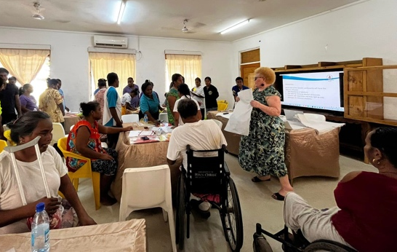
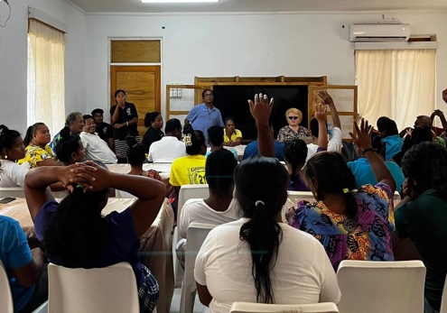

A local gathering of persons with disabilities in Kiribati, learning about the political process. Dialogues such as this could help Kiribati citizens further realise their Article 29 rights.

- In 2020, a woman who was using a wheelchair in South Tarawa could not vote because the maneaba was only accessible by stairs. In another instance, a man with low vision was unable to vote independently due to lack of ballot magnification or large print, forcing him to rely on family to complete his vote.

- Indeed, the situation for disabled persons’ political participation in Kiribati is stuck in a loop of cyclical marginalisation: disabled persons cannot initially reach the electoral centre nor get inside due to a lack of reasonable accommodations. Hence, they are unable to express concern through the political system, reverberating the status quo and hindering any prospects of change through policy.

- The best way of eliminating a lack of reforming policies for disabled persons is by including them in the process of changemaking. The creation and integration of procedural remedies, such as a voter complaint and feedback mechanism, could help establish an accessible system by giving disenfranchised voters a centre to report barriers or discrimination during the electoral process.

In light of the feelings of marginalisation and voicelessness from civil society groups, the Committee should press the State party to develop an institutionalised system to hear complaints from persons with disabilities. In particular, this system should be accessible to hear feedback regularly to effectively identify areas for improvement.

Lack of Access to Civic Education
- According to a 2022 report from the United States Department of State, most children with disabilities in Kiribati lack access to fundamental civics education. The report specifically notes only seven schools in the outer islands were accessible to children with disabilities. Whatsmore, Kiribati’s National Disability Policy & Action Plan notes many persons with disabilities do not get basic education services.

- As a result of limited educational opportunities, children with disabilities are often excluded from learning environments where civic knowledge is typically taught and reinforced. Thus, disabled citizens in Kiribati are less likely to be equipped with the knowledge and skills to actively participate in civic processes. This only exacerbates the concern of long-term civic exclusion for persons with disabilities.

- In Kiribati, there is a stark contrast between educational outcomes for disabled and non-disabled persons. The Kiribati National Statistics Office found in a 2025 report that 18.7% of disabled children and youth between the ages of 5-24 have never attended a school, whilst the rate for non-disabled peers is less than 1%.

- Consequently, the literacy rate for persons with disabilities in Kiribati is 73.1% compared to 95.6% for those without disabilities. While illiteracy is not a disqualification for voting in Kiribati, it presents a significant challenge in the voting process and in overall civic participation.

The Centre strongly emphasises the importance of civics education and voter awareness in playing a central role to future generations. For persons with disabilities, civics education can pave a road to an ability to improve their lives through the political life.

Thus, the Centre politely pushes the Committee to:

- Ask, during the interactive dialogue, the measures currently taken and/or planned to promote civic education amongst young boys and girls with disabilities; and
- Emphasise, in its concluding observations, the strong need for the State party to pursue civic education measures in order to foster political engagement and contribute to the country’s future development.

Conclusion
- In closing, the human rights situation in Kiribati regarding civic participation for persons with disabilities remains a significant concern. The Centre hopes the Committee has found this information useful and will incorporate these findings into its concluding observations. As outlined in this report, the Centre strongly advocates for comprehensive reforms aimed at ensuring equal access to voting, improving civic education, and fostering inclusive political engagement for persons with disabilities.

- In particular, the Committee should focus its dialogue with Kiribati on the Constitutional limitations surrounding mentally ill persons, accessibility of their polling centres, and civic education measures for youths with disabilities. Indeed, these combined factors reveal Kiribati to be struggling in fulfilling its obligations under Article 29 of the Convention.

- The aforementioned issues in this report undermine the core of Article 29 rights for Kiribati’s civil society and pose a substantial obstacle to inclusive democracy. Addressing them is crucial to ensuring that persons with disabilities can fully exercise their political rights and contribute to the democratic process. We hope these concerns will be addressed to build a more inclusive and equitable future for all.

- This submission may be published on the OHCHR website or any other places necessary. For any enquiries regarding this submission, please contact the primary contributors of this report:

Samad QURAISHI / Executive Director
squraishi@cvia.ch

Josselyn GOULD / Executive Assistant
jgould@cvia.ch

Centre for Voters Initiative & Action Inc.
1200 Pennsylvania Avenue NW, P.O. 294
Washington, D.C. 20004

Constitution of Kiribati, Article 64(2), The franchise. Adopted July 1979, rev. 2013.
Committee on the Rights of Persons with Disabilities, Concluding observations on the initial report of Laos, (30 September 2022), U.N. Doc. CRPD/C/LAO/CO/1, ¶ 6(a). https://docs.un.org/en/CRPD/C/LAO/CO/1.
Committee on the Rights of Persons with Disabilities, Concluding observations on the initial report of China, (15 October 2012), U.N. Doc. CRPD/C/CHN/CO/1, ¶ 45. https://docs.un.org/en/CRPD/C/CHN/CO/1.
Constitution of Kiribati, Article 56(1), Disqualifications for elected membership. Adopted July 1979, rev. 2013.
Laws of Kiribati, Elections Ordinance, CAP. 29B, 1979. http://www.paclii.org/ki/legis/consol_act/eo167.pdf.
International Institute for Democracy and Electoral Assistance, Kiribati Voting Method, https://www.idea.int/answer/ans9377335574314.
Government of Kiribati, Kiribati National Disability Policy and Action, (24 September 2018), https://extranet.who.int/mindbank/item/7325. For the effective period 2018 – 2021.
Australian Government Department of Foreign Affairs and Trade, Report of the Independent Review of the Kiribati Disability Inclusive Development Program, (May 2017), https://dfat.gov.au/sites/default/files/kiribati-disability-inclusiveness-program-eval-report-man-resp.pdf.
Kiribati National Statistics Office & Pacific Community, Kiribati Disability Monograph, (2020).
Pacific Disability Forum, https://facebook.com/100064643441211.
Human Rights Council, Compilation of Kiribati's Universal Periodic Review, (12 November 2014), U.N. Doc. A/HRC/WG.6/21/KIR/2, ¶ 5. https://upr-info.org/sites/default/files/documents/2015-01/a_hrc_wg.6_21_kir_2_e.pdf.
United Nations Educational, Scientific and Cultural Organization, Kiribati Education Profile, (28 July 2021), §2, https://education-profiles.org/oceania/kiribati.
Kiribati School & Centre for Children with Special Needs, UPR Stakeholder’s Report for the Review of Kiribati, https://upr-info.org/sites/default/files/documents/2019-12/ngo_upr35_kir_e_main.pdf.
Pacific Disability Forum, (20 September 2017), https://lists.pacificdisability.org/pipermail/dpo-officemanagers_lists.pacificdisability.org/2017-October.txt.
United Nations Population Fund and Australian Agency of International Development, A Deeper Silence, (March 2013), https://pacific.unfpa.org/sites/default/files/pub-pdf/UNFPAReport-ADeeperSilenceA4PublicationLR3%283%29.pdf.
Ibid.
U.S. Department of State, 2022 Country Reports on Human Rights Practices: Kiribati, ﷟https://www.state.gov/reports/2022-country-reports-on-human-rights-practices/kiribati/.
Government of Kiribati.
Kiribati National Statistics Office, Kiribati Power of Data – Empowering Kiribati disability inclusion: Report shows progress and gaps, (24 June 2025), https://nso.gov.ki/news/kiribati-power-of-data-empowering-kiribati-disability-inclusion-report-shows-progress-and-gaps/.

