Submission to the UN Committee on the Rights of the Child for its 98th pre-sessional Working Group ahead of the adoption of recommendations in the periodic review of Ecuador
— 1 April 2024 —

1. This thematic submission addresses sexual violence against children in institutional settings in Ecuador, with a focus on reported cases.
The scale of child sexual abuse in Ecuador and the call for a national inquiry
2. According to the Pan American Health Organization, 21% of children suffer sexual violence in Ecuador. The National Women's Coalition of Ecuador estimates that, out of every 10 victims of sexual violence in the country, six are children. Among these, 8 out of 10 cases occur in the home at the hands of a family member. However, there are also high levels of sexual violence in institutional settings. For example, Human Right Watch termed sexual violence in Ecuadorian schools as an endemic “silent epidemic” in the country. This was further confirmed by the National Assembly’s AAMPETRA Commission into child sexual abuse in educational settings, which presented in its report in 2018, concluding that between 2015 and 2018, 4,564 cases were recorded. The Commission also highlights that there were a further 7,531 abuse reports that it was unable to include in its investigation. More recently, a report from the Ecuadorian Office of the Ombudsperson states that there were 52,051 cases of sexual violence committed against children between 2018 and 2023. If we divide this figure, it represents approximately an average of 11,566 victims each year, 963 each month, 221 every week and 31 every day.
3. Regarding the number of complaints, figures highlighted by the Office of the Ombudsperson estimate that for every four girls raped or sexually abused, only one files the respective complaint, while out of every ten boys who have been abused, only one files the complaint. In general, only 15% of cases of sexual abuse against children are reported, and only 5% are punished, according to UNICEF figures.
4. Given the worrying figures, and after its investigation of sexual violence in educational settings, the AAMPETRA Commission recommended in its final report “establishing a Truth Commission” made up of national experts and representatives of the victims in order to investigate “the 7,531 complaints of violence and sexual abuse against children and adolescents that were not known to this Commission and [to reveal] the truth completely.” In view of the high number of abuses perpetrated in institutions run by the Catholic Church, it also recommended that the Truth Commission “specifically address the problem of sexual violence against children and adolescents in religious settings, and that it include in its investigation cases of cover-ups and the failure to report.“
5. The call for a truth commission in Ecuador to address sexual violence against children is part of an emerging wave of countries in Latin America in which survivors are increasingly demanding truth, justice and reparations. The others are so far Argentina, Chile and Mexico. In June 2022, the Committee on the Rights of the Child already urged the State of Chile to “Establish an independent, impartial, adequately funded truth commission to examine all cases of abuse of children in institutional settings, including within the Catholic Church and in residential centres”.
6. Truth commissions play a crucial role in establishing facts around child abuse scandals, especially when there is a systemic lack of data, there are multiple versions of events or allegations have been covered up, dismissed or minimised by both the accused institutions and government. Many States around the world have responded to the systemic abuse of children by conducting large-scale, independent inquiries led by teams of independent experts to investigate the scale of abuse and identify institutional failures. National inquiries - or truth commissions, as they are better known in Latin America - are quasi-judicial bodies that create an official historical account of events; draw on the testimony of victims; set out steps in the form of recommendations for government and institutions to improve child protection law, policy and practice; and in some cases can also lead to the creation of redress schemes that may include an official apology, the construction of monuments to commemorate historical trauma and suffering, financial reparations, the provision of support services such as counselling and hotlines for more abuse victims to come forward. An inquiry’s recommendations also seek to prevent the problem from recurring, including by advising on law reform to make reporting of abuse mandatory, pre-employment screening, staff training, mechanisms for children to report abuse, public awareness campaigns, prevention education for school children, oversight agencies and ratification of relevant human rights treaties and conventions.
7. Recommendationss:
- The State Party should establish an independent and impartial truth commission to examine all cases of sexual violence against children in institutional settings in Ecuador. It should be adequately funded, endowed with the necessary legal powers to summon public and private actors and entities and to access all necessary information even if deemed confidential, and the commissioners assigned should be independent of all the institutions to be investigated to avoid any conflict of interest and ensure impartiality.

Abuse complaints and impunity
8. In December 2023, the Office of the Ombudsperson issued an Interim Report of its investigation in sexual violence in institutional settings in Ecuador, which aimed to determine how State entities responsible for the protection, detection, investigation, trial and reparation to victims comply with their legal responsibilities. The findings of this report underline the conclusions found five years earlier by the AAMPETRA Commission.
9. Using data from these two sources of information, the AAMPETRA Commission report and the Ombudsperson report, a comparative table has been prepared below that shows the setbacks in the handling of complaints in Ecuador. The graph shows how the number of complaints has increased by 935.35% between 2018 and 2023. This increase can be deemed plausible, as it may reflect higher awareness in society. However, the lack of responses from the judicial system is also evident, with the impunity rate, which was 78% in 2018, having grown to 95.78% in 2023.
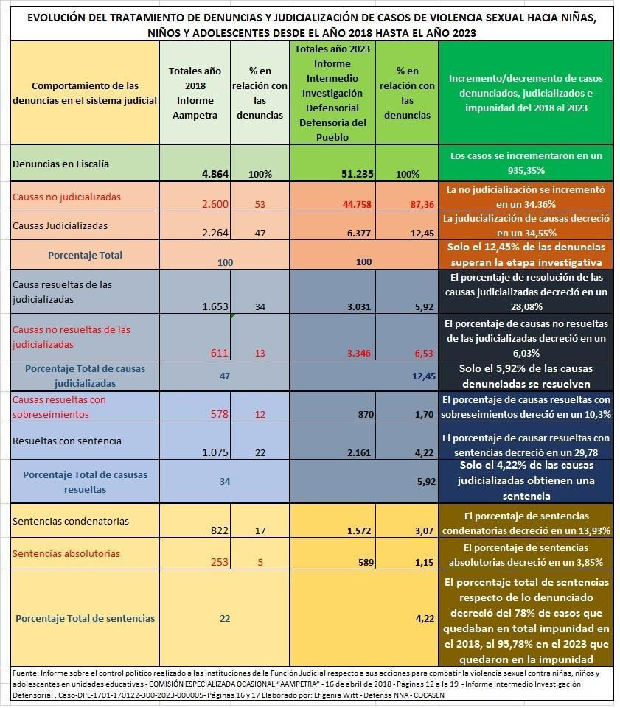
10. According to the data available in the reports, of the 51,235 cases that were reported, 44,758 did not pass the investigative stage, that is, 87.36% never reached trial. There is a bottleneck in the investigative stage of sexual crimes against children and adolescents that occurs due to the lack of specialised prosecutor's offices for the specific and specialised handling of this type of offences. The greatest specialisation that exists in the country is in a single sexual crimes prosecutor's office located in the Azogues canton in the Province of Cañar. Albeit it is a prosecutor's office that deals with this type of offence committed against adults and children alike, without further specialisation or specificity.
11. According to information from the State Attorney General's Office, Ecuador has 33 Prosecutor's Offices specialising in Gender Violence, which are located 14 out of 24 provinces and in 19 of the 221 cantons of the country. These offices are the ones that handle complaints of sexual violence against children, along with those against adults, femicides, physical violence, etc. But with the specialisation being on gender, not age, they lack expertise and even basic knowledge on the best interests of the child. This causes, among other things, that victims, especially in rural areas, have to travel from their homes for long hours to attend proceedings and have to deal with people who are unaware of their cultural particularities in the multicultural and multiethnic nature that characterises them to the country.
12. In relation to the Specialised Judicial Units, although the number of units is greater, and cover a greater part of the country, the problem of specialty and specificity remains the same, the lack of proximity of the victims to their processes, the lack of pediatric specialisation of the technical-forensic teams and of the justice administrators themselves with regard to the best interests of the children, as a human right and as a procedural and general rule of application as defined in General Comment 14 (2013) of the Committee.
13. The Judicial Units that serve with greater specialisation are those of Violence against Women and the Family, which exclusively deal with criminal cases. These are also handled by the Family, Women and Adolescents Judicial Units, which, along with criminal cases, handle civil cases such as divorces, child support, visitation rights, parental custody, among others. According to data from the Judicial Council, among all these specialised judicial units, Ecuador has 79 judicial units, concentrated in 23 of the 24 provinces, and in 72 of the 221 cantons of the country.
14. Regarding the recording of data and information related to sexual violence against children and adolescents, the Office of the Ombudsperson concludes that there are no analogous systems where State institutions can exchange information, the data does not always coincide between the institutions, and each institution calculates and disaggregates the data differently, all of which complicates tracking and verifying information.
15. Recomendations:
- The State party must establish a specific criminal justice system specialised in handling cases of violence against children, including sexual violence, at all procedural stages, from the moment a complaint is made until the perpetrator completes their sentence. This system should have adequately trained personnel and it should also guarantee access to holistic reparations to the victims.
- The State party must allocate adequate resources for the immediate investigation and prosecution of cases of sexual violence against children, through, among other thing, the provision of sufficient resources to the Prosecutor's Office to be able to carry out its work.
- The State Party should establish a national database on all forms of violence that disaggregates data by as many key variables as possible, including the victim’s age, sex, gender identity, disability, socio-cultural or ethnic background, migratory status, geographical location and urban/rural location, and that this data be articulated in a coherent manner among and across all government agencies.
The social causes that account for these violations
16. The reported problems are explained by a set of intersecting causes. Institutional and family cover-up of abuse could be said to be one of the fundamental causes, which in fact prevents victims from accessing the reporting process and services for their protection.
17. The concealment of information within educational settings, institutions run by the Catholic Church and other institutions occurs in the name of institutional prestige, and within families it is explained in the naturalisation of the phenomenon, as well as in patriarchal and adult-centric structures. existing in families and as an exercise of male domination and supremacy.
18. Children know and are aware of the existence of cases of abuse, harassment and sexual violence in the educational system and within the home, as well as in other settings; but they report that they do not have in their homes or in the educational system, training and education in sexuality or in ways to prevent the sexual violence to which they are exposed. Forty percent of children state that they have not received any training related to sexual violence against children with a focus on gender from the Ministry of Education.
19. There is a lack of trust in the testimony of children when they report abuse, harassment or sexual violence, they are accused of fabrication or they are blamed for the abuse, especially girls. It would seem that one of the fundamental reasons for this to happen is that sexual violence is naturalised.
20. Children and the rest of society do not trust the justice system, either because it re-victimises and blames them, or because the investigation procedures are not specialised and respectful of their rights. There is no adequate care, protection or accompaniment, nor restitution and comprehensive reparation for victims of sexual violence. There is also little coverage of specialised services to comply with administrative protection measures. There are few psychology professionals who provide therapeutic spaces to children who are victims of violence in the four cantons.
21. All of this contributes to the above-mentioned low percentage of complaints of sexual violence, compared to the actual number of cases. And, when a victim manages to make a report, there is a fear of reprisals that may exist not only on the part of the perpetrators of violence, but also on the part of other close adults (teachers, educational authorities, mothers, fathers or other family members). that they blame and stigmatize them.

Staff training and protection of children against sexual violence
22. There is a lack of training for the personnel responsible for acting in cases of sexual violence within the educational system, who are the professionals of the DECE (Department of Student Counseling) as well as a shortage of personnel in these organisations. In other government ministries, the situation is even worse: in the Ministry of Economic and Social Inclusion, the personnel who are responsible for relevant services, do not have any specialised training, and yet deal with cases that arise daily. In the two national services specialised in the protection of children rescued from trafficking situations, it is assumed that they have other capacity. In the Ministry of Health, the care provided when cases of sexual violence come to them is based on procedures designed for women and girls, not children generally.
23. First of all, it is worth mentioning that the country does not have a national entity specialised in children, as mandated by the Constitution. The public organisations in charge of the administration of justice (Prosecutor's Office, Judicial Council, with its Judicial Units, Cantonal Boards for the Protection of Rights, DINAPEN - National Directorate of Specialized Police for Children, the Ombudsman's Office, and the Public Defender's Office) are responsible for the process that leads to the punishment of the perpetrators. Without a doubt, the Ministry of Education is one of the most important institutional actors with regard to the child protection system, because it is one of the fundamental settings to activate the practical management model.
24. Another institution that plays an important role in the protection process is the Ministry of Public Health. In all the provinces, it has been pointed out by the majority of the actors interviewed, that this Institution provides immediate attention to children with sufficient speed and timeliness.
25. On the other hand, in the case of the Public Prosecutor's Office and the Judicial Council, there are countless complaints and mistrust that have been expressed by each of the social and institutional actors who took part in interviews. There is a high perception of corruption and the imposition of obstacles to reporting; likewise, it is perceived that there is no effectiveness and inclusion in the protection system for victims and witnesses, that it does not provide adequate and free technical defense for victims and witnesses or their families, and that cases are not won and that sentences take a long time. The general complaint is that “the processes are long and exhausting”, which is why many families and children and adolescents become discouraged in the middle of the process.
26. In recent years, at the initiative of the Judiciary Council, the formation of inter-institutional commissions has been promoted to deal with cases of sexual violence. Yet interviewees state that while "the commissions are exist, they are of no use, because the cases are not expedited” and, additionally, “this only happens when a case draws media attention, therefore they are not sustainable.” Additionally, it must be noted that civil society was not involved in these inter-institutional coordination spaces. As for the DINAPEN (National Police of Ecuador through the National Unit for Investigation and Protection of Children and Adolescents), the perception is that “they do not provide support either, they are not familiar with the law, they do not give good advice about where to go, and members of staff do not understand well what their work involves”.
27. Recommendations:
- The State party must establish a Decentralised Comprehensive Protection System for the Rights of Children, as set out in Ecuador's Constitution and in all related legislation for the protection of children. Additionally, all personnel in the child protection system should have adequate training in child protection.
- The State party must develop and implement a national strategy for the prevention of sexual violence against children in all settings This strategy must include the training of all personnel who are in contact with children, that all personnel be subject to background checks before receiving employment, and that mandatory reporting be implemented in all institutions.
- FIN -

This submission is made jointly by Red de Sobrevivientes al abuso sexual institucional de Ecuador (twitter.com/sobrevivecuador) and CRIN - Child Rights International Network (www.crin.org).
‘Violencia sexual contra niñas, niños y adolescentes. Ecuador, 2021’, Organización Panamericana de la Salud, November 2021. Available at: https://www.paho.org/es/historias/violencia-sexual-contra-ninas-ninos-adolescentes-ecuador-2021
Contribución conjunta para el Examen del Comité de Derechos del Niño: Una mirada desde las organizaciones de mujeres de la sociedad civil, a los derechos de las niñas, adolescentes y mujeres ecuatorianas a una vida libre de violencias, Coalición Nacional de Mujeres del Ecuador, July 2017, p.6. Available at: https://tbinternet.ohchr.org/_layouts/15/treatybodyexternal/Download.aspx?symbolno=INT%2FCRC%2FNGO%2FECU%2F46421&Lang=en
“Es una lucha constante”: La violencia sexual en instituciones educativas y los esfuerzos de jóvenes sobrevivientes por obtener justicia en Ecuador, Human Rights Watch, December 2020. Available at: https://www.hrw.org/es/report/2020/12/09/es-una-lucha-constante/la-violencia-sexual-en-instituciones-educativas-y-los#_ftn7
Ibidem.
Informe de Resultados del Trabajo realizado por la Comisión Especializada Ocasional AAMPETRA, October 2018, p.201. Available at: www.asambleanacional.gob.ec/es/blogs/comision-especializada-ocasional-aampetra/58109-comision https://educacion.gob.ec/wp-content/uploads/downloads/2018/03/INFORME-CONTROL-POLITICO-EDUCACION-remitido-Sesion-20.pdf
Ibidem.
Informe Intermedio Investigación Defensorial, Defensoría del Pueblo de Ecuador, Caso-DPE 1701-170122-300-2023-000005, December de 2023, p.6. Available at: https://repositorio.dpe.gob.ec/handle/39000/3549
‘En seis meses, la Defensoría del Pueblo prevé terminar una investigación sobre violencia sexual infantil a nivel institucional en Ecuador, El Universal, 20 June de 2023. Available at: https://www.eluniverso.com/noticias/ecuador/defensoria-del-pueblo-investigacion-violencia-sexual-ninos-ninas-adolescentes-ecuador-nota/
Ahora que lo ves, Di No Más: Juntos contra el abuso sexual, UNICEF Ecuador. Available at: https://www.unicef.org/ecuador/ahora-que-lo-ves-di-no-m%C3%A1s
Informe de Resultados del Trabajo realizado por la Comisión Especializada Ocasional AAMPETRA, October 2018, p.201. Available at: www.asambleanacional.gob.ec/es/blogs/comision-especializada-ocasional-aampetra/58109-comision
Ibidem.
‘Proyecto de Ley: Comisión Investigadora Independiente de la Verdad y la Reparación sobre Delitos de Violencia Sexual Padecidos en la Infancia y/o Adolescencia’. Disponible en: https://www4.hcdn.gob.ar/dependencias/dsecretaria/Periodo2023/PDF2023/TP2023/4259-D-2023.pdf
‘ONU urge a Chile crear comisión para examinar casos institucionales de abuso contra menores’, Biobío Chile, 9 June de 2022. Available at: https://www.biobiochile.cl/noticias/nacional/chile/2022/06/09/onu-urge-a-chile-crear-comision-para-examinar-casos-institucionales-de-abuso-contra-menores.shtml
‘Exigen al presidente de México crear una Comisión de la Verdad contra la pederastia clerical’, Religión Digital, 21 Febrero 2023. Available at: https://www.religiondigital.org/america/Exigen-presidente-Mexico-Comision-Verdad_0_2535346460.html
‘Observaciones finales sobre los informes periódicos sexto y séptimo combinados de Chile’, CRC/C/CHL/CO/6-7, Comité de los Derechos del Niño, 22 de junio de 2022, pág. 7, párr. 20.a. Available at: https://tbinternet.ohchr.org/_layouts/15/treatybodyexternal/Download.aspx?symbolno=CRC%2FC%2FCHL%2FCO%2F6-7&Lang=en
See, for example, ‘The Age of Inquiry: A global mapping of institutional abuse inquiries’, Melbourne: La Trobe University, 2020. Disponible en: https://www.lib.latrobe.edu.au/research/ageofinquiry/index.html
CRIN, ‘Comisiones de investigación independientes del abuso infantil´, in La tercera oleada: Justicia para los sobrevivientes de abuso sexual infantil en la Iglesia católica de América Latina, November 2019, pp. 45-68. Available at: https://static1.squarespace.com/static/5afadb22e17ba3eddf90c02f/t/5dd53b1ce71f5a106132a4bb/1574255393397/La+Tercera+Oleada_Informe+Final_.pdf
Ibid., pp. 57-60.
Informe Intermedio Investigación Defensorial, Caso-DPE-1701-170122-300-2023-000005, December 2023. Available at: https://repositorio.dpe.gob.ec/handle/39000/3549
Directory of Provincial Prosecutors’ Offices. Available at: https://www.fiscalia.gob.ec/directorio-fiscalias/
Available at: https://www.igualdadgenero.gob.ec/wp-content/uploads/2016/04/Unidades-Judiciales-que-conocen-casos-de-violencia-contra-la-mujer.pdf
Informe Intermedio Investigación Defensorial, Caso-DPE-1701-170122-300-2023-000005, December 2023, p.52, para.. 1. Available at: https://repositorio.dpe.gob.ec/handle/39000/3549
Testimonios recogidos durante el desarrollo del proyecto ‘Diagnóstico CAP: Proyecto Educación Libre de Violencia’, realizado por CARE Ecuador y COCASEN, octubre de 2021. Disponible en: https://careevaluations.org/keywords/education-system/
Ibidem, testimonio durante sistematización del taller 1.1.4 de Lago Agrio.
Ibidem, testimonio de autoridad educativa de Guayaquil.
Ibidem, testimonio de miembro de la JCPD de Guayaquil.
Ibidem, testimonio de profesional del Departamento de Consejería Estudiantil, Guayaquil.

