Annexure
a) Labour force participation and unemployment rate from 2017-2021
Year | Labor Force Participation (percentage) |  | Unemployment rate (Percentage)
 | Male | Female | Male | Female
2017 | 72.1 | 59.9 | 2.7 | 3.6
2018 | 70.1 | 55.5 | 2.2 | 4.2
2019 | 71.8 | 61.2 | 2.2 | 3.3
2020 | 72.5 | 63.5 | 4.1 | 6.0
2021 | 73.1 | 65.3 | 3.6 | 6.1

b) Prevalence of violence against women and girls
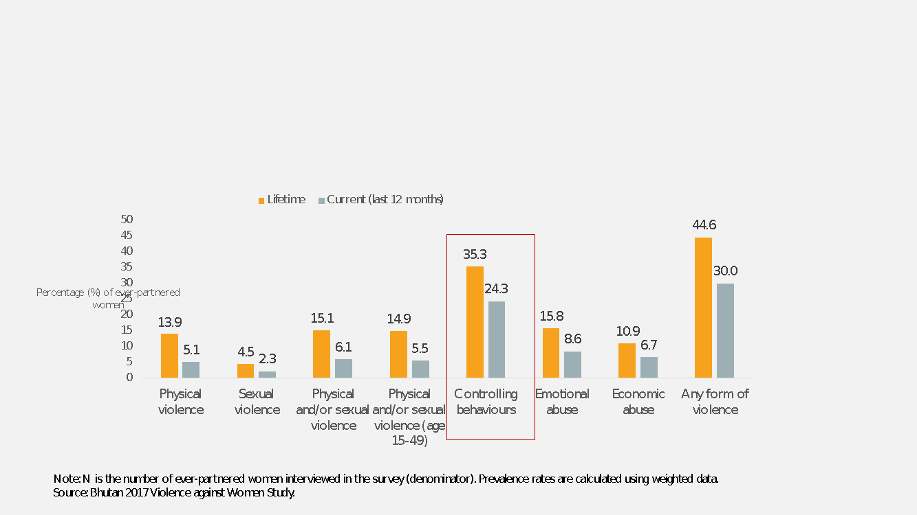

c) Participation in decision making
Sl No | Area | Participation rate (percent) | Year
1 | Parliament | 14.9 | 2021
2 | Local Government | 12.6 | 2021
3 | Civil Service | 18.9 | 2021

Organizational structure, NCWC


