Assessment of Economic and Social Rights Fulfilment in The Republic of Honduras
Submission from the Human Rights Measurement Initiative to the United Nations Committee on Economic, Social and Cultural Rights for the 76th Pre-Sessional Working Group Geneva, August 2024.
I. Reporting Organisation
- The Human Rights Measurement Initiative (HRMI) measures the human rights performance of countries, including Honduras. HRMI is an independent, not-for-profit NGO with a primary base of operations in New Zealand, and a second base in the United States at the University of Georgia’s Center for the Study of Global Issues (GLOBIS).
II. Assessment Methodology
2. HRMI uses the award-winning and peer-reviewed SERF Index methodology to measure the fulfilment of economic and social rights (ESR).
3. This methodology uses bellwether indicator data from international organisations—such as the World Health Organization and UNICEF—and compares each country’s achievement to what other countries at the same level of income have achieved. In this way, HRMI measures progressive realisation of economic and social rights (ESRs) as defined in the International Covenant on Economic, Social, and Cultural Rights (ICESCR). A country’s income-adjusted HRMI score is a measure of how well its government is converting its resources into good human rights outcomes for its people.
3. HRMI supplements these scores with qualitative information sourced by a confidential survey of on-the-ground human rights experts, such as NGO researchers, journalists, and human rights lawyers and advocates. For more details on HRMI’s methodology, please refer to the resources on our website.
4. All HRMI’s data are published annually on the Rights Tracker and are freely available for non-commercial use under a Creative Commons License. HRMI’s Rights Tracker is a certified Digital Public Good with the Digital Public Good Alliance.
III. Overview of Economic and Social Rights Fulfilment in The Republic of Honduras
5. HRMI’s most recent ESR scores for The Republic of Honduras (Honduras) measures its achievement as of 2021 and show significant room for improvement. They are shown in the table below.
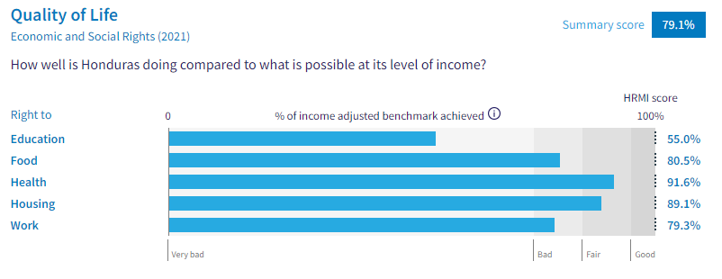6. Honduras’s scores for 2021 are as follows:
▪ Overall Quality of Life score = 79.1%
▪ Right to education = 55.0%
▪ Right to food = 80.5%
▪ Right to health = 91.6%
▪ Right to housing = 89.1%
▪ Right to work = 79.3%
7. These scores fall between the ‘very bad’ and ‘fair’ ranges, with none reaching the ‘good’ range.
8. Honduras scores 79.1% on Quality of Life when scored against the 'Income adjusted' benchmark. This score takes into account Honduras's resources and how well it is using them to make sure its people's Quality of Life rights are fulfilled.
9. This score tells us that Honduras is only doing 79.1% of what should be possible right now with the resources it has. This score may seem positive, however, since anything less than 100% indicates that a country is not meeting its current duty under international human rights law, our assessment is that Honduras has a long way to go to meet its immediate economic and social rights duty.
10. Compared with other countries in the Americas, Honduras is performing lower than average on Quality of Life rights.
IV. Right to Education
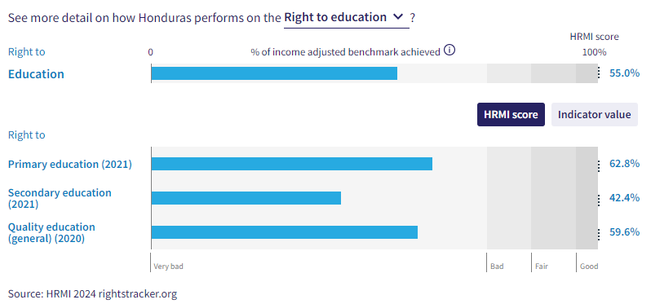
11. HRMI defines the right to education in accordance with ICESCR Article 13 and CESCR General Comments 11 and 13. In the case of low- and middle-income countries, such as Honduras, HRMI further breaks down the right to education into three areas of measurement: primary school enrolment, secondary school enrolment, and quality of education. Our scores show significant challenges in all three areas, with all scores falling into the ‘very bad’ range.
12. Honduras’s score for primary school education (adjusted for income) has been varied, with a steady decline since 2004. Honduras’s right to primary education score dropped from 85.8% to 62.8% across the period of 2004-2021. The score draws on indicator data from UNESCO showing that only 77.6% of primary school-aged children were enrolled in school in 2021. Some recovery was made recently over the 2015-2020 period, but there was a notable drop in 2021. Honduras is currently ranked fifth from the bottom out of 35 countries in the Americas.
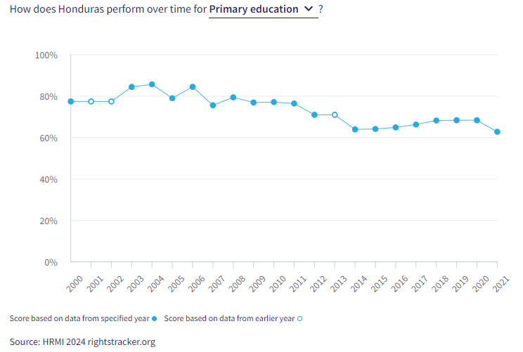
13. Secondary education is also faring very poorly, as only 38.6% of children were enrolled in secondary education in 2021. The HRMI score has been dropping consistently over this period, with Honduras only achieving 42.4% of what is possible with their resources in 2021. Honduras is currently ranked third from the bottom for secondary education when compared to other countries in the Americas.
14. The quality of education score is also in the ‘very bad’ range. Honduras is achieving only 59.6% of what we calculate ought to be possible in terms of quality of education. However, among all countries in the Americas, Honduras’s score is sixth highest.
V. Right to Food
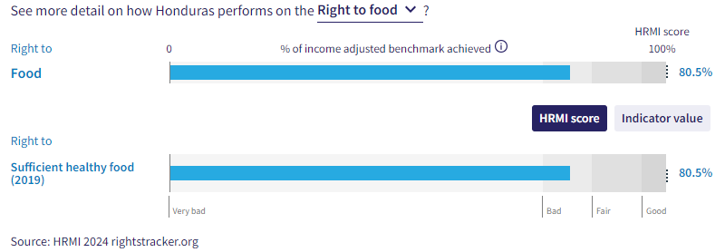
15. HRMI defines the right to food in accordance with ICESCR Article 11 and CESCR General Comment 12. For low- and middle-income countries, such as Honduras, HRMI first uses a bellwether indicator of how many children are growing well (are not stunted). Honduras’s score for the right to food is 80.5% and falls in the ‘bad’ range. This means that Honduras is doing 80.5% of what ought to be possible to ensure the right to food for its people. This score draws on indicator data on child stunting rates published by the UNICEF-WHO-World Bank: Joint child malnutrition (JME) database.
16. We have a supplemental HRMI score of 43.2% on the right to food security, placing Honduras in the middle of the ‘very bad’ range. Honduras is ranked 23rd from the bottom when compared to 146 other countries.
17. In 2019, 81.3% of children were not stunted. Honduras is currently ranked fourth from the bottom regarding this right when compared to other nations within the Americas. There has been significant improvement over the 2001-2019 period. In 2000, Honduras achieved a HRMI score of only 46.3%, demonstrating encouraging progress. Honduras still has a very long way to go, but it is headed in a positive direction.
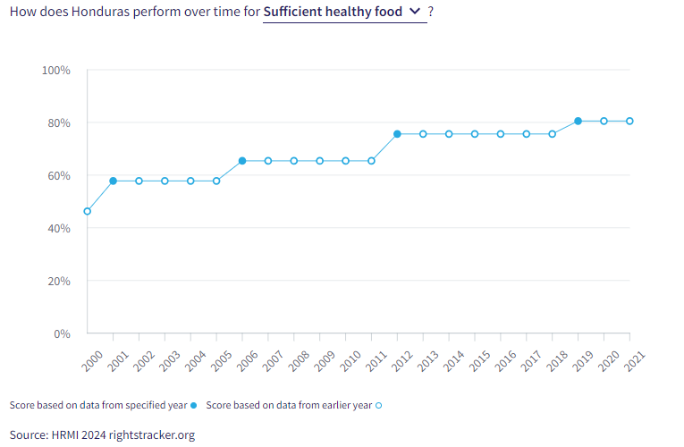
VI. Right to Health
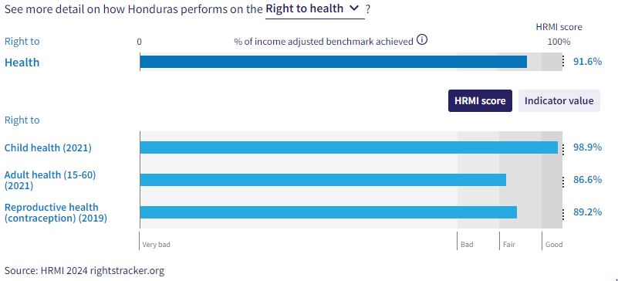

18. HRMI defines the right to health in accordance with ICESCR Article 12.1 and CESCR General Comment 14. In the case of low- and middle-income countries, such as Honduras, HRMI uses three indicators to measure the country’s achievement in child health, adult health, and reproductive health. Honduras has an overall HRMI score of 91.6% and is ranked sixth from the top within the Americas region. There has been improvement over the past 20 years, yet there has been a drop in 2020 and 2021 across adult and child health alike.

19. Child health across low- and middle-income countries is measured by survival to the age of five. Within Honduras, child health has been growing steadily over the past 20 years, reaching a peak HRMI score of 99.2% in 2020. This score places Honduras within the top 20 countries who are upholding the right to health. However, the score dropped to 98.9% in 2021, with 98.3% of children surviving to the age of five.
20. Adult health has been declining over recent years, reaching a peak HRMI score of 92.3% in 2015, and now residing at 86.6% in 2021. Honduras is 15th within the Americas’ region regarding adult health.
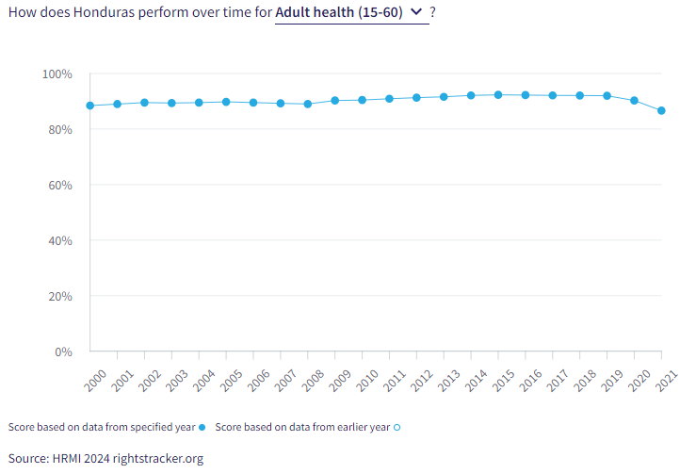
21. The right to reproductive health is measured by the rate of modern contraceptive use. In 2019, there was a rate of 66.5% for modern contraceptive use. This contributed to a HRMI score of 89.2%, placing Honduras within the ‘fair’ range and fifth within the Americas region.
VII. Right to Housing
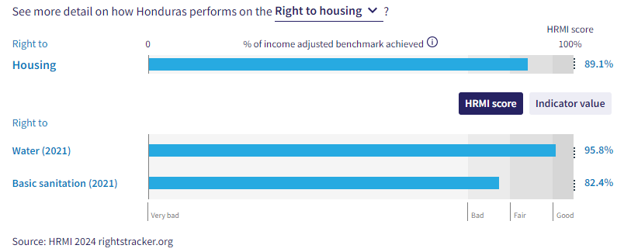

22. HRMI defines the right to housing in accordance with ICESCR Article 11.1 and CESCR General Comment 4. In the case of low- and middle-income countries, such as Honduras, HRMI uses an assessment standard that measures the right to water on premises and ‘basic’ sanitation (each household having its own improved toilet facilities). For basic sanitation, Honduras has a score within the ‘bad’ range, and for water, its score is scraping into the ‘good’ range. The overall HRMI score for the right to housing is 89.1%, falling within the ‘fair’ range.

23. In Honduras, 89.7% of households have water on premises. Given what other countries with the same level of income have shown to be possible, these statistics lead to a HRMI score of 95.8% for the right to water. However, the HRMI score dropped from 97% to 95.8% over to 2020-2021 period. Many more people in Honduras would have access to these necessities if Honduras were using its maximum available resources towards progressive realisation of these rights.

24. There have been significant improvements regarding basic sanitation over the past two decades, as Honduras was only doing 66.5% of what was possible in 2000, but that score has now risen to 82.4% in 2021. While Honduras is still not achieving 100% of what is possible, Honduras’s progress in the realm of right to basic sanitation is a step in the right direction.

VIII. Right to Work and Adequate Income
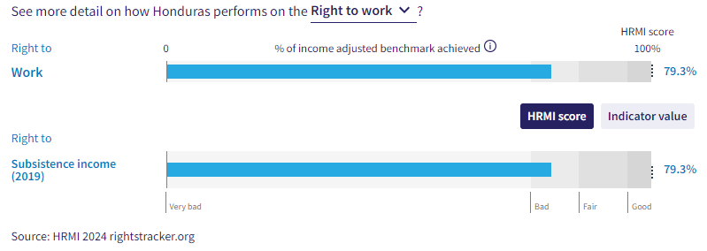
29. HRMI measures the right to work in accordance with ICESCR Articles 6 and 7. For low and middle-income countries, such as Honduras, HRMI measures the right to work and social security using a subsistence income indicator. According to the World Bank PovcalNet, in Honduras, the percentage of people who are not absolutely poor is only 73.6%, leading to a HRMI score of 79.3%.
30. The HRMI score is residing within the ‘bad’ range. Over the course of the last two decades, Honduras has had several rises and falls regarding this right. The first large increase occurred in 2001, achieving a HRMI score of 78.2%, but then dropping to a low of 66.5% in 2003. Honduras recovered to a high point of 84.0% in 2009, but once again dropping in 2012 to 74.8%. There has been minimal recovery since 2012, as human rights progression has stalled over the 2013-2021 period.
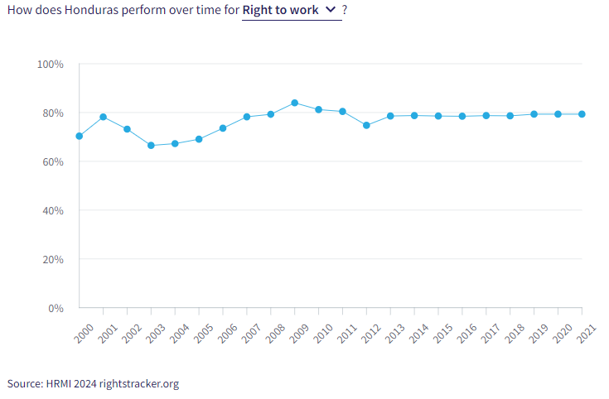

X. Concluding Remarks

36. HRMI respectfully submits its data and findings on the fulfilment of economic and social rights in Honduras. We hope that this Submission will serve as a useful resource to the Committee on Economic, Social and Cultural Rights for drafting specific and meaningful questions to Honduras during the CESCR’s 76th Pre-Sessional Working Group.

Visit HRMI’s website to learn more about our mission and work, https://humanrightsmeasurement.org/.
This content represents the opinions of the Human Rights Measurements Initiative. It carries no endorsement of the University of Georgia.
See HRMI’s methodology for measuring economic and social rights: https://humanrightsmeasurement.org/methodology and https://rightstracker.org/page/methodology.
Ibid
Ibid
HRMI 2023 Rights Tracker, https://rightstracker.org/
See Human Rights Measurement Initiative (HRMI) Digital Public Good Certificate, https://app.digitalpublicgoods.net/a/11781 The Digital Public Goods Alliance is endorsed by the UN Secretary General’s “Roadmap for Digital Cooperation,” https://www.un.org/en/content/digital-cooperationroadmap/assets/pdf/Roadmap_for_Digital_Cooperation_EN.pdf. It defines digital public goods as: “open source software, open data, open AI models, open standards and open content that adhere to privacy and other applicable laws and best practices, do no harm, and help attain the SDGs,” https://digitalpublicgoods.net/standard/.
HRMI 2023 Rights Tracker, https://rightstracker.org/country/HND?tab=report-esr&qolFdScore=hrmi&as=core
The labels on the country charts of good, fair, bad, and very bad are used to give a general indication of how to understand the scores. HRMI’s income adjusted Quality of Life scores can be broadly interpreted as showing the percentage of the country’s obligation it has met, compared to what the best performing countries have achieved at each income level. A country scoring below 75% with a label of “Very bad” is failing to put in place the kinds of structures and policies that help people claim the right concerned, but the structures and policies in place most likely prevent many people from claiming their rights. See HRMI’s methodology for measuring human rights, https://rightstracker.org/page/methodology.
HRMI 2023 Rights Tracker, https://rightstracker.org/country/HND?tab=report-esr&qolFdScore=hrmi&as=core
HRMI 2023 Rights Tracker, https://rightstracker.org/metric/esr?tab=report-esr&region=americas
HRMI 2023 Rights Tracker, https://rightstracker.org/metric/education.
HRMI 2023 Rights Tracker, https://rightstracker.org/country/HND?tab=report-esr&qolFdScore=hrmi&as=core
HRMI 2023 Rights Tracker, https://rightstracker.org/metric/educqual?tab=report-esr&region=americas
HRMI 2023 Rights Tracker, https://rightstracker.org/country/HND?tab=report-esr&qolFdScore=hrmi&as=core
HRMI 2023 Rights Tracker, https://rightstracker.org/metric/not-stunted.
HRMI 2023 Rights Tracker, https://rightstracker.org/metric/food-security?tab=report-esr
HRMI 2023 Rights Tracker, https://rightstracker.org/country/HND?tab=report-esr&qolFdScore=hrmi&as=core
HRMI 2023 Rights Tracker, https://rightstracker.org/metric/under-5-survival?tab=report-esr
HRMI 2023 Rights Tracker, https://rightstracker.org/country/HND?tab=report-esr&qolFdScore=hrmi&as=core
Ibid
HRMI 2023 Rights Tracker, https://rightstracker.org/country/HND?tab=report-esr&qolFdScore=hrmi&as=core
Ibid
Ibid
HRMI 2023 Rights Tracker, https://rightstracker.org/country/HND?tab=report-esr&qolFdScore=hrmi&as=core

