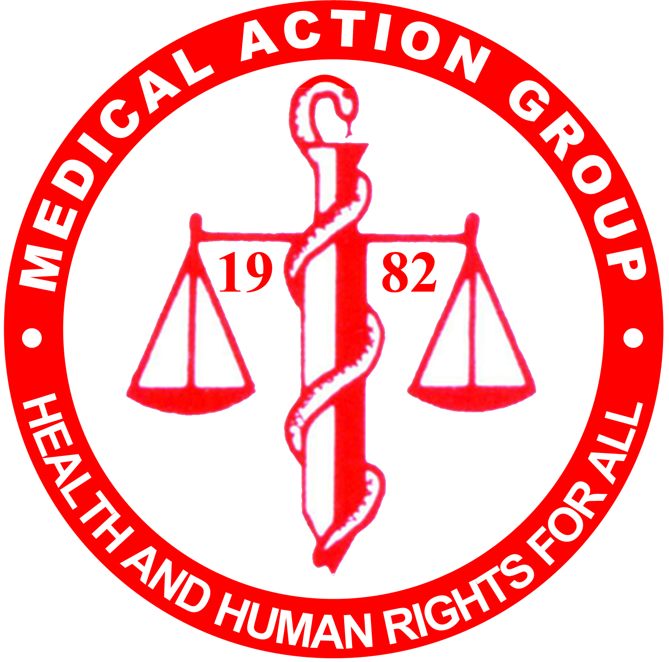
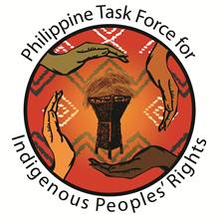

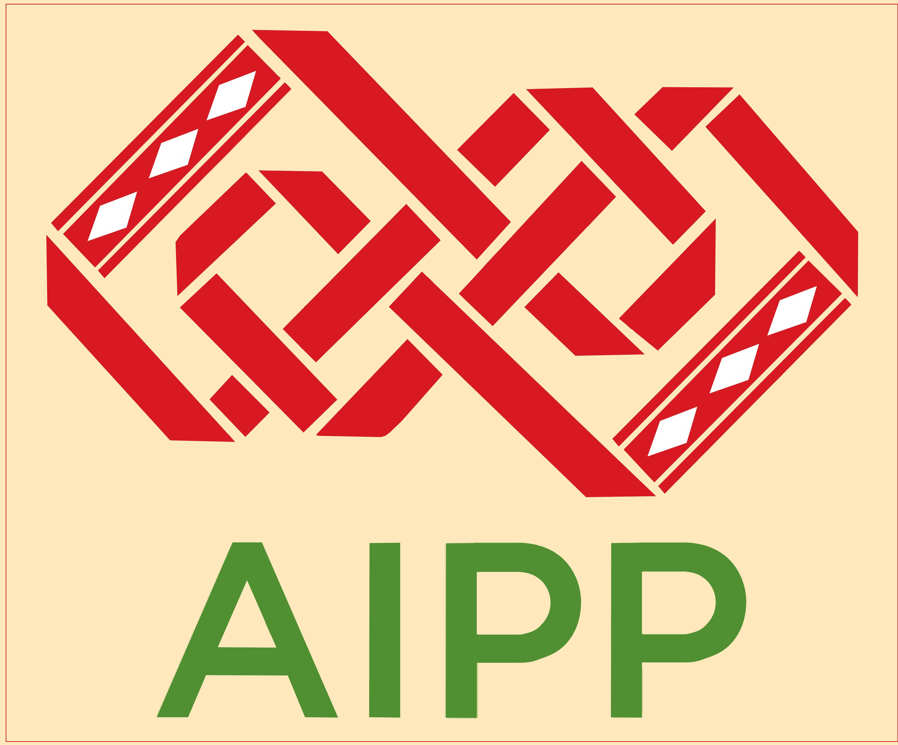
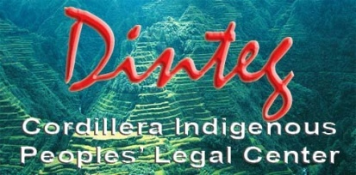
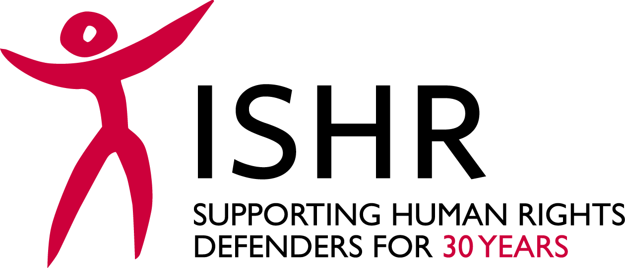
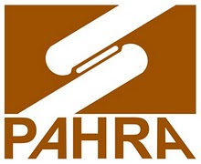

The Situation of Human Rights Defenders working on Economic, Social and Cultural Rights in the Philippines

Submission to the UN Committee on Economic, Social and Cultural Rights to inform the Pre-sessional Working Group (and List of Issues) for the Philippines

A. Introduction
This is a joint submission made by the International Service for Human Rights (ISHR) and Philippine Task Force for Indigenous Peoples Rights (TFIP), Cordillera Indigenous Peoples Legal Center (DINTEG), Rural Missionaries of the Philippines – Northern Mindanao Region, Inc. (RMP NMR), Medical Action Group (MAG), Task Force Detainees of the Philippines (TFDP), Philippine Alliance of Human Rights Advocates (PAHRA) and Asia Indigenous Peoples Pact (AIPP).
This submission is made on the occasion of the consideration of the List of Issues for Philippines at the 57th Pre-Sessional Working Group of the UN Committee on Economic, Social and Cultural Rights (the Committee) and it addresses the issue of human rights defenders (HRDs) working on economic, social and cultural (ESC) rights in the Philippines.
Section A of this report provides general, background arguments from the co-authors as to why we believe it is important that the Committee continue to assess the situation facing human rights defenders in States under review. Sections B to E ,meanwhile, contain specific information pertaining to the situation in the Philippines.
We contend that the issue of HRDs should be prominent on the List of Issues and that the undue suppression of HRDs and civil society who work to prevent the violation of, and seek to advance, ESC rights enshrined in the International Covenant on Economic Social and Cultural Rights, is a corollary violation of those rights.
This submission illustrates the risks and obstacles facing HRDs in the Philippines and that defenders working on ESC rights face particular risks and obstacles to their human rights work. This submission highlights defenders working on environmental rights and land rights and defenders working to protect indigenous peoples as particularly at-risk groups. We conclude that the government of Philippines must do more to guarantee a safe and enabling environment for HRDs if it is to guarantee the respect, protection and fulfilment of ESC rights.
- The definition of human rights defenders
The United Nations Declaration on the Right and Responsibility of Individuals, Groups and Organs of Society to Promote and Protect Universally Recognized Human Rights and Fundamental Freedoms, (Declaration on Human Rights Defenders), defines a human rights defender as anyone working for the promotion and protection of human rights. This broad definition encompasses professional as well as non-professional human rights workers, volunteers, journalists, lawyers and anyone else carrying out, even on an occasional basis, a human rights activity.
- The UN Special Rapporteur on HRDs stated in 2014 that ‘those who promote and defend human rights are ipso facto defenders, even if they are not members of an organisation’.
- OHCHR Fact Sheet 29 on HRDs states that ‘To be a human rights defender, a person can act to address any human right (or rights) on behalf of individuals or groups. Human rights defenders seek the promotion and protection of civil and political rights as well as the promotion, protection and realization of economic, social and cultural rights’.
- It illustrates by saying that ‘Human rights defenders address any human rights concerns [including]… discrimination, employment issues, forced evictions, access to health care, and toxic waste and its impact on the environment… the rights to life, to food and water, to the highest attainable standard of health, to adequate housing, to a name and a nationality, to education, to freedom of movement and to non-discrimination…’ For example, lawyers seeking accountability for ESC rights violations, journalists exposing violations, community housing associations campaigning for better housing conditions or protesting development or beautification projects that involve evictions or resettlement or violate other ESC rights.
- It argues that defenders working on housing, health care and sustainable income projects merit ‘particular attention as its members are not always described as human rights defenders and they themselves may not use the term “human rights” in a description of their work, focusing instead on terms such as “health”, “housing” or “development” which reflect their area of activity’. However, their work ‘is central to respect for and protection and achievement of human rights standards, and they need and deserve the protection given to their activities by the Declaration on Human Rights Defenders’.
- The importance of human rights defenders in the protection and realisation of economic, social and cultural rights
The United Nations Declaration on the Right and Responsibility of Individuals, Groups and Organs of Society to Promote and Protect Universally Recognized Human Rights and Fundamental Freedoms, (Declaration on Human Rights Defenders), as well as numerous Human Rights Council resolutions and reports by Special Procedures, have underlined the importance of HRDs in contributing to the implementation of human rights law.
- The UN Human Rights Council has stressed that respect and support for the activities of HRDs, including women HRDs, is essential to the overall enjoyment of human rights.
- The Declaration on Human Rights Defenders states that defenders have an important role to play and an essential responsibility in safeguarding democracy, ensuring that it remains open and pluralistic, promoting human rights and fundamental freedoms and contributing to the promotion and advancement of democratic societies, institutions and processes.
- The previous UN Special Rapporteur on HRDs stated that ‘The defence and promotion of human rights is a legitimate and courageous activity which is necessary to ensure that communities can fully enjoy their entitlements and realize their potential. Defenders can play a key role in safeguarding democracy and ensuring that it remains open, pluralistic and participatory and in line with the principles of rule of law and good governance. Defenders should be able to carry out their activities in an environment that empowers them to defend all human rights for all’.
The effective protection and realisation of ESC rights relies upon the valuable contribution of civil society and HRDs. Civil society and HRDs play a vital role by monitoring and evaluating State compliance with the Covenant, providing input into policy formulation and program and service design, raising the alarm on rights violations and holding decision-makers accountable for the consequences of their actions. Without civil society and HRDs the effective protection and realisation of ESC rights protected by the Covenant would be seriously undermined.
Therefore, for ESC rights to have meaning in practice, States must ensure that HRDs can play this vital role, by providing an enabling environment and respecting and protecting the rights of HRDs, so that defenders can voice their concerns and critiques of government action without fear of reprisals. This obligation is implicit in the normative content of ESC rights, such as the right to adequate housing, to health and to education.
- The Committee’s pronouncements on human rights defenders
The Committee has confirmed the importance of the State obligations to respect and protect HRDs on numerous occasions.
CESCR Concluding Observations:
- Philippines (2008):
The Committee urges the State party to take all necessary measures for the protection of trade union activists, indigenous leaders, peasant activists and human rights defenders engaged in defending the economic, social and cultural rights of their communities against any intimidation, threat and violence, whether perpetrated by State security forces and agents or non-State actors. It also calls on the State party to ensure that all alleged cases of forced disappearances and extra-judicial killings are promptly and thoroughly investigated, and that alleged perpetrators are prosecuted and appropriately punished, if found guilty. The Committee requests the State party to provide, in its next periodic report, detailed information on the progress made in preventing and punishing forced disappearances and extra-judicial killings
- Angola (2009):
The Committee is concerned that NGOs involved in the realization of economic, social and cultural rights are allegedly still under strict oversight, subject to coordination, evaluation and inspections carried out by the Technical Unit for the Coordination of Humanitarian Assistance, and that human rights defenders are still subjected to many legal and de facto restrictions, which constitutes a serious obstacle to the promotion and protection of economic, social and cultural rights.
The Committee urges the State party to establish legal guarantees to enable NGOs to carry out their activities for the promotion and protection of economic, social and cultural rights without arbitrary interferences. The Committee further urges the State party should to ensure that perpetrators of attacks to the human rights defenders are brought to justice.
- Equatorial Guinea (2012):
The Committee is concerned by reports that indicate that human rights activists are subjected to intimidation and harassment.
The Committee urges the State party to adopt all measures necessary to protect human rights defenders and activists — particularly those working in the area of economic, social and cultural rights — from any and all acts of intimidation and harassment and to ensure that perpetrators of such acts are brought to justice.
- Argentina (2011):
The Committee is concerned about instances in which security forces and agents, both public and private, resorted to reprisals and disproportionate use of force against persons participating in activities in defence of economic, social and cultural rights, in particular in the context of land disputes.
The Committee urges the State party to protect social activists and human rights defenders against any form of intimidation, threat and, especially, disproportionate use of force perpetrated by security forces and agents, both public and private. It also calls on the State party to ensure that all allegations of reprisals and abuse are promptly and thoroughly investigated, and that the perpetrators are brought to justice.
- Cambodia (2009):
The Committee expresses its deep concern about the culture of violence and impunity prevalent in the State party and the repression of human rights activists defending economic, social and cultural rights, particularly those defending housing and land rights. The Committee is also concerned about reports that the court system has been used to legitimize forced evictions and falsely prosecute housing rights defenders. (art. 11)
The Committee urges the State party to take all necessary measures to combat the culture of violence and impunity prevalent in the State party, and for the protection of human rights defenders, including indigenous leaders, peasant activists engaged in defending the economic, social and cultural rights of their communities against any intimidation, threat and violence, whether perpetrated by State security forces and agents or non-State actors. It also calls on the State party to ensure that all alleged cases of repression and abuse are promptly and thoroughly investigated.……
- Other examples can be found in the Concluding Observations on: Brazil, Viet Nam, India, DRC, and Sri Lanka.

In addition the Committee has addressed the issue of HRDs and the role of civil society in protecting and realising ESC rights in its General Comments as follows:
- General Comment 15 - Right to Water:
The formulation and implementation of national water strategies and plans of action should respect, inter alia, the principles of non-discrimination and people's participation. The right of individuals and groups to participate in decision-making processes that may affect their exercise of the right to water must be an integral part of any policy, programme or strategy concerning water…
States parties should respect, protect, facilitate and promote the work of human rights advocates and other members of civil society with a view to assisting vulnerable or marginalized groups in the realization of their right to water.
- General Comment 19 - Right to Social Security:
Beneficiaries of social security schemes must be able to participate in the administration of the social security system. ..…
The formulation and implementation of national social security strategies and plans of action should respect, inter alia, the principles of non-discrimination, gender equality and people's participation. The right of individuals and groups to participate in decision-making processes that may affect their exercise of the right to social security should be an integral part of any policy, programme or strategy concerning social security.
States parties should respect, protect, facilitate and promote the work of human rights advocates and other members of civil society, with a view to assisting disadvantaged and marginalized individuals and groups in the realization of their right to social security.
- General Comment 12 - Right to Food:
The formulation and implementation of national strategies for the right to food requires full compliance with the principles of accountability, transparency, people's participation, decentralization, legislative capacity and the independence of the judiciary. ..…
States parties should respect and protect the work of human rights advocates and other members of civil society who assist vulnerable groups in the realization of their right to adequate food.
- General Comment 18 - Right to Work:
The formulation and implementation of a national employment strategy should involve full respect for the principles of accountability, transparency, and participation by interested groups. The right of individuals and groups to participate in decision-making should be an integral part of all policies, programmes and strategies intended to implement the obligations of States parties under article 6. The promotion of employment also requires effective involvement of the community and, more specifically, of associations for the protection and promotion of the rights of workers and trade unions in the definition of priorities, decision-making, planning, implementation and evaluation of the strategy to promote employment.
States parties should respect and protect the work of human rights defenders and other members of civil society, in particular the trade unions.
Trade unions play a fundamental role in ensuring respect for the right to work at the local and national levels and in assisting States parties to comply with their obligations under article 6.
- Human rights defenders working on economic, social and cultural rights face heightened risks and specific threats and obstacles
Unfortunately the situation of HRDs working on ESC rights issues is deteriorating worldwide as is evidenced by the proliferation of reports of increases in threats, harassment, arbitrary detention, murder and enforced disappearances of defenders working on ESCR. A more recent trend has been the filing of trumped-up charges and criminalisation of HRDs, indigenous leaders and their communities, that restrict and seek to silence NGOs working on human rights issues. Unfortunately both these trends are particularly severe in the Philippines.These attacks and restrictions on defenders of ESC rights obviously have serious consequences for individuals and their families, but also for their communities and campaigns. Such attacks have a devastatingly chilling effect on all voices of dissent.
This trend is also well documented by UN human rights experts. The former Special Rapporteur on HRDs, Ms Hina Jilani, in a 2007 report found that labour rights activists suffered the highest number of attacks, harassment, arbitrary detention and disappearances and those working on land and natural resources issues or campaigning against forced evictions were the second most harassed group seen by her mandate. She noted that there was a global trend towards targeting of ESC rights advocates, particularly in the Asian and Latin American regions. In August 2013, the former Special Rapporteur on Human Rights Defenders, Margaret Sekaggya, considered the relationship between large scale development projects and HRDs. She found that the situation of HRDs working on land rights, natural resources and environmental issues had worsened since 2007.
In 2014, the current Special Rapporteur on HRDs identified HRDs working on ESC rights and minority rights, environmental defenders, and defenders who work in the area of business and human rights as three of the five most vulnerable groups of defenders, recommending that States pay particular attention to them.
Similar trends have been noted by the Special Rapporteur on Extreme Poverty and Human Rights and the UN Working Group on the issue of Human Rights and Transnational Corporations and other Business Enterprises, which in March 2013 noted the very high number of cases brought to their attention relating to conflict over land and natural resources and the harassment and attacks on persons protesting against the impact of business activities.
Most recently the UN Working Group on Enforced Disappearances published a ‘Study on enforced or involuntary disappearances and economic, social and cultural rights.’ One focus of the Study was ‘enforced disappearances against those working on the promotion and protection of economic, social and cultural rights’ where the Working Group noted that ‘persons who live in poverty and lack the enjoyment of a number of economic, social and cultural rights are more vulnerable to becoming victims of enforced disappearance.’ Further, the Study confirmed the greater risk of enforced disappearance of people actively defending ESC rights and stated that ‘enforced disappearance is used as a repressive measure and a tool to deter the legitimate exercise, defence, or promotion of the enjoyment of economic, social and cultural rights.’ The Study explains:
When an individual becomes a victim of enforced disappearance as a result of exercising or promoting economic, social and cultural rights, the enjoyment of those rights is also violated. For instance, the disappearance of a teacher who promoted cultural rights also interferes with the right to cultural life as well as the exercise of students’ right to education (A/HRC/22/45, para. 69).
Further, because enforced disappearances are a tool to intimidate and prevent others from claiming their ESC rights, they have a collective impact on the ESC rights of others working in the field: ‘this deterrence leads to violations of the rights of the disappeared, others engaged in related activities and the larger community, because of the chilling effect of enforced disappearances.’
The Commentary on the Declaration on Human Rights Defenders says that ‘States should make more efforts to recognize and protect [inter alia]… defenders working to promote economic, social and cultural rights…. Those defenders need specific and enhanced protection, as well as targeted and deliberate efforts to make the environment in which they operate a safer, more enabling and more accepting one’, because they represent some of the defenders most exposed to attacks and violations.

B. Threats and obstacles facing human rights defenders in the Philippines in general
HRDs and their families are subjected to intimidation, harassment, forced evictions and killings. Defenders, journalists and justice operators in the Philippines are also frequently victims of criminalisation and arbitrary detention.
- Harassment, surveilance and extrajudicial killings are commonnly used against Women Human rights Defenders (WHRDs) for conducting their human rights work. The use of tactics such as villification and criminalisation are also becoming more frequent.
- The Philippines’ strict abortion laws continues to criminalise women who seek to have an abortion, as abortion remains illegal under all circumstances. This puts those who defend sexual and reproductive rights in a situation of heightened risk.
- Many HRDs are subjected to judicial harassment which is characterised by the filing of trumped up charges against HRDs to impede and criminalise their human rights work. It is not uncommon for non-State actors and private corporations to file libel charges against defenders.
- Three counts of kidnapping and homicide were filed against 69 human rights defenders in Cagayan Valley shortly after a fact-finding mission was conducted in relation to human rights violations against the local indigenous population.
- Local NGOs have documented repeated restrictions upon HRDs’ rights to to freedom of opinion and expression, as well as freedom of association and peaceful assembly. Laws are often invoked to silence dissent, particularly in connection with expression of opposition to private development projects such as large-scale mining.
- Anti-mining advocate Mr Benito E. Molino received death threats through private messages on his facebook account. He is also facing charges of cyber libel which was filed by a mining corporation operating where he lives. HRDs Ms. Yolanda Esguerra, Ms. Candy Hidalgo, Mr. Edel Garingan and Mr. Victor Morillo were accused of libel by Hinatuan Mining Corporation, in apparent retribution for the release of a press release and social media posts regarding the mining situation in Manicani.

C. Heightened and specific threats and obstacles facing human rights defenders working on economic, social and cultural rights
- General trends in the risks and obstacles facing defenders of economic, social and cultural rights
Many activists demanding basic ESC rights are finding that the space for their human rights work is being closed by the filipino authorities. Extra-judicial killings, enforced disappearance, arbitrary arrest and detention and forced evictions are common, whilst death threats and trumped up charges are often used to intimidate and restrict those defenders promoting economic, social and cultural rights.
Civil society organisations have highlighted that private security firms and paramilitary groups, including those sanctioned through government schemes and official policy, and amongst the prime aggressors against defenders working on ESC rights. Examples include the deployment of auxiliary groups established by Executive Order 546 in 2006, and the ‘Investment Defence Forces’ introduced by a presidential programme in 2008.
- Extrajudicial killings of HRDs and other opponents continue to be a trend in the Philippines with indigenous, land and environmental defenders the most frequent victims.
- In 2015, Front Line Defenders documented a total of 156 human rights defenders killed globally, of which 31 were from the Philippines. This means the Philippines accounts for 60% level of all defenders killed in Asia and means the country is second globally only to Colombia in terms of the number murdered human rights defenders.
- Defenders of indigenous rights are particularly vulnerable to extra-judical killings. From July 2010 to September 2015, the NGOs KATRIBU and KARAPATAN recorded the extra-judicial killing of at least 38 indigenous HRDs. 14 incidents of massacre were registered, in which many defenders were victims. Attacks on defenders of the rights of the Lumad indigenous people increased enormously in 2015.
- High profile murders of indigenous rights defenders include Italian priest Fr. Fausto Tentorio in 2011 and Emerito Samarca, the executive director of Lumad school ALCADEV, in September 2015. Most of the incidents of killings against indigenous peoples and their advocates are associated with their ancestral land rights and access to natural resources.
- NGOs - especially those dedicated to farmers’ rights, labour rights and ending extrajudicial killings - frequently face threats, harassment and raids of their offices. The extrajudicial killings of labour leaders have increased in the last decade.
- There has been a significant rise in the criminalisation of HRDs in the Philippines. Criminalisation is apparently used to silence HRDs and protect business interests with frequency. This is most often done via trumped up charges and arbitrary detention; an effective strategy used to delegitimise and criminalise human rights work. So frequent a phenomenon is the criminalisation of ESC HRDs that it was only possible to cover a fraction of the documented cases within this briefing paper.
- In July 2015, charges of kidnapping, serious illegal detention (Republic Act 267) and human trafficking (Expanded Anti-Trafficking of Persons Act of 2012) were filed against 16 HRDs in relation to the evacuation of indigenous Talaingod and Kapalong in Davao del Norte and Bukidnon, Mindanao.
- Jomorito Goaynon, also known as Datu Imbanwag, together with his brothers, has been charged with the killing of a Dela Mance paramilitary member, an act that had been claimed by the New People’s Army. The reason for the charges, alleged by NGOS, is that the brothers held an active campaign against the encroachment of mining, agroindustrial plantations, and megadams in ancestral domains in Mindanao.
- Likewise, the start of 2016 saw the filing of murder charges against 4 datus (indigenous chieftains) along with eight other members of the Higaonon community who had all been actively calling to end the killings of Lumads. The complainant is known as a member of the Alamara paramilitary group.
- Another strategy used to silence HRDs in the Philippines is public vilification of defenders. This is often done through media and social media campaigns, with accusations of crimes as well as accusing HRDs of being part of or supporting the New People’s Army (NPA), a guerrilla group belonging to the communist party. Lately there has been an increase in the vilification of church workers who advocate for the ESC rights of indigenous peoples; primarily by accusing them of being supporters of the NPA. Former Chairperson of the Sister’s Association in Mindanao, Sr. Stella Matutina was charged with kidnapping and human trafficking for her active support of Lumad people who sought refuge in Davao City in early 2015. Likewise rural missionary Joel Yagao who works with farmers to defend land rights, was charged with two cases of murder and frustrated murder that had apparently been committed by the NPA.
- Between april and august 2015 at least 9 WHRDs who worked with public sector trade unions suffered repeated threats. Since july 2010, 28 WHRDs in the Philippines have been murdered with impunity.
- WHRD Alma Sinumlag suffered threats and harassment from army members, including a phonecall to her family alleging that she had died in a collision between State forces and the NPA. She defends womens rights, as well as the rights of indigenous communities, against multinational corporations. Alma was involved in exposing the impacts on indigenous ancestral territories by Chevron’s geothermal development project.
- Evacuations/evictions of indigenous communities in Mindanao due to military operations and extra-judicial killings of community members by paramilitary groups have become frequent and massive in 2015. This has had a destabilising effect on community organisation and the defence of ESC rights. Thousands of indigenous Lumad in Mindanao fled their homes in fear of military operations, harassment and forced recruitment by paramilitary groups. From January to March almost 1000 individuals were evacuated from 15 villages in Agusan del Sur due to military operations and encampment in Lumad schools. In September 2015 the UN Special Rapporteurs on the situation of HRDs and on Indigenous Peoples requested the investigation of the killing of Emerito Samarca and two other HRDs in connection to these attacks and the displacement of thousands of people.

- Particular risks and obstacles for land and environmental rights defenders
Filipino activists exposing violations of the rights to housing, health, development and public participation around land and environmental issues face some of the gravest risks in the world, often leading to forced evictions or internal displacement, harassment and killings.
- Research from Global Witness shows that the Philippines is one of the most dangerous countries to be a land and environmental defender. There has been 67 killings of land and environmental defenders in the Philippines between 2002-2013. There were 15 killings of land and environmental defenders in 2014 alone - the majority carried out by paramilitary groups defending mining interests. 9 out of the 15 killings were of defenders working against mining projects. Similarily 9 out of the 15 killings were of indigenous victims.
- The vast majority of conflicts over land in the Philippines are due to disputes about ownership and rights associated with agribusiness and mining. This has resulted in forced evictions, attacks and killings of peasants and indigenous people defending their land, environment and other ESC rights.
- Active opponent to landgrabbing, Ms Venecia “Inday” Natinga Nestor, was shot on June 19 2012 on a public highway in Lanao del Norte, after facing threats and harassment. Other land rights defenders have also been killed. For example, Elisa Tulid who was killed in front of her husband and daughter, whilst well-known environmental rights defenders Teresito Mula Labastilla and Menelao Barciahave also been murdered.
- The alarming trend of attacks against land defenders have not gone unnoticed. For example, 8 out of 16 communications reports sent by Special Rapporteurs to the Philippines between 2012 and 2015 concerned attacks, threats and extrajudicial killings of HRDs and indigenous leaders working with land and environmental issues.
- Land defenders are also more prone to suffer vilification, particularly when their work had brought them into opposition of large development projects. In April 2015, death threats were mailed to staff and community leaders of the Ifugao Peasant Movement (IPM). This happened at the same time that they were made targets of political vilification through social media. IPM and the Cordillera Peoples Alliance (CPA) strongly believe that these death threats came from people connected to big energy corporations - who felt their financial interests in Ifugao threatened by human rights concerns - and suspected State intelligence agents.
- HRDs working against the negative impact of mining companies upon ESC rights have suffered death threats and other forms of harassments. They include Dr Benito Molino, chairperson of Concerned Citizens of Sta Cruz Zambales (CCOS), who has suffered death threats and harassmens by miners in Zambales since 2013.
- Chito Trillanes, an anti-mining advocate based in CARAGA in Mindanao received death threats in 2013 after taking a strong position against mining and environmental abuses. Threats included text messages and harassments by unknown men wearing bonnets and jackets, riding in tandem. Anti-mining activist Mr Anting Freay has been killed, whilst the massacre of the anti-mining Capion family remains unresolved.
- In 2015 the Comission on Human Rights found a mining company responsioble for illegal detention and deprivation of livelihood in Bicol Province. 6 small scale miners were sued by the mining company for trespassing, theft and illegal obstruction. A paramilitary group destroyed their equipment.
- Access to information is another obstacle for HRDs working on land rights. The mining industry in particular operate with a lack transparency, whilst contracts and data are rarely published. There is no law guaranteeing freedom of information in the Philippines.
- Mining companies are regularly accused of flaunting regulations regarding the consultation of affected communities. The right of indigenous peoples to free, prior, informed consent is usually overlooked and often manipulated.
- Land and environmental defenders who participate in protests suffer intimidation, criminalisation and killings.
- Indigenous leaders face additional risks, particularly as they raise human rights concerns regarding corporations who want to conduct business in their area. For example indigenous leader Henry Alameda who was killed by a paramilitary group for protesting against mining operations and plantations in Caraga, Jimmy Liguyon official of local government and leader of the indigenous organisation Kasilo and Gilbert Paborada indigenous leader and chair of a community based Lumad organisation.
- The Indigenous community of Sitio Mintakei in Mindanao were threatened by a paramilitary group if they did not sign a memorandum of agreement with the Malampay mining company. Two days later the paramilitary group killed the community leader Datu Roger Alaki. The entire community fled their homes in fear following the killing.
- Indigenous communities and defenders have been targeted as part of the government’s counter-insurgency operations. The Armed Forces of the Philippines (AFP) has openly stated in its statements and presentation that 74% of NPA in Eastern Mindanao are indigenous peoples and that 90% of the guerrilla bases are located in areas of the indigenous communities. The Special Rapporteur Philip Alston noted in his report from his country visist in 2007 that one the risks facing HRDs is the AFPs practice of not making a distinction between armed and unarmed dissenters.

- Reprisals against defenders of economic, social and cultural rights for interacting with international human rights mechanisms
- Included in the Secretary Generals 2013 report was the case of Stella Matutina - a Benedectine nun and the Secretary-General of the human rights group Panalipdan Mindanao. As a consequence of Ms Matutina’s involvement Philippine Universal Periodic Review (UPR) Watch delegation and her involvement in a side event at the 19th Session of the Human Rights Council, she has faced threats and harassment and has been accused of being part of the New People’s Army.

D. The response of the State regarding the protection of human rights defenders
In spite of resounding calls from civil society for the government to disband paramilitary groups, provide recognition and protection for human rights defenders and end impunity for attacks against them, the Filipino State has done very little to guarantee the right to defend ESC rights.
- There is a culture of impunity in the Philippines. Out of the 67 confirmed killings by Global Witness, only 2 perpetrators have been convicted.
- Whilst the authorities have been unable to identify the perpetrators of the majority of violations against HRDs, Global Witness found that 14 killings could be linked to the armed forces, three to local government officials and two to the police. Despite the issuance of arrest warrants for some identified paramilitary members - such as Alde Salusad in March 2013, against Dela Mance members in July 2015, and bandit Magahat members in September 2015 - the perpetrators of extra-judicial killings remain at large and continue to threaten the families of the victims.
- Despite overwhelming call to disband paramilitary groups, President Benigno Aquino has allegedly further emboldened their use, through the use of ‘force multipliers’ in his counter-insurgency program Operation Plan Bayanihan, as expressed in a press conference in November 2010.
- There exist allegations that the counterinsurgency campaign ‘Oplan Bayanihan’ is used to remove HRDs and indigenous groups by labelling them as terrorists or insurgents to justify arbitrary detention or military actions. Special forces conduct surveillance of HRDs and file apparently trumped up criminal charges against them.
- The retention of the Executive Order 546 s. 2006 directs the Philippine National Police (PNP) to take part of the AFP’s (Armed Forces of the Philippines) internal security operations for the suppression of insurgency and other serious threats to national security. This executive order also deputizes barangay tanods as force multipliers in the implementation of the peace and order plan.
- In February 2008, the government also announced the creation of ‘investment defense forces’ that will act as ‘protective shields’ for to power and mineral assets. In a congressional inquiry by the National Cultural Communities Committee in February 2013, the Mayor of Kiblawan confirmed that the mining company had been providing an additional allowance for the Taskforce KITACO aside from the amount provided by the AFP.
- There is a lack of investigations into the legitimacy charges filed by non-State actors against HRDs.

E. Questions to the Phillippine State
- What steps is the Filipino State taking to prevent attacks against ESC rights defenders – and in particular land and environmental rights defenders – and to guarantee a safe and enabling environment for their work?
- How will the Filipino State ensure that businesses contribute to a safe and enabling environment for human rights defenders, including by guaranteeing the free, prior and informed consent of affected indigenous communities, and through the joint implementation of the UN Guiding Principles on Business and Human Rights?
- What steps will the Philippine State take to end impunity for crimes against human rights defenders?
- What is the response of the Philippine State to the continuing call by civil society to disband paramilitary groups and Investment Defence Forces, given the accusations of human rights abuses carried out by these groups, including against HRDs?
- What actions have been carried out by the National Commission on Indigenous Peoples to end the systematic attacks against indigenous leaders, schools and communities?
29 January 2016
Contacts:
ISHR | AIPP | DINTEG | RMP NMR | PAHRA | TFIP | MAG
Ben Leather  b.leather@ishr.ch | Robie Halip  robie@aippnet.org | Rhoda Dalang  rhodadalang@gmail.com | Sr.Ma. Famita N. Somogod  rmpnmr@gmail.com | Rose Trajano  pahra@philippinehumanrights.org | Jill Carino  jillcarino@gmail.com | Jerbert Briola  jerbertmb@gmail.com

The Declaration on human rights defenders refers to “individuals, groups and associations ... contributing to ... the effective elimination of all violations of human rights and fundamental freedoms of peoples and individuals” (fourth preambular paragraph), General Assembly Resolution A/RES/53/144.
Report of the Special Rapporteur on the situation of human rights defenders, Michel Forst – Twenty-eighth, A/HRC/28/63, para. 103, December 2014.
Human Rights Defenders: Protecting the Right to Defend Human Rights, Fact Sheet No. 29, United Nations.
Ibid.
Ibid.
Human Rights Council Resolution 22/6, A/HRC/22/6, April 2013.
General Assembly Resolution A/RES/53/144, article 18, March 1999.
Report of the Special Rapporteur on the situation of human rights defenders, Margaret Sekaggya - Twenty-fifth session, A/HRC/25/55, para. 60, December 2013.
E/C.12/PHL/CO/4 (CESCR, 2008) para 15
E/C.12/GNQ/CO/1 (CESCR, 2012) para 14
E/C.12/ARG/CO/3 (CESCR, 2011) para 13
E/C.12/KHM/CO/1 (CESCR, 2009) para 31
E/C.12/BRA/CO/2 (CESCR, 2009) para 8
E/C.12/VNM/CO/2-4 (CESCR, 2014) para 11
E/C.12/IND/CO/5 (CESCR, 2008) para 50
E/C.12/COD/CO/4 (CESCR, 2009) para 12
E/C.12/LKA/CO/2-4 (CESCR, 2010) para 10
E/C.12/2002/11 para 48
op cit. para 59
E/C.12/GC/19 para 26
op cit. para 69
op cit. para 81
E/C.12/1999/5 para 23
op cit. para 35
E/C.12/GC/18 para 42
op cit. para 54
Global Witness, ‘Deadly Environment: The dramatic rise in killings of environmental and land defenders’, April 2014, accessible here: https://www.globalwitness.org/sites/default/files/deadly%20environment%20embargoed.pdf; FIDH, ‘Land and environmental rights defenders in danger: an overview of recent cases’, December 2013, accessible here: https://www.fidh.org/International-Federation-for-Human-Rights/human-rights-defenders/international-and-regional-protection-of-human-rights-defenders/14326-land-and-environmental-rights-defenders-in-danger-a-compilation-of-recent
Report of the UN Special Rapporteur on Human Rights Defenders A/HRC/4/37
A/68/262
Ibid. at para 18
Report of the Special Rapporteur on the situation of human rights defenders, Michel Forst – Twenty-eighth, para. 54.
Working Group on the issue of human rights and transnational corporations and other business enterprises, A/HRC/23/32, para 13
A/HRC/30/38/Add.5
op. cit. para 8
op cit. para 33
op cit para 36
op cit. para 75
United Nations Special Rapporteur on the situation of human rights defenders, Margaret Sekaggya, Mission to Honduras Doc A/HRC/22/47/Add.1: http://daccess-ods.un.org/access.nsf/Get?Open&DS=A/HRC/22/47/Add.1&Lang=E
http://www.awid.org/news-and-analysis/philippines-women-human-rights-defenders-are-targeted-legitimate-human-rights
Amnesty International, ’Report 2014/15 The State of the Worlds Human Rights’, 2015, accessible here: https://www.amnesty.org/en/documents/pol10/0001/2015/en/
Documentation by Medical Action Group (MAG) and Task Force Detainees of the Philippines (TFDP)
http://www.rappler.com/nation/108068-murder-kidnapping-suspected-rebels-activists-cagayan-valley
Medical Action Group (MAG) and Task Force Detainees of the Philippines (TFDP)
https://asianhrds.forum-asia.org/?events=philippines-anti-mining-activist-receives-death-threats
http://www.tfdp.net/campaigns/general-campaigns/509-urgent-appeal-the-harassment-of-the-staff-of-philippine-misereor-partnership-inc-pmpi-a-network-of-peoples-organizations-pos-non-governmental-organizations-ngos-and-churchfaith-based-groups-active-in-the-campaign-against-mining
Rappler, ‘PH 2nd highest in killings of human rights defenders – watchdog’, January 2016, accessible here : http://www.rappler.com/move-ph/118249-philippines-second-highest-human-rights-defenders-killings-report
https://freedomhouse.org/report/freedom-world/2015/philippines
DINTEG (CORDILLERA INDIGENOUS PEOPLES LEGAL CENTER) have extensive documentation of numerous cases of criminalise ESC rights defenders, including the cases of indigenous leader Genasque Enriquez Sr., Congressman Carlos Zarate, activist Virgilia Ondog “Rebing” Duhaylungsod, plus the emblematic case of charges against 22 human rights defenders in Saranggani, Mindanao. For more information, contact Rhoda Dalang on rhodadalang@gmail.com.
http://www.miils.org/type/reports/who-are-dela-mance-paramilitary-group
‘Higala sa Lumad’ [Friends of the Lumad] Network. Katungod Lumad ALERT: 4 Higanonon Datus face trumped-up murder charges January 18, 2016
http://www.chrp.org.uk/2015/a-statement-from-catholic-nuns-of-mindanao/
http://www.rmp-nmr.org/articles/2016/01/24/acquitted-rmp-nmr-lay-co-worker-not-yet-free
https://www.fidh.org/en/region/asia/philippines/the-philippines-women-human-rights-defenders-are-targeted-for
http://apwld.org/stop-harassment-of-indigenous-woman-human-rights-defender-alma-sinumlag/
http://reliefweb.int/sites/reliefweb.int/files/resources/phl-ocha-mindanao_surigao_tandag_city_evacuation_centre-20_oct_2015.pdf
http://www.ohchr.org/EN/NewsEvents/Pages/DisplayNews.aspx?NewsID=16481&LangID=E
Global Witness, ‘Deadly Environment: The dramatic rise in killings of environmental and land defenders’, April 2014, accessible here: https://www.globalwitness.org/sites/default/files/deadly%20environment%20embargoed.pdf
Global Witness, ‘How Many More?’, April 2015, Accessible here: https://www.globalwitness.org/en/campaigns/environmental-activists/how-many-more/
Global Witness, ‘How Many More?’, April 2015, Accessible here: https://www.globalwitness.org/en/campaigns/environmental-activists/how-many-more
Global Witness, ‘How Many More?’, April 2015, Accessible here: https://www.globalwitness.org/en/campaigns/environmental-activists/how-many-more
https://www.globalwitness.org/en/campaigns/environmental-activists/filipinos-front-line/
http://www.omct.org/human-rights-defenders/urgent-interventions/philippines/2012/11/d22037/
http://magph.org/news/185-urgent-appeal; http://www.omct.org/human-rightsdefenders/urgentinterventions/philippines/2013/11/d22443/
http://www.ahrchk.org/ruleoflawasia.net/news.php?id=AHRC-UAC-075-2015
http://www.humanrights.asia/news/forwarded-news/AHRC-FUA-002-2014
http://www.ohchr.org/EN/HRBodies/SP/Pages/CommunicationsreportsSP.aspx
https://cpaphils.wordpress.com/2015/07/10/thank-you-for-your-support-cordillera-peoples-alliance-and-ifugao-peasant-movement/
Urgent appeal: https://www.fidh.org/en/region/asia/philippines/16357-the-philippines-death-threats-against-mr-benito-e-molino
News articles: http://www.piplinks.org/threats-hound-anti-mining-advocate.html
http://www.minesandcommunities.org/article.php?a=12425
Submission to the UNHRC in 2014: Tampakan Copper-Gold Project and Human Rights Violations in South Cotabato, Philippines < http://www.cetim.ch/legacy/en/interventions/386/the-tampakan-copper-gold-project-and-human-rights-violations-in-the-south-cotabato-philippines>
News article: http://bicoltoday.com/2015/06/24/chr-finds-violations-vs-masbate-mine-firm/
Global Witness, ‘Deadly Environment: The dramatic rise in killings of environmental and land defenders’, April 2014, accessible here: https://www.globalwitness.org/sites/default/files/deadly%20environment%20embargoed.pdf
https://www.globalwitness.org/sites/default/files/deadly%20environment%20embargoed.pdf
Oral Statement to the UNHRC 24th Session: http://franciscansinternational.org/fileadmin/docs/24th_Session_of_the_HRC/HRC-24th_Session_-Oral_Statement-Item_4_-_Philippines_FINAL.pdf
Global Witness, ‘How Many More?’, April 2015, Accessible here: https://www.globalwitness.org/en/campaigns/environmental-activists/how-many-more
https://www.fidh.org/en/region/asia/philippines/Killing-of-Mr-Jimmy-Liguyon
http://www.fidh.org/en/asia/Philippines/The-Philippines-assassination-of-12287
http://www.miils.org/type/reports/who-are-dela-mance-paramilitary-group
Solita Collas Palma, Who is exploting the lumad ?. accessible: http://opinion.inquirer.net/88664/who-is-exploiting-the-lumad
A/HRC/24/29
Global Witness, ‘Deadly Environment: The dramatic rise in killings of environmental and land defenders’, April 2014, accessible here: https://www.globalwitness.org/sites/default/files/deadly%20environment%20embargoed.pdf
http://www.gmanetwork.com/news/story/206685/news/nation/aquino-thumbs-down-abolition-of-militia-forces
http://www.karapatan.org/files/2014%20KarapatanYearendReport_Web.pdf
http://www.gov.ph/2006/07/14/executive-order-no-546-s-2006/
The barangay tanod is a community brigade composed of civilian volunteers duly appointed by the Punong Barangay upon recommendation of the Barangay Peace and Order Committee (BPOC). http://lgupdates.weebly.com/1/post/2013/12/barangay-tanods.html
https://www.iwgia.org/iwgia_files_publications_files/0721_Blaan_final_book.pdf
Documentation by MAG and TFDP

