Breach of Articles 2, 11 and 12 of the International Covenant on Economic, Social and Cultural Rights, occasioned by long-term exposure of the community in Arica to hazardous industrial waste

Contribution to the List of Issues submitted to the Working Group on Chile’s Report

Committee on Economic, Social and Cultural Rights
66th Pre-Sessional Working Group
March 9 – 13, 2020

Report submitted by:
Rodrigo Pino Vargas - Community Leader and coordinator, Arica, Chile; and Chilean Impact Producer, ARICA IMPACT
Ellie Smith – International Impact Producer, ARICA IMPACT (initial point of contact ellie@radiofilm.co.uk)
This submission has been elaborated with the legal advice of Franciscans International

ARICA IMPACT is honoured to submit the following issues to the Committee on Economic, Social and Cultural Rights with the aim of helping the Committee in producing the List of Issues for the review of the implementation of the International Covenant on Economic, Social and Cultural Rights by Chile.

Introduction
Between 1984 and 1985, the Swedish mining company Boliden shipped 19,139 tonnes of toxic waste, containing arsenic, mercury, cadmium and lead, from its smelter in Rönnskärsverken in Skellefteå, Sweden, to Arica, in northern Chile.
Boliden exported the sludge for processing and arsenic extraction to a subcontractor, Promel S.A., a Chilean mining company. Promel processed just 120 of the 19,139 tonnes. The remainder of the waste was left outdoors and uncovered, at a site known as Sitio F, 250 metres from Sica Sica, a neighbourhood of low-income family housing. The location of the storage site is indicated on the attached map. It remained there for 14 years.
The surrounding community was not advised that the material was toxic, and families used some of the abandoned material to build or extend patio areas for their houses. The waste pile also became a playground for local children.
In 1997, toxicology samples taken from the site revealed high levels of arsenic (including weapons-grade arsenic), mercury, lead, cadmium, zinc and copper, amongst other heavy metals. In Spring 1998, the State relocated the waste pile from Sitio F to a location known as Quebrada Encantada, to the east of Arica and approximately 650 metres away from the neighbourhood of Cerro Chuño. The site is marked on the map and remains the location of the waste today.
In 2009 the Chilean government introduced a program that included the destruction of 1,880 homes, restoration of the contaminated areas and an assessment of the scale of existing health problems. A law was also enacted (Law 20,590) to provide specific assistance to victims in the areas of health, environment, education and housing. In practice, however, these rights have not materialized, and the State is in breach of its obligations under the law, and under Articles 2, 11 and 12 of the International Covenant on Economic, Social and Cultural Rights.

Obligation to Protect
Article 2

- As mentioned, between 1984 and 1985, the Swedish mining conglomerate Boliden shipped 19,139 tonnes of toxic waste, containing arsenic, mercury, cadmium and lead, from its smelter in Rönnskärsverken in Skellefteå, Sweden, to Arica.
- The people in Arica were never advised that the material that was dumped in the area they had been living in was toxic, and families used some of the abandoned material to build or extend patio areas for their houses.
- As a consequence of leaving the waste outdoors and uncovered, the health and environmental consequences of the waste have been catastrophic. In 1998, the Chilean government estimated that approximately 5,000 people had been exposed to dangerous toxins. Moreover, in 2009 the Chilean government also acknowledged that the area was heavily contaminated by toxic heavy metals.
- Over the years, the community has made requests for help and remediation to Boliden, the Swedish company. Boliden has offered to make its experts available to the communities on the basis that the community would pay for their services, including their Business class flights to Chile. As a result, the communities have not accepted this offer, nor been in a financial position to do so.
- In 2003, the mayor of Arica, Carlos Valcarce, travelled to Sweden and asked Boliden to take their waste back for safe disposal. Boliden have refused to do so. No other known action has been taken by Chile and/or Sweden to look for cooperation or assistance in this case.

Questions for the State:

- What measures have been adopted by the State to effectively protect economic, social and cultural rights and prevent further infringements in the context of business activities including those activities with an extraterritorial dimension?
- What are the concrete actions taken by the State to look for cooperation and assistance with third States concerned by abuses within the context of business activities?
- What efforts or actions is the State carrying out to address possible legal and policy gaps concerning similar cases of violations of ESCR involving third parties such as third States and foreign business enterprises?

Right to an adequate standard of living, including housing
Article 11

- In 2007, the Chilean Supreme Court ordered Promel to restore the site. However, Promel had become bankrupt during the course of the legal proceedings, and restoration of the site was not undertaken.
- In 2009 the Chilean government acknowledged that the area was heavily contaminated by toxic heavy metals and initiated a program that included the destruction of 1,880 homes in the vicinity of Sitio F and restoration of the contaminated sectors.
- Under that program, a number of residents have been rehoused, although not all properties within the contaminated areas have been demolished.
- Many residents are still living in properties that are either contaminated by the toxic waste or are threatened by exposure due to the current storage conditions of the waste materials. As a result, their right to adequate housing is being violated.
- Where empty properties have not been demolished, they have now been occupied by illegal migrants – principally from Colombia – who live in the houses with ongoing toxic exposure and without State protections. The individuals concerned are also suffering violations of their right to adequate housing.

Questions for the State
- What measures have been adopted by the State to guarantee adequate housing in the neighbourhoods of Sica Sica and Cerro Chuño, Arica, together with those who lived in proximity to Sitio F and Quebrada Encantada, storage sites for toxic waste?
- To what extent are existing measures applied and enforced in these areas?
- What measures are in place to ensure adequate housing for migrants and other poor families who have moved into empty houses in the Sica Sica and Cerro Chuño neighbourhoods of Arica?
- What measures or policies are in place to ensure that the waste pile, currently stored at Quebrada Encantada, Arica, does not continue to pose a risk to the right to adequate housing of the neighbouring communities, including in light of heavy rains and the entry of toxic materials into the ground water?

The right to the highest attainable standard of physical and mental health
Article 12

- In 1998, the Chilean government estimated that approximately 5,000 people had been exposed to dangerous toxins, and in 2009 it identified an array of illnesses and health conditions within the community, which include cancers, pains in the joints and bones, chronic cough and respiratory difficulties, allergies and anemia.
- Many of the women who played on the waste pile as children have been unable to conceive. They experience high rates of miscarriage, and also suffer significant birth defects in their children, including neurological disorders, hydrocephalus and spina bifida. The State is therefore in breach of the rights of children to healthy development, guaranteed by Article 12(2)(a).
- Contrary to Article 12, and in breach of Chilean Law 20,590, the State has failed to provide the necessary medical treatment to the people of Arica, or to create the conditions that would assure accessible services (Article 12(2)(c) and (d)). In particular, there are no toxicology specialists and not enough health professionals to treat the victims. There is no monitoring of diseases within the community, and the State has also failed to perform any biological sampling on residents to determine levels of chromium, mercury or cadmium.
- The current site of the waste is accessible to the public and largely exposed to the elements, including the heavy rains that have recently begun to fall in Arica.
- The environment remains contaminated in many sectors, in breach of the obligation to improve all aspects of environmental and industrial hygiene (Article 12(2)(b)).

Questions for the State
- What measures have been adopted by the State to guarantee the physical and mental health of those currently or previously living in the neighbourhoods of Sica Sica and Cerro Chuño, Arica, together with those who lived in proximity to Sitio F and Quebrada Encantada, storage sites for toxic waste?
- To what extent are existing measures applied and enforced in these areas?
- What policies are in place or will be enacted to ensure adequate access to medical treatment for individuals in Arica affected by exposure to toxic waste, including the provision of medical specialists?
- What actions are envisaged to ensure monitoring of diseases within the affected communities of Arica, including the conduct of biological sampling to determine levels of chromium, mercury and cadmium?
- What measures are in place or will be in place to protect the health of migrants and other poor families who have moved into empty houses in the Sica Sica and Cerro Chuño neighbourhoods of Arica, and who are threatened by toxic waste exposure?
- What measures or policies are in place to ensure that the waste pile, currently stored at Quebrada Encantada, Arica, does not continue to pose a risk to the health of the neighbouring communities?

Map of Arica, Chile, indicating original and current
storage sites for the waste

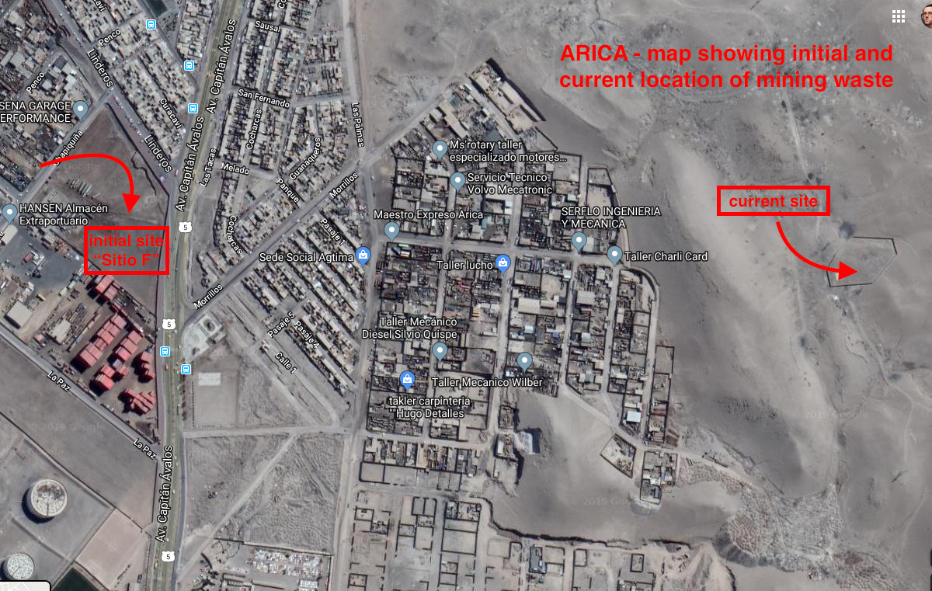

http://www.serviu15.cl/opensite_20130822152329.aspx
Arica Victims KB v. Boliden, Judgment, (County Court, 8th March 2018), p.33.
http://www.serviu15.cl/opensite_20130822152329.aspx
https://ejatlas.org/conflict/contaminacion-plomo-arica

