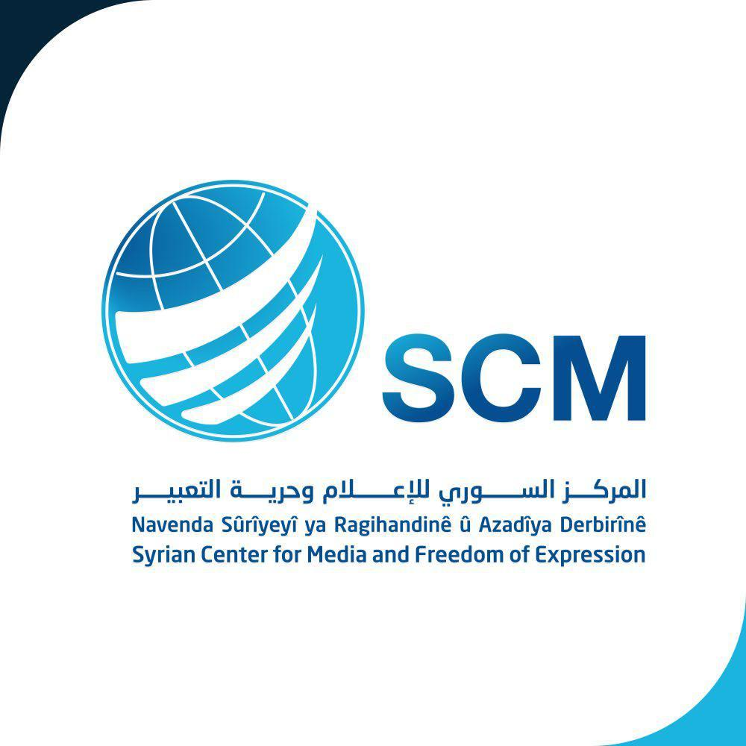

Syrian Arab Republic
submission to the United Nations Human Rights Committee
at its 130th Session for its List of Issues Prior to Reporting

Submitted by:
Syrian Centre for Media and Freedom of Expression (SCM)
A non-governmental organization in special consultative status with ECOSOC since 2011

Date: 28 August 2020

Table of Contents

- Organization
- Introduction
- Constitutional and legal framework within which the Covenant is implemented (Article 2)
- Non-discrimination and Women’s rights (Article 3)
- State of emergency (Article 4)
V. Right to life (Article 6)
VI. Arbitrary arrest or detention, prohibition of torture, right to liberty and security of the person, treatment of detainees (Articles 7, 9 and 10)
VII. Freedom of movement (Article 12)
VIII. Right to a fair trial (Article 14)
IX. Non-discrimination and rights of persons belonging to minorities (Articles 26 and 27)

Organization
The Syrian Center for Media and Freedom of Expression (SCM) is a leading Syrian non-profit and independent non-governmental organization aimed at defending human rights, protecting freedom and achieving justice in Syria. The SCM was founded in 2004 .
SCM strives for a world where democracy, justice, freedom, equality, dignity and human rights are respected. SCM’s actions are guided by the principles of credibility, integrity, transparency, professionalism and independence.
SCM developed three concrete and unique programs aimed at:
- Having democratic societies guaranteeing freedom of expression and belief;
- Ensuring respect of human rights, fighting impunity and enabling victims to reach justice;
- Supporting citizenship and empowering civil society actors in policy making and justice processes.
Since 2011, SCM benefits from a consultative status with the United Nations. It is the only Syrian NGO with such status at the United Nations. Furthermore, SCM has a solid international partners network such as IIIM & COI.

Introduction
The Syrian Center for Media and Freedom of Expression (hereinafter SCM) is pleased to present this submission to the United Nations Human Rights Committee (hereinafter the Committee) at its 130th Session for its List of Issues Prior to Reporting on the Syrian Arab Republic.
The SCM appreciates this opportunity to submit information to the Human Rights Committee, with regard to the implementation of the International Covenant on Civil and Political Rights (hereinafter the ICCPR or the Covenant), by the Syrian government in Syria.
This submission comes within the framework of the Syrian Center for media and freedom of expression commitment to promote and protect the rights of the Syrian people for a decent life for all Syrians without discrimination for any reason and the duty for the Syrian government to respect the international bill of human rights and human dignity and the treaties it has ratified.
The submission is based on analysing the human rights situation in the Syrian Arab Republic through monitoring and documenting human rights violations by the SCM Violations Documentation Center (VDC) project, in addition to information gained from the victims and their families to ensure the reliability, accuracy and comprehensiveness of the information provided.
For the Committee’s list of Issues Prior to Reporting on the Syrian Arab Republic, SCM highlights the Syrian government widespread and systematic human rights violations committed against the Syrian people as a whole, within the legal framework of international human rights law. This submission examines Syria’s’ violations of its obligation under the International Covenant on Civil and Political rights to respect, protect, and fulfil the human rights of all Syrians, focusing on violations of the right to life, freedom from arbitrary arrest and detention, prohibition of torture and other ill-treatment in Syrian prisons and detention centres, the right to liberty and security of persons, treatment of detainees, freedom of movement, right to fair trial as well as non-discrimination and right of persons belonging to minorities.

Constitutional and legal framework within which the Covenant is implemented (Article 2)
Syria is a founded member of the United Nations. Syria acceded to the International Covenant on Civil and Political Rights on 21 April 1969 and consequently, the Covenant should have become part of its domestic legislation and, as such, its provisions should have been enforceable in accordance to the Syrian domestic law. From this perspective, the rights referred to in the International Covenant on Civil and Political Rights must be guaranteed in the Syrian legislation pursuant to the principle that the principles and provisions of international law shall prevail over domestic law. This rule is formally observed under articles 33, 50, 51, 53, 54 of the Syrian Constitution of 27 February 2012.
The Syrian president approved the Anti-Terrorism Decree No. (19) on July 2, 2012. Following the approval of the above decree, he laso he also approved Decree No. (22) dated 26.07.2012 creating Counter-Terrorism Court which located in the capital Damascus. Most of peaceful activists, human rights defenders, media professionals, journalists and others are being tried since that time before the Anti-terrorism Court.

Despite the consecutive recommendations of the Human Rights Committee addressed to the Syrian government regarding the implementation of the covenant the Syrian government failed to submit any periodic reports since 2005. Hence, and by virtue of the ongoing armed conflict since 2012, the state party is requested to provide information concerning the following issues:

In the light of the Constitution of the Syrian Arab Republic of 27 February 2012, please clarify the status of the Covenant within the national legal order, in particular whether its provisions take precedence over national laws and whether provisions of the Covenant are given full effect in the domestic legal order.

Please provide information on the coexistence of the statutory law alongside with the customary legal system and legislation sourced from Sharia law and how it complies with the Covenant.

Please provide examples of cases in which the Covenant has been invoked or applied by national courts and information on the measures taken to raise awareness of the Covenant among judges, prosecutors, Security services, the administration of prisons and detention centres, lawyers and the public at large.

Please provide detailed precise information on the measures taken to create a national human rights institution in line with previous recommendations of the committee. What is the scope of the role of the “Public Freedoms and Human Rights Committee” of the People's Assembly, what kind of inputs it has in upholding human rights in Syria?

Please provide precise information on steps which have been undertaken by the state party to adopt laws and/or other measures to give effect to the rights recognized in the Covenant since 2006 onwards, with special focus on the period of 2011 to 2020.
- Has the State party examined and considered recommendations addressed to it by the Committee and taken necessary steps to ensure that the national legislation and its implementation ensure the effective enjoyment of all Covenant rights in the State party?
- Has the State party revised its legislation to ensure that it is in strict compliance with the basic rules of the Covenant? Please provide detailed information on specific laws or measures that have been adopted since 2006 onwards, specifically since 2011 to this date.
- Please provide precise and detailed examples of cases in which provisions of the Covenant were directly invoked before the courts since 2011, including the State Security Court (Canceled), Military Courts, Field military Court and with what results.
- Please provide details of the cases in which ordinary judiciary and administrative tribunals have revoked decisions by the Counter-Terrorism Court and the Military Field Court.
- Please provide information regarding military courts and tribunals formed under military jurisdiction. Are civilians tried before military courts and tribunals, and in what cases?
- Please elaborate on the implementation in practice of the right to an effective remedy. What steps have been taken to ensure that victims have access to effective and enforceable remedies?
- Please provide information on the activities of the National Committee for International Humanitarian Law In the armed conflict in Syria, as well as on its composition, human rights law-related functions and its budget.
- Non-discrimination and Women’s rights (Article 3)
Violations and discriminatory policies against women in Syria existed for a long time before the armed conflict began. Syrian women are experiencing gross violations to their basic rights, and they are accordingly victims of discriminatory practices for decades. Since before the conflict began, the Syrian domestic law system contains various laws that clearly discriminate against women, encourage impunity for gender-based violence and prevent women from their basic right of accessing justice. The armed conflict marked an escalation of gender-based violence, where Syrian women and girls face sexual violence, forced and early marriages, and "honor" crimes, amongst other forms of violations and discriminatory policies.
By virtue of the discriminatory policies and practices against women in violation of their basic rights, please provide precise information with regard to the following issues:

- Why the Syrian Penal Code contains discriminatory provisions against women (e.garticles. 473-475, 508,192,242),(Criminalization of abortion 527-528)?
- (Article 3 of the Nationality Law 1969 : (An Syrian Arab is considered Syrian by law: whoever was born in or outside the country to a Syrian Arab father
- Provide details about what review of all legislation, in line with article 154 of the Constitution, as regards to the amendment or repeal of any legal provisions - that discriminate against women
- Article 154 (The legislation in force and passed before approving this Constitution remain in force until they are amended in accordance with its provisions, provided that the amendment is done within a period of no longer than 3 years
- Violence against women
Why doesn't comprehensive legislation against domestic violence exist yet?
Why the Syrian Penal Code doesn’t criminalize marital rape.

State of emergency (Article 4)
Syria gained independence in April 1946 as a parliamentary republic. The post-independence period was marked by several military coups and coup attempts. A state of emergency, from 1963 to April 2011, effectively suspended most constitutional protections for citizens.
It is admitted that derogations from the Covenant provisions are exclusively permitted under specific circumstances. As a state party, the Syrian Arab Republic has never notified the Secretary-General of any state of emergency and subsequent derogations made to its obligations under the International Covenant on Civil and Political Rights.
Obviously, derogations “in time of public emergency which threatens the life of the nation” (article 4 of the Covenant), obligated the state party to ensure firstly that the measures it has taken, in law and practice, to derogate from the Covenant rights are strictly required by the exigencies of the situation; secondly, that the rights provided for in article 4 (2) of the Covenant are made non-derogable in law and practice; and thirdly, that States parties are duly informed, as required by article 4 (3) of the Covenant, of the provisions from which it has derogated and the reasons therefor, and of the termination of any particular derogation.
As the state of emergency was formally lift by the Syrian president in April 2011, Syria is requested to provide precise information as follows:
- Please provide detailed and precise information on the conditions resulting from the issuance of the Legislative decrees No. (161) 2011 to lift the state of emergency imposed in Syria since 1963, the decree to abolish the State Security Court, and the decree of regulation the right of peaceful protest for citizens.
- Please clarify whether there has been any derogation of Covenant rights, mainly after the issuance of these decrees and if so, please indicate which rights and the scope of the derogation. Has the State party notified other States parties, through the intermediary of the Secretary-General of the United Nations, of this/these derogation(s), in accordance with article 4 (3) of the Covenant; if so, when?
- Please provide precise information to what extent the Counter-Terrorism Court and Field Military Court consider the terms of the covenant and guided by it in its decisions. Please provide specific judgements in this regard.
- Please provide details of the cases in which emergency acts/laws have been adopted and/or applied since the termination of the state of emergency according to decree No (161) 2011.

Right to life (Article 6)

The violence in Syria evolved from unrest in March 2011 into internal disturbances and the emergence of a non-international armed conflict in February 2012. The involvement of an ever-increasing number of local and international actors in the conflict is characterized by a complete lack of adherence to the norms of international law.

Since the outset, hundreds of thousands of Syrians have been killed. Hundreds of thousands have also been arbitrarily arrested, and more than one hundred thousand of them have been forcibly disappeared.

Half of the country’s population have fled their homes, becoming refugees or internally displaced persons. The current needs outstrip the existing humanitarian response. Many people are hard to reach, making basic and essential protection efforts virtually impossible.
Non-derogable provisions include, but are not limited to, the right to life and liberty, the prohibition of arbitrary arrest, torture or cruel, inhuman or degrading punishment. Article 2(2) of the Convention against Torture states that “no exceptional circumstances whatsoever, whether a state of war or a threat of war, internal political instability or any other public emergency, may be invoked as a justification of torture.” Article 6 of the Covenant states that “every human being has the inherent right to life. This right shall be protected by law. No one shall be arbitrarily deprived of his life”.
Hence, the Syrian government is requested to provide precise information and data of people who were killed during, arbitrary arrested and forcibly disappeared during the ongoing conflict
- Please provide exact information and date of Syrians who were killed since March 2011 as a result of the use of excessive force during the military conflict. Please specify the number of civilian and military deaths during March 2011 onwards to this date.
- With reference to the death penalty, please provide detailed statistics on the number of death sentences pronounced from 2006 to March 2011 when a wide peaceful mass protests have erupted. Please identify the number and identity of the persons sentenced to death during this period, the grounds for their sentences, the number of persons whose sentences have been commuted, the number of persons awaiting execution, and the number and identity of the persons executed and the dates of execution.
- Please provide detailed facts and statistics on the numbers of death sentences pronounced from March 2011 to this date. Please identify the number and identity of the persons sentenced to death during this period, the grounds for their sentences, the number of persons whose sentences have been commuted, the number of persons awaiting execution, and the number and identity of the persons executed and the dates of execution.
- Has the Syrian government taken any measures to reduce the number of offences punishable by death penalty and enact laws that are consistent with the provisions of article 6 (2) of the Covenant?

Arbitrary arrest or detention and treatment of detainees, prohibition of torture, Right to liberty and security of the person (Article 7,9,10)
Syria is state party to various international conventions that protect the lives of detainees and prohibit killings and summary executions, enforced disappearance, torture and other forms of ill treatment, including the International Covenant on Civil and Political Rights, the Convention against Torture and Other Cruel, Inhuman or Degrading Treatment and the Arab Charter on Human Rights

Massive systematic violence, including arbitrary arrest, killing and forced disappearances of detainees in official and temporary prisons and detention centres has become a common phenomenon in Syria especially since March 2011. These are deaths for which military necessity cannot be invoked as a legal justification. Deaths in custody continue to occur in near-total secrecy and are largely lost to the international public and political discourse surrounding the violence of the conflict, in spite of their devastating impact on the lives of hundreds of thousands of Syrians.

The prohibition of arbitrary arrest, forced disappearances, summary and extrajudicial executions or killings applies regardless of detainees’ status or of any offenses with which they may be charged. Sanctions may only be imposed after a trial conducted in accordance with due process. Both international human rights and humanitarian law contain rules ensuring that criminal justice is not carried out in secret. Detainees have the right to challenge the legality of their detention, to be informed of charges brought against them and to be represented by counsel.

These obligations are non-derogable and apply in situations of armed conflict as well as in times of peace. They are indispensable to prevent impunity for the deaths of prisoners, persons held incommunicado and victims of enforced disappearance. They form core principles for safeguarding the right to life, liberty and security of persons.

In late 2013, a Syrian military photographer so-called Caesar have defected from the Syrian Government forces after having smuggled photos of more than 6000 persons who were killed under torture and ill-treatment under the custody of Government forces after having been victims of arbitraty detention, enforced disappearance and torture. The photos of these victims were published online in 2015 without any records of names of the victims by a Syrian NGO, and they correspond to persons detained between March 2011 and August 2013. Families of these victims have not been informed of the whereabouts of their detained relatives in accordance with international laws. We have records of 26 families who received death notifications of the death of their relatives who were forcibly disappeared by the government, but the vast majority of them did not accept to receive these notifications without impartial investigation of the cause of death and location of burial. While 127 families out of over 270 records have informed us that they never received any form of information about the whereabouts of their relatives.

by virtue of the tragic situation prevails in Syria, specifically since March 2011, please provide precise information regarding the following issues:

- Measures that has been taken by the Syrian Arab Republic to comply with the conclusions and recommendations of the Human Rights Committee of August 2005 with regard to allegations of extrajudicial executions, incommunicado detention, forced disappearances, torture, acts of cruel, inhuman or degrading treatment or punishment by law enforcement personnel.
- Measures taken by the state party to stop the use of incommunicado detention and eradicate all Forms of torture and cruel, inhuman or degrading treatment or punishment by law enforcement officials, and ensure prompt, thorough, and impartial investigations by an independent mechanism into all allegations of torture and ill-treatment, prosecute and punish perpetrators.
- Please provide precise information on steps of prompt, impartial and full investigations that have been conducted on allegations of torture or cruel, inhuman or degrading treatment or punishment practices by law enforcement personnel. Have the perpetrators been prosecuted and punished? Has compensation been awarded to victims or their families? Please provide accurate information Especially the 12 cases submitted by civilians before the Syrian judiciary according to the letter of the Permanent Mission of the Syrian Arab Republic to the United Nations Office / Geneva registered under the number 11/395 dated 5-8-2011.
- Please provide information on the number of claims received from accused persons to the effect that their confessions were made under duress, the number of investigations carried out into such claims and the results of such investigations.
- Are procedures in place to pursue complaints of criminal conduct against members of the police and prison guards and to obtain compensation when such claims are upheld? Please provide statistics on the number of such cases that have been brought, details of any such cases and their results (para. 104). Has the State party established an independent mechanism for the investigation of complaints?
- Please provide precise information on the number of complaints received from families regarding the forced disappearances of their loved ones in official and temporary prisons and detention centres administered by the Syrian government.
- What measures have been taken to improve prison conditions and to investigate deaths in custody? Please provide information on any investigations carried out into those deaths. Please provide statistics on the number of prisoners, disaggregated by age, sex, and type of offence committed.
- Please provide detailed information on the practice of police custody and pre-trial detention, and explain what measures have been taken to ensure that the rights recognized in article 9 are guaranteed in practice. Detailed statistics on the number of people held in pre-trial detention and on the duration of and reasons for such detention should be provided.
- Please provide information and accurate statistics of numbers of political and criminal detainees in the government prisons since 2005. Please provide separate lists of criminal and political prisoners.
- Please provide exact numbers of detainees since 2011. How many people were arrested since March 2011 to date, how many people are still in prisons, and what is the number of prisoners who have been tried.
- Measures taken by the state party to provide victims of violations with an effective remedy, including reparation, and to undertake prompt and impartial investigations of alleged violations.
- Please provide precise information on the implementation of Legislative Decree No. (14) issued on January 25, 1969, of establishing the General Intelligence Department, the State Security Administration which blocks the prosecution of any of the official employees for crimes they commit while carrying out the tasks assigned to them or when carrying out their missions without prosecution order issued by the director (Article 16 of the Decree).
- Please provide information on the Code of Military Procedure issued in Decree 61 of 1950, which protects military and security personnel from prosecution, without obtaining permission from the Minister of Defence. Does this Decree protect perpetrators from prosecution for their human rights violations? Please provide information on concrete cases when the minister of defense issued permissions to prosecute perpetrators.

Freedom of movement (Article 12)
- Please provide precise information on allegations that individuals have been prevented from leaving the country for security reasons since 2006. please elaborate as precise as possible on the period since March 2011 onwards to this date.
- Has the state party expelled aliens from the Syrian Arab Republic? If so, what procedures are in place to ensure that aliens, before their expulsion, enjoy the safeguards and an effective remedy, in conformity with article 13 of the Covenant?

Right to a fair trial (Article 14)
Obviously, the Anti-Terrorism Court is using the broad provisions of the Anti-Terrorism Law to convict peaceful activists on charges of aiding terrorists in trials that violate basic rights to due process. The accusations are brought under the guise of combating violent extremism, but the allegations made against the activists do not in fact exceed actions such as distributing humanitarian aid, participating in demonstrations and documenting human rights violations.

The Anti-Terrorism Court is an exceptional and an unfair court in view of the circumstances in which it was established in violation of article 14 of the covenant which states that:

“all persons shall be equal before the courts and tribunals. In the determination of any criminal charge against him, or of his rights and obligations in a suit at law, everyone shall be entitled to a fair and public hearing by a competent, independent and impartial tribunal established by law”.

In February 16, the Security services arrested 13 employees (5 women and 8 men) of the SCM,The trial of the SCM member was postponed 23 from the date of their arrest tell June 2015, mostly due to the failure of the public prosecution to provide evidence regarding the legality of the detention of SCM Team. The detainees were released in successive periods, where the last detainee was released on August 10, 2015, while Ayham Ghazoul has died under torture.

The main argument of the case of the SCM team is related to the jurisdiction of the court itself. In accordance with the indictment, SCM colleagues were charged because of their human rights activities, including the following-up and monitoring of the news broadcasted by the Syrian opposition on the Internet, publishing reports on human rights and the state of the media in Syria, and keeping a record of the names of detainees, arbitrary detention and torture, forced disappearances and victims killed in the course of the Syrian conflict Through the Violations Documentation Center (VDC) project, which was established by SCM in April 2011. These actions were considered by the Syrian government as an attempt to “destabilize the internal situation in Syria. Provoking international organizations to condemn Syria in international forums.

With regard to the right of fair trial enshrined in article 14 of the covenant, please provide precise information and data regarding the following regarding the following issues:

- What measures have been taken to ensure the independence and impartiality of the judiciary?
- Please elaborate on measures taken to ensure the rights enshrined in article 14 of the Covenant are guaranteed and respected in the operation of the military and security courts and tribunals. Has the state party taken any measures to ensure that all rights article 14 of the Covenant are respected with regard to the composition, functions and procedures of these Courts and tribunals? Are there any guarantees for accused persons to exercise their right to appeal against decisions of these Courts?
- Please explain the operation of the Counter-Terrorism Court which was created in 2012 by Law No. 22 of 2012, the compatibility of its procedures with article 14, and the fact that their verdicts are not subject to appeal to a higher tribunal.

Non-discrimination and rights of persons belonging to minorities (Articles 26 and 27)
- Please provide information and statistics on all measures taken by the Syrian government to safeguard the rights of the Kurdish minority. Do all persons belonging to Kurdish minority enjoy Syrian nationality? Please provide exact statistics on Kurdish citizens who were granted Syrian citizenship in accordance with Legislative Decree No. (49) 2011 of “granting Syrian Arab nationality to those registered in the al-Hasakah foreigners registry”.
- Please provide accurate statistics on the numbers of Kurdish people who don’t hold Syrian nationality yet.
- is the Kurdish minority can speak their mother tongue without restrictions and learn it in schools . Is publishing and printing allowed in the Kurdish language?
- Please clarify the status of minorities and ethnicities in Syria in light of the introduction to the Constitution of the Syrian Arab Republic of 27 February 2012, “The Syrian Arab Republic is proud of its Arab identity and the fact that its people are an integral part of the Arab nation”.

