Annex
- Stakeholders Consulted
- Annual and Periodic studies conducted by the Statistical Institute of Belize
- Judges by Court and Sex.
- Gender Focal Points.
- Women in Municipal Elections.
- Older Persons Population by Sex, 2010-2021.
- Gender-based Violence Report 2021.
- References

1: Stakeholders Consulted

2012- List of Interviewees

Toledo Mayan Women Council
- Adelia Ishim, Programme Officer

Plenty Belize-
- Mark Miller, Coordinator,
- Tasha Petillo, Financial assistant (GFP)

Women’s Issues Network Belize
- Lara Smith- PASMO National Manager
- Karen Cain- YES
- Rodel Beltran Perrera- Alliance Against AIDS
- Mindy Pratt - Haven House
- Florence Goldson- WIN Belize Secretariat
- Carolyn Reynolds- WIN Belize Secretariat
- Kiri Lizama- WIN Belize Secretariat
- Sarah Lewis- YWCA
- Yolanda Murray - YWCA
- Caleb Orosco- UNIBAM

National AIDS Commission
- Kathy Esquivel - Chair
- Dr. Martin Cuellar- Executive Director

National Women’s Commission
        - Anne-Marie Williams - Executive Director
                - Ashanti Garcia - Programme Officer

Ministry of Health
- Vincent Perez, Gender Focal Point
- Dr. Marvin Manzanero, HIV/AIDS Unit (Director)
- Dr. Aisha Andrewin, Epidemiologist
- Dr. Natalia L. Beer, Maternal Child Health

Ministry of Economic Development
- Nerie Sanz, National Authorizing Organization

Ministry of Education and Youth
- Dr. Ellajean Gillett, GFP, Director Policy and Planning

Omdudsman
- Cynthia Pitts

Family Court
- Margaret Nicholas, Director of Family Court
- Sandra Arnold, Magistrate
- Alberta Perez, Magistrate

Magistrate Court
- Aretha Ford, Magistrate

Council of Churches
- Canon Leroy Flowers- Anglican Church
- Fr Noel Leslie- Catholic Church
- Rev.Roosevelt Papouloute - Methodist Church
- Bishop Phillip Wright - Anglican Church

Black Cross Nurses
- Rose Armstrong

Stakeholder’s consulted 2022

Governmental Agencies
Statutory Bodies
- Attorney General Office
- Legal Advice and Service Center
- Judiciary of Belize
- Vital Statistics
- Ministry of Agriculture
- Cooperative Department
- Ministry of Economic Development
- Ministry of Education
- Ministry of Health
- Ministry of Human Development
- Anti-Trafficking in Persons Committee
- Ministry of Immigration
- Department of Women and Family Services
- Gender Based Violence Committee
- Ministry of Community Development, Labour, and Rural Transformation
- Joint Intelligence Coordinating Center
- Department of Youth Services
- Belize Police Department
- National Security
- Domestic Violence Unit
- Disability Desk
- Department of Rural Transformation
- Department of Local Government
- Election and Boundaries

- Social Security Board
- Statistical Institute of Belize
- National Aids Commission
- National Committee for Families and Children
- Belize Tourism Board
- BELTRAIDE
- National Council for the Aging
- Development Finance Corporation
- Belize Social Investment Fund

Non-governmental agencies
- Child Development Foundation
- Youth Enhancement Services
- Young Women’s Christian Association
- Cornerstone Foundation
- Haven House
- Belize Credit Union League
- Belize Enterprise for Sustainable Technology
- Chamber of Commerce and Industry
- Maya Leaders Alliance
- Toledo Maya Women’s Council
- Toledo Alcalde Association
- National Garifuna Council
- National Association of Village Councils

3. Annual and Periodic studies conducted by the Statistical Institute of Belize

Key studies relevant to Articles of the CEDAW conducted by the Statistical Institute of Belize which collects sex-disagreed data.

  - It conducts a bi-annual Labour Force Survey which includes labour market data on rural and urban Belizean and foreign-born women. In addition to collecting data related to employment and unemployment, this survey serves as a vehicle for the collection of other socio-economic data in the form of short modules attached to the survey.
  - In 2009, the Country Poverty Assessment was conducted with support from the Caribbean Development Bank and an updated Poverty Study in 2018 which provides sex-disaggregated data on several poverty-related issues.
  - In 2011 and 2015, the Multiple Indicator Cluster Survey were done in collaboration with UNICEF which collects data on the girl child.
  - In 2013, the Child Activity Survey was carried out with support from the International Labour Organization. It contains data on the girls engaged in child labour.
  - In 2014, the Country Report on Knowledge, Practices, and Attitudes in Sexual Behavior and HIV in Belize was done with the National Aids Commission.
  - In 2010, it conducted the Population and Housing Census. The 2020 Population and Housing Census was postponed to 2022 due to the COVID-19 pandemic.
  - In 2020, it conducted a national Poverty Study, using data collected in the 2018 Household Budget Survey.
  - In 2021 it conducted a Food Insecurity Study with technical assistance from the Food and Agriculture Organization which provides insights into food security of female-headed households and rural women.
  - In 2021 it commenced production of an annual Multidimensional Poverty Index (MPI) using Census data which will allow more in-depth look at the poverty situation of Belizean women and girls.

5. Judges by Court and Sex

Table 2- Judiciary of Belize by Court, Sex and Year, 2009-2016
Courts | Magistrate |  |  | Family |  |  | Supreme |  |  | Appeal
Sex | Male | Female | Total | Male | Female | Total | Male | Female | Total | Male | Female | Total
2009-2010 | 0 | 4 | 4 | 8 | 8 | 16 | 9 | 2 | 11 | 6 | 0 | 6
2011-2012 | 7 | 6 | 13 | 0 | 3 | 3 | 9 | 2 | 11 | 5 | 0 | 5
2013-2014 | 2 | 10 | 12 | 5 | 10 | 15 | 7 | 1 | 8 | 4 | 1 | 5
2015-2016 | 2 | 10 | 12 | 1 | 3 | 4 | 6 | 4 | 10 | 4 | 1 | 5
Source: Judiciary of Belize. Chief Justice Reports 2009-2016.
Data available only for these years.

6. Gender Focal Points.

- National Women’s Commission- Chair
- Ministry of Human Development, Families, and Indigenous Peoples' Affairs
- Ministry of Foreign Affairs, Foreign Trade, and Immigration
- Ministry of Home Affairs & New Growth industry (Police)
- Ministry of Tourism & Diaspora Relations
- Ministry of Blue Economy and Civil Aviation
- Ministry of Infrastructure Development & Housing
- Ministry of Youth, Sports & E-Governance
- Ministry of National Defense
- Ministry of Rural Transformation, Community Development, Labor and Local Government
- Belize Defense Force
- Ministry of Public Utilities, Energy and Logistic (Postmaster General)
- Ministry of Finance, Economic Development & Investment Service,
- Ministry of Political and Constitutional Reform
- Ministry of Sustainable Development, Climate Change and Disaster Risk Management

Source: National Women’s Commission, 2022.

7. Women in Municipal Elections

Table 3: Belmopan City Elections 2009-2021
Belmopan | Persons contested | Women contested | Women elected
2009 | 21 | 7 | 3
2012 | 23 | 7 | 1
2015 | 22 | 5 | 3
2018 | 20 | 6 | 3
2021 | 15 | 7 | 4
Table 4: San Pedro Town Elections 2009-2021
San Pedro | Persons contested | Women contested | Women elected
2009 | 14 | 5 | 1
2012 | 17 | 5 | 0
2015 | 21 | 5 | 1
2018 | 14 | 5 | 1
2021 | 14 | 7 | 4
Table 5: Corozal Town Elections 2009-2021
Corozal | Persons contested | Women contested | Women elected
2009 | 15 | 6 | 1
2012 | 14 | 4 | 3
2015 | 14 | 5 | 2
2018 | 15 | 3 | 1
2021 | 14 | 4 | 1
Table 6: Orange Walk Town Elections 2009-2021
Orange Walk | Persons contested | Women contested | Women elected
2009 | 14 | 2 | 1
2012 | 14 | 3 | 1
2015 | 14 | 5 | 2
2018 | 14 | 3 | 1
2021 | 15 | 6 | 3
Table 7: Dangriga Town Elections 2009-2021
Dangriga | Persons contested | Women contested | Women elected
2009 | 16 | 2 | 1
2012 | 14 | 5 | 2
2015 | 16 | 5 | 3
2018 | 16 | 7 | 2
2021 | 17 | 2 | 1
Table 8: San Ignacio/Santa Elena Town Elections 2009-2021
San Ignacio/Santa Elene | Persons contested | Women contested | Women elected
2009 | 16 | 5 | 3
2012 | 14 | 4 | 2
2015 | 14 | 5 | 2
2018 | 16 | 5 | 3
2021 | 19 | 2 | 1
Table 9: Benque Viejo Town Elections 2009-2021
Benque Viejo | Persons contested | Women contested | Women elected
2009 | 21 | 5 | 2
2012 | 17 | 2 | 0
2015 | 15 | 1 | 0
2018 | 15 | 3 | 2
2021 | 14 | 2 | 2
Table 10: Punta Gorda Town Elections 2009-2021
Punta Gorda | Persons contested | Women contested | Women elected
2009 | 25 | 3 | 1
2012 | 25 | 1 | 1
2015 | 24 | 7 | 4
2018 | 21 | 5 | 2
2021 | 22 | 4 | 1
Table 11: Belize City Elections 2009-2021
Belize City | Persons contested | Women contested | Women elected
2009 | 22 | 6 | 3
2012 | 32 | 5 | 1
2015 | 28 | 7 | 3
2018 | 27 | 7 | 3
2021 | 26 | 8 | 4
Source: Election and Boundaries, Municipal Elections Results, 2009-2021.
9.. Gender-based Violence Report January-December 2021

Table 12: Domestic Violence Reports by Category and Period
Period | Cases | Future Reference | Unknown | Total
Jan-Dec 2018 | 676 | 1379 | 6 | 2061
Jan-Dec 2019 | 959 | 1377 | 0 | 2336
Jan-Dec 2020 | 885 | 1525 | 9 | 2419
Jan-Dec 2021 | 773 | 1589 | 0 | 2362

Table 13: Domestic Violence Reports by Sex
Period | Females | Males | Total
Jan-Dec 2016 | 1708 | 341 | 2049
Jan-Dec 2017 | 1854 | 429 | 2283
Jan-Dec 2018 | 1617 | 444 | 2061
Jan-Dec 2019 | 1863 | 473 | 2336
Jan-Dec 2020 | 1918 | 501 | 2419
Jan-Dec 2021 | 1841 | 521 | 2362

Source: Domestic Violence Reports. National Crime Observatory. Joint Intelligence Coordinating Centre, Police Department 2022.

Graph 1: Gender-based Violence Cases, 2020 & 2021.
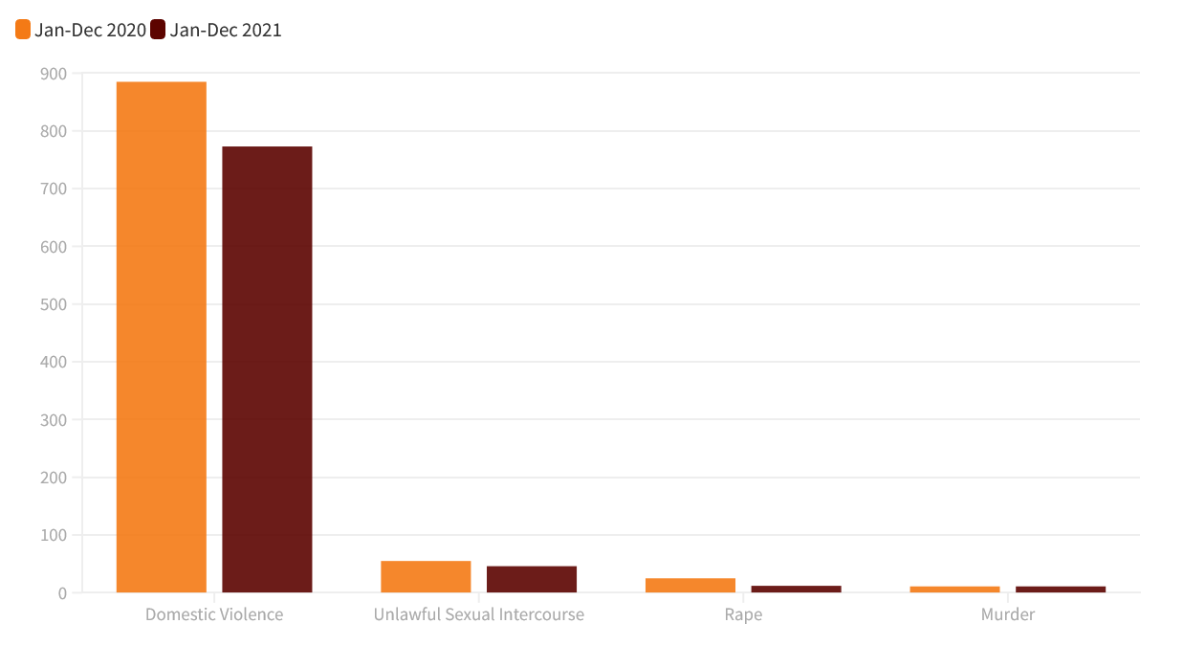

Graph 2: Gender-based Violence Documented, Opened, ‘Future reference’, 2018-2021.

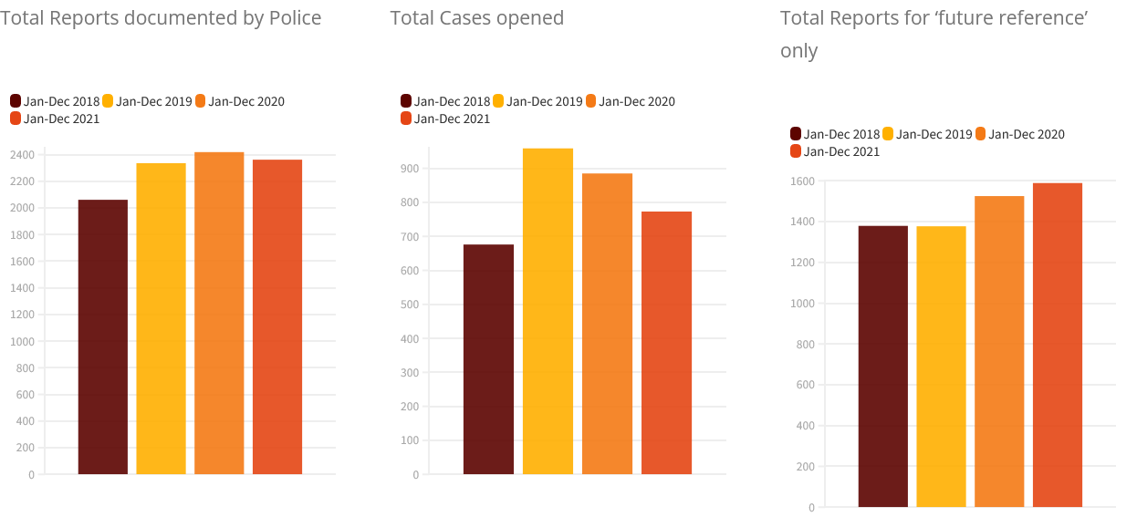
National Crime Observatory. Joint Intelligence Coordinating Centre, Police Department 2022.

Graph 3: Gender-based violence reports by sex, 2016-2018.
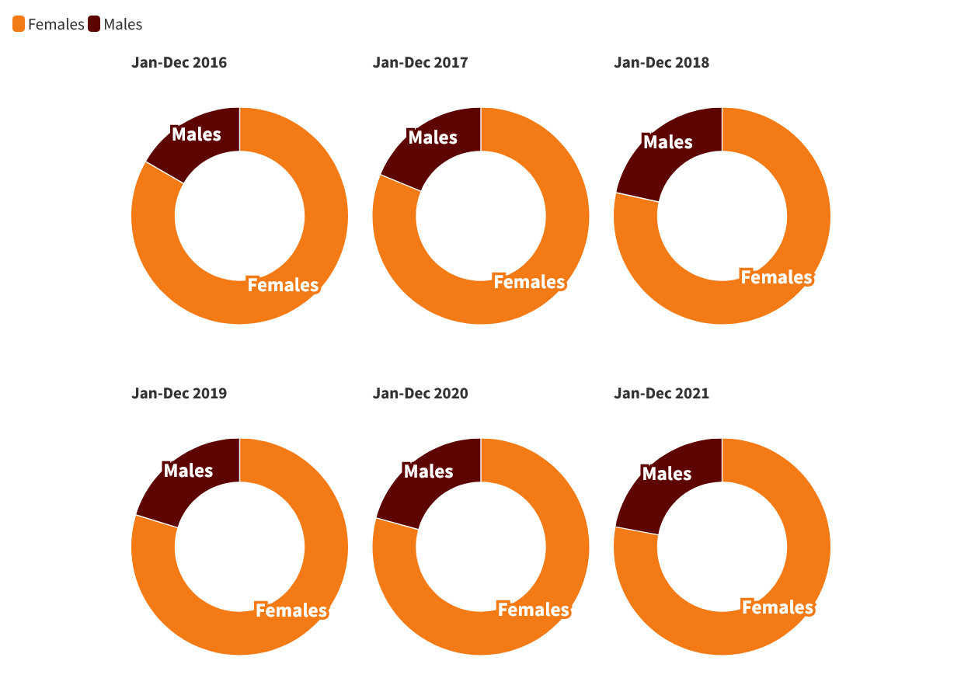
Source: National Crime Observatory. Joint Intelligence Coordinating Centre, Police Department 2022.

Graph 4: Domestic Violence Reports per Month (2016-2021).
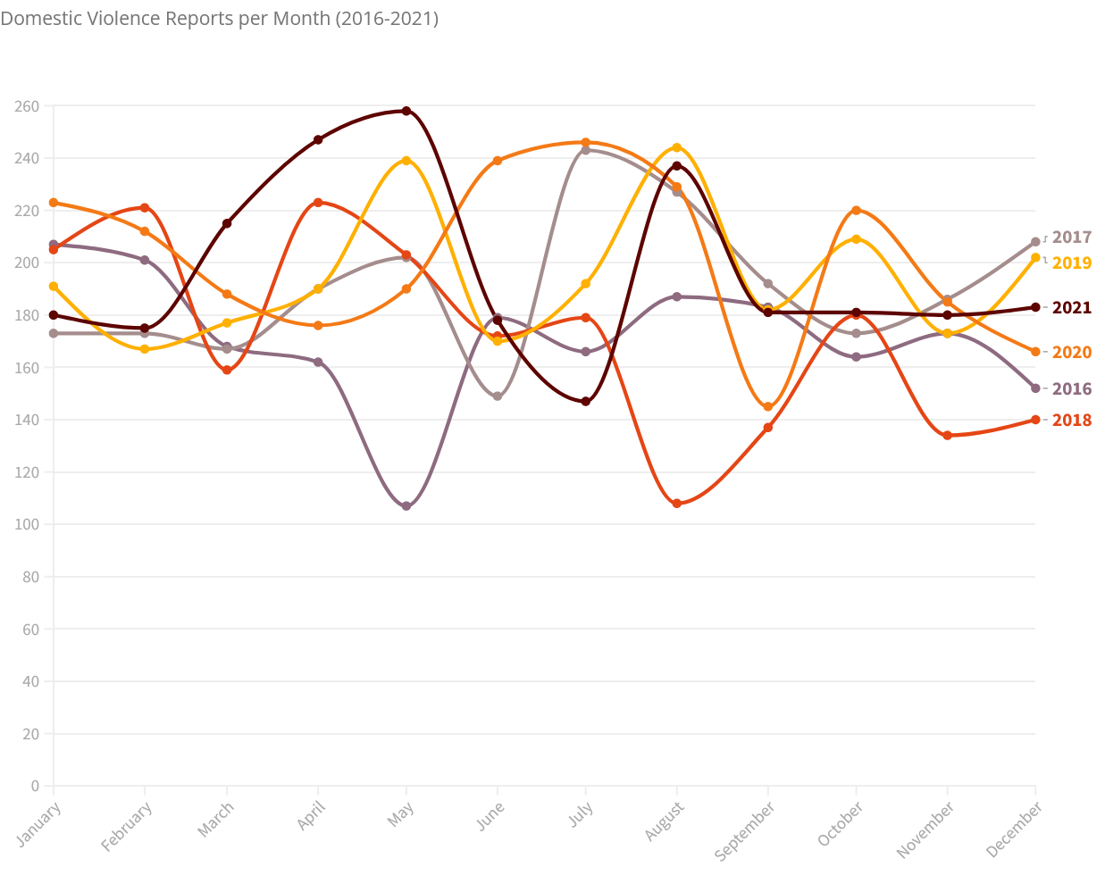

Source: Domestic Violence Reports. National Crime Observatory. Joint Intelligence Coordinating Centre, Police Department 2022.

8. Older Persons Population by Sex, 2010-2021

Table 14: Belize Postcensal National Population Estimates, 2010 to 2020
Age | Census Population 2010 | Estimated Mid Year Population 2010 | Estimated Mid Year Population 2011 | Estimated Mid Year Population 2012 | Estimated Mid Year Population 2013 | Estimated Mid Year Population 2014 | Estimated Mid Year Population 2015 | Estimated Mid Year Population 2016 | Estimated Mid Year Population 2017 | Estimated Mid Year Population 2018 | Estimated Mid Year Population 2019 | Estimated Mid Year Population 2020 | Estimated Mid Year Population 2021
60 - 64 | 6,223 | 6,245 | 6,409 | 6,577 | 6,750 | 6,926 | 7,107 | 7,293 | 7,484 | 7,681 | 7,883 | 8,090 | 8,302
65 - 69 | 4,397 | 4,412 | 4,527 | 4,646 | 4,768 | 4,894 | 5,022 | 5,153 | 5,288 | 5,427 | 5,570 | 5,715 | 5,865
70 - 74 | 3,495 | 3,508 | 3,600 | 3,694 | 3,790 | 3,889 | 3,992 | 4,097 | 4,205 | 4,314 | 4,427 | 4,544 | 4,663
75 - 79 | 2,564 | 2,573 | 2,640 | 2,709 | 2,780 | 2,853 | 2,927 | 3,004 | 3,082 | 3,163 | 3,246 | 3,331 | 3,419
80 - 84 | 3,132 | 3,143 | 3,226 | 3,311 | 3,398 | 3,487 | 3,579 | 3,673 | 3,770 | 3,869 | 3,970 | 4,074 | 4,181
Total | 322,453 | 323,598 | 332,084 | 340,792 | 349,728 | 358,899 | 368,310 | 377,968 | 387,879 | 398,050 | 408,487 | 419,199 | 430,191
Source: Belize PHC, 2000 & 2010
Table 15: Belize Postcensal National Male Population Estimates, 2010 to 2020
Age | Census Population 2010 | Estimated Mid Year Population 2010 | Estimated Mid Year Population 2011 | Estimated Mid Year Population 2012 | Estimated Mid Year Population 2013 | Estimated Mid Year Population 2014 | Estimated Mid Year Population 2015 | Estimated Mid Year Population 2016 | Estimated Mid Year Population 2017 | Estimated Mid Year Population 2018 | Estimated Mid Year Population 2019 | Estimated Mid Year Population 2020 | Estimated Mid Year Population 2021
60 - 64 | 3,290 | 3,302 | 3,389 | 3,478 | 3,569 | 3,662 | 3,758 | 3,856 | 3,957 | 4,061 | 4,168 | 4,278 | 4,390
65 - 69 | 2,340 | 2,348 | 2,409 | 2,472 | 2,537 | 2,604 | 2,672 | 2,742 | 2,814 | 2,888 | 2,964 | 3,041 | 3,121
70 - 74 | 1,852 | 1,859 | 1,908 | 1,958 | 2,009 | 2,062 | 2,117 | 2,173 | 2,230 | 2,288 | 2,348 | 2,410 | 2,473
75 - 79 | 1,302 | 1,306 | 1,340 | 1,375 | 1,411 | 1,448 | 1,485 | 1,524 | 1,564 | 1,605 | 1,647 | 1,690 | 1,735
80 + | 1,474 | 1,480 | 1,519 | 1,559 | 1,600 | 1,642 | 1,686 | 1,730 | 1,776 | 1,823 | 1,871 | 1,920 | 1,970
Total | 161,227 | 161,800 | 166,043 | 170,397 | 174,865 | 179,451 | 184,157 | 188,986 | 193,942 | 199,028 | 204,247 | 209,603 | 215,099
Source: Belize PHC, 2000 & 2010
Table 16: Belize Postcensal National Female Population Estimates, 2010 to 2020
Age | Census Population 2010 | Estimated Mid Year Population 2010 | Estimated Mid Year Population 2011 | Estimated Mid Year Population 2012 | Estimated Mid Year Population 2013 | Estimated Mid Year Population 2014 | Estimated Mid Year Population 2015 | Estimated Mid Year Population 2016 | Estimated Mid Year Population 2017 | Estimated Mid Year Population 2018 | Estimated Mid Year Population 2019 | Estimated Mid Year Population 2020 | Estimated Mid Year Population 2021
60 - 64 | 2,933 | 2,943 | 3,020 | 3,099 | 3,181 | 3,264 | 3,349 | 3,437 | 3,527 | 3,620 | 3,715 | 3,812 | 3,912
65 - 69 | 2,057 | 2,064 | 2,118 | 2,174 | 2,231 | 2,290 | 2,350 | 2,411 | 2,474 | 2,539 | 2,606 | 2,674 | 2,744
70 – 74 | 1,643 | 1,649 | 1,692 | 1,736 | 1,781 | 1,827 | 1,875 | 1,924 | 1,975 | 2,026 | 2,079 | 2,134 | 2,190
75 – 79 | 1,262 | 1,267 | 1,300 | 1,334 | 1,369 | 1,405 | 1,442 | 1,480 | 1,518 | 1,558 | 1,599 | 1,641 | 1,684
80 + | 1,658 | 1,663 | 1,707 | 1,752 | 1,798 | 1,845 | 1,893 | 1,943 | 1,994 | 2,046 | 2,099 | 2,154 | 2,211
Total | 161,226 | 161,798 | 166,041 | 170,395 | 174,863 | 179,448 | 184,153 | 188,982 | 193,937 | 199,022 | 204,240 | 209,596 | 215,092
Source: Belize PHC, 2000 & 2010

Reports & Official Publications
2022. Common Core Document. Ministry of Foreign Affairs. Belmopan, Belize.
2022. Social Security Board of Belize. Statistical Abstract. 2021. SSB, Belmopan. Retrieved from https://www.socialsecurity.org.bz/publications/
2021. UNICEF Country Report: Belize. Retrieved from https://www.unicef.org/reports/country-regional-divisional-annual-reports-2021/Belize
2021. Trafficking in Persons Report: Belize. U.S. Department of State. Office to Monitor and Combat Trafficking in Persons. Retrieved from https://www.state.gov/reports/2021-trafficking-in-persons-report/belize/
2021. Human Rights Report: Belize. U.S. Department of State. Retrieved from https://www.state.gov/wp-content/uploads/2022/02/313615_BELIZE-2021-HUMAN-RIGHTS-REPORT.pdf
2021. Abstract of Education Statistics. 2020-2021. Retrieved from https://www.moecst.gov.bz/abstract-of-education-statistics-2020-2021/
2021. Social Security Board of Belize. Statistical Abstract. 2010. SSB, Belmopan. Retrieved from https://www.socialsecurity.org.bz/publications/
2020. Road Map to End Child Marriage & Early Unions in Belize. Government of Belize.
UNFPA, NCFC, UNICEF, Belize, Belize City. Retrieved from https://www.unicef.org/belize/media/1966/file/Road%20Map%20To%20End%20Child%20Marriage%20and%20Early%20Unions%20in%20Belize-NCFC%20UNICEF%20&%20UNFPA-2020.pdf
2020. Ombudsman Annual Report. Office of the Ombudsman. Retrieved from https://www.nationalassembly.gov.bz/wp-content/uploads/2021/04/2020-Ombudsman-Annual-Report-20th-Report.FINAL_.pdf
2020. Social Security Board of Belize. Statistical Abstract. 2019. SSB, Belmopan. Retrieved from https://www.socialsecurity.org.bz/publications/
2019. UNICEF Country Report: Belize.
2019. Belize Project Performance Evaluation. Rural Finance Program. Report No. 5102-BZ. International Fund for Agricultural Development Retrieved from https://www.ifad.org/documents/38714182/41219005/Belize_PPE_final+for+web.pdf/b904bd75-bb9a-a161-5c21-7cfe0a334849
2019. Belize Country Profile. Child Marriages and Early Unions. UNICEF. Retrieved from https://www.unicef.org/belize/media/1486/file/Belize%20country%20profile%20child%20marriages%20and%20early%20unions%20.pdf
2019. Adolescent Health National Strategic Plan 2019-2030 Mapping a holistic approach to adolescent health and development. GoB/UNICEF. Retrieved from https://www.unicef.org/belize/media/2486/file/Adolescent%20Health%20National%20Strategic%20Plan%202019-2030.pdf
2019 Spotlight Initiative- Spotlight Initiative to End Violence Against Women and Girls. Country Programme Document Belize. UNDP, UNICEF, UNFPA.
2019. Social Security Board of Belize. Statistical Abstract. 2018. SSB, Belmopan. Retrieved from https://www.socialsecurity.org.bz/publications/
2018. Social Security Board of Belize. Statistical Abstract. 2017. SSB, Belmopan. Retrieved from https://www.socialsecurity.org.bz/publications/
2017. National Gender-Based Violence Action Plan: A Multisectoral Plan to Prevent and Respond to Gender-Based Violence in Belize 2017 – 2020. Ministry of Human Development, Social Transformation and Poverty Alleviation. Retrieved from https://uploads-ssl.webflow.com/604665626bb4328821a62cb8/60b52905f862f460df551c17_National%20Gender%20Based%20Violence%20Action%20Plan%202017-2020_%20reduced.pdf
2017. Children’s Agenda. Ministry of Human Development. Retrieved from http://humandevelopment.gov.bz/wp-content/uploads/2017/06/Childrens-Agenda-2017-2030.pdf
2017. Belize National Voluntary Review for the Sustainable Development Goals. Government of Belize. Retrieved from https://sustainabledevelopment.un.org/content/documents/16389Belize.pdf
2016. National Entrepreneurship Strategy Belize. BELTRAIDE. Retrieved from https://issuu.com/beltraidemarketing/docs/national_entrepreneurship_strategy_
2016. Multiple Indicator Cluster Survey. 2015-2016. UNICEF/SIB. Retrieved from https://www.unicef.org/belize/media/936/file/Multiple%20indicator%20cluster%20survey.pdf
2016. Growth and Sustainable Development Strategy of Belize (2016-2019), Ministry of Economic Development. Retrieved from https://med.gov.bz/wp-content/uploads/2020/08/Final-Summary-Strategy-April-7-2016.pdf
2016. End of Term Review of the Commonwealth Plan of Action for Gender Equality
2005–2015. The Commonwealth. Retrieved from https://production-new-commonwealth-files.s3.eu-west 2.amazonaws.com/migrated/inline/103%20-%20CW%20Gender%20Plan%20of%20Action%202005-2015%20Evaluation%20Report_1.pdf
2016 Chief Justice Annual Report. Belize Judiciary. Retrieved from https://www.belizejudiciary.org/publications/annual-reports/
2015. National HIV and TB Strategic Plan 2016 – 2020. National AIDS Commission. Retrieved from https://pancap.org/pc/pcc/media/pancap_document/Belize_NSP-2016-2020.pdf
2015. Final Evaluation: Implementation of National Gender-based Violence Plan of Action (Belize). Tzec, A. U.N. Trust Fund. Retrieved from https://untf.unwomen.org/sites/default/files/Field%20Office%20UNTF/Publications/2015/C16_BLZ_WD_FE_a_compressed.pdf
2015 Chief Justice Annual Report. Belize Judiciary. Retrieved from https://www.belizejudiciary.org/publications/annual-reports/
2015. Social Security Board of Belize. Statistical Segment 2014. SSB, Belmopan. Retrieved from https://www.socialsecurity.org.bz/publications/
2014. Poverty Reduction Action Plan. Basic Needs Trust Fund/Caribbean Development Bank Government of Belize. Retrieved from https://www.fao.org/faolex/results/details/en/c/LEX-FAOC169440/
2014. Knowledge, Attitude and Practices in Sexual Behaviour and HIV/AIDS in Belize Country Report. Statistical Institute of Belize. Retrieved from https://www.unaids.org/sites/default/files/country/documents/BLZ_narrative_report_2015.pdf
2014. Belize Health Sector Strategic Plan for 2014-2024. Improving quality Health Services. A safer & healthier Belize by 2024. Retrieved from http://sisco.copolad.eu/web/uploads/documentos/Belize_Health_Sector_Strategic_Plan_2014-2024-April_2014.pdf
2014 Chief Justice Annual Report. Belize Judiciary. Retrieved from https://www.belizejudiciary.org/publications/annual-reports/
2014. Social Security Board of Belize. Statistical Segment 2013. SSB, Belmopan. Retrieved from https://www.socialsecurity.org.bz/publications/
2013. End mission Statement-Visit to Belize by the Special Rapporteur on trafficking in persons, especially women and children. Ngozi, J. UNHCR. Retrieved from Uhttps://www.ohchr.org/en/statements/2013/12/end-mission-statement-visit-belize-special-rapporteur-trafficking-persons
2013. Belize Report-National Composite Policy Index (NCPI). National AIDS Commission. Retrieved from https://www.unaids.org/sites/default/files/Belize%2520NCPI%25202013.pdf
2013 Chief Justice Annual Report. Belize Judiciary. Retrieved from https://www.belizejudiciary.org/publications/annual-reports/
2013. Social Security Board of Belize. Statistical Segment 2012. SSB, Belmopan. Retrieved from https://www.socialsecurity.org.bz/publications/
2012. Un Aids Global Aids Country Progress Report Belize. January 2010–December 2011. Belize, Retrieved from
https://www.unaids.org/sites/default/files/country/documents/ce_BZ_Narrative_Report[1].pdf

2012. National Youth Development Policy of Belize. Belizean Youth Taking the Lead. 2012. Ministry of Education, Youth & Sports.
2012. Getting to Zero: Belize HIV Strategic Plan 2012 – 2016. NAC. Retrieved from https://data.miraquetemiro.org/sites/default/files/documentos/Belize_HIV_Strategic_Plan_2012_-2016.pdf
2012 Chief Justice Annual Report. Belize Judiciary. Retrieved from https://www.belizejudiciary.org/publications/annual-reports/
2011. The Situational Analysis of Children and Women in Belize: An Ecological Review. Retrieved from https://www.ncfc.org.bz/download/the-situational-analysis-of-children-and-women-in-belize-2011-an-ecological-review/
2011. Rapid Assessment of Sexual and Reproductive Health and HIV Linkages. IPPF/WHO/UNAIDS/UNFPA. Retrieved from https://caribbean.unfpa.org/sites/default/files/pub-pdf/REPORT%20ON%20LINKAGES%20ASSESSMENT%20IN%20BELIZE.pdf
2011 Chief Justice Annual Report. Belize Judiciary. Retrieved from https://www.belizejudiciary.org/publications/annual-reports/
2010. UNGASS Country Progress Report: Belize. National AIDS Commission. Retrieved from http://www.unaids.org/en/dataanalysis/monitoringcountryprogress/2010progressreportssubmprogressreportss/belize _2010_country_progress_report_en.pdf
2010. The National Gender-Based Violence Plan of Action 2010 – 2013. Debra J. Lewis.
Women’s Department, Ministry of Human Development, Social Transformation and Poverty Alleviation. Belize.
2010. Quito Consensus Belize Country report. UNECLAC preparation for the 11th Session of the Regional Conference on Women in Latin America and the Caribbean. Retrieved from https://www.cepal.org/sites/default/files/events/files/belize.pdf
2010. A Gender-Based Analysis of HIV/AIDS in Belize. Prairie Women’s Health Center of Excellence/Ministry of Health, Belize. Pan American Health Organization. https://www.paho.org/blz/dmdocuments/Report_GBA_HIV_Belize_June2010.pdf
2010 Chief Justice Annual Report. Belize Judiciary. Retrieved from https://www.belizejudiciary.org/publications/annual-reports/
2009. National Poverty Elimination Strategy and Action Plan (NPESAP). 2009-2013. Mendoza, P, ABEN Consulting. Ministry of Economic Development. National Human Development Advisory Committee. Retrieved from https://mfa.gov.bz/wp-content/uploads/2019/09/Poverty-Strategy.pdf
2009 Chief Justice Annual Report. Belize Judiciary. Retrieved from https://www.belizejudiciary.org/publications/annual-reports/
2008. UNGASS Country Progress Report. Belize. National AIDS Commission. Retrieved from https://www.unaids.org/sites/default/files/country/documents//belize_2008_country_progress_report_en.pdf
2008 Chief Justice Annual Report. Belize Judiciary. Retrieved from https://www.belizejudiciary.org/publications/annual-reports/
2007. UNGASS Watch Belize. Young, T. Retrieved from https://healtheducationresources.unesco.org/sites/default/files/resources/santiago_belize_ungass.pdf
2007. HIV/AIDS Policy of the Public Service of Belize. Office of Governance. GoB. Retrieved from https://www.ilo.org/dyn/natlex/docs/ELECTRONIC/95175/111955/F-1320722225/BLZ95175.pdf
2007. Chief Justice Annual Report. Belize Judiciary. Retrieved from https://www.belizejudiciary.org/publications/annual-reports/
2007. Belize: Country Report on Progress Since Mexico Consensus 2004. Women’s Department, Ministry of Human Development. Retrieved from https://www.cepal.org/sites/default/files/events/files/informebelize_1.pdf

Laws
Amended Labor Act (2011)
Commercial Sexual Exploitation of Children (CSEC) Prohibition Act 2012
Trafficking in Persons Prohibition Act 2012
Families and Children Act - Revised Edition 2000
Families and Children Subsidiary Act -
Revised Edition 2003
Belize: Protection Against Sexual Harassment Act of 1996
Domestic Violence Act

Data sets & Database
Statistical Institute of Belize- www.sib.org
- National Census
- Abstract of Statistics
- Population
- Health
- Education
- Labour Force
- MICS5 Metadata

Crime Observatory- https://bco.gov.bz/
- Gender-based Violence
- Sexual Violence
- Crime statistics
- Trafficking in Persons
- Homicides

Election & Boundaries-https://elections.gov.bz/general-elections-results/
- General Elections Results
- Municipal Elections Results
- Village Council Elections Results

Curriculum, Teachers Guide, Training Manuals
2019. National Curriculum Primary School H.F.L.E. Learning Outcomes. 2019-2020. Retrieved from http://www.belizeanstudies.com/uploads/1/1/7/3/117332085/h.f.l.e._national_curriculum_learning_outcomes_for_primary_schools.pdf
2012. Education Today for a Healthy Tomorrow. Teacher’s Guide. Lessons for HFLE Curriculum. Peace Corps. http://amandala.com.bz/news/wp-content/uploads/2012/09/HFLEManual_HIVCommittee__2010_1.pdf
2012. Clinical Management Guidelines for HIV/AIDS. Ministry of Health. National TB, HIV/AIDS & other STIs Programme. Belize. Retrieved from https://data.miraquetemiro.org/sites/default/files/documentos/National%20HIV%20Treatment%20Guidelines.pdf

Websites & Dashboards
Anti-trafficking in Person Council-http://humandevelopment.gov.bz/index.php/atips/
Code of Conduct for the Protection of Children from Sexual Exploitation in Travel and Tourism-https://ecpat.org/the-code/
Female Entrepreneurs in Belize- https://femaleentrepreneurs.bz/
Gender Equality Observatory for Central America and the Caribbean. Belize-Country Profile https://oig.cepal.org/en/countries/69/profile
Infosegura- Citizens Security Belize. https://infosegura.org/perfiles/belice/
Inspiration Center- https://inspirationcenter.bz/who-we-are/
Legal Aid. https://www.agm.gov.bz/legal-aid/
Resilient Rural Belize Programme- https://med.gov.bz/rrb/
Sexual and reproductive health and rights: infographic snapshot: Belize World Health Organization- https://apps.who.int/iris/handle/10665/349292.
Sustainable Development Goals. Key plans or Strategies for Implementation of the Sustainable Development Goals- https://sustainabledevelopment.un.org/memberstates/belize
SDG’s-Belize Results Indicators. https://dashboards.sdgindex.org/profiles/belize/indicators
The Spotlight Initiative- 2021 A Year in Review https://www.spotlightinitiative.org/publications/spotlight-initiative-belize-2021-year-review
UNICEF Birth Registration- https://www.unicef.org/belize/topics/birth-registration
Women and Justice. Belize. https://www.law.cornell.edu/women-and-justice/location/belize
Women in Politics 2017- https://www.nwcbelize.org/programs/women-in-politics

Handbooks, Guidelines, Protocols
2012. Handbook on Sexual Violence. A resource guide to Legislation, Policies, Services and more. Women’s Department. Retrieved from http://www.humandevelopment.gov.bz/wp-content/uploads/2013/03/Sexual-Violence-handbook.pdf
2018. Belize Judiciary. Justice Through a Gender Lens. Gender Equality Protocol for Judicial Officers. https://www.unodc.org/res/ji/import/law_on_administration_of_justice/belize_gender_protocol/belize_gender_protocol.pdf

Other resources.
2022- Belize National Child Labor Policy. 2022-2025. Retrieved from https://www.ruraltransformation.gov.bz/docs/50/NationalChildLabourPolicy-BELIZE-HighResolutionWithoutCropMarks_sNO45qE.pdf
2019. Belize. Results of the High-Level Segment on Statelessness. Pledges-Belize. Retrieved from https://www.unhcr.org/ibelong/results-of-the-high-level-segment-on-statelessness/
2017. From Commitment to Action: Policies to End Violence Against Women in Latin America and the Caribbean. Regional Analysis Document. UNDP, UN WOMEN. Retrieved from https://oig.cepal.org/sites/default/files/from_commitment_to_action_policies_to_end_vaw_in_latin_america_and_the_caribbean.pdf
2007. United Nations Study on Violence against Children Response to questionnaire received from the Government of Belize. Retrieved from https://www.ohchr.org/sites/default/files/Documents/HRBodies/CRC/StudyViolenceChildren/Responses/Belize.pdf
2006. Strategic Plan for a Multi-Sectoral National Response to HIVAIDS in Belize (2006 – 2011). NAC. Retrieved from http://ilo.org/wcmsp5/groups/public/---ed_protect/---protrav/---ilo_aids/documents/legaldocument/wcms_127748.pdf
2006. Gender Mainstreaming Belize’s HIV&AIDS National Strategic Plan 2006 – 2011. NAC Retrieved from https://healtheducationresources.unesco.org/sites/default/files/resources/santiago_20100924130248_2.pdf
2005. Belize Report on Violence Against Women. Ministry of Human Development. https://www.un.org/womenwatch//daw/vaw/responses/BELIZEweb.pdf
2005 Women’s Handbook on Domestic Violence. Peace Corps
2004. National Plan of Action for Children and Adolescents in Belize 2004-2015. GoB/UNICEF. Retrieved from https://extranet.who.int/nutrition/gina/sites/default/filesstore/BLZ%202004%20National%20Plan%20of%20Action%20for%20Children%20and%20Adolescents.pdf
2004. Beijing Report-Belize. Retrieved from https://www.un.org/womenwatch/daw/Review/responses/BELIZE-English.pdf

