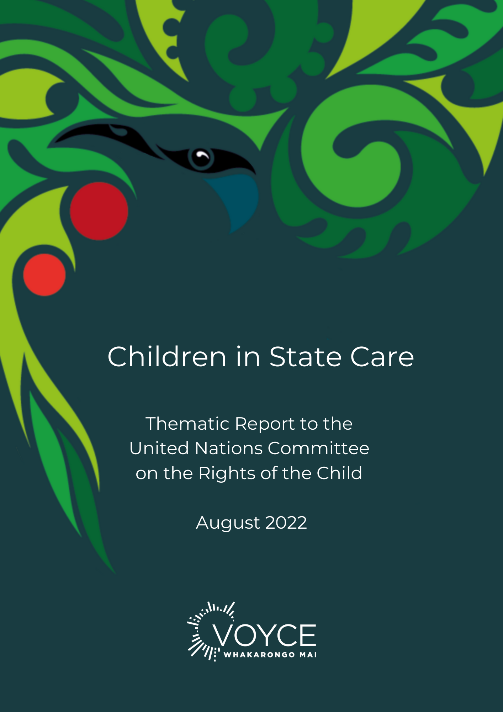

Contents
INTRODUCTION 2
6 PROMISES 3
UNITED NATIONS ARTICLE: VIOLENCE AGAINST CHILDREN 4
PROMISE #1 – PARENTAL CARE 4
NATIONAL CARE STANDARDS 4
THE OVERSIGHT SYSTEM FOR ORANGA TAMARIKI 5
THE ROYAL COMMISSION OF INQUIRY INTO HISTORICAL ABUSE IN CARE 7
VOYCE RECOMMENDATIONS – PARENTAL CARE 8
UNITED NATIONS ARTICLE: FAMILY ENVIRONMENT, ALTERNATIVE CARE + SPECIAL PROTECTION MEASURES 8
PROMISE #2 - STABILITY 8
CHILDREN DEPRIVED OF A FAMILY ENVIRONMENT 8
LEAVING CARE 9
YOUTH JUSTICE 9
VOYCE RECOMMENDATIONS – STABILITY 11
UNITED NATIONS ARTICLE: EDUCATION, LEISURE & CULTURAL ACTIVITIES 12
PROMISE #3 – EDUCATION 12
VOYCE RECOMMENDATIONS – EDUCATION 13
UNITED NATIONS ARTICLES: HEALTH & WELFARE + CHILDREN WITH DISABILITY 14
PROMISE #4 – HEALTH 14
DISABILITY 15
REDRESS FOR ABUSE IN STATE CARE 15
VOYCE RECOMMENDATIONS – HEALTH 16
UNITED NATIONS ARTICLE: GENERAL PRINCIPLES 17
PROMISE #5 - VOICE 17
RIGHT TO BE HEARD 17
CONSULT WITH CHILDREN 17
VOYCE RECOMMENDATIONS – VOICE 18
UNITED NATIONS ARTICLE: CIVIL RIGHTS & FREEDOMS 19
PROMISE #6 - IDENTITY 19
IDENTITY 19
ADOPTION 19
VOYCE RECOMMENDATIONS – IDENTITY 20
GLOSSARY Annex
REFERENCES Annex

INTRODUCTION
“Helping set up VOYCE – Whakarongo Mai and see it turn from an idea and a calling from children and young people, into reality, has been a real journey and a privilege. I look forward to seeing how the service grows in the future; to connect and walk alongside children and young people in care to make sure they are listened to.”
– Monique Goodhew, one of the founding care experienced members of VOYCE – Whakarongo Mai
VOYCE - Whakarongo Mai means ‘Voice of the Young and Care Experienced - Listen to me’. It is the nationwide independent advocacy and connection service supporting care experienced young people in Aotearoa New Zealand and was established in 2017. VOYCE exists to amplify the young voices of those in care. It was co-created by care experienced young people, for care experienced young people.
In 2015, the national state care system was in crisis. A groundswell of traumatised young people was growing and demanding meaningful change. Young people spoke of how helpless they felt in the face of a system seen to hold all the power. They felt a lack of honesty and transparency in decision making processes, that they had no voice in important decisions about their future.
The 2015 Expert Advisory Group on Modernising Child Youth and Family recommended, “the voices of children and young people are embedded into decision-making at both individual and system levels, including through the establishment of a permanent and independent advocacy service”. The ‘business case’ for independent advocacy and connection for those with care experience was co-designed by young people, Government, the philanthropic and non-Government sectors.
VOYCE was formally established in 2017, founded on rights and relationship-based principles. VOYCE provides independent advocacy and connection events to anyone aged 0 – 25 years old with care experience. It is not-for-profit and funded by Government and philanthropic organisations.
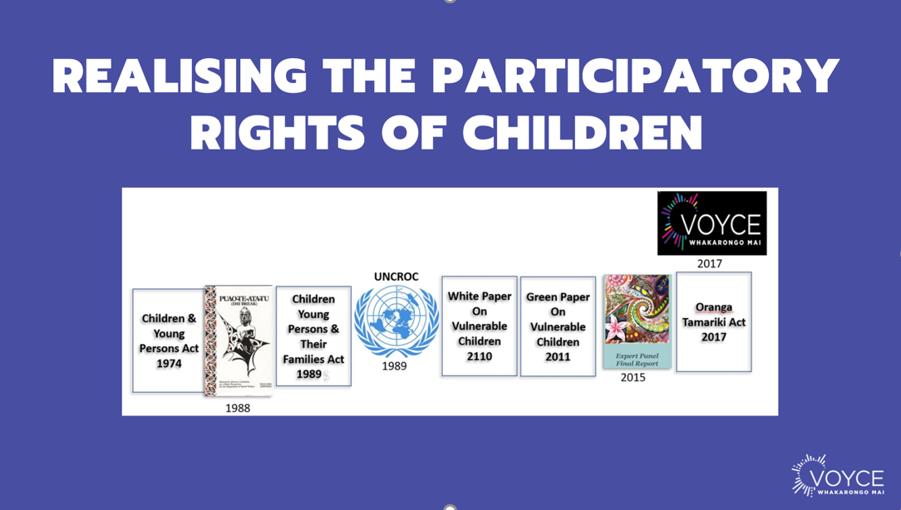

In the past five years, VOYCE has grown to 50 employees, available to support more than 30,000 babies, children and young people in care or with care experience. Staff are mainly advocates, working in communities across the country, elevating the voices of care experienced children and young people in the hopes of them living with love and mana.
In 2015, there were 3,500 babies, children and young people in state care across New Zealand. There are now 7,153 NZ children and young people in care, with 99% (7,056) in the care of Oranga Tamariki (the national state care system). The increase in these numbers is not proportionate to the country’s population growth, even when factoring the upper age of care being raised in the past five years.
Demand and recognition for upholding the rights, mana and love for those in care remains a challenge.
"As a community, we are constantly having to fight for our basic needs to be fulfilled, we are having to fight to be acknowledged as people who deserve the bare minimum."
In February 2020, VOYCE submitted a Thematic Report to UNCRC highlighting the disproportionate discrimination experienced by children in New Zealand state care. In 2022, care experienced children and young people continue to face discrimination across all areas of their lives in New Zealand.

6 PROMISES
In 2020, during New Zealand’s national government election, VOYCE launched the 6 Promises For 6000 campaign. These 6 Promises were developed by the steering committee of VOYCE and its National Youth Council; a group made up of care experienced young people who are emerging leaders in the care community. The petition called for political parties to agree to uphold six basic asks to make the care system a more caring system, and to address discrimination faced by care experienced young people. The incoming Labour majority government has yet to demonstrate their commitment to the promises. The 6 rights-based promises are as follows and form the framework of our UNCRC response:
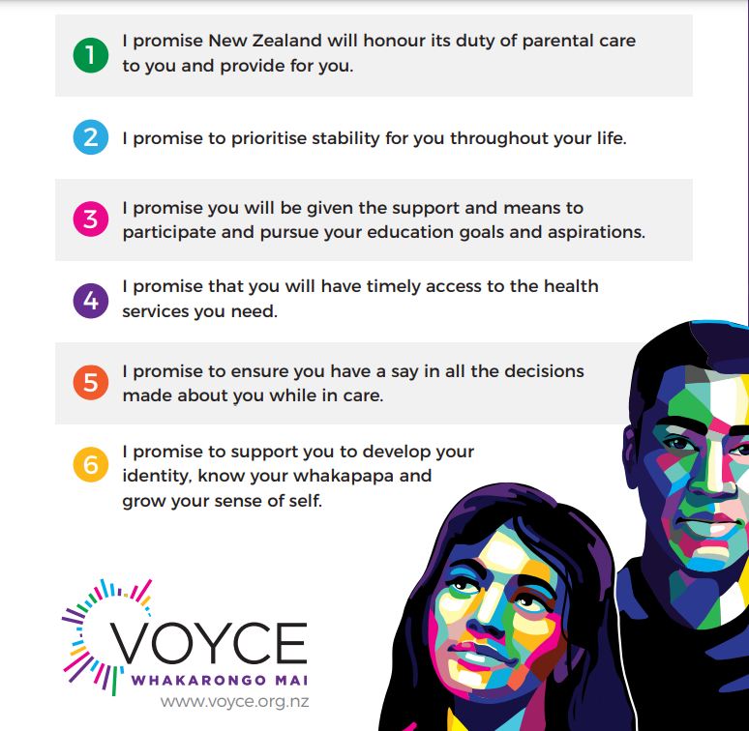

This submission highlights issues care-experienced young people have shared their opinions on since VOYCE’s inception in 2017. The report pulls together key priorities and recommendations identified by care experienced rangatahi – their voices woven through the report in the anonymised quotes highlighted.
“Our young people are constantly slipping through the cracks in AND out of state care but far more in care. How is it that we have so many laws and standards and codes and our kids are still getting abused and failed? Something needs to change in the whole way we approach our system.”

***

UNITED NATIONS ARTICLE: VIOLENCE AGAINST CHILDREN

PROMISE #1 – PARENTAL CARE
I promise New Zealand will honour its duty of parental care to you and provide for you
“Politicians say ‘this is a system’. This is not a system. This is how I lived. The state becomes our parents and the system becomes our childhood”
Care experienced young people have grave concerns that measures to mitigate the risk of the use of violence and abuse against children in state care do not go far enough to protect them. These measures include:

- National Care Standards
- The Oversight System for Oranga Tamariki
- The Royal Commission of Inquiry into Historical Abuse in State Care

Care experienced young people believe these measures are happening in piecemeal fashion, with minimal input and consideration of the views of those with lived experience.

NATIONAL CARE STANDARDS
“It is unacceptable that the report finds the minimum level of care required by the standards are not being applied for the majority of the 7,152 children in state care.”
The Government claims that the “introduction of the National Care Standards (NCS) brought New Zealand closer in line with the Convention”. VOYCE disagrees. The standards only cover the bare minimum of what a good life looks like for a child. The VOYCE National Youth Council recently stated a priority must be for young people in care to have “everything they need to thrive”.

Not only are the National Care Standards the bare minimum, New Zealand is falling well short of meeting these Standards. The Independent Children’s Monitor (ICM) recently released their first report that looks at compliance with the Oranga Tamariki Regulations.
Key Findings included:
- Agencies still have no self-monitoring or data collection in place to ensure they are meeting the basic rights/needs of the children and young people in their care.
- Tamariki and young people still don’t know and understand their rights or feel able to complain.
- A significant proportion of children and young people are still not getting what is set out in their care plan.
- Important assessments around wellbeing, including cultural, health (physical and mental) and transition to independence are largely not being completed.
The report demonstrates that the ICM’s Outcomes Framework lacks direction or accountability for how compliance with National Care Standards and quality of care provision will be independently and effectively monitored and assessed. There is also no evident commitment to the process being informed by young people.

THE OVERSIGHT SYSTEM FOR ORANGA TAMARIKI

THE PROPOSED OVERSIGHT OF ORANGA TAMARIKI SYSTEM AND CHILDRENS AND YOUNG PEOPLE’S COMMISSION BILL

Of urgent concern is the Government’s response, “MSD [The Ministry of Social Development] is leading work to strengthen oversight of the Oranga Tamariki system” and proposals to “strengthen independent monitoring and assurance of the Oranga Tamariki system” to improve “the rights, interests and wellbeing of children and young people.” VOYCE submits that the proposed Bill is deeply flawed.

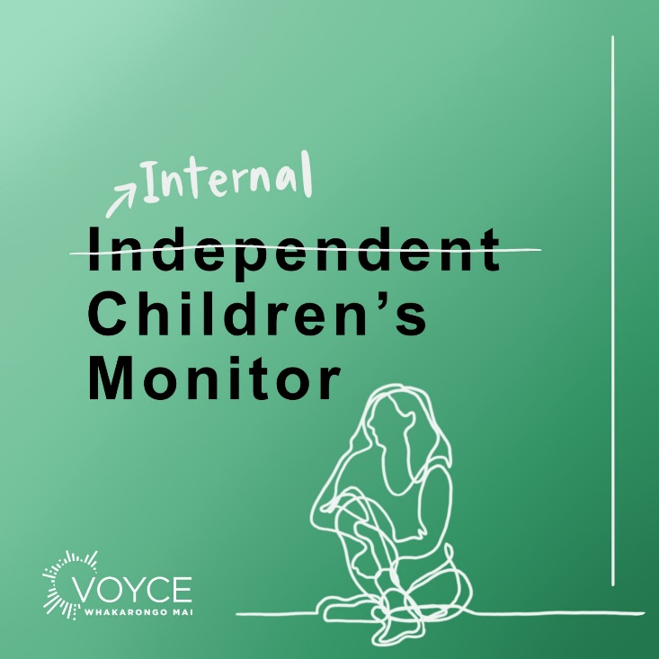

The Bill changes how the rights, interests and well-being of young New Zealanders are protected. It also proposes significant changes to the monitoring, complaints and advocacy functions around Oranga Tamariki. The proposed Bill strips the Children’s Commissioner role of oversight of Oranga Tamariki and hands this to a new entity - the ‘Independent’ Children’s Monitor (ICM). This entity was first established in the Ministry of Social Development in 2019 and, as explained above, has yet to prove its independence or its ability to adequately monitor what’s going on for children.

Under the proposed legislation, the ICM will be shifted into the Education Review Office, the entity responsible for inspecting schools, and complaints about Oranga Tamariki would be shifted into the adult-centric Ombudsman office.

“We need a monitor that has the power to shake things up when the system is getting it wrong, right now we have a monitor that is afraid of being bold in its reporting.”

Care experienced young people’s biggest concerns about the Bill:

- Tamariki and Rangatahi are not at the heart of this Bill – they’ve not been consulted in the Bill’s development, nor does the Bill include mechanisms for their involvement in the monitoring frameworks.
- Separation of advocacy from monitoring and complaints – Data and insights from monitoring and complaints should form the basis of good advocacy. Monitoring is pointless if no one is going to advocate for change and improvements.
- No independence of the Independent Children’s Monitor – the Bill proposes housing the monitor within a government department. Young people and Māori (who are overrepresented in Oranga Tamariki statistics do not trust that another government department will be independent or impartial in their monitoring and they have won’t have the powers to stand up for them when needed.
- Token partnership approach to governance – inclusion of a Māori advisory board does not represent partnership honouring Te Tiriti o Waitangi obligations.
- Limited powers of entry – the proposed Bill restricts the Monitor’s access to children and young people, such as requiring written notice before entering a residence.

Care experienced young people have been very vocal about their concerns and opposition to this Bill, including speaking at Select Committee, directly to the responsible Minister and in the media. Nevertheless, their concerns have not been listened to and the Bill continues to pass through parliamentary processes taking it closer to becoming law, undermining their confidence in the government’s democratic process. The Government’s suggested 5-year review period of the Bill is a lifetime to any child suffering abuse and neglect under legislation not fit for purpose.

“This Bill is a disservice to our voices and suffering at the hands of the state. We are doomed to repeat history. The Government has not listened to a single recommendation from young people with lived experience”
Care experienced young people are concerned if this Bill is implemented it will pave the way to further systemic abuse, and another Royal Commission of Inquiry into Abuse in Care (described below).

THE ROYAL COMMISSION OF INQUIRY INTO HISTORICAL ABUSE IN CARE
The Royal Commission Inquiry into Abuse in Care (the Inquiry) demonstrates the prevalence of abuse in care in their interim report, estimating “up to 655,000 children, young people and vulnerable adults were in State and faith-based care during 1950-2019 and up to 250,000 children, young people and vulnerable adults were abused”

VOYCE is concerned that the voices of those with lived experience who bravely shared with the Inquiry are not being considered, in the development of the OT Oversight System. These processes are occurring under different Ministers in isolation of each other. Ironically, the Inquiry’s final report will be delivered in June 2023, the same time the proposed Oversight Bill will come into force if passed.

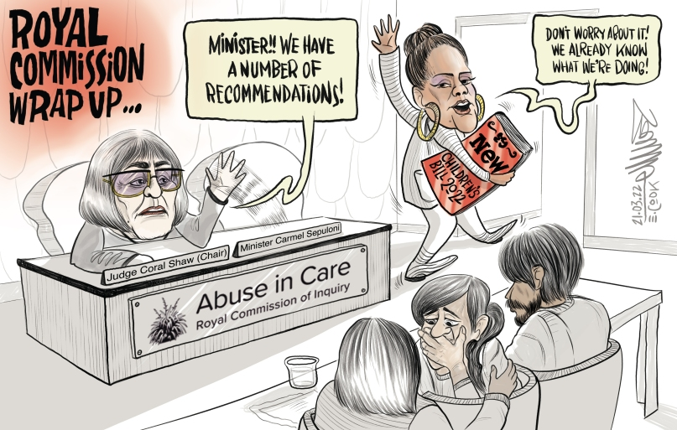

Emma Cook Cartoon on the Oversight Bill and the Royal Commission of Inquiry into Abuse in Care

By not waiting for the recommendations from the Inquiry to best inform the oversight of the state care system, the Government has signalled it is not committed to eradicating abuse against children in state care. Pre-empting the work of the Inquiry has “made a mockery of those brave enough to share their stories”, Judge Frances Eivers, current Children’s Commissioner.
“After more than 60 years of weak oversight and accountability, what’s the rush to ignore our voices and the Royal Commission’s final recommendations in June next year?”

VOYCE RECOMMENDATIONS – PARENTAL CARE
1)“We ask you to honour your duty of parental care to us and provide for us”
“To feel safe and secure we need to know there is someone committed to our long-term wellbeing, and to feel valued we need to know that we are worth somebody making this commitment to us.”
- BEST INTERESTS OF CHILD
- Listen to the voices of lived care experience: Stop the Oversight of Oranga Tamariki Bill.
  - This Bill needs time to be co-designed with those it affects the most: the care experienced community and Māori, drawing on the recommendations from the survivors who have shared their stories with the Royal Commission of Inquiry into Abuse in State Care.

- FREEDOM FROM VIOLENCE
- Give the ICM the authority to effectively carry out its functions, to ensure the needs, rights and interests of children and young people in care are upheld.
  - The Monitor be provided unlimited powers of entry
  - OCC’s monitoring, complaints and advocacy functions be retained and strengthened
  - Place the Monitor with the Office of the Children’s Commissioner so it is truly independent

UNITED NATIONS ARTICLE: FAMILY ENVIRONMENT, ALTERNATIVE CARE + SPECIAL PROTECTION MEASURES

PROMISE #2 - STABILITY
I promise to prioritise stability for you throughout your life
“Developing the resilience you need to succeed, requires having a stable base where you can take risks knowing that everything will be OK because someone will be there to catch you.”

CHILDREN DEPRIVED OF A FAMILY ENVIRONMENT
“The current youth system is like pass the parcel but the music never stops, you just get passed around until you reach 18, then you are on your own”
“The first 8 years of my life, I spent moving between families. All the disruption taught me was to be afraid.”
Children’s views were taken into account in the reform of the care system, but there is still much work to be done to ensure that the rights of care experienced children and young people are upheld and their voices continue to influence decisions made across the care sector.

A priority identified by the VOYCE National Youth Council is “Suitable accommodation for all youth. This includes providing families with additional supports and reviewing placements to ensure wellbeing, safety and voice of youth are being met.”

This is especially relevant for tamariki and rangatahi Māori who remain significantly over-represented in state care, making up 68% of children and young people in care. VOYCE Whakarongo Mai rangatahi support an ongoing shift towards early intervention and strengthening community driven responses for Māori by Māori.

VOYCE - Whakarongo Mai supports the focus on improvements in data collection and specifically the need for improvements in data and reporting on the outcomes of children while they are in care and after they leave care. This data includes listening to the voices of children and young people in care to ensure that all system responses are designed to work best for them.

LEAVING CARE

VOYCE Rangatahi have also recently conducted research on leaving care, with a focus on young people’s experiences of the entitlement to remain or return to living with a caregiver after the age of 18 years. Interviews with young people brought to light key recommendations on upholding the right of every child and young person to a safe and loving home and ensuring that the needs of children and young people are met throughout their care journey.

“You’ve been moved around so much and then all of a sudden you get to an age where it’s like, oh no, now you’re just… you feel like a bird that’s finally been let out of it’s cage. Well, where do I go from here?”

YOUTH JUSTICE
Custody should only be used as a last resort and for the shortest appropriate period. Pre-sentence detention should be taken into account to ensure total periods in custody are no longer than that imposed at sentencing.
In the Adult justice system: Period spent in pre-sentence detention is deemed to be time served
In the Youth justice system: There is NO equivalent provision.
Most young people in the youth justice system here fall under the Oranga Tamariki Act while on remand and when serving a custodial sentence. Young people who offend may be remanded in custody prior to sentencing and subsequently sentenced to a custodial outcome, a Supervision with Residence order, for up to 6 months. The pre-sentence detention period is not currently recognised as time served and so not deducted from the post-sentence detention period, extending the total time spent in custody beyond that imposed at sentencing. Effectively, this creates a disproportionate response to their offending in the youth jurisdiction and exposes them to extended periods of exclusion from families and communities at a critical time in their development. We believe youth offenders are being detained in custody for longer periods due to a bureaucratic oversight.
“I’ve been to FGC seven times, got declined every time, just got told false hopes”
The stories from young people in Youth Justice Residences are bleak. Regularly they are given “false hopes” that they may be released into the community, only to be remanded back in custody usually because they don’t have a place to stay or there aren’t any programmes for them where they live.
“…6 different charges and each time put back on remand, resulting in weeks before the next FGC and next court case every time… 2-3 months of being put back on remand due to a plan not being presented or not being approved”
Extended periods on remand are often a result of delayed court processes and decision making, which include multiple delays.
“There’s no accountability on the social worker to ensure they’re doing their job properly in these situations”. “A delay in court dates, not hearing from social workers, drawn out decision making… it’s the normal culture in residence to have all these delays”

VOYCE RECOMMENDATIONS – STABILITY
2) “We ask you to ensure we have stability”
“Right now we so often move from place to place, from family to family, from school to school, without getting a chance to develop deep relationships. Children and youth cannot easily build resilience, or a real sense of confidence, when we cannot even predict for sure where we will be next month, but when we have people we can trust and rely on, we can.”
- CHILDREN DEPRIVED OF A FAMILY ENVIRONMENT
- Do not pre-determine outcomes before consulting with with care-experienced children and young people on matters that affect them.
- Suitable accommodation for all youth. This includes providing families with additional supports and reviewing placements to ensure wellbeing, safety and voice of youth are being met.
- Continue to shift focus towards early intervention services in communities, with more support delivered for Māori by Māori.
- Improve data collection and reports on the outcomes of children while they are in care and after they leave care, with emphasis on voices of care experienced children and young people.

- LEAVING CARE
- Uphold the right of every child and young person to a safe and loving home
- Uphold right of children and young people to connection with whānau, identity & culture
- Ensure the needs of children and young people are met throughout their care journey so they can successfully transition from the care system
- Support diverse needs & preferences regarding accommodation & caregiver relationships
- Address systemic practice and process issues that impede young people’s transitions

- YOUTH JUSTICE
- Amend the Oranga Tamariki Act to acknowledge time served on pre-sentence detention in custodial sentences in the youth justice system.

UNITED NATIONS ARTICLE: EDUCATION, LEISURE & CULTURAL ACTIVITIES

PROMISE #3 – EDUCATION
I promise you will be given the support and means to participate and pursue your education goals and aspirations.
“This shapes who we are, who we’re going to be and who we want to be… From just being kids in care to being future CEOs, future changemakers… whatever and whoever we want to be.”
The gap in education access and outcomes for care experienced children and young people is not acknowledged or addressed by the government.
“Staff need a real understanding of overlapping complex needs – trauma, being in foster care, disability - and not just being trauma-informed from a Western perspective but understanding the trauma in us as Māori and Pacific”
Students who have been in care are more likely to have challenges around school engagement, achievement, and education pathways. Education can change the direction of these students’ lives and lead to greater levels of participation in further education, training and employment.
Fewer young people with experience of care (55%) achieve Secondary School NCEA qualifications than young people with no experience of care (84%). They also have a higher rate of disengagement from education (exclusion or enrolment in alternative education) and change schools more frequently. 25% of children with experience of care have at least three school changes, compared with 3% of children with no experience of care.
“Having OT constantly cutting their connections by moving them around the country, around placements, communities, schools- that’s not healthy for young people, it leads to them having no sense of community. Education ties into this, as youth are much more likely to succeed in education when they have a strong support network and other needs met.”
Children and young people in Oranga Tamariki residential care are among the most at risk of poor outcomes later in life. The quality of education in residences is not consistent. A recent study found a number of issues, including: disrupted learning; no agreed model for high quality education; variable commitment to culturally responsive practice for Māori and; a lack of opportunities for whānau and caregivers to connect to their children’s learning.

“Too often we go in with the education provider being impersonal. Focussed on getting it done and ticking a box – it’s not mana enhancing.”
Only 14% of those who have ever been in the care of Oranga Tamariki gain a tertiary qualification by the age of 25; this compares with 50% for the general population. Care experienced young people express a lack of support, stability and means as well as not feeling prepared to succeed in tertiary education when they transition from care.
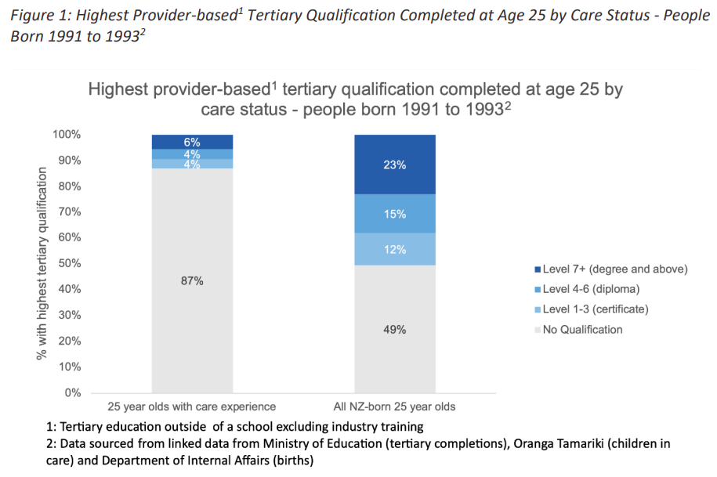

VOYCE RECOMMENDATIONS – EDUCATION
3) “We ask you to ensure we have the support we need to meet our educational goals and aspirations”
“Like everyone we need someone to encourage us to strive to be the best we can be. No matter what our goals are, it is always easier to succeed if we have the chance to get the skills and knowledge we need, and the assistance required to take this chance.”

- EDUCATION
- Decrease the gap in access to education for care experienced children and young people by acknowledging the unique needs of this group and making specific supports available to meet these needs.

UNITED NATIONS ARTICLES: HEALTH & WELFARE + CHILDREN WITH DISABILITY

PROMISE #4 – HEALTH
I promise that you will have timely access to the health services you need
“Growing up in state care, we often faced many traumatic experiences and trauma gone uncared for can develop into something far more dangerous and extremely difficult to live with.”
The NZ Government mention “substantial work to improve access to education, healthcare and protection” for Māori and Pasifika children and children with disabilities. However, there is no mention of specific health care services ensuring a minimum standard of living for the care-experienced population. This population struggles with adequate access to health services, including age-appropriate mental health services.
“People only care when the person is dead, the discussions are happening too late, too late for them to have an effect.”
Oranga Tamariki data shows that “40 % of children and young people in its care are not currently registered with a general practitioner (GP) or medical practice”. OT data does not show if children have annual health and dental checks. It does show that the assessments and plans of 37% of children do not include expert opinions. Gateway assessments (including health and education assessments) are concerningly out of date (some dated back to 2011). The ICM report highlights that “Oranga Tamariki screening for substance use, psychological distress and suicide risk is also very low”. Most young people said that, even if they know they need support, they are unsure where or how to find help. “For those that do access support like therapy, they can come out of it feeling unheard and misunderstood.”

MENTAL HEALTH
“Every person that's in foster care should have a counsellor.”
The VOYCE Whakarongo Mai National Youth Council identified “lifelong mental health services for anyone who is care experienced” as a priority.
Currently, Canterbury is the only DHB in New Zealand with a "Children in Care Team", a service for children and young people between the ages of 0-12 years, including those who are in the custody of the Chief Executive of Oranga Tamariki, and who have a confirmed or suspected moderate to severe mental health issue.
The Mental Health and Wellbeing Commission’s ‘He Ara Āwhina’ monitoring framework consultation, sought the views of care-experienced children and young people on their journeys through the mental health and addiction system. VOYCE Rangatahi raised the following concerns:
- “Hard to even get in contact with support places. Already very hard to ask for help because of the stigma”
- “Once you’re out of care you’re left to deal with it all by yourself”
- “A lot of counsellors are not qualified for PTSD and uplift related issues. Hard for them to help as they don’t understand.”
- “Wait times can be 2 years sometimes”
- “What if shit hits the fan in the time that it took for the service to be available? The young person could be dead.”
Young people also identified their hopes for the mental health and addiction system, including:
- “Quick, inclusive and non-judgmental support that is available for those that seek it.”
- “Removal of stigma with care kids”
- “Support in place when out of systems, people not being dropped. Care experienced is a lifelong thing”
- “Children and young people can express what they need rather than the system telling them”
- “Mental health system that knows what the care system is”

DISABILITY
1 in 10 children aged 0-17 with current or previous Oranga Tamariki involvement have at least one indicator of disability, making them 2.6 times more likely to have an indicator of disability than children with no previous involvement with Oranga Tamariki
The Transitions Cohort Needs Assessment study explored the needs of ‘high need’ young people soon to transition from state care. The study found that 35% of young people had a known disability; 53% had a mental health need and 46% a substance abuse issue. 13% were reported to have a ‘suspected’ disability and 22% mental health need with no evidence of an assessment. Of the young people that had a disability or suspected disability, only 44% were perceived as having their needs adequately addressed. Just over half had the services they need available to them in their region. 17% of the total cohort surveyed felt adequate services were not available in their area.
The rights of children with disabilities under the UNCRC and the UNCRPD must be taken into account on entry into care and transition from care.

REDRESS FOR ABUSE IN STATE CARE
“There should be no limitations as to what redress might look like for each individual, whether it’s re-building confidence; reconnection with their culture or heritage; being connected to their marae; learning coping mechanisms etc. But support will need to be provided to help young people to define their process of healing”
As part of the ongoing Royal Commission Inquiry into Abuse in State Care, care-experienced young people discussed what a new redress scheme should look like, with a focus on the scheme:
“As closely as possible, restoring a survivor of abuse to their state of being prior to experiencing abuse in care.”
Care experienced young people recommended the following purpose for a new Redress scheme:
Kai tau ai te mauri tū, te mauri ora ki te tangata - to restore the overall health and wellbeing to the individual

VOYCE RECOMMENDATIONS – HEALTH
4) “We ask you to ensure we have timely access to health care when we need it”
“Too many youth in care are known, or suspected, to have mental health needs or a disability and yet we often come to the end of our time in care and still have not been assessed or received access to the health services we need.”
- HEALTH CARE
- Life-long access to Mental Health Services for all care experienced children and young people
- The child at the centre of decisions made about their health and wellbeing
- Knowledge of and tailored support toward the care system within the health system

- DISABILITY
- UNCRC rights and UNCRPD rights for children with disability taken into account by the care system, including on entry into care and transition from care

- REDRESS
- An independent redress scheme focused on restoring the overall health and wellbeing to the individual:
  - Provide survivors with holistic and tailored rehabilitation to meet individual needs to restore health and wellbeing
  - Work with survivors to understand their needs and to provide choice in the process and in the redress received

UNITED NATIONS ARTICLE: GENERAL PRINCIPLES

PROMISE #5 - VOICE
I promise to ensure you have a say in all the decisions made about you while in care
“While I was in care, I had no direct involvement with the decisions that were made about me and the decisions had detrimental effects on my life.”

RIGHT TO BE HEARD
“The right to be heard. Nothing for us without us. These problems are things that we are constantly asking for solutions to, we are not being listened to.”
The VOYCE Whakarongo Mai youth council identified the need to “ensure the voices of care and youth justice experienced youth are heard in all decisions that affect them” as a priority.
“I spent sixteen years in care and in that time, I wasn’t once asked if I wanted to participate in any of the decisions that were made around my care”
Care experienced children and young people report they are seldom consulted on decisions that affect them and, when they are, communication from social workers and other professionals is often challenging.
“Often a social worker will explain something but not in a way that a young person can understand or retain that information”.
“55% of children did not know why their planned care transition was happening and were not encouraged or helped to take part in planning”.

“Young people need to understand what’s going on”.

CONSULT WITH CHILDREN
“If you do not bring the affected communities on the journey with you from the beginning, you will not make any meaningful change or progress.”
Care-experienced young people and VOYCE Whakarongo Mai, collaborated with researchers from Waipapa Taumata Rau/ The University of Auckland and Te Rōpū Rangahau Hauora a Eru Pōmare, University of Otago (Wellington) to develop practice guidance to support good engagement with the care-experienced community: Kia Tika, Kia Pono. “the right people, doing the right things”. It describes the elements needed to ensure that adults and organisations honour and respect children and young people who are care experienced and their contributions. Doing so requires processes that recognise these children and young people as expert leaders (rangatira) on their stories, lived experience and knowledge, uphold their mana, and add value to their lives.
"The government’s direct disregard for the voices of those with lived experience clearly communicates to us as a community that this fight is something that will only continue, as the oranga of our children, the actual wellbeing of our children is clearly not something that they value as much as they’d like us to believe."

The recent Oranga Tamariki Oversight Bill process has highlighted just how tokenistic the current opportunities are for young people to participate.

"Reassurances were given, acknowledgement of our kōrero provided, and yet still, the bill is being pushed forward. Not only with an absence of young people voice, but actively in opposition to the expressed whakaaro of our care experienced community."

Another example of the tokenistic consultation of OT with young people includes the 2021 ‘Te Kahu Aroha report’ on improving Oranga Tamariki and the care system for young people.

“We are disappointed in the report’s minimal reference to amplifying the voices of tamariki and rangatahi and enabling our participation in decision making, given our engagement with the Board and significant feedback”

Young people are becoming demoralized and are fast losing faith in Aotearoa’s democratic system.
"Officials ask us for that whakaaro, only to completely disregard our kōrero and virtue signal to others by saying that they’ve taken on what we’ve had to say."

Care experienced young people have had enough of the box-ticking and tokenistic ‘consultation’ from the government and demand genuine consultation on issues of national policy development affecting their community.

VOYCE RECOMMENDATIONS – VOICE
5) “We ask you to make sure we have a say in all decisions made about us while we are in care”
“So often we feel like everybody else is in control of our situation. While we know we can’t always get what we want, sometimes we do know better than the adults around us what is best for us, and we need to feel that we have been heard and that our thoughts matter.”
- PARTICIPATORY RIGHTS
- Strengthen participatory rights by removing the loophole in current legislation that can prevent young people from participating in decisions about their lives

- CONSULTING WITH CHILDREN
- Genuine co-design and consultation on all policy development related to care experienced children and young people

UNITED NATIONS ARTICLE: CIVIL RIGHTS & FREEDOMS

PROMISE #6 - IDENTITY
I promise to support you to develop your identity, know your whakapapa and grow your sense of self
“When I was removed from my family, I was in a very unfamiliar world… I didn’t go down the path that I wanted to. I lost my language…”

IDENTITY
“It’s important to know where you’re from”

The Government highlights the Mana Tamaiti objectives. Objective #4 is: “Support Māori children and young people to establish, maintain or strengthen their sense of belonging through cultural identity and connections to whānau, hapū and iwi.” Recent Oranga Tamariki reporting suggests that just over half of Māori children aged 10–17 (59 per cent) felt that they knew their whakapapa. Oranga Tamariki also has obligations under section 7AA of the Oranga Tamariki Act to ensure that its policies, practices, and services support and improve outcomes for children and whānau Māori.

“The history of State care, in particular the care and protection system’s predilection for institutionalising and otherwise removing children from their homes, has estranged children from their whakapapa and Māori environments. This has left ‘a legacy of cultural disconnection which has created successive generations of young people damaged by the experience they endured”.

“If someone doesn’t have that cultural connection … it would just make them feel disconnected”
A recent Oranga Tamariki review of 352 Māori children in care shows that 38% had not had an assessment of their identity, cultural, connection or belonging needs; and 61% had not had wider cultural connections identified (including making contact arrangements with important members of their indigenous tribe/s).

ADOPTION
“The child not knowing who they are and where they come from, that sort of thing, creates more trauma in the future than it does in that moment”
One of the important issues the UN has requested feedback on is “information about the measures taken to provide Māori children adopted by non Māori parents with access to information about their cultural identity”.

Because adoption removes a child’s legal ties to their birth family and whānau, their legal connections to their culture, heritage and language may also be lost. For Māori children, this impacts their whakapapa and whanaungatanga connections. Adoptive parents are responsible for supporting a child to maintain, understand, and foster their cultural heritage, language and identity. However, they may not know how to meet the child’s needs or lack access to support and resources. Adoptive parents may not understand the importance of a child’s cultural heritage and identity and the child may feel displaced or disconnected from their birth family, whānau and cultural community. This can make it harder for the child to create a sense of identity. Impacts can affect future generations, with children of the person who has been adopted also feeling a loss of identity and connection to their whakapapa.

Adoption Law is currently undergoing reform in Aotearoa. As part of the public consultation process, care experienced young people provided their recommendations for change, including:

“Children’s cultural and language needs included in the adoption process and introduction of, and ongoing access to, educational resources and support services for all parties (the child, adoptive parents and birth parents).”

VOYCE RECOMMENDATIONS – IDENTITY
6) “We ask you to support us to grow our own sense of identity”
“Make sure we can connect with our whakapapa, culture, religion, or language, and develop an understanding of our gender identity, sexual orientation or anything else which makes us who we are. In unpredictable, unfamiliar and often isolating situations we can use this to have a sense of belonging and derive strength from what makes us unique. However, we need someone to make a conscious effort to ensure we get the chance to develop, nurture and grow this in the first place.”

- IDENTITY
- Care experienced children are supported to establish, maintain, and strengthen their sense of belonging through cultural identity and connections to whānau, hapū, and iwi.

- ADOPTION
- Children’s rights, best interests and welfare must be safeguarded and promoted throughout the adoption process, including the right to identity and access to information.

CONCLUSION
In conclusion, we leave you with the wish of a care experienced young person, wanting better for all those young lives in the NZ care system, and reminding us to remember the children amidst all the noise of bureaucracy:
“Imagine if we all had tangible support throughout the fostering system. I have no doubt all of us would have done better at our chosen fields. Our plan has always been to never forget the children and provide a service where all the foster children could have access, no matter their age and background. We all hope to see the foster children represented throughout the process and they must remain our priority – not forgotten in the bureaucracy of it all”

Care experienced is someone who, at any stage of their life, and for any length of time, has been in the care of the child protection system. This includes the following: family foster care (non-family and family), residential care, and placement in a care and protection or youth justice residence. (Te-Rōpū-Arotahi, 2022)
(then ‘Child, Youth and Family Services’)
(Independent Children's Monitor (ICM), 2022)
(New Zealand Government Report., 2021)
(Independent Children's Monitor (ICM), 2022)
(New Zealand Government Report., 2021)
(Royal Commission, 2020).
Cartoon published 21/03/2022 Dominion Post and syndicated across New Zealand – Emma Cook © 2022
(Katie Doyle., 2022).
(Independent Children's Monitor (ICM), 2022)
Article 37(b) (UNCRC)
(Parole Act, 2002)
(The Oranga Tamariki Act, 1989)
(Education Review Office, 2021)
(Oranga Tamariki., Voices of Children and Young People Team: Experiences of Education for Children in Care: Part 2: Review of New Zealand Government Data, 2019)
(Oranga Tamariki., Voices of Children and Young People Team: Experiences of Education for Children in Care: Part 2: Review of New Zealand Government Data, 2019)
(Education Review Office, 2021)
(Education Review Office, 2021)
(Iain Matheson., 2022)
(New Zealand Government Report., 2021)
(Independent Children's Monitor (ICM), 2022)
(Independent Children's Monitor (ICM), 2022)
(Mental Health and Wellbeing Commission (MHWC), 2022)
(Oranga Tamariki, Children and young people with impairments, 2020)
(Oranga Tamariki, Transitions Cohort Needs, 2018)
(Talking Trouble, 2018)
(Independent Children's Monitor (ICM), 2022)
(Te-Rōpū-Arotahi, 2022)
(Oranga Tamariki., 'Te Kahu Aroha' – Ministerial Advisory Board report, 2021)
(New Zealand Government Report., 2021)
(Oranga Tamariki., Improving outcomes for tamariki Māori, their whānau, hapū and iwi. Section 7AA Report, 2020)
(Waitangi Tribunal, 2021)
(Oranga Tamariki., Improving outcomes for tamariki Māori, their whānau, hapū and iwi. Section 7AA Report, 2020)
(United Nations Convention on the Rights of the Child., 2020)

